// 杜教筛（来自bzoj5230）

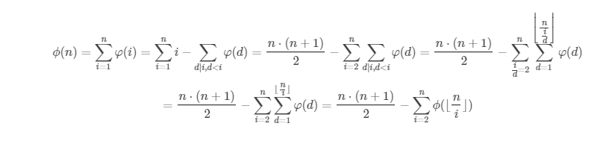

LL res[10048][5];

inline LL getsum(LL m,int k)

{

if (k==1) return ((m+1)\*m/2)%p;

if (k==2)

{

unsigned long long M=m;

LL res=((M\*(M+1))%(6ll\*p)\*(M\*2+1))%(6ll\*p);

res/=6;return res;

}

if (k==3)

{

LL res=getsum(m,1)%p;

return mul(res\*res);

}

}

inline LL solve(int m,int k)

{

if (m<=lim) return F[m][k];

if (res[n/m][k]!=-1) return res[n/m][k];

LL Res=getsum(m,k+1)%p,curans;

int pre=m,i;

do

{

i=m/(m/pre+1);

curans=mod(getsum(pre,k)%p-getsum(i,k)%p);

curans=mul(curans\*solve(m/pre,k));

Res=mod(Res-curans);

pre=i;

}

while (pre!=1);

res[n/m][k]=Res;

return Res;

}