测试环境: windows+phpStudy

软件版本: php 7.2 + mysql 5.5

数据库 “grocery”

表单:

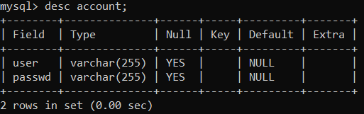  
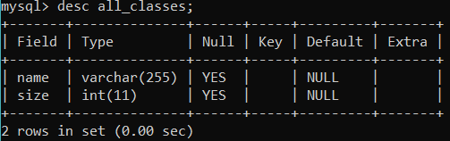

目录说明:

controllers: codeigniter/application/controllers

views: codeigniter/application/controllers

www: 网站根目录