|  |  |  |  |  |
| --- | --- | --- | --- | --- |
|  | INTERNATIONAL TELECOMMUNICATION UNION  **TELECOMMUNICATION** **STANDARDIZATION SECTOR**  STUDY PERIOD 2022-2024 | | **Focus Group on AI Native Networks** | |
| **AINN-I-xx** | |
| **Original: English** | |
| **Question(s):** | | N/A | Virtual, TBD 2024 | |
| **INPUT DOCUMENT** | | | | |
| **Source:** | | *Team FAHL-VICTHORS (Zimbabwe)* | | |
| **Title:** | | *Team FAHL-VICTHORS (Zimbabwe)* *- Report on* *ITU WTSA Hackathon 2024 –Energy Engine* | | |
| **Contact:** | | Mr. Victor Mpala | | E-mail: vctrmpala@gmail.com |

|  |  |
| --- | --- |
| **Abstract:** | This document contains the submission of report for *Team FAHL-VICTHORS (Zimbabwe)* towards ITU WTSA Hackathon 2024 for use case Energy Engine |

## Use case introduction: “Energy Engine”

In the bustling city of Harare, life comes to a standstill as the sun sets. The familiar hum of daily activities fades, replaced by the eerie silence of a city plunged into darkness. For the residents of Zimbabwe, power outages have become an all-too-common occurrence, disrupting businesses, schools, and homes. The aging infrastructure of the national power grid, coupled with increasing demand and the challenges of integrating renewable energy sources, has left the country grappling with frequent faults and anomalies.

Take the case of Mrs. Chipo, a small business owner in Mutare. Her bakery, a cornerstone of the community, relies heavily on a consistent power supply to keep the ovens running and the bread fresh. However, the frequent power cuts have not only led to spoiled ingredients but also significant financial losses. Mrs. Chipo's story is just one among many, highlighting the urgent need for a reliable and efficient solution to Zimbabwe's power grid challenges.

In response to this pressing issue, a groundbreaking solution is on the horizon. Imagine a future where the power grid is equipped with smart sensors and IoT devices, continuously monitoring the health and performance of critical infrastructure. These sensors, connected through high-speed 5G/6G networks, transmit real-time data to advanced machine learning (ML) models. These models are capable of detecting faults and anomalies before they escalate into major problems.

For instance, a sudden drop in voltage or an unusual rise in temperature in a transformer can trigger immediate alerts, allowing maintenance teams to address the issue proactively. Automated circuit breakers can isolate faulty sections of the grid, ensuring that power is rerouted and service continuity is maintained. This not only minimizes downtime but also reduces maintenance costs and enhances overall grid safety.

By leveraging the power of ML and advanced communication networks, Zimbabwe can transform its power grid into a resilient and efficient system. This innovative approach promises to bring an end to the frequent power outages, providing a stable and reliable power supply to millions of citizens like Mrs. Chipo. The future of Zimbabwe's power grid is bright, and with the right technology, it can illuminate the path to a more prosperous and sustainable nation.

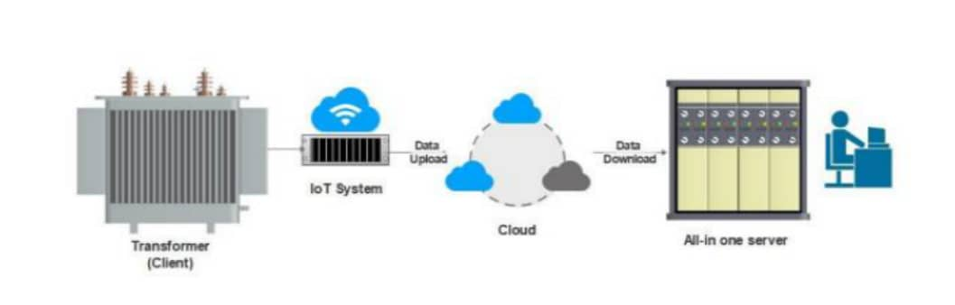

Phase 1: Sensors installed in the grid continually check for any abnormal voltage or current within the grid

Phase 2: Data is transmitted in real time over a 5G/6G networks to a central information processing unit.

Phase3: AI and ML algorithms analyze the data in order to see the trend and detect any anomalies

Phase 4: Users see any detected anomaly via web application and get notifications

Phase 5: AI predicts power transformer maintenance schedules and advices on measures to be taken for extremely faulty transformers

Phase6: The system adjusts resource allocation and notifies local authorities on any interventions to be taken

**Clause-2: use case requirements**

Real time monitoring

Predictive analytics

User Alerts

Data integration

**Clause-3: PS1: pipeline design**

* AI /ML Concept used is fault prediction and anomaly detection
* Linear regression model

**Clause-4: PS2: xApp design**

* Open RAN concept used is smart grid communications

**Clause-5: Relation to Standards.**

Solution adheres to ITU standards for IOT and communication networks ensuring compliance with the latest guidelines on smart grid communications

**Clause-6: Code submission details**

**Clause-7: Self-Testing results**

_________________