Hustle Caslte Bot

Supported OS: Windows 10 (x64), Windows 8.1 (x64), Windows 7 (x64).  
Supported Emulator: Nox. Emulator Version: 6.3.0.7006.  
Download the emulator here:  
<https://www.bignox.com>  
Download the bot here:  
<https://github.com/denesik/hustle_castle_bot_pack>

1. Installing the bot.

We open the link <https://github.com/denesik/hustle_castle_bot_pack> and press the button "1", then the button "2". You will download the archive, it must be unzipped. We will get a folder in which the entire contents of the bot, I have this folder is e:\work\hc_bot_pack\

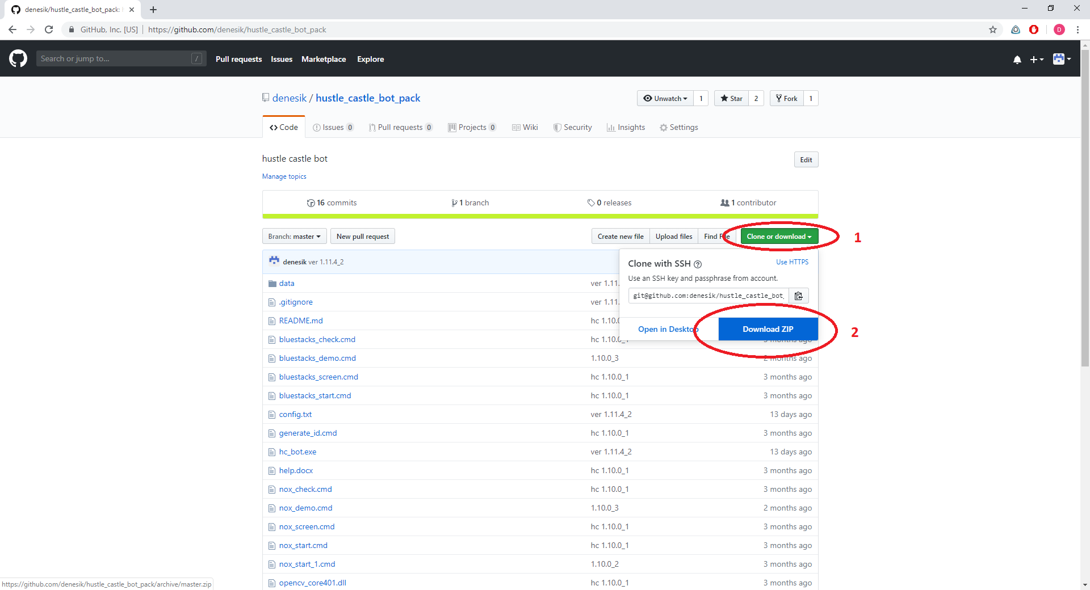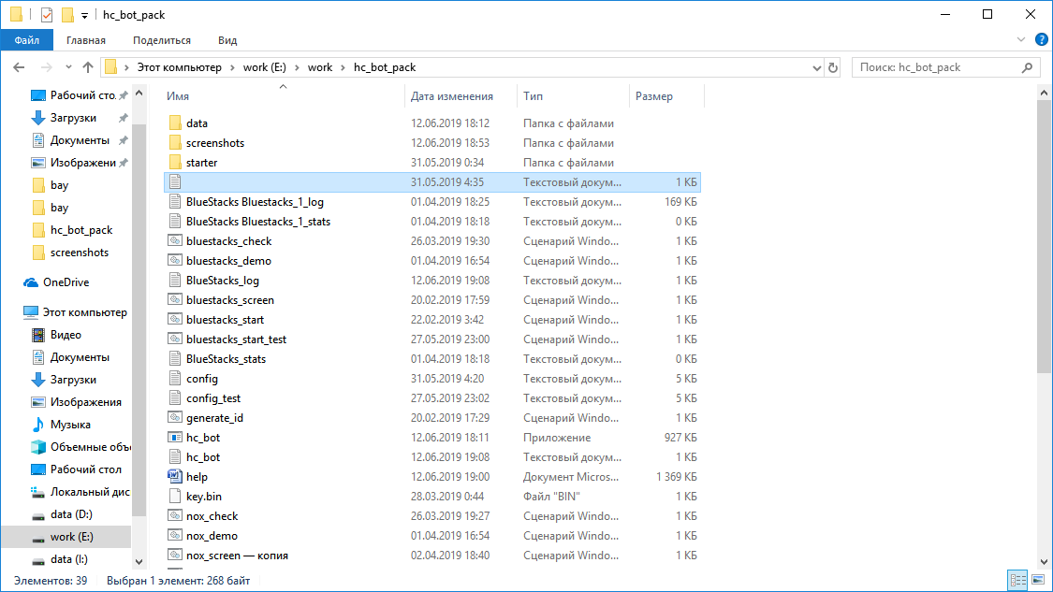

2. Registration process

1. We register your existing email address in the bin\login.txt file in the email field and save the changes. Specify your email address instead of “you@gmail.com” in the bin\login.txt file.

2. Run the file get_access_code.cmd and wait for the answer "Ok"

3. We go to your mail (email that indicated), you should receive a letter with an access code. Check your spam email!

4. Specify the specified access code in the file bin\login.txt in the email field and save the changes.

5. Run the file nox_start.cmd. If the answer is "Ok" and the lines of this kind run:

1.12.1_g 16:26:17 [MainMap :: MainState] ...

then you have successfully completed the registration process.

After registration, you will automatically be available all the functionality of the bot for three days.

3. System setup.

Check the screen settings: the screen scale should be 100%. When changing this parameter, you need to restart the PC !!! Screen resolution is any.

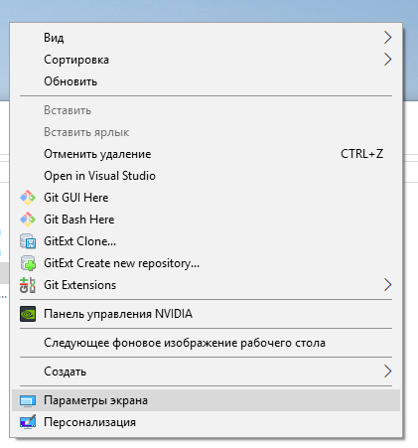

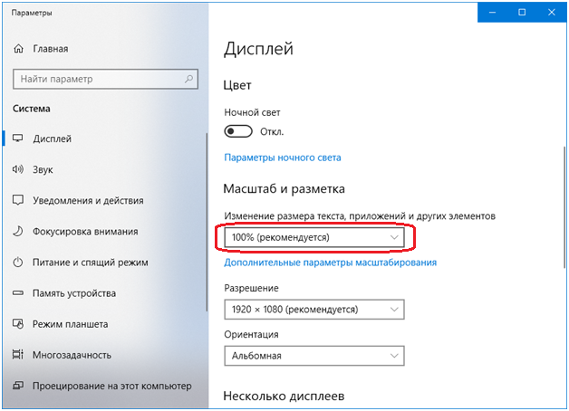

4. Configuring the emulator (Nox).

Size 1600x900, 240 dpi

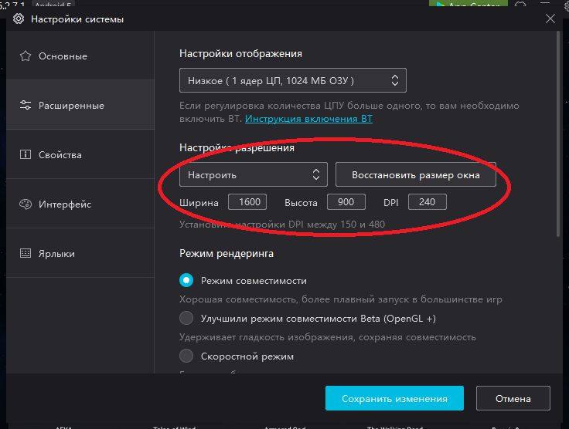

In case of an “unknown” error, try changing the rendering mode: choose compatibility mode or high-speed mode. OpenGL + mode does not work for me on this version of the emulator, but this does not mean that it will not work for you, try it!

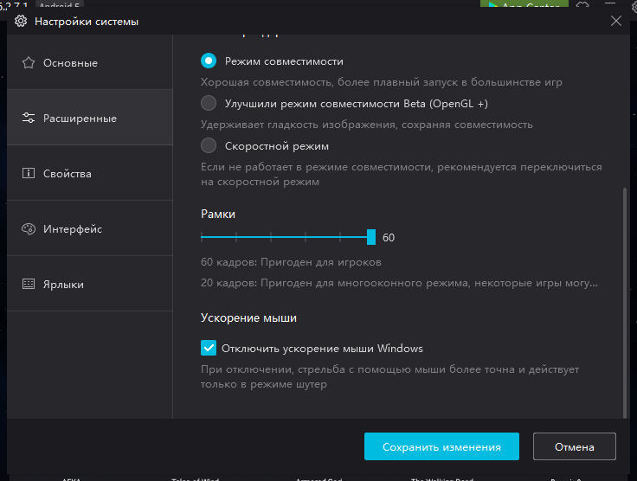

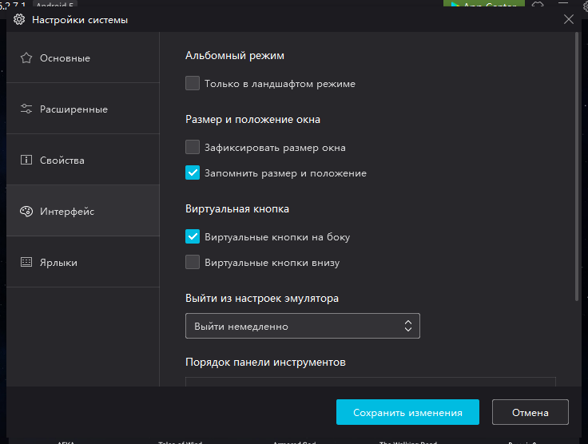

The bot may not immediately recognize the knox emulator. If you changed the size of the knox window with your hands, start the bot so that the window size automatically changes. After that, restart the emulator and restart the bot. This manipulation should help. Do this after each manual resizing of the knox window. And it’s better never to resize its window at all, it’s important that the “Fix window size” checkbox in the picture above is unchecked.

Once again, the steps for installing and configuring Nox:

- install the Nox emulator.

- run the emulator, the emulator window will be the wrong size.

- configure the emulator, according to the instructions above (1600: 900 240)

- save the emulator settings (close the settings window)

- launch the bot, wait for the bot to resize the emulator window

- when the emulator window becomes smaller, turn off the bot.

- restart the emulator, start the game.

- start the bot.

The language in the game must be English:

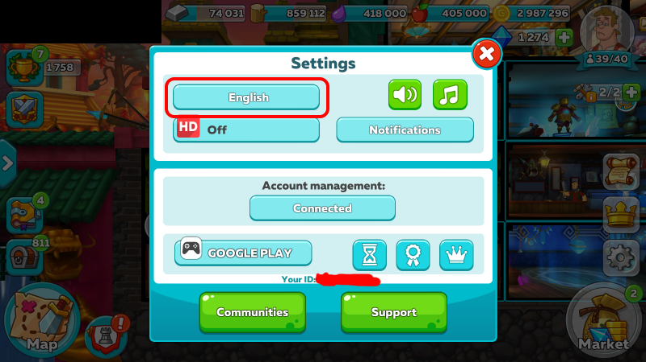

5. Configure the bot.

Configure settings.txt and config.txt files

In the settings.txt file, you need to specify the correct path to your emulator so that the autostart of the emulator works. Slashes on the way should be double. You can find the paths from the corresponding labels.

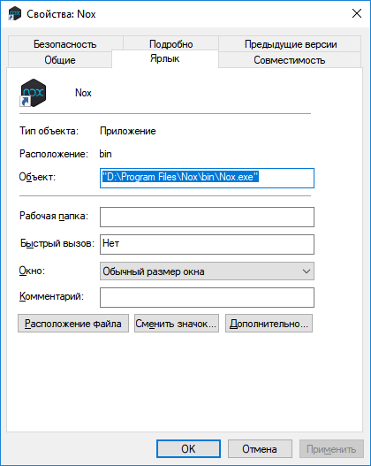

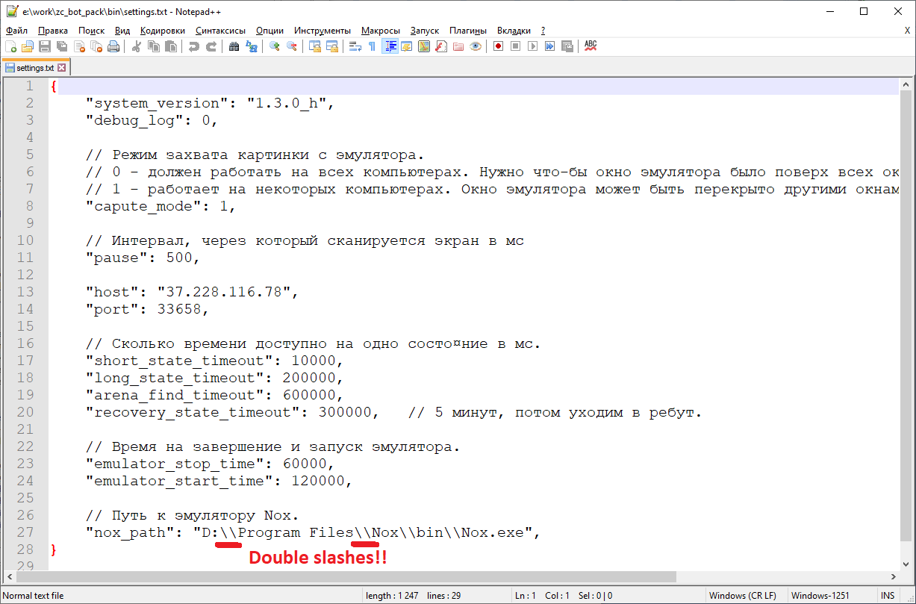

In the config.txt file, the bot operation mode is configured. For starters, the default operating mode is suitable; changing this file is not necessary.

The bot is launched by the nox_start.cmd file

To check the autostart performance, run the desired file and wait 5-10 minutes, if the path to the emulator is spelled correctly, the emulator should start and a little later the game.

If you have an emulator and a bot running, but a “scan error” error occurs, then the bot does not detect a running emulator window. Perhaps it is not correctly called (in the case of a multi-boat).

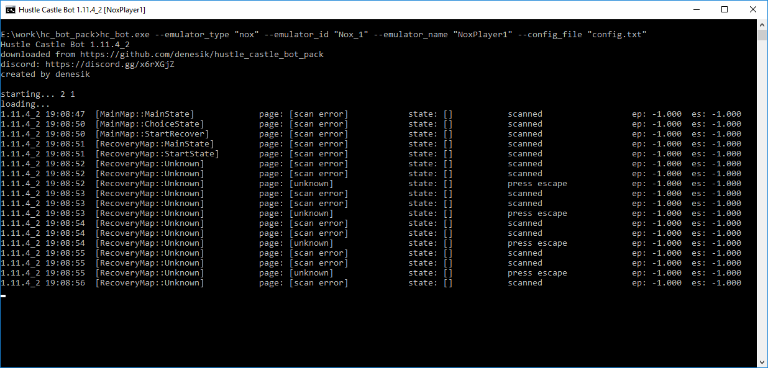

If you have an emulator and a bot running, but an “unknown” error occurs (the bot is trying to exit the lock), it means the bot does not correctly recognize the image from the emulator - the system or emulator is not configured, it is also possible that the antivirus blocks access (in this case, try disabling the antivirus) .

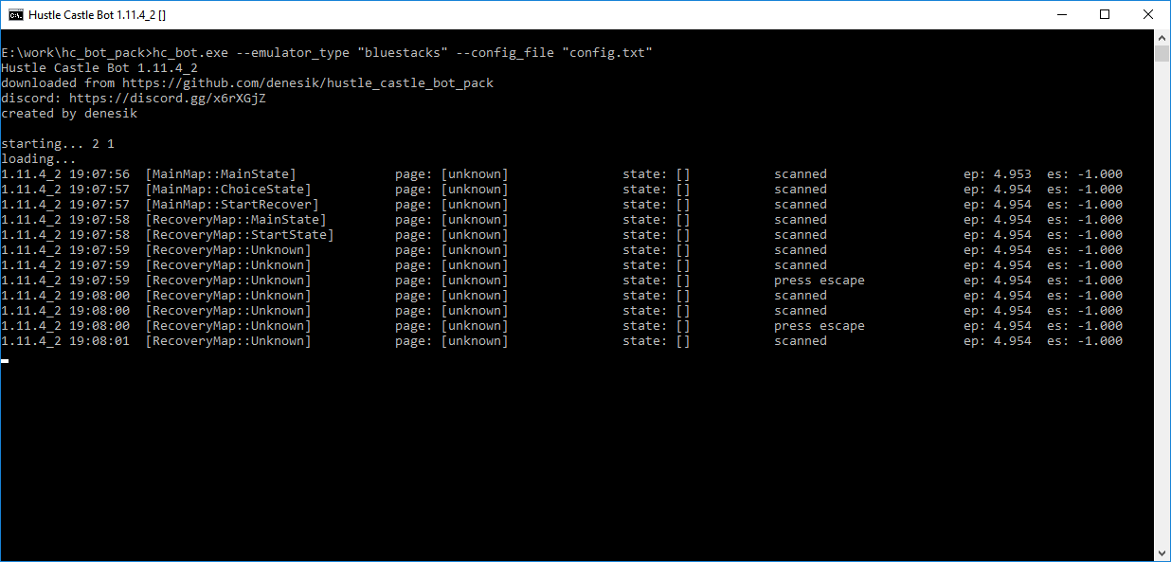

6. Additional information

If the settings above did not help, try setting the capture_mode mode in the settings.txt file: 0. This mode always works, but requires the emulator window to be on top of all windows and completely fit on the monitor, i.e. it should not go beyond the screen.

The game must be set to English.

If the bot crashes when starting up with an error - there is no msvcp140.dll library, you need to download and install the visual c ++ 2017 redistributable package vc_redist.x64.exe

link: <https://support.microsoft.com/ru-ru/help/2977003/the-latest-supported-visual-c-downloads>

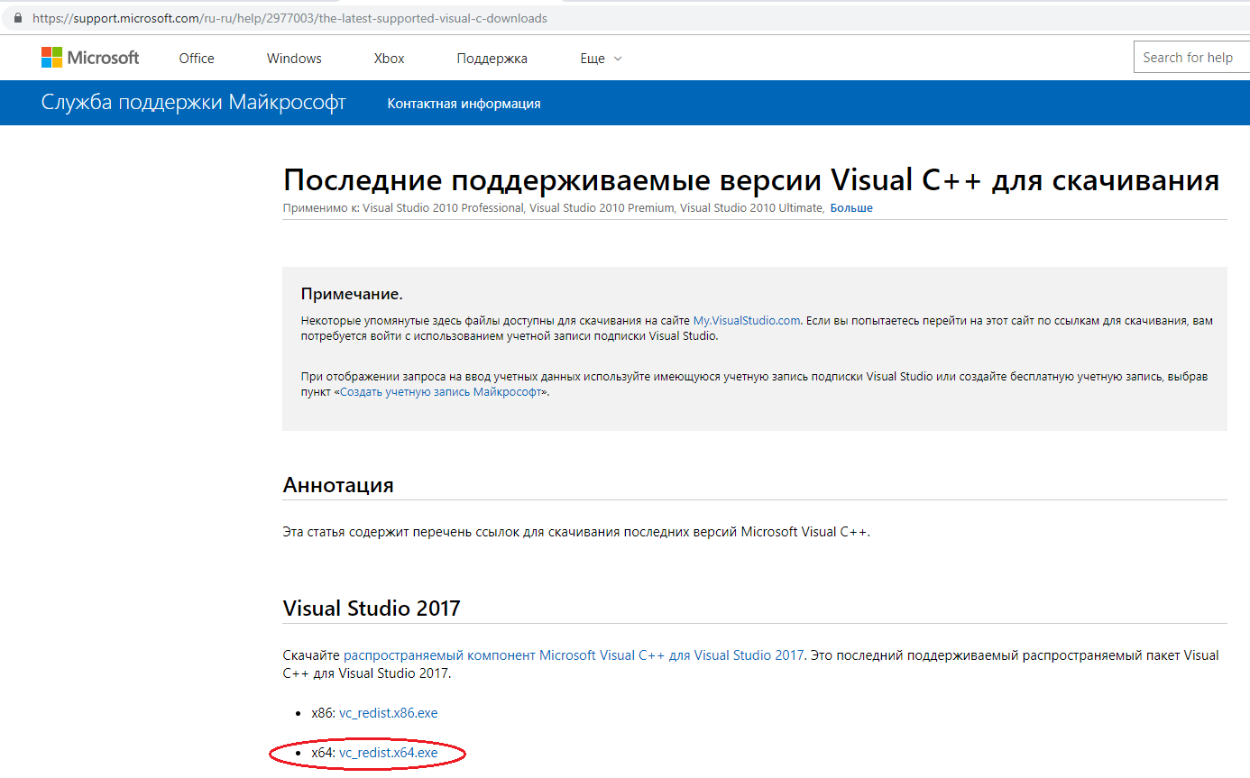

In some cases, if the monitor falls asleep, the bot stops working.

Sometimes it’s important to install windows updates so that everything works. If you have not updated windows, please update.

7. Multibot (Nox)

Multibot is supported only on the knox. To start the second copy, you need to use the nox_start_1.cmd file or create your own file with text:

hc_bot.exe --emulator_type "nox" --emulator_id "Nox_1" --emulator_name "NoxPlayer1" --config_file "config.txt"

Where you need to specify the emulator id Nox_number (A in the screenshot) and the name of the emulator (B in the screenshot).

You can also specify a different config.

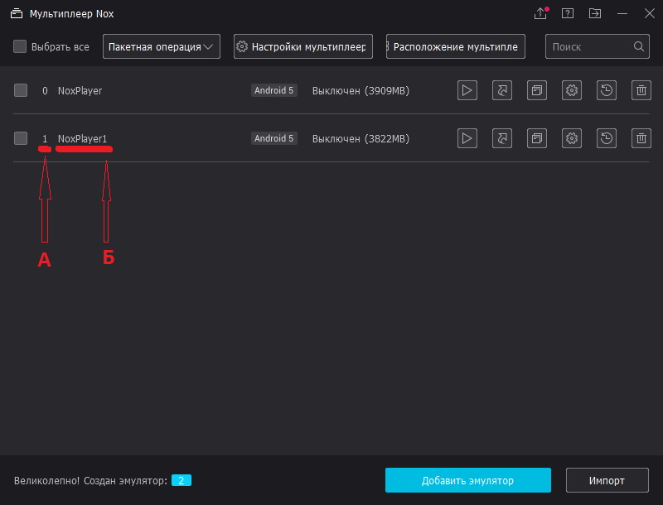

8. Config

How does the repeat setting in the config work?

The config is divided into modules, the number of modules with different settings can be specified any.

Each module is a separate task, for example, an arena, a portal, etc.

As a result, your config will be the program that the bot executes.

In the repeat setting, the number of repetitions of a particular module is indicated.

Thus, you can configure the bot program:

1 time arena

2 times the collection of resources (in a row),

1 time portal,

1 time invasion,

0 times advertising chest, etc.

The bot starts this program and when it ends, the bot starts this program again!

You do not need to indicate 100500 times the arena, 100500 times the portal, etc. because the bot repeats the program in a circle endlessly.

To view advertisements in the event and with the donkey, you need to place the barracks as in the picture. Before these two modes, you need to start the camera orientation mode.

Also, to run the quarter, you need the clan hall to be located above the barracks, as in the picture. The location of the barracks relative to the castle in this mode is not important. Before this mode, you also need to start the "reset camera position" mode.

