FIELD NOTES / THE NIGHT ISSUE

Chasing the light
A field guide to the edge of night.
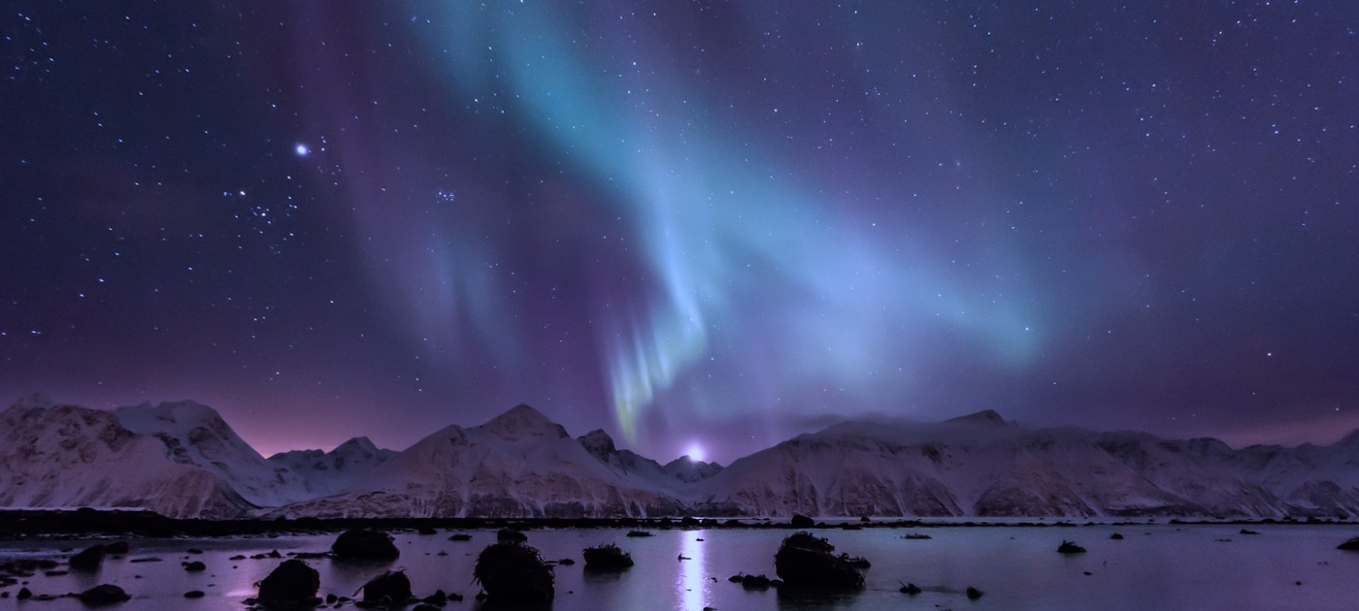
Photograph: Carsten / CC BY 2.0. Cropped and color-graded in pale blue.

Trip overview
Past the last village, the horizon opens into a quiet world of snow, sea and stars. Follow a fictional three-night expedition in search of a different perspective.
03 NIGHTS | 66° NORTH | 01 SHARED SKY
A slower journey | Fictional polar route | A little more wonder
All places, groups, dates, and figures in this guide are fictional.

01 / PLAN THE NIGHT

Route and activities
NIGHT | LOCATION | MOMENT | DETAIL
01 | Lyra fjord | Blue hour | Scout the shoreline
02 | Northlight ridge | After dark | Watch the horizon
03 | Orion camp | Before dawn | Keep a field journal

Packing checklist
Warm layers · insulated boots · a headlamp with a red-light mode · spare batteries · a tripod · a reusable flask.

Make room for the unexpected.
Arrive before dark, let your eyes adjust and give the sky time. The itinerary is a story for this public sample, not a live weather forecast or a real expedition plan.

02 / LOOK BEYOND

A universe of detail
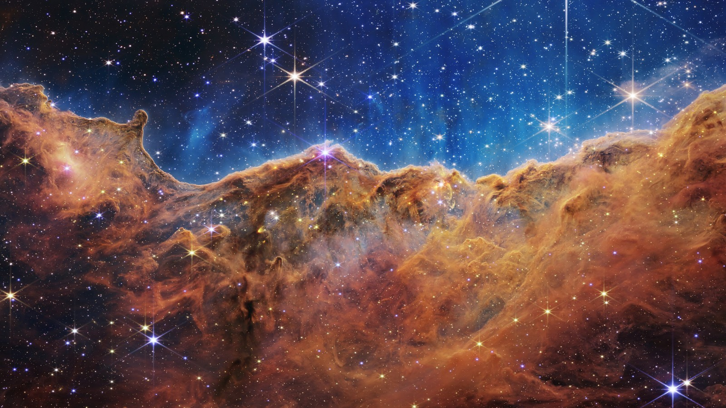
The Cosmic Cliffs, NGC 3324. Image: NASA, ESA, CSA, STScI.

The sky is only the beginning.
Webb’s infrared view reveals the sculpted edge of a star-forming region in the Carina Nebula. Photography brings the distant into view; a good document gives every detail room to breathe.
END OF FIELD GUIDE / FILENS PUBLIC SAMPLE

