Methods

A multi-scale model of co-transcriptional CPA assembly
We modeled cleavage and polyadenylation (CPA) as a coupled multiscale process comprising transcription, CTD modification, CPA-factor loading, and post-PAS commitment. These processes occur on two kinetic scales. The slow module simulates RNA polymerase II (Pol II) transcription along a discretized gene and removal by CPA commitment, whereas the fast module computes local Ser2 phosphorylation and early CPA-factor occupancy at each position. These dynamics are constrained by global resource conservation, which caps the shared pool of early CPA factors. 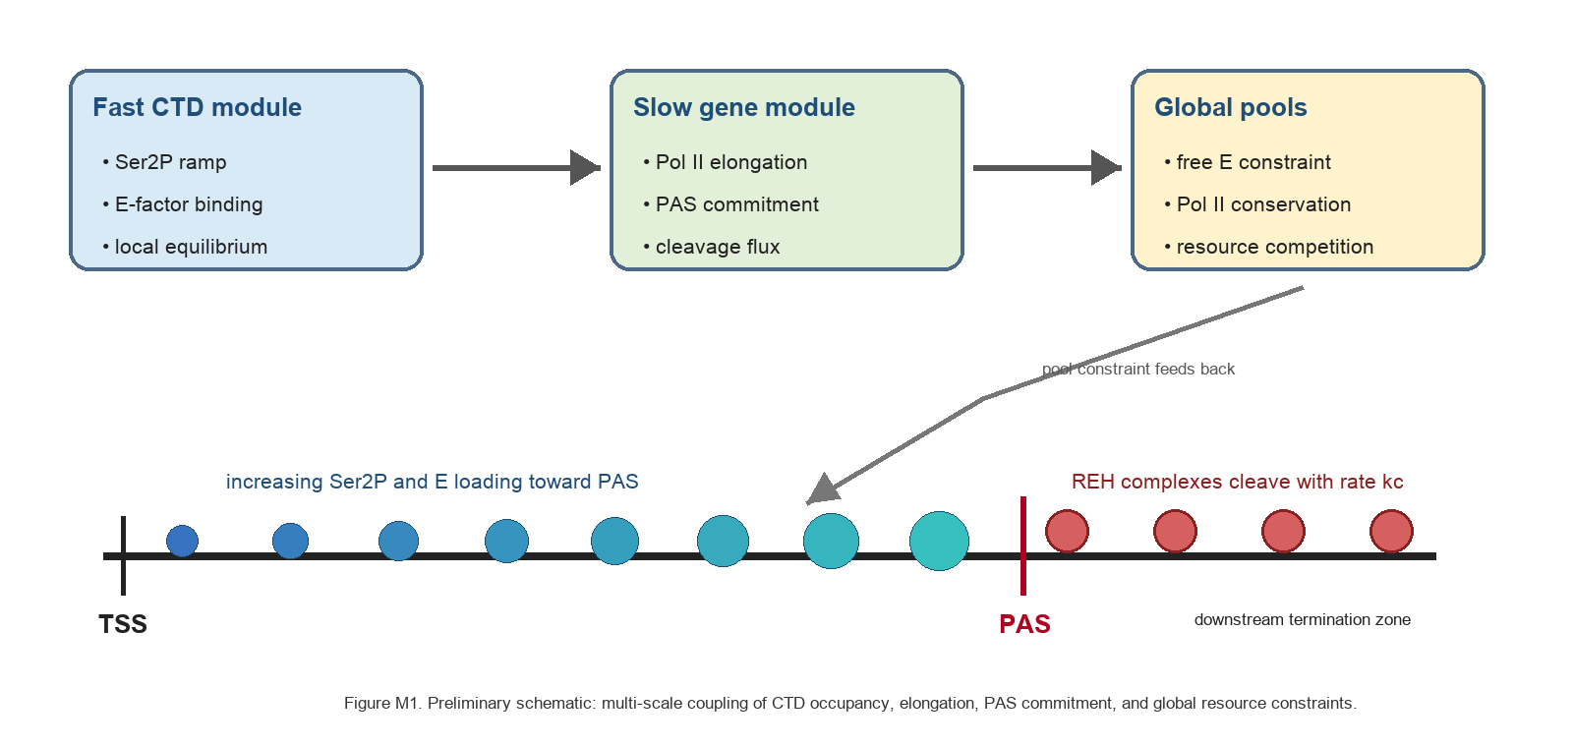
Figure M1. Model schematic. The fast module computes local Ser2P and early-factor occupancy, the slow module propagates Pol II and REH densities along the gene, and the global-pool module constrains the availability of free E factors.
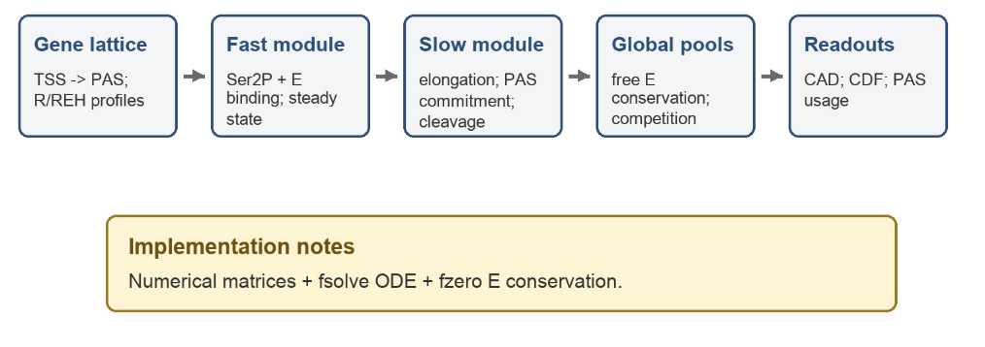
Figure M2. Computational workflow. The model defines the gene lattice and local Pol II states, computes fast Ser2P and E-factor equilibria, solves slow Pol II commitment dynamics, applies global pool constraints, and reports CAD, commitment CDFs, and proximal PAS usage.
The computational workflow is described in detail as follows:
Gene discretization and Pol II state variables
Each gene was represented as a one-dimensional lattice with node spacing L = 100 bp. For a gene of length G, the number of nodes was N = floor(G/L), and the PAS node was p = floor(PAS_position/L). At node l, R(l) and RE(l) denoted pre-PAS Pol II state variables, and REH(l) denoted polymerase-PAS complexes downstream of the PAS. Pol II entered the lattice at rate k_in and elongated before the PAS at rate k_e. After PAS binding, REH complexes moved downstream at rate k_e2, representing the reduced velocity associated with post-PAS pausing, and were removed by cleavage/commitment at rate k_c.
Unless otherwise stated, the default single-gene simulation used a 25 kb gene with the PAS located 20 kb downstream of the transcription start site (TSS).
Fast equilibrium for Ser2P and E-factor loading
Ser2 phosphorylation was modeled as a position-dependent process that increased linearly with distance along the gene, kPon(l) = kPon_min + kPon_slope * l, with dephosphorylation at rate kPoff. Early CPA factors (E) reversibly associated with phosphorylated CTD sites with rates kEon and kEoff. The maximum number of E factors simultaneously bound per polymerase, Ebindingnumber, was set to 5 in the standard model.
For each lattice node, we constructed a state-transition matrix for phosphorylation, dephosphorylation, E association, and E dissociation. The stationary distribution was obtained from the null space of this matrix. The model then extracted the mean number of bound E factors and the mean Ser2P level at each node and passed these quantities to the slow gene-scale module.
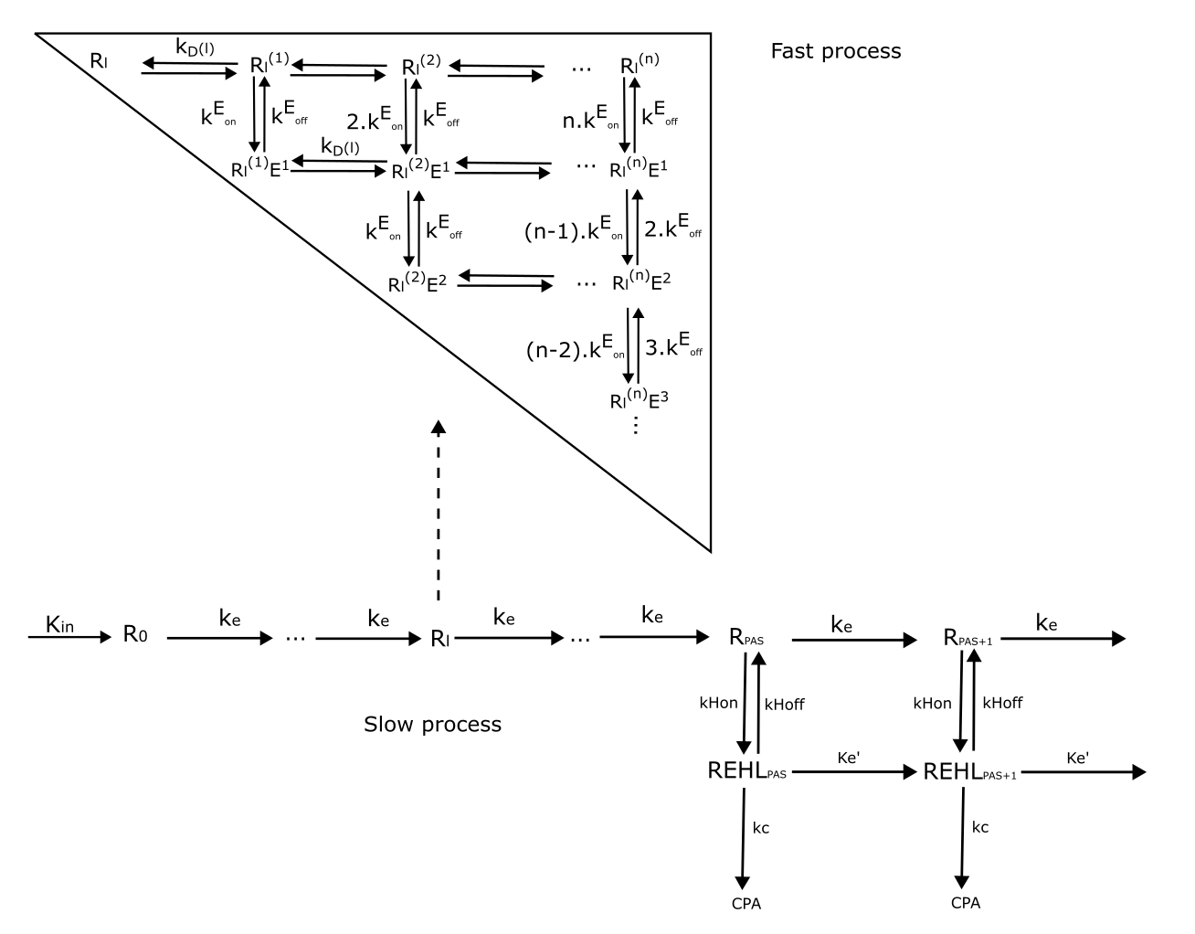
Coupling CTD loading to PAS binding rate
PAS recognition was modeled as the transition from an elongating Pol II state (RE) to a PAS-bound REH state at the PAS. The effective PAS binding rate was obtained by scaling the basal rate kHon by the mean number of E factors loaded at the PAS. This coupling represents the assumption that Pol II molecules arriving with higher early-factor occupancy are more likely to enter a cleavage-competent, post-PAS complex.
Resource conservation and free E estimation
Free E was determined by enforcing conservation of total E. At steady state, the total E pool equals free E plus E bound across all R, RE, and REH states. Thus, the free E concentration used by the fast module was updated until local binding equilibria and global factor conservation were consistent.
CPA Assembly Distance
We quantified CPA assembly efficiency using the CPA Assembly Distance (CAD), defined as the distance downstream of the PAS at which the cumulative commitment probability reaches 50%. Conceptually, CAD reports the downstream distance required for half of polymerases that encounter the PAS to commit to CPA. This definition was chosen because it maps naturally onto cis-antisense rescue assays, in which protection increases when CPA commitment occurs before downstream interference.
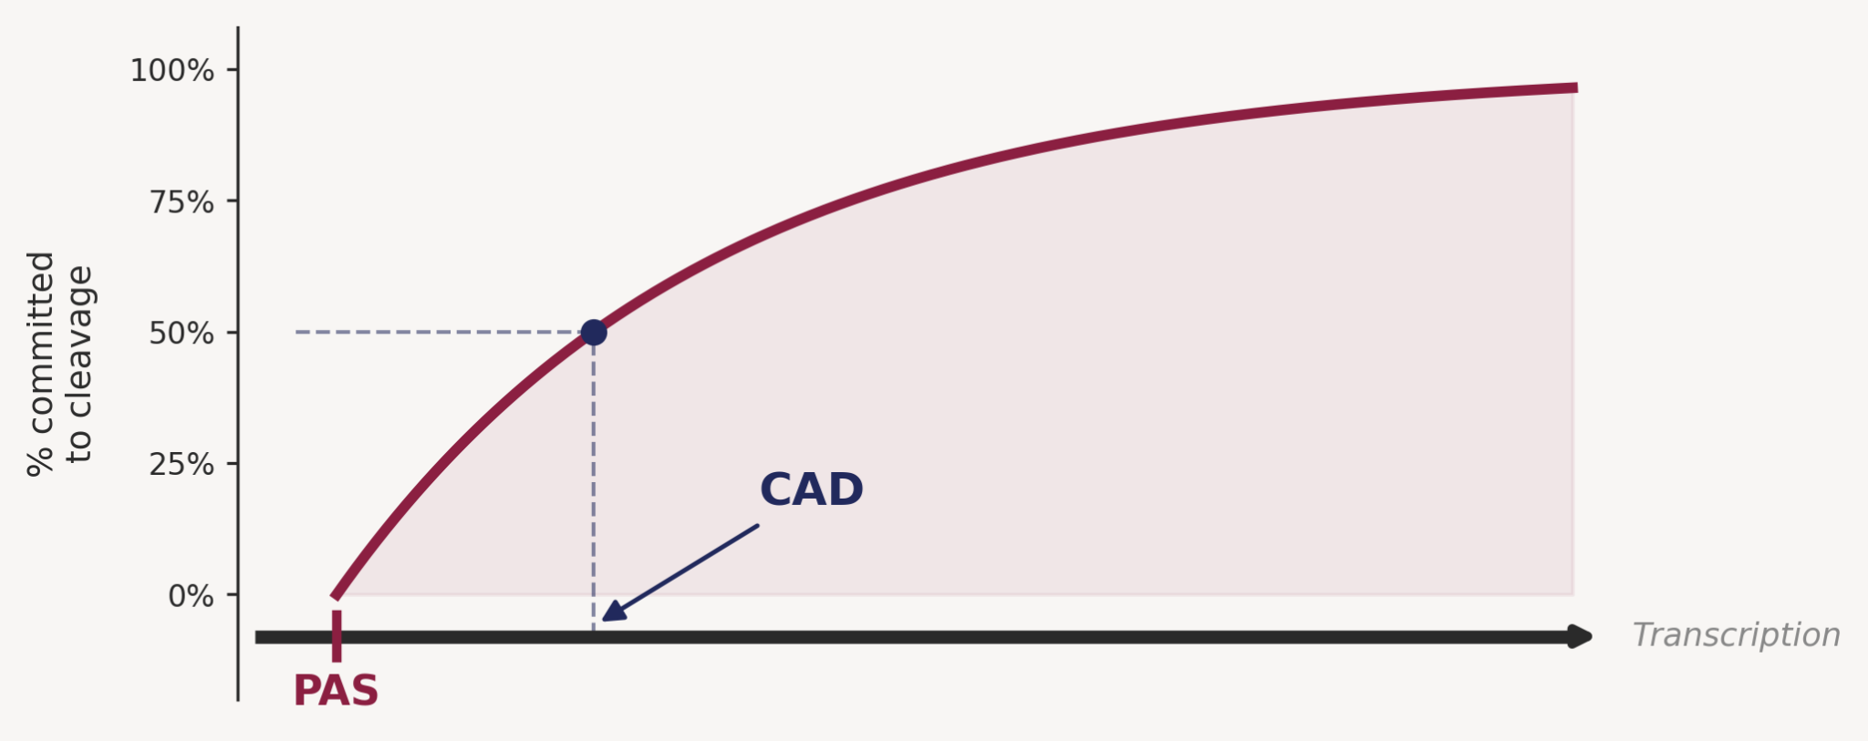
Figure M3. CAD calculation from the commitment flux. The cleavage/commitment flux at downstream node l is k_c · REH(l). CAD is obtained by normalizing the cumulative exit-flux distribution and interpolating the distance at which the cumulative probability reaches 50%.
For each steady-state solution, the local commitment flux was computed as k_c · REH(l). Run-off from the terminal node was treated as a terminal flux to ensure that polymerases reaching the end of the simulated template without commitment were included in the output distribution. The normalized cumulative sum of downstream commitment and terminal fluxes defined the termination CDF F(l), and CAD was obtained by linear interpolation at F(l) = 0.5.
Gene-length and alternative polyadenylation analyses
To test whether gene architecture affects CPA efficiency, we varied the TSS-to-PAS distance while holding the downstream model structure fixed and computed CAD for each simulated gene. To evaluate genome-wide resource competition, we precomputed a three-dimensional lookup grid for R_occupied and E_occupied as functions of free Pol II, free E, and gene length. These functions were interpolated and combined with a log-normal gene-length distribution to solve conservation equations for total Pol II and total E. This procedure links the single-gene assembly model to genome-wide competition for limiting transcription and CPA factors.
To model alternative polyadenylation (APA), we treated the termination CDF downstream of a proximal PAS as the probability that a polymerase commits to that PAS before reaching a distal PAS. Proximal PAS usage was estimated by evaluating the CDF at the inter-PAS distance. PAS strength was varied by sweeping the PAS dissociation parameter, allowing us to ask how intrinsic PAS strength and spacing jointly control proximal-site usage.

Implementation and parameters
Simulations were implemented in MATLAB. The pipeline constructs the E-binding equilibrium rate matrix, solves the steady-state gene-scale ODE system with fsolve, and uses fzero to satisfy E-conservation after each ODE solve. Unless otherwise stated, figures were generated using the default parameter set described in the supplemental methods, which provide full parameter values and script-level reproducibility details.

Results

Multivalent CTD scaffolding reduces the distance required for CPA assembly
We first tested whether a single early-factor binding site on Pol II was sufficient to generate the short downstream assembly window expected for CPA. When each polymerase was restricted to a single E factor, the model produced a CAD of 1273 bp, which exceeded the expected 400-800 bp assembly window. Increasing the maximum number of E-binding sites progressively shortened CAD; a five-site scaffold reduced CAD to 436 bp and a six-site scaffold to 397 bp. Thus, multiple CTD-binding and preloading of the early CPA factor provide a mechanism for accelerating PAS commitment.
The occupancy profiles show why this effect emerges. Allowing more E-binding events increases the mean number of E factors carried by Pol II near the PAS, whereas the Ser2P profile remains defined by the upstream phosphorylation program. Parameter sweeps also indicated that the one-site regime remains inefficient over a broad range of binding parameters, supporting the interpretation that multivalent E-factor recruitment, rather than a single high-affinity interaction, is required for rapid CPA assembly.
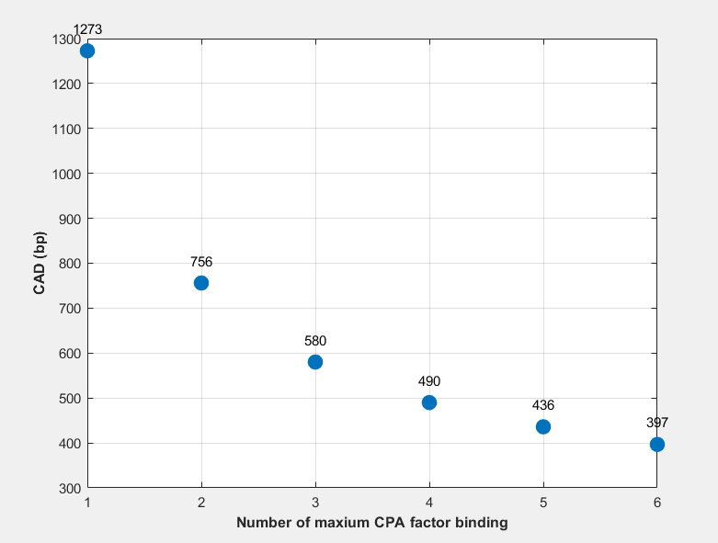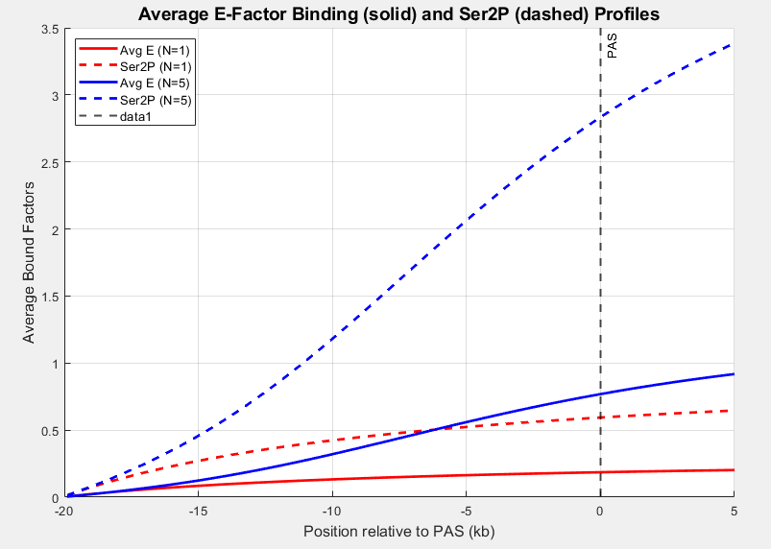
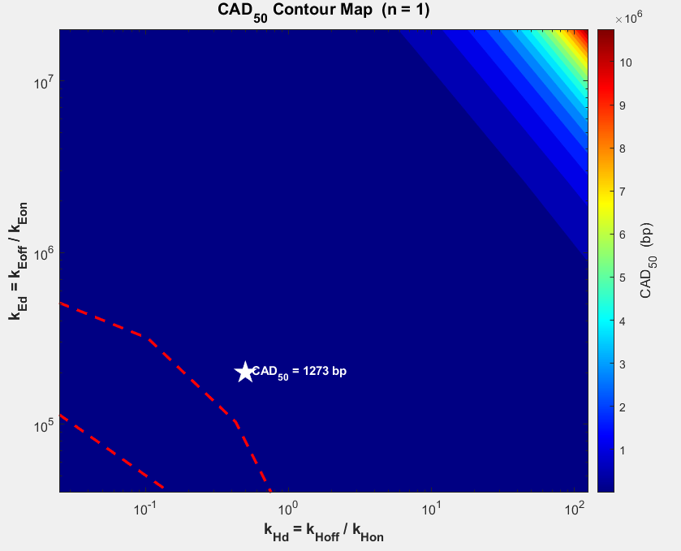

Gene length creates a pre-PAS loading runway for CPA factors
We next varied the distance between the TSS and the PAS to ask whether gene architecture affects assembly efficiency. CAD was highest for short TSS-to-PAS distances and decreased sharply as the upstream transcribed region increased. In the simulated parameter set, CAD approached a plateau near 400 bp once the gene length exceeded the human medium gene length (20k bp), indicating that the PAS was sufficiently far from the TSS.
These results suggest a pre-PAS loading-runway effect. On short genes, Pol II reaches the PAS before substantial Ser2P accumulation and E-factor loading have occurred, so commitment must be completed farther downstream. For longer genes, the polymerase arrives at the PAS with a more mature CTD binding CPA-factor state, allowing productive assembly over a shorter downstream distance.
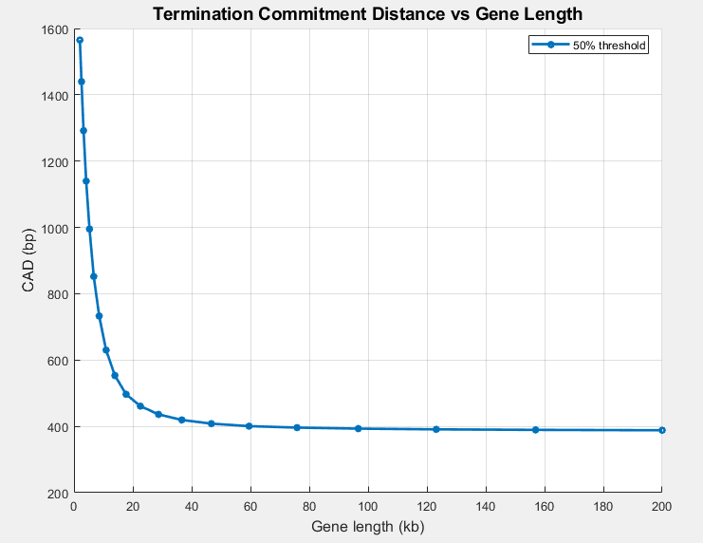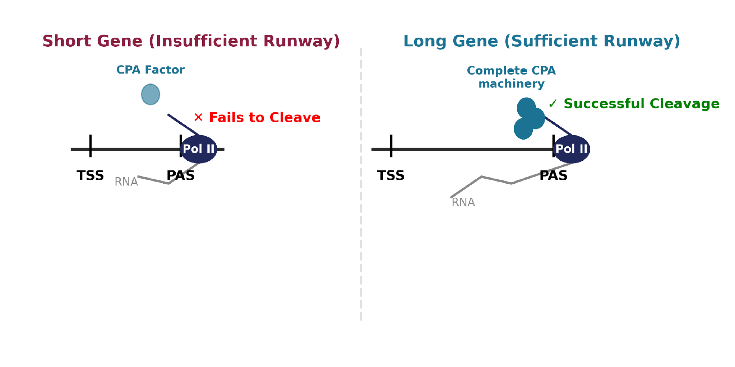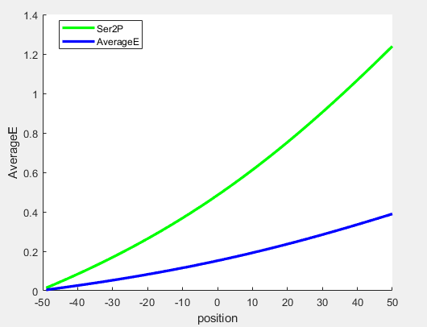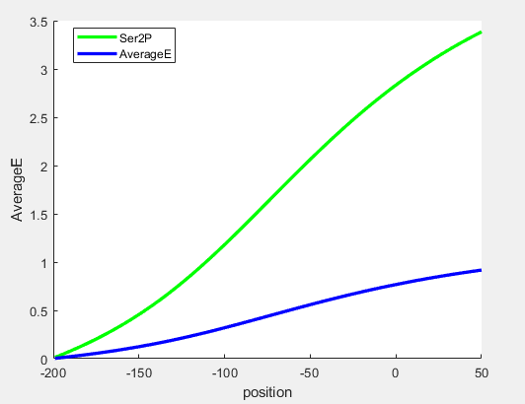

Termination CDFs recapitulate the logic of cis-antisense rescue assays
The cis-antisense rescue assay asks how far Pol II must travel after a PAS for the transcript to become resistant to downstream interference. In the model, this quantity maps directly to the termination CDF: the fraction committed by a given downstream distance is interpreted as the fraction protected from antisense disruption. The same CDF also provides a mechanistic estimate of proximal PAS usage in APA, because a polymerase will use the proximal PAS only if it commits before reaching the downstream PAS. For the most common inter-PAS distance in human genes (300 bp), proximal usage is intermediate, at around 40%, rather than fixed at 0% or 100%, making APA tunable to both PAS strength and factor availability.
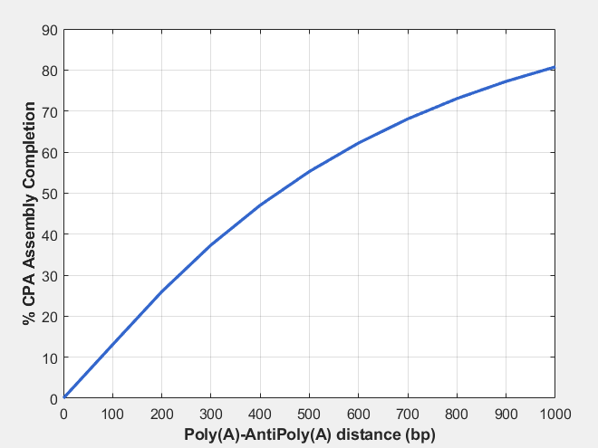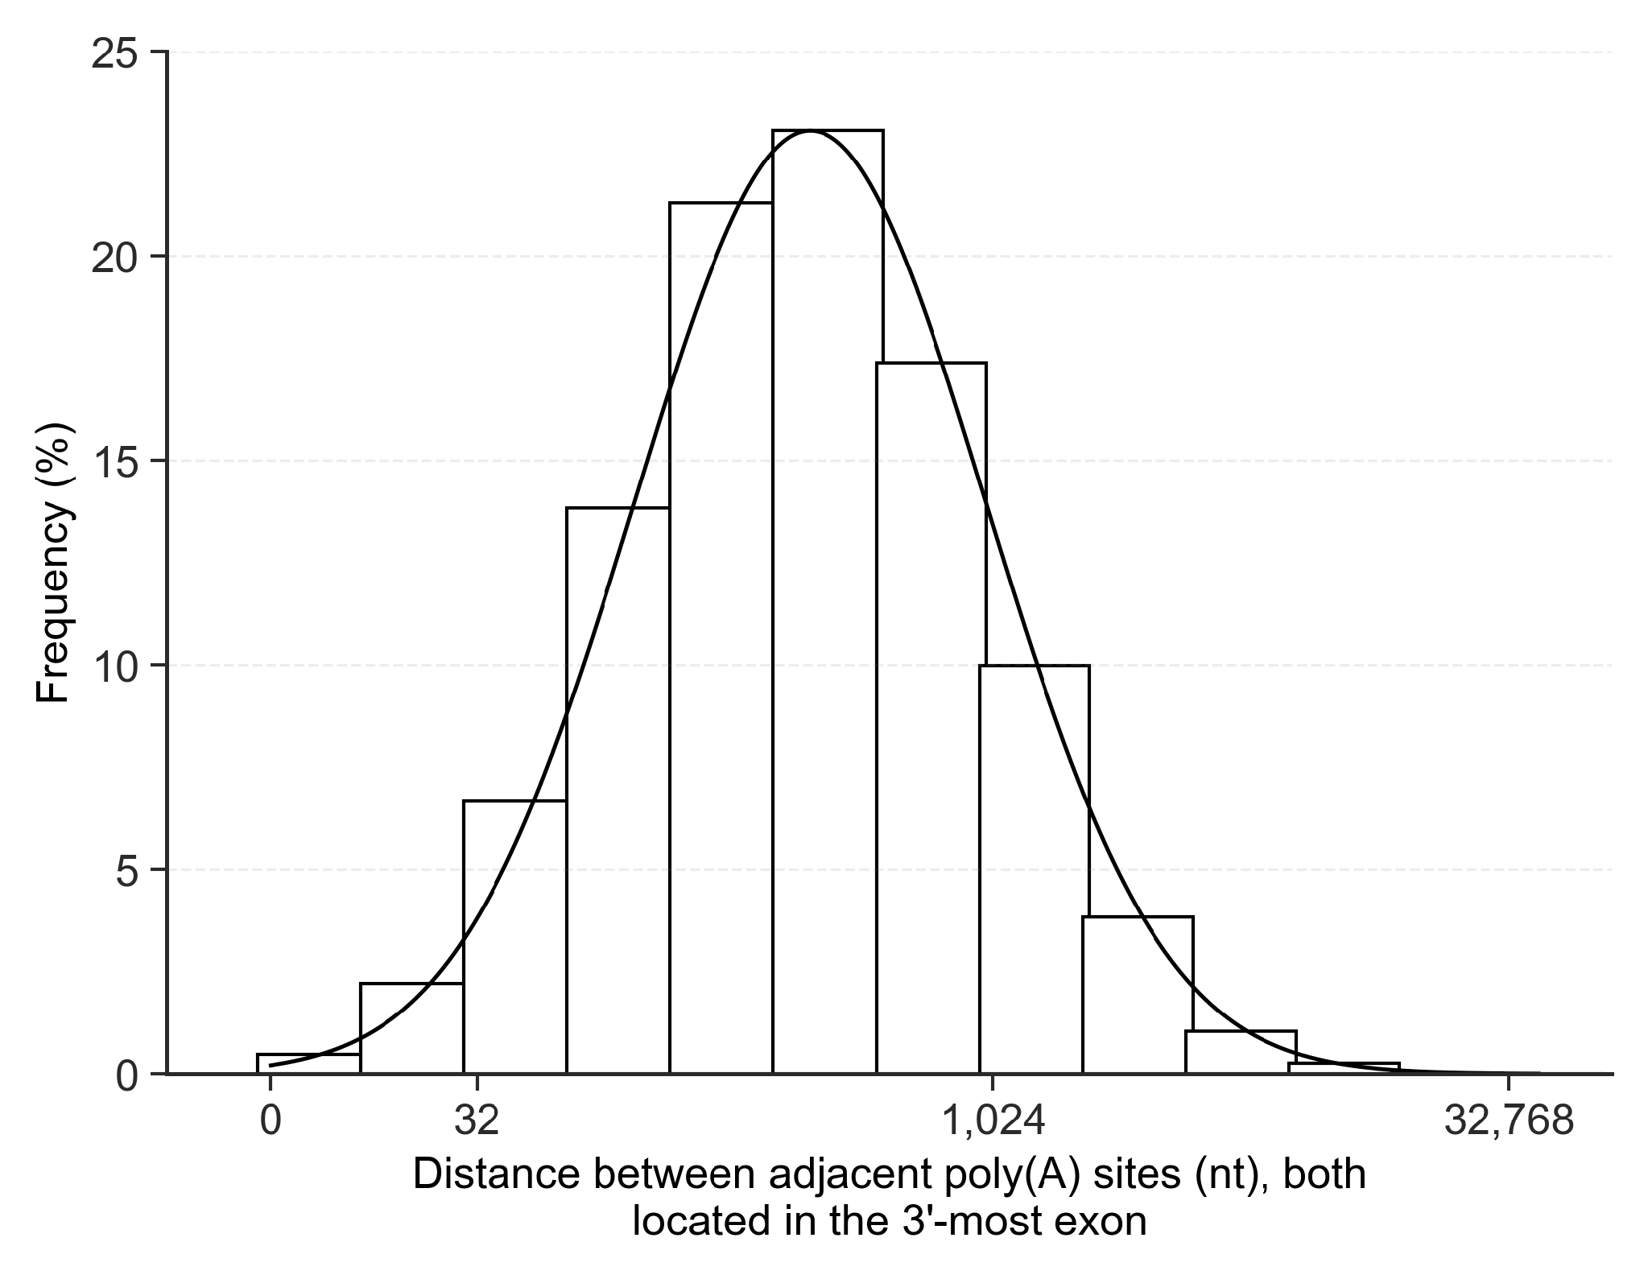

APA tunability persists across a wide PAS-strength range
We then asked whether this tunability persisted when the inter-PAS distance and PAS strength was varied. Sweeping the PAS dissociation rate shifted the proximal-usage curves over a broad range: stronger PASs reached high proximal usage over short inter-PAS distances, whereas weaker PASs required longer spacing and often remained only partially used. The qualitative dependence on distance was retained across the sweep, indicating that PAS spacing and PAS strength jointly determine the APA response.
