Supplementary Methods and Results for CPAdynamics

Supplementary Results

The five-site model is sensitive to interpretable kinetic parameters
One-dimensional parameter sweeps for EBindingNumber = 5 should show how CAD changes with elongation, cleavage, factor abundance, PAS commitment, and E-binding parameters. These analyses are important for the assessment of robustness and parameter dependence.
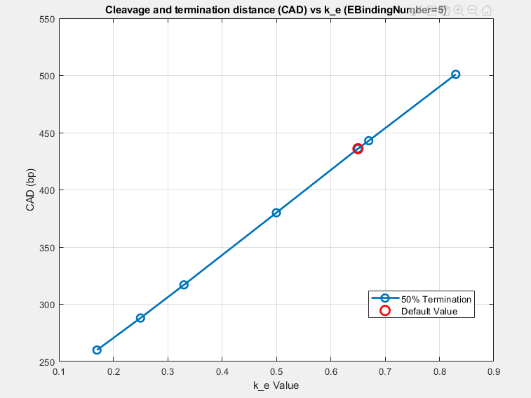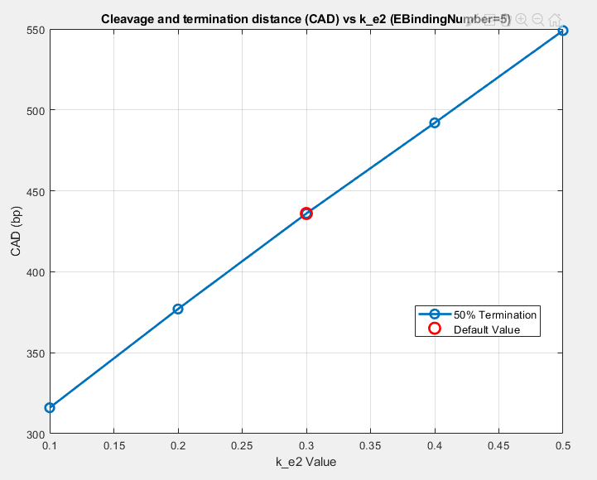

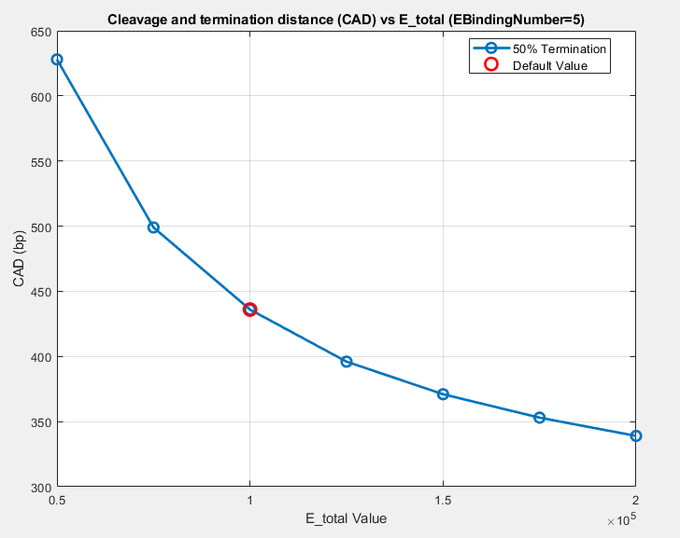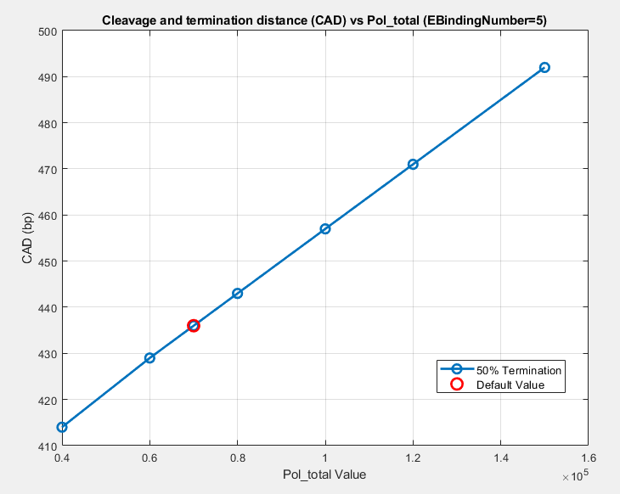
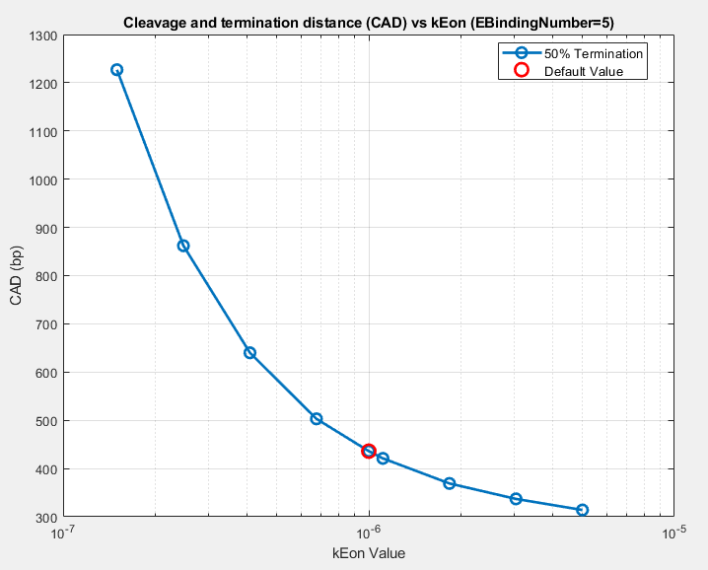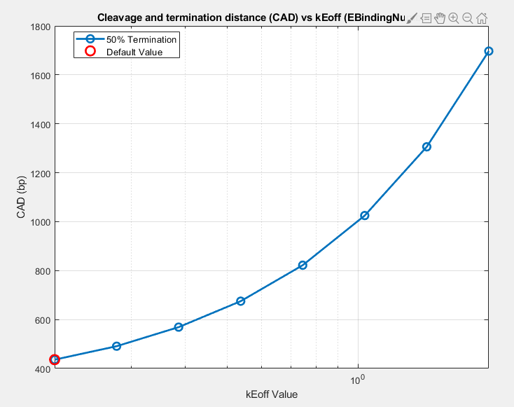

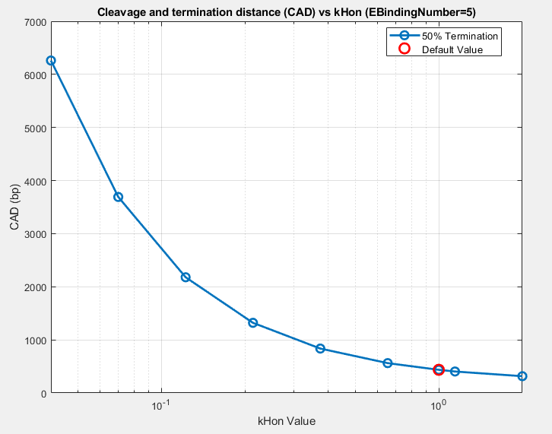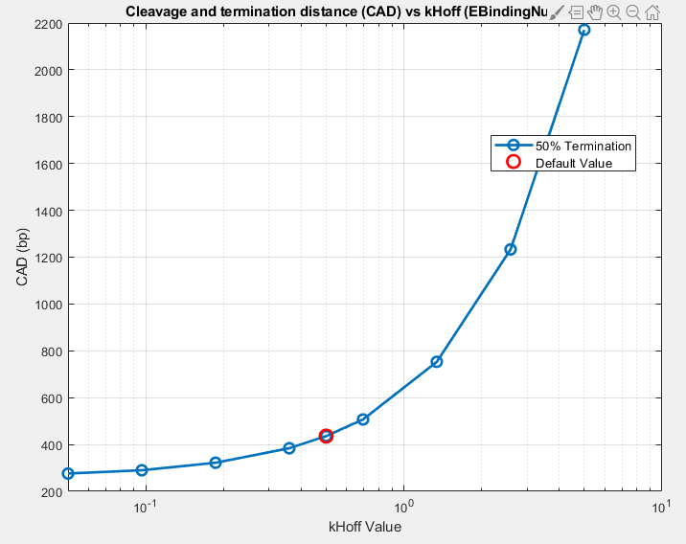

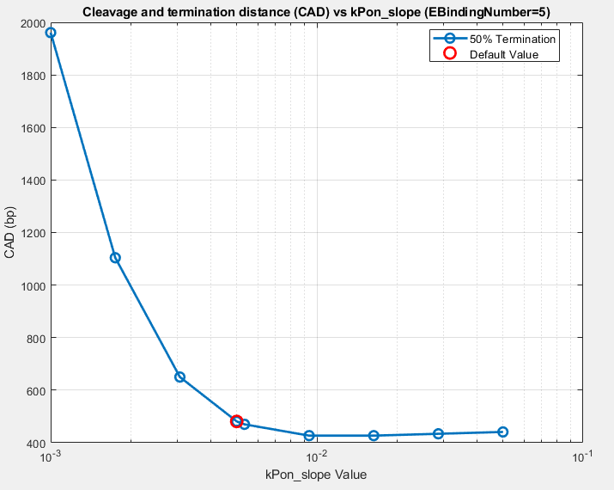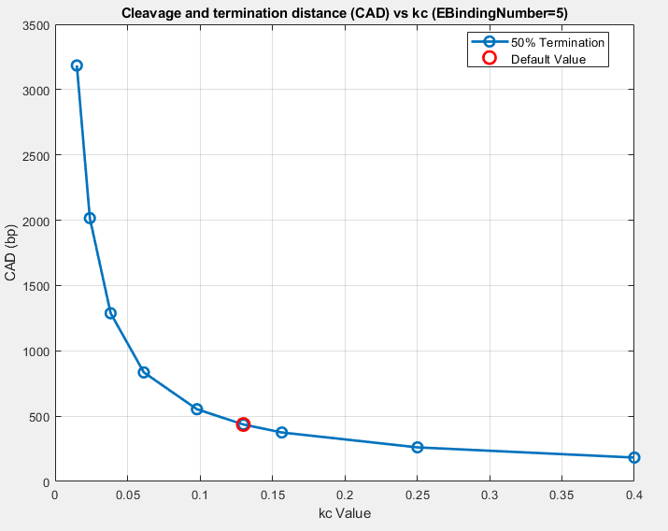

Average E loading follows the imposed Ser2P gradient
The E-binding profile analysis supports the mechanism underlying the main scaffold result. Average E occupancy should increase toward the PAS in parallel with the Ser2P gradient, and a higher allowed binding capacity should increase the achievable occupancy without altering the model's basic spatial logic.

Supplementary Methods

Publication analysis scripts
Script | Role
EBindingNumberVsCad.m | CAD versus CTD E-binding capacity
PlotEBindingProfile.m | Average E and Ser2P spatial profiles
GeneLengthGenerateGrid.m | Resource-occupancy lookup grid
GeneLengthBuildInterpolation.m | Interpolants and gene-length distribution
GeneLengthAnalyze.m | Conservation solution and CAD versus gene length
SimulateCpaAssembly.m | Termination CDF versus downstream distance
SweepParameterPasUsage.m | Proximal PAS usage versus inter-PAS distance
Sweep2DkHdkEdCad.m | kHd/kEd sensitivity for EBindingNumber = 1
ParameterSweep1D.m | One-dimensional sensitivity sweeps for EBindingNumber = 5
RunPublicationAnalyses.m | Aggregate publication runner

Supplementary Table S1. Default parameter set
Values correspond to default_parameters.m in the current codebase and are overridden only in the indicated analysis scripts.
Parameter | Description | Default value | Unit
L_a | Node length | 100 | bp
geneLength_bp | Default gene length | 25,000 | bp
PASposition | Default PAS position from TSS | 20,000 | bp
k_in | Pol II initiation rate | 2 | model units
k_e | Elongation rate before PAS | 65/100 | nodes s^-1
k_e2 | Elongation rate after PAS | 30/100 | nodes s^-1
E_total | Total early CPA factor pool | 100,000 | molecules
Pol_total | Total Pol II pool | 70,000 | molecules
kEon | E-factor association rate | 1.0e-6 | molecule^-1 s^-1
kEoff | E-factor dissociation rate | 0.2 | s^-1
kHon | PAS commitment on-rate | 1 | s^-1
kHoff | PAS dissociation rate | 0.5 | s^-1
kc | Cleavage rate | 0.13 | s^-1
kPon_min | Minimum Ser2P phosphorylation rate | 0.01 | s^-1
kPon_slope | Position-dependent Ser2P slope | 0.005 | s^-1 node^-1
kPoff | Ser2P dephosphorylation rate | 1 | s^-1
E_max | Default max E factors per Pol II | 5 | sites

