**hw6 linear model (II)**

**郑苏育 经62 2016012602**

1. Given a Gaussian linear regression model, Maximum likelihood estimation of 𝒘 under Gaussian noise assumption is equivalent to ________________________. Please prove it.

A: Result: $$\underset{W}{argmin}{\sum_{n=1}^{N}{(y_{n}}}{-w^{T}x_{n})}^{2}$$

Proof: In the set D= $\left\{\left(x_{1,}y_{1}\right),…,\left(x_{N,}y_{N}\right)\right\}$, we want to use MLE to maximize $p\left(D;θ^\right)=\prod_{n=1}^{n=N}{p\left(x_{n,}y_{n};θ^{^}\right)=\prod_{n=1}^{n=N}{p\left(y_{n}|x_{n};θ^{^}\right)*p(x_{n}) } }$.Then we assume (discriminative model), we can get = , and when we want to maximize it, it is the same as equation $\prod_{n=1}^{n=N}{p\left(y_{n}|x_{n};θ^{^}\right) }$. For simpler calculation, we use the log-likelihood, so the equation we want to maximize become $log\sum_{n=1}^{n=N}{p\left(y_{n}|x_{n};θ^{^}\right)}$.

For Gaussian distribution, we have $θ^{^}=w,σ$, $y_{n}|w,x_{n}\sim N\left(w^{T}x_{n}, σ^{2}\right)$ and $p\left(y_{n}|w,x_{n}\right)=\frac{1}{\sqrt{2π}σ}exp⁡\{-\frac{1}{2σ^{2}}(y_{n}{-w^{T}x_{n})}^{2}$. So $log\sum_{n=1}^{n=N}{p\left(y_{n}|x_{n};θ^{^}\right)}$ = $log\sum_{n=1}^{n=N}{p\left(y_{n}|w,x_{n}\right)}$ = $\frac{N}{2}log\frac{1}{2πσ^{2}}-\frac{1}{2σ^{2}}\sum_{n=1}^{n=N}{(y_{n}}{-w^{T}x_{n})}^{2}$. So when we want to do the maximization, it equals $\underset{W}{argmin}{\sum_{n=1}^{N}{(y_{n}}}{-w^{T}x_{n})}^{2}$.

1. Given a Laplacian linear regression model, Maximum likelihood estimation of 𝒘 under Laplacian noise assumption is equivalent to __________________________.

Please prove it.

A: Result: $$\underset{W}{argmin}{\sum_{n=1}^{N}{|y_{n}}}-w^{T}x_{n}|$$

Proof: In the set D= $\left\{\left(x_{1,}y_{1}\right),…,\left(x_{N,}y_{N}\right)\right\}$, we want to use MLE to maximize $p\left(D;θ^\right)=\prod_{n=1}^{n=N}{p\left(x_{n,}y_{n};θ^{^}\right)=\prod_{n=1}^{n=N}{p\left(y_{n}|x_{n};θ^{^}\right)*p(x_{n}) } }$.Then we assume (discriminative model), we can get = , and when we want to maximize it, it is the same as equation $\prod_{n=1}^{n=N}{p\left(y_{n}|x_{n};θ^{^}\right) }$. For simpler calculation, we use the log-likelihood, so the equation we want to maximize become $log\sum_{n=1}^{n=N}{p\left(y_{n}|x_{n};θ^{^}\right)}$.

For Laplacian distribution, we have $θ^{^}=w,b$, $y_{n}|w,x_{n}\sim Laplace\left(w^{T}x_{n}, b\right)$ and $p\left(y_{n}|w,x_{n}\right)=\frac{1}{2b}exp⁡\{-\frac{{|y}_{n}-w^{T}x_{n}|}{b}\}$. So $log\sum_{n=1}^{n=N}{p\left(y_{n}|x_{n};θ^{^}\right)}$ = $log\sum_{n=1}^{n=N}{p\left(y_{n}|w,x_{n}\right)}$ = $-\frac{1}{2b^{2}}\sum_{n=1}^{n=N}{{|y}_{n}-w^{T}x_{n}|}$. So when we want to do the maximization, it equals $\underset{W}{argmin}{\sum_{n=1}^{N}{|y_{n}}}-w^{T}x_{n}|$.

1. Given a linear regression model, please write down the Tikhonov Form and Ivanov Form of Ridge Regression, and these two forms of Lasso Regression as well.  
   A: Ridge Regression:

Tikhonov: $\hat{w}={argmin}_{w}\frac{1}{n}\sum_{i=1}^{i=n}{{(w^{T}x_{i}-y_{i})}^{2}+α{|\left|w\right||}_{2}^{2}}$

Ivanov: $\hat{w}={argmin}_{{|\left|w\right||}_{2}^{2}≤r} \frac{1}{n}\sum_{i=1}^{i=n}{{(w^{T}x_{i}-y_{i})}^{2}}$

Lasso Regression:

Tikhonov: $\hat{w}={argmin}_{w}\frac{1}{n}\sum_{i=1}^{i=n}{{(w^{T}x_{i}-y_{i})}^{2}+α{|\left|w\right||}_{1}}$

Ivanov: $\hat{w}={argmin}_{{|\left|w\right||}_{1}≤r} \frac{1}{n}\sum_{i=1}^{i=n}{{(w^{T}x_{i}-y_{i})}^{2}}$

1. By adding a Ridge Regression in the linear regression model of *Question 4 in hw5-linear-model,* can we get a lower generalization error? If yes, use cross validation to attain the best regularization parameter 𝜆, whose possible values are [1.e-06, 1.e-05, 1.e-04, 1.e-03, 1.e-02, 1.e-01, 1.e+00, 1.e+01, 1.e+02, 1.e+03, 1.e+04, 1.e+05, 1.e+06]. If no, please explain why. See the tutorial of linear model in sklearn: <https://scikit-learn.org/stable/modules/linear_model.html> if you need some help.

A：我认为 Ridge regression 是用来解决多重共线性导致的过拟合问题的，所以我使用了计算VIF的方法来判断x1,x2,x3之间的相关性。

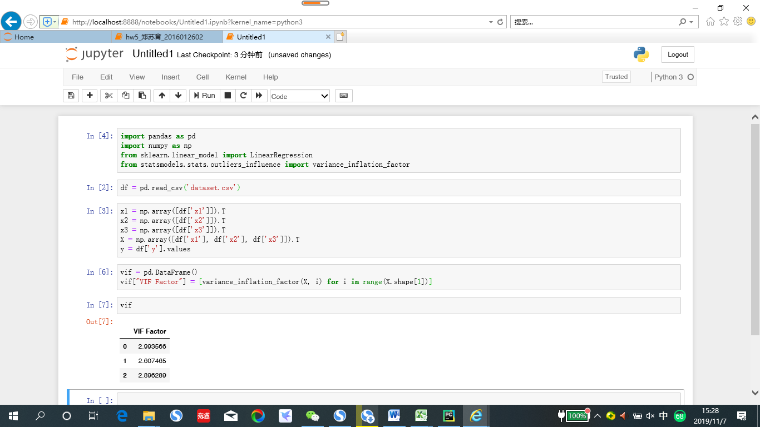

可以看到三个变量的VIF都不大（一般大于10才算大），所以使用Ridge或Lasso效果可能都不会有太好的效果，但我仍然使用这两种模型进行了回归。

Best 𝜆 is 1.0.

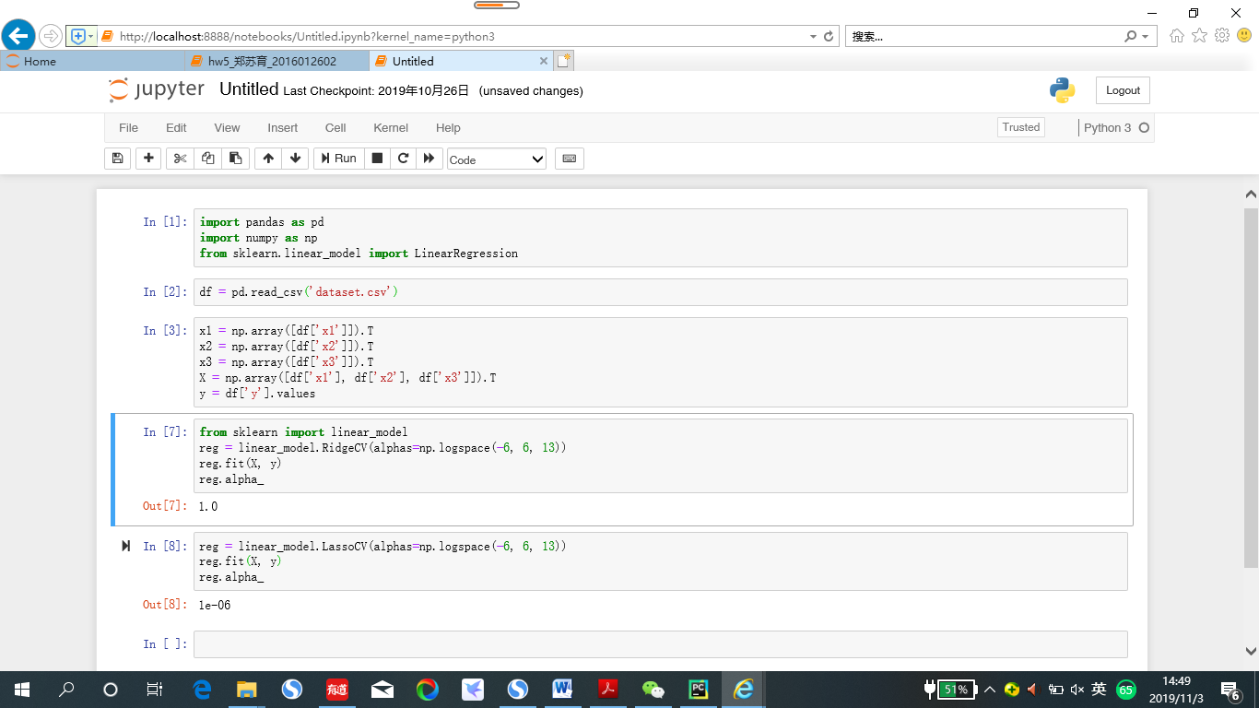

1. By adding a Lasso Regression in the linear regression model of *Question 4 in hw5-linear-model,* can we get a lower generalization error? If yes, use cross validation to attain the best regularization parameter 𝜆, whose possible values are [1.e-06, 1.e-05, 1.e-04, 1.e-03, 1.e-02, 1.e-01, 1.e+00, 1.e+01, 1.e+02, 1.e+03, 1.e+04, 1.e+05, 1.e+06]. If no, please explain why. See the tutorial of linear model in sklearn: <https://scikit-learn.org/stable/modules/linear_model.html> if you need some help.

A：Best 𝜆 is 1e-06.

