CEBU INSTITUTE OF TECHNOLOGY
UNIVERSITY

COLLEGE OF COMPUTER STUDIES

Software Design Description
for
Noctra

Members:
Escasinas, Luezyl Dominic C.
Lao, Hilary Danne C.
Guimoc, Earl John G.
Estrada, Julianna Carmel
Estela, Gerard Grant M.

Change History Signature

Preface

This Software Design Description (SDD) describes the architectural and detailed design of Noctra, a gamified pre-sleep routine assistant developed for Filipino college students experiencing sleep onset difficulties due to the absence of structured wind-down habits. The document serves as the primary technical blueprint for the development team and academic evaluators throughout the implementation phase. All design decisions are grounded in the findings of the team's Review of Related Literature and are directly traceable to the research gaps and system features defined in the revised Software Proposal. The system is built as a native Android application in Kotlin with a Supabase backend and integrates a Health Connect-compatible smartwatch for passive sleep monitoring.

Table of Contents

1. Introduction 6
1.1. Purpose 6
1.2. Scope 6
1.3. Definitions and Acronyms 6
1.4. References 6
2. Architectural Design 7
3. Detailed Design 8
Module 1 8
Module 2 9

Introduction

Purpose
This document describes the software design of Noctra, a native Android mobile application that helps Filipino college students establish consistent pre-sleep routines through personalized wind-down guidance, gamified positive reinforcement, and passive smartwatch-based sleep monitoring. The purpose of this SDD is to translate the functional requirements established in the revised Software Proposal into a concrete, implementable design. It defines the system's architectural structure, module decomposition, component responsibilities, data design, and component interactions. This document is the authoritative technical reference for the development team across all implementation sprints.

Scope
Noctra is scoped as a behavioral habit-formation mobile application targeting Filipino college students who experience difficulty transitioning from wakefulness to sleep due to the absence of consistent pre-sleep behavioral routines. The system is implemented across four functional modules — User Onboarding & Routine Configuration (Module 1), Gamified Nightly Engagement (Module 2), Sleep Quality Monitoring (Module 3), and Routine Auditing & Analytics (Module 4) — which collectively fulfill the system's three General Objectives. Modules 1 and 2 jointly fulfill GO1; Module 3 fulfills GO2; Module 4 fulfills GO3.
Module 1 — User Onboarding: A one-time entry and setup flow covering user authentication (registration and login) and routine configuration, where users build a personalized pre-sleep routine by selecting activities from a curated library, configure a target bedtime, and grant Health Connect permissions for passive sleep monitoring.
Module 2 — Gamified Nightly Engagement: A nightly execution layer that guides users step by step through their saved routine, rewards consistent completion through a dual-layer reward system of Dream Tokens and Growth Points, sustains long-term engagement through a virtual companion evolution mechanic, and supports social motivation through an opt-in private friends leaderboard where users connect by entering a friend's registered email address and view a ranked top-10 leaderboard of their accepted friends.
Module 3 — Sleep Quality Monitoring: A passive sleep monitoring layer that, upon routine completion, reads sleep data from the paired Health Connect-compatible smartwatch — including sleep duration, heart rate, and movement — and generates a nightly composite sleep quality score without requiring further user input during the sleep period.
Module 4 — Routine Auditing and Analytics: An automated feedback system that logs each session's start time and completion status, integrates smartwatch-captured sleep data into visual progress reports, and presents users with weekly and monthly views of their routine adherence and sleep quality trends to support the four-week evaluation of sleep-timing consistency improvement
Noctra is explicitly not designed as a clinical sleep intervention. It does not diagnose or treat sleep disorders, does not provide medical advice, and does not restrict or lock smartphone use. The system is validated for Filipino college students enrolled in tertiary education only and is not intended for clinical populations, working professionals, adolescents below college age, or older adults.

Definitions and Acronyms
Term / Acronym | Definition
Noctra | The proposed mobile pre-sleep routine assistant application developed for Filipino college students
Sleep Onset Latency | The amount of time it takes a person to transition from full wakefulness to sleep after lying down
Wind-Down Routine | A user-configured sequence of low-cognitive-load pre-sleep activities completed before the target bedtime to facilitate the transition from wakefulness to rest
Target Bedtime | The user's self-defined time at which they intend to fall asleep, configured during onboarding and used as the system's primary operational threshold
Bedtime Adherence Rate (BAR) | The primary evaluation metric of the system, defined as the proportion of nights in which the user falls asleep within 30 minutes of their configured target bedtime as detected by the paired smartwatch via Health Connect
Pre-Bedtime Window | The period beginning 30 minutes before the user's target bedtime during which wind-down nudge notifications are delivered
Cognitive Offloading | The process of externalizing mental content (e.g., worries, tasks, thoughts) into a written or spoken form to reduce pre-sleep cognitive arousal
Brain Dump | A micro-journaling wind-down activity in Noctra that operationalizes cognitive offloading by prompting the user to write freely before sleep
Localized Audioscapes | Bundled offline audio files featuring locally familiar Philippine ambient soundscapes (e.g., provincial rain on a tin roof, dorm-room lo-fi with electric fan ambience) playable within the routine without network dependency
Dream Tokens | Short-term spendable digital currency in Noctra awarded immediately upon nightly routine completion and amplified by streak multipliers; spent in the Sleep Shop
Growth Points (XP) | Non-spendable long-term progression currency that accumulates nightly upon routine completion and drives the virtual companion's evolution stages
Streak | A consecutive count of nights on which the user completed their pre-sleep routine. Resets to zero on a missed night, which also triggers companion devolution — a visual regression of the virtual companion to a lower evolution stage.
Streak Multiplier | A bonus coefficient applied to the Dream Token award based on the user's current streak length, designed to reinforce sustained engagement
Sleep Shop | The in-app customization store accessible via CustomizationFragment where users spend Dream Tokens on cosmetic items for their virtual companion, organized across four categories: Hats, Outfits, Accessories, and Footwear.
Virtual Companion | A culturally themed in-app animated character that evolves visually through multiple stages as the user accumulates Growth Points, intended to create emotional investment and sustain long-term engagement
Companion Evolution | The progression of the virtual companion through predefined XP milestone stages, triggered when the user's total Growth Points crosses a threshold defined by CompanionEvolutionUseCase
Composite Sleep Quality Score | A single nightly score from 0 to 100 computed by SleepQualityProcessingUseCase from three Health Connect-derived signals: Sleep Duration Score, Heart Rate Score, and Movement Score
Sleep Duration Score | A 0–100 sub-score measuring whether the user's sleep duration fell within the clinically recommended 7–9 hour range for college-aged adults
Heart Rate Score | A 0–100 sub-score measuring deviation of the user's average sleep-period heart rate from their personalized baseline, indicating physiological relaxation quality
Movement Score | A 0–100 sub-score derived from the total step count recorded during the sleep window as a proxy for physical restlessness and sleep fragmentation
Personal HR Baseline | The user's computed average resting heart rate during sleep, derived from a minimum of three nights of Health Connect heart rate data and updated using an exponential moving average; used as the reference point for Heart Rate Score calculation
Exponential Moving Average (EMA) | A statistical smoothing technique applied to the personal HR baseline update, giving more weight to recent observations while preserving historical stability; computed as (α × new observation) + ((1 − α) × current baseline) where α = 0.1
Partial Data Flag | The is_partial_data boolean field in sleep_records, set to true when one or more Health Connect sub-signals are unavailable for a given night, indicating the composite score was computed from a redistributed subset of signals
Weight Redistribution | The process by which the composite score formula reallocates the weights of missing signals proportionally across available signals to ensure the composite always produces a valid 0–100 score
Sleeptime Adherence Classification | The per-night categorization produced by BedtimeAdherenceCalculator: ADHERENT (≤30 min delay), SLIGHT_DELAY (31–60 min), SIGNIFICANT_DELAY (>60 min), or NO_DATA
Relationship Insight | A plain-language behavioral summary generated by InsightGenerationUseCase comparing the user's average composite sleep quality score on routine completion nights versus non-completion nights
Health Connect | Google's unified Android health data platform (androidx.health.connect.client) that aggregates health and fitness data from compatible smartwatches and fitness apps; used by Noctra to passively retrieve sleep session, heart rate, and step data
Health Connect-Compatible Smartwatch | Any consumer-grade, non-Wear OS smartwatch that writes sleep and biometric data to the Android Health Connect platform through its paired brand health application. Compatible devices include but are not limited to Xiaomi Smart Band / Mi Band series (via Zepp), Fitbit devices (via Fitbit app), Huawei Band series (via Huawei Health), and Samsung Galaxy Fit series. Wear OS smartwatches — including Samsung Galaxy Watch 4 and above and Pixel Watch — are explicitly outside the supported scope for two reasons: Wear OS integration requires a separate watch-side companion application developed using the Wear OS Health Services API, which is outside the project scope; and Wear OS devices are priced significantly above the budget-realistic range for the target population of Filipino college students.
SleepSessionRecord | The Health Connect data type representing a recorded sleep session, containing sleep onset time, wake time, and duration
HeartRateRecord | The Health Connect data type containing timestamped heart rate measurements in beats per minute recorded during a specified time window
StepsRecord | The Health Connect data type containing the total step count recorded during a specified time window, used as the movement proxy for the Movement Score
MorningSyncWorker | A WorkManager CoroutineWorker scheduled daily between 6:00 AM and 9:00 AM that retrieves the previous night's Health Connect data and computes the nightly composite sleep quality score
WindDownNotificationWorker | A WorkManager CoroutineWorker that delivers wind-down nudge notifications at T-30 and T-15 minutes before the user's target bedtime each night
MissedSessionCheckerWorker | A WorkManager CoroutineWorker scheduled each morning that detects whether the user failed to complete their routine the previous night and resets the streak accordingly
MVVM | Model-View-ViewModel — the architectural pattern used throughout Noctra, separating UI rendering (View), state management and orchestration (ViewModel), and data/domain logic (Model)
Single-Activity Architecture | The Android navigation pattern used by Noctra in which a single MainActivity hosts one NavHostFragment and all screens are implemented as Fragments navigated via the Navigation Component
NavHostFragment | The Android Navigation Component container embedded in MainActivity that manages the Fragment back stack and renders the currently active destination from nav_graph.xml
Nested Navigation Graph | A sub-graph within nav_graph.xml that groups related destinations — Noctra uses three: auth_graph, onboarding_graph, and main_graph
navGraphViewModels | A Kotlin delegate that scopes a ViewModel to a specific nested navigation graph's back stack entry, used in Noctra to share onboarding state across all four onboarding Fragments
StateFlow | A Kotlin Coroutines Flow type that holds and emits the current state value; used in Noctra for all UI state exposed from ViewModels to Fragments
SharedFlow | A Kotlin Coroutines Flow type used for one-shot events (navigation commands, error dialogs) that should not be re-emitted on configuration change
WorkManager | The Android Jetpack library used by Noctra to schedule and execute reliable background tasks (morning sync, notifications, missed session detection) independent of app lifecycle state
Supabase | The open-source Backend-as-a-Service platform used as Noctra's cloud backend, providing Auth, PostgREST, Realtime, and Storage services
Supabase Auth | The Supabase service managing user registration, login, session tokens, and password reset for Noctra
Supabase PostgREST | The Supabase service providing auto-generated REST API access to the PostgreSQL database, used for all CRUD operations in Noctra
Supabase Realtime | The Supabase service that broadcasts PostgreSQL table change events to subscribed clients via WebSocket, used in Noctra for live leaderboard updates in the Social feature and for event-driven push notifications triggered by friend request and acceptance actions
Friendship | A mutual social connection between two users, established when a friend request transitions from PENDING to ACCEPTED. Both users appear on each other's Friends Leaderboard once the friendship is accepted.
FriendRequest | A directional social action initiated by one user (requester) toward another (receiver) by entering the receiver's registered email address. Has one of three states: PENDING, ACCEPTED, or DECLINED.
Leaderboard Rank | A user's position among their accepted friends, sorted primarily by current streak descending. Tiebreaker: the timestamp of the most recently completed routine session (most recent ranks higher).
Supabase Storage | The Supabase service used to store exported weekly and monthly report JSON files for researcher access
Supabase RPC | Remote Procedure Call functions defined in the Supabase PostgreSQL database and invoked from the Android client; used in Noctra for credit_rewards() and equip_item() atomic operations
Row Level Security (RLS) | A PostgreSQL security feature enforced through Supabase policies that ensures each user can only read and write their own data across all tables
PostgREST | The open-source REST API layer that Supabase uses to expose the PostgreSQL database; all Repository classes in Noctra interact with it via the Supabase Kotlin client
Repository | A Data Access Layer class in Noctra's MVVM architecture that abstracts all read and write operations for one data domain and exposes suspend functions and Flows to the Business Logic Layer
Use Case | A Business Logic Layer class in Noctra's MVVM architecture that encapsulates one discrete domain operation, invoked by ViewModels and invoking Repositories; has no Android framework dependencies
ViewModel | A Jetpack Architecture Component class that survives configuration changes, exposes UI state as StateFlow, and orchestrates Use Case invocations in response to user events
Lottie | An open-source animation library (com.airbnb.android:lottie) used in Noctra to render animated JSON-based companion character animations
MPAndroidChart | An open-source Android charting library used in Noctra's analytics dashboard to render bar charts, line charts, and pie charts
MediaPlayer | The Android system API used in Noctra to play locally bundled audioscape files during routine execution without network dependency
ItemTouchHelper | An Android RecyclerView utility used in Noctra's routine sequence builder to enable drag-and-drop reordering of selected activities
EncryptedSharedPreferences | An Android Jetpack security component used to securely store Supabase session tokens on the device
SDD | Software Design Description — this document
SRS | Software Requirements Specification — the companion requirements document that defines what the system must do
MVP | Minimum Viable Product — the initial deployable version of Noctra demonstrating functional IPO behavior across all four modules
UAT | User Acceptance Testing — validation conducted with Filipino college students to confirm the system functions as intended within the local academic and cultural context
IPO | Input-Process-Output — the fundamental functional model used to evaluate whether the system correctly transforms user inputs and sensor data into meaningful outputs
MCII | Mental Contrasting with Implementation Intentions — an evidence-based self-regulation strategy referenced in the RRL (Valshtein et al., 2019); the theoretical basis for the Brain Dump and intention-setting activities in Noctra's wind-down routine
SUS | System Usability Scale — a validated ten-item questionnaire used to evaluate the perceived usability of Noctra during UAT
EMA | Exponential Moving Average — see definition under Exponential Moving Average above
RLS | Row Level Security — see definition under Row Level Security above
HR | Heart Rate — used as shorthand throughout the SDD when referring to heart rate values, baseline computations, and Health Connect HeartRateRecord data
XP | Experience Points — used interchangeably with Growth Points throughout the SDD to refer to the non-spendable long-term progression currency in Noctra's gamification system

References

Valshtein, T. J., Oettingen, G., & Gollwitzer, P. M. (2020). Using mental contrasting with implementation intentions to reduce bedtime procrastination: Two randomised trials. Psychology & Health, 35(3), 275–301. https://doi.org/10.1080/08870446.2019.1652753

Hirshkowitz, M., Whiton, K., Albert, S. M., Alessi, C., Bruni, O., DonCarlos, L., Hazen, N., Herman, J., Katz, E. S., Kheirandish-Gozal, L., Neubauer, D. N., O'Donnell, A. E., Ohayon, M., Peever, J., Rawding, R., Sachdeva, R. C., Setters, B., Vitiello, M. V., Ware, J. C., & Adams Hillard, P. J. (2015). National Sleep Foundation's sleep time duration recommendations: Methodology and results summary. Sleep Health, 1(1), 40–43. https://doi.org/10.1016/j.sleh.2014.12.010

Taub, J. M., & Berger, R. J. (1976). The effects of changing the phase and duration of sleep. Journal of Experimental Psychology: Human Perception and Performance, 2(1), 30–41. https://doi.org/10.1037/0096-1523.2.1.30

Architectural Design

Overview
Noctra follows a client-server architecture organized into four distinct layers: the Presentation Layer, the Business Logic Layer, the Data Access Layer, and the Backend Layer. The system is a single-platform native Android application written entirely in Kotlin. There is no web client, desktop client, or companion watch application — all user interaction occurs through the Android mobile app. The backend is hosted entirely on Supabase, providing authentication, relational data persistence, real-time data synchronization, and file storage as managed cloud services.
The application adheres to the MVVM (Model-View-ViewModel) architectural pattern throughout all four modules. UI components observe state exposed by ViewModels. ViewModels contain no business logic of their own — they delegate to Use Case classes which contain all domain logic and invoke Repository classes for data operations. This separation ensures that business logic is independently testable and that no Android framework dependencies leak into the domain layer.
All asynchronous operations are handled using Kotlin Coroutines and StateFlow/SharedFlow. Long-running background tasks — morning sync, wind-down notifications, and missed session detection — are managed by WorkManager to ensure reliable execution independent of app lifecycle state.

Layer 1 — Presentation Layer
The Presentation Layer encompasses all UI components the user interacts with directly. It consists of a single host Activity, Fragments, and custom Views written in Kotlin using XML layouts. The layer is responsible exclusively for rendering state and capturing user input — it contains no business logic and performs no direct data operations.
Single-Activity Architecture Noctra is built on a single-Activity architecture. MainActivity serves as the sole host Activity for the entire application. It contains one NavHostFragment that occupies the full screen and is controlled by the Navigation Component using a centralized nav_graph.xml. All screens in the application — authentication, onboarding, routine execution, companion, leaderboard, and analytics — are implemented as Fragments and navigated through this single navigation graph. MainActivity has no screen-specific logic of its own beyond hosting the navigation graph and managing the bottom navigation bar visibility, which is toggled based on the current destination.
Navigation Structure The navigation graph is organized into three nested graphs to maintain clarity and enforce flow boundaries:
nav_graph.xml
│
├── auth_graph (nested)
│ ├── RegistrationFragment ← Start destination if not logged in
│ ├── LoginFragment
│ ├── ForgotPasswordFragment ← Launched from LoginFragment
│ └── PasswordResetConfirmationFragment ← Launched from ForgotPasswordFragment

│
├── onboarding_graph (nested) ← Start destination if logged in but
│ ├── BedtimeConfigFragment onboarding not completed
│ ├── ActivityLibraryFragment
│ ├── RoutineSequenceFragment
│ ├── HealthConnectSetupFragment
│ └── OnboardingSummaryFragment
│
└── main_graph (nested) ← Start destination if fully onboarded
├── CompanionFragment ← Bottom nav tab: Companion (first screen)
├── CustomizationFragment ← Launched from CompanionFragment
├── RoutineHomeFragment ← Bottom nav tab: Routine
├── RoutineExecutionFragment ← Launched from RoutineHomeFragment
├── AnalyticsDashboardFragment ← Bottom nav tab: Progress
├── WeeklyReportFragment ← Launched from AnalyticsDashboardFragment
├── MonthlyReportFragment ← Launched from AnalyticsDashboardFragment
├── UserProfileFragment ← Bottom nav tab: Profile
├── SocialFragment ← Launched from UserProfileFragment
├── FriendRequestsFragment ← Launched from SocialFragment
└── SettingsFragment ← Launched from UserProfileFragment

The start destination of nav_graph.xml is determined at runtime by MainActivity based on authentication and onboarding state retrieved from AuthRepository and UserProfileRepository on launch. If the user is unauthenticated, navigation begins at auth_graph. If authenticated but onboarding is incomplete, navigation begins at the correct step within onboarding_graph using the onboarding_step value stored in user_profiles.If fully onboarded, navigation begins at CompanionFragment within main_graph.
The bottom navigation bar is visible only when the current destination is one of the four main tab roots (CompanionFragment, RoutineHomeFragment, AnalyticsDashboardFragment, UserProfileFragment). For all other destinations — including RoutineExecutionFragment, CustomizationFragment, SocialFragment, FriendRequestsFragment, SettingsFragment, WeeklyReportFragment, and MonthlyReportFragment — the bottom bar is hidden. This is managed in MainActivity by observing the Navigation Component's currentBackStackEntry and checking the destination ID against a defined set of top-level destination IDs. The bottom bar is hidden during RoutineExecutionFragment specifically to prevent interruption during the step-by-step routine flow.
Deep Links Wind-down nudge notifications carry deep-link PendingIntents generated via the Navigation Component's deep-link mechanism targeting RoutineExecutionFragment within main_graph, reconstructing the back stack through RoutineHomeFragment. Morning sync result notifications similarly deep-link to AnalyticsDashboardFragment. Friend request notifications deep-link to SocialFragment, reconstructing the back stack through UserProfileFragment. All deep links ensure the correct back stack is reconstructed when the user enters the app from a notification.
State Management Each Fragment observes its corresponding ViewModel using viewLifecycleOwner to collect StateFlow emissions safely within the Fragment's view lifecycle. One-shot navigation and UI events are delivered through SharedFlow rather than StateFlow to prevent re-emission on configuration change. ViewModels are scoped to their Fragment by default, except for onboarding ViewModels which are scoped to the onboarding_graph back stack entry using by navGraphViewModels(R.id.onboarding_graph), allowing state to be shared across all five onboarding Fragments without persisting beyond the onboarding flow. Custom Views encapsulate reusable rendering logic and communicate with their parent Fragment exclusively through callbacks or direct binding.

Layer 2 — Business Logic Layer
The Business Logic Layer contains all domain logic for Noctra's four modules. It is implemented as a set of Use Case classes — single-responsibility Kotlin classes that each encapsulate one discrete operation. ViewModels invoke Use Cases; Use Cases invoke Repositories. Use Case classes have no dependency on Android framework classes, making them fully unit-testable with standard JUnit.
The primary Use Case classes defined across the four modules are:
Use Case | Module | Responsibility
PasswordStrengthEvaluator | Module 1 | Evaluates password strength for registration validation
RewardCalculationUseCase | Module 2 | Computes Dream Tokens and Growth Points from streak state
CompanionEvolutionUseCase | Module 2 | Determines companion evolution stage from total XP
SleepQualityProcessingUseCase | Module 3 | Computes the three sub-scores and composite sleep quality score
HeartRateBaselineUseCase | Module 3 | Computes and updates the user's personal HR baseline
BedtimeAdherenceCalculator | Module 4 | Classifies each night's sleep onset as adherent or delayed
InsightGenerationUseCase | Module 4 | Generates behavioral insight text from routine and sleep data
MonthlyInsightGenerationUseCase | Module 4 | Generates month-level trend insight comparing Week 1 vs Week 4
ReportExportUseCase | Module 4 | Serializes the weekly and monthly report and uploads it to Supabase Storage
ViewModels in Noctra do not call Repositories directly. All data access is mediated through Use Cases, which ensures the ViewModel remains a thin orchestration layer between the UI and the domain.

Layer 3 — Data Access Layer
The Data Access Layer abstracts all data operations behind Repository classes. Each Repository is responsible for one data domain and exposes suspend functions and Flow-returning functions to the Use Case and ViewModel layers above it. The layer has no knowledge of UI state and no dependency on Android View classes.
Noctra does not implement a local Room database. Given that the MVP is designed to demonstrate functional IPO behavior on a stable network connection, all data persistence is handled directly through the Supabase Kotlin client. This simplifies the architecture by eliminating the dual local-cache-plus-remote-sync layer that Room would require. Network availability is assumed for the MVP deployment context.
The primary Repository classes and their corresponding data domains are:
Repository | Data Domain | Supabase Service Used
AuthRepository | User authentication and session management | Supabase Auth
UserProfileRepository | User profile configurations, target bedtime values, and personal HR baseline metrics | Supabase PostgREST
RoutineRepository | Routine configurations and activity library | Supabase PostgREST
RoutineSessionRepository | Nightly session logs, brain dump entries | Supabase PostgREST
RewardRepository | Reward ledger (tokens, XP, streak) | Supabase PostgREST + RPC
ShopRepository | Available shop items, item metadata, and pricing configurations | Supabase PostgREST
InventoryRepository | User shop inventory and equipped items | Supabase PostgREST + RPC
SleepRecordRepository | Nightly sleep quality records | Supabase PostgREST
FriendshipRepository | Friend list, friend requests, leaderboard ranking, encouragement reactions | Supabase PostgREST + Realtime
HealthConnectManager | Health Connect data retrieval (sleep, HR, steps) | Health Connect API
HealthConnectManager is architecturally positioned at this layer despite not being a Supabase repository — it acts as a data source adapter, translating Health Connect API responses into domain model objects consumed by SleepQualityProcessingUseCase.

Layer 4 — Backend Layer (Supabase)
The backend is hosted entirely on Supabase and consists of four services.
Supabase Auth Manages user registration, login, session tokens, and password reset flows. The Android client uses the Supabase Kotlin client library's auth module. On successful registration, a corresponding user_profiles row is created immediately via PostgREST. Session tokens are stored securely in Android's EncryptedSharedPreferences and refreshed automatically by the Supabase client.
Supabase PostgREST (PostgreSQL) The primary data store for all application data. All tables defined in the Detailed Design are hosted in a single PostgreSQL database accessed via Supabase's auto-generated REST API. Row Level Security (RLS) policies are applied to all tables to ensure users can only read and write their own data. Two Supabase RPC functions handle atomic multi-row operations: credit_rewards(user_id, tokens, xp) atomically increments both token_balance and total_xp in reward_ledger within a single transaction; equip_item(user_id, item_id, category) atomically sets the target item's is_equipped = true and all other items in the same category to is_equipped = false.
Supabase Realtime Used exclusively for the leaderboard feature in Module 2. A Realtime channel is subscribed per user, listening for UPDATE and INSERT events on the friendships table and routine_sessions table. When any accepted friend completes their routine, connected devices receive the change event and the leaderboard re-renders automatically. Friend request and acceptance events are also broadcast via Realtime to trigger push notifications on the recipient's device. The Supabase Kotlin client's postgresChangeFlow is used to consume these events as a Kotlin Flow in FriendshipRepository.
Supabase Storage Used for storing exported weekly and monthly report JSON files for researcher access. Report files are stored in the reports bucket under paths keyed by user ID and date range, accessed via signed URLs with a configurable expiry period. All audioscape files are bundled locally within the app's res/raw directory to ensure full offline playback without network dependency.

Android System Services and Libraries
The following Android system services and third-party libraries are used across the application in addition to the Supabase backend:
Service / Library | Purpose | Used In
Health Connect (androidx.health.connect.client) | Reads sleep session, heart rate, and step data from Health Connect-compatible smartwatches | Module 3
WorkManager (androidx.work) | Schedules and executes background tasks reliably across app lifecycle states | Modules 2, 3
Navigation Component (androidx.navigation) | Manages all in-app navigation, back stack, and notification deep links within the single-Activity architecture | All modules
NotificationManager | Delivers wind-down nudge notifications, morning sync result notifications, and friend request and acceptance social notifications | Modules 2, 3
MediaPlayer | Plays locally bundled audioscape files during routine execution | Module 2
MPAndroidChart | Renders bar charts and line charts on the analytics dashboard | Module 4
Lottie (com.airbnb.android:lottie) | Renders animated companion character and UI micro-animations | Module 2
Kotlin Coroutines + Flow | Handles all asynchronous operations and reactive UI state across all layers | All modules
Kotlin Serialization | Serializes weekly and monthly report data to JSON for researcher export | Module 4
EncryptedSharedPreferences | Securely stores Supabase session tokens on-device | Module 1
ItemTouchHelper | Enables drag-and-drop reordering in the routine sequence builder | Module 1

System Block Diagram Description
The system's component relationships form a strict unidirectional flow. At the outermost level, MainActivity hosts the NavHostFragment which renders the currently active Fragment. Fragments observe ViewModels and dispatch user events to them. ViewModels invoke Use Cases which invoke Repositories. Repositories communicate outward to two external systems: the Supabase cloud backend over HTTPS via the Supabase Kotlin client, and the Android Health Connect platform via the Health Connect Kotlin API.
WorkManager Workers operate as scheduled entry points into the Business Logic Layer that bypass the Presentation Layer entirely. MorningSyncWorker invokes HealthConnectManager and SleepQualityProcessingUseCase directly each morning. WindDownNotificationWorker reads from RoutineSessionRepository and dispatches through NotificationManager. MissedSessionCheckerWorker invokes RoutineSessionRepository to record missed sessions and reset streaks. All three Workers are registered with WorkManager on app launch and rescheduled automatically whenever the user's target bedtime is updated.
Data flows upward exclusively through Kotlin StateFlow and SharedFlow emissions. No layer communicates upward through direct method calls — the Presentation Layer is purely reactive, consuming emitted state rather than pulling data on demand.

Block diagram showing all components of the system including frameworks, libraries, APIs and other technologies used in the front and back ends.

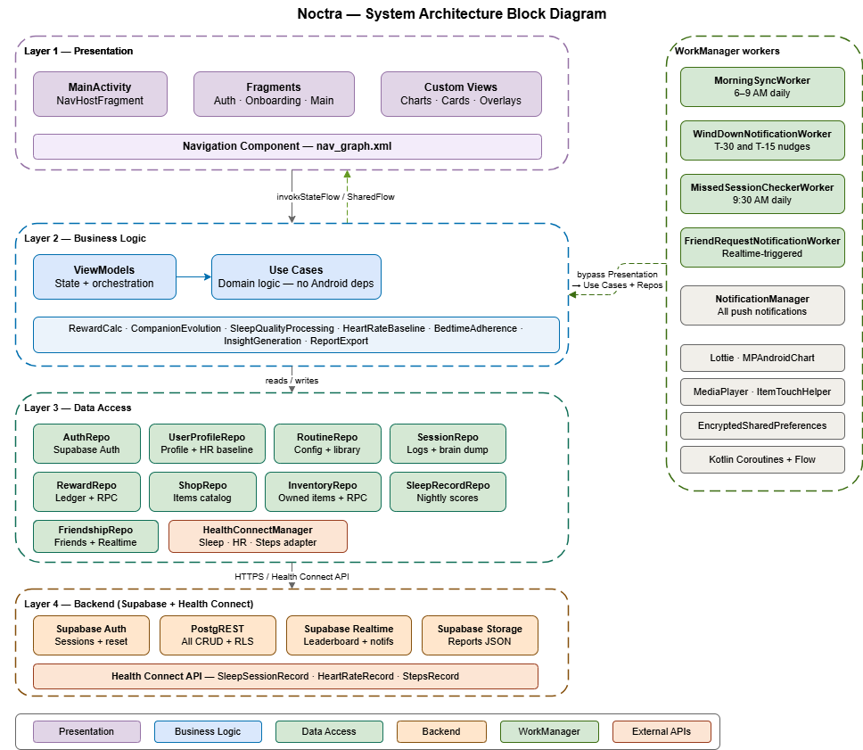

Detailed Design

Module 1 - Onboarding & Routine Configuration

1.1 User Registration and Account Setup
- User Interface Design

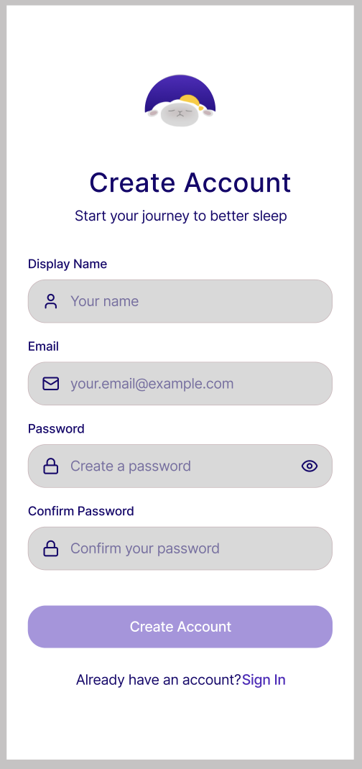

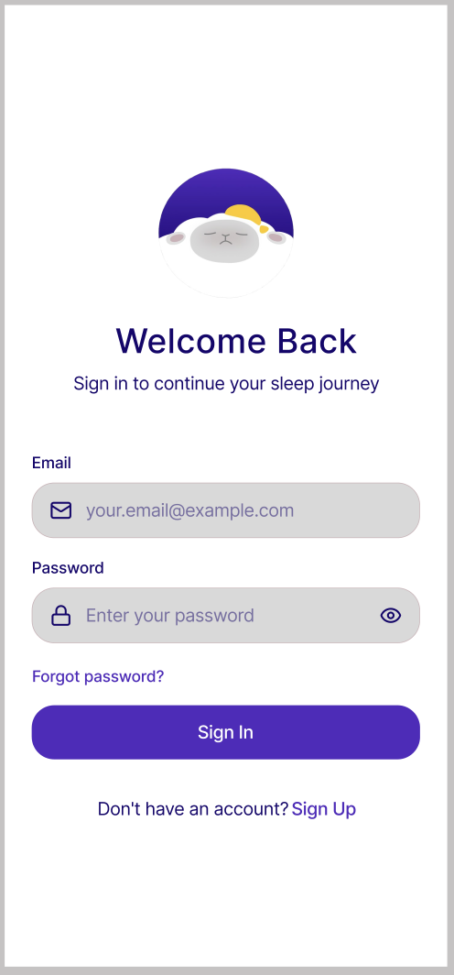

A two-screen authentication flow presented on first launch. The registration screen collects the user's display name, email address, and password with a confirm password field. Input validation is performed inline — the display name field enforces a minimum of two characters, the email field validates format on focus loss, and the password field enforces a minimum of eight characters with a strength indicator. Error messages appear directly below the offending field rather than as a dialog. A "Create Account" button is disabled until all fields pass validation. On successful registration the user is navigated directly into the onboarding flow. Returning users are shown a login screen with email and password fields and a "Forgot Password" link that triggers a Supabase password reset email. On successful login, returning users who have completed onboarding are navigated to CompanionFragment; users who abandoned onboarding mid-flow are returned to their last completed onboarding step.
- Front-end component(s)
  - MainActivity
    - The sole host Activity of the application. On launch, it determines the start destination of the navigation graph based on authentication state from AuthRepository and onboarding completion state from UserProfileRepository. If unauthenticated, navigate to auth_graph. If authenticated but onboarding is incomplete, navigate to the appropriate step in onboarding_graph. If fully onboarded, navigate to CompanionFragment in main_graph. Manages bottom navigation bar visibility by observing the Navigation Component's currentBackStackEntry and showing the bar only for the four tab root destinations (CompanionFragment, RoutineHomeFragment, AnalyticsDashboardFragment, UserProfileFragment).
    - Type:Activity (Kotlin), Navigation Component with NavHostFragment
  - RegistrationFragment
    - Renders the registration form. Each field is bound to a corresponding property in AuthViewModel via two-way data binding or StateFlow observation. The Create Account button observes a formIsValid: Boolean LiveData property that enables or disables it. On successful registration, posts a navigation event via SharedFlow that triggers navigation to the onboarding_graph start destination.
    - Type: Fragment
  - LoginFragment
    - Renders the login form with email and password fields. Hosts a "Forgot Password" TextView that triggers a password reset dialog collecting the user's email. Observes AuthViewModel for login success and error states. On success, dispatches a navigation command to the Navigation Component to route the user to their appropriate destination based on onboarding completion state.
    - Type: Fragment
  - ForgotPasswordFragment
    - Displayed when the user taps the "Forgot Password" link on LoginFragment. Renders a single email input field with a brief instructional label ("Enter the email address associated with your account") and a "Send Reset Link" button. Validates email format before enabling the button. On submission, invokes AuthViewModel.sendPasswordReset(email) and navigates to PasswordResetConfirmationFragment on success. A "Back to Login" text button navigates back to LoginFragment without submitting.
    - Type: Fragment (Kotlin)
  - PasswordResetConfirmationFragment
    - A static confirmation screen displayed after the password reset email has been sent. Displays a confirmation illustration, a heading ("Check your email"), and a brief message informing the user that a reset link has been sent to their email address. Hosts a single "Back to Login" button that navigates back to LoginFragment. No further interaction is required on this screen.
    - Type: Fragment (Kotlin)
  - PasswordStrengthIndicatorView
    - A custom View rendered below the password field on the registration screen. Displays a horizontal segmented bar that fills progressively as password strength increases through three states: Weak (red, 1 segment), Fair (yellow, 2 segments), Strong (green, 3 segments). Strength is evaluated by PasswordStrengthEvaluator in the ViewModel.
    - Type: Custom View (Kotlin)

- Back-end component(s)
  - AuthViewModel
    - The single ViewModel for both registration and login screens. Holds form field StateFlow properties for each input. Exposes a formIsValid: StateFlow<Boolean> that combines all field validation states. On registration submission, invokes AuthRepository.register(email, password, displayName). On login submission, invokes AuthRepository.login(email, password). Posts navigation events as a SharedFlow. Handles loading and error states exposed as StateFlow for UI observation.
    - Type: AndroidViewModel (Kotlin)
  - AuthRepository
    - Wraps Supabase Auth client operations. register() calls supabase.auth.signUpWith(Email) and on success immediately creates a corresponding row in the user_profiles table via supabase.from("user_profiles").insert(). login() calls supabase.auth.signInWith(Email). resetPassword() calls supabase.auth.resetPasswordForEmail(). Exposes the current session state as a Flow.
    - Type: Repository (Kotlin), Supabase Auth + Supabase PostgREST client
  - PasswordStrengthEvaluator
    - A pure utility class that receives a password string and returns a PasswordStrength enum (WEAK, FAIR, STRONG) based on length, presence of numbers, and presence of special characters. Called reactively from AuthViewModel as the user types.
    - Type: Utility class (Kotlin)
- Object-Oriented Components
  - Class Diagram
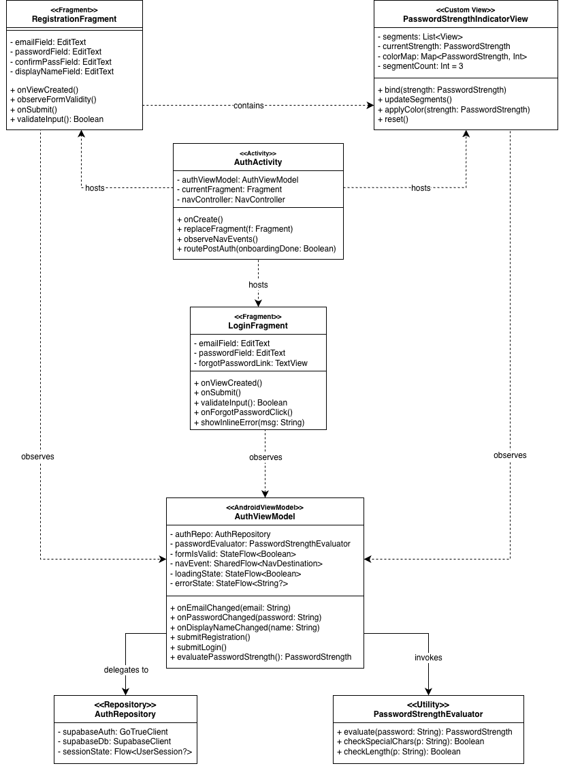
  - Sequence Diagram
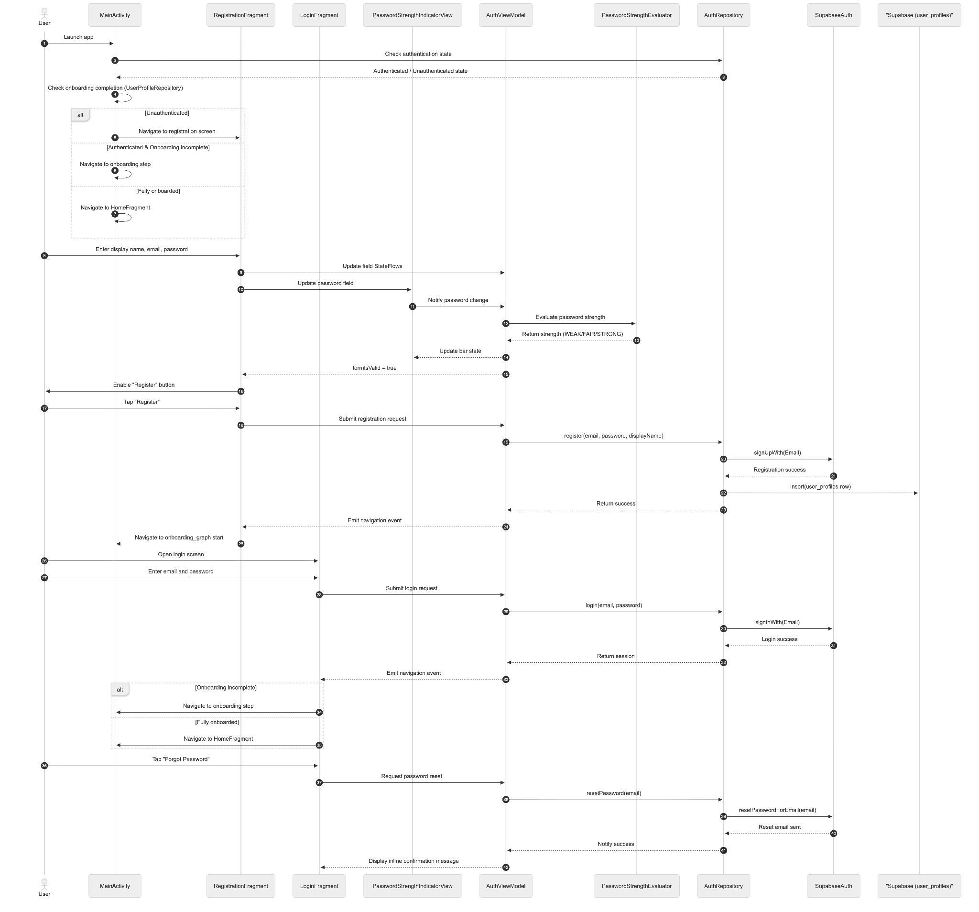

- Data Design
  - ERD or schema
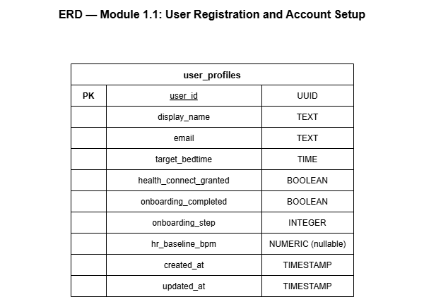

1.2 Routine Configuration and Layout Setup
- User Interface Design
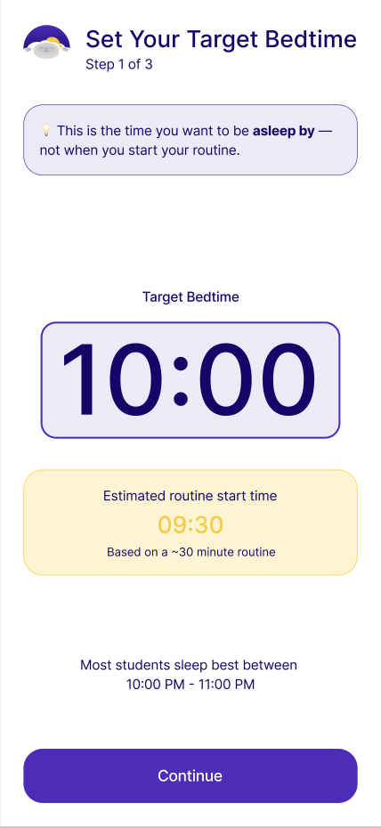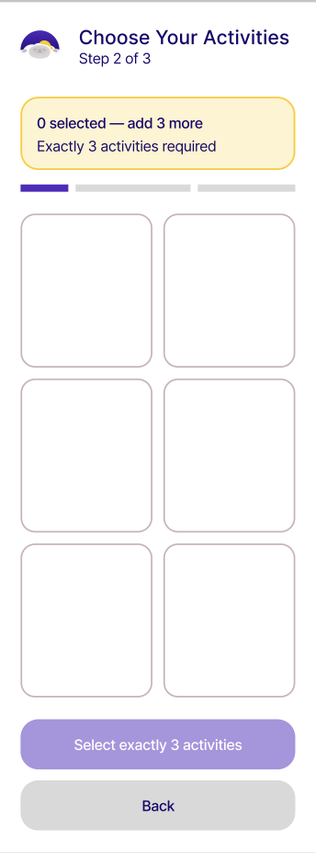
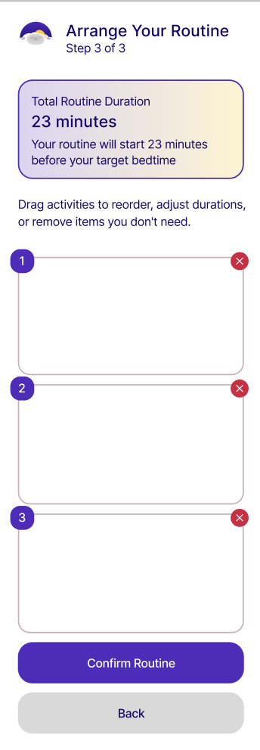
A three-step sequential flow within onboarding_graph that collects the user's target bedtime, builds their initial wind-down routine, and confirms the sequence before proceeding to Health Connect setup.
  - Step 1 — Bedtime Configuration: A full-screen step presenting a large scrollable time-picker wheel or clock interface where the user selects their desired target bedtime. A brief instructional label below the picker reads "This is the time you want to be asleep by — not when you start your routine." A preview text below the picker shows the estimated routine start time based on the selected bedtime and a default assumed routine duration (e.g., "Your routine will begin at approximately 10:30 PM"). The selection is saved immediately to the graph-scoped ViewModel on every scroll change.
  - Step 2 — Activity Library: A grid display of all available pre-sleep activities from the activity_library table, presented as selectable cards. Each card displays the activity icon, label, category tag, and estimated duration. Exactly three activities must be selected to advance. A selection counter at the top of the screen shows how many activities have been selected out of the required three (e.g., "2 selected — add 1 more"). When three activities are selected, unselected cards enter a disabled visual state.
  - Step 3 — Routine Sequencing: Renders the user's selected activities as a vertically ordered drag-and-drop list. Each row displays the activity label, estimated duration, a drag handle icon on the right, and a remove button. Below the list, a total estimated routine duration is shown and updates reactively as items are reordered or removed. A "Confirm Routine" button at the bottom saves the final sequence.
- Front-end component(s)
  - BedtimeConfigFragment
    - Renders the time-picker wheel interface for target bedtime selection. On every scroll interaction, updates OnboardingViewModel.targetBedtime: MutableStateFlow<LocalTime>. Computes and displays the estimated routine start time by subtracting the total default routine duration from the selected bedtime. A "Next" button advances to ActivityLibraryFragment and is enabled at all times since a default bedtime is pre-selected.
    - Type: Fragment (Kotlin)
  - ActivityLibraryFragment
    - Fetches and displays all activities from RoutineRepository.getAllActivities() in a two-column GridLayoutManager RecyclerView. Each item is rendered as an ActivityCardView. Manages multi-select state through OnboardingViewModel.selectedActivities: MutableStateFlow<List<Activity>>. The "Next" button is enabled only when exactly three activities are selected. When three activities are selected, unselected cards enter a disabled visual state. Category filter chips above the grid filter the visible list without affecting the selection state.
    - Type: Fragment (Kotlin)
  - ActivityCardView
    - A custom ViewGroup rendering a single activity card. Displays the activity icon, label, category chip, and estimated duration. In the selected state, the card border highlights with the app's primary color and a checkmark overlay appears in the top-right corner. In the disabled state (max selection reached and this card is not selected), the card is rendered at reduced opacity. Fires a selection callback to the parent Fragment on tap.
    - Type: Custom ViewGroup (Kotlin)
  - RoutineSequenceFragment
    - Renders the selected activities as a vertically ordered RecyclerView with ItemTouchHelper configured for vertical drag-and-drop reordering. Each row shows the step number, activity label, duration, drag handle icon, and a remove button. Persists reorder and removal changes to OnboardingViewModel.routineSequence: MutableStateFlow<List<Activity>> after each interaction. Displays the total routine duration as a reactive label at the bottom. The "Confirm Routine" button triggers OnboardingViewModel.saveRoutineConfiguration().
    - Type: Fragment (Kotlin)
  - OnboardingSummaryFragment
    - The final step of the onboarding flow, displayed after Health Connect setup. Shows a summary card of the confirmed routine sequence as a non-interactive list, the confirmed target bedtime, and Health Connect permission status with a color-coded indicator. Hosts the "Start Using Noctra" button that invokes OnboardingViewModel.completeOnboarding(), which sets onboarding_completed = true in user_profiles and navigates to CompanionFragment in main_graph.
    - Type: Fragment (Kotlin)
- Back-end component(s)
  - OnboardingViewModel
    - Scoped to the onboarding_graph back stack entry using by navGraphViewModels(R.id.onboarding_graph). This ensures the ViewModel is shared across all five onboarding Fragments (BedtimeConfigFragment, ActivityLibraryFragment, RoutineSequenceFragment, HealthConnectSetupFragment, OnboardingSummaryFragment) and is destroyed when the user exits the onboarding graph. Holds MutableStateFlow properties for targetBedtime, selectedActivities, and routineSequence. Exposes canAdvanceFromStep: StateFlow<Boolean> for each step's Next button binding. On saveRoutineConfiguration(), invokes UserProfileRepository.updateBedtime() and RoutineRepository.saveRoutineConfiguration(). On completeOnboarding(), invokes UserProfileRepository.completeOnboarding() and posts a navigation event to CompanionFragment.
    - Type: ViewModel (Kotlin), scoped via navGraphViewModels
  - RoutineRepository
    - Manages all read and write operations for routine_configurations and the activity_library seed table. getAllActivities() queries activity_library ordered by sort_order and returns the full list. saveRoutineConfiguration() inserts a new routine_configurations row and atomically sets all previous configurations for the same user to is_active = false using a Supabase RPC function to prevent multiple active configurations. getActiveRoutine() queries routine_configurations where user_id = current_user and is_active = true and returns the result with the activity sequence hydrated from activity_library.
    - Type: Repository (Kotlin), Supabase PostgREST client
  - UserProfileRepository
    - Manages all read and write operations for user_profiles. updateBedtime(time) updates the target_bedtime column. updateOnboardingStep(step) updates onboarding_step for resume support, called after each onboarding step is completed. completeOnboarding() sets onboarding_completed = true. updateHRBaseline(bpm) updates hr_baseline_bpm. updateDisplayName(name) updates the display_name column for the current user. All writes use Supabase PostgREST upsert on user_id.
    - Type: Repository (Kotlin), Supabase PostgREST client
- Object-Oriented Components
  - Class Diagram
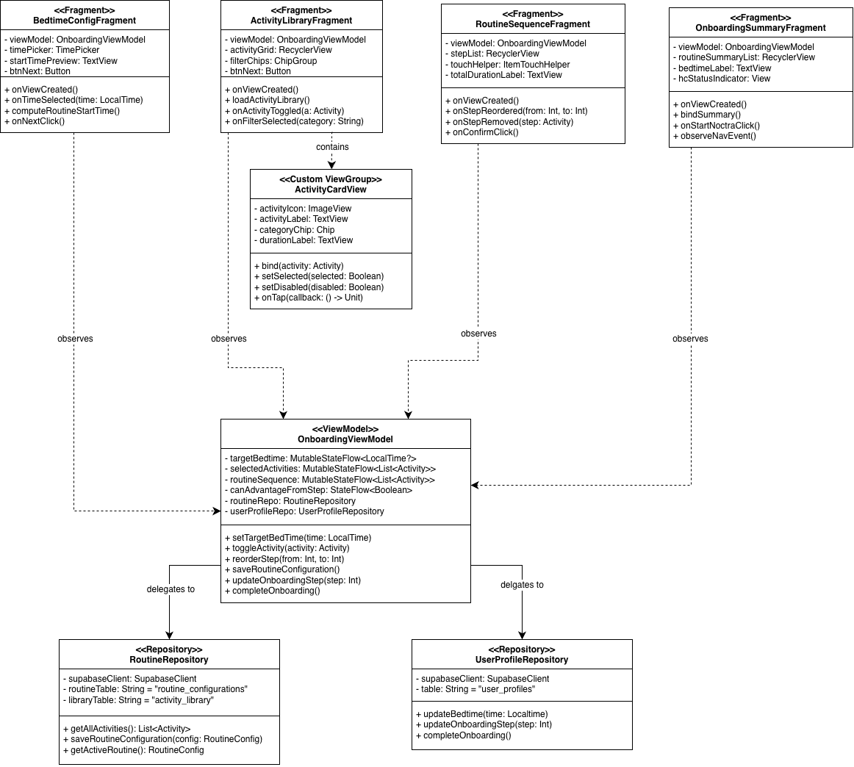
  - Sequence Diagram
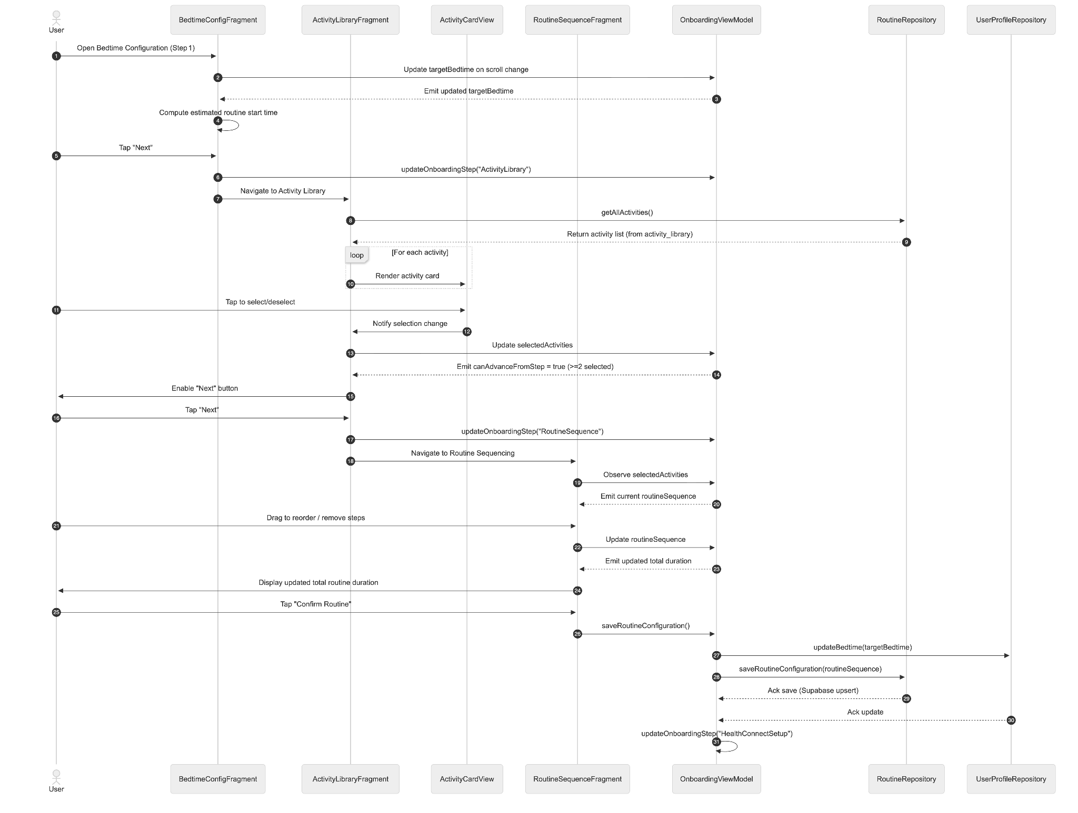
- Data Design
  - ERD or Schema
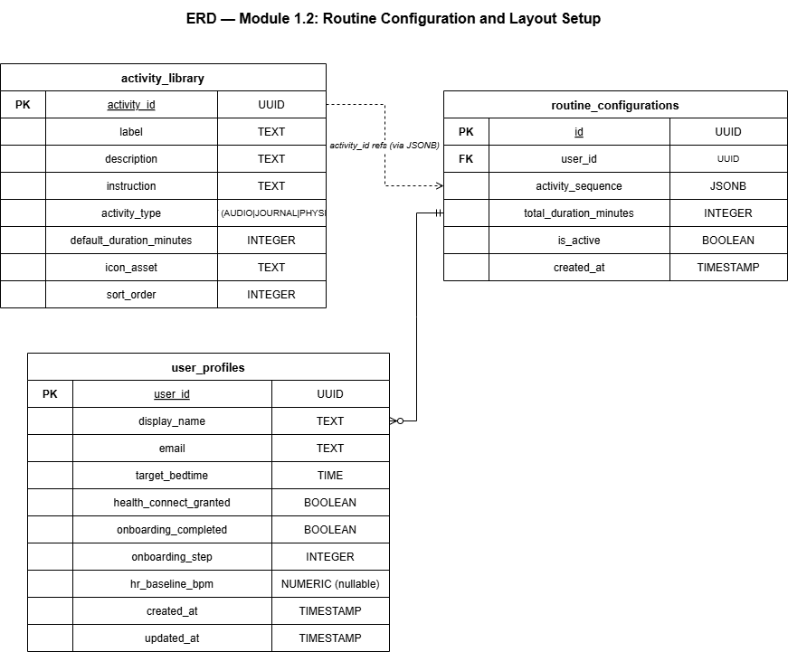

1.3 Health Connect Permission Setup
- User Interface Design -
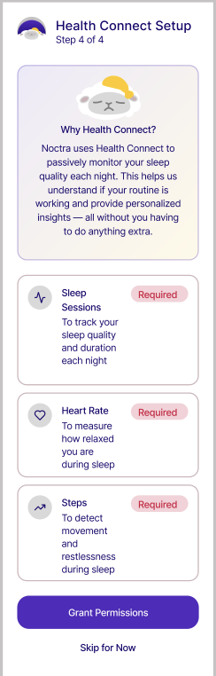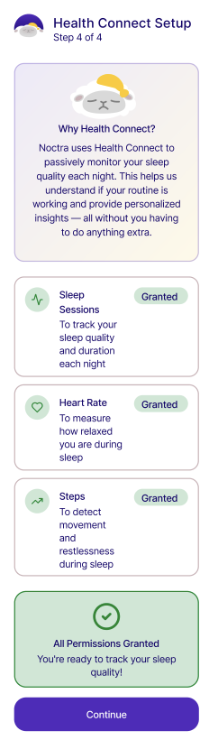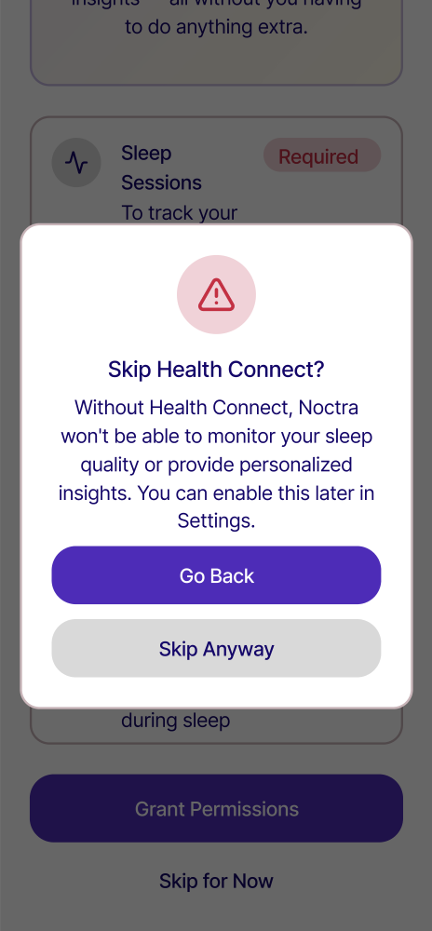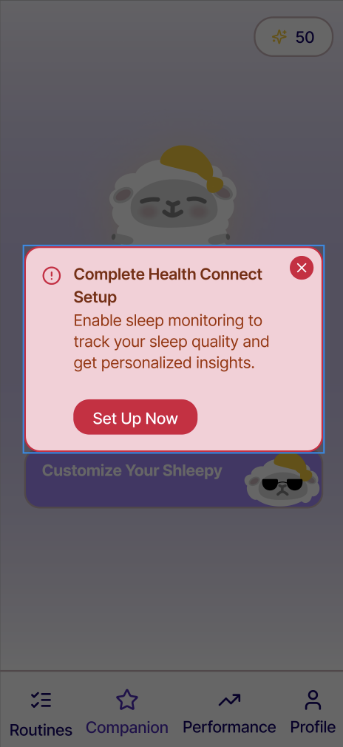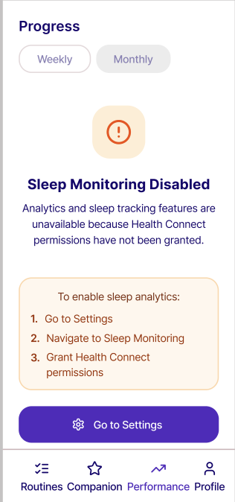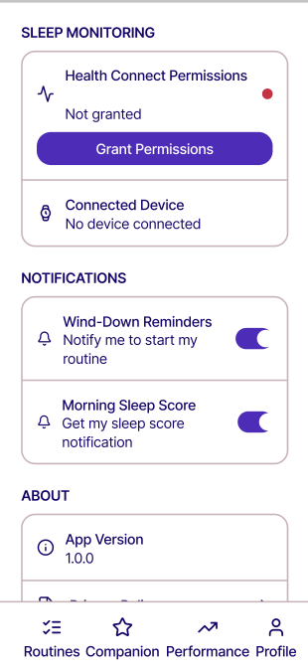
A dedicated permission setup screen shown as Step 4 of onboarding and also accessible from the Settings screen. The screen opens with a brief explanation section using plain, non-technical language explaining what Health Connect is and why Noctra needs it, accompanied by a simple illustration. Below the explanation, three permission status rows are displayed — one each for Sleep Sessions, Heart Rate, and Steps — each showing the data type name, a one-line description of why it is needed, and a colored status chip (green "Granted" or red "Required"). A "Grant Permissions" button below the rows launches the system Health Connect permission dialog. If the user has already granted all permissions, the button is replaced with a green "All Permissions Granted" confirmation state. A "Skip for Now" text button is available but triggers a warning dialog explaining that sleep monitoring will be inactive until permissions are granted. If skipped, a persistent banner on CompanionFragment prompts the user to complete permission setup.
- Front-end component(s)
  - HealthConnectSetupFragment
    - Renders the explanation card, three PermissionStatusRowView components, and the Grant/Skip action buttons. Observes HealthConnectViewModel.permissionState: StateFlow<HealthConnectPermissionState> and updates each row's status chip reactively. On "Grant Permissions" tap, launches the Health Connect permission request contract via ActivityResultLauncher using the contract returned by HealthConnectClient.createRequestPermissionResultContract(). On all permissions granted, invokes OnboardingViewModel to advance to OnboardingSummaryFragment.
    - Type: Fragment (Kotlin)
  - PermissionStatusRowView
    - A custom View rendering a single permission row. Displays a data type icon, label, one-line description of the data's purpose in Noctra, and a colored status chip. The chip animates from red to green when the permission transitions to granted state using a color value animator.
    - Type: Custom View (Kotlin)
  - HealthConnectUnavailableBanner
    - A dismissible full-width banner shown at the top of CompanionFragment when Health Connect permissions are not granted or when Health Connect is not installed on the device. Displays a contextual message and a "Set Up Now" action button that navigates to HealthConnectSetupFragment via the Navigation Component deep link. Dismissal state is stored in SharedPreferences so the banner does not reappear until the following day.
    - Type: Custom View (Kotlin), embedded in CompanionFragment layout
- Back-end component(s)
  - HealthConnectViewModel
    - On initialization, invokes HealthConnectManager.checkAvailability() to determine whether Health Connect is installed and supported. If available, invokes HealthConnectManager.getGrantedPermissions() to check the current grant status of each required permission. Exposes permissionState: StateFlow<HealthConnectPermissionState> — a data class containing individual boolean grant flags for READ_SLEEP, READ_HEART_RATE, and READ_STEPS. Launches the system permission request dialog via ActivityResultContract when the Grant button is tapped. On permission grant, invokes UserProfileRepository.updateHealthConnectGranted(true).
    - Type: ViewModel (Kotlin)
  - HealthConnectManager
    - The architectural adapter and wrapper around androidx.health.connect.client.HealthConnectClient. It handles five primary operations across the application lifecycle:
- checkAvailability(): Verifies whether the Health Connect system APK is installed, missing, or unsupported on the current hardware platform.
- getRequiredPermissions(): Returns the set of necessary permission strings (READ_SLEEP, READ_HEART_RATE, READ_STEPS).
- readSleepData(date: LocalDate): Connects to SleepSessionRecord and pulls sessions spanning from the target bedtime window through mid-day.
- readHeartRateData(startTime: Instant, endTime: Instant): Extracts historical intervals from HeartRateRecord during active rest.
- readMovementData(startTime: Instant, endTime: Instant): Queries total step indexes via StepsRecord to map physiological tossing and turning.
    - Type: Manager class (Kotlin), androidx.health.connect.client
- Object-Oriented Components
  - Class Diagram
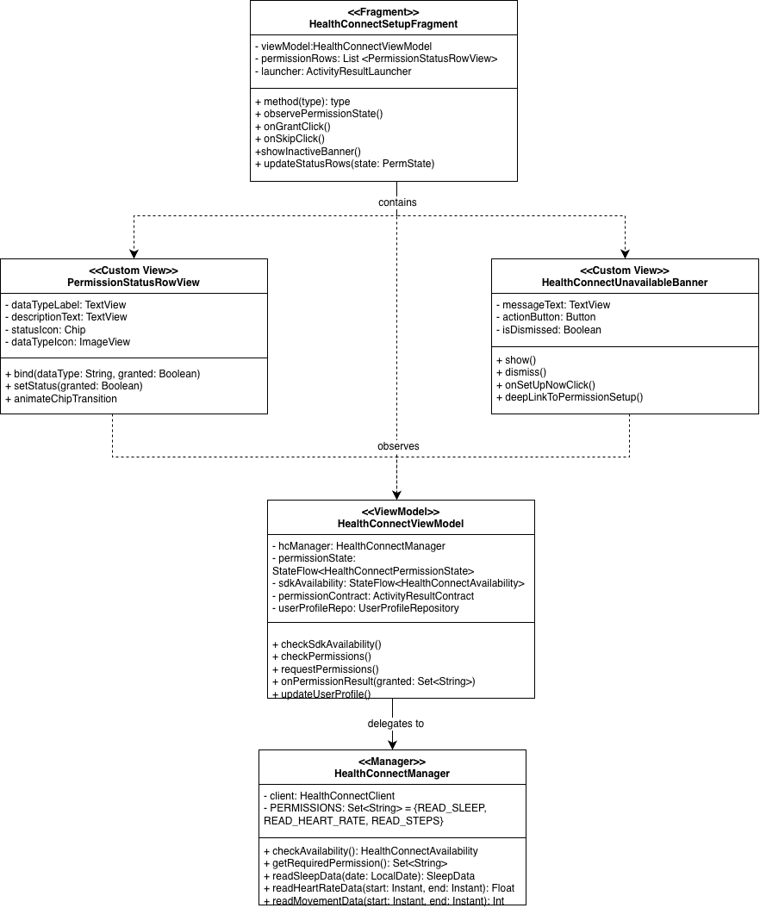
  - Sequence Diagram

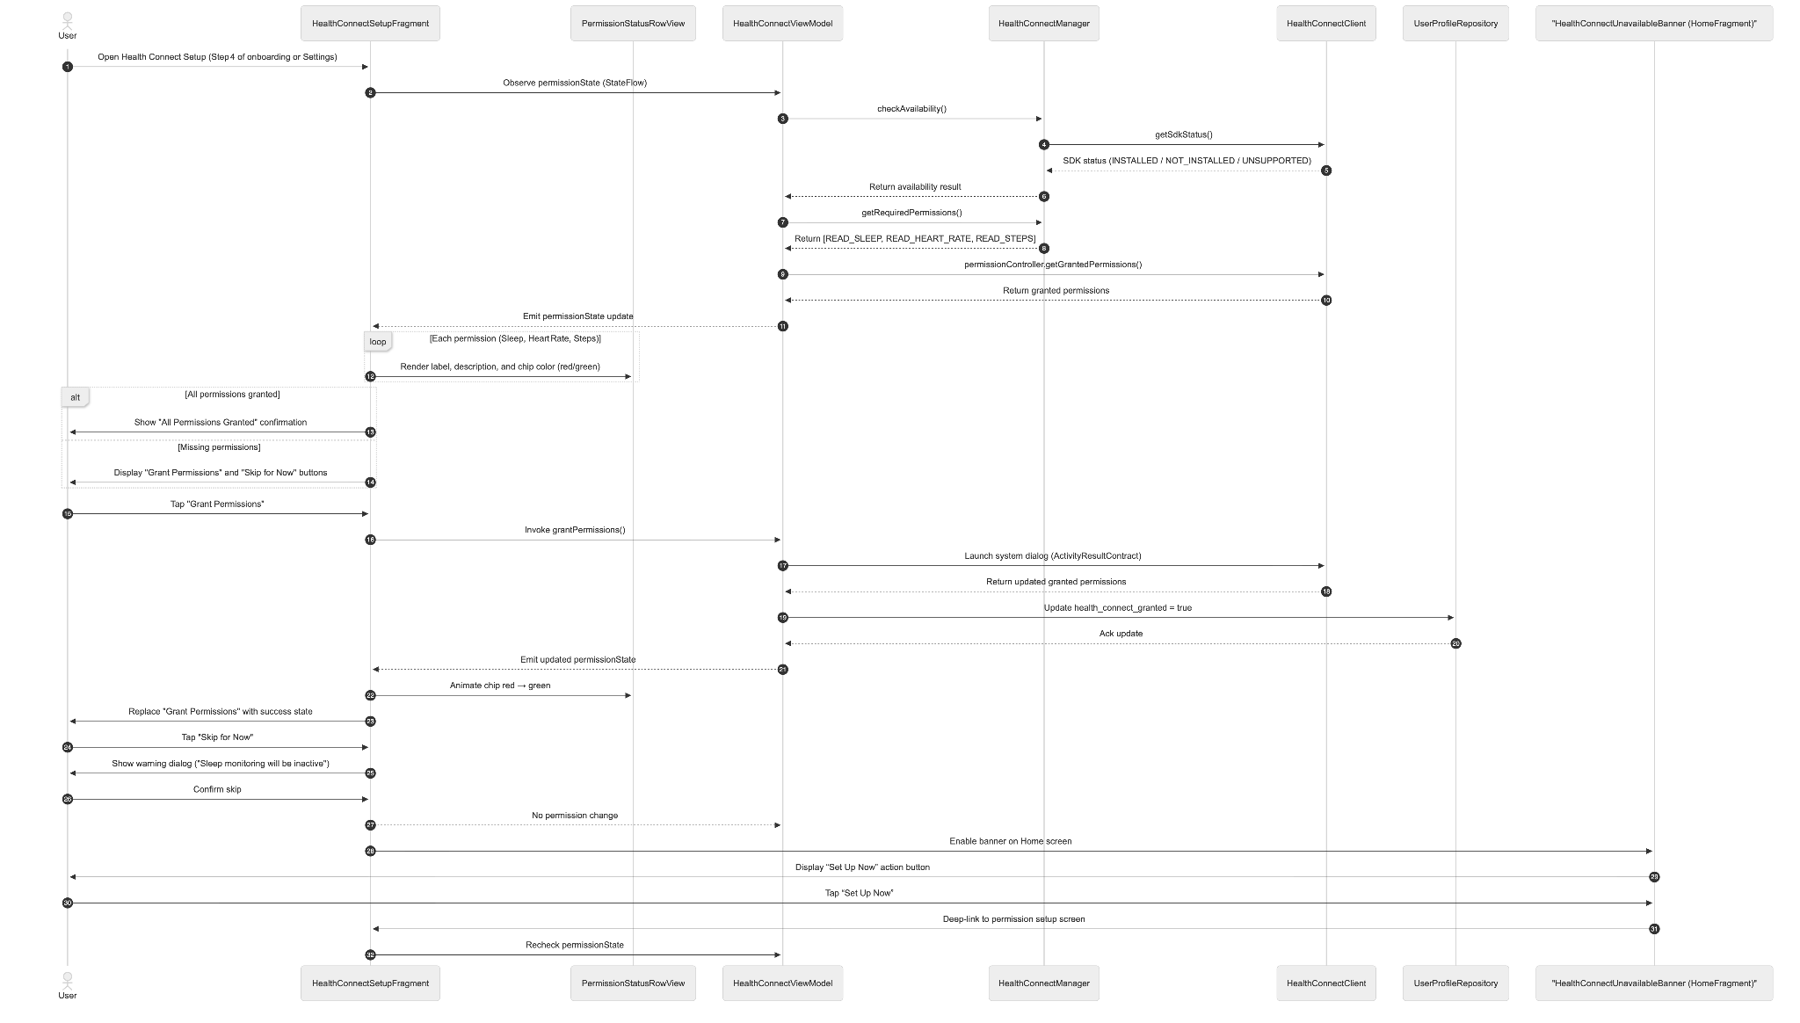
- Data Design

1.4 Settings
- User Interface Design -
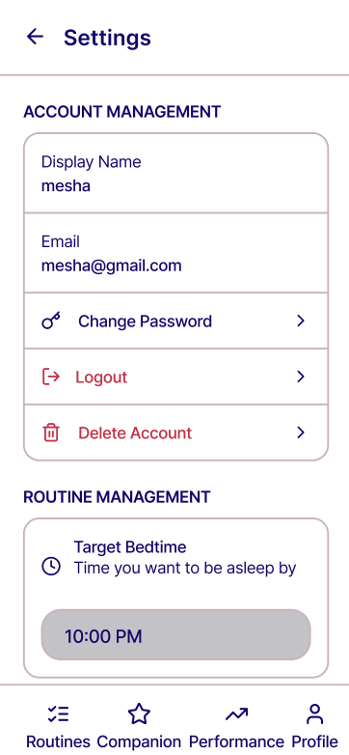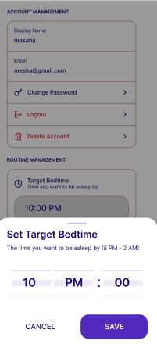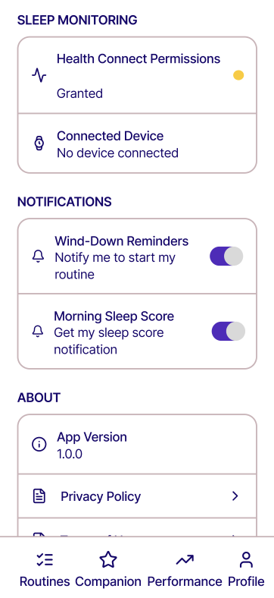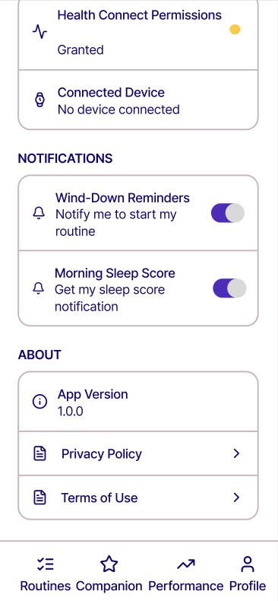
SettingsFragment is accessible from the "Settings" button in UserProfileFragment. It is not a bottom navigation tab. The screen is organized into five grouped sections presented as a standard list.
  - Account Management: Read-only display name display; read-only email display; a "Change Password" option that triggers a Supabase password reset email (same flow as Forgot Password); a "Logout" button that triggers a confirmation dialog then calls AuthRepository.logout() and navigates back to auth_graph; and an optional "Delete Account" action that triggers a confirmation dialog before invoking Supabase account deletion.
  - Routine Management: A "Target Bedtime" time picker (8PM–2AM range) that updates the user's target_bedtime in user_profiles and reschedules WindDownNotificationWorker with the new time.
  - Sleep Monitoring: A "Health Connect Permissions" row showing current permission status with a button to open Health Connect settings if permissions need to be re-granted; a "Connected Device" row displaying whether a Health Connect-compatible smartwatch has synced recently.
  - Notifications: A toggle for Wind-Down Reminders (enables or disables WindDownNotificationWorker); a toggle for Morning Sleep Score notifications (enables or disables the MorningSyncWorker result notification).
  - About: App version number; privacy policy link; terms of use link.
- Front-end component(s)
  - SettingsFragment
    - The root Fragment for the Settings screen. Observes SettingsViewModel for current preference states and user profile data. Handles logout confirmation dialog and logout action. Renders each settings group as a labeled section with the appropriate input controls (EditText dialogs, time pickers, toggles, navigation rows).
    - Type: Fragment (Kotlin)

- Back-end component(s)
  - SettingsViewModel
    - Loads the current user profile (email, target bedtime) from UserProfileRepository. Exposes current notification toggle states from SharedPreferences. On bedtime change, invokes UserProfileRepository.updateBedtime() and then reschedules WindDownNotificationWorker via WorkManager with the new bedtime value. On logout, invokes AuthRepository.logout(). Exposes action result states as SharedFlow for one-shot UI events (success, error).
    - Type: ViewModel (Kotlin)
- Object-Oriented Components
  - Class Diagram
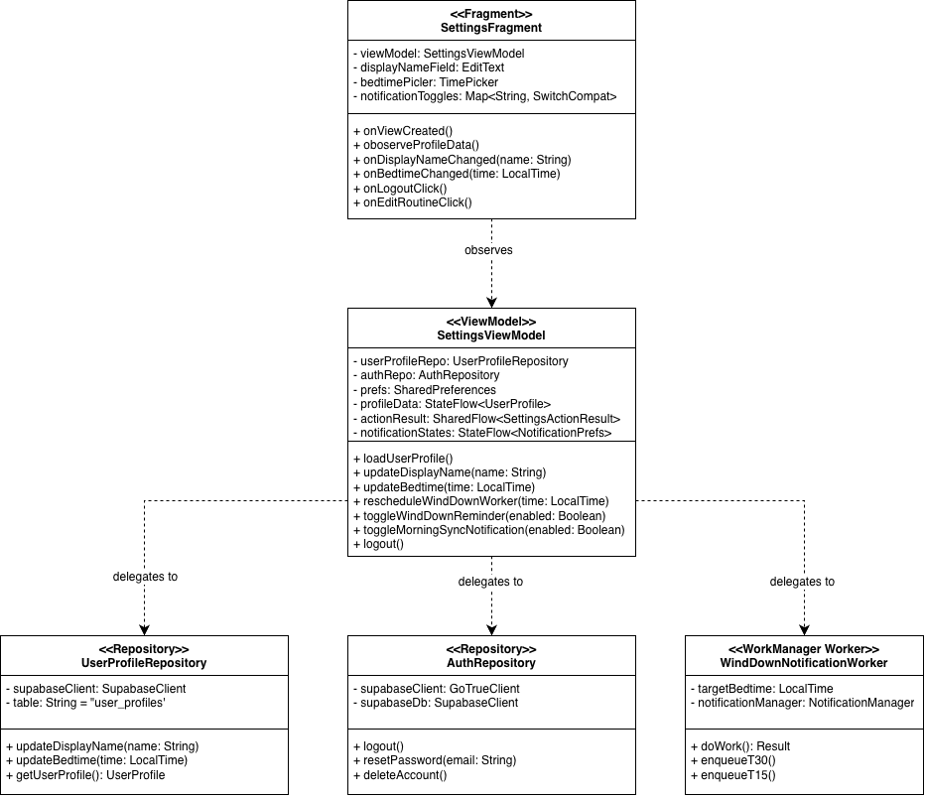
  - Sequence Diagram
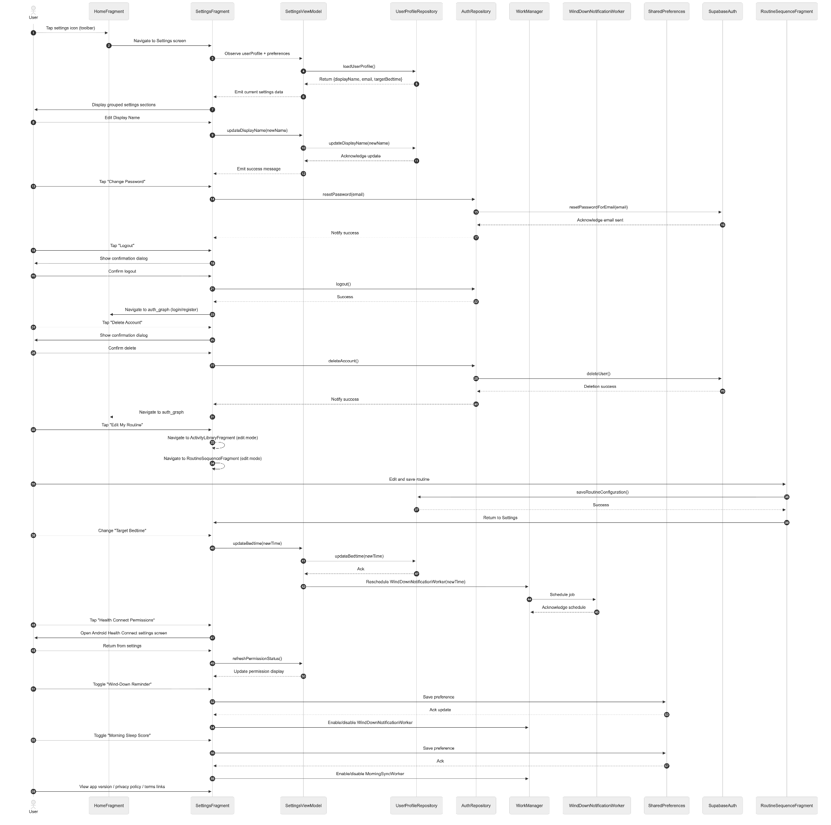
- Data Design

1.5 User Profile
- User Interface Design
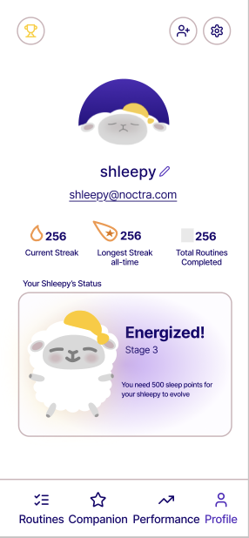
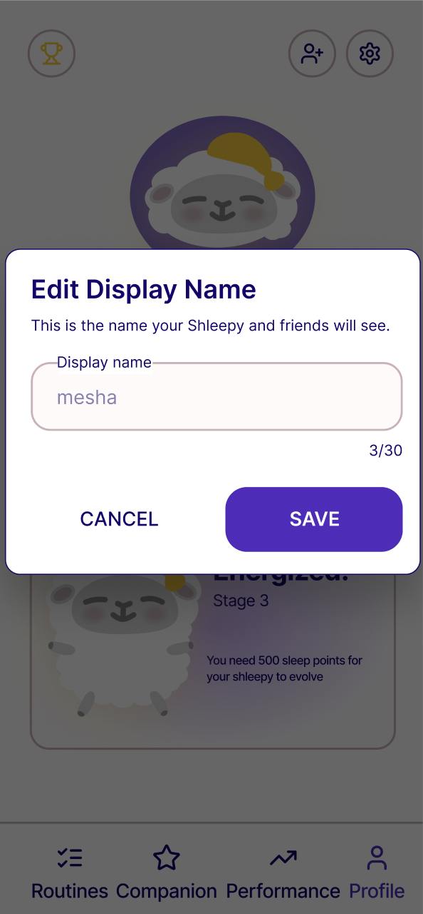
UserProfileFragment is the fourth bottom navigation tab, labeled "Profile." It is the entry point for both social features and settings. The screen is divided into three sections.
  - Identity: A default Shleepy picture as profile avatar; display name in large prominent text; and email address in smaller read-only text. An "Edit" icon beside the display name opens an inline edit field.
  - Stats Summary: Current streak with flame icon; all-time longest streak; total routines completed (count of is_completed = true in routine_sessions); current companion evolution stage name; Shleepy stage card showing XP needed to evolve to the next stage as text.
  - Quick Actions: A "Friends & Leaderboard" button that navigates to SocialFragment; a "Settings" button that navigates to SettingsFragment.
- Front-end component(s)
  - UserProfileFragment
    - The root Fragment for the Profile tab. Observes UserProfileViewModel for profile data and stats. Hosts navigation actions to SocialFragment and SettingsFragment. The bottom navigation bar remains visible on this screen since it is a tab root destination.
    - Type: Fragment (Kotlin)
- Back-end component(s)
  - UserProfileViewModel
    - Loads user profile data from UserProfileRepository and aggregates stats from RoutineSessionRepository and RewardRepository. Exposes displayName, email, currentStreak, longestStreak, totalRoutinesCompleted, and companionStageName as StateFlow properties. On display name edit submission, invokes UserProfileRepository.updateDisplayName() and refreshes exposed state.
    - Type: ViewModel (Kotlin)
- Object-Oriented Components
  - Class Diagram
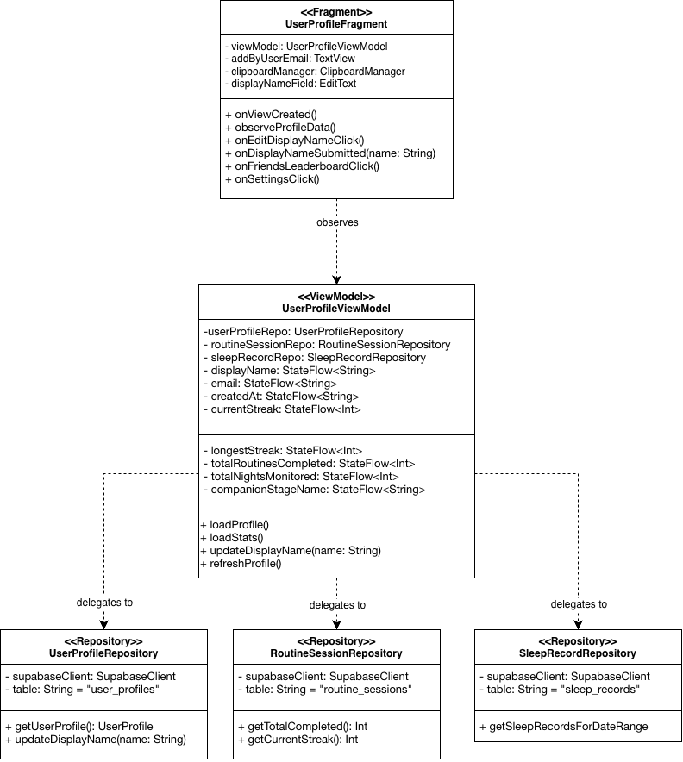
  - Sequence Diagram
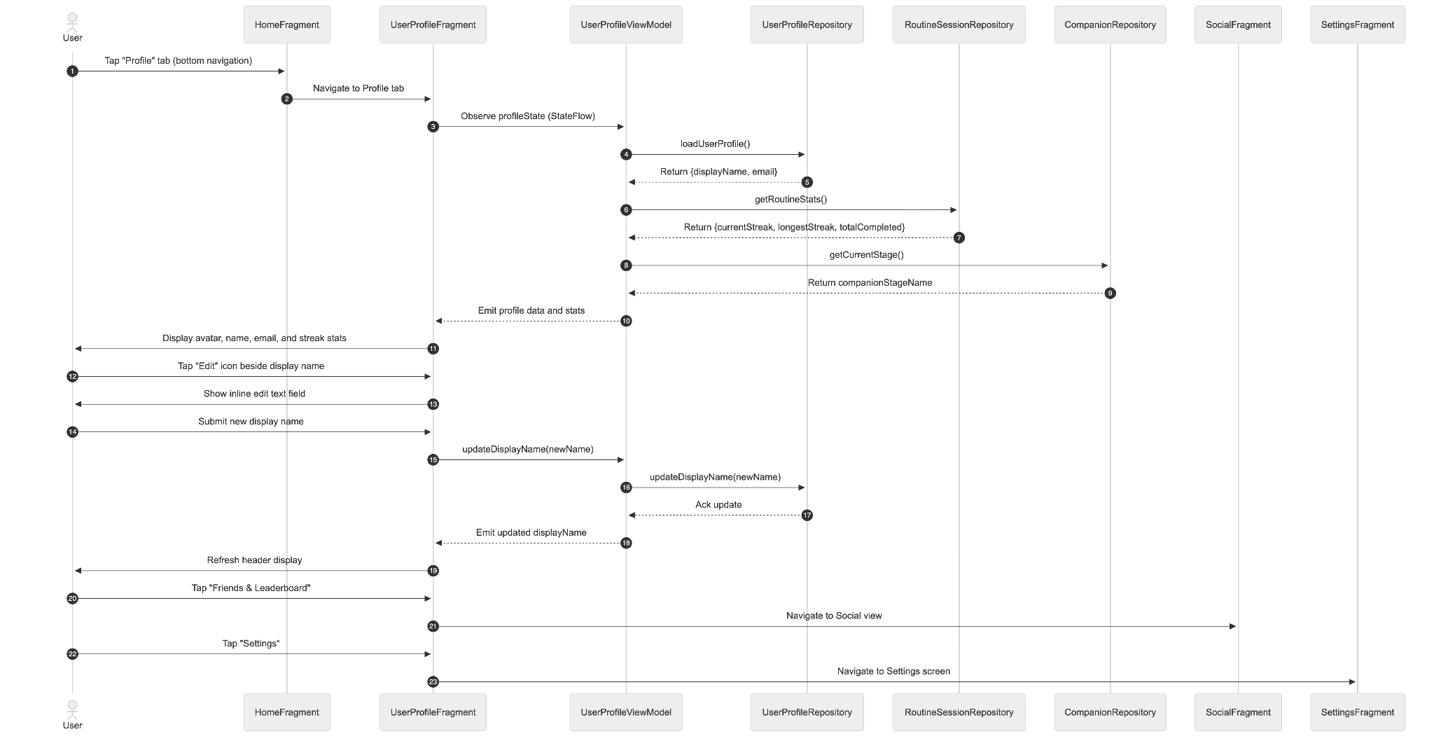

- Data Design

Module 2 - Gamified Nightly Engagement

2.1 Nightly Routine Execution
- User Interface Design
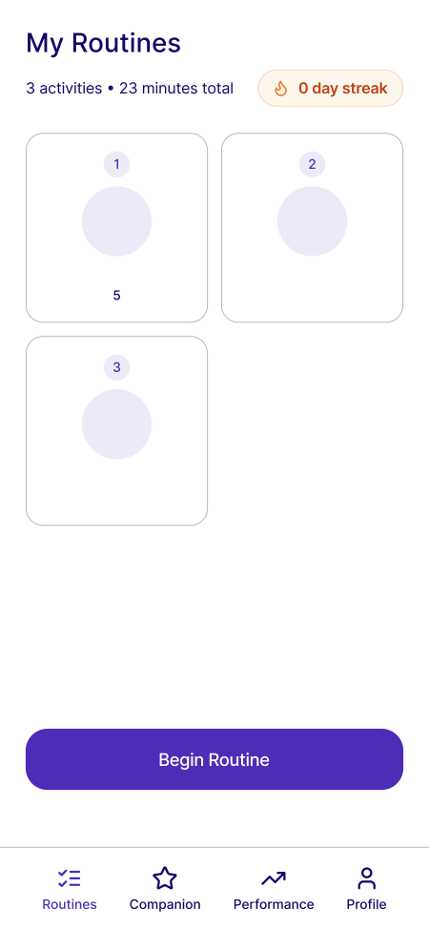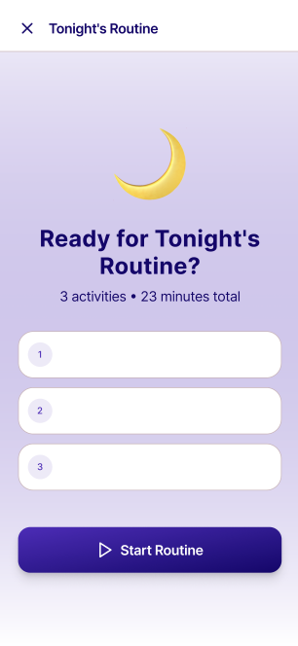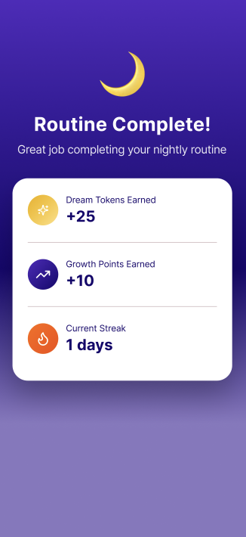
The primary nightly interaction screen, accessible from RoutineHomeFragment's "Begin Routine" button and via wind-down nudge notification deep links. Opens with a start screen showing routine name, total estimated duration, and a Start button. Each activity occupies its own full screen showing the activity name, instructions, and activity-specific content. Activities transition automatically one after another when each activity's timer runs out. An audio chime plays automatically between activity transitions. The final activity shows a Complete Routine button instead of auto-transitioning. A 60-minute session timer runs in the background from when Start is tapped. If Complete Routine is not tapped within 60 minutes, the morning sync checks sleep onset to determine if the user fell asleep; if sleep onset is detected within 60 minutes, the session is marked as completed and the streak is preserved.
- Front-end component(s)
  - RoutineExecutionFragment
    - The root Fragment for the nightly routine execution flow, hosted inside MainActivity's NavHostFragment within main_graph. On onResume(), calls requireActivity().window.addFlags(WindowManager.LayoutParams.FLAG_KEEP_SCREEN_ON) to prevent the screen from sleeping during audio playback or physical activity steps. Clears the flag in onPause() to ensure it does not affect other screens in the app. Opens with a start screen showing the routine name, total estimated duration, and a Start button. Each activity is then rendered as its own full-screen view, transitioning automatically when the activity's timer runs out. An audio chime plays between activity transitions. The final activity shows a Complete Routine button instead of auto-transitioning. A 60-minute background session timer runs from when Start is tapped. If Complete Routine is not tapped within 60 minutes, the morning sync checks sleep onset to determine if the user fell asleep; if sleep onset is detected within 60 minutes, the session is marked as completed and the streak is preserved. Observes RoutineViewModel for the ordered activity list, current active screen index, countdown timer state, and session completion events. Handles the system back button by intercepting it with OnBackPressedCallback and showing an exit confirmation dialog warning that no tokens or streak update will occur.
    - Type: Fragment (Kotlin)
  - BreathingActivityScreen
    - A full-screen View rendered during a slow-paced breathing activity. Displays an animated breathing circle that expands and contracts with timed inhale, hold, and exhale intervals. Phase labels (Inhale / Hold / Exhale) update in sync with the animation. The activity's countdown timer runs in the background and triggers automatic transition to the next activity on completion.
    - Type: Custom View (Kotlin)
  - MuscleRelaxationActivityScreen
    - A full-screen View rendered during a progressive muscle relaxation activity. Displays sequential exercises each with a brief instruction text and a visual animation. Cycles automatically through a tensing phase and a releasing phase for each exercise until all exercises are complete, at which point the activity ends and transitions to the next.
    - Type: Custom View (Kotlin)
  - StretchingActivityScreen
    - A full-screen View rendered during a bedtime stretching activity. Displays 5 stretching exercises in sequence, each with a brief instruction and a visual guide. Progresses through an execution phase for each exercise and repeats until all exercises are done, then triggers automatic transition to the next activity.
    - Type: Custom View (Kotlin)
  - MindfulnessActivityScreen
    - A full-screen View rendered during a mindfulness activity. Displays a nature-themed ambient visual with bundled meditation audio playing throughout the activity duration. Audio is sourced from the app's res/raw directory and requires no network dependency. The activity's countdown timer runs in the background and triggers automatic transition on completion.
    - Type: Custom View (Kotlin)
  - AudioActivityScreen
    - A full-screen View rendered during low-stimulus audio and white/pink noise activities. Displays an audio player with an animated waveform visualization reacting to playback state. Audio plays automatically on screen entry with no pause control available, using locally bundled audio files from the app's res/raw directory. The activity's countdown timer runs in the background and triggers automatic transition on completion.
    - Type: Custom View (Kotlin), MediaPlayer
  - GratitudeJournalingActivityScreen
    - A full-screen View rendered during a gratitude journaling activity. Displays a text input field with a prompt for the user's private reflection. Text entered is not saved by the system and exists solely for the user's in-session use. The activity's countdown timer runs alongside the input field and triggers automatic transition on completion.
    - Type: Custom View (Kotlin)
  - ToDoListActivityScreen
    - A full-screen View rendered during a bedtime to-do list writing activity. Displays a message prompting the user to write their to-dos in their own notebook or external medium, accompanied by a countdown timer. No text input field is provided in the app. The timer triggers automatic transition to the next activity on completion.
    - Type: Custom View (Kotlin)
  - ReadingActivityScreen
    - A full-screen View rendered during a reading activity. Displays a prompt encouraging the user to pick up their book, accompanied by a countdown timer. No interactive elements are provided beyond the timer. The timer triggers automatic transition to the next activity on completion.
    - Type: Custom View (Kotlin)
  - WarmShowerActivityScreen
    - A full-screen View rendered during a warm shower activity. Displays instructional text and a countdown timer. No interactive elements are provided beyond the timer. The timer triggers automatic transition to the next activity on completion.
    - Type: Custom View (Kotlin)
  - RoutineHomeFragment
    - The root Fragment for the Routine bottom navigation tab. Serves as the entry point and summary screen for the user's nightly routine — it is not the execution screen itself. Displays the user's saved routine sequence as a non-interactive preview list showing each activity label, type, and duration. Shows tonight's completion status (if the routine has already been completed today, displays a completion badge and disables the Begin button). Displays the user's current streak with a flame icon and the estimated total routine duration. Hosts a prominent "Begin Routine" button that navigates to RoutineExecutionFragment. If the routine has already been completed for the night, the button is replaced with a "Routine Complete" state. If no routine has been configured (edge case: onboarding was skipped or incomplete), displays a prompt to complete routine setup navigating back to onboarding_graph. Hosts an "Edit Routine" button that navigates to the routine edit flow (ActivityLibraryFragment in edit mode → RoutineSequenceFragment in edit mode → saves and returns to RoutineHomeFragment). This is the single entry point for routine modification after onboarding.
    - Type: Fragment (Kotlin)
  - RoutineCompletionOverlay
    - A full-screen overlay displayed upon routine completion. Animates in using a scale-and-fade transition. Displays a congratulatory heading, the Dream Tokens earned with a coin icon animation, the Growth Points earned with an XP icon animation, the current streak count with a fire icon, and the active streak multiplier. Fades out automatically after a few seconds revealing the Companion screen underneath. Not dismissible via back button.
    - Type: Fragment displayed as a full-screen dialog (Kotlin)
- Back-end component(s)
  - RoutineViewModel
    - The central ViewModel for RoutineExecutionFragment. On initialization, loads the active routine configuration from RoutineRepository and exposes the ordered activity list as a StateFlow. Tracks the current active step index as a MutableStateFlow<Int>. Exposes the current step's activity data as a derived StateFlow. On advanceStep() call, increments the step index. On reaching the final step and receiving the completion event, invokes RewardCalculationUseCase with the current streak count, then invokes RoutineSessionRepository to persist the session record, then posts a session completion event with the reward result.
    - Type: ViewModel (Kotlin)
  - RoutineHomeViewModel
    - The ViewModel for RoutineHomeFragment. On initialization, loads the user's active routine configuration from RoutineRepository and exposes the ordered activity preview list as a StateFlow<List<Activity>>. Loads tonight's session completion status from RoutineSessionRepository.getTonightSession() and exposes isCompletedTonight: StateFlow<Boolean> — when true, the Begin Routine button is replaced with the Routine Complete state. Loads the user's current streak from RewardRepository and exposes currentStreak: StateFlow<Int> for the streak display. Loads the total estimated routine duration from the active routine configuration and exposes it as totalDurationMinutes: StateFlow<Int>. Exposes a navigation event via SharedFlow when the Edit Routine button is tapped, directing the Navigation Component to ActivityLibraryFragment in edit mode.
    - Type: ViewModel (Kotlin)
  - RewardCalculationUseCase
    - Receives the user's current streak count from the RewardRepository and computes the Dream Tokens and Growth Points earned for the completed session. Token formula: BASE_TOKEN_AWARD × streakMultiplier. Streak multiplier is determined by a tiered lookup:
      - Streak 0–2: ×1.0
      - Streak 3–6: ×1.25
      - Streak 7–13: ×1.5
      - Streak 14+: ×2.0
Growth Points award is a flat value per session (e.g., 10 XP) regardless of streak. On a missed night, streak resets to zero via RewardRepository.resetStreak() with no token penalty applied. CompanionEvolutionUseCase.applyDevolution() is then invoked to decrement the companion's stage and reduce total_xp to the devolution floor of the new stage, reflecting the behavioral consequence of the missed session through the companion's visual regression. After calculating rewards, invokes RewardRepository.creditRewards() to update the ledger atomically.
    - Type: Use Case class (Kotlin)
  - RoutineSessionRepository
    - Manages all read and write operations for routine_sessions and brain_dump_entries. saveSession() inserts a new routine_sessions row with all session fields. If a journal_entry is present (Brain Dump was completed), also inserts a corresponding brain_dump_entries row. Updates reward_ledger.current_streak by incrementing it on completion or resetting it to zero on a missed night via a separate scheduled check.
    - Type: Repository (Kotlin), Supabase PostgREST client
  - WindDownNotificationWorker
    - A WorkManager CoroutineWorker that delivers wind-down nudge notifications. Scheduled as two OneTimeWorkRequest instances per day: one at T-30 minutes before target bedtime and one at T-15. Both are rescheduled via a PeriodicWorkRequest that fires daily at a time computed from the user's target bedtime. A WorkManager CoroutineWorker that handles building and pushing notification channels. It delivers standard wind-down reminders at T-30 minutes and T-15 minutes prior to the configured user target bedtime. Each intent acts as an explicit structural deep-link into the single-activity architecture, immediately expanding RoutineExecutionFragment when tapped. Each notification carries a deep-link PendingIntent generated via the Navigation Component targeting RoutineExecutionFragment within main_graph.
    - Type: WorkManager CoroutineWorker (Kotlin)
  - MissedSessionCheckerWorker
    - A WorkManager CoroutineWorker scheduled to run each morning at 9:30 AM — after the MorningSyncWorker flex window closes — to avoid false missed-session detection during the sync period. Checks whether a routine_sessions record with is_completed = true exists for the previous calendar date. If no such record exists, invokes RoutineSessionRepository.recordMissedSession() which inserts an incomplete session record and resets the streak to zero in reward_ledger. Following a missed session detection, MissedSessionCheckerWorker invokes CompanionEvolutionUseCase.applyDevolution(), which decrements the companion's stage by one level and reduces total_xp to the devolution floor of the new stage via RewardRepository.applyDevolution(). Stage 1 is the minimum — no further devolution occurs below this floor. On the user's next open of CompanionFragment, the devolution animation plays automatically if the devolution_pending flag is true, after which the flag is cleared. This ensures streak accuracy and companion state accuracy even when the user does not open the app on a given night.
    - Type: WorkManager CoroutineWorker (Kotlin)
  - FriendRequestNotificationWorker
    - An event-driven notification handler (not a scheduled WorkManager job) triggered by Supabase Realtime events on the friendships table. When a new row is inserted with receiver_id matching the current user and status = PENDING, the handler dispatches a local push notification: "You have a new friend request on Noctra!" with a deep-link PendingIntent targeting FriendRequestsFragment. When an existing row's status changes to ACCEPTED and requester_id matches the current user, dispatches a notification: "Your friend request was accepted!" with a deep-link to SocialFragment. Both notification types are delivered through the Android NotificationManager using a dedicated "Social" notification channel.
    - Type: Supabase Realtime event handler, NotificationManager (Kotlin)
- Object-Oriented Components
  - Class Diagram
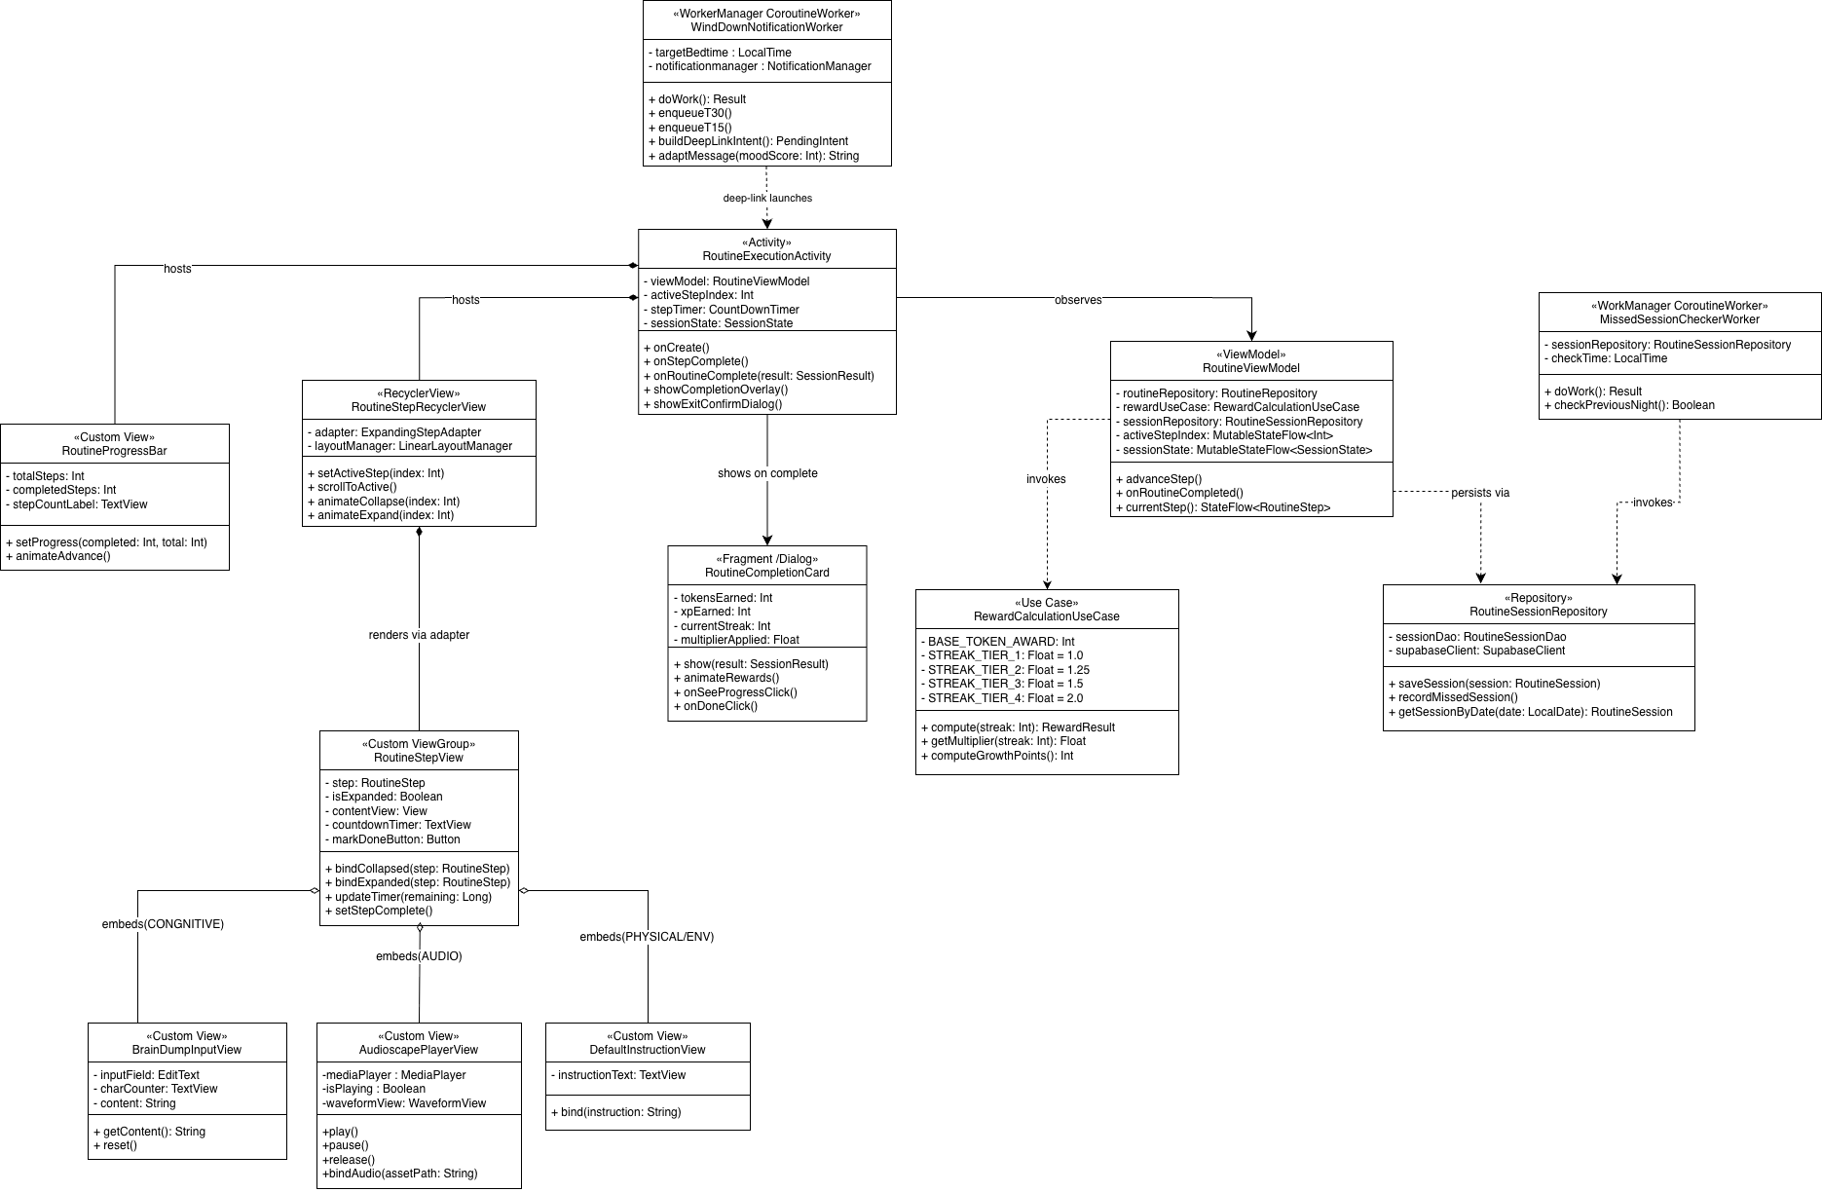

  - Sequence Diagram
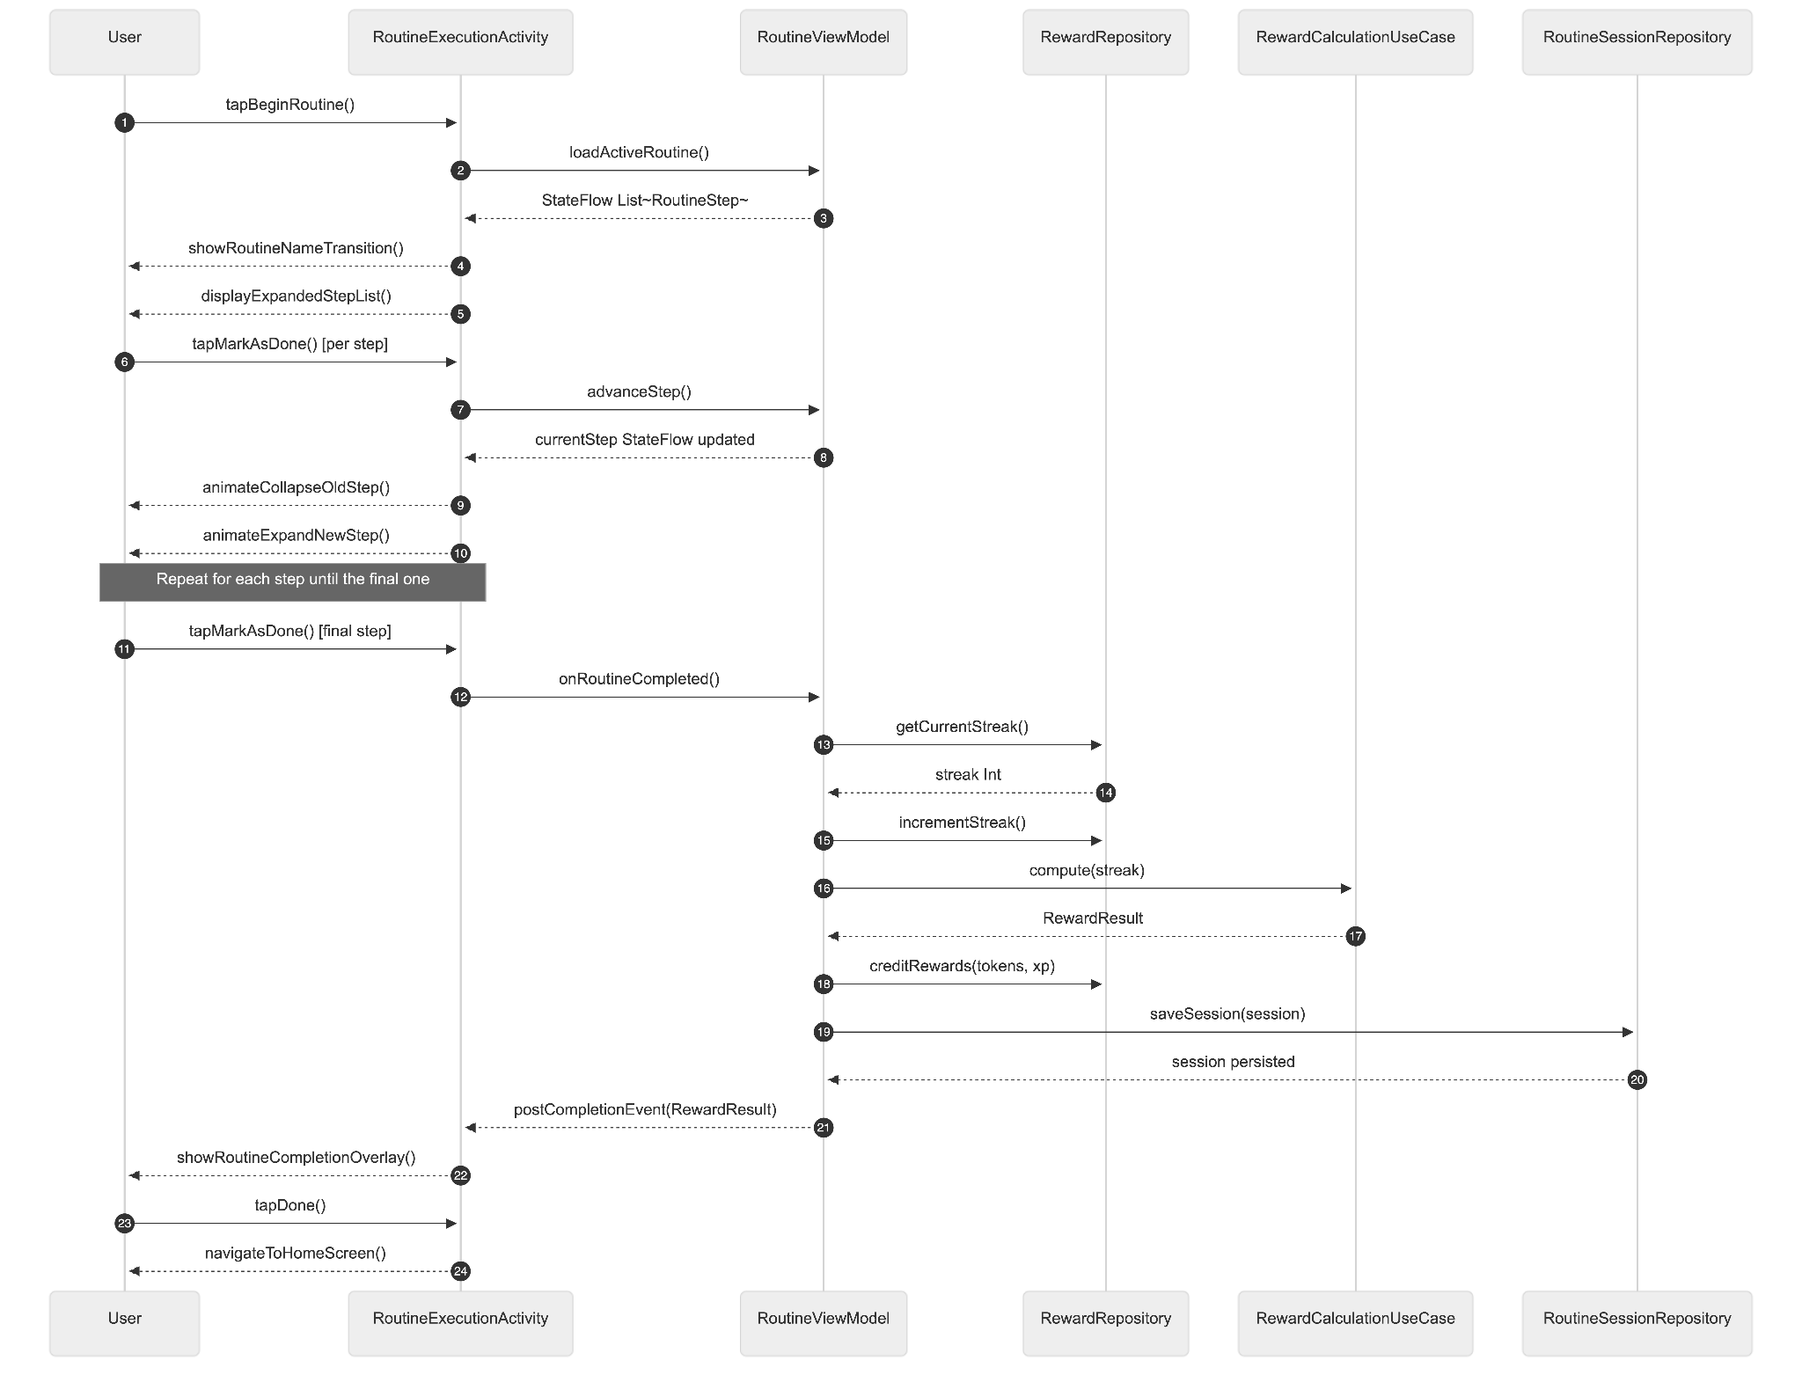
- Data Design
  - ERD or schema
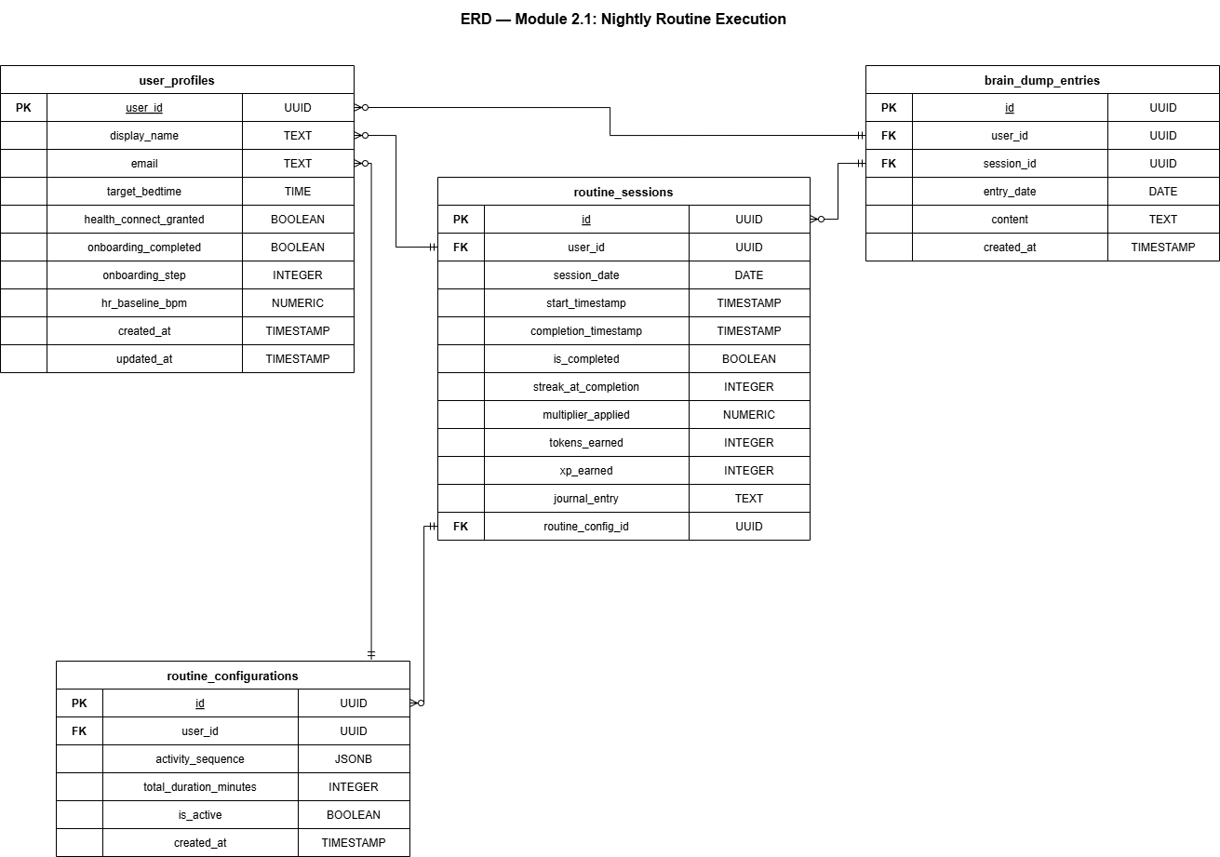

2.2 Gamification — Rewards, Companion, and Sleep Shop
- User Interface Design
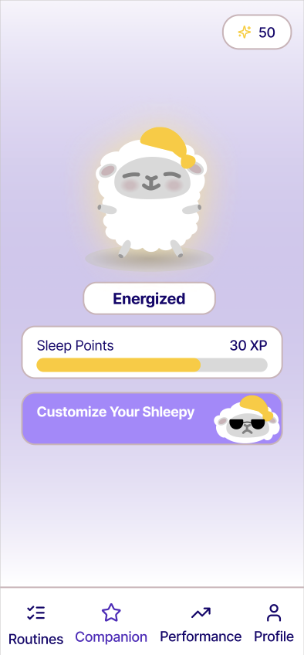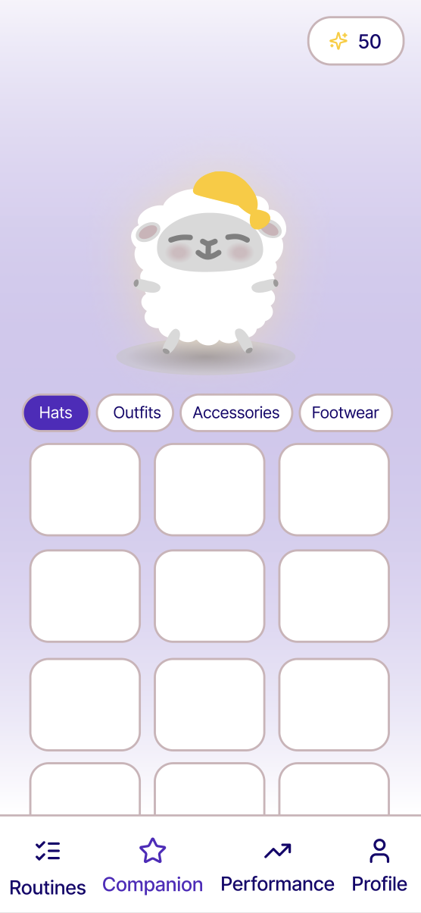
A "Companion" tab accessible from the bottom navigation bar. The screen is divided into three visual sections. The top section displays the virtual companion character as a Lottie animation at the center of a themed background. The companion animates idly when no interaction is occurring. Below the character, the companion's name and current evolution stage label are shown. The middle section displays a horizontal XP progress bar with the current Growth Points total on the left and the next evolution milestone target on the right. A percentage label inside the bar shows progress. Dream Token balance with coin icon shown in the top-right corner. A "Customize Your Shleepy" button replaces the "Visit Sleep Shop" button. When a new evolution milestone is crossed (triggered from the completion overlay or on the next app open), a special full-screen evolution animation plays showing the companion transforming to its next stage. The Sleep Shop bottom sheet displays items organized in tabs by category (Hats, Outfits, Accessories, Footwear). Each item card shows a preview thumbnail, label, and token cost. Items already owned show a checkmark state instead of a cost.
- Front-end component(s)
  - CompanionFragment
    - The root Fragment for the Companion tab and the first screen the user sees after logging in. Observes CompanionViewModel for the current evolution stage, XP progress, token balance, equipped item states, and devolution_pending flag. Manages the Lottie animation asset loading based on the current evolution stage index. Handles the evolution milestone animation trigger — when CompanionViewModel emits a newEvolutionUnlocked event, pauses the idle animation and plays the evolution sequence before resuming the new stage's idle animation. On resume, CompanionFragment checks the devolution_pending flag from RewardRepository via CompanionViewModel. If true, CompanionCharacterView.playDevolutionAnimation() plays a devolution transition animation before settling into the lower stage's idle loop. A re-engagement message is displayed after the animation (e.g., "Your companion needs you — complete tonight's routine to start recovering."). The devolution_pending flag is cleared after the animation plays. Hosts a "Customize Your Shleepy" button that opens the CustomizationFragment.
    - Type: Fragment (Kotlin)
  - CompanionCharacterView
    - A custom View wrapping a LottieAnimationView. Exposes a setEvolutionStage(stage: Int) method that loads the corresponding Lottie JSON asset file (e.g., companion_stage_1.json, companion_stage_2.json). Exposes playEvolutionAnimation() that plays a one-shot evolution transition animation before settling into the new stage's idle loop. Supports applying equipped accessory overlays as additional Lottie layers.
    - Type: Custom View (Kotlin), LottieAnimationView
  - XPProgressView
    - A custom horizontal progress bar displaying Growth Points progress toward the next evolution milestone. Displays the current XP total as a label on the left, the milestone target on the right, and an animated fill that updates smoothly when new XP is credited. Shows a brief burst animation when XP is added.
    - Type: Custom View (Kotlin
  - CustomizationFragment
    - Accessible via the 'Customize Your Shleepy' button on CompanionFragment. The full Shleepy illustration is visible at the top and updates in real time when items are equipped. Items are organized by four categories: Hats, Outfits, Accessories, Footwear. Item cards show: preview thumbnail, label; price shown if not yet purchased; no price shown if owned; checkmark if currently equipped. Only one item is equippable per category at a time. A purchase confirmation dialog appears before deducting tokens. Insufficient balance disables the purchase button.
    - Type: Fragment (Kotlin)
  - ShopItemCardView
    - A custom ViewGroup rendering a single shop item. Displays the preview thumbnail, item label, and an action button whose state (Buy / Equip / Equipped / Insufficient Funds) is driven by the item's ownership and equipment status and the user's current token balance.
    - Type: Custom ViewGroup (Kotlin)
- Back-end component(s)
  - CompanionViewModel
    - Observes the reward_ledger via RewardRepository for changes to total_xp and token_balance. On each XP update, invokes CompanionEvolutionUseCase to determine the current stage and progress percentage. Emits a newEvolutionUnlocked: SharedFlow<Int> event when the XP total crosses a milestone threshold. Exposes currentStage: StateFlow<Int>, xpProgress: StateFlow<XPProgressState>, and tokenBalance: StateFlow<Int> for UI binding.
    - Type: ViewModel (Kotlin)
  - CompanionEvolutionUseCase
    - Defines the XP milestone thresholds for each evolution stage and computes the current state from a given total XP value. Returns a CompanionEvolutionState data class containing the current stage index, the XP required for the current stage, the XP required for the next stage, and the progress percentage between them.
The Use Case also handles companion devolution triggered by streak loss. When MissedSessionCheckerWorker detects a missed session and resets the streak to zero, it invokes CompanionEvolutionUseCase.applyDevolution(), which decrements the companion's current stage by one level if the user is above Stage 1. The user's total_xp in reward_ledger is reduced to the floor XP value of the decremented stage — that is, the minimum XP required to be at that stage — ensuring the companion visually reflects the regression. Stage 1 (The Depleted) is the floor; devolution cannot reduce the companion below this stage. On the user's next open of CompanionFragment, if a devolution event has occurred since the last visit, a devolution animation plays before settling into the new stage's idle loop, followed by a re-engagement message (e.g., "Your companion needs you — complete tonight's routine to start recovering.").
Example milestone structure with devolution floors:

Stage | Name | XP Range | Devolution Floor
1 | The Depleted | 0–1499 XP | 0 XP (cannot devolve further)
2 | The Awakening | 1500–4999 XP | 1500 XP
3 | The Charged | 5000–14999 XP | 5000 XP
4 | The Peak Overdrive | 15000–49999 XP | 15000 XP
5 | The Zen Master | 50000+ XP | 50000 XP

    - Type: Use Case class (Kotlin)
  - ShopViewModel
    - Loads all shop items from ShopRepository.getAllItems() and the user's current inventory from InventoryRepository.getUserInventory(). Merges the two datasets to resolve each item's ownership and equipment status. Exposes per-category item lists as StateFlow<List<ShopItemDisplayModel>>. On purchase action, validates token balance, then invokes RewardRepository.deductTokens(amount) and InventoryRepository.addItem(itemId) sequentially within a single coroutine scope. On equip action, invokes InventoryRepository.equipItem(itemId, category).
    - Type: ViewModel (Kotlin)
  - RewardRepository
    - The single source of truth for all reward state. Reads and writes reward_ledger via Supabase PostgREST. creditRewards(tokens, xp) increments both balances atomically using a Supabase RPC function to avoid race conditions. deductTokens(amount) decrements the token balance after validating sufficiency. resetStreak() sets current_streak = 0. incrementStreak() increments current_streak and updates longest_streak if the new value exceeds it. applyDevolution() — invoked by MissedSessionCheckerWorker via CompanionEvolutionUseCase.applyDevolution(). Reads the current total_xp from reward_ledger, determines the current stage, decrements the stage by one if above Stage 1, and updates total_xp to the devolution floor of the decremented stage via a Supabase RPC function to ensure the operation is atomic. Also sets a devolution_pending boolean flag in reward_ledger to true, which CompanionFragment reads on resume to trigger the devolution animation.
    - Type: Repository (Kotlin), Supabase PostgREST + Supabase RPC
  - ShopRepository
    - Reads the seeded shop_items table. getAllItems() returns the full item catalog ordered by category and sort_order. getItemsByCategory(category) returns items filtered to a single category. The table is read-only and never written to by the client.
    - Type: Repository (Kotlin), Supabase PostgREST client
  - InventoryRepository
    - Manages the user_inventory table. getUserInventory() returns all owned items for the current user. addItem(itemId) inserts a new inventory record. equipItem(itemId, category) uses a Supabase RPC function to atomically set the target item's is_equipped = true and all other items in the same category to is_equipped = false.
    - Type: Repository (Kotlin), Supabase PostgREST + Supabase RPC
- Object-Oriented Components
  - Class Diagram
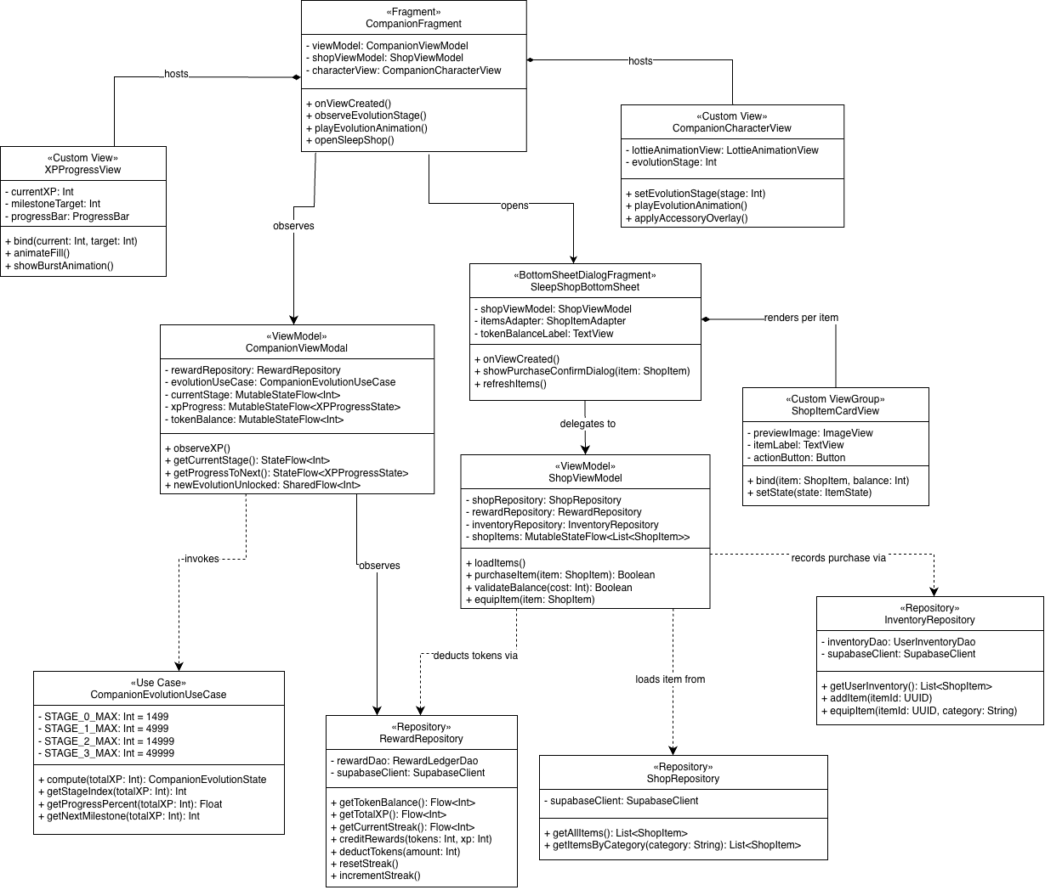

  - Sequence Diagram
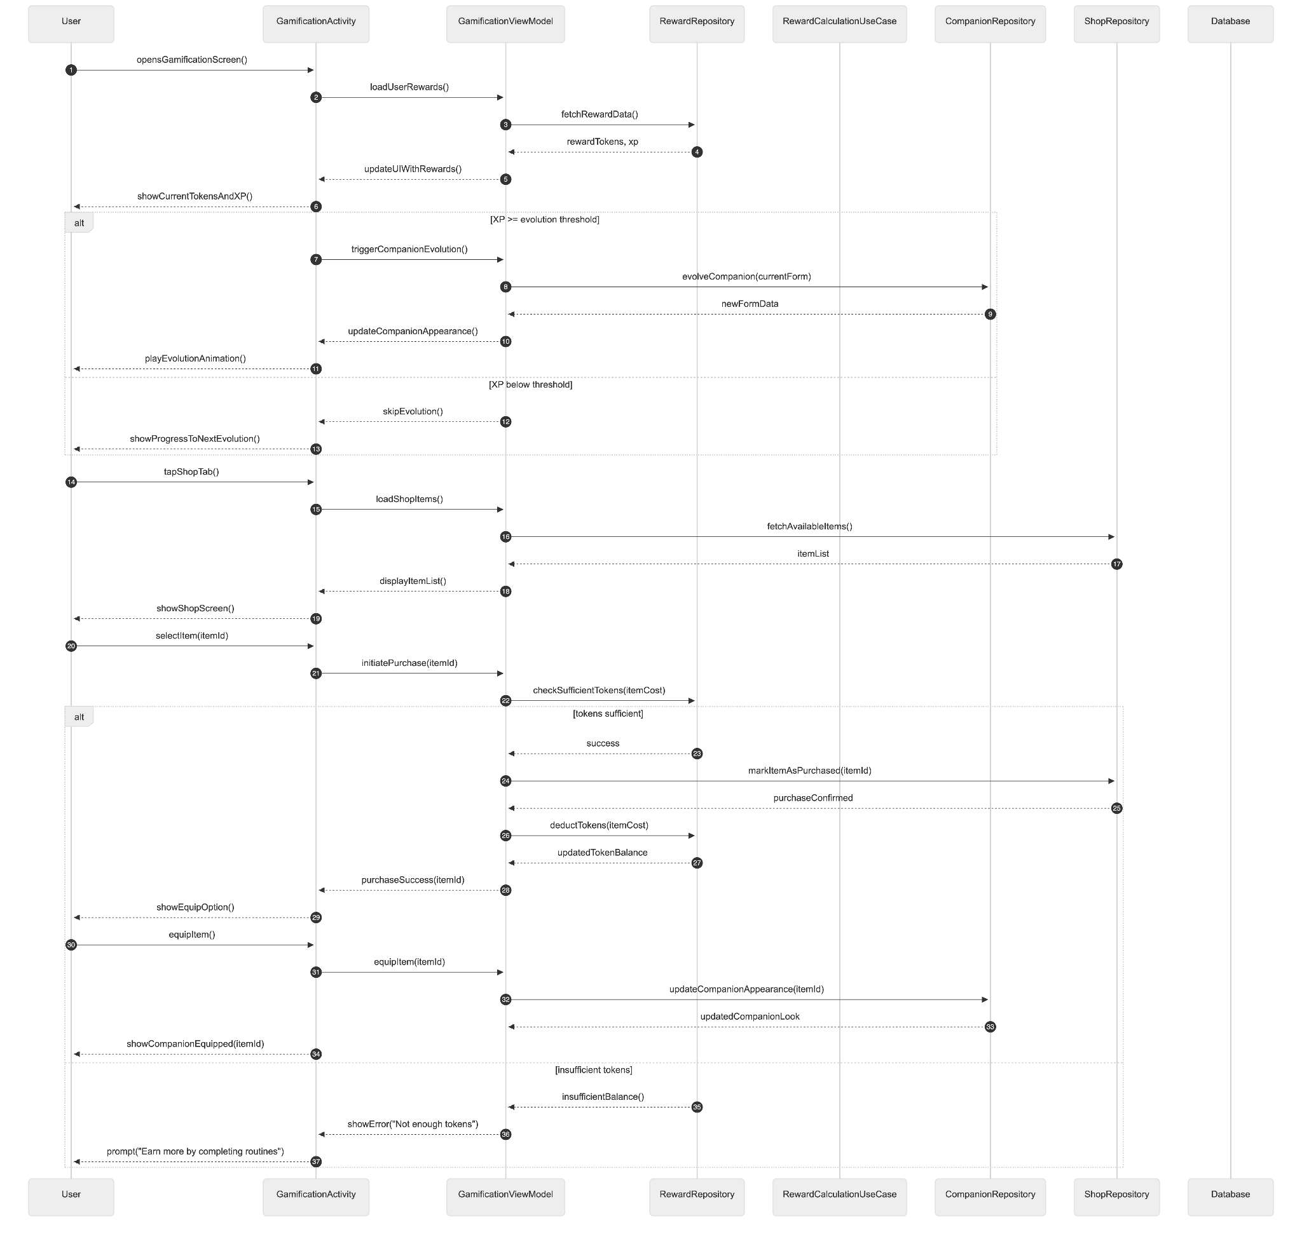
- Data Design
  - ERD or schema
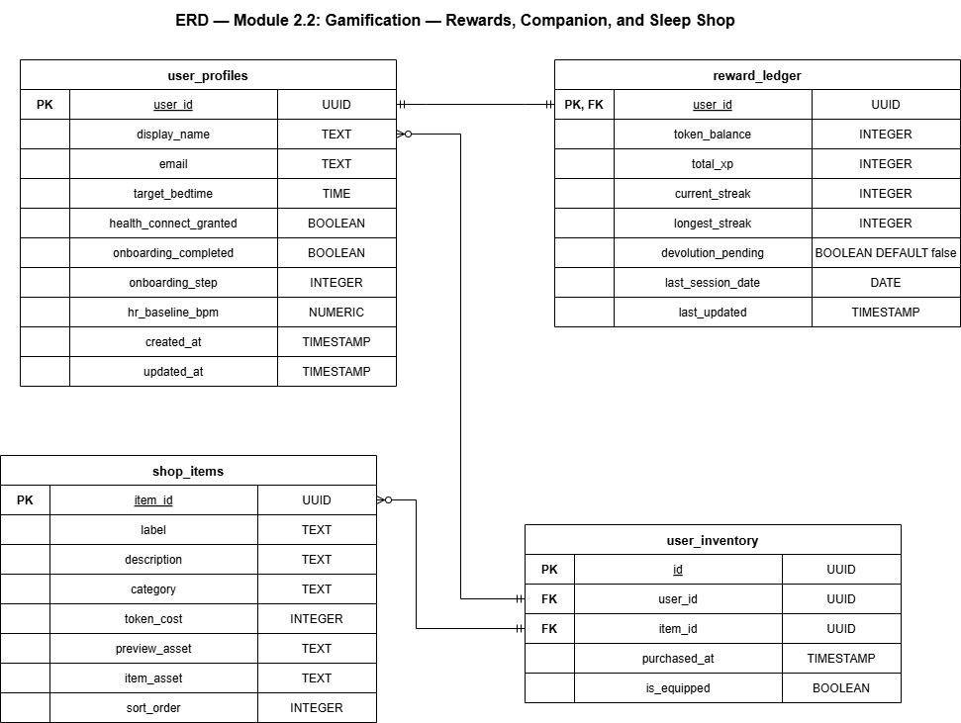

2.3 Peer Leaderboard
- User Interface Design
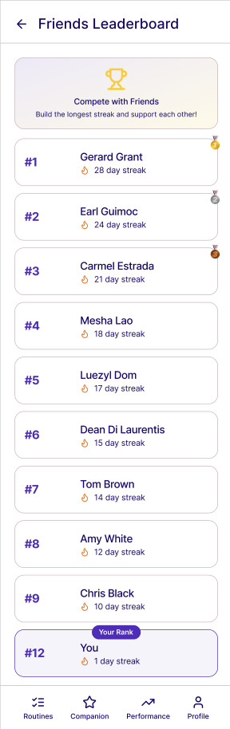
Accessible from UserProfileFragment via the "Friends & Leaderboard" button. The screen is organized into two tabs: My Progress and Friends Leaderboard.
  - My Progress tab: Displays a summary card showing the user's current streak with a flame icon, last night's composite sleep score, this week's routine completion rate, and the user's current rank among their accepted friends. This tab is a lightweight summary — full analytics remain on the Progress tab.
  - Friends Leaderboard tab: Displays the top 10 accepted friends ranked by current streak descending. Each friend card shows rank number, display name, streak count with a flame icon, and a tonight's completion badge (green star if completed tonight, grey circle if not yet). If the user ranks outside the top 10, the top 9 friends are shown normally and the user's own card is pinned in the 10th position with their actual rank displayed. If no friends have been added yet, the user sees only themselves on the leaderboard. A badge count on the Profile tab icon shows the number of pending incoming friend requests. A floating encouragement button (heart icon) appears on each friend card, allowing the user to send one encouragement reaction per friend per day. Sent reactions show a brief heart animation on the recipient's card.
  - A pending friend requests indicator is accessible via a notification bell icon or a "Requests" button at the top of the Friends Leaderboard tab, which navigates to FriendRequestsFragment displaying all incoming pending requests with Accept and Decline actions.
  - To add a friend, the user taps the Add Friend button on the Profile screen, navigates to the Friends screen, then taps the Add by Email button which opens a bottom sheet with an email input field. On submission, a friend request is sent to the recipient. The sender sees a "Request Sent" confirmation. The system does not expose any user's information to non-friends; all social data is private and scoped exclusively to the user's accepted friend network.
  - Leaderboard ranking criteria: Friends are sorted primarily by current streak descending. When two friends have equal streaks, the tiebreaker is the timestamp of the most recently completed routine session — whoever completed most recently ranks higher.
- Front-end component(s)
  - SocialFragment
    - Launched from UserProfileFragment via the "Friends" button. Hosts a TabLayout with two tabs: My Progress and Friends Leaderboard. Observes SocialViewModel for friend list state, leaderboard data, and pending request count. Displays a badge on the Profile icon when pending_request_count > 0. Subscribes to Supabase Realtime through SocialViewModel and updates the leaderboard RecyclerView via ListAdapter with DiffUtil for smooth animated updates when friend data changes.
    - Type: Fragment (Kotlin)
  - MyProgressTabView
    - Renders the summary card on the My Progress tab. Displays current streak, last night's sleep score, this week's completion rate, and the user's own rank among friends. Data is derived from SocialViewModel which aggregates from RewardRepository and SleepRecordRepository.
    - Type: Custom ViewGroup (Kotlin)
  - FriendsLeaderboardRecyclerView
    - Displays the top 10 friend cards ranked by streak. Each card shows rank position, display name, streak count, and tonight's completion badge. The user's own pinned card is rendered below a divider if they fall outside the top 10. Updates in real time via SocialViewModel. Long-pressing or tapping the heart icon on a card sends an encouragement reaction via SocialViewModel.
    - Type: RecyclerView with custom FriendCardView (Kotlin)
  - FriendRequestsFragment
    - Displays all incoming pending friend requests as a list.Each row shows the requester's display name and email address, with Accept and Decline action buttons. Accepting invokes SocialViewModel.acceptFriendRequest(), which updates the friendship status to ACCEPTED. Declining invokes SocialViewModel.declineFriendRequest(), which updates status to DECLINED silently with no notification sent to the requester.
    - Type: Fragment (Kotlin)
  - AddFriendBottomSheet
    - A BottomSheetDialogFragment containing a single text input field for entering the recipient's registered email address and a "Send Request" button. Validates that the entered email exists in user_profiles, does not belong to the current user, and is not already a connected friend before submission. On success, shows a "Request Sent" confirmation state and dismisses the bottom sheet.
    - Type: BottomSheetDialogFragment (Kotlin)
- Back-end Components
  - SocialViewModel
    - Manages the two-tab social screen state. Loads the user's accepted friends list and their current routine/streak data from FriendshipRepository. Computes the top-10 ranked leaderboard and the user's own rank. Exposes pendingRequestCount: StateFlow<Int> for the tab badge. Handles send/accept/decline friend request actions. Subscribes to Supabase Realtime via FriendshipRepository to receive live leaderboard updates and incoming request events. On encouragement reaction tap, validates the one-per-day constraint and invokes FriendshipRepository.sendReaction(). Invokes SleepRecordRepository.getSleepRecordsForDateRange() scoped to the previous night to resolve last night's composite sleep score for the My Progress tab summary card.
    - Type: ViewModel (Kotlin)
  - FriendshipRepository
    - Manages all read and write operations for the friendships and encouragement_reactions tables. sendFriendRequest(email) looks up the user_id corresponding to the given registered email address in user_profiles, validates that the email exists and is not the current user's own email, then inserts a new friendships row with status = PENDING. acceptFriendRequest(friendshipId) updates the row's status to ACCEPTED. declineFriendRequest(friendshipId) updates status to DECLINED. getAcceptedFriends() returns all friendships where status = ACCEPTED and either requester_id or receiver_id matches the current user, joined with user_profiles and the latest routine_sessions record to resolve display name, streak, and tonight's completion status. getPendingIncomingRequests() returns all rows where receiver_id = current user and status = PENDING. sendReaction(receiverId) inserts an encouragement_reactions row after validating that no row exists for the same sender_id, receiver_id, and reaction_date. Manages Supabase Realtime channel subscription for live leaderboard and request event updates.
    - Type: Repository (Kotlin), Supabase PostgREST + Realtime
- Object-Oriented Components
  - Class Diagram
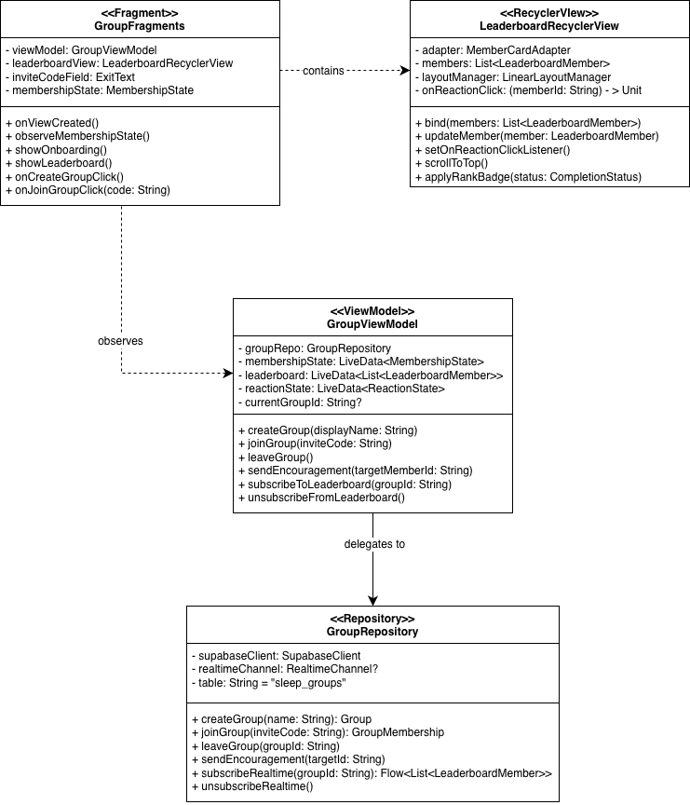

  - Sequence Diagram
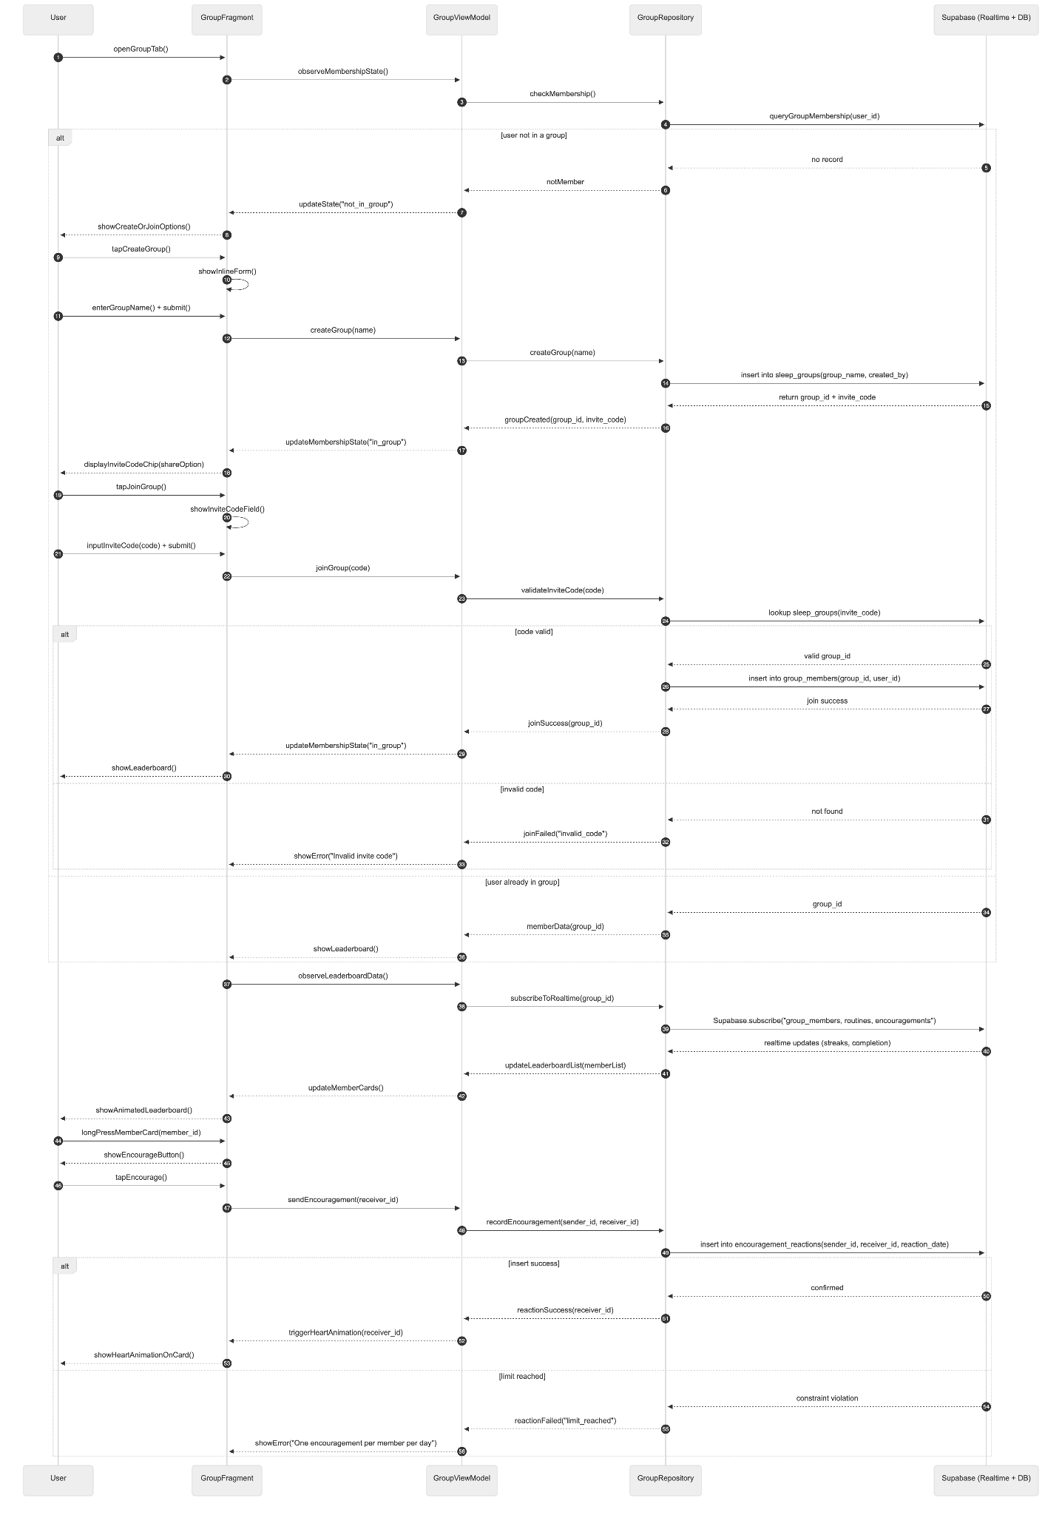
- Data Design
  - ERD or schema
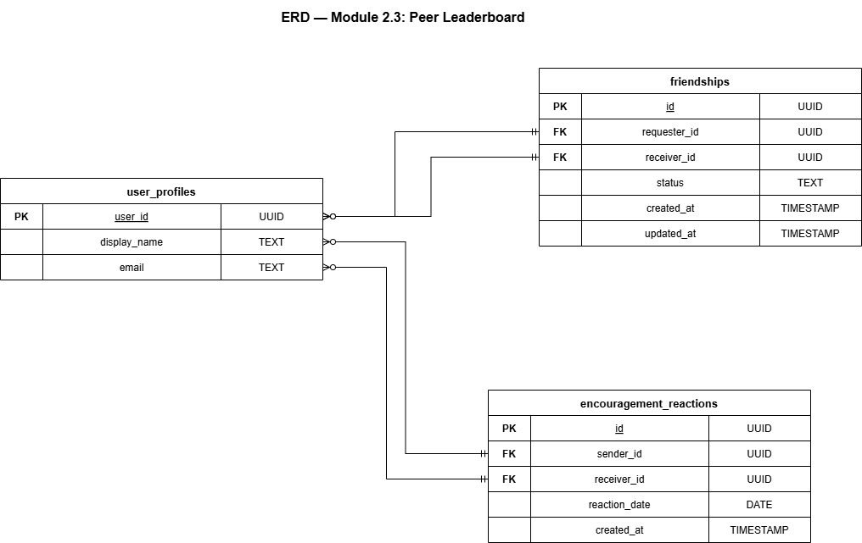

Module 3 - Sleep Quality Monitoring

3.1 Health Connect Integration and Sleep Data Retrieval
- User Interface Design -
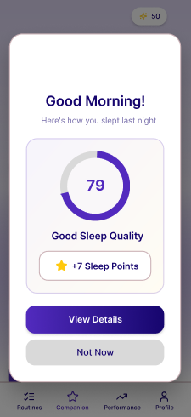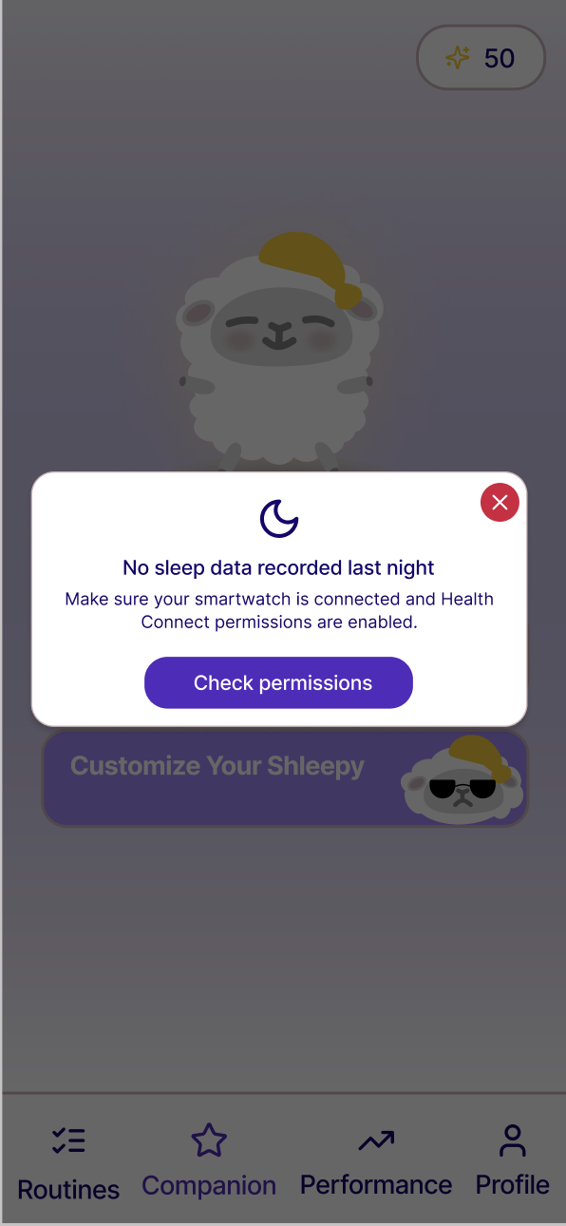
There is no active UI during the sleep period itself. After the user completes their nightly routine, the RoutineCompletionOverlay informs them that their Health Connect-compatible smartwatch will monitor their sleep automatically and that they will see their results in the morning. No further action is required. The following morning, when the user opens the app or when the MorningSyncWorker fires, a data retrieval process runs in the background. During this process, a subtle pulsing sync indicator appears on CompanionFragment's sleep quality card. If data retrieval is successful, the card populates with last night's composite score. If retrieval fails or returns no records (watch not worn, Health Connect sync incomplete, permissions revoked), the card displays a "No sleep data recorded last night" message with a brief troubleshooting tip and a "Retry" button that manually triggers another retrieval attempt.
- Front-end component(s)
  - SleepQualityCardView
    - A custom ViewGroup displayed on the CompanionFragment. Shows three states: (1) Loading — a pulsing shimmer placeholder while the morning sync is running; (2) Success — displays last night's composite score as a circular gauge with a color gradient (red at 0, yellow at 50, green at 100), the score number, and a brief label (e.g., "Good Sleep," "Fair Sleep," "Poor Sleep") determined by score range thresholds; (3) No Data — displays the unavailable message and Retry button. Transitions between states with a fade animation.
    - Type: Custom ViewGroup (Kotlin)
  - SleepSyncStatusBanner
    - A non-intrusive inline banner shown below the navigation bar on the CompanionFragment only when Health Connect permissions are missing or when the smartwatch has not synced data in more than 48 hours. Displays a contextual message and a "Fix This" action button. Dismissible by the user with the dismissal state stored in shared preferences so it does not reappear until the next day.
    - Type: Custom View (Kotlin)
- Back-end component(s)
  - HealthConnectManager
    - Wraps the androidx.health.connect.client.HealthConnectClient. Responsible for:
      - Checking Health Connect SDK availability on the device.
      - Managing the runtime permission request contract for HealthPermission.getReadPermission(SleepSessionRecord::class), HealthPermission.getReadPermission(HeartRateRecord::class), and HealthPermission.getReadPermission(StepsRecord::class).
      - Exposing a readLastNightSleepData(date: LocalDate) suspend function that queries SleepSessionRecord and HeartRateRecord for the time window from the previous day's target bedtime to the current morning.
    - Type: Manager class (Kotlin), androidx.health.connect.client
  - MorningSyncWorker
    - A WorkManager CoroutineWorker scheduled as a daily PeriodicWorkRequest with a flex window, targeting execution between 6:00 AM and 9:00 AM each morning. On execution, first checks whether a sleep_records entry with data_capture_success = true already exists for the previous date — if so, exits immediately to avoid duplicate processing.
      - If no completed record exists, invokes HealthConnectManager.readSleepData() to query for a completed SleepSessionRecord from the previous night's window. Health Connect does not detect wake time independently — the completed sleep session is written to Health Connect by the smartwatch's companion app only after the user wakes up and the watch processes the night's data. If no completed SleepSessionRecord is found, the Worker exits and schedules a retry using WorkManager's exponential backoff retry policy, up to a maximum of three retries spaced 30 minutes apart. This handles users who wake up after the Worker's initial execution time within the morning window.
      - If a completed SleepSessionRecord is found, invokes HealthConnectManager.readHeartRateData() and HealthConnectManager.readMovementData() for the confirmed sleep window. Passes the retrieved raw data to SleepQualityProcessingUseCase to compute the composite score. Persists the result via SleepRecordRepository. Posts a local notification if the composite score exceeds 80 as a positive reinforcement gesture ("Great sleep last night! Check your score.").
      - If all three retries are exhausted without finding a completed SleepSessionRecord — indicating the user woke after the morning window closed — the Worker records the night with data_capture_success = false and exits. To handle this edge case, CompanionFragment performs a lightweight sync check on resume: if no sleep_records entry with data_capture_success = true exists for the previous night and the current time is before 12:00 PM, it triggers a manual HealthConnectManager read to attempt a late retrieval for users who woke after 9:00 AM.
      - Upon successful morning sync, an in-app popup appears showing the sleep quality score and XP earned from sleep quality, with a "View Details" button navigating to the Analytics screen and a "Not Now" button to dismiss. A morning push notification is also sent; if the user opens the app via the notification, the in-app popup is skipped.
    - Type: WorkManager CoroutineWorker (Kotlin)
  - HeartRateBaselineUseCase
    - A separate Use Case responsible exclusively for computing and updating the user's personal heart rate baseline. The personal HR baseline is established over 7 nights. After establishment (minimum three data points, ideal seven), subsequent invocations update the baseline using the exponential moving average formula.
      - B_{t} = 0.1(O) + 0.9(B_{t-1})
Where:
B_{t} = new baseline
O = new reading/observation
B_{t-1} = current baseline
The smoothing factor of 0.1 means the baseline shifts gradually and is not distorted by a single anomalous night.
    - Type: Use Case class (Kotlin)
  - SleepQualityProcessingUseCase
    - The core computation class for the nightly sleep quality score. Receives raw Health Connect data and the user's current HR baseline from user_profiles. Computes three sub-scores and combines them into a composite score. Full formula documentation follows.
      - Sub-Score 1 — Sleep Duration Score (0–100): Reference range: 7–9 hours for college-aged adults. Any duration within this range scores 100. Durations outside this range are penalized using the following formula:
        - <7 hours = hours/7 * 100
        - ≤ 7 ≤ hours ≤ 9 = 100
        - >9 hours = 100 - (hours - 9) * 20
Rationale: The 7–9 hour range is the clinically established recommendation for young adults (National Sleep Foundation). The linear penalty below 7 hours reflects the proportional relationship between sleep deprivation and cognitive impairment documented by Taub and Berger (1976). The accelerated penalty above 9 hours reflects the association between excessive sleep duration and sleep fragmentation.
      - Sub-Score 2 — Heart Rate Score (0–100): Computed relative to the user's personal HR baseline established by HeartRateBaselineUseCase. Scoring is deviation-based: zero deviation from baseline scores 100, with each BPM of deviation reducing the score by 5 points.
        - HR_{Score} = 100 - (HR_{avg} - HR_{base}) * 5
Rationale: Individual heart rate varies significantly between users, making a universal threshold inappropriate. A personalized baseline ensures the score reflects deviation from the user's own physiological norm rather than a population average. The 5-point penalty per BPM is calibrated so that a 20 BPM deviation — indicative of significantly disrupted sleep — produces a score of 0.
Null handling: If no HR baseline exists (fewer than three nights of data collected) or if the smartwatch did not capture heart rate data for the night, heartRateScore is set to null and excluded from the composite calculation with weight redistributed across available signals.
      - Sub-Score 3 — Movement Score (0–100): Derived from the total step count recorded by Health Connect during the sleep window as a proxy for physical restlessness. A step count of 10 or below scores 100. Each step above 10 reduces the score by 0.5 points.
        - Movements ≤ 10 = 100
        - Movements > 10 = 100 - (Movements - 10) * 0.5
Rationale: Movement during sleep is a well-established proxy for sleep fragmentation and restlessness, and is the measurement basis of actigraphy research (Pu et al., 2022). The step count proxy is used rather than raw accelerometer data because Health Connect standardizes it across devices, reducing inter-device variability. The 0.5 penalty per step is calibrated so that 200 steps — indicative of a highly restless night — produces a score of 0. Movement receives the lowest weight in the composite (20%) due to its relative inconsistency across consumer smartwatch brands compared to duration and heart rate.
      - Composite Score — Weighted Average: The three sub-scores are combined using a weighted average. Weights reflect the relative empirical support for each signal as a sleep quality predictor in the reviewed literature and are acknowledged as informed design parameters subject to empirical validation through study data (Taub & Berger, 1976; Pu et al., 2022):

Signal | Weight | Rationale
Sleep Duration | 50% | Strongest single predictor of cognitive outcomes in the RRL
Heart Rate | 30% | Direct physiological relaxation indicator; personalized baseline improves validity
Movement | 20% | Useful proxy; lowest weight due to inter-device measurement inconsistency

To calculate the Sleep Composite Score:
S_{comp} = $\frac{ (Sd * Wd) + (Sh * Wh) + (Sm * Wm)}{Wtotal}$
Where:
S_{comp} = Sleep Composite Score
S_{d} = Sleep Duration score
W_{d} = Sleep Duration weight
S_{h} = Heart Rate score
W_{h} = Heart Rate weight
S_{m} = Movement score
W_{m} = Movement weight
W_{total} = Weight total
Weight redistribution ensures the composite always lands on the 0–100 scale even when one or two signals are unavailable. For example, if only Duration Score is available, it receives 100% of the weight and the composite equals the Duration Score directly.
    - Type: Use Case class (Kotlin)
  - SleepRecordRepository
    - Manages all read and write operations for the sleep_records table. saveSleepRecord() inserts the processed nightly record. getSleepRecordsForDateRange() returns records for a specified date window used by Module 4's analytics queries. getHRBaselineInputs() returns all historical heart rate values for HeartRateBaselineUseCase.
    - Type: Repository (Kotlin), Supabase PostgREST client
- Object-Oriented Components
  - Class Diagram
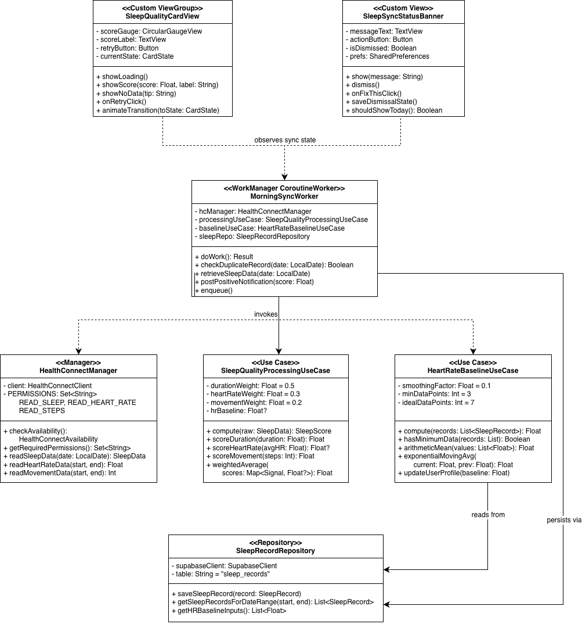
  - Sequence Diagram
- Data Design
  - ERD or schema
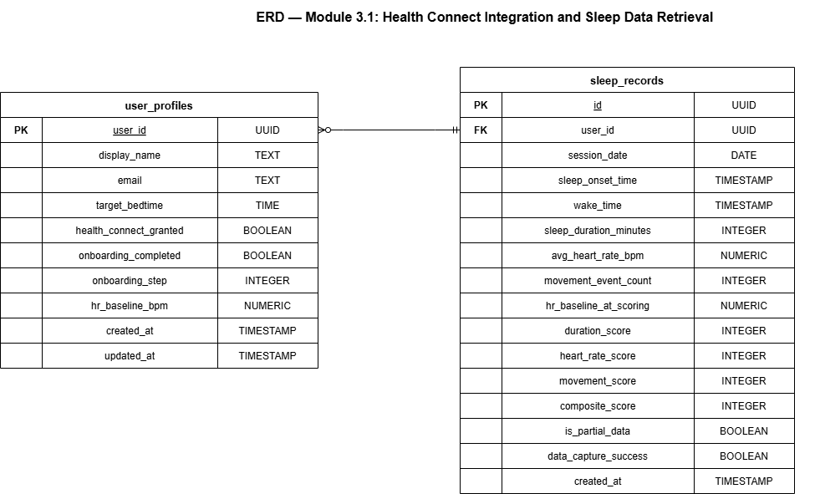

Module 4 - Routine Auditing & Analytics

4.1 Personal Analytics Dashboard
- User Interface Design
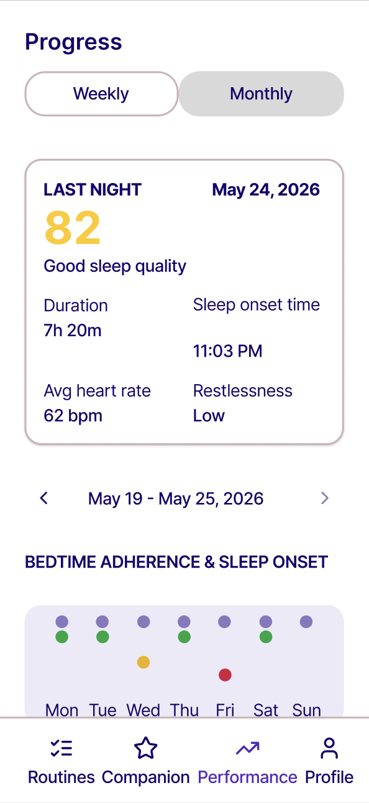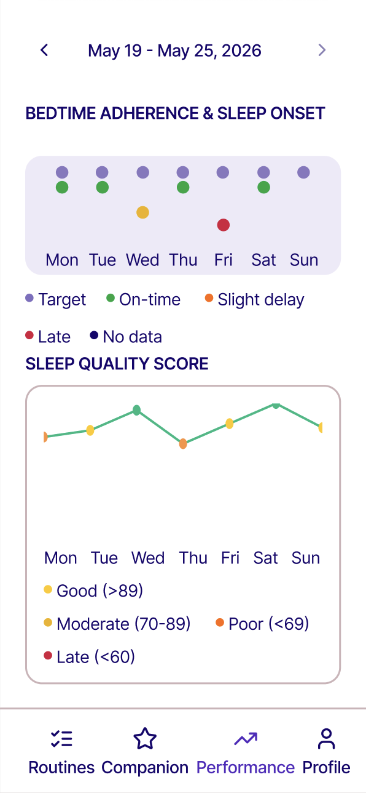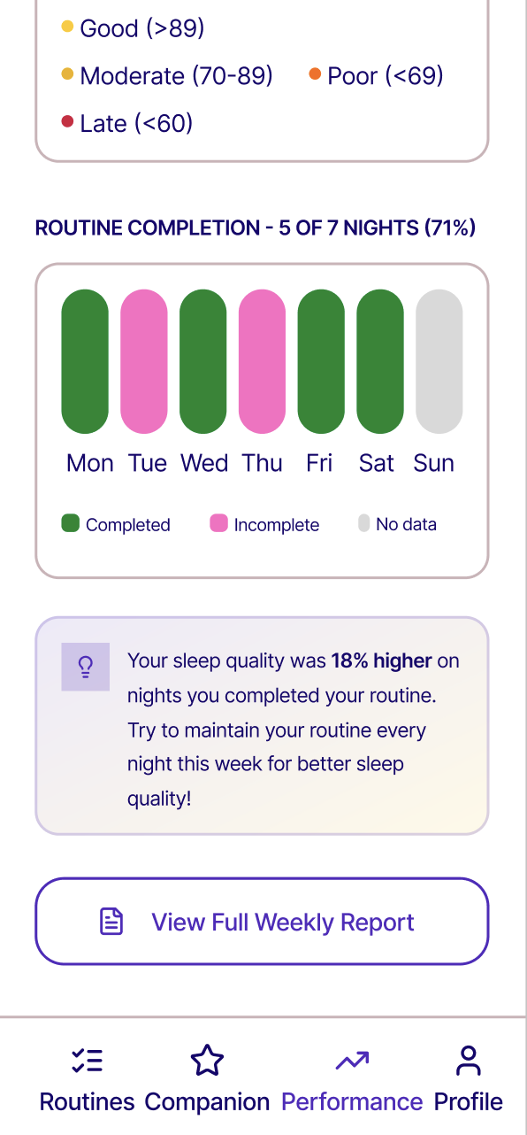

A "Progress" tab in the bottom navigation bar. The screen opens with a view mode toggle at the top (Weekly / Monthly). Both views share the same tab destination — the toggle switches the ViewModel's active data mode and re-renders all content accordingly.
  - Both views begin with a Last Night Summary card pinned at the top of the screen, above the week/month navigation. The card displays the composite sleep quality score as a large prominent number with a plain-language label (e.g., "Good sleep quality"), followed by four stat tiles in a two-by-two grid: Sleep Duration, Sleep Onset time, Average Heart Rate, and Restlessness level. This card gives the user an immediate summary of last night's session without requiring them to navigate to the analytics charts. If no sleep data was recorded for the previous night, the card displays a "No sleep data recorded last night" state.
  - Weekly View: A date range selector below the Last Night Summary card defaults to the current week (Monday to Sunday) with left and right navigation arrows. Sections: (1) a Bedtime Adherence and Sleep Onset chart — a merged dot-and-line chart where each day column shows a grey target circle at the target bedtime position on a shared time-scale Y-axis, a colored actual-sleep-onset dot positioned below it proportional to the delay in minutes, a vertical connector line between the two whose length encodes the magnitude of the delay, and time labels showing the exact target time above the grey circle and the exact actual time below the colored dot; dot color encodes adherence classification (green = on time, orange = slight delay, red = late, grey circle only = no data); (2) a Sleep Quality Score line chart showing nightly composite scores with a horizontal reference line at 75 marking the "Good" threshold, data points colored by score range, and NO_DATA nights rendered as gaps; (3) a Routine Completion row showing seven tiles — one per night — color-coded green for completed, pink/red for incomplete, and muted for no data, with a completion summary label above (e.g., "5 of 7 nights — 71%"); (4) a Relationship Insight card showing a plain-language behavioral summary.
  - Monthly View: A month selector below the Last Night Summary card defaults to the current calendar month with left and right navigation arrows. Sections: (1) a Weekly Adherence Rate chart showing four colored bars — one per week — labeled with their BAR percentage above each bar and color-coded by tier (red below 57%, orange 57–74%, green 75%+), with a "Target: 75%" label on the right as a reference; (2) a 30-Day Sleep Quality Trend line chart showing nightly composite scores across the full month with NO_DATA nights rendered as gaps and a "Good (75)" reference label on the right; (3) a Monthly Routine Completion section showing the completion rate as a large percentage, the raw count below it (e.g., "21 of 30 nights completed"), and a proportional horizontal fill bar; (4) a Month Insight card comparing Week 1 versus Week 4 performance with bolded key metrics.
- Front-end component(s)
  - LastNightSummaryCard
    - A card View pinned at the top of AnalyticsDashboardFragment, above the view mode toggle and week/month navigation. Displays the previous night's composite sleep quality score as a large prominent number with a plain-language quality label below it (e.g., "Good sleep quality" for scores above 75, "Moderate sleep quality" for 50–74, "Poor sleep quality" below 50). Below the score, four stat tiles are arranged in a two-by-two grid: Sleep Duration (e.g., "7h 20m"), Sleep Onset (e.g., "11:08 PM"), Avg Heart Rate (e.g., "62 bpm"), and Restlessness (e.g., "Low", "Moderate", or "High" derived from the movement score). If no sleep_records entry with data_capture_success = true exists for the previous night, the card displays a "No sleep data recorded last night" state with a muted placeholder. The card is non-interactive and read-only — its data is loaded by AnalyticsViewModel from SleepRecordRepository on tab entry.
    - Type: Custom ViewGroup (Kotlin)
  - AnalyticsDashboardFragment
    - The root Fragment for the Progress tab. Hosts the view mode toggle, the week/month navigation selector, and all chart components. Observes AnalyticsViewModel StateFlow properties. Handles toggle state by updating AnalyticsViewModel.viewMode: MutableStateFlow<AnalyticsViewMode> (WEEKLY or MONTHLY), which triggers all downstream data refreshes. Handles week and month navigation by updating selectedWeekStart or selectedMonth in the ViewModel.
    - Type: Fragment (Kotlin)
  - ViewModeToggleView
    - A custom View rendering a two-option segmented control ("Weekly" / "Monthly"). The active option is highlighted. Posts view mode change events to the parent Fragment via a callback.
    - Type: Custom View (Kotlin)
  - WeekDateRangeSelectorView
    - A custom View displaying the current week's date range as a formatted label (e.g., "May 19 – May 25, 2026") with left and right navigation arrow buttons. The right arrow is disabled when the current week is selected. Posts navigation events to the parent Fragment via a callback.
    - Type: Custom View (Kotlin)
  - MonthSelectorView
    - Shown in Monthly View only. Displays the current month and year as a formatted label (e.g., "May 2026") with left and right navigation arrow buttons. The right arrow is disabled for the current month.
    - Type: Custom View (Kotlin)
  - BedtimeAdherenceSleepOnsetChart
    - A custom View rendering the merged bedtime adherence and sleep onset visualization. Displays seven day columns in a horizontal layout sharing a common time-scale Y-axis on the left, with time labels at regular 30-minute intervals. For each day: a grey hollow circle is plotted at the Y-position corresponding to the user's target bedtime, with the exact target time displayed in small muted text above it; if actual sleep onset data exists, a colored filled circle is plotted at the Y-position corresponding to the actual sleep onset time, with the exact actual time displayed in the matching color below it, and a vertical connector line runs between the two circles whose pixel length is proportional to the delay in minutes; if no data exists, only the grey target circle is rendered with no connector or colored dot. Dot color encodes adherence classification: green for ADHERENT (≤30 min), orange for SLIGHT_DELAY (31–60 min), red for SIGNIFICANT_DELAY (>60 min). A shared horizontal baseline is drawn at the target bedtime Y-position across all columns. Day labels (Mon–Sun) are rendered below each column. The chart is non-interactive and purely visual — all data is resolved from sleep_records and user_profiles by AnalyticsViewModel before rendering.
    - Type: Custom View (Kotlin)
  - WeeklyAdherenceGroupedBarChart
    - Shown in Monthly View. An MPAndroidChart BarChart displaying four bars — one per week of the selected month — each labeled with its BAR percentage above the bar. Bars are color-coded by adherence tier: red below 57%, orange 57–74%, green 75% and above. A "Target: 75%" reference label is shown to the right of the chart. Week labels (Wk 1 through Wk 4) are shown below each bar. This chart directly visualizes the four-week improvement trend for GO3 evaluation.
    - Type: MPAndroidChart BarChart (Kotlin)
  - SleepQualityTrendLineChart
    - An MPAndroidChart LineChart displaying nightly composite sleep quality scores (0–100). Shown in both Weekly and Monthly Views. In Weekly View, plots 7 data points. In Monthly View, plots up to 31 data points across the selected month. The line uses a smooth cubic bezier interpolation. Data points are colored individually by score range (green above 75, yellow 50–74, red below 50). NO_DATA nights are rendered as gaps in the line rather than zero values, preventing misleading dips. A horizontal reference line at 75 marks the "Good Sleep" threshold.
    - Type: MPAndroidChart LineChart (Kotlin)
  - RoutineCompletionBarChart
    - A custom View displaying seven equal-width tile cards in a horizontal row — one per night of the selected week. Completed nights render with a green fill. Incomplete nights render with a pink-red fill. NO_DATA nights render with a muted/empty fill. A completion summary label above the row shows the count and rate (e.g., "Routine completion — 5 of 7 nights (71%)"). A legend below the row identifies the three tile states (Completed, Incomplete, No data).
    - Type: Custom View (Kotlin)
  - MonthlyCompletionRateView
    - Shown in Monthly View. Displays the month's overall routine completion rate as a large percentage label and a proportional horizontal fill bar.
    - Type: Custom View (Kotlin)
  - RelationshipInsightCard
    - A styled card view displaying a dynamically generated plain-language insight string from InsightGenerationUseCase. The card has a subtle gradient background and a lightbulb icon. If insufficient data exists for a comparison, the card shows an encouraging message prompting continued use. When a valid insight is available, the key metric (e.g., "18% higher") is bolded for visual emphasis.
    - Type: Custom ViewGroup (Kotlin)
  - MonthInsightCard
    - Shown in Monthly View. Displays the month-level trend insight from MonthlyInsightGenerationUseCase comparing Week 1 versus Week 4 performance. If fewer than two complete weeks of data are available, shows an encouraging message instead.
    - Type: Custom ViewGroup (Kotlin)
- Back-end component(s)
  - AnalyticsViewModel
    - Holds viewMode: MutableStateFlow<AnalyticsViewMode>, selectedWeekStart: MutableStateFlow<LocalDate>, and selectedMonth: MutableStateFlow<YearMonth>. Observes all three and re-fetches data reactively on any change. For weekly mode, invokes SleepRecordRepository.getSleepRecordsForDateRange() and RoutineSessionRepository.getSessionsForDateRange() for the 7-day window and passes results to BedtimeAdherenceCalculator and InsightGenerationUseCase. For monthly mode, fetches the full month's data and passes it to MonthlyInsightGenerationUseCase and BedtimeAdherenceCalculator. Exposes all chart data and insight text as typed StateFlow properties consumed by the Fragment. On tab entry, also invokes SleepRecordRepository.getSleepRecordsForDateRange() scoped to the previous night to populate LastNightSummaryCard, exposing the result as lastNightRecord: StateFlow<SleepRecord?>.
    - Type: ViewModel (Kotlin)
  - BedtimeAdherenceCalculator
    - A pure Use Case class that receives a list of SleepRecord objects and the user's target_bedtime and returns a list of AdherenceStatus enum values, one per day in the requested date range. Classification logic:
ΔM = Minutes between(T_{target}, T_{onset})
NO_DATA T_onset is null
ADHERENT ΔM ≤ 30
SLIGHT_DELAY 30 < ΔM ≤ 60
SIGNIFICANT_DELAY ΔM > 60
Where:
ΔM = minutes slept past bedtime goal
T_{target} = target bedtime
T_{onset} = actual sleep onset time
Handles the edge case where sleep onset is before the target bedtime (user fell asleep early) by treating negative delay values as ADHERENT.
    - Type: Use Case class (Kotlin)
  - InsightGenerationUseCase
    - Computes a behavioral insight by comparing the average composite sleep quality score on nights where the routine was completed versus nights where it was not. Requires a minimum of three data points in each group before generating a comparison to ensure statistical meaningfulness. Returns an InsightResult sealed class with two subtypes: InsufficientData(message: String) and InsightAvailable(completionAvgScore, nonCompletionAvgScore, percentageDifference, insightText). The insight text is generated programmatically based on the direction and magnitude of the difference:
d = C - N
P = $\left|\frac{d}{N}\right|$ x 100
if d>0:
I = “On nights you completed your routine, your sleep quality score was P% higher on average. Keep it up!”
if d<0:
I = “Your sleep scores have been similar on routine and non-routine nights. Try completing your full routine for a week to see a clearer pattern.”
if d=0:
I = “Your sleep quality is consistent. Complete your routine regularly to build a stronger pattern.”
Where:
C = average sleep score on routine-completion nights
N = average sleep score on non-completion nights
d = raw difference
P = absolute percentage difference
I = Insight message
    - Type: Use Case class (Kotlin)
  - MonthlyInsightGenerationUseCase
    - Computes a month-level trend insight by comparing the average Bedtime Adherence Rate and average composite sleep quality score between Week 1 (days 1–7 of the month) and Week 4 (days 22–28 of the month). Requires at least three data points in each week to generate a comparison. Returns a plain-language insight string identifying whether adherence and sleep quality improved, declined, or remained consistent between the first and fourth weeks — directly operationalizing the GO3 measurement of improvement over the four-week study period.
    - Type: Use Case class (Kotlin)
- Object-Oriented Components
  - Class Diagram
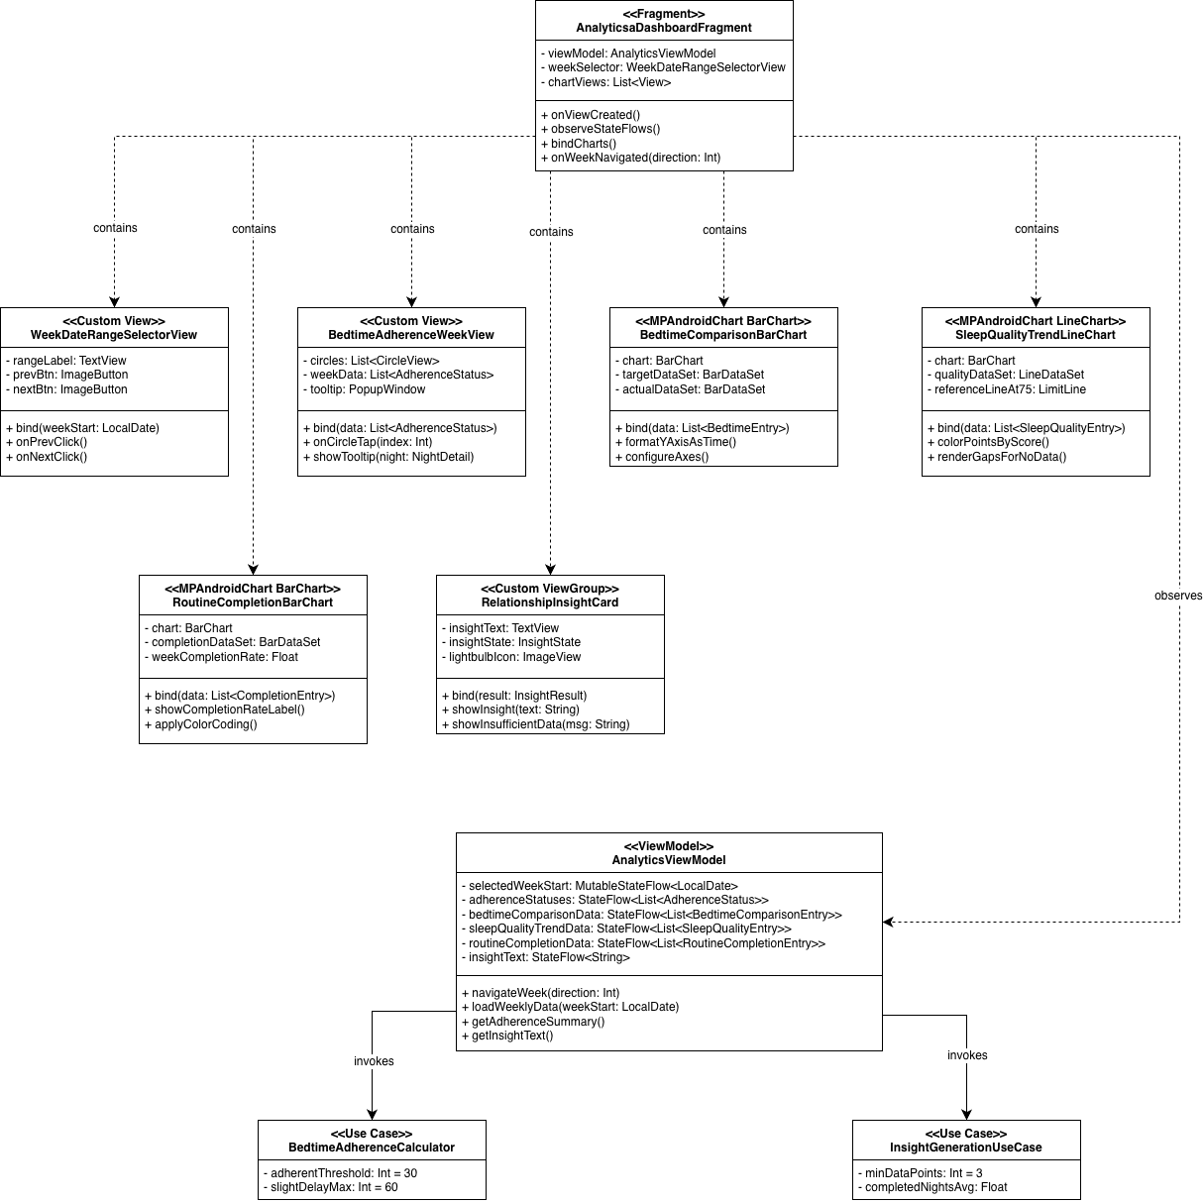

  - Sequence Diagram
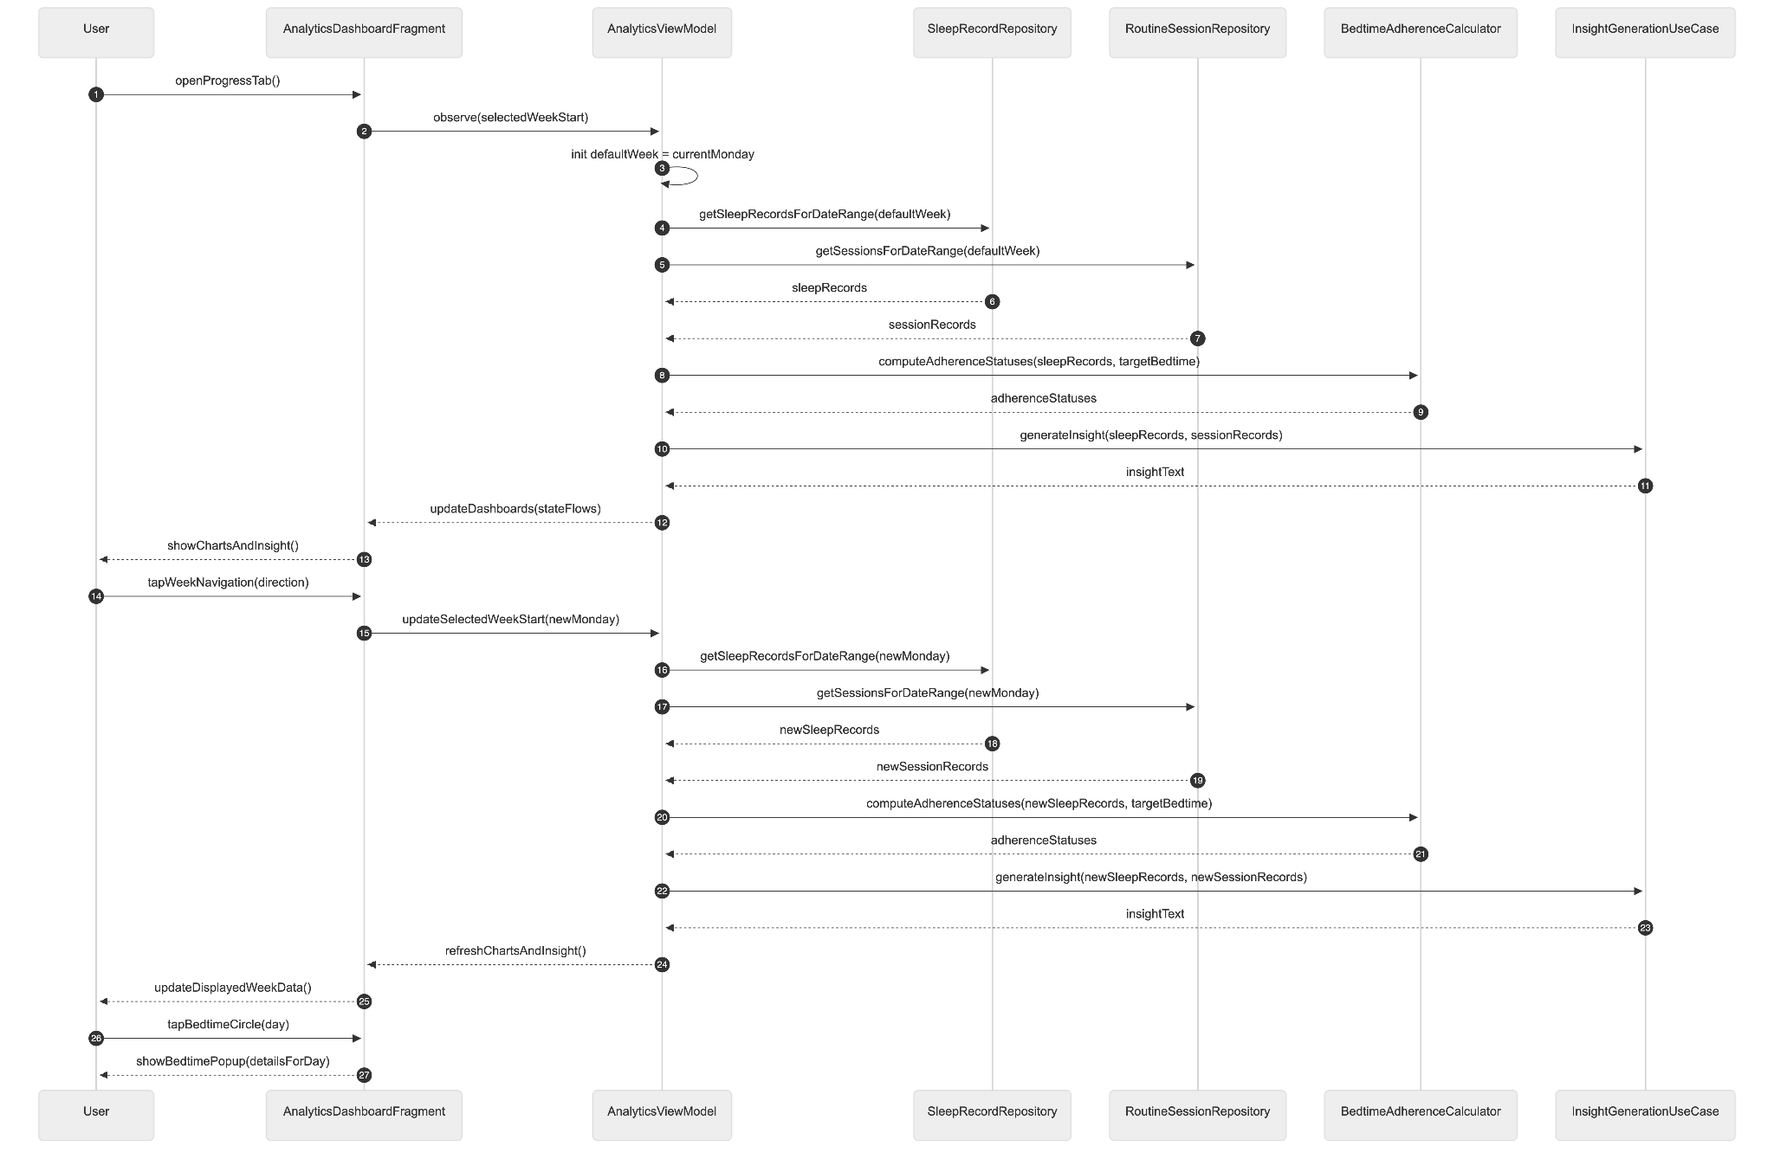
- Data Design
Module 4 does not introduce new tables. All data is read from tables defined in earlier modules. The following cross-reference documents which tables each component queries:
Component | Tables Queried | Defined In
LastNightSummaryCard data | sleep_records | Module 3
BedtimeAdherenceCalculator | sleep_records, user_profiles | Module 3, Module 1
BedtimeAdherenceSleepOnsetChart data | sleep_records, user_profiles | Module 3, Module 1
SleepQualityTrendLineChart data | sleep_records | Module 3
RoutineCompletionBarChart data | routine_sessions | Module 2
WeeklyAdherenceGroupedBarChart data | sleep_records, user_profiles | Module 3, Module 1
MonthlyCompletionRateView data | routine_sessions | Module 2
InsightGenerationUseCase | sleep_records, routine_sessions | Module 3, Module 2
MonthlyInsightGenerationUseCase | sleep_records, routine_sessions | Module 3, Module 2

4.2 Weekly Progress Report and Researcher Export
- User Interface Design
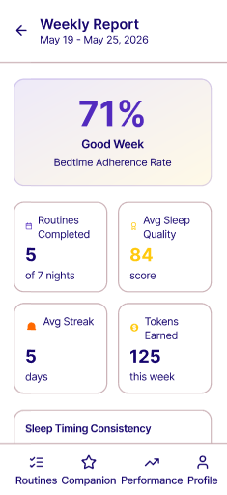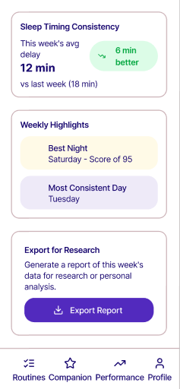
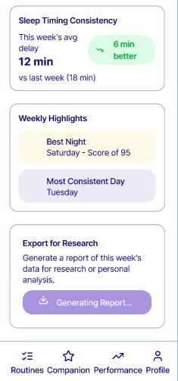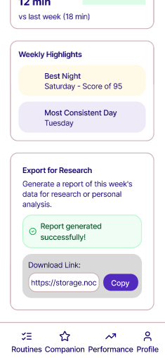
A "Weekly Report" section accessible from the Progress tab via a "View Full Report" button at the bottom of the analytics dashboard. Displays a scrollable single-screen report card for the selected week containing: a headline adherence rate percentage rendered in large bold text with a contextual label (e.g., "Great Week," "Room to Improve"); a four-stat summary row showing routines completed, average sleep quality score, average streak maintained, and total tokens earned for the week; a week-over-week sleep timing consistency comparison showing this week's average delay versus last week's with an up or down arrow indicator; and a highlights row with "Best Night" and "Most Consistent Day" badges. At the bottom, an "Export Report" button with a researcher icon generates and uploads the report. A success state shows the download link in a copyable chip; a failure state shows a retry option.
- Front-end component(s)
  - WeeklyReportFragment
    - Renders the full weekly report card. Observes WeeklyReportViewModel for all report data. The Export button shows a loading spinner during upload and transitions to a success or error state on completion.
    - Type: Fragment (Kotlin)
  - AdherenceHeadlineView
    - A custom View displaying the week's adherence rate as a large percentage value with a contextual label below it. The label text and background color change based on the adherence rate tier (e.g., ≥85% = "Great Week" with green background; 60–84% = "Good Progress" with yellow background; <60% = "Room to Improve" with red background).
    - Type: Custom View (Kotlin)
  - WeeklyStatsSummaryRow
    - A custom ViewGroup rendering four stat tiles in a horizontal row. Each tile shows a label and a value. Tiles are: Routines Completed (e.g., "5/7"), Avg Sleep Score (e.g., "82"), Avg Streak (e.g., "4 nights"), Tokens Earned (e.g., "125").
    - Type: Custom ViewGroup (Kotlin)
  - WeekOverWeekComparisonView
    - A custom View displaying this week's average sleep onset delay versus last week's value with a directional arrow indicator. Green down arrow for improvement (lower delay), red up arrow for regression (higher delay), grey dash for no change or insufficient data.
    - Type: Custom View (Kotlin)
- Back-end component(s)
  - WeeklyReportViewModel
    - Aggregates data from RoutineSessionRepository, SleepRecordRepository, and RewardRepository for the selected week and the previous week. Computes the weekly stats summary, week-over-week comparison, and highlights. Invokes ReportExportUseCase on export request. Exposes all aggregated data as StateFlow properties and export state as a ReportExportState sealed class (Idle, Loading, Success(url), Error).
    - Type: ViewModel (Kotlin)
  - ReportExportUseCase
    - Constructs a WeeklyReportModel data class from the aggregated data and serializes it to a JSON string using Kotlin serialization. Uploads the JSON file to the Supabase Storage reports bucket under the path {user_id}/{week_start_date}.json using the Supabase Storage Kotlin client. On success, returns the file's public or signed URL. On failure, returns an error result. Also inserts a metadata record into the weekly_reports table.
    - Type: Use Case class (Kotlin)
- Object-Oriented Components
  - Class Diagram
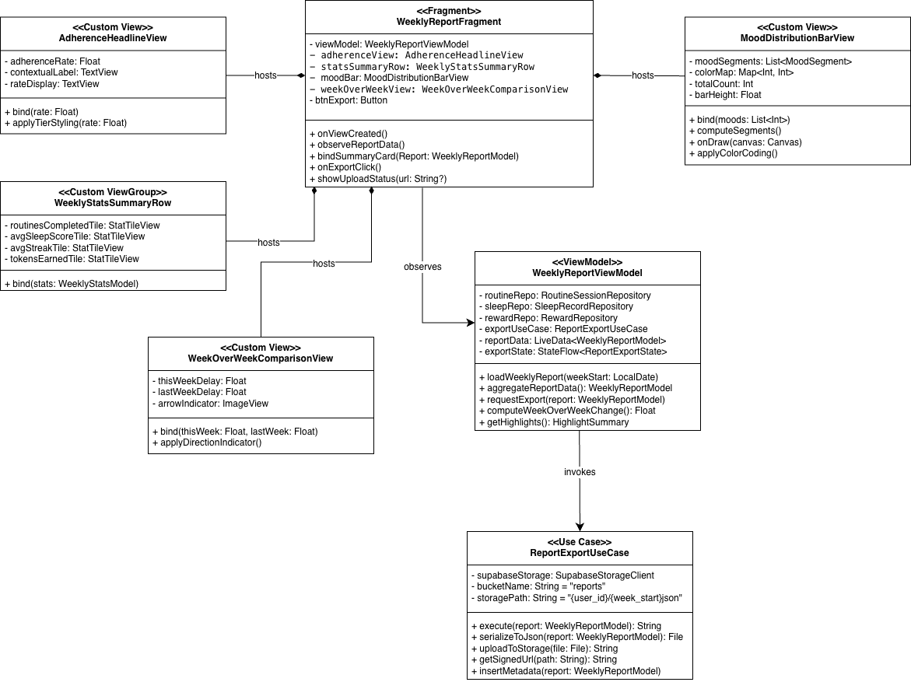
  - Sequence Diagram
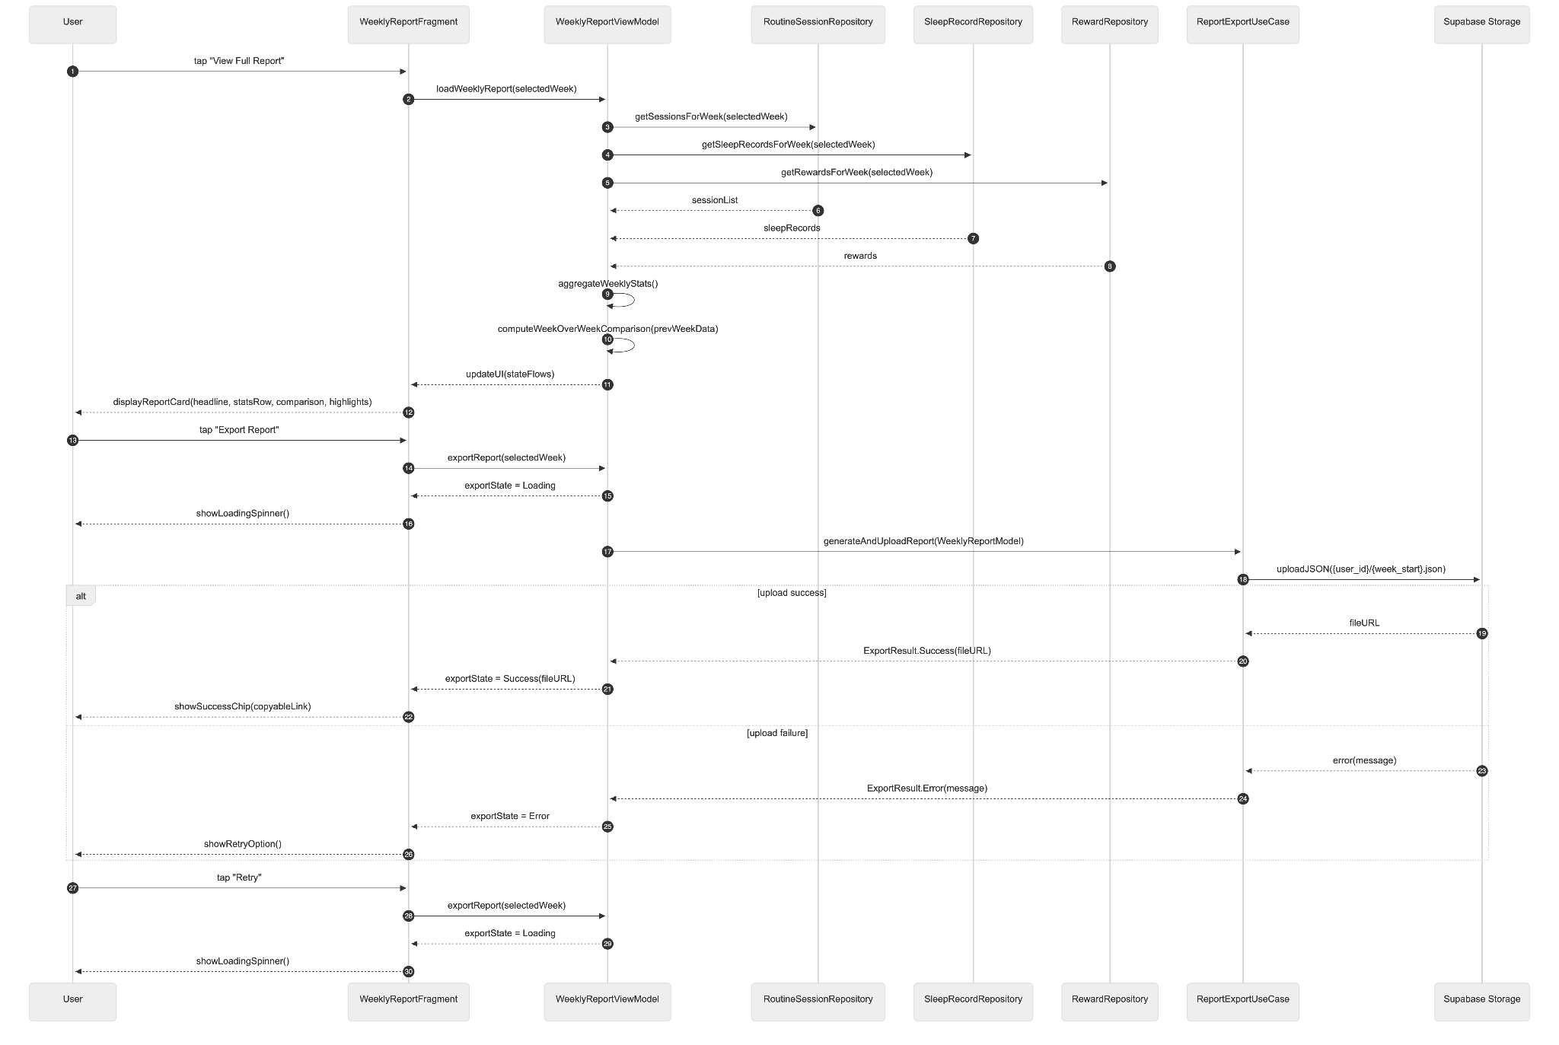
- Data Design
  - ERD or schema
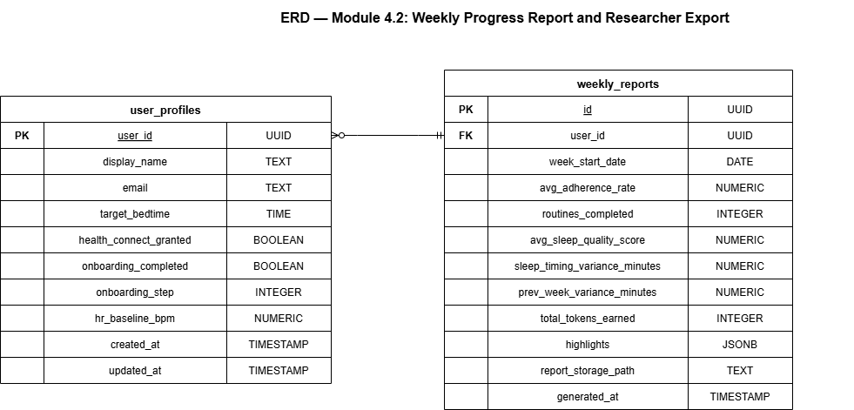

4.3 Monthly Progress Overview
- User Interface Design
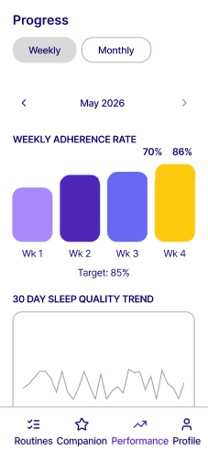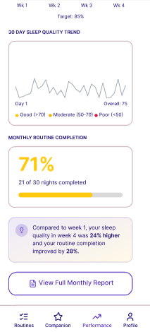

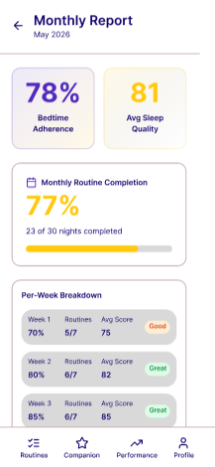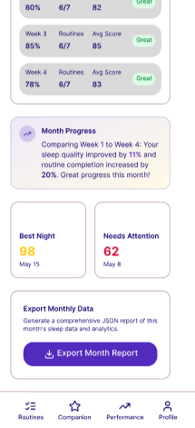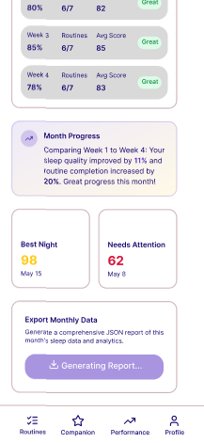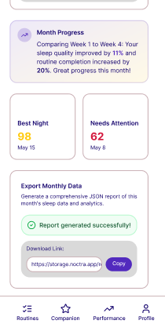
Accessible via the Monthly View toggle on the Analytics Dashboard. The MonthlyReportFragment is a deeper detail view accessible from the Monthly View via a "View Full Month Report" button, presenting a scrollable card summarizing the selected month's data for researcher export.
The monthly export report contains: the month's overall Bedtime Adherence Rate; total routines completed out of the number of days in the month; average composite sleep quality score for the month; per-week BAR breakdown (Week 1 through Week 4) as a data table; the Month Insight text comparing Week 1 and Week 4; and the month's best and worst night. An "Export Month Report" button uploads the JSON to Supabase Storage and returns a download link.
- Front-end component(s)
  - MonthlyReportFragment
    - Renders the monthly report card. Observes MonthlyReportViewModel. Hosts the Export button with the same loading/success/error state pattern as WeeklyReportFragment.
    - Type: Fragment (Kotlin)
  - WeeklyBreakdownTableView
    - A custom View rendering a four-row data table showing BAR and average sleep quality score per week of the selected month. Each row is labeled "Week 1" through "Week 4." Rows with insufficient data are rendered with a "—" placeholder.
    - Type: Custom View (Kotlin)
- Back-end component(s)
  - MonthlyReportViewModel
    - Aggregates a full month of data from RoutineSessionRepository and SleepRecordRepository. Computes the monthly stats summary, per-week BAR breakdown, and invokes MonthlyInsightGenerationUseCase. Invokes MonthlyReportExportUseCase on export request.
    - Type: ViewModel (Kotlin)
  - MonthlyReportExportUseCase
    - Constructs a MonthlyReportModel data class and serializes it to JSON. Uploads to Supabase Storage reports bucket under {user_id}/monthly/{year_month}.json. Inserts a metadata record into monthly_reports and returns the signed URL.
    - Type: Use Case class (Kotlin)
- Object-Oriented Components
  - Class Diagram
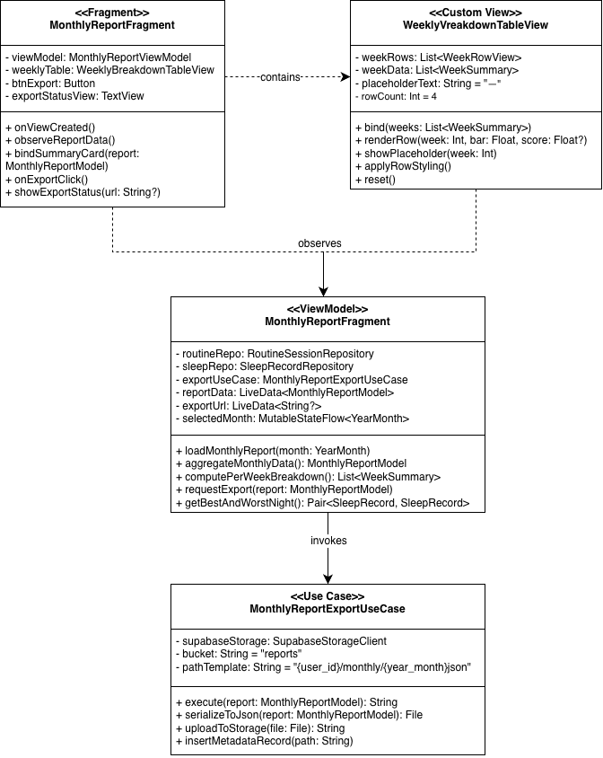
  - Sequence Diagram
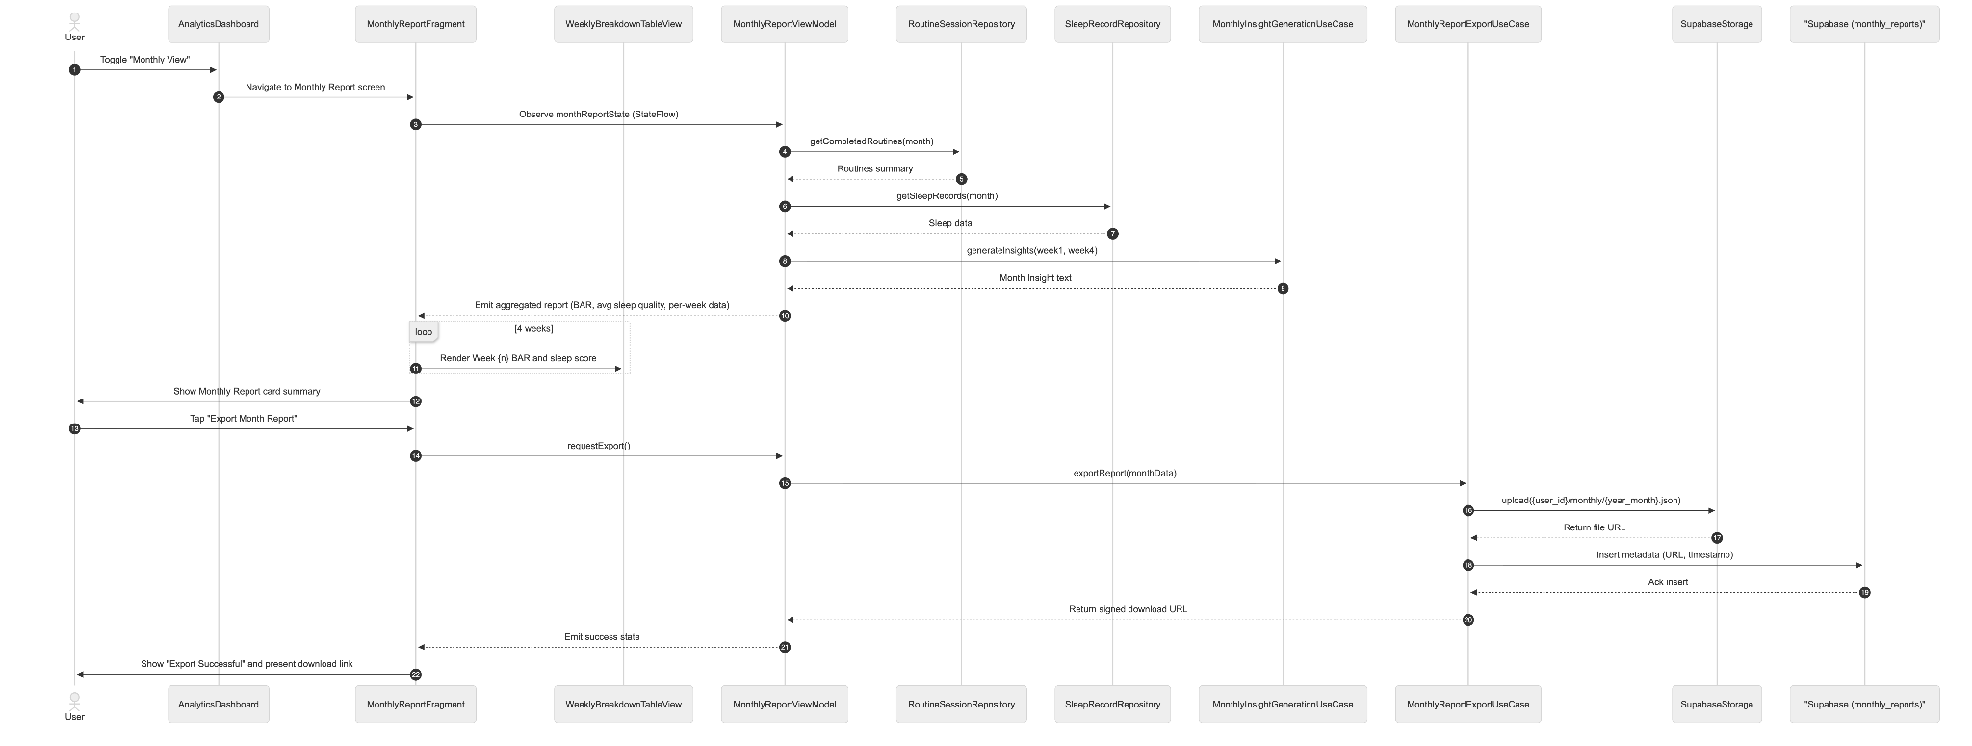
- Data Design
  - ERD or schema
