CEBU INSTITUTE OF TECHNOLOGY
UNIVERSITY

COLLEGE OF COMPUTER STUDIES

Software Requirements Specifications
for
Noctra

Members:
Escasinas, Luezyl Dominic C.
Lao, Hilary Danne C.
Guimoc, Earl John G.
Estrada, Julianna Carmel
Estela, Gerard Grant M.

Change History

Table of Contents

Change History 2
Table of Contents 3
1. Introduction 4
1.1. Purpose 4
1.2. Scope 4
1.3. Definitions, Acronyms and Abbreviations 4
1.4. References 4
2. Overall Description 5
2.1. Product perspective 5
2.2. User characteristics 5
2.4. Constraints 5
2.5. Assumptions and dependencies 6
3. Specific Requirements 7
3.1. External interface requirements 7
3.1.1. Hardware interfaces 7
3.1.2. Software interfaces 7
3.1.3. Communications interfaces 7
3.2. Functional requirements 7
Module 1 7
Module 2 8
3.4 Non-functional requirements 8
Performance 8
Security 8
Reliability 8

Introduction

Purpose
The purpose of this document is to provide a detailed description of Noctra, a mobile pre-sleep routine assistant designed to improve bedtime adherence and sleep quality among Filipino college students. This document serves as a reference for developers, project managers, and stakeholders to ensure alignment with functional and non-functional requirements.

Scope
Noctra is a mobile application that helps Filipino college students establish consistent pre-sleep habits by guiding them through personalized wind-down routines, reinforcing nightly engagement through gamified mechanics, monitoring sleep quality through smartwatch integration, and providing automated visual feedback on their progress over time. The system is implemented across four functional modules — User Onboarding & Routine Configuration (Module 1), Gamified Nightly Engagement (Module 2), Sleep Quality Monitoring (Module 3), and Routine Auditing & Analytics (Module 4) — which collectively fulfill the system's three General Objectives. Modules 1 and 2 jointly fulfill GO1; Module 3 fulfills GO2; Module 4 fulfills GO3. The system includes the following core functionalities:
- Pre-Sleep Routine & Gamified Engagement
- Sleep Quality Monitoring
- Routine Auditing & Analytics

Definitions, Acronyms and Abbreviations

Term / Acronym | Definition
Noctra | The proposed mobile pre-sleep routine assistant application developed for Filipino college students
Sleep Onset Latency | The amount of time it takes a person to transition from full wakefulness to sleep after lying down
Wind-Down Routine | A user-configured sequence of low-cognitive-load pre-sleep activities completed before the target bedtime to facilitate the transition from wakefulness to rest
Target Bedtime | The user's self-defined time at which they intend to fall asleep, configured during onboarding and used as the system's primary operational threshold
Bedtime Adherence Rate (BAR) | The primary evaluation metric of the system, defined as the proportion of nights in which the user falls asleep within 30 minutes of their configured target bedtime as detected by the paired smartwatch via Health Connect
Pre-Bedtime Window | The period beginning 30 minutes before the user's target bedtime during which wind-down nudge notifications are delivered
Cognitive Offloading | The process of externalizing mental content (e.g., worries, tasks, thoughts) into a written or spoken form to reduce pre-sleep cognitive arousal
Brain Dump | A micro-journaling wind-down activity in Noctra that operationalizes cognitive offloading by prompting the user to write freely before sleep
Localized Audioscapes | Bundled offline audio files featuring locally familiar Philippine ambient soundscapes (e.g., provincial rain on a tin roof, dorm-room lo-fi with electric fan ambience) playable within the routine without network dependency
Dream Tokens | Short-term spendable digital currency in Noctra awarded immediately upon nightly routine completion and amplified by streak multipliers; spent in the Sleep Shop
Growth Points (XP) | Non-spendable long-term progression currency that accumulates nightly upon routine completion and drives the virtual companion's evolution stages
Streak | A consecutive count of nights on which the user completed their pre-sleep routine. Resets to zero on a missed night, which also triggers companion devolution — a visual regression of the virtual companion to a lower evolution stage.
Streak Multiplier | A bonus coefficient applied to the Dream Token award based on the user's current streak length, designed to reinforce sustained engagement
Sleep Shop | The in-app customization store accessible via CustomizationFragment where users spend Dream Tokens on cosmetic items for their virtual companion, organized across four categories: Hats, Outfits, Accessories, and Footwear.
Virtual Companion | A culturally themed in-app animated character that evolves visually through multiple stages as the user accumulates Growth Points, intended to create emotional investment and sustain long-term engagement
Companion Evolution | The progression of the virtual companion through predefined XP milestone stages, triggered when the user's total Growth Points crosses a threshold defined by CompanionEvolutionUseCase
Composite Sleep Quality Score | A single nightly score from 0 to 100 computed by SleepQualityProcessingUseCase from three Health Connect-derived signals: Sleep Duration Score, Heart Rate Score, and Movement Score
Sleep Duration Score | A 0–100 sub-score measuring whether the user's sleep duration fell within the clinically recommended 7–9 hour range for college-aged adults
Heart Rate Score | A 0–100 sub-score measuring deviation of the user's average sleep-period heart rate from their personalized baseline, indicating physiological relaxation quality
Movement Score | A 0–100 sub-score derived from the total step count recorded during the sleep window as a proxy for physical restlessness and sleep fragmentation
Personal HR Baseline | The user's computed average resting heart rate during sleep, derived from a minimum of three nights of Health Connect heart rate data and updated using an exponential moving average; used as the reference point for Heart Rate Score calculation
Exponential Moving Average (EMA) | A statistical smoothing technique applied to the personal HR baseline update, giving more weight to recent observations while preserving historical stability; computed as (α × new observation) + ((1 − α) × current baseline) where α = 0.1
Partial Data Flag | The is_partial_data boolean field in sleep_records, set to true when one or more Health Connect sub-signals are unavailable for a given night, indicating the composite score was computed from a redistributed subset of signals
Weight Redistribution | The process by which the composite score formula reallocates the weights of missing signals proportionally across available signals to ensure the composite always produces a valid 0–100 score
Sleeptime Adherence Classification | The per-night categorization produced by BedtimeAdherenceCalculator: ADHERENT (≤30 min delay), SLIGHT_DELAY (31–60 min), SIGNIFICANT_DELAY (>60 min), or NO_DATA
Relationship Insight | A plain-language behavioral summary generated by InsightGenerationUseCase comparing the user's average composite sleep quality score on routine completion nights versus non-completion nights
Health Connect | Google's unified Android health data platform (androidx.health.connect.client) that aggregates health and fitness data from compatible smartwatches and fitness apps; used by Noctra to passively retrieve sleep session, heart rate, and step data
Health Connect-Compatible Smartwatch | Any consumer-grade, non-Wear OS smartwatch that writes sleep and biometric data to the Android Health Connect platform through its paired brand health application. Compatible devices include but are not limited to Xiaomi Smart Band / Mi Band series (via Zepp), Fitbit devices (via Fitbit app), Huawei Band series (via Huawei Health), and Samsung Galaxy Fit series. Wear OS smartwatches — including Samsung Galaxy Watch 4 and above and Pixel Watch — are explicitly outside the supported scope for two reasons: Wear OS integration requires a separate watch-side companion application developed using the Wear OS Health Services API, which is outside the project scope; and Wear OS devices are priced significantly above the budget-realistic range for the target population of Filipino college students.
SleepSessionRecord | The Health Connect data type representing a recorded sleep session, containing sleep onset time, wake time, and duration
HeartRateRecord | The Health Connect data type containing timestamped heart rate measurements in beats per minute recorded during a specified time window
StepsRecord | The Health Connect data type containing the total step count recorded during a specified time window, used as the movement proxy for the Movement Score
MorningSyncWorker | A WorkManager CoroutineWorker scheduled daily between 6:00 AM and 9:00 AM that retrieves the previous night's Health Connect data and computes the nightly composite sleep quality score
WindDownNotificationWorker | A WorkManager CoroutineWorker that delivers wind-down nudge notifications at T-30 and T-15 minutes before the user's target bedtime each night
MissedSessionCheckerWorker | A WorkManager CoroutineWorker scheduled each morning that detects whether the user failed to complete their routine the previous night and resets the streak accordingly
MVVM | Model-View-ViewModel — the architectural pattern used throughout Noctra, separating UI rendering (View), state management and orchestration (ViewModel), and data/domain logic (Model)
Single-Activity Architecture | The Android navigation pattern used by Noctra in which a single MainActivity hosts one NavHostFragment and all screens are implemented as Fragments navigated via the Navigation Component
NavHostFragment | The Android Navigation Component container embedded in MainActivity that manages the Fragment back stack and renders the currently active destination from nav_graph.xml
Nested Navigation Graph | A sub-graph within nav_graph.xml that groups related destinations — Noctra uses three: auth_graph, onboarding_graph, and main_graph
navGraphViewModels | A Kotlin delegate that scopes a ViewModel to a specific nested navigation graph's back stack entry, used in Noctra to share onboarding state across all four onboarding Fragments
StateFlow | A Kotlin Coroutines Flow type that holds and emits the current state value; used in Noctra for all UI state exposed from ViewModels to Fragments
SharedFlow | A Kotlin Coroutines Flow type used for one-shot events (navigation commands, error dialogs) that should not be re-emitted on configuration change
WorkManager | The Android Jetpack library used by Noctra to schedule and execute reliable background tasks (morning sync, notifications, missed session detection) independent of app lifecycle state
Supabase | The open-source Backend-as-a-Service platform used as Noctra's cloud backend, providing Auth, PostgREST, Realtime, and Storage services
Supabase Auth | The Supabase service managing user registration, login, session tokens, and password reset for Noctra
Supabase PostgREST | The Supabase service providing auto-generated REST API access to the PostgreSQL database, used for all CRUD operations in Noctra
Supabase Realtime | The Supabase service that broadcasts PostgreSQL table change events to subscribed clients via WebSocket, used in Noctra for live leaderboard updates in the Social feature and for event-driven push notifications triggered by friend request and acceptance actions
Friendship | A mutual social connection between two users, established when a friend request transitions from PENDING to ACCEPTED. Both users appear on each other's Friends Leaderboard once the friendship is accepted.
FriendRequest | A directional social action initiated by one user (requester) toward another (receiver) by entering the receiver's registered email address. Has one of three states: PENDING, ACCEPTED, or DECLINED.
Leaderboard Rank | A user's position among their accepted friends, sorted primarily by current streak descending. Tiebreaker: the timestamp of the most recently completed routine session (most recent ranks higher).
Supabase Storage | The Supabase service used to store exported weekly and monthly report JSON files for researcher access
Supabase RPC | Remote Procedure Call functions defined in the Supabase PostgreSQL database and invoked from the Android client; used in Noctra for credit_rewards() and equip_item() atomic operations
Row Level Security (RLS) | A PostgreSQL security feature enforced through Supabase policies that ensures each user can only read and write their own data across all tables
PostgREST | The open-source REST API layer that Supabase uses to expose the PostgreSQL database; all Repository classes in Noctra interact with it via the Supabase Kotlin client
Repository | A Data Access Layer class in Noctra's MVVM architecture that abstracts all read and write operations for one data domain and exposes suspend functions and Flows to the Business Logic Layer
Use Case | A Business Logic Layer class in Noctra's MVVM architecture that encapsulates one discrete domain operation, invoked by ViewModels and invoking Repositories; has no Android framework dependencies
ViewModel | A Jetpack Architecture Component class that survives configuration changes, exposes UI state as StateFlow, and orchestrates Use Case invocations in response to user events
Lottie | An open-source animation library (com.airbnb.android:lottie) used in Noctra to render animated JSON-based companion character animations
MPAndroidChart | An open-source Android charting library used in Noctra's analytics dashboard to render bar charts, line charts, and pie charts
MediaPlayer | The Android system API used in Noctra to play locally bundled audioscape files during routine execution without network dependency
ItemTouchHelper | An Android RecyclerView utility used in Noctra's routine sequence builder to enable drag-and-drop reordering of selected activities
EncryptedSharedPreferences | An Android Jetpack security component used to securely store Supabase session tokens on the device
SDD | Software Design Description — this document
SRS | Software Requirements Specification — the companion requirements document that defines what the system must do
MVP | Minimum Viable Product — the initial deployable version of Noctra demonstrating functional IPO behavior across all four modules
UAT | User Acceptance Testing — validation conducted with Filipino college students to confirm the system functions as intended within the local academic and cultural context
IPO | Input-Process-Output — the fundamental functional model used to evaluate whether the system correctly transforms user inputs and sensor data into meaningful outputs
MCII | Mental Contrasting with Implementation Intentions — an evidence-based self-regulation strategy referenced in the RRL (Valshtein et al., 2019); the theoretical basis for the Brain Dump and intention-setting activities in Noctra's wind-down routine
SUS | System Usability Scale — a validated ten-item questionnaire used to evaluate the perceived usability of Noctra during UAT
EMA | Exponential Moving Average — see definition under Exponential Moving Average above
RLS | Row Level Security — see definition under Row Level Security above
HR | Heart Rate — used as shorthand throughout the SDD when referring to heart rate values, baseline computations, and Health Connect HeartRateRecord data
XP | Experience Points — used interchangeably with Growth Points throughout the SDD to refer to the non-spendable long-term progression currency in Noctra's gamification system

References
Valshtein, T. J., Oettingen, G., & Gollwitzer, P. M. (2020). Using mental contrasting with implementation intentions to reduce bedtime procrastination: Two randomised trials. Psychology & Health, 35(3), 275–301. https://doi.org/10.1080/08870446.2019.1652753

Hirshkowitz, M., Whiton, K., Albert, S. M., Alessi, C., Bruni, O., DonCarlos, L., Hazen, N., Herman, J., Katz, E. S., Kheirandish-Gozal, L., Neubauer, D. N., O'Donnell, A. E., Ohayon, M., Peever, J., Rawding, R., Sachdeva, R. C., Setters, B., Vitiello, M. V., Ware, J. C., & Adams Hillard, P. J. (2015). National Sleep Foundation's sleep time duration recommendations: Methodology and results summary. Sleep Health, 1(1), 40–43. https://doi.org/10.1016/j.sleh.2014.12.010

Taub, J. M., & Berger, R. J. (1976). The effects of changing the phase and duration of sleep. Journal of Experimental Psychology: Human Perception and Performance, 2(1), 30–41. https://doi.org/10.1037/0096-1523.2.1.30

Overall Description

Product perspective
Noctra is a standalone mobile application developed for Android devices, operating within a client-server architecture. The mobile client handles user interaction, routine guidance, and gamification display, while the server manages user data, session logs, and analytics processing. The system integrates with consumer-grade, non-Wear OS Android-compatible smartwatches through Google Health Connect, which aggregates sleep data captured by the user's smartwatch and its paired health application, and makes it available to Noctra upon the user waking. All collected data, including routine completion records, gamification progress, and sleep quality scores, is stored server-side and retrieved by the mobile client to populate the analytics dashboard.

User characteristics
- Registered Users: Access the full system including routine customization and onboarding, nightly routine guidance and gamification, smartwatch-based sleep monitoring, and the analytics dashboard. Users are expected to own an Android smartphone and a consumer-grade, non-Wear OS Google Health Connect-compatible smartwatch, and are assumed to have basic mobile application literacy.

2.4. Constraints

Hardware Limitations
Noctra requires users to own an Android smartphone and a consumer-grade, non-Wear OS Google Health Connect-compatible smartwatch. The sleep monitoring functionality cannot operate without a paired compatible smartwatch, and the full analytics dashboard cannot be populated without nightly sleep data capture. Users with incompatible or unpaired wearable devices will have access to routine guidance and gamification features only.
Wear OS smartwatches are explicitly outside the supported device scope for two reasons. First, Wear OS integration requires a separate companion application developed for and installed on the watch itself via the Wear OS Health Services API, which constitutes a development workstream outside the scope of this project. Second, Wear OS devices are significantly more expensive than consumer fitness bands, reducing their accessibility among Filipino college students — the primary target population — for whom budget-friendly devices such as Xiaomi Smart Band, Huawei Band, and Samsung Galaxy Fit series represent more realistic ownership scenarios. The system's Health Connect integration layer is therefore designed exclusively around the companion-app sync pipeline, where the smartwatch brand application (e.g., Zepp, Huawei Health, Fitbit) captures raw sleep data and writes it to Google Health Connect for retrieval by Noctra.
Software Limitations
Noctra is developed exclusively for Android and is not compatible with iOS devices. The system's sleep monitoring layer depends on Google Health Connect, which is an Android-exclusive platform, making cross-platform support outside the current scope. Sleep stage classification (Light, Deep, REM) is additionally outside the system's measurement scope. While some Google Health Connect-compatible smartwatches record sleep stage information, consumer-grade device accuracy for sleep stage classification is approximately 50–65% compared to polysomnography, making stage-level data unsuitable for reliable composite scoring within the system's non-clinical scope. Sleep quality assessment is therefore bounded to sleep duration, heart rate deviation, and movement proxy signals.
Third-Party Dependencies
Sleep data availability is dependent on the user's smartwatch brand application, such as Zepp for Xiaomi or the Tracer companion app, successfully syncing captured sleep data to Google Health Connect. Any failure in this sync pipeline, whether due to the brand app, device firmware, or Google Health Connect itself, may result in incomplete or missing nightly sleep data in Noctra.
Connectivity Requirements
An active internet connection is required for server-side data storage, session logging, analytics processing, and friend-group leaderboard functionality. The bundled audio feature within the pre-sleep routine is the only component that operates fully offline.
Scope Constraints
The system is designed and validated exclusively for Filipino college students enrolled in tertiary education. It is not intended for use among other populations including non-Filipino students, working professionals, adolescents, or older adults.

2.5. Assumptions and dependencies
Assumptions
- Users own an Android smartphone and a consumer-grade, non-Wear OS Google Health Connect-compatible smartwatch at the time of system deployment.
- Users are willing to wear their smartwatch to bed every night for the duration of the study, as sleep data capture is dependent on continuous wearable use during sleep.
- Users' smartwatch brand applications are properly installed, configured, and actively syncing captured health data to Google Health Connect prior to using Noctra.
- Users have access to a stable internet connection for most nightly sessions to support server-side data storage, analytics processing, and leaderboard functionality.
- Users are willing to engage with the onboarding process and configure a personalized routine before first use.
- The gamification mechanics, including the reward system and virtual companion, sufficiently resonate with the target population to sustain nightly engagement over the study period.
- Users' self-defined target bedtimes are realistic and personally meaningful, serving as accurate reference points for bedtime adherence measurement.

Specific Requirements

External interface requirements

3.1.1. Hardware interfaces
Noctra operates on Android smartphones running Android 9 (API level 28) or higher. The system interfaces with a Google Health Connect-compatible smartwatch as a required peripheral for sleep monitoring functionality. The smartwatch communicates with the user's smartphone through its paired brand health application, which aggregates captured sleep data, including sleep duration, heart rate, and movement, and makes it available to Noctra through Google Health Connect.

3.1.2. Software interfaces
Android Operating System
Noctra is developed natively for Android using Kotlin and requires Android 9 (API level 28) or higher. The Android OS provides the core platform services the application depends on, including notifications, audio playback, and background data sync.
Google Health Connect
Noctra integrates with Google Health Connect to retrieve sleep data captured by the user's paired smartwatch. Google Health Connect serves as the standardized data intermediary between the smartwatch brand application and Noctra, providing sleep duration, heart rate, and movement data recorded during the user's sleep session.
Smartwatch Brand Health Applications
Sleep data is sourced from the user's smartwatch through its paired brand health application, such as Zepp for Xiaomi devices or the Tracer companion app, which captures raw sensor data from the smartwatch and syncs it to Google Health Connect for retrieval by Noctra.
Supabase
Noctra uses Supabase as its backend platform for data storage and analytics processing. Supabase provides a PostgreSQL relational database that stores routine session logs, sleep quality scores, gamification progress, and leaderboard room data through structured schemas and table relationships. User authentication is managed through Supabase Auth, which handles account creation and login using name and password credentials.

3.1.3. Communications interfaces
Internet Connectivity
Noctra requires an active internet connection for communication between the mobile client and the Supabase backend. This covers routine session logging, sleep quality score syncing, gamification progress updates, and friend-group leaderboard data retrieval. All client-server communication is conducted over HTTPS to ensure data transmission security.
Google Health Connect Data Sync
Communication between the smartwatch brand health application and Noctra is handled through Google Health Connect's local on-device API. This communication does not require an active internet connection as it occurs locally on the user's Android device.
Push Notifications
Noctra delivers bedtime reminders and social notifications to the user through the Android NotificationManager via dedicated notification channels. Wind-down nudge notifications are dispatched by WindDownNotificationWorker via WorkManager, triggered based on each user's configured target bedtime at T-30 and T-15 minutes. Social notifications — including friend requests and friend request acceptances — are triggered by Supabase Realtime events on the friendships table and dispatched locally through FriendRequestNotificationWorker.

Functional requirements

Module 1 - Onboarding & Routine Configuration

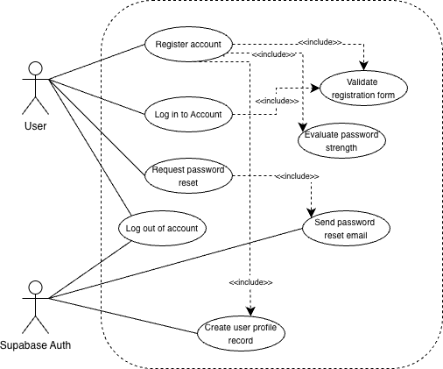
Figure 1. Authentication Module Use Case Diagram

1.1.1 Register Account

Use Case Diagram: Refer to Figure 1. Authentication Module Use Case Diagram

Use Case Description:
Use case name | Register account
Use case ID | UC-1.1.1
Actor(s) | User
Description | A new user creates a Noctra account by providing a display name, email address, and password. The system validates all fields inline, evaluates password strength, and on success creates the account and a corresponding user profile record, then navigates the user to onboarding.
Preconditions | The user does not already have a Noctra account. The device has an active internet connection.
Postconditions | A new Supabase Auth user record and a corresponding user_profiles row are created. The user is navigated to the onboarding flow (BedtimeConfigFragment).
Main Flow | - The user opens the app for the first time and is shown RegistrationFragment.  - User enters display name (min. 2 characters), email address, and password (min. 8 characters).  - The system validates each field inline on focus loss; the password strength indicator updates in real time.  - The Register button becomes enabled once all fields pass validation.  - User taps Register.  - System calls AuthRepository.register(), which calls supabase.auth.signUpWith(Email).  - On success, the system immediately inserts a row into user_profiles.  - The system navigates the user to the onboarding flow.

Activity Diagram:

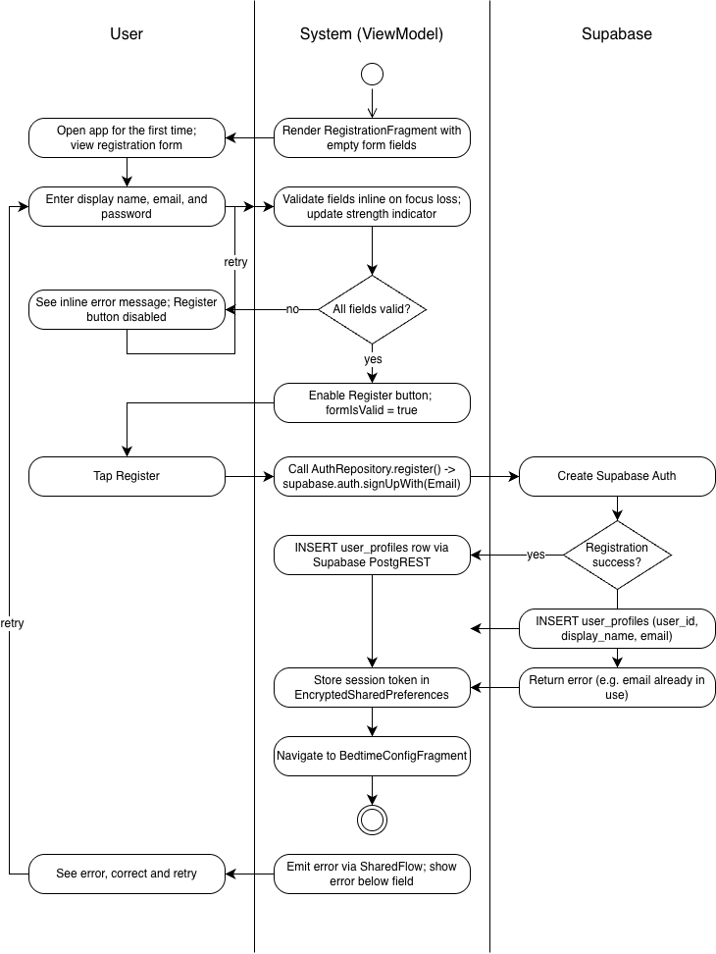

Wireframe:

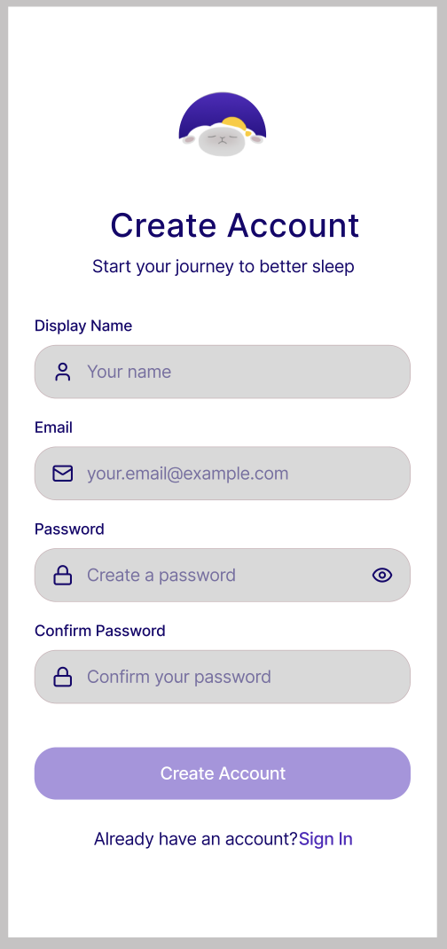

1.1.2 Login

Use Case Diagram: Refer to Figure 1. Authentication Module Use Case Diagram

Use Case Description:
Use case name | Login
Use case ID | UC-1.1.2
Actor(s) | User
Description | A returning user authenticates with their email and password. The system routes them to the home screen or resumes onboarding depending on their onboarding completion status.
Preconditions | The user has a registered Noctra account. The device has an active internet connection.
Postconditions | User is authenticated. System navigates to HomeFragment (onboarding complete) or to the last completed onboarding step (onboarding incomplete).
Main Flow | - User opens app and is shown LoginFragment.  - User enters email address and password.  - User taps Log In.  - System calls AuthRepository.login(), which calls supabase.auth.signInWith(Email).  - On success, system reads onboarding_completed from user_profiles.  - If true, system navigates to HomeFragment. If false, system navigates to the last saved onboarding step.

Activity Diagram:
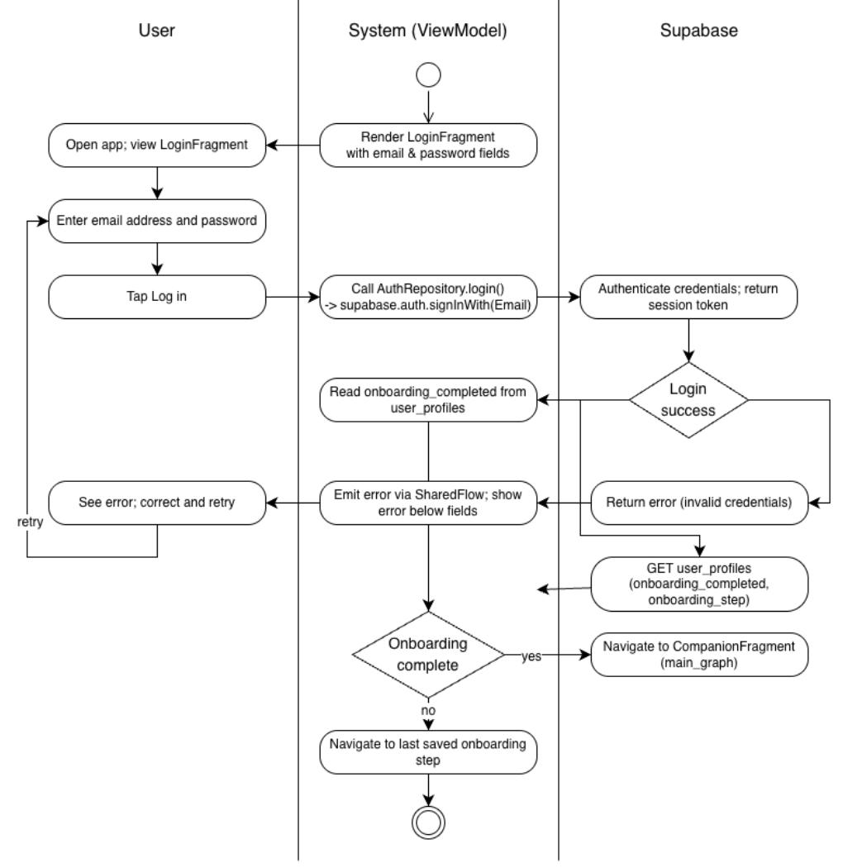

Wireframe

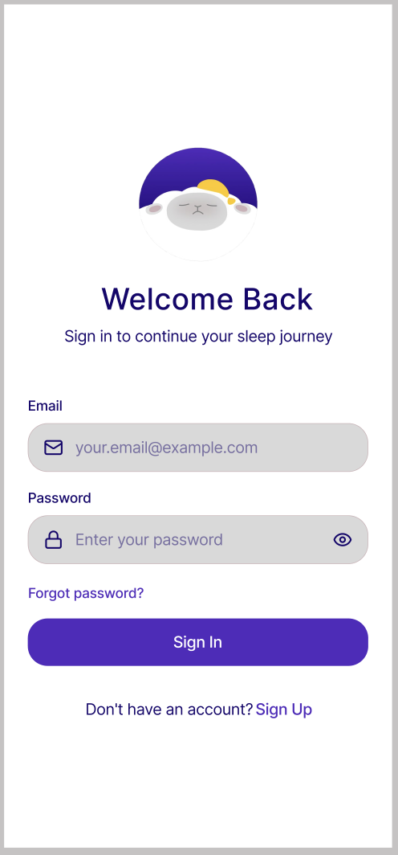

1.1.3 Request Password Reset

Use Case Diagram: Refer to Figure 1. Authentication Module Use Case Diagram
- Use Case Description:

Use case name | Request password reset
Use case Id | UC-1.1.3
Actor(s) | User
Description | A user who has forgotten their password navigates to ForgotPasswordFragment by tapping "Forgot Password" on LoginFragment. The user enters their registered email address and taps "Send Reset Link." The system validates the email format, delegates the reset email dispatch to Supabase Auth, and navigates the user to PasswordResetConfirmationFragment on success.
Preconditions | The user has a registered Noctra account. The device has an active internet connection. The user has tapped "Forgot Password" on LoginFragment.
Postconditions | Supabase Auth sends a password reset email to the provided address. The user is navigated to PasswordResetConfirmationFragment showing a confirmation message to check their inbox.
Main Flow | - User taps "Forgot Password" on LoginFragment.  - System navigates to ForgotPasswordFragment displaying a single email input field and a "Send Reset Link" button.  - User enters their registered email address.  - System validates email format inline — the "Send Reset Link" button is disabled until a valid email format is entered.  - User taps "Send Reset Link."  - System calls AuthRepository.resetPassword(), which calls supabase.auth.resetPasswordForEmail().  - On success, system navigates the user to PasswordResetConfirmationFragment.  - PasswordResetConfirmationFragment displays a confirmation message instructing the user to check their inbox. A "Back to Login" button navigates back to LoginFragment.

- Activity Diagram:

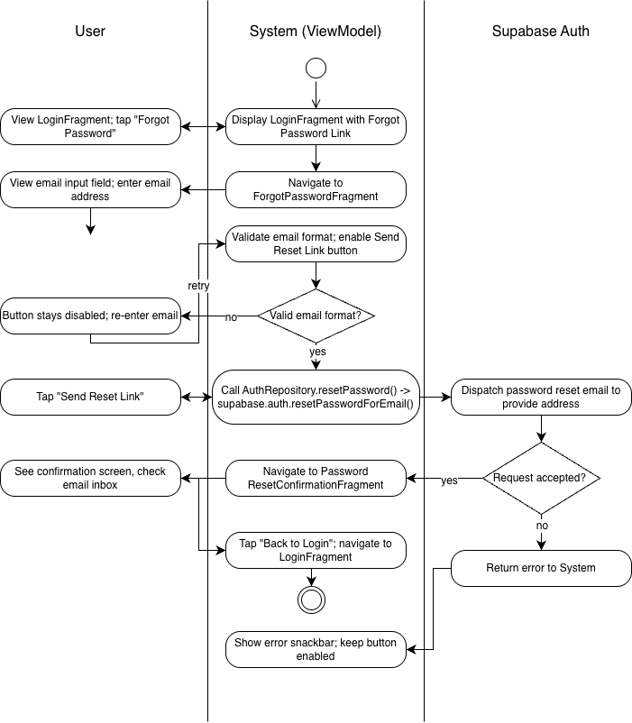
- Wireframe:
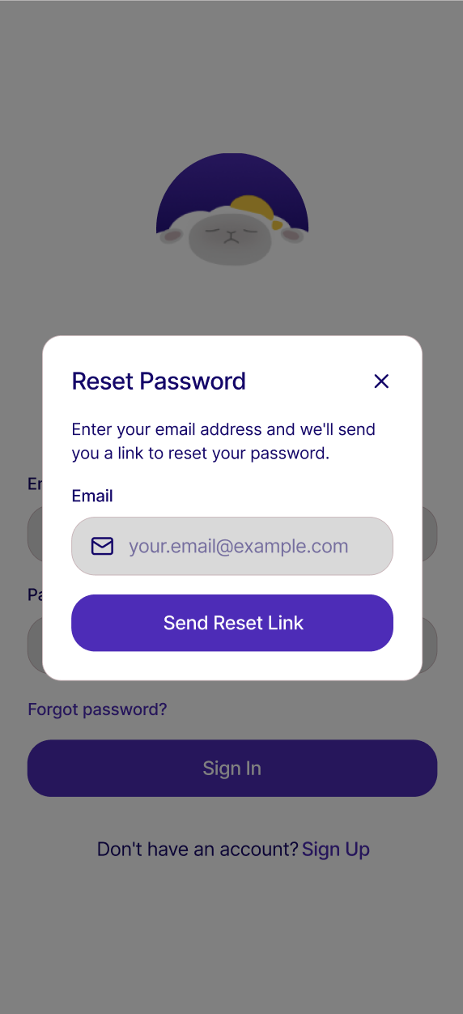

1.1.4 Reset Password

Use Case Diagram: Refer to Figure 1. Authentication Module Use Case Diagram

Use Case Description
Use case name | Confirm Password Reset
Use case Id | UC-1.1.4
Actor(s) | User, Supabase Auth
Description | After receiving the password reset email dispatched in UC-03, the user taps the reset link in their email. Supabase Auth validates the reset token and redirects the user to a password reset screen where they enter and confirm their new password. On success, the user is navigated back to LoginFragment.
Preconditions | The user has successfully completed UC-03 and received a password reset email from Supabase Auth. The reset link has not expired. The device has an active internet connection.
Postconditions | The user's password is updated in Supabase Auth. The user is navigated to LoginFragment and may log in with their new password.
Main Flow | - User taps the password reset link in their email.  - Supabase Auth validates the reset token embedded in the link  - System displays a password reset screen with a new password field and a confirm password field.  - User enters and confirms their new password (minimum 8 characters)  - System validates that both fields match and meet the minimum length requirement.  - User taps "Reset Password."  - System calls AuthRepository.updatePassword(), which calls supabase.auth.updateUser() with the new password.  - On success, system navigates the user to LoginFragment with a brief confirmation message ("Password updated successfully. Please log in.").

Activity Diagram

Wireframe
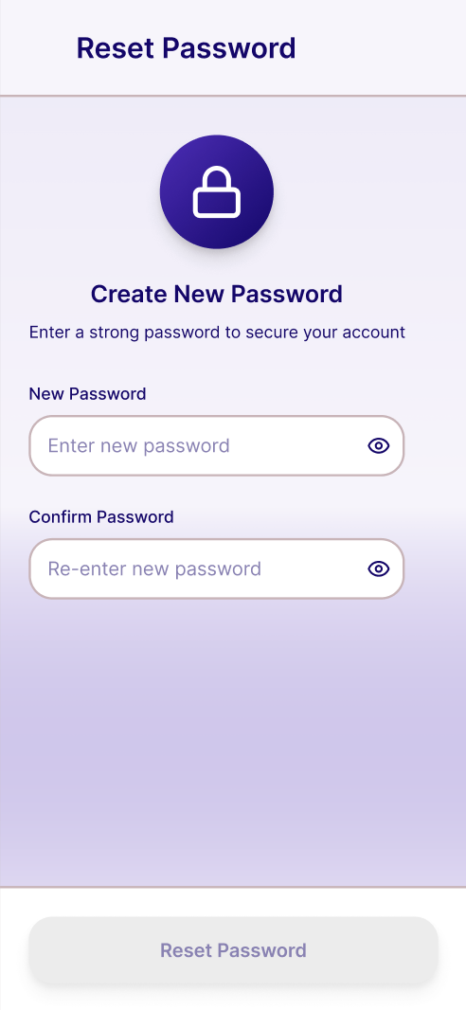

1.2.1 Configure Target Bedtime

Use Case Diagram:
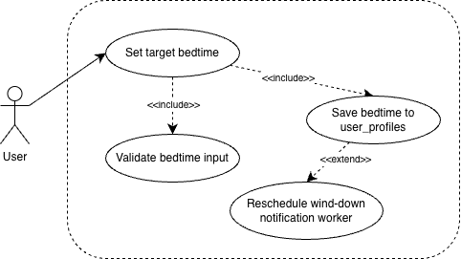

Use Case Description:
Use case name | Configure Target Bedtime
Use case Id | UC-1.2.1
Actor(s) | User
Description | The user selects their desired target bedtime using a time-picker interface, either during onboarding (Step 1) or through SettingsFragment post-onboarding. The system validates the input, saves it to user_profiles, and reschedules the WindDownNotificationWorker to deliver nudge notifications relative to the new bedtime.
Preconditions | The user is authenticated. The user is either on BedtimeConfigFragment (onboarding) or SettingsFragment (post-onboarding). An active internet connection is available.
Postconditions | The selected target bedtime is persisted to user_profiles.target_bedtime. WindDownNotificationWorker is rescheduled to fire at T-30 and T-15 minutes relative to the new bedtime. The estimated routine start time preview updates to reflect the new selection.
Main Flow | - User opens BedtimeConfigFragment (onboarding) or SettingsFragment (post-onboarding).  - System displays the time-picker pre-loaded with the current or default bedtime value.  - User scrolls the time-picker to select their desired target bedtime.  - System reactively updates the estimated routine start time preview below the picker.  - User taps "Next" (onboarding) or confirms the selection (settings).  - System validates that the selected time is a valid LocalTime value.  - OnboardingViewModel / SettingsViewModel invokes UserProfileRepository.updateBedtime().  - UserProfileRepository sends a PATCH request to user_profiles.target_bedtime via Supabase PostgREST.  - System reschedules WindDownNotificationWorker via WorkManager with the updated bedtime.  - User is advanced to ActivityLibraryFragment (onboarding) or remains on SettingsFragment with a success confirmation (post-onboarding).

Activity Diagram
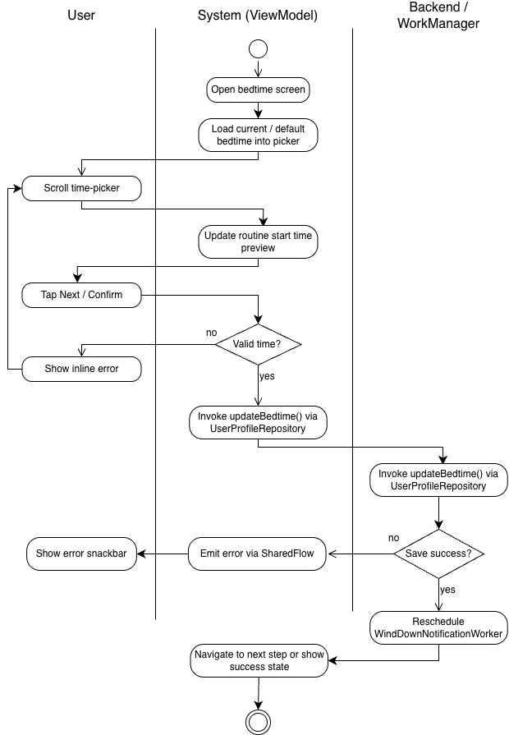

Wireframe
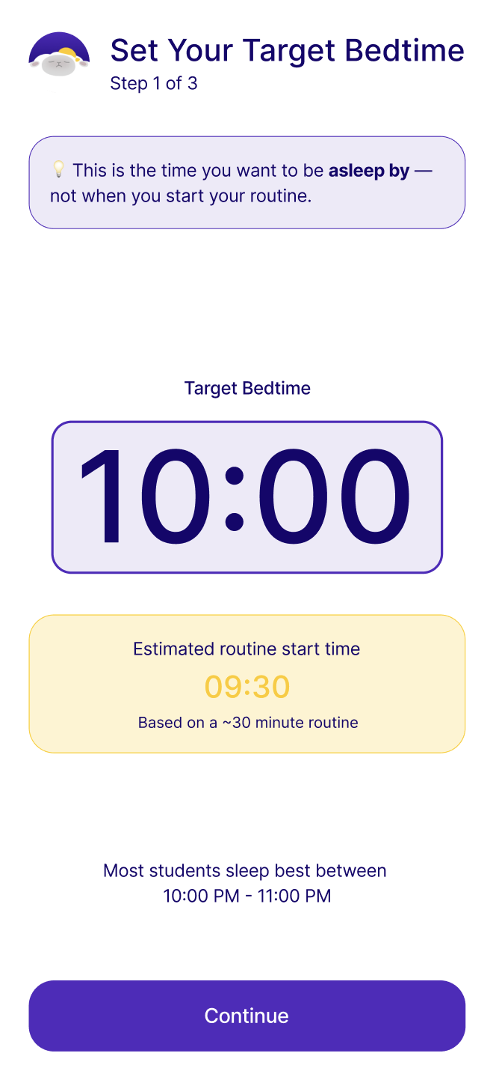

1.2.2 Select Routine Activities

Use Case Diagram:
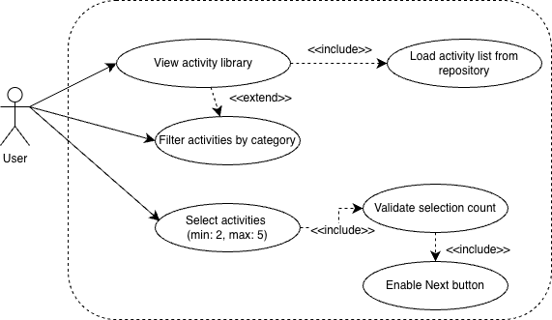

Use Case Description:

Use case name | Select Routine Activities
Use case Id | UC-1.2.2
Actor(s) | User
Description | During onboarding Step 2, the user browses a grid of pre-sleep activities loaded from activity_library and selects between two and five activities to form the basis of their nightly wind-down routine. The system enforces the selection bounds reactively, disabling unselected cards when the maximum is reached and enabling the Next button only when the minimum is met.
Preconditions | The user has completed bedtime configuration (Step 1 of onboarding). ActivityLibraryFragment is displayed with all activities loaded from RoutineRepository.getAllActivities(). No activities are pre-selected.
Postconditions | Between two and five activities are stored in OnboardingViewModel.selectedActivities. The Next button is enabled and the user can advance to RoutineSequenceFragment. Selection state is preserved if the user navigates back to this step within the same onboarding session.
Main Flow | - System loads all activities from RoutineRepository.getAllActivities() and renders them as a two-column grid of ActivityCardView items in ActivityLibraryFragment.  - User browses the grid; each card displays the activity icon, label, category tag, and estimated duration.  - User optionally filters the visible list by tapping a category chip; the grid updates without affecting existing selections.  - User taps an activity card to select it; the card highlights with the primary color border and a checkmark overlay. OnboardingViewModel.selectedActivities is updated.  - The selection counter at the top updates (e.g., "2 selected — add up to 3 more").  - System validates the selection count: if fewer than two are selected, the Next button remains disabled; if exactly five are selected, all unselected cards enter a disabled visual state preventing further selection.  - Once two or more activities are selected, the Next button becomes enabled.  - User taps Next; system navigates to RoutineSequenceFragment.

- Activity Diagram:
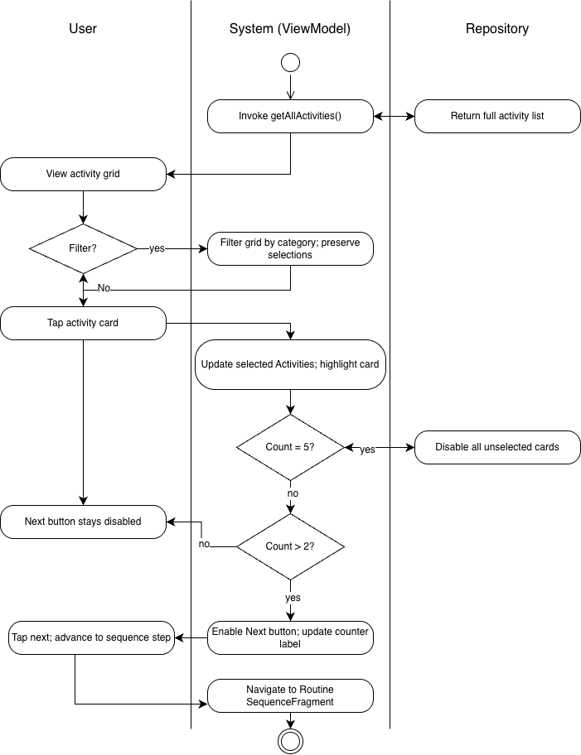
- Wireframe:
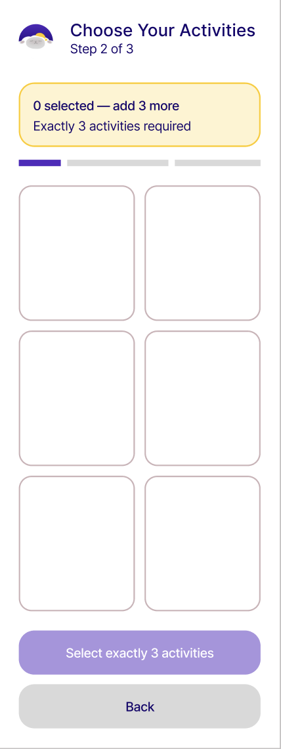

1.2.3 Sequence Routine Activities

Use Case Diagram:
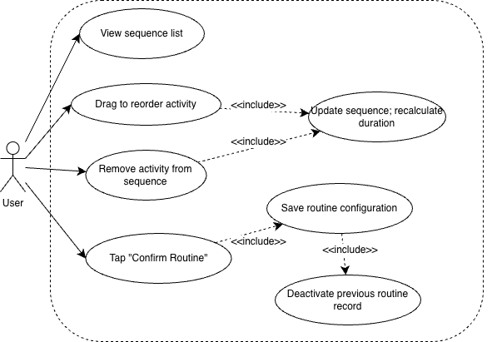

Use Case Description:

Use case name | Sequence Routine Activities
Use case Id | UC-1.2.3
Actor(s) | User
Description | During onboarding Step 3, the user arranges their selected activities into a preferred execution order using drag-and-drop, optionally removes activities, and confirms the final sequence. The system recalculates the total estimated routine duration after each change. On confirmation, the sequence is saved to routine_configurations via RoutineRepository.
Preconditions | The user has selected between two and five activities in ActivityLibraryFragment. RoutineSequenceFragment is displayed with the selected activities rendered as a drag-and-drop list via ItemTouchHelper. OnboardingViewModel.routineSequence is pre-populated from selectedActivities.
Postconditions | The final ordered sequence is stored in OnboardingViewModel.routineSequence. RoutineRepository.saveRoutineConfiguration() has inserted a routine_configurations row with the ordered activity list. The user is advanced to HealthConnectSetupFragment.
Main Flow | - RoutineSequenceFragment renders the selected activities as an ordered list; each row shows the step number, activity label, duration, drag handle, and remove button.  - A total estimated routine duration is displayed at the bottom and updates reactively.  - User drags an activity row to a new position using the drag handle; ItemTouchHelper handles the reorder gesture.  - System updates OnboardingViewModel.routineSequence and recalculates the total duration label.  - User optionally taps the remove button on a row; the activity is removed from the sequence. System re-numbers remaining rows and recalculates duration.  - User taps "Confirm Routine."  - OnboardingViewModel.saveRoutineConfiguration() invokes RoutineRepository.saveRoutineConfiguration(), inserting the routine_configurations row and setting all previous configurations for this user to is_active = false.  - System navigates to HealthConnectSetupFragment.

Activity Diagram:
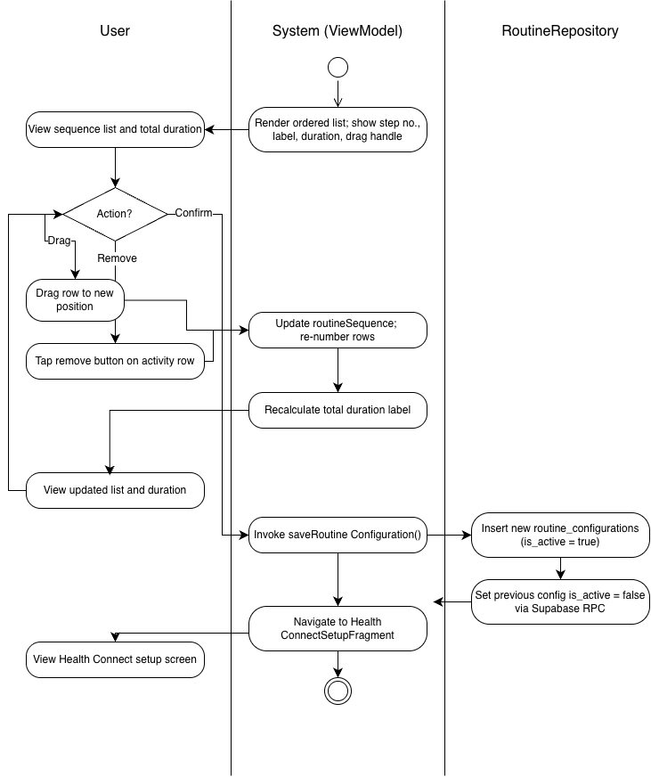

Wireframe:
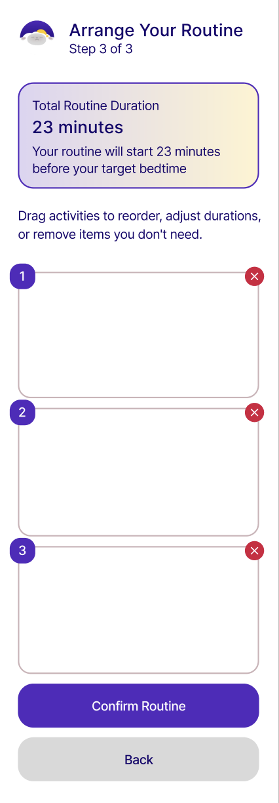

1.2.4 Edit Routine

Use Case Diagram:
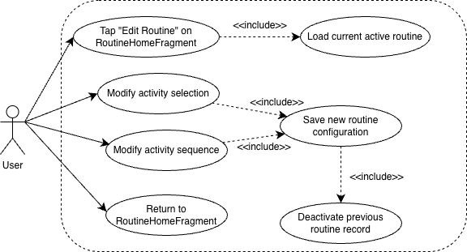

Use Case Description:

Use case name | Edit Routine
Use case Id | UC-1.2.4
Actor(s) | User
Description | After onboarding, the user can modify their active wind-down routine at any time by tapping "Edit Routine" on RoutineHomeFragment. The system re-enters the user into the activity selection and sequencing flows in edit mode, pre-populated with the current active routine. On confirmation, a new routine_configurations row is inserted as active and the previous configuration is deactivated.
Preconditions | The user is authenticated and fully onboarded. An active routine_configurations record exists for the current user. The user is on RoutineHomeFragment and the routine has not been started tonight.
Postconditions | A new routine_configurations row with is_active = true exists reflecting the updated selection and sequence. The previous active configuration's is_active flag is set to false. RoutineHomeFragment re-renders with the updated routine preview and total duration.
Main Flow | - User taps "Edit Routine" on RoutineHomeFragment.  - RoutineHomeViewModel emits a navigation event directing the user to ActivityLibraryFragment in edit mode, pre-selecting the current active routine's activities.  - User modifies activity selections (adding, removing within the 2–5 bound) and taps Next.  - System navigates to RoutineSequenceFragment in edit mode, pre-populated with the current sequence.  - User modifies the order or removes activities via drag-and-drop and taps "Confirm Routine."  - OnboardingViewModel.saveRoutineConfiguration() invokes RoutineRepository.saveRoutineConfiguration(), which inserts a new routine_configurations row with is_active = true and sets the previous configuration's is_active to false using a Supabase RPC call.  - System navigates back to RoutineHomeFragment, which re-loads and renders the updated routine preview.

Activity Diagram:
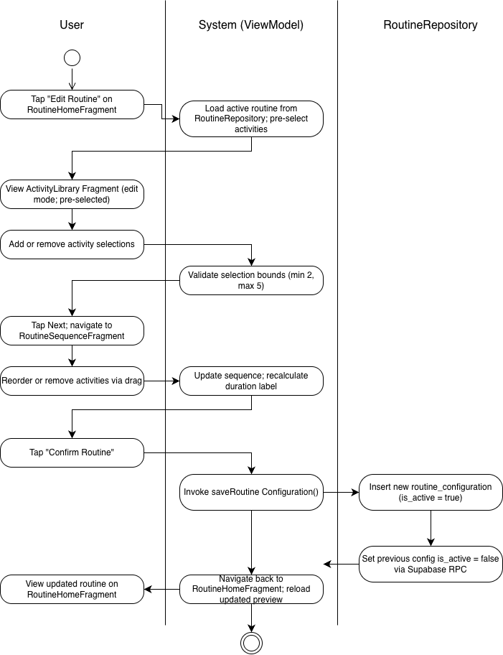

Wireframe:
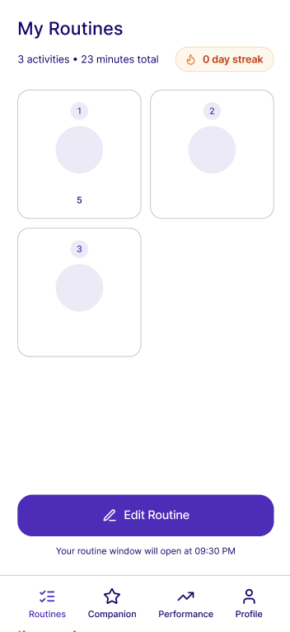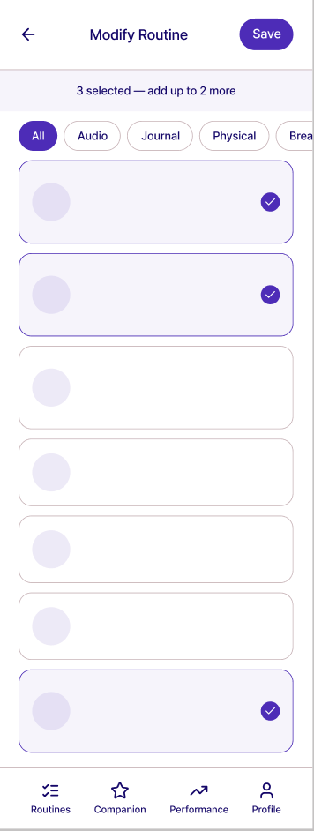

1.3.1 Grant Health Connect Permissions

Use Case Diagram
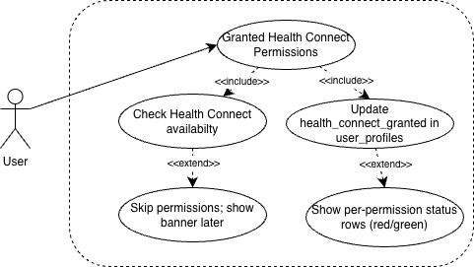

Use Case Description
Use case name | Grant Health Connect Permissions
Use case Id | UC-1.3.1
Actor(s) | User
Description | The user grants Noctra access to their Health Connect data by approving three runtime permissions — Read Sleep Sessions, Read Heart Rate, and Read Steps — through the system Health Connect permission dialog. The system checks Health Connect availability on launch, displays the per-permission status rows, updates user_profiles upon grant, and shows a persistent banner if the user skips. This use case applies both during onboarding (Step 4) and when accessed post-onboarding via SettingsFragment.
Preconditions | The user is authenticated. Health Connect is installed and supported on the device. The user is on HealthConnectSetupFragment (onboarding) or the Health Connect row in SettingsFragment (post-onboarding). An active internet connection is available.
Postconditions | If all permissions are granted: user_profiles.health_connect_granted is set to true. All three PermissionStatusRowView chips animate to green "Granted." The system advances to OnboardingSummaryFragment (onboarding) or confirms success in SettingsFragment (post-onboarding). If skipped: health_connect_granted remains false. A persistent HealthConnectUnavailableBanner is shown on CompanionFragment the next day if not dismissed.
Main Flow | - System navigates the user to HealthConnectSetupFragment as Step 4 of onboarding.  - HealthConnectViewModel invokes HealthConnectManager.checkAvailability() to verify Health Connect is installed and supported on the device.  - HealthConnectViewModel invokes HealthConnectManager.getGrantedPermissions() to check current permission grant status.  - System renders the explanation card and three PermissionStatusRowView components — one each for Sleep Sessions, Heart Rate, and Steps — each showing a red "Required" chip if not yet granted.  - User taps the "Grant Permissions" button.  - System launches the Android system Health Connect permission dialog via ActivityResultLauncher using HealthConnectClient.createRequestPermissionResultContract().  - User approves all three permissions in the system dialog.  - HealthConnectViewModel receives the grant result and invokes UserProfileRepository.updateHealthConnectGranted(true), sending a PATCH to user_profiles.health_connect_granted via Supabase PostgREST.  - All three PermissionStatusRowView chips animate from red to green "Granted."  - The "Grant Permissions" button is replaced with a green "All Permissions Granted" confirmation state.  - System advances to OnboardingSummaryFragment.

Activity Diagram
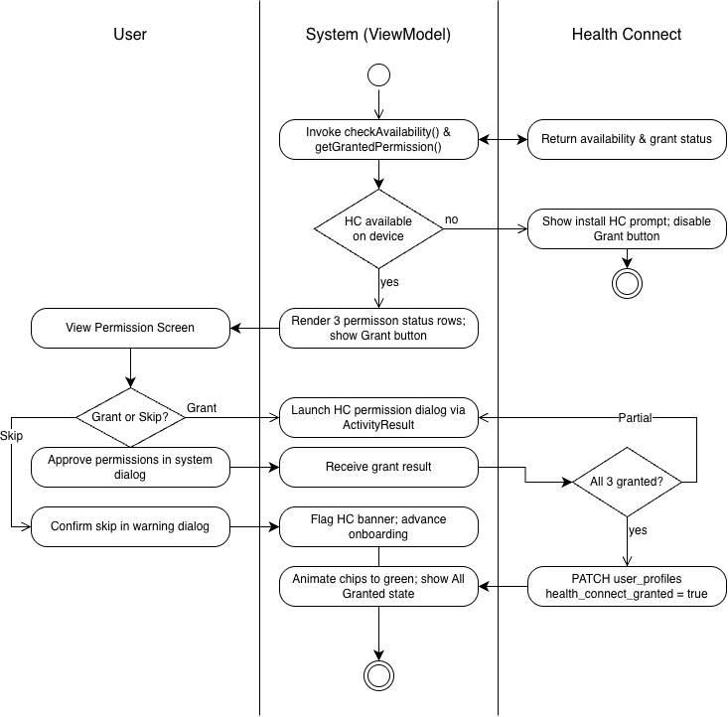
Figure 2: Health Connect Permissions Activity Diagram

Wireframe

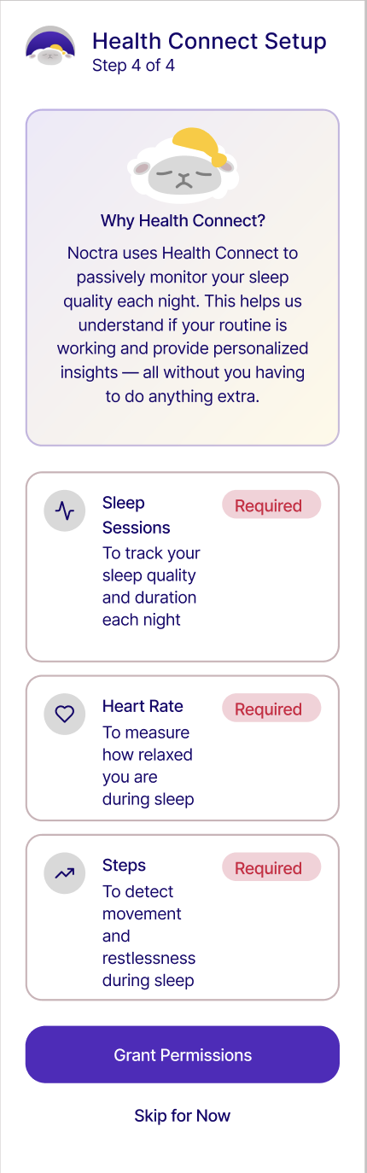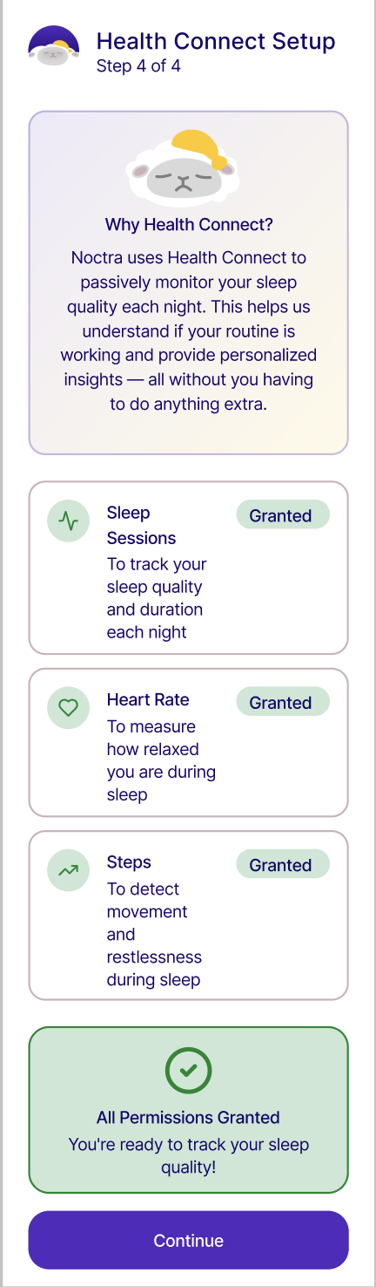

1.3.2 Skip Health Connect Setup

Use Case Diagram:
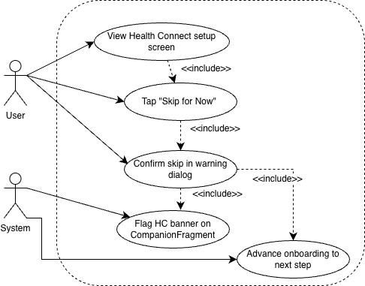

Use Case Description:

Use case name | Skip Health Connect Setup
Use case Id | UC-1.3.2
Actor(s) | User, System
Description | During onboarding, a user who does not wish to grant Health Connect permissions at this time taps "Skip for Now" on HealthConnectSetupFragment. The system presents a warning dialog explaining that sleep monitoring will be inactive until permissions are granted. Upon confirmation, the system flags a persistent Health Connect banner on CompanionFragment and advances the onboarding flow to OnboardingSummaryFragment.
Preconditions | The user is authenticated and has reached Step 4 of the onboarding flow (HealthConnectSetupFragment). Health Connect permissions have not yet been granted. The "Skip for Now" button is visible and enabled.
Postconditions | No Health Connect permissions are granted; health_connect_granted remains false in user_profiles. A persistent HealthConnectUnavailableBanner is flagged to appear on CompanionFragment until permissions are granted. The onboarding flow advances to OnboardingSummaryFragment. Sleep monitoring via MorningSyncWorker remains inactive until the user completes Health Connect setup from Settings.
Main Flow | - User views HealthConnectSetupFragment showing the three permission status rows and the "Skip for Now" text button.  - User taps "Skip for Now."  - System displays a warning dialog explaining that passive sleep monitoring will be unavailable until Health Connect permissions are granted and that setup can be completed later via Settings.  - User confirms the skip by tapping "Skip Anyway" in the dialog.  - HealthConnectViewModel sets the banner flag in SharedPreferences so HealthConnectUnavailableBanner renders on CompanionFragment on the next app open.  - OnboardingViewModel advances the onboarding flow, navigating the user to OnboardingSummaryFragment.

Activity Diagram: Refer to Figure 2: Health Connect Permissions Activity Diagram

Wireframe:
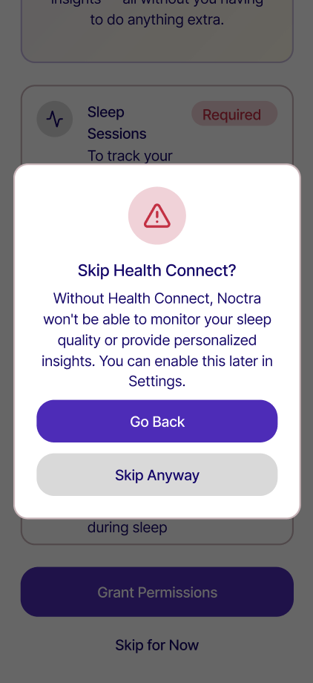

1.4.1 Update Target Bedtime

Use Case Diagram
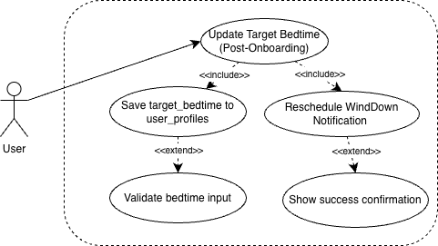

Use Case Description
Use case name | Update Target Bedtime
Use case Id | UC-1.4.1
Actor(s) | User
Description | A fully onboarded user navigates to SettingsFragment and changes their target bedtime using the time picker under the Routine Management section. The system validates the new value, persists it to user_profiles via Supabase PostgREST, and reschedules WindDownNotificationWorker via WorkManager so that T-30 and T-15 nudge notifications fire relative to the updated bedtime that same night.
Preconditions | The user is authenticated and has completed onboarding. The user is on SettingsFragment, accessible via UserProfileFragment. An active internet connection is available.
Postconditions | user_profiles.target_bedtime is updated to the new value. WindDownNotificationWorker is rescheduled via WorkManager with the new target bedtime, replacing the previously scheduled notifications. A success confirmation is displayed on SettingsFragment.
Main Flow | - User navigates to SettingsFragment from UserProfileFragment.  - System loads and displays the current target_bedtime value pre-populated in the time picker under the Routine Management section.  - User scrolls the time picker to select a new target bedtime.  - User confirms the selection by tapping the confirmation control.  - System validates that the selected value is a valid LocalTime.  - SettingsViewModel invokes UserProfileRepository.updateBedtime(), which sends a PATCH request to user_profiles.target_bedtime via Supabase PostgREST.  - On success, SettingsViewModel reschedules WindDownNotificationWorker via WorkManager using the new bedtime value, cancelling any previously scheduled worker instances for that user.  - System displays a brief success confirmation on SettingsFragment (e.g., snackbar: "Bedtime updated").

Activity Diagram
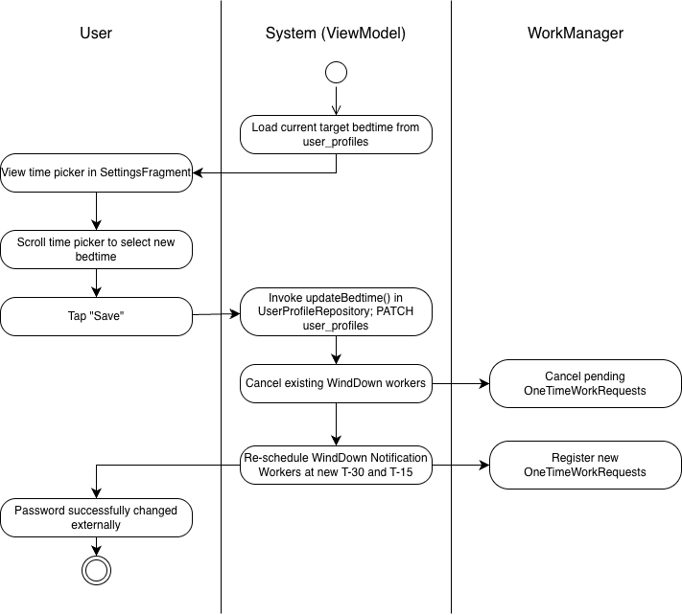

Wireframe
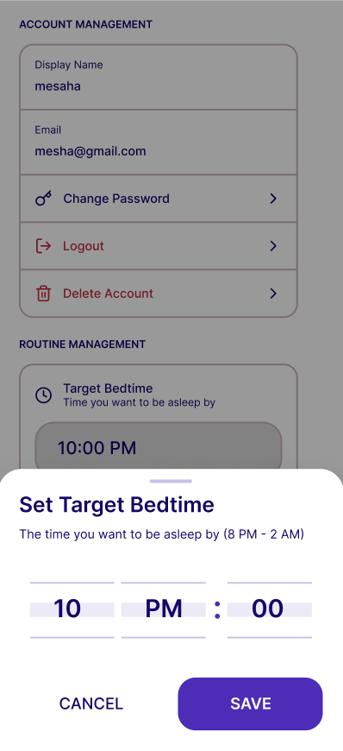

1.4.2 Toggle Wind-Down Reminders

Use Case Diagram:
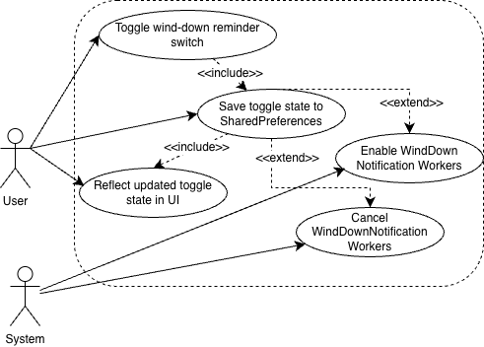

Use Case Description:

Use case name | Toggle Wind-Down Reminders
Use case Id | UC-1.4.2
Actor(s) | User, System
Description | From SettingsFragment, the user flips the Wind-Down Reminders toggle to enable or disable the nightly T-30 and T-15 push notifications. The system saves the new preference to SharedPreferences and either registers or cancels the WindDownNotificationWorker instances in WorkManager accordingly. The toggle state is reflected immediately in the UI.
Preconditions | The user is authenticated and on SettingsFragment. A target bedtime is configured in user_profiles. The current toggle state is loaded and displayed from SharedPreferences by SettingsViewModel on screen entry.
Postconditions | The new toggle preference is persisted in SharedPreferences. If toggled ON: two WindDownNotificationWorker OneTimeWorkRequest instances are registered with WorkManager at T-30 and T-15 relative to the user's target bedtime. If toggled OFF: all pending WindDownNotificationWorker tasks are cancelled via WorkManager using their work tag. The toggle switch in SettingsFragment reflects the updated state immediately.
Main Flow | - User views SettingsFragment and locates the Wind-Down Reminders toggle under the Notifications section.  - User taps the toggle switch to change its state.  - SettingsViewModel reads the new boolean value and persists it to SharedPreferences.  - If the new state is ON: SettingsViewModel invokes WorkManager to schedule two WindDownNotificationWorker OneTimeWorkRequest instances computed from the user's current target_bedtime in user_profiles.  - If the new state is OFF: SettingsViewModel invokes WorkManager.cancelAllWorkByTag("wind_down_worker"), cancelling all pending notification workers.  - SettingsFragment observes the updated toggle state from SettingsViewModel and re-renders the switch in its new position.

Activity Diagram:
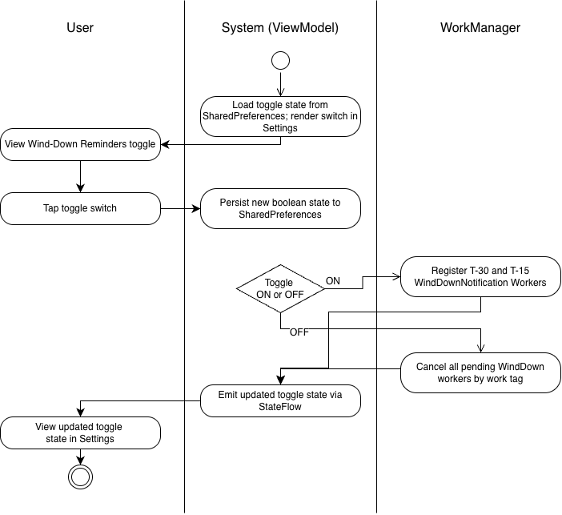

Wireframe:
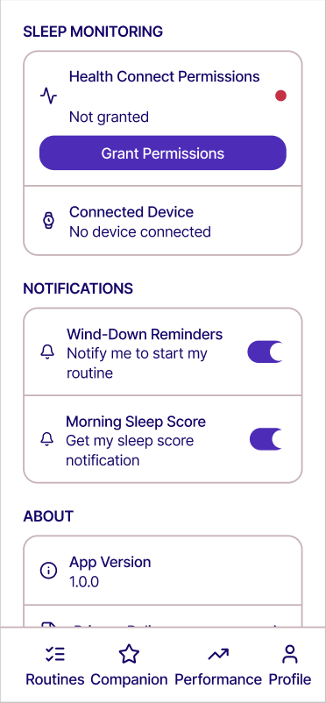

1.4.3 Toggle Morning Sleep Score Notification

Use Case Diagram:
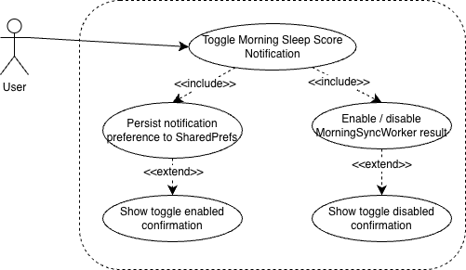

Use Case Description:

Use case name | Toggle Morning Sleep Score Notification
Use case Id | UC - 1.4.3
Actor(s) | User
Description | The user navigates to SettingsFragment and toggles the Morning Sleep Score notification switch under the Notifications section. The system persists the preference to SharedPreferences and enables or disables the MorningSyncWorker result notification accordingly. When enabled, a local push notification is dispatched each morning after the sleep score is computed if the composite score exceeds 80.
Preconditions | The user is authenticated and has completed onboarding. The user is on SettingsFragment under the Notifications section. An active internet connection is not required for this action.
Postconditions | The notification toggle state is persisted in SharedPreferences. If toggled on, MorningSyncWorker result notifications are enabled and will fire the following morning after sleep score computation. If toggled off, no morning score notification is delivered regardless of the computed score.
Main Flow | - User navigates to SettingsFragment from UserProfileFragment.  - System loads the current notification toggle state from SharedPreferences and renders the Morning Sleep Score toggle in its current on/off state.  - User taps the toggle switch.  - SettingsViewModel reads the new toggle state and persists it to SharedPreferences.  - If toggled on: SettingsViewModel enables the MorningSyncWorker result notification channel. The toggle animates to the enabled state.  - If toggled off: SettingsViewModel disables the MorningSyncWorker result notification. The toggle animates to the disabled state.  - System shows a brief confirmation (e.g., snackbar: "Morning score notifications on" or "Morning score notifications off").

Activity Diagram:
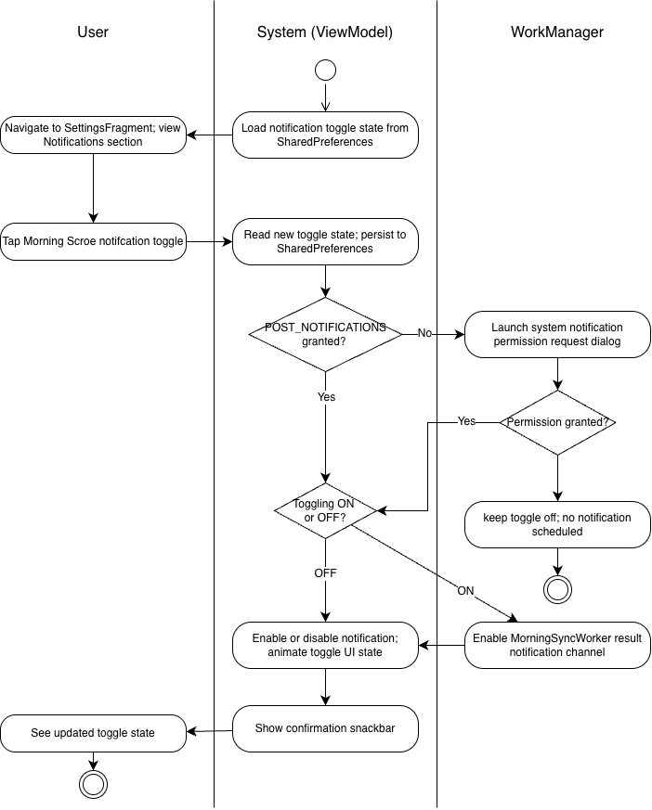

Wireframe:
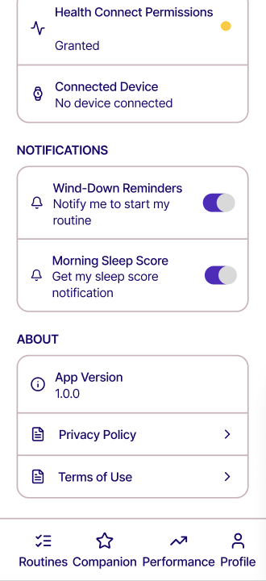

1.4.4 Manage Health Connect Permissions

Use Case Diagram:
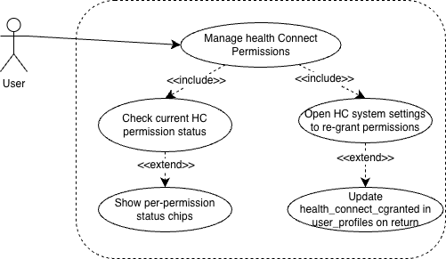

Use Case Description:

Use case name | Manage Health Connect Permissions
Use case Id | UC - 1.4.4
Actor(s) | User
Description | The user navigates to SettingsFragment and views the Health Connect Permissions row under the Sleep Monitoring section. The system checks the current grant status of all three required Health Connect permissions and displays a color-coded status chip for each. If any permissions are missing, the user can tap a button to open the Health Connect system settings to re-grant them. On returning to the app, the system re-checks the grant status and updates user_profiles.health_connect_granted accordingly.
Preconditions | The user is authenticated and has completed onboarding. The user is on SettingsFragment under the Sleep Monitoring section. Health Connect is installed on the device.
Postconditions | The current grant status of all three Health Connect permissions (Read Sleep, Read Heart Rate, Read Steps) is displayed. If the user re-grants permissions via the system settings, user_profiles.health_connect_granted is updated to true on return to the app.
Main Flow | - User navigates to SettingsFragment from UserProfileFragment.  - System invokes HealthConnectManager.getGrantedPermissions() to check the current grant status of READ_SLEEP, READ_HEART_RATE, and READ_STEPS.  - System renders the Health Connect Permissions row with a color-coded status chip for each permission (green "Granted" or red "Required").  - User taps the "Manage in Health Connect" button.  - System opens the Health Connect system settings screen via an Intent directed at the Health Connect app, allowing the user to review or re-grant permissions.  - User adjusts permissions within the Health Connect settings and returns to Noctra.  - System invokes HealthConnectManager.getGrantedPermissions() again on app resume (onResume()).  - If all three permissions are now granted, system calls UserProfileRepository.updateHealthConnectGranted(true), sending a PATCH to user_profiles.health_connect_granted.  - The permission status chips update reactively to reflect the new grant state.

Activity Diagram:
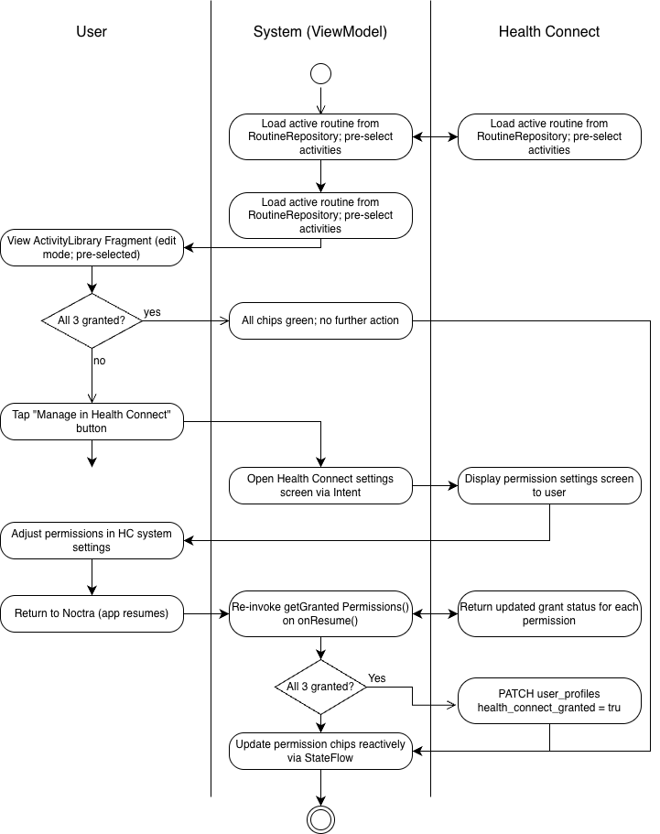

Wireframe:
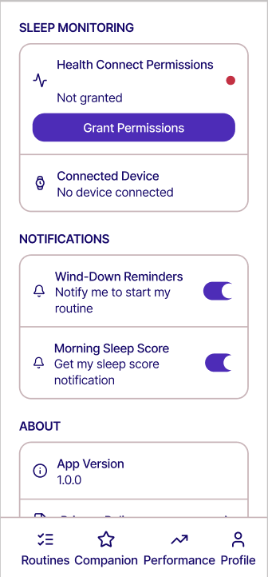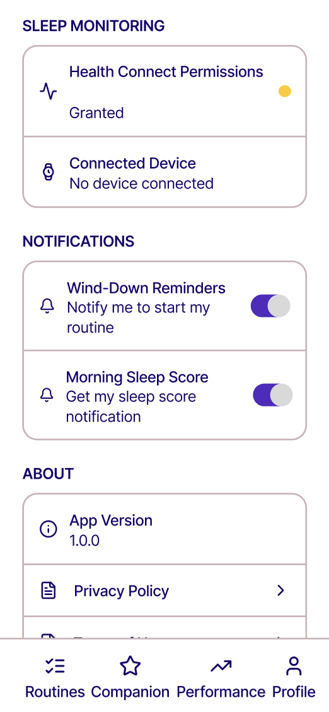

1.4.5 Logout

Use Case Diagram: Refer to Figure 1. Authentication Module Use Case Diagram

Use Case Description:
Use case name | Logout
Use case Id | UC-1.4.5
Actor(s) | User
Description | An authenticated user ends their session. The system invalidates the Supabase session token, clears it from the device, and navigates the user back to the login screen.
Preconditions | The user is authenticated with an active Supabase session stored in EncryptedSharedPreferences. The user has navigated to SettingsFragment via UserProfileFragment.
Postconditions | The Supabase session is invalidated and cleared from EncryptedSharedPreferences. The user is navigated to LoginFragment within auth_graph.
Main Flow | - User opens SettingsFragment from UserProfileFragment.  - User taps the "Logout" button under Account Management.  - System displays a confirmation dialog.  - User confirms by tapping "Logout" in the dialog.  - System calls AuthRepository.logout(), which calls supabase.auth.signOut().  - Session token is cleared from EncryptedSharedPreferences.  - System navigates the user to LoginFragment within auth_graph.

Activity Diagram
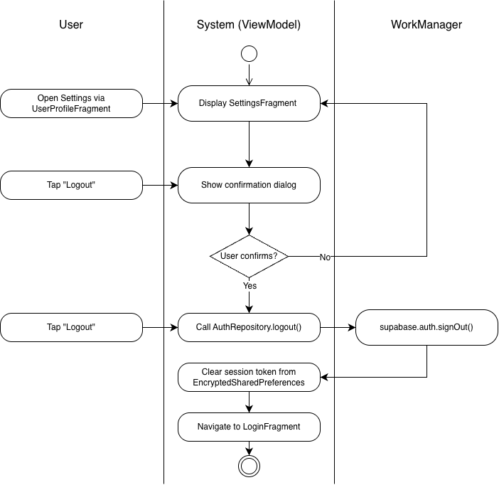

Wireframe

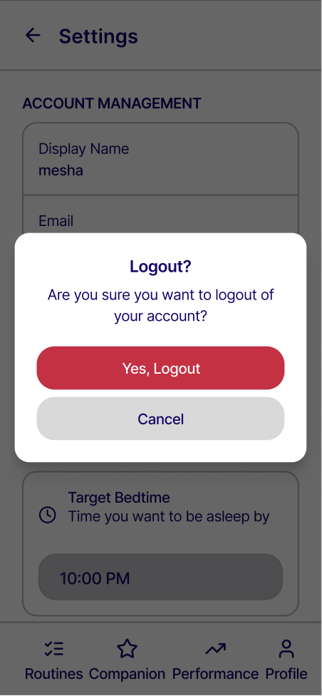

1.4.6 Delete Account

Use Case Diagram:
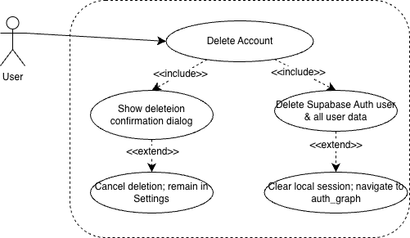

Use Case Description:

Use case name | Delete Account
Use case Id | UC-1.4.6
Actor(s) | User
Description | An authenticated user permanently deletes their Noctra account from SettingsFragment. The system presents a confirmation dialog warning that all data will be permanently removed. Upon confirmation, the system deletes the user's data from all Supabase tables, invokes Supabase Auth account deletion, clears the session token from EncryptedSharedPreferences, and navigates the user to RegistrationFragment.
Preconditions | The user is authenticated with an active Supabase session. The user is on SettingsFragment accessible via UserProfileFragment. An active internet connection is available.
Postconditions | All rows associated with the user's user_id are deleted from user_profiles, routine_configurations, routine_sessions, reward_ledger, sleep_records, user_inventory, friendships, and encouragement_reactions. The Supabase Auth user record is deleted. The session token is cleared from EncryptedSharedPreferences. The user is navigated to RegistrationFragment within auth_graph.
Main Flow | - User navigates to SettingsFragment and taps "Delete Account" under the Account Management section.  - User taps "Delete Account" under the Account Management section.  - User confirms by tapping "Delete Account" in the dialog.  - System invokes AuthRepository.deleteAccount(), which sends deletion requests to all user-associated Supabase PostgREST tables via cascading delete enforced by foreign key constraints on user_id.  - System calls supabase.auth.admin.deleteUser() to remove the Supabase Auth record.  - Session token is cleared from EncryptedSharedPreferences.  - System navigates the user to RegistrationFragment within auth_graph.

Activity Diagram:
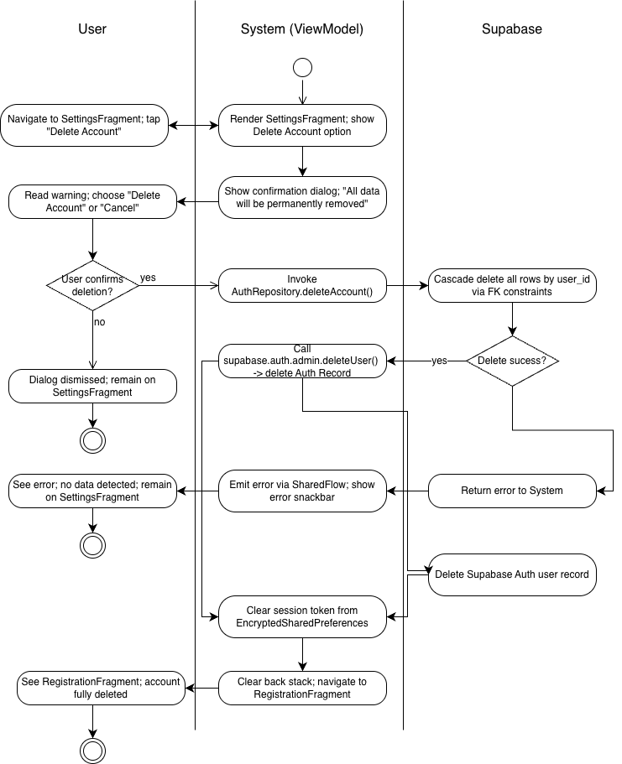

Wireframe:
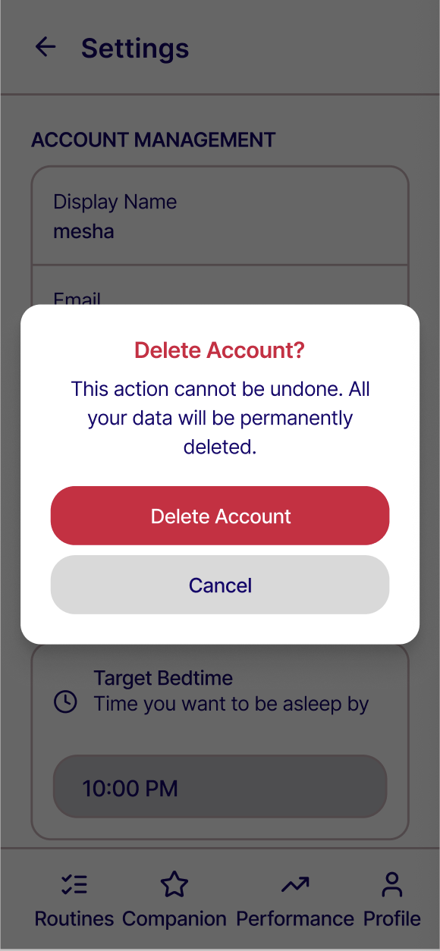

1.5.1 View Profile

Use Case Diagram
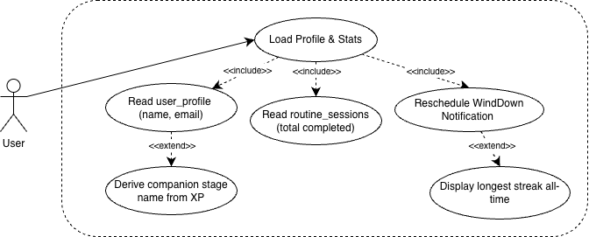
- Use Case Description

Use case name | View Profile
Use case Id | UC-1.5.1
Actor(s) | User
Description | When the user opens the Profile tab, the system concurrently reads three data sources — user_profiles, routine_sessions, and reward_ledger — and aggregates the results into a unified profile screen. The screen displays the user's identity section (display name, email, letter avatar), a stats summary (current streak, longest streak, total routines completed, companion stage name), and quick action buttons to navigate to Friends & Leaderboard and Settings.
Preconditions | The user is authenticated and has completed onboarding. The user has tapped the Profile tab in the bottom navigation bar, opening UserProfileFragment. An active internet connection is available.
Postconditions | UserProfileFragment is fully populated with the user's current display name, email, current streak, longest streak, total routines completed, and companion stage name. Quick action buttons to SocialFragment and SettingsFragment are visible and tappable.
Main Flow | - User taps the Profile tab in the bottom navigation bar.  - System navigates to UserProfileFragment. UserProfileViewModel initializes and concurrently invokes three data reads.  - UserProfileRepository reads user_profiles for the current user, returning display_name and email.  - RoutineSessionRepository reads routine_sessions, returning a count of all rows where is_completed = true for the current user.  - RewardRepository reads reward_ledger, returning current_streak, longest_streak, and total_xp.  - UserProfileViewModel passes total_xp to CompanionEvolutionUseCase to derive the current companion stage name.  - System renders the identity section with a letter avatar generated from the first character of display_name, the display name in large text, and the email in smaller read-only text.  - System renders the stats summary row showing current streak with a flame icon, longest streak, total routines completed, and companion stage name.  - System renders the "Friends & Leaderboard" and "Settings" quick action buttons.  - User views the fully populated profile screen.

Activity Diagram:
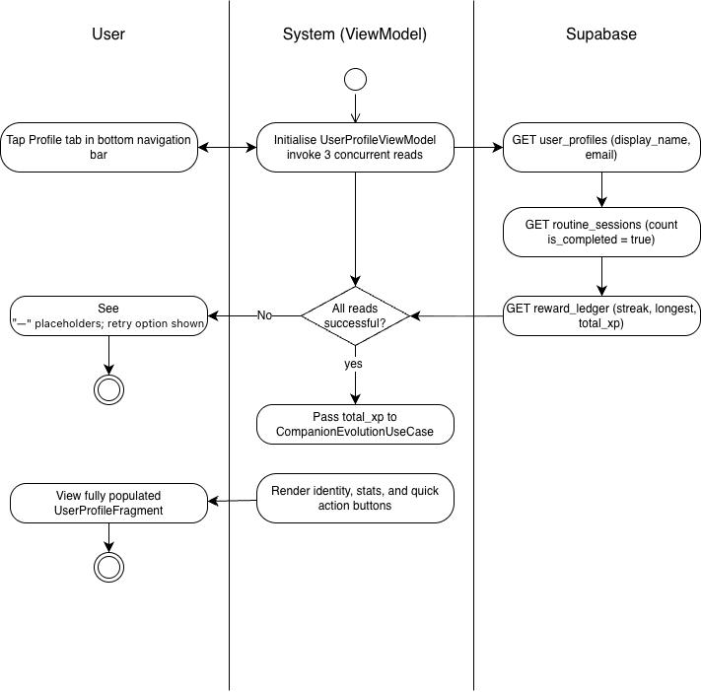

Wireframe
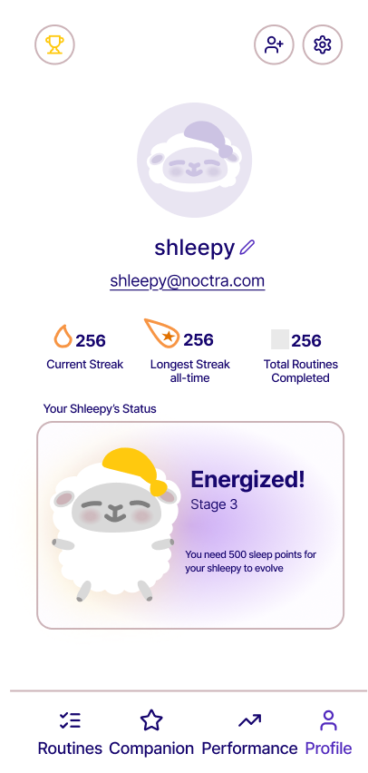

1.5.2 Edit display name

Use Case Diagram
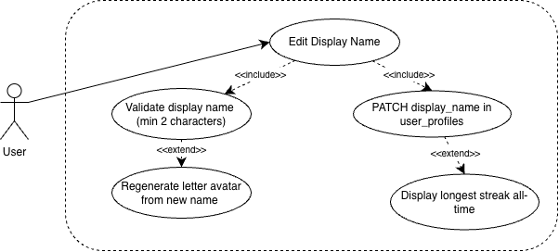

Use Case Description
Use case name | Edit Display Name
Use case Id | UC-1.5.2
Actor(s) | User
Description | The user taps the Edit icon beside their display name on UserProfileFragment, types a new name in the inline editable field, and confirms. The system validates the input, persists the updated name to user_profiles via Supabase PostgREST, and reactively refreshes the display name label and letter avatar on screen.
Preconditions | The user is authenticated and has completed onboarding. The user is on UserProfileFragment with the profile screen fully loaded. An active internet connection is available.
Postconditions | user_profiles.display_name is updated to the new value. The display name label on UserProfileFragment reflects the new name. The letter avatar regenerates from the first character of the new display name. The updated name is reflected on the Friends Leaderboard for all accepted friends on their next load.
Main Flow | - User taps the Edit icon beside the display name on UserProfileFragment.  - System switches the display name label to an inline editable TextField pre-filled with the current display name.  - User clears the field and types a new display name.  - System validates the input inline — the confirm button is disabled until the name meets the minimum of two characters.  - User taps the confirm button.  - UserProfileViewModel invokes UserProfileRepository.updateDisplayName(), which sends a PATCH request to user_profiles.display_name via Supabase PostgREST.  - On success, the inline TextField collapses back to a read-only label showing the new display name.  - The letter avatar regenerates from the first character of the new display name.  - UserProfileViewModel refreshes the exposed displayName StateFlow, updating all observing UI components.

Activity Diagram:
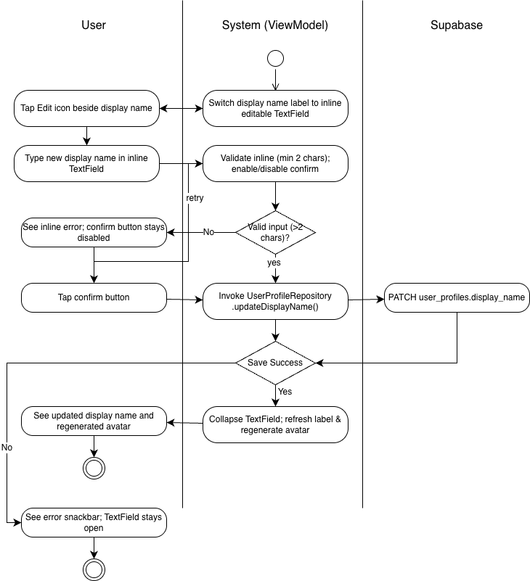

Wireframe
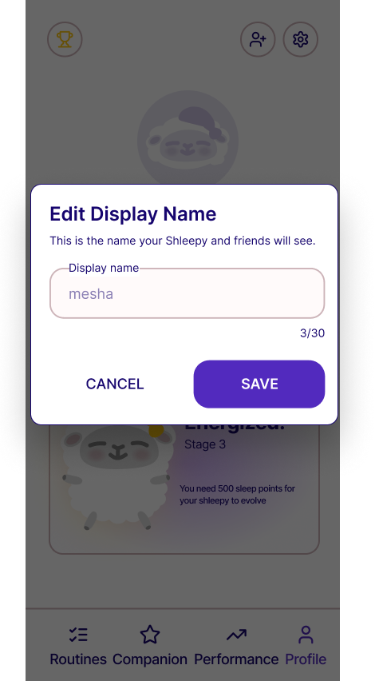

Module 2 - Gamified Nightly Engagement

2.1.1 Start Nightly Routine

Use Case Diagram:
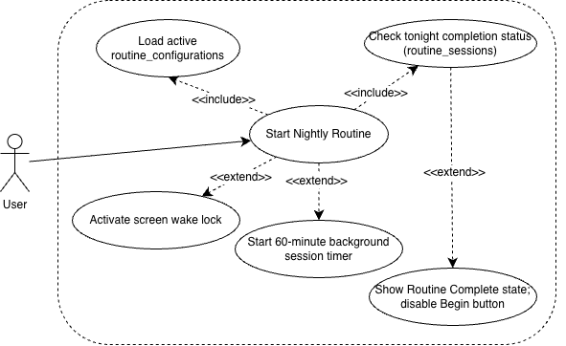

Use Case Description:

Use case name | Start Nightly Routine
Use case Id | UC-2.1.1
Actor(s) | User
Description | The user navigates to the Routine tab and taps the "Begin Routine" button on RoutineHomeFragment. The system loads the user's active routine configuration and navigates to RoutineExecutionFragment, which displays a start screen showing the routine name, total estimated duration, and a Start button. On tapping Start, the system begins the step-by-step routine execution flow and starts the 60-minute background session timer.
Preconditions | The user is authenticated and has completed onboarding. An active routine configuration exists for the user. The routine has not already been completed tonight (is_completed = true does not exist for today's date in routine_sessions). An active internet connection is available.
Postconditions | RoutineExecutionFragment is displayed with the first activity screen rendered. The 60-minute background session timer has started. The screen wake lock is active to prevent the display from sleeping during routine execution.
Main Flow | - User taps the Routine tab in the bottom navigation bar, opening RoutineHomeFragment.  - System displays the user's saved routine sequence as a non-interactive preview list with each activity label, type, and duration. The current streak and total estimated duration are shown.  - User taps "Begin Routine.  - System navigates to RoutineExecutionFragment.  - RoutineExecutionFragment displays the start screen showing the routine name and total estimated duration  - User taps "Start."  - System starts the 60-minute background session timer.  - Screen wake lock is activated via WindowManager.LayoutParams.FLAG_KEEP_SCREEN_ON.  - System renders the first activity screen and begins the step-by-step execution flow.

Activity Diagram:
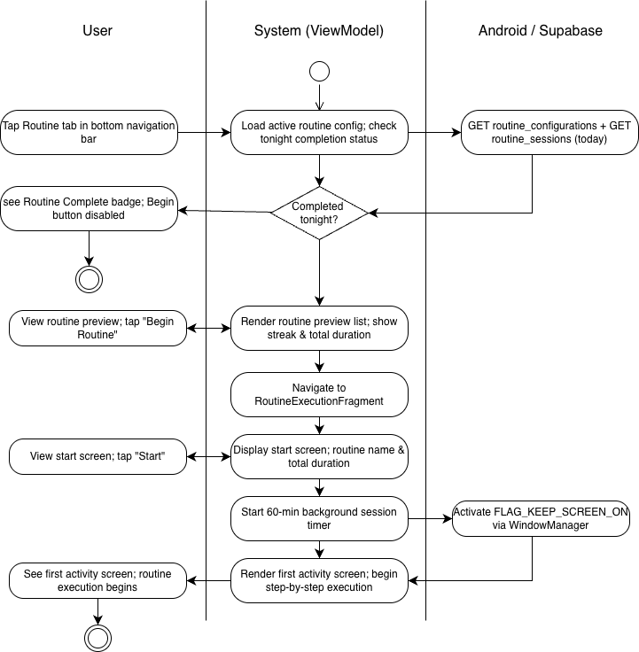

Wireframe:
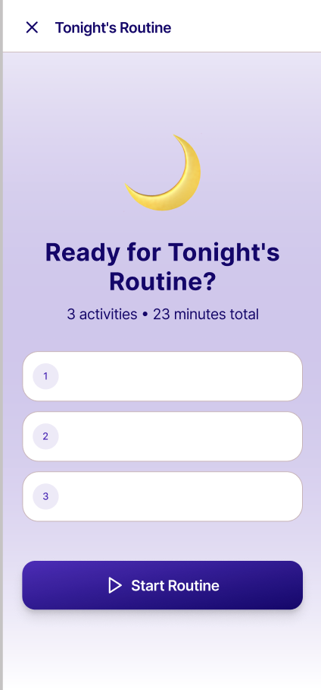

2.1.2 Complete Nightly Routine

Use Case Diagram:
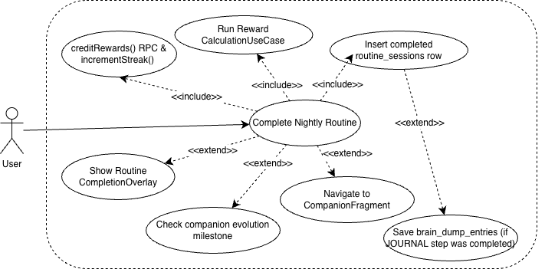

Use Case Description:

Use case name | Complete Nightly Routine
Use case Id | UC-2.1.2
Actor(s) | User
Description | The user completes all steps in their saved routine sequence on RoutineExecutionFragment and taps the "Complete Routine" button on the final activity screen. The system records the completed session, invokes RewardCalculationUseCase to compute Dream Tokens and Growth Points earned, atomically credits both to the reward ledger, and displays the RoutineCompletionOverlay showing the rewards earned. If CompanionEvolutionUseCase detects a new evolution milestone, the evolution animation plays on the next open of CompanionFragment.
Preconditions | The user is authenticated and has completed onboarding. The user is on the final activity screen of RoutineExecutionFragment. The 60-minute session timer has not yet expired. An active internet connection is available.
Postconditions | A new routine_sessions row is inserted with is_completed = true, session_start_time, and session_end_time for the current date. reward_ledger.token_balance is incremented by the computed Dream Token award. reward_ledger.total_xp is incremented by the flat Growth Points award. reward_ledger.current_streak is incremented by 1. reward_ledger.longest_streak is updated if the new streak exceeds the previous record. The RoutineCompletionOverlay is displayed showing tokens earned, XP earned, current streak, and active streak multiplier.
Main Flow | - User completes the final activity in their routine sequence on RoutineExecutionFragment.  - System displays a "Complete Routine" button instead of auto-transitioning.  - User taps "Complete Routine."  - RoutineViewModel invokes RoutineSessionRepository.saveSession(), inserting a new routine_sessions row with is_completed = true.  - RoutineViewModel invokes RewardCalculationUseCase with the user's current streak count.  - RewardCalculationUseCase computes the Dream Token award (BASE_TOKEN_AWARD × streak multiplier) and the flat Growth Points award.  - RewardRepository.creditRewards() atomically increments token_balance and total_xp in reward_ledger via Supabase RPC.  - RewardRepository.incrementStreak() increments current_streak and updates longest_streak if applicable.  - CompanionEvolutionUseCase checks whether the new total_xp crosses a milestone threshold and sets the evolution_pending flag if so.  - RoutineCompletionOverlay animates in, displaying tokens earned, XP earned, current streak count, and active streak multiplier.  - Overlay fades out after a few seconds, revealing CompanionFragment.

Activity Diagram:
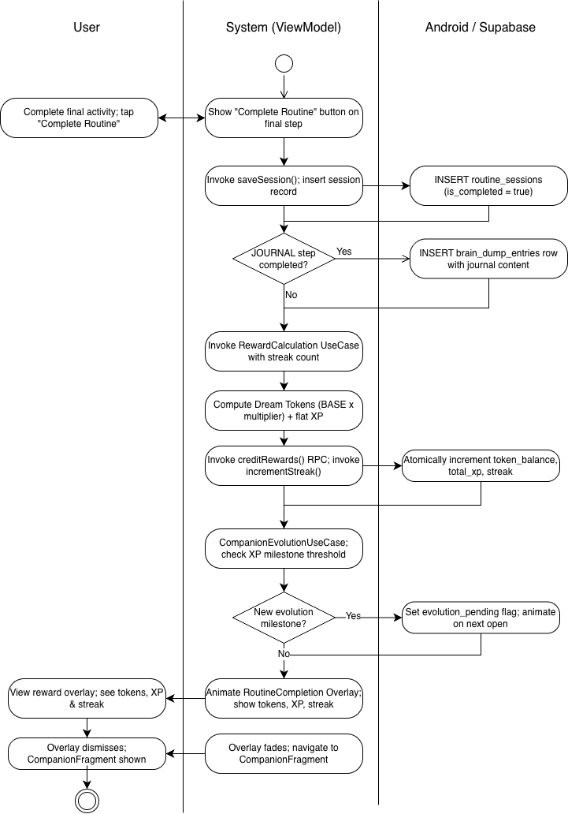

Wireframe:
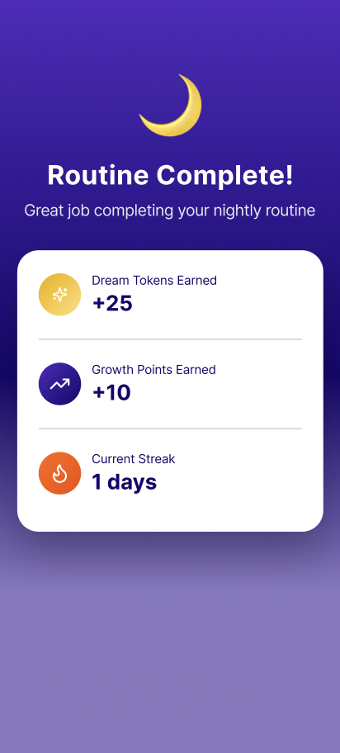

2.2.1 View Companion

Use Case Diagram
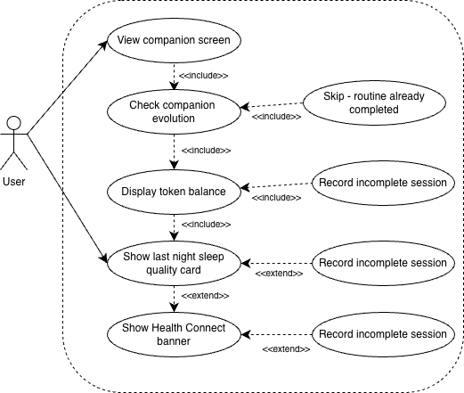

Use Case Description

Use case name | View Companion
Use case Id | UC-2.2.1
Actor(s) | User
Description | When the student navigates to the Companion tab, CompanionFragment initializes and CompanionViewModel loads all data required to render the companion character, XP progress, token balance, and last night's sleep quality card. If a new evolution milestone was crossed since the last visit, the evolution animation plays automatically. If Health Connect permissions are missing or the smartwatch has not synced recently, a persistent banner is displayed.
Preconditions | (1) User is authenticated and fully onboarded. (2) At least one nightly routine session has occurred. (3) A reward_ledger record exists for the current user.
Postconditions | (1) CompanionFragment is fully rendered with the correct evolution stage animation, XP progress, and token balance. (2) The sleep quality card reflects the previous night's data or the appropriate empty state. (3) If a new evolution was unlocked, the animation has played and the new stage is displayed. (4) A late Health Connect sync was attempted if no sleep data exists and the current time is before 12:00 PM.
Main Flow | - Student taps the Companion tab or the app opens to CompanionFragment.  - CompanionViewModel initializes and concurrently reads reward_ledger from RewardRepository for token_balance and total_xp, invokes CompanionEvolutionUseCase with total_xp to determine the current stage and XP progress percentage, and queries SleepRecordRepository for the previous night's sleep record.  - If CompanionEvolutionUseCase detects that total_xp has crossed a new milestone threshold, CompanionViewModel emits a newEvolutionUnlocked event; CompanionFragment pauses the idle animation, plays the evolution transition via CompanionCharacterView.playEvolutionAnimation(), then resumes the new stage's idle loop.  - CompanionCharacterView loads the Lottie asset for the current stage (e.g., companion_stage_2.json) and begins the idle animation.  - XPProgressView renders the progress bar animating to the current fill level, with the XP total on the left and the next milestone target on the right.  - Token balance is displayed with a coin icon below the progress bar.  - SleepQualityCardView renders last night's composite score, or the "No sleep data recorded last night" state if no record exists or data_capture_success = false.  - CompanionFragment.onResume() performs a late-sync check: if no sleep_records entry with data_capture_success = true exists for the previous night and the current time is before 12:00 PM, HealthConnectManager is invoked to attempt a late retrieval.  - If Health Connect permissions are missing or the last sync is more than 48 hours ago, HealthConnectUnavailableBanner is shown unless already dismissed today.

Activity Diagram
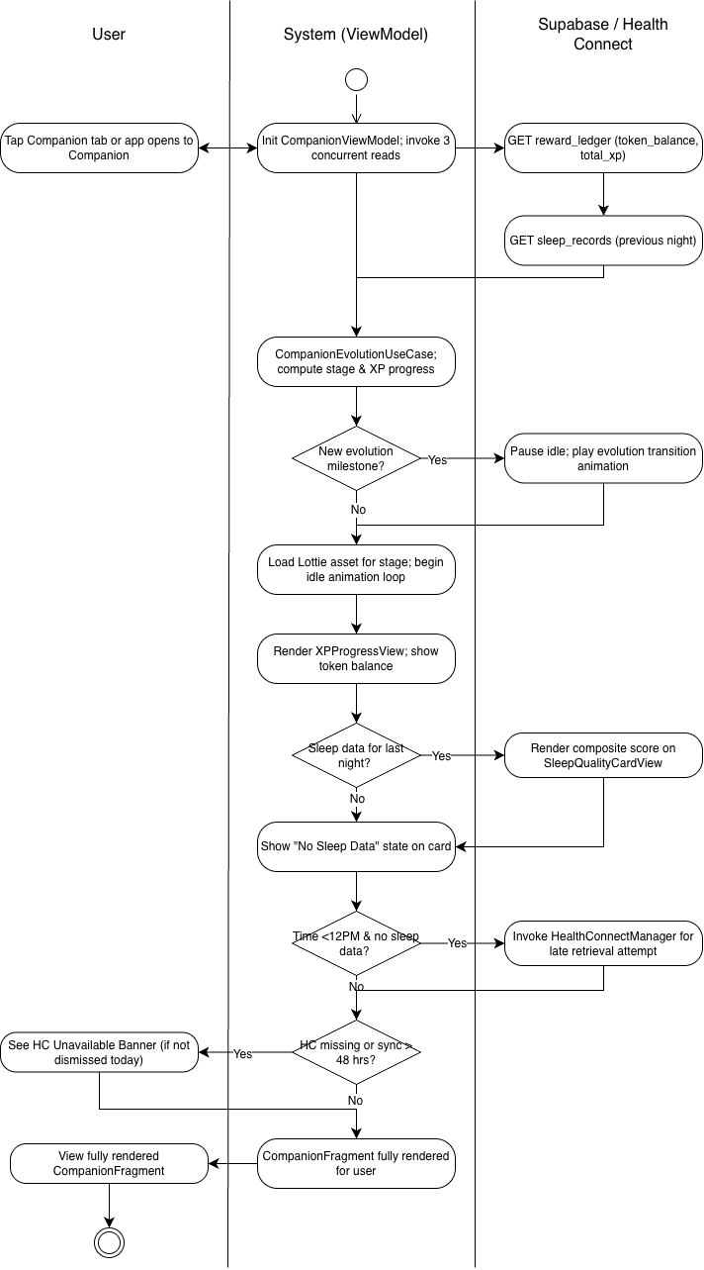

Wireframe
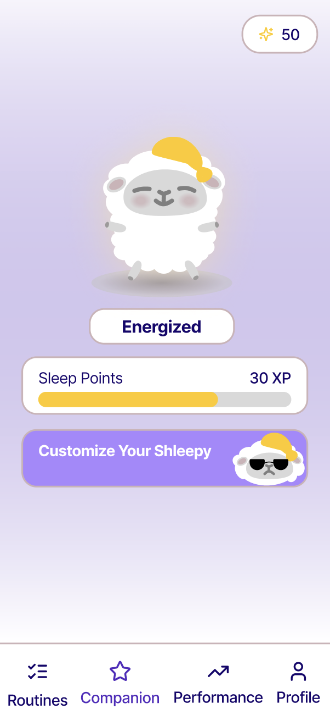

2.2.2 Customize Shleepy

Use Case Diagram:
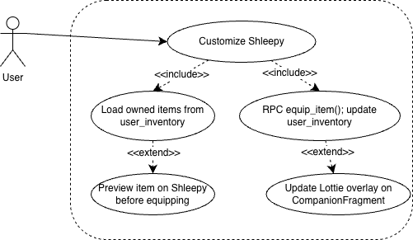

Use Case Description:

Use case name | Customize Shleepy
Use case Id | UC-2.2.2
Actor(s) | User
Description | The user taps "Customize Your Shleepy" on CompanionFragment, opening CustomizationFragment. The screen displays the full Shleepy illustration at the top, which updates in real time as items are equipped. Items are organized across four category tabs: Hats, Outfits, Accessories, and Footwear. The user can browse, purchase, equip, and unequip items within a single screen.
Preconditions | The user is authenticated and has completed onboarding. The user is on CompanionFragment and taps the "Customize Your Shleepy" button. An active internet connection is available.
Postconditions | CustomizationFragment is fully rendered showing the Shleepy illustration and all item cards organized by category. The user's current token balance is displayed. Owned items show Equip or Equipped states. Unowned items show Buy buttons with token costs.
Main Flow | - User taps "Customize Your Shleepy" on CompanionFragment.  - System navigates to CustomizationFragment.  - ShopViewModel loads all items from ShopRepository.getAllItems() and the user's current inventory from InventoryRepository.getUserInventory(), merging both into ShopItemDisplayModel.  - System renders the full Shleepy illustration at the top of the screen, reflecting currently equipped items.  - System renders four category tabs: Hats, Outfits, Accessories, Footwear.  - User browses item cards within each tab. Each card shows: preview thumbnail, label, token cost if unowned, and an action button (Buy, Equip, or Equipped).  - User may tap Buy on an unowned item to trigger UC-25 Purchase Shop Item.  - User may tap Equip on an owned item to trigger UC-26 Equip Shop Item.  - The Shleepy illustration at the top updates in real time whenever an item is equipped or unequipped, reflecting the current loadout via CompanionCharacterView.applyAccessoryOverlay().

Activity Diagram:
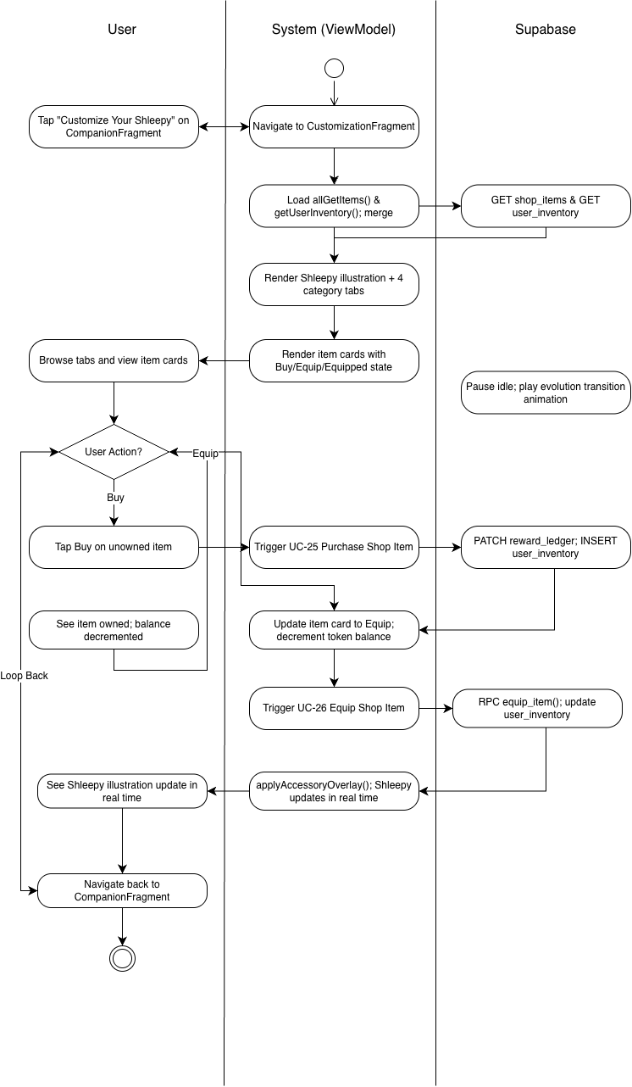

Wireframe:
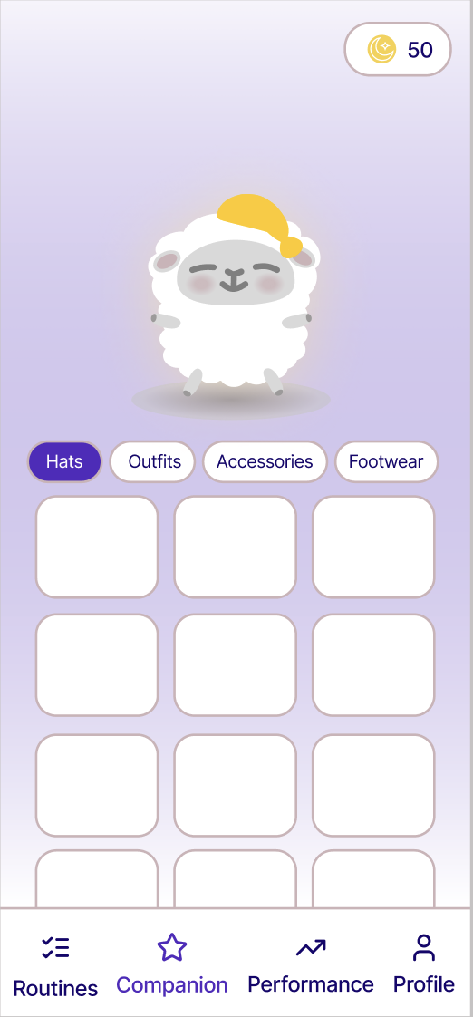
Figure 3: Companion Page Wireframe

2.2.3 Purchase shop item

Use Case Diagram
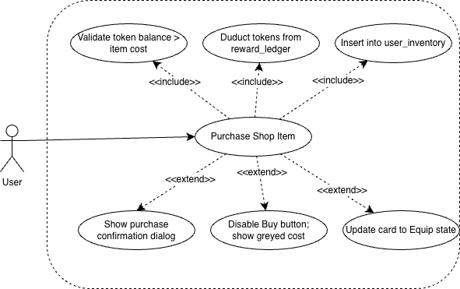

Use Case Description

Use case name | Purchase Shop Item
Use case Id | UC - 2.2.3
Actor(s) | User
Description | The user opens CustomizationFragment via the "Customize Your Shleepy" button on CompanionFragment and taps the Buy button on an unowned shop item. The system validates that the user's current Dream Token balance is sufficient, displays a purchase confirmation dialog, then atomically deducts the token cost from reward_ledger and inserts the item into user_inventory. The item card updates to an Equip state and the token balance decrements reactively on screen. If the user has insufficient tokens, the Buy button is disabled and the cost label is greyed out.
Preconditions | The user is authenticated and has completed onboarding. The user has opened CustomizationFragment via the "Customize Your Shleepy" button on CompanionFragment. The item has not already been purchased (not present in user_inventory for this user). An active internet connection is available.
Postconditions | reward_ledger.token_balance is decremented by the item's token_cost. A new row is inserted into user_inventory for the purchased item. The item card state changes from Buy to Equip. The token balance display at the top of CustomizationFragment updates reactively.
Main Flow | - User taps "Customize Your Shleepy" on CompanionFragment.  - System opens CustomizationFragment. ShopViewModel loads all items from ShopRepository.getAllItems() and the user's current inventory from InventoryRepository.getUserInventory().  - System merges the two datasets and renders each item card with its ownership and purchase state. The user's current token balance is displayed at the top of the screen.  - User browses items across the four category tabs (Hats, Outfits, Accessories, Footwear).  - User taps the Buy button on an unowned item.  - System displays a purchase confirmation dialog showing the item name and token cost.  - User confirms the purchase.  - ShopViewModel validates that reward_ledger.token_balance ≥ item token_cost.  - ShopViewModel invokes RewardRepository.deductTokens(amount), sending a PATCH to reward_ledger.token_balance via Supabase PostgREST.  - ShopViewModel invokes InventoryRepository.addItem(itemId), inserting a new row into user_inventory via Supabase PostgREST.  - The item card state changes from Buy to Equip. The token balance display decrements reactively.

Activity Diagram
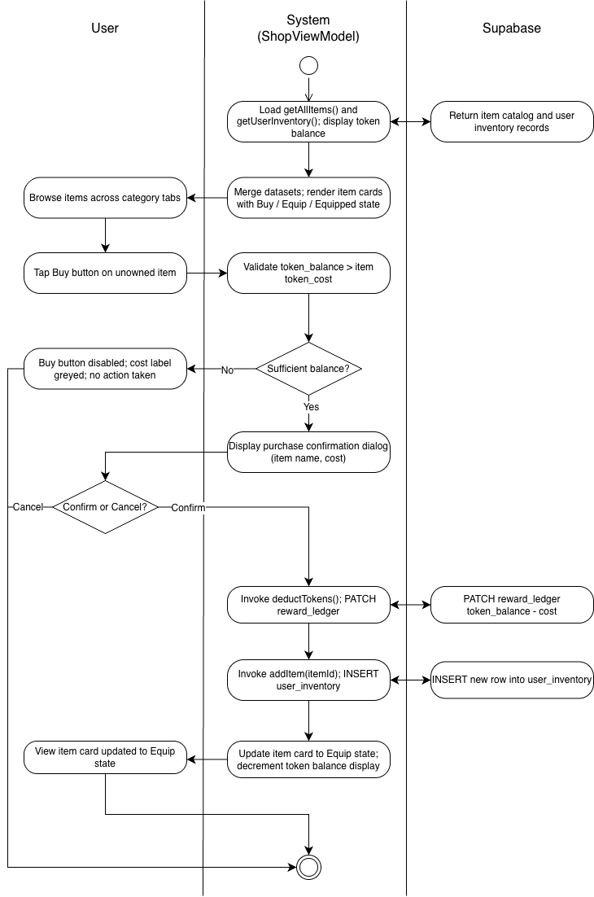

Wireframe: Refer to Figure 3: Companion Page Wireframe

2.2.4 Equip shop item

Use Case Diagram
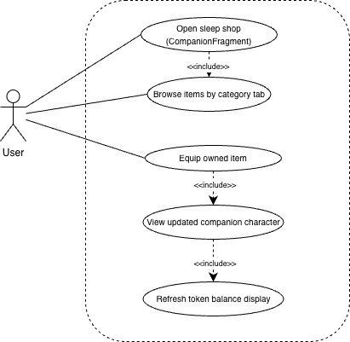

Use Case Description

Use case name | Equip Shop Item
Use case Id | UC-2.2.4
Actor(s) | User
Description | The user opens CustomizationFragment via the "Customize Your Shleepy" button on CompanionFragment and browses items by category tab. When the user taps "Equip" on an already-owned item, ShopViewModel invokes InventoryRepository.equipItem(itemId, category), which calls the Supabase RPC equip_item(user_id, item_id, category). The RPC atomically sets the selected item's is_equipped = true and all other items in the same category to is_equipped = false. The item list refreshes reactively and CompanionFragment re-renders the companion character to reflect the change.
Preconditions | The user is authenticated and has completed onboarding. The user has opened CustomizationFragment via the "Customize Your Shleepy" button on CompanionFragment. The item the user wishes to equip already exists in user_inventory. An active internet connection is available.
Postconditions | The selected item's is_equipped = true in user_inventory. All other items in the same category have is_equipped = false. The previously equipped item's action button reverts to "Equip." The newly equipped item's action button shows "Equipped." CompanionFragment re-renders the companion character to reflect the newly equipped item.
Main Flow | - User taps "Customize Your Shleepy" on CompanionFragment.  - System opens CustomizationFragment displaying items organized in tabs by category (Hats, Outfits, Accessories, Footwear).  - ShopViewModel.loadItems() fetches all items from ShopRepository.getAllItems() and the user's owned items from InventoryRepository.getUserInventory(), merging both into ShopItemDisplayModel to resolve each item's ownership and equipment status.  - The token balance is displayed persistently at the top of the screen and updates reactively.  - User browses the category tabs and identifies an already-owned item showing the "Equip" action button.  - User taps "Equip" on the item.  - ShopViewModel.equipItem(item: ShopItem) is invoked.  - InventoryRepository.equipItem(itemId, category) calls the Supabase RPC equip_item(user_id, item_id, category).  - The RPC atomically sets the target item's is_equipped = true and all other items in the same category to is_equipped = false.  - ShopViewModel refreshes the per-category item list state exposed as StateFlow<List<ShopItemDisplayModel>>.  - The previously equipped item's button reverts to "Equip"; the newly equipped item's button transitions to "Equipped."  - CompanionFragment observes the updated equipped state and re-renders the companion character via CompanionCharacterView.applyAccessoryOverlay().

Activity Diagram
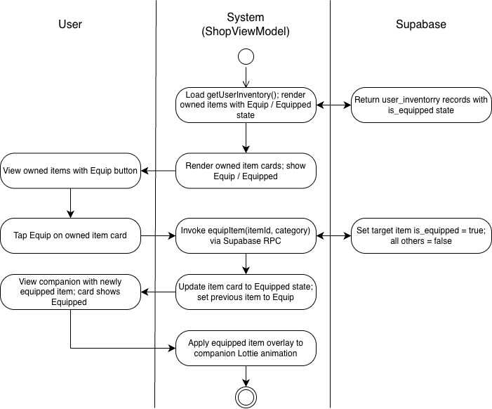

Wireframe: Refer to Figure 3: Companion Page Wireframe

2.2.5 Unequip item

Use Case Diagram:
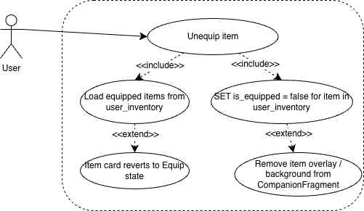

Use Case Description:

Use case name | Unequip Item
Use case Id | UC- 2.2.5
Actor(s) | User
Description | The user opens CustomizationFragment and taps "Unequip" on a currently equipped item. The system updates the item's is_equipped flag to false in user_inventory via a Supabase PostgREST PATCH and re-renders the companion character without the removed item. No token cost is incurred for unequipping.
Preconditions | The user is authenticated and has completed onboarding. The user is on CustomizationFragment. The item the user wishes to unequip is currently equipped (is_equipped = true in user_inventory). An active internet connection is available.
Postconditions | The item's is_equipped = false in user_inventory. The companion character re-renders without the unequipped item. The item's action button reverts from "Equipped" to "Equip."
Main Flow | - User opens CustomizationFragment via the "Customize Your Shleepy" button on CompanionFragment.  - User browses to a category tab containing a currently equipped item showing an "Equipped" action button.  - User taps "Equipped" to toggle the item off.  - ShopViewModel.unequipItem(item: ShopItem) is invoked.  - InventoryRepository.unequipItem(itemId) sends a PATCH request to user_inventory setting is_equipped = false for the target item via Supabase PostgREST.  - ShopViewModel refreshes the per-category item list StateFlow.  - The item's action button transitions from "Equipped" to "Equip."  - CompanionFragment observes the updated equipped state and re-renders the companion character via CompanionCharacterView.applyAccessoryOverlay(), removing the item from the illustration.

Activity Diagram:
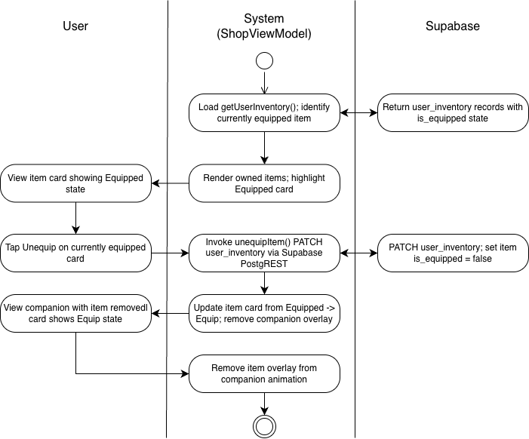

Wireframe: Refer to Figure 3: Companion Page Wireframe

2.3.1 View Leaderboard

Use Case Diagram:
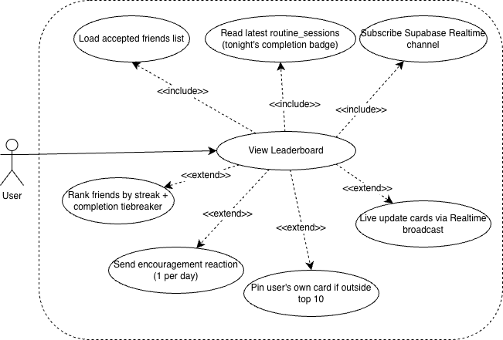

Use Case Description:

Use case name | View Leaderboard
Use case Id | UC- 2.3.1
Actor(s) | User
Description | The user navigates to SocialFragment via the "Friends & Leaderboard" button on UserProfileFragment and opens the Friends Leaderboard tab. The system loads the user's accepted friends list, ranks them by current streak descending, and renders the top 10 as friend cards. The leaderboard updates in real time via Supabase Realtime when any accepted friend completes their routine. If the user ranks outside the top 10, their card is pinned in the 10th position with their actual rank displayed.
Preconditions | The user is authenticated and has completed onboarding. The user has tapped "Friends & Leaderboard" on UserProfileFragment, opening SocialFragment. An active internet connection is available.
Postconditions | SocialFragment is fully rendered with the Friends Leaderboard tab displaying up to 10 accepted friend cards ranked by current streak descending. Each card shows the friend's rank number, display name, streak count, and tonight's completion badge. The user's own pinned card is visible if they rank outside the top 10.
Main Flow | - User taps "Friends & Leaderboard" on UserProfileFragment.  - System navigates to SocialFragment and defaults to the Friends Leaderboard tab.  - SocialViewModel invokes FriendshipRepository.getAcceptedFriends(), which returns all accepted friendships joined with user_profiles and the latest routine_sessions record to resolve display name, streak, and tonight's completion status for each friend.  - SocialViewModel computes the leaderboard ranking: friends are sorted by current_streak descending; tiebreaker is the timestamp of the most recently completed routine session.  - System renders the top 10 friend cards in FriendsLeaderboardRecyclerView. Each card displays rank number, display name, streak count with a flame icon, and tonight's completion badge (green star if is_completed = true for tonight, grey circle if not).  - If the user ranks outside the top 10, the top 9 friends are displayed normally and the user's own card is pinned in the 10th position with their actual rank shown.  - If no friends have been added yet, the user sees only their own card on the leaderboard.  - SocialViewModel subscribes to Supabase Realtime via FriendshipRepository for live updates. When any accepted friend completes their routine, the leaderboard RecyclerView updates reactively via ListAdapter with DiffUtil.

Activity Diagram:
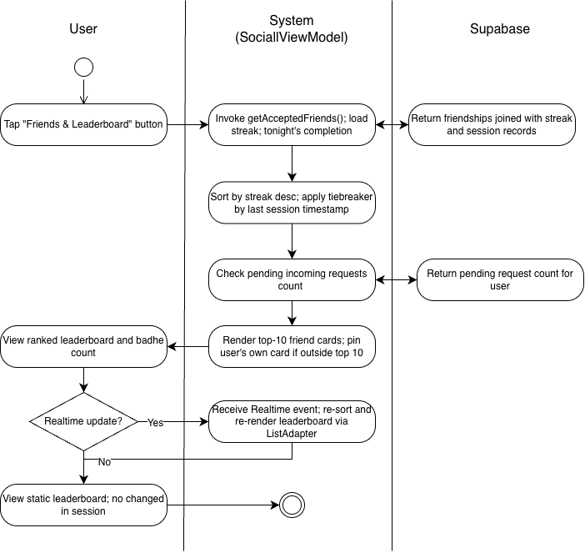

Wireframe:

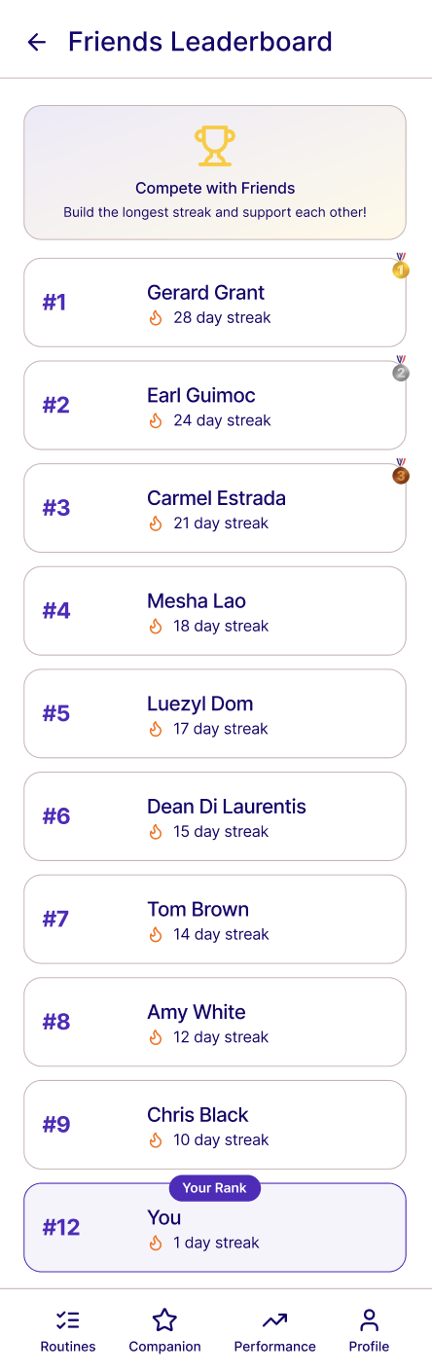

2.3.2 Send friend request

Use Case Diagram
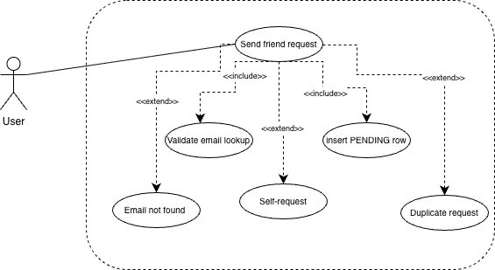

Use Case Description
Use case name | Send Friend Request
Use case Id | UC- 2.3.2
Actor(s) | User(requester)
Description | The user taps "Add Friend" in SocialFragment, opening AddFriendBottomSheet. The user enters the recipient's registered email address and taps "Send Request." FriendshipRepository.sendFriendRequest(email) looks up the matching user_id in user_profiles, validates the email, and inserts a new friendships row with status = PENDING. Supabase Realtime broadcasts the INSERT event to the recipient's device, triggering a push notification. The bottom sheet transitions to a "Request Sent" confirmation state and dismisses.
Preconditions | The user is authenticated and has completed onboarding. The user is on SocialFragment with the Friends Leaderboard tab open. The user has tapped "Add Friend," opening AddFriendBottomSheet. An active internet connection is available.
Postconditions | A new row exists in the friendships table with requester_id = current_user_id, receiver_id = resolved_user_id, and status = PENDING. AddFriendBottomSheet displays a "Request Sent" confirmation state and dismisses. The recipient's device receives a push notification: "You have a new friend request on Noctra!" with a deep-link PendingIntent targeting FriendRequestsFragment.
Main Flow | - User taps the "Add Friend" button in SocialFragment.  - System opens AddFriendBottomSheet containing a single email input field and a "Send Request" button.  - User types the recipient's registered email address into the input field.  - System validates email format inline — the "Send Request" button is disabled until a valid email format is entered.  - User taps "Send Request."  - SocialViewModel.sendFriendRequest(email) is invoked.  - FriendshipRepository.sendFriendRequest(email) looks up the user_id in user_profiles where email matches the entered value.  - System validates: the email exists in user_profiles, the email does not belong to the current user, and no existing PENDING or ACCEPTED friendships row exists for this requester–receiver pair.  - FriendshipRepository inserts a new friendships row with status = PENDING.  - Supabase Realtime broadcasts the INSERT event on the friendships table to the recipient's subscribed device.  - The recipient's FriendRequestNotificationWorker handler dispatches a local push notification: "You have a new friend request on Noctra!" with a deep-link PendingIntent targeting FriendRequestsFragment, delivered via NotificationManager on the "Social" notification channel.  - AddFriendBottomSheet transitions to a "Request Sent" confirmation state and dismisses.

Activity Diagram
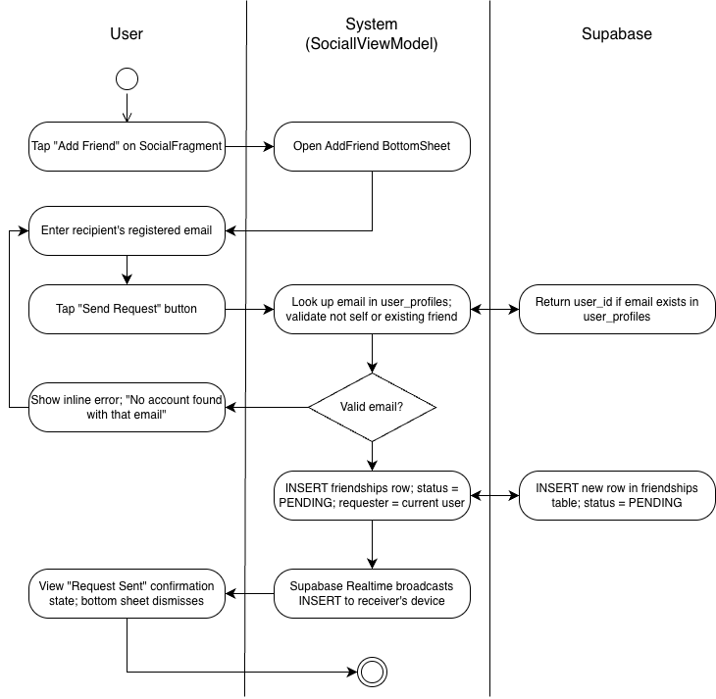

Wireframe
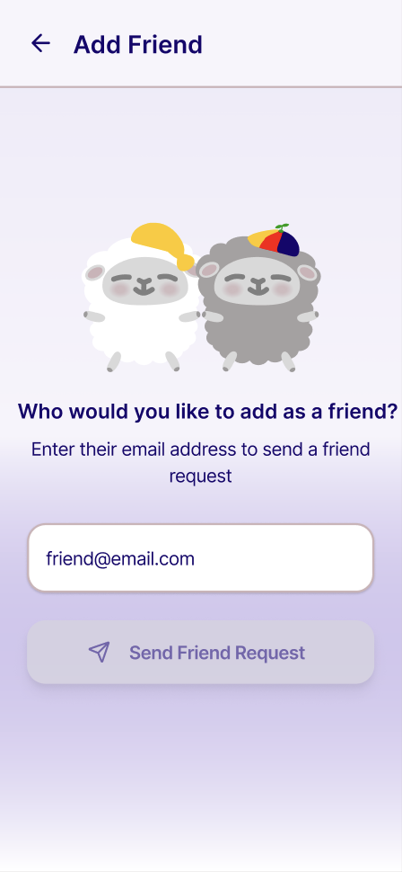

2.3.3 Accept friend request

Use Case Diagram
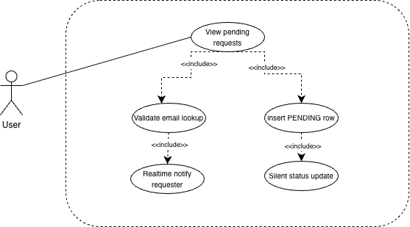
Figure 4: Accept/Decline Friend Request Use Case Diagram

Use Case Description
Use case name | Accept Friend Request
Use case Id | UC- 2.3.3
Actor(s) | User(receiver)
Description | The user opens FriendRequestsFragment via the notification bell icon or the "Requests" button in SocialFragment. Pending incoming requests are listed, each showing the requester's display name and email with Accept and Decline buttons. Tapping "Accept" updates the friendships row to status = ACCEPTED and Supabase Realtime notifies the requester.
Preconditions | The user is authenticated and has completed onboarding. At least one friendships row exists where receiver_id = current_user_idand status = PENDING. The user has opened FriendRequestsFragment via the notification bell icon or the "Requests" button in SocialFragment. An active internet connection is available.
Postconditions | The friendships row status = ACCEPTED. Both users appear on each other's Friends Leaderboard on next load. The requester receives a push notification: "Your friend request was accepted!" with a deep-link PendingIntent targeting SocialFragment. The accepted request row is removed from FriendRequestsFragment.
Main Flow | - User opens FriendRequestsFragment via the notification bell icon or the "Requests" button at the top of the Friends Leaderboard tab.  - SocialViewModel invokes FriendshipRepository.getPendingIncomingRequests(), which returns all friendships rows where receiver_id = current_user_id and status = PENDING.  - System renders each request as a row showing the requester's display name and email address, with "Accept" and "Decline" action buttons.  - User taps "Accept" on a request row.  - SocialViewModel.acceptFriendRequest(friendshipId) is invoked.  - FriendshipRepository.acceptFriendRequest(friendshipId) updates the friendships row status = ACCEPTED via Supabase PostgREST.  - Supabase Realtime broadcasts the UPDATE event on the friendships table to the requester's subscribed device.  - The accepted request row animates out of FriendRequestsFragment.  - The Friends Leaderboard refreshes to include the newly accepted friend.

Activity Diagram
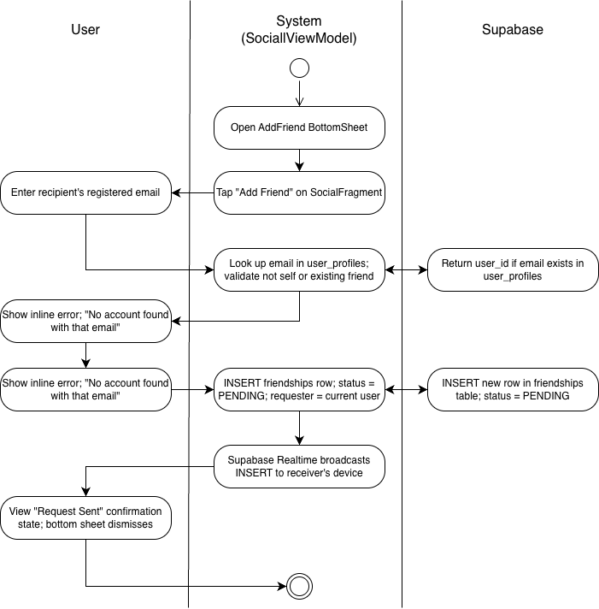

Wireframe
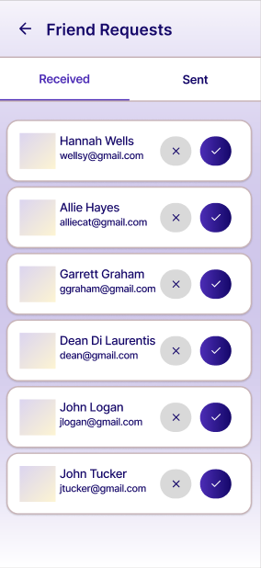
Figure 5: Accept / Decline Friend Request Wireframe

2.3.4 Decline Friend Request

Use Case Diagram: Refer to Figure 4: Accept/Decline Friend Request Use Case Diagram

Use Case Description:

Use case name | Decline Friend Request
Use case Id | UC- 2.3.4
Actor(s) | User(receiver)
Description | The user opens FriendRequestsFragment via the notification bell icon or the "Requests" button in SocialFragment. Pending incoming requests are listed, each showing the requester's display name and email with Accept and Decline buttons. Tapping "Decline" updates the row to status = DECLINED silently with no notification sent. In both cases the request row animates out of the list.
Preconditions | The user is authenticated and has completed onboarding. At least one friendships row exists where receiver_id = current_user_idand status = PENDING. The user has opened FriendRequestsFragment via the notification bell icon or the "Requests" button in SocialFragment. An active internet connection is available.
Postconditions | The friendships row status = DECLINED. No push notification is sent to the requester. The declined request row is removed from FriendRequestsFragmentsilently.
Main Flow | - User opens FriendRequestsFragment via the notification bell icon or the "Requests" button at the top of the Friends Leaderboard tab.  - SocialViewModel invokes FriendshipRepository.getPendingIncomingRequests(), which returns all friendships rows where receiver_id = current_user_id and status = PENDING.  - System renders each request as a row showing the requester's display name and email address, with "Accept" and "Decline" action buttons.  - User taps "Decline" on a request row.  - SocialViewModel.acceptFriendRequest(friendshipId) is invoked.  - FriendshipRepository.acceptFriendRequest(friendshipId) updates the friendships row status = DECLINED via Supabase PostgREST.  - Supabase Realtime broadcasts the UPDATE event on the friendships table to the requester's subscribed device.

Activity Diagram:
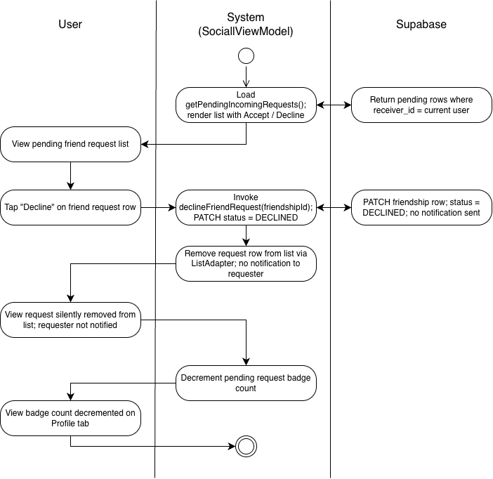

Wireframe: Refer to Figure 5: Accept / Decline Request Wireframe

Module 3 - Sleep Quality Monitoring

3.1.1 View Sleep Quality Score

Use Case Diagram:
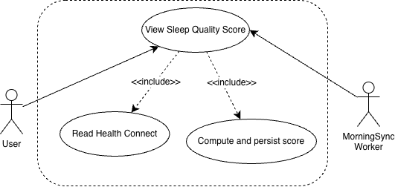

Use Case Description:

Use case name | View Sleep Quality Score
Use case Id | UC-3.1.1
Actor(s) | User
Description | The user opens CompanionFragment and views last night's composite sleep quality score on SleepQualityCardView. The score is computed by MorningSyncWorker from Health Connect sleep data retrieved in the background after the user wakes. The card displays one of three states: Loading (sync in progress), Success (score displayed), or No Data (sync failed or Health Connect unavailable).
Preconditions | The user is authenticated and has completed onboarding. Health Connect permissions are granted. The user has opened CompanionFragment. MorningSyncWorker has executed or is executing within its 6:00 AM–9:00 AM flex window.
Postconditions | SleepQualityCardView renders in the Success state displaying the composite sleep quality score as a circular gauge with a color gradient, the score number, and a plain-language quality label (e.g., "Good Sleep," "Fair Sleep," "Poor Sleep"). If no data is available, the card renders in the No Data state with a Retry button.
Main Flow | - User opens CompanionFragment.  - CompanionViewModel queries SleepRecordRepository for the previous night's sleep record.  - If a sleep_records entry with data_capture_success = true exists for the previous date, SleepQualityCardView renders in the Success state displaying the composite score, color gradient gauge, and plain-language quality label.  - If no completed record exists and the current time is before 12:00 PM, CompanionFragment performs a late-sync check by invoking HealthConnectManager to attempt a late retrieval. SleepQualityCardView renders in the Loading state during retrieval.  - If the late retrieval succeeds, SleepQualityProcessingUseCase computes the composite score and SleepRecordRepository.saveSleepRecord() persists the result. SleepQualityCardView transitions to the Success state.  - If the late retrieval fails or no data is available, SleepQualityCardView renders in the No Data state displaying a "No sleep data recorded last night" message and a Retry button.  - If Health Connect permissions are missing or the last sync is more than 48 hours ago, HealthConnectUnavailableBanner is shown on CompanionFragment.

Activity Diagram:

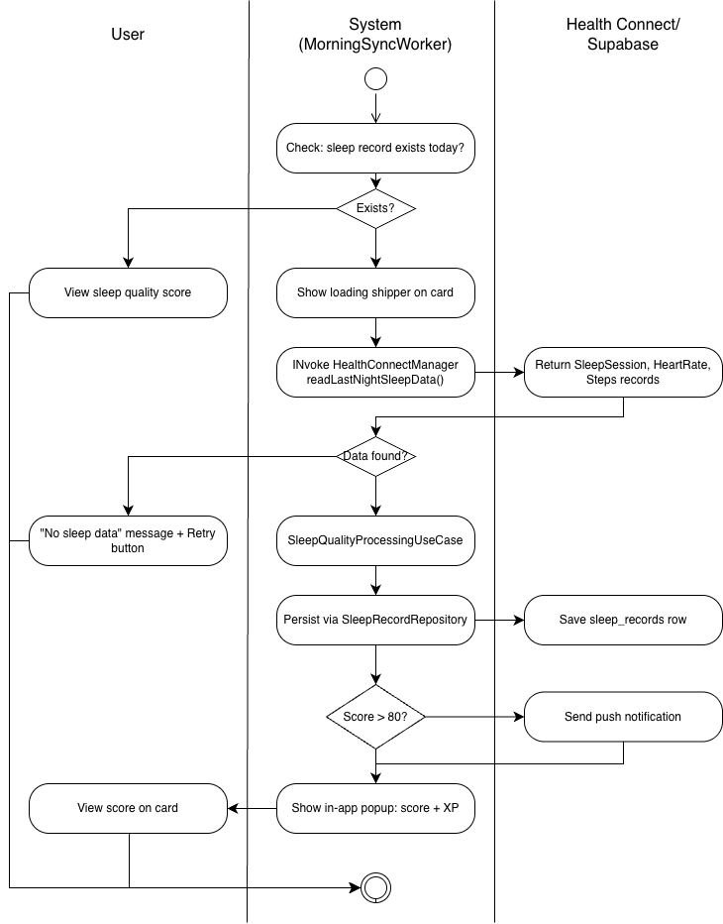

Wireframe:
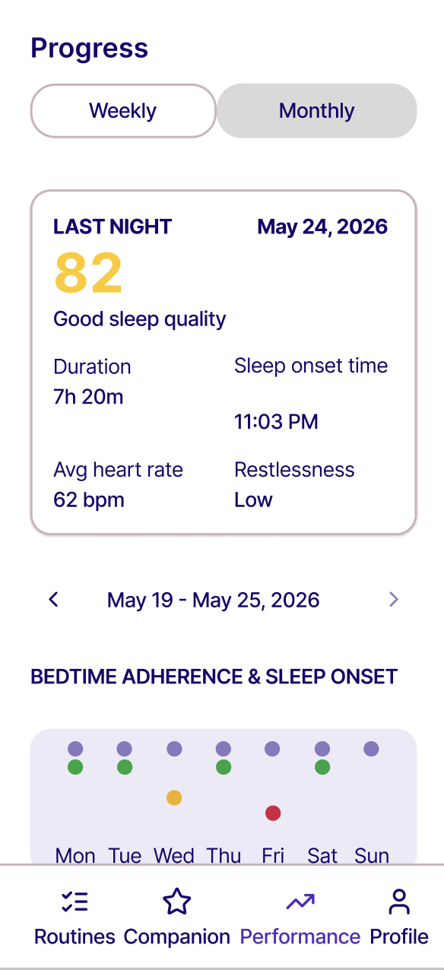

3.1.2 Retry Sleep Data Sync

Use Case Diagram
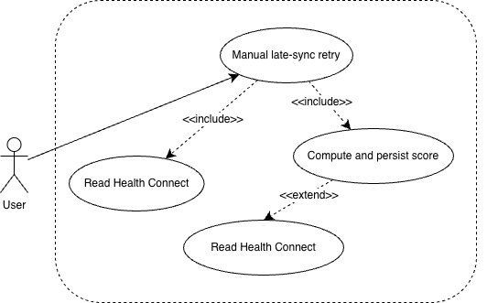

Use Case Description

Use case name | Retry Sleep Data Sync
Use case Id | UC-3.1.2
Actor(s) | User
Description | When the user opens CompanionFragment and SleepQualityCardView shows the "No sleep data recorded last night" state, they can tap the "Retry" button to manually trigger a late Health Connect retrieval attempt. This handles the edge case where the user woke after 9:00 AM, after MorningSyncWorker's flex window had already closed. CompanionFragment performs a lightweight sync check on resume: if no sleep_records entry with data_capture_success = true exists for the previous night and the current time is before 12:00 PM, it triggers a manual HealthConnectManager read. On the "Retry" tap, HealthConnectManager.readSleepData() is invoked again for the previous night's window. If a completed SleepSessionRecord is now available, the full scoring flow runs through SleepQualityProcessingUseCase and the result is persisted via SleepRecordRepository.saveSleepRecord(). If data is still unavailable, the card remains in the no-data state.
Preconditions | The user is authenticated and has completed onboarding. Health Connect permissions are granted. The user has opened CompanionFragment and SleepQualityCardView is showing the "No sleep data recorded last night" state with a visible "Retry" button. No sleep_records row with data_capture_success = true exists for the previous date. The current time is before 12:00 PM.
Postconditions | Success path: A new sleep_records row is inserted with data_capture_success = true and the computed composite_score. SleepQualityCardView transitions from the no-data state to the success state displaying the composite score. user_profiles.hr_baseline_bpm is updated.  No-data path: No new sleep_records row is inserted with data_capture_success = true. SleepQualityCardView remains in the no-data state with a brief message informing the user that sleep data is still unavailable.
Main Flow | - User opens CompanionFragment. On resume, the system checks whether a sleep_records entry with data_capture_success = trueexists for the previous night.  - No such record is found and the current time is before 12:00 PM. SleepQualityCardView renders in the "No sleep data recorded last night" state showing the "Retry" button and a brief troubleshooting tip.  - User taps "Retry."  - SleepQualityCardView transitions to the loading shimmer state.  - HealthConnectManager.readSleepData(date) is invoked for the previous night's window.  - A completed SleepSessionRecord is found.  - HealthConnectManager.readHeartRateData() and HealthConnectManager.readMovementData() are invoked for the confirmed sleep window.  - SleepQualityProcessingUseCase.compute() calculates the sub-scores and composite score.  - SleepRecordRepository.saveSleepRecord() inserts the record with data_capture_success = true.  - HeartRateBaselineUseCase updates user_profiles.hr_baseline_bpm.  - SleepQualityCardView transitions to the success state and displays the composite score.

Activity Diagram
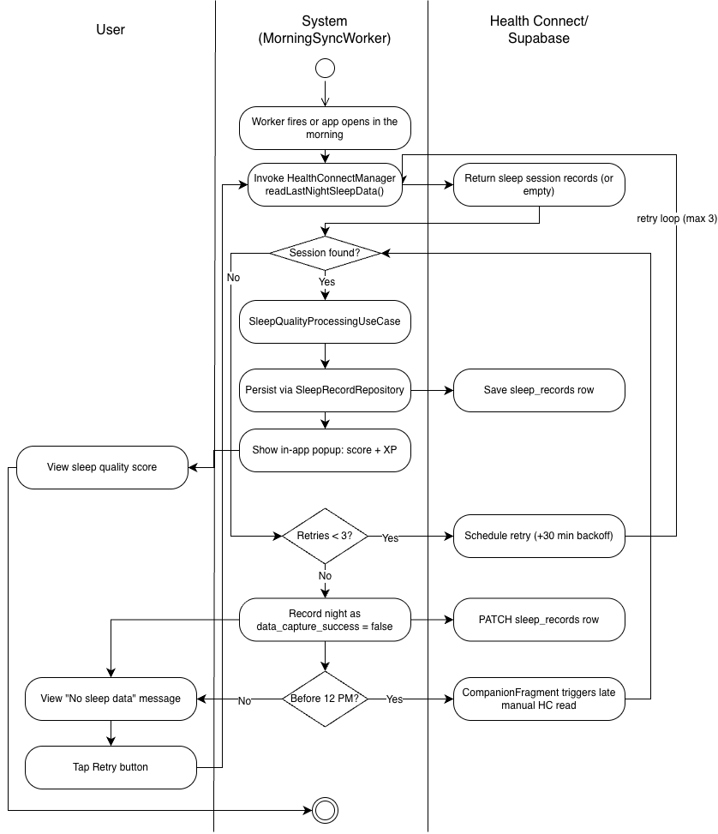

Module 4 - Routine Auditing & Analytics

4.1.1 View Weekly Analytics Dashboard

Use Case Diagram
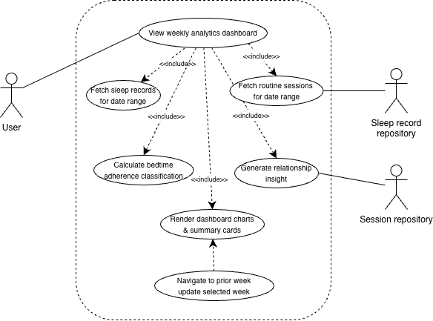
Figure 6: View / Navigate Use Case Diagram

Use Case Description

Use case name | View Weekly Analytics Dashboard
Use case Id | UC-4.1.1
Actor(s) | User, SleepRecordRepository, RoutineSessionRepository,
Description | The user taps the Progress tab in the bottom navigation bar, opening AnalyticsDashboardFragment in its default Weekly view. AnalyticsViewModel initialises with selectedWeekStart defaulting to the current Monday and viewMode = WEEKLY. It concurrently invokes SleepRecordRepository.getSleepRecordsForDateRange() and RoutineSessionRepository.getSessionsForDateRange() for the 7-day window. The sleep records and the user's target_bedtime from user_profiles are passed to BedtimeAdherenceCalculator, which classifies each night as ADHERENT, SLIGHT_DELAY, SIGNIFICANT_DELAY, or NO_DATA. The session and sleep records are passed to InsightGenerationUseCase, which compares average composite scores on completion versus non-completion nights and returns an InsightResult. All results are exposed as typed StateFlow properties and the fragment renders the Last Night Summary card, BedtimeAdherenceSleepOnsetChart, SleepQualityTrendLineChart, RoutineCompletionBarChart, and RelationshipInsightCard. The user may tap the week navigation arrows to move to a prior week, which updates selectedWeekStart and re-fetches all data reactively.
Preconditions | The user is authenticated and has completed onboarding. The user taps the Progress tab, opening AnalyticsDashboardFragment. n active internet connection is available. At least one sleep_records or routine_sessions row exists for the selected week (charts render gap or empty states otherwise).
Postconditions | AnalyticsDashboardFragment is fully rendered in Weekly view showing: the Last Night Summary card populated from the previous night's sleep_records entry; the BedtimeAdherenceSleepOnsetChart with per-night adherence classification dots; the SleepQualityTrendLineChart with nightly composite scores; the RoutineCompletionBarChart with per-night completion tiles and a completion rate label; and the RelationshipInsightCard showing the generated insight text. The right navigation arrow is disabled when the current week is selected.
Main Flow | - User taps the Progress tab in the bottom navigation bar.  - System navigates to AnalyticsDashboardFragment. AnalyticsViewModel initialises with viewMode = WEEKLY and selectedWeekStart set to the current Monday.  - AnalyticsViewModel invokes SleepRecordRepository.getSleepRecordsForDateRange() for the 7-day window and RoutineSessionRepository.getSessionsForDateRange() for the same window concurrently.  - BedtimeAdherenceCalculator receives the sleep records and target_bedtime from user_profiles and classifies each night: ADHERENT(≤30 min delay), SLIGHT_DELAY (31–60 min), SIGNIFICANT_DELAY (>60 min), or NO_DATA.  - InsightGenerationUseCase receives the sleep records and session records. If at least three data points exist in each group (completion nights vs non-completion nights), it returns an InsightAvailable result with the insight text; otherwise returns InsufficientData.  - AnalyticsViewModel exposes all chart data and the insight text as typed StateFlow properties.  - AnalyticsDashboardFragment renders the Last Night Summary card from lastNightRecord: StateFlow<SleepRecord?>.  - BedtimeAdherenceSleepOnsetChart renders seven day columns with grey target circles and coloured actual-onset dots connected by vertical lines, coloured by adherence classification.  - SleepQualityTrendLineChart renders nightly composite scores with NO_DATA nights as gaps and a reference line at 75.  - RoutineCompletionBarChart renders seven tiles colour-coded by completion status with a completion rate label.  - RelationshipInsightCard renders the insight text with bolded key metrics.  - User taps a week navigation arrow to move to a prior week. AnalyticsViewModel.selectedWeekStart updates and steps 3–11 repeat reactively.

Activity Diagram

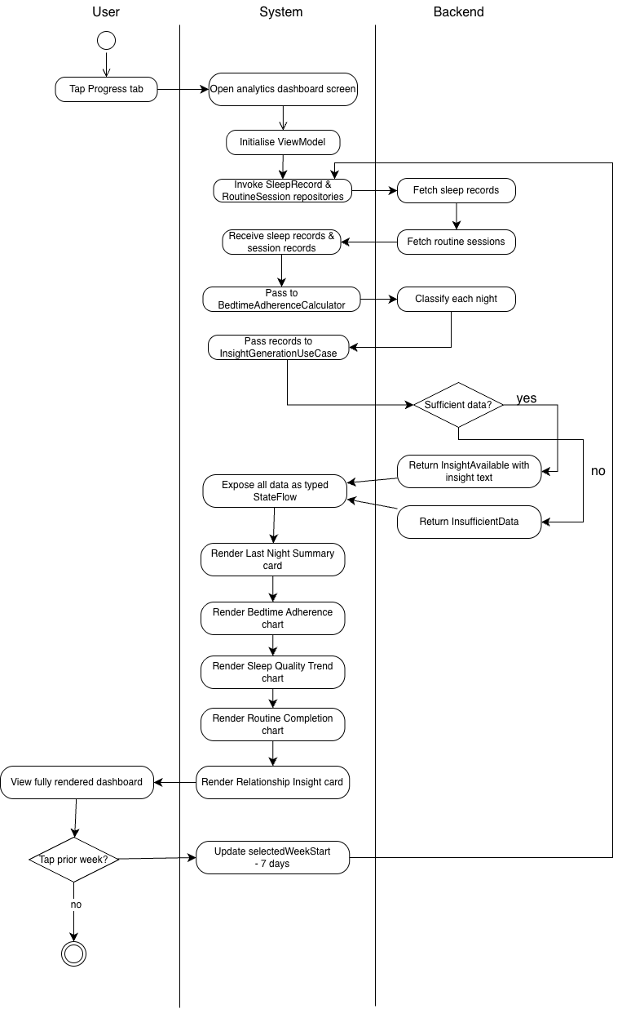
Figure 7: View / Navigate Analytics Activity Diagram

Wireframe

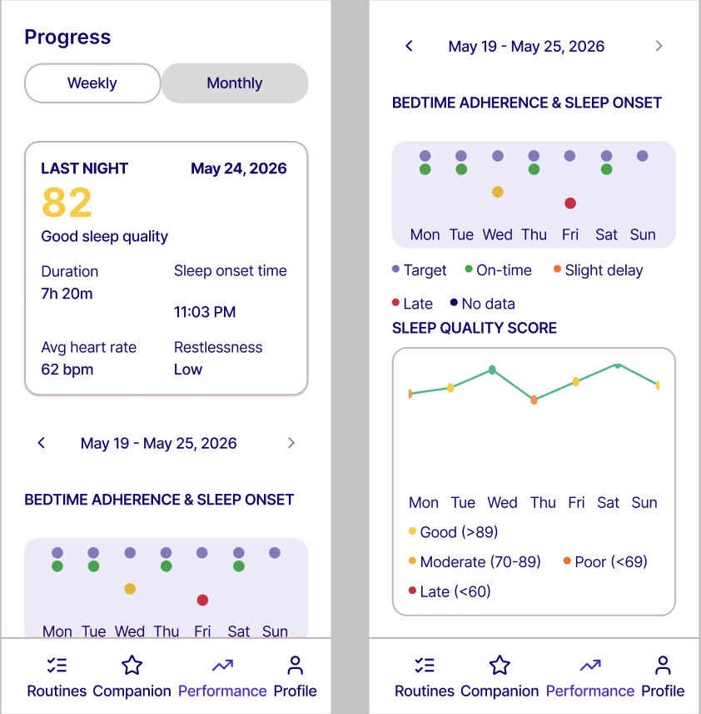
Figure 8: View / Navigate Weekly Analytics Wireframe

4.1.2 Navigate Weekly Analytics

Use Case Diagram: Refer to Figure 6: View / Navigate Use Case Diagram

Use Case Description:

Use case name | Navigate Weekly Analytics
Use case Id | UC - 4.1.2
Actor(s) | User
Description | While viewing the Weekly Analytics Dashboard on AnalyticsDashboardFragment, the user taps the left navigation arrow on WeekDateRangeSelectorView to move to a prior week. The system updates selectedWeekStart in AnalyticsViewModel, re-fetches all data for the new week window, and re-renders all charts and the insight card reactively. The right navigation arrow is disabled when the current week is selected.
Preconditions | The user is authenticated and has completed onboarding. The user is on AnalyticsDashboardFragment in Weekly view mode. An active internet connection is available.
Postconditions | AnalyticsViewModel.selectedWeekStart is updated to the prior week's Monday. All chart data and the insight text are refreshed for the new date range. The week date range label on WeekDateRangeSelectorView updates to reflect the new selection. The right navigation arrow is re-enabled if the user was previously on the current week.
Main Flow | - User views AnalyticsDashboardFragment in Weekly view with the current week displayed.  - User taps the left navigation arrow on WeekDateRangeSelectorView.  - AnalyticsViewModel.selectedWeekStart decrements by 7 days to the previous Monday.  - The week date range label updates (e.g., "May 12 – May 18, 2026").  - AnalyticsViewModel re-fetches SleepRecordRepository.getSleepRecordsForDateRange() and RoutineSessionRepository.getSessionsForDateRange() for the new 7-day window.  - BedtimeAdherenceCalculator recomputes adherence classifications for the new week.  - InsightGenerationUseCase recomputes the insight text for the new week.  - All chart components — BedtimeAdherenceSleepOnsetChart, SleepQualityTrendLineChart, RoutineCompletionBarChart, and RelationshipInsightCard — re-render reactively with the new data.  - The right navigation arrow becomes enabled since the user is no longer on the current week.  - User may continue tapping the left arrow to navigate further back, or tap the right arrow to return toward the current week.

Activity Diagram: Refer to Figure 7: View / Navigate Weekly Analytics Activity Diagram

Wireframe: Refer to Figure 8: View / Navigate Weekly Analytics Wireframe

4.1.3 View Monthly Analytics Dashboard

Use Case Diagram: Refer to Figure 6: View / Navigate Use Case Diagram

Use Case Description:
Use case name | View Monthly Analytics Dashboard
Use case Id | UC - 4.1.3
Actor(s) | User, SleepRecordRepository, RoutineSessionRepository, BedtimeAdherenceCalculator, MonthlyInsightGenerationUseCase
Description | The user taps the "Monthly" option on ViewModeToggleView in AnalyticsDashboardFragment. AnalyticsViewModel.viewMode updates to MONTHLY and selectedMonth defaults to the current calendar month. AnalyticsViewModel fetches the full month's data from SleepRecordRepository.getSleepRecordsForDateRange() and RoutineSessionRepository.getSessionsForDateRange(). BedtimeAdherenceCalculatorcomputes per-week Bedtime Adherence Rates for weeks 1 through 4. MonthlyInsightGenerationUseCase compares the average BAR and average composite sleep quality score between Week 1 (days 1–7) and Week 4 (days 22–28), requiring at least three data points in each week. The fragment renders the Last Night Summary card, WeeklyAdherenceGroupedBarChart, the 30-day SleepQualityTrendLineChart, MonthlyCompletionRateView, and MonthInsightCard. The user may tap the month navigation arrows to move to a prior month.
Preconditions | The user is authenticated and has completed onboarding. The user is on AnalyticsDashboardFragment and taps the "Monthly" toggle on ViewModeToggleView. An active internet connection is available.
Postconditions | AnalyticsDashboardFragment re-renders in Monthly view showing: the Last Night Summary card; WeeklyAdherenceGroupedBarChart with four bars colour-coded by adherence tier (red below 57%, orange 57–74%, green 75%+) and a "Target: 75%" reference label; the 30-day SleepQualityTrendLineChart with NO_DATA nights as gaps; MonthlyCompletionRateView showing the overall completion rate as a large percentage and proportional fill bar; and MonthInsightCard with the Week 1 vs Week 4 insight text. The right navigation arrow is disabled for the current month.
Main Flow | - User taps "Monthly" on ViewModeToggleView in AnalyticsDashboardFragment.  - AnalyticsViewModel.viewMode updates to MONTHLY. selectedMonth defaults to the current YearMonth.  - AnalyticsViewModel fetches the full month's sleep records via SleepRecordRepository.getSleepRecordsForDateRange() and session records via RoutineSessionRepository.getSessionsForDateRange().  - BedtimeAdherenceCalculator computes the per-week Bedtime Adherence Rate for weeks 1–4 of the month.  - MonthlyInsightGenerationUseCase compares average BAR and average composite sleep quality score between Week 1 (days 1–7) and Week 4 (days 22–28). If fewer than three data points exist in either week, it returns an encouraging message instead.  - AnalyticsViewModel exposes all chart data and the insight text as typed StateFlow properties.  - AnalyticsDashboardFragment renders WeeklyAdherenceGroupedBarChart with four bars labelled Week 1 through Week 4, each coloured by tier with the BAR percentage above.  - SleepQualityTrendLineChart renders up to 31 nightly composite scores with NO_DATA nights as gaps and the 75 reference line.  - MonthlyCompletionRateView renders the month's overall completion rate and proportional fill bar.  - MonthInsightCard renders the Month 1 vs Week 4 insight text.  - User taps a month navigation arrow. AnalyticsViewModel.selectedMonth updates and steps 3–10 repeat reactively.

Activity Diagram: Refer to Figure 7: View / Navigate Analytics Activity Diagram

Wireframe

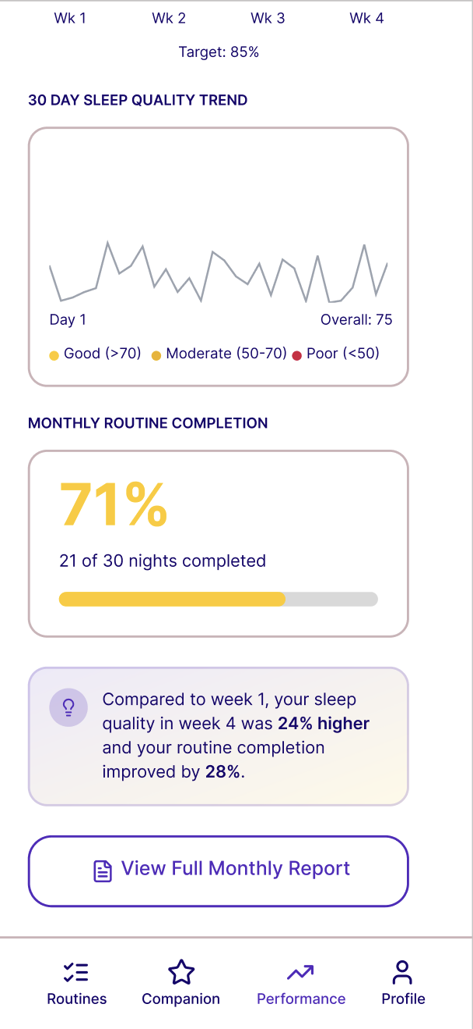

Figure 9: View / Navigate Monthly Analytics Wireframe

4.1.4 Navigate Monthly Analytics

Use Case Diagram: Refer to Figure 6: View / Navigate Analytics Use Case Diagram

Use Case Description:

Use case name | Navigate Monthly Analytics
Use case Id | UC - 4.1.4
Actor(s) | User
Description | While viewing the Monthly Analytics Dashboard on AnalyticsDashboardFragment, the user taps the left navigation arrow on MonthSelectorView to move to a prior month. The system updates selectedMonth in AnalyticsViewModel, re-fetches all data for the new month window, and re-renders all charts and the insight card reactively. The right navigation arrow is disabled when the current month is selected.
Preconditions | The user is authenticated and has completed onboarding. The user is on AnalyticsDashboardFragment in Monthly view mode. An active internet connection is available.
Postconditions | AnalyticsViewModel.selectedMonth is updated to the prior calendar month. All chart data and the monthly insight text are refreshed for the new month. The month label on MonthSelectorView updates to reflect the new selection. The right navigation arrow is re-enabled if the user was previously on the current month.
Main Flow | - User views AnalyticsDashboardFragment in Monthly view with the current month displayed.  - User taps the left navigation arrow on MonthSelectorView.  - AnalyticsViewModel.selectedMonth decrements by one calendar month.  - The month label updates (e.g., "April 2026").  - AnalyticsViewModel re-fetches SleepRecordRepository.getSleepRecordsForDateRange() and RoutineSessionRepository.getSessionsForDateRange() for the full new month window.  - BedtimeAdherenceCalculator recomputes the per-week Bedtime Adherence Rates for weeks 1 through 4 of the new month.  - MonthlyInsightGenerationUseCase recomputes the Week 1 vs Week 4 insight for the new month.  - All chart components — WeeklyAdherenceGroupedBarChart, SleepQualityTrendLineChart, MonthlyCompletionRateView, and MonthInsightCard — re-render reactively with the new data.  - The right navigation arrow becomes enabled since the user is no longer on the current month.  - User may continue tapping the left arrow to navigate further back, or tap the right arrow to return toward the current month.

Activity Diagram: Refer to Figure 7: View / Navigate Analytics Activity Diagram

Wireframe: Refer to Figure 8: View / Navigate Monthly Analytics Wireframe

4.2.1 View Weekly Progress Report

Use Case Diagram
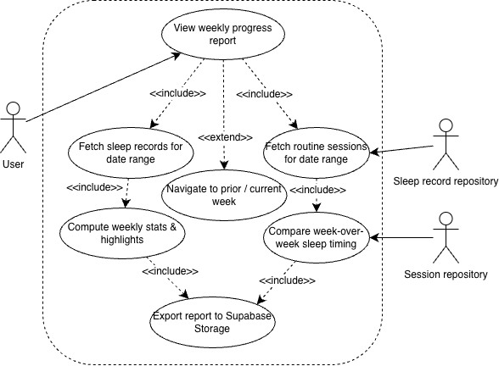
Figure 10: View Progress Report Use Case Diagram

Use Case Description

Use case name | View Weekly Progress Report
Use case Id | UC - 4.2.1
Actor(s) | User, SleepRecord Repository. Session Repository
Description | The user taps "View Full Report" at the bottom of AnalyticsDashboardFragment, navigating to WeeklyReportFragment. WeeklyReportViewModel aggregates data for the selected week from RoutineSessionRepository, SleepRecordRepository, and RewardRepository, and for the previous week from the same repositories to enable week-over-week comparison. It computes the weekly stats summary (routines completed, average sleep quality score, average streak maintained, total tokens earned), the week-over-week sleep timing consistency comparison (this week's average delay vs last week's with a directional arrow indicator), and the highlights row identifying the "Best Night" and "Most Consistent Day." The fragment renders AdherenceHeadlineView with a tier-coloured headline and contextual label, WeeklyStatsSummaryRow with four stat tiles, and WeekOverWeekComparisonView. An "Export Report" button is visible at the bottom.
Preconditions | The user is authenticated and has completed onboarding. The user has tapped "View Full Report" from AnalyticsDashboardFragment, navigating to WeeklyReportFragment. An active internet connection is available.
Postconditions | WeeklyReportFragment is fully rendered showing: AdherenceHeadlineView with the week's adherence rate percentage and contextual label; WeeklyStatsSummaryRow with four tiles (routines completed, average sleep score, average streak, tokens earned); WeekOverWeekComparisonView with a directional arrow indicator comparing this week's average delay to the prior week; and a highlights row with "Best Night" and "Most Consistent Day" badges. The "Export Report" button is visible and active.
Main Flow | - User taps "View Full Report" on AnalyticsDashboardFragment.  - System navigates to WeeklyReportFragment. WeeklyReportViewModel.loadWeeklyReport(weekStart) is invoked.  - WeeklyReportViewModel concurrently fetches session records from RoutineSessionRepository.getSessionsForDateRange(), sleep records from SleepRecordRepository.getSleepRecordsForDateRange(), and reward data from RewardRepository for the selected week.  - The same repositories are queried for the previous week to compute the week-over-week comparison.  - WeeklyReportViewModel.aggregateReportData() computes: routines completed count, average composite sleep quality score, average streak maintained, and total Dream Tokens earned for the week.  - WeeklyReportViewModel.computeWeekOverWeekChange() computes the average sleep onset delay for this week versus the prior week and determines the directional indicator (green down arrow for improvement, red up arrow for regression, grey dash for no change).  - WeeklyReportViewModel.getHighlights() identifies the "Best Night" (highest composite score) and "Most Consistent Day" (day with the smallest delay from target bedtime).  - WeeklyReportViewModel exposes all aggregated data as StateFlow<WeeklyReportModel>.  - WeeklyReportFragment renders AdherenceHeadlineView, WeeklyStatsSummaryRow, WeekOverWeekComparisonView, and the highlights row.

Activity Diagram
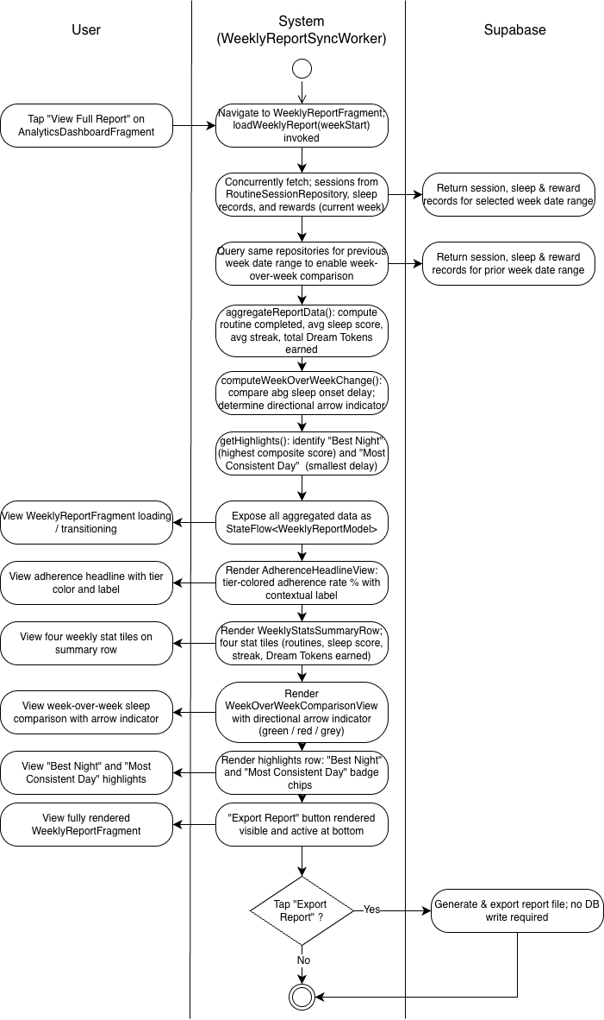
Figure 11: View Weekly / Monthly Progress Report Activity Diagram

Wireframe
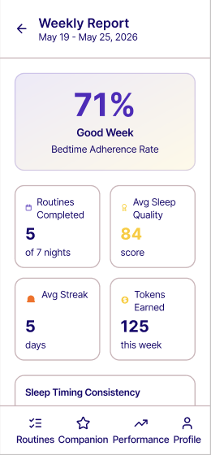

4.2.2 Export Weekly Progress Report

Use Case Diagram
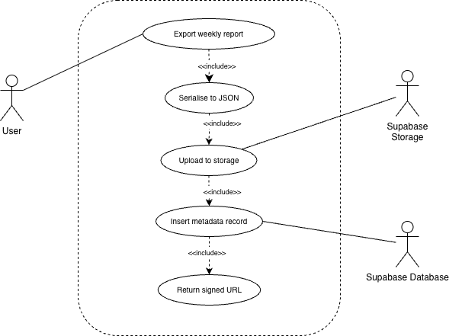Figure 12: Export Progress Report Use Case Diagram

Use Case Description
u
Use case name | Export Weekly Progress Report
Use case Id | UC - 4.2.2
Actor(s) | User, ReportExportUseCase, Supabase Storage, Supabase Database
Description | From WeeklyReportFragment, the user taps "Export Report." WeeklyReportViewModel invokes ReportExportUseCase, which constructs a WeeklyReportModel data class from the aggregated data and serialises it to a JSON string using Kotlin serialization. The JSON file is uploaded to the Supabase Storage reports bucket under the path {user_id}/{week_start_date}.jsonvia the Supabase Storage Kotlin client. A metadata record is inserted into the weekly_reports table. On success, the signed URL is returned and displayed in a copyable chip on WeeklyReportFragment. On failure, a retry option is shown.
Preconditions | The user is on WeeklyReportFragment with the report fully loaded. WeeklyReportViewModel.reportData is in a non-null success state. An active internet connection is available.
Postconditions | A JSON file exists in Supabase Storage at {user_id}/{week_start_date}.json. A metadata row exists in weekly_reports with report_storage_path, avg_adherence_rate, routines_completed, avg_sleep_quality_score, sleep_timing_variance_minutes, prev_week_variance_minutes, total_tokens_earned, highlights, and generated_at. The "Export Report" button transitions to a success state displaying the signed URL in a copyable chip.
Main Flow | - User taps "Export Report" on WeeklyReportFragment.  - WeeklyReportViewModel.exportReport(selectedWeek) is invoked. exportState transitions to ReportExportState.Loading. The button shows a loading spinner.  - ReportExportUseCase.execute(report: WeeklyReportModel) constructs the WeeklyReportModel and serialises it to a JSON string via Kotlin serialization.  - ReportExportUseCase.uploadToStorage() uploads the JSON file to Supabase Storage reports bucket at path {user_id}/{week_start_date}.json.  - Upload succeeds. ReportExportUseCase.getSignedUrl() retrieves the signed URL with a configurable expiry period.  - ReportExportUseCase.insertMetadata() inserts a row into the weekly_reports table with all metadata fields.  - ReportExportUseCase returns ExportResult.Success(url).  - WeeklyReportViewModel.exportState transitions to ReportExportState.Success(url).  - WeeklyReportFragment.showUploadStatus(url) renders the signed URL in a copyable chip. The user can copy the link to share with a researcher.

Activity Diagram
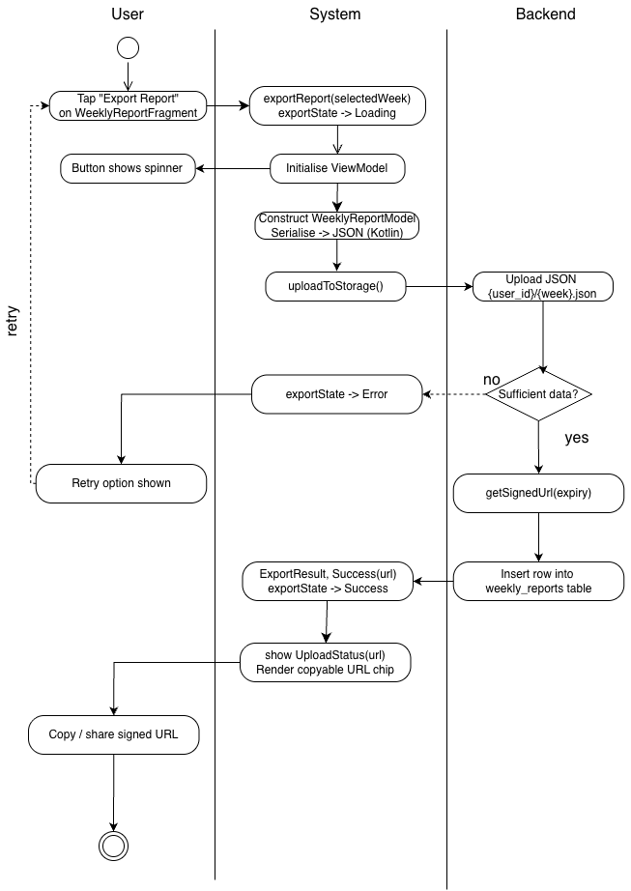
Figure 13: Export Progress Report Activity Diagram

Wireframe
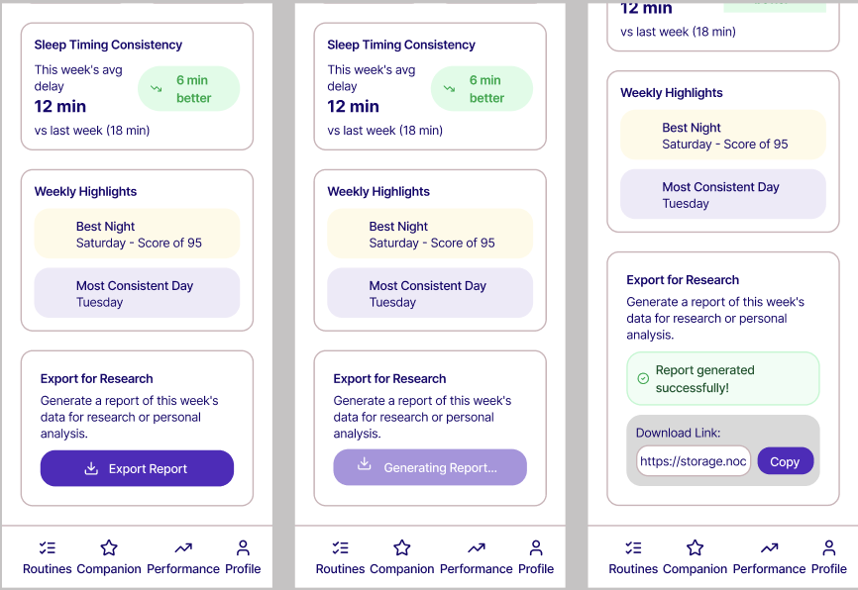

4.3.1 View Monthly Progress Overview

Use Case Diagram: Refer to Figure 10: View Progress Report Use Case Diagram

Use Case Description

Use case name | View Monthly Progress Overview
Use case Id | UC - 4.3.1
Actor(s) | User, RoutineSessionRepository, SleepRecordRepository, MonthlyInsightGenerationUseCase
Description | The user taps "View Full Month Report" from the Monthly View on AnalyticsDashboardFragment, navigating to MonthlyReportFragment. MonthlyReportViewModel.loadMonthlyReport(month) aggregates a full month of data from RoutineSessionRepository and SleepRecordRepository. It computes the overall Bedtime Adherence Rate, total routines completed out of the number of days in the month, average composite sleep quality score, and a per-week BAR breakdown for weeks 1 through 4 rendered via WeeklyBreakdownTableView. MonthlyInsightGenerationUseCase compares Week 1 and Week 4 performance. MonthlyReportViewModel.getBestAndWorstNight() identifies the best night (highest composite score) and worst night (lowest composite score). The fragment renders all sections as a scrollable report card with an "Export Month Report" button at the bottom.
Preconditions | The user is authenticated and has completed onboarding. The user has tapped "View Full Month Report" from AnalyticsDashboardFragment in Monthly view, navigating to MonthlyReportFragment. An active internet connection is available.
Postconditions | MonthlyReportFragment is fully rendered showing: the month's overall BAR as a large percentage; total routines completed out of total days; average composite sleep quality score; WeeklyBreakdownTableView with per-week BAR and average sleep quality per week (weeks with insufficient data show "—"); MonthInsightCard with the Week 1 vs Week 4 insight; and the month's best and worst nights. The "Export Month Report" button is visible and active.
Main Flow | - User taps "View Full Month Report" on AnalyticsDashboardFragment.  - System navigates to MonthlyReportFragment. MonthlyReportViewModel.loadMonthlyReport(month: YearMonth) is invoked.  - MonthlyReportViewModel fetches the full month's session records from RoutineSessionRepository.getSessionsForDateRange() and sleep records from SleepRecordRepository.getSleepRecordsForDateRange().  - MonthlyReportViewModel.aggregateMonthlyData() computes: overall BAR, total routines completed, average composite sleep quality score for the month.  - MonthlyReportViewModel.computePerWeekBreakdown() computes the BAR and average sleep quality score for each of the four weeks: Week 1 (days 1–7), Week 2 (days 8–14), Week 3 (days 15–21), Week 4 (days 22–28).  - MonthlyInsightGenerationUseCase compares Week 1 and Week 4. If at least three data points exist in each week, it returns a plain-language insight; otherwise returns an encouraging message.  - MonthlyReportViewModel.getBestAndWorstNight() returns the dates and scores of the best and worst nights.  - MonthlyReportViewModel exposes all data as StateFlow<MonthlyReportModel>.  - MonthlyReportFragment renders all sections as a scrollable report card with WeeklyBreakdownTableView showing per-week data with "—" placeholders for insufficient weeks.

Activity Diagram: Refer to Figure 11: View Weekly/Monthly Progress Report Activity Diagram

Wireframe
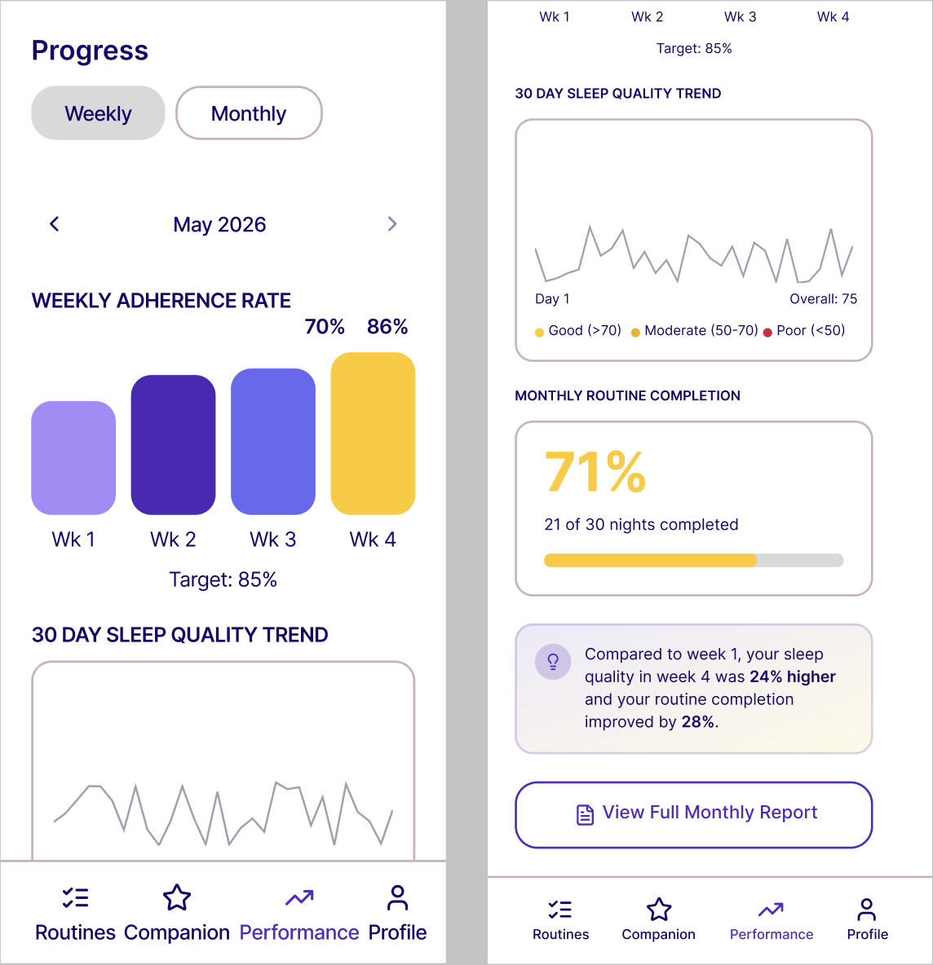

4.3.2 Export Monthly Progress Report

Use Case Diagram Refer to Figure 12: Export Progress Report Use Case Diagram

Use Case Description

Use case name | Export Monthly Progress Report
Use case Id | UC - 4.3.2
Actor(s) | User, Supabase Database
Description | From MonthlyReportFragment, the user taps "Export Month Report." MonthlyReportViewModel invokes MonthlyReportExportUseCase, which constructs a MonthlyReportModel data class and serialises it to JSON using Kotlin serialization. The JSON file is uploaded to Supabase Storage reports bucket under the path {user_id}/monthly/{year_month}.json. A metadata row is inserted into the monthly_reports table containing all monthly aggregated fields. On success, the signed URL is returned and displayed in a copyable chip. On failure, a retry option is shown.
Preconditions | The user is on MonthlyReportFragment with the report fully loaded. MonthlyReportViewModel.reportData is in a non-null success state. An active internet connection is available.
Postconditions | A JSON file exists in Supabase Storage at {user_id}/monthly/{year_month}.json. A metadata row exists in monthly_reportscontaining avg_adherence_rate, routines_completed, avg_sleep_quality_score, week1_adherence_rate through week4_adherence_rate, month_insight_text, report_storage_path, and generated_at. The "Export Month Report" button transitions to a success state displaying the signed URL in a copyable chip.
Main Flow | - User taps "Export Month Report" on MonthlyReportFragment.  - MonthlyReportViewModel.requestExport(report: MonthlyReportModel) is invoked. exportUrl: LiveData<String?> transitions to loading state. The button shows a loading spinner.  - MonthlyReportExportUseCase.execute(report: MonthlyReportModel) constructs the MonthlyReportModel and serialises it to a JSON string via Kotlin serialization.  - MonthlyReportExportUseCase.uploadToStorage() uploads the JSON file to Supabase Storage reports bucket at path {user_id}/monthly/{year_month}.json.  - Upload succeeds. MonthlyReportExportUseCase.getSignedUrl() retrieves the signed URL.  - MonthlyReportExportUseCase.insertMetadataRecord() inserts a row into monthly_reports with all metadata fields including all four per-week BAR fields and month_insight_text.  - MonthlyReportExportUseCase returns the signed URL.  - MonthlyReportViewModel.exportUrl updates with the URL. MonthlyReportFragment.showExportStatus(url) renders the signed URL in a copyable chip.

Activity Diagram Refer to Figure 13: Export Weekly Progress Report Activity Diagram

Wireframe
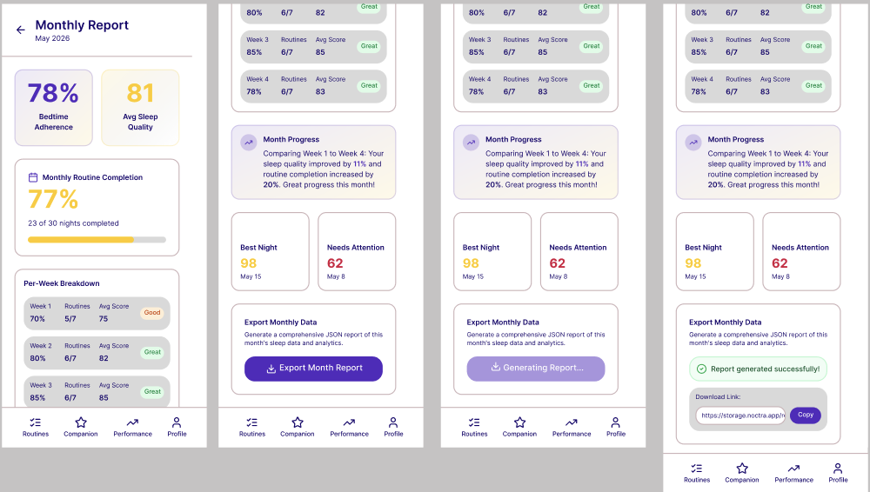

Non-functional requirements

Performance

The system shall load the correct start destination — RegistrationFragment, the appropriate onboarding step, or HomeFragment — within 3 seconds of app launch on a mid-range Android device under normal network conditions.

The system shall complete all in-app screen transitions via the Navigation Component within 300 milliseconds of a user tap under normal testing conditions.

The system shall display the updated leaderboard reflecting the latest group member data within 3 seconds of the user manually refreshing the Group tab under normal network conditions.

The system shall load and begin playing the companion's Lottie idle animation within 1 second of the Companion tab being opened, and shall complete the evolution transition animation without frame drops before resuming the new stage's idle loop.

The system shall provide clear success, error, loading, and retry status feedback to the user after major operations, including registration, login, routine completion, morning sync, report export, and group join or creation.

The system shall allow Filipino college student users to access all assigned functions through the Android mobile interface without unnecessary delay under a normal internet connection.

Security

The system shall enforce Row Level Security (RLS) policies on all Supabase database tables, ensuring that each authenticated user can only read and write their own data.

The system shall store Supabase session tokens exclusively in Android EncryptedSharedPreferences and shall never persist them in plaintext storage.

All communication between the Android client and the Supabase backend shall be conducted exclusively over HTTPS.

The system shall manage user authentication exclusively through Supabase Auth, supporting account creation, login, session refresh, and password reset flows.

The system shall not expose any user's personal information, routine data, or sleep records to other users outside of their explicitly accepted friend network.

Reliability

The system shall use WorkManager to schedule all background tasks (MorningSyncWorker, WindDownNotificationWorker, MissedSessionCheckerWorker), ensuring execution is maintained across app lifecycle states, device restarts, and low-memory conditions.

MorningSyncWorker shall implement an exponential backoff retry policy with a maximum of three retries spaced 30 minutes apart when a completed SleepSessionRecord is not yet available from Health Connect.

The system shall use Supabase RPC functions for all multi-row atomic operations (credit_rewards, equip_item) to prevent partial writes under concurrent access conditions.

The system shall display appropriate loading, success, error, and retry states for all major operations including registration, login, routine completion, morning sync, report export, and friend request actions.

The system shall maintain streak accuracy and companion devolution state even when the user does not open the app on a given night, ensured through MissedSessionCheckerWorker's scheduled morning execution.

