1. Consider the directed graph G = 〈V, E〉 represented by the following cost adjacency matrix:
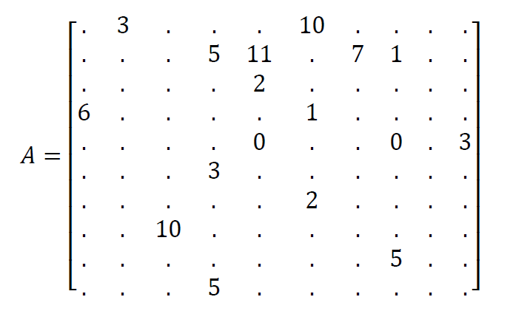
Assume that element a_{ij} positioned in row i and column j in matrix A stores the distance between node i and node j in graph G. Draw the graph and solve the single‐source‐shortest path problem by running Dijkstra’s algorithm on G, starting at node 1. What is the order in which nodes get removed from the associated priority queue? What is the resulting shortest‐path tree?

2. Let P be a shortest path from some vertex s to some other vertex t in a graph. If the weight of each edge in the graph is increased by one, then will P be still a shortest path from s to t? Explain your answer.

3. Consider the directed graph G = 〈V, E〉 represented by the following cost adjacency matrix:
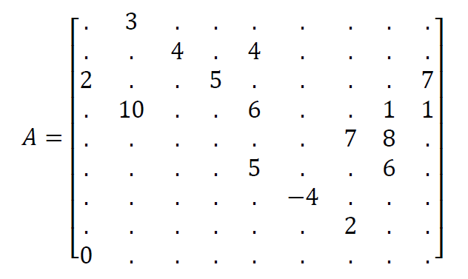
Assume that element a_{ij} positioned in row i and column j in matrix A stores the distance between node i and node j in graph G. Draw the graph and solve the single‐source‐shortest path problem by running Bellman‐Ford’s algorithm on G, starting at vertex 1. What is the resulting shortest‐path tree? Which nodes are get ‘infected’?

