SIT201
Data Structure and Algorithms
STUDENT NAME: Xiangtian Zheng
STUDENT ID: 217081651
Learning Summary Report

Self-Assessment Details
The following checklists provide an overview of my self-assessment for this unit.

 | Pass (D) | Credit (C) | Distinction (B) | High Distinction (A)
Self-Assessment

  - Self-Assessment Statement
Included
Learning Summary Report
Pass tasks complete

  - Minimum Pass Checklist
Included
All Credit Tasks are Complete on Doubtfire

  - Minimum Credit Checklist (in addition to Pass Checklist)
Included
Distinction tasks (other than Custom Program) are Complete
Custom program meets Distinction criteria

  - Minimum Distinction Checklist (in addition to Credit Checklist)
Included
Something Awesome included
Custom project meets HD requirements

  - Minimum High Distinction Checklist (in addition to Distinction Checklist)

Declaration
I declare that this portfolio is my individual work. I have not copied from any other student’s work or from any other source except where due acknowledgment is made explicitly in the text, nor has any part of this submission been written for me by another person.

Signature: Xiangtian Zheng

Portfolio Overview
This portfolio includes work that demonstrates that I have achieve all Unit Learning Outcomes for SIT221 Unit Title to a Pass level.

I think I can get a pass level in SIT221 Unit. I have hard work for the Unit and finish all the Pass level task. In the future, I will keep working before the unit. Get more useful knowledge for coding and logic to improve my solve problem skill. In another way, I can keep study to learn how to shorten the project runtime for different algorithms and use what you have learned to improve yourself.

Reflection

The most important things I learnt:
In this unit, I learned multiple algorithms. For example: In week 1, I learned what is algorithms and in 1.1P task. I learned how to use vector to work the project. How to use the Insert(), Clear(), Contains(), Remove(), RemoveAt(), ToString() and what are they algorithms. In there, I think the Remove is harder than other tasks. In the week 2, we are starting learned sort algorithms. In the week 3, we are learned complexity of each algorithms. I think this is a little hard for all tasks’ description. This is because, the first time I don’t know how to calculate the algorithms complexity. In there I spend more time to learn this one. In week 4, we are learning the some of the sorting. Like BubbleSort(), InsertionSort(), SelectSort(). This will sort the list in different way. In the week 5, we are learning Skip-List. I think this one is a little hard for me. This is because I not really understand how to work the Skip-List and what is the Skip-List algorithms. I spend 2 weeks to solve this problem with teacher. In week 6, we are learned the Double-Link List. In week 7 and week 8, I am working on binary heap. I think this one is the hardest in all unit. In the upheap() function or downheap() function is the task the hardest part, I spend more time to learn and solve this problem. In the week 9, I down the AVL tree task. In the week 10, I down all task for all unit. In the last task is about Dijkstra’s and Bellman‐Ford’s algorithms. This logic is all about BFS logic to solve the problem.

The things that helped me most were:
I think the most helped is the task is 1.1P, 2.1P, 6.1P, 7.1P, 8.1P, 9.1P
This task all can improve my logic and give me more knowledge for the future.

I found the following topics particularly challenging:
I think the 1.1P’s remove() function and 6.1P task buildHeap() function will have more challenging in the task.

I feel I learnt these topics, concepts, and/or tools really well:
I think all of task and lecture is good topics, concepts really well. We will hard working and brainstorm all task. I believe they can improve our logic and algorithms.

My progress in this unit was …:
In the unit I was meeting 2 problem for all task. The first problem is August 5 to August 12. I spend 1 week to solve the sort problem. The second problem is form August 19 to August 26. I spend one week to solve this problem. This problem is about the Binary Heap sorting and build new Binary Heap.
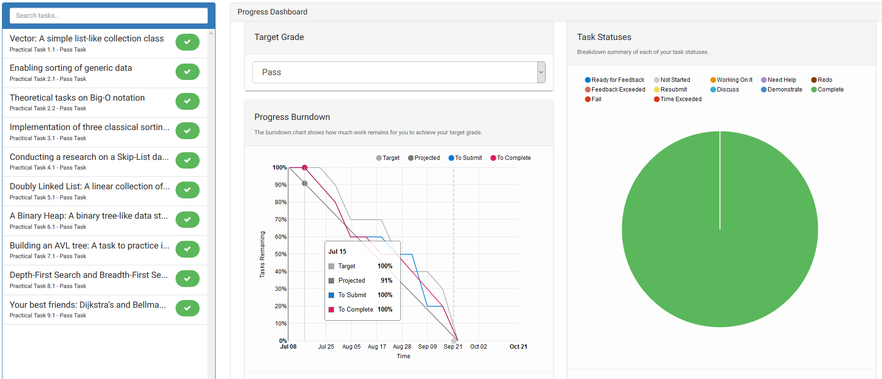

This unit will help me in the future:
In this unit, all the knowledge is useful and valuable for my future. This is because this unit improve our logic and let me know how to shorten the project runtime.

If I did this unit again I would do the following things differently:
If I did this unit again, I will do all the credit task to learn more useful knowledge. I will keep last time knowledge and learn new knowledge.

