2. Solve the following numeric example. For the given undirected (bi‐directed) graph, compute a minimum spanning tree using Prim‐Jarnik’s algorithm. Show the structure of your partial minimum spanning tree after each edge insertion and indicate for each edge whether it is included in the minimum spanning tree.
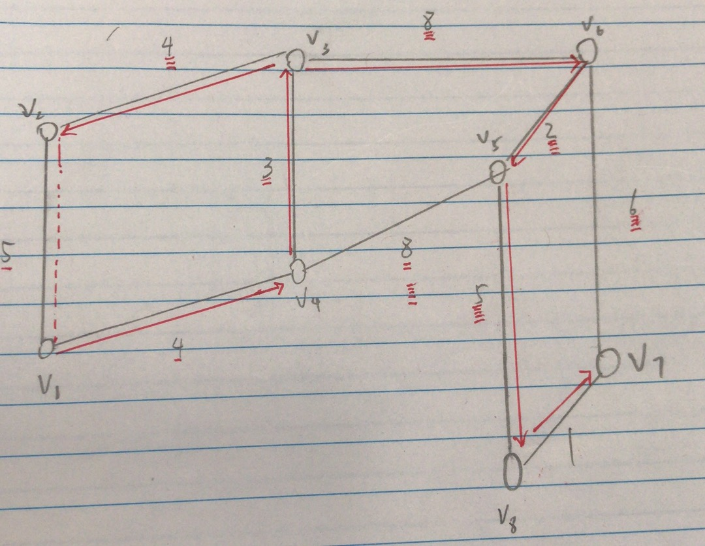

3. Solve the following numeric example. For the given undirected (bi‐directed) graph, compute a minimum spanning tree using Kruskal’s algorithm. Show the structure of your partial minimum spanning tree after each edge insertion and indicate for each edge whether it is included in the minimum spanning tree.
