Portfolio
Week 1
In this week, I do a plan to the next 2-3 weeks work. I my plan, I prepare the resources for the next 2-3 weeks work. I did the plan Video and make a PPT to show how to do this plan. And I draw two images to input in UI.

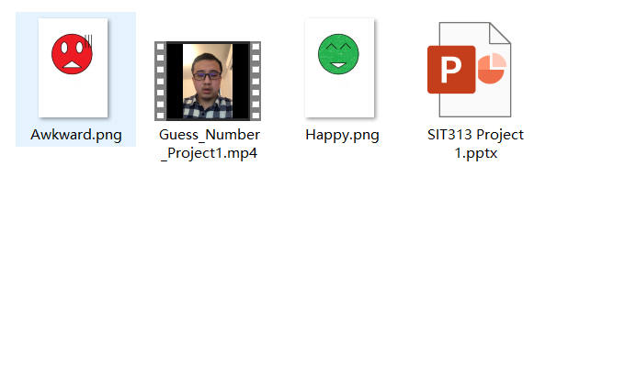

Week 2
In this week, I learn and understand how to do the layout for the Android in visual studio. I have created a 2 screen for my project. For the first screen, is login page and the second screen are a I did plan for Guess number plan. I just put some format for the image space and button in the second page. In the week 2 practical, I learn and understand how to add image in the project. For the impotent thing is I understand how to debug it. In this week Friday’s practical class, I learned more idea for the Lab handout file.
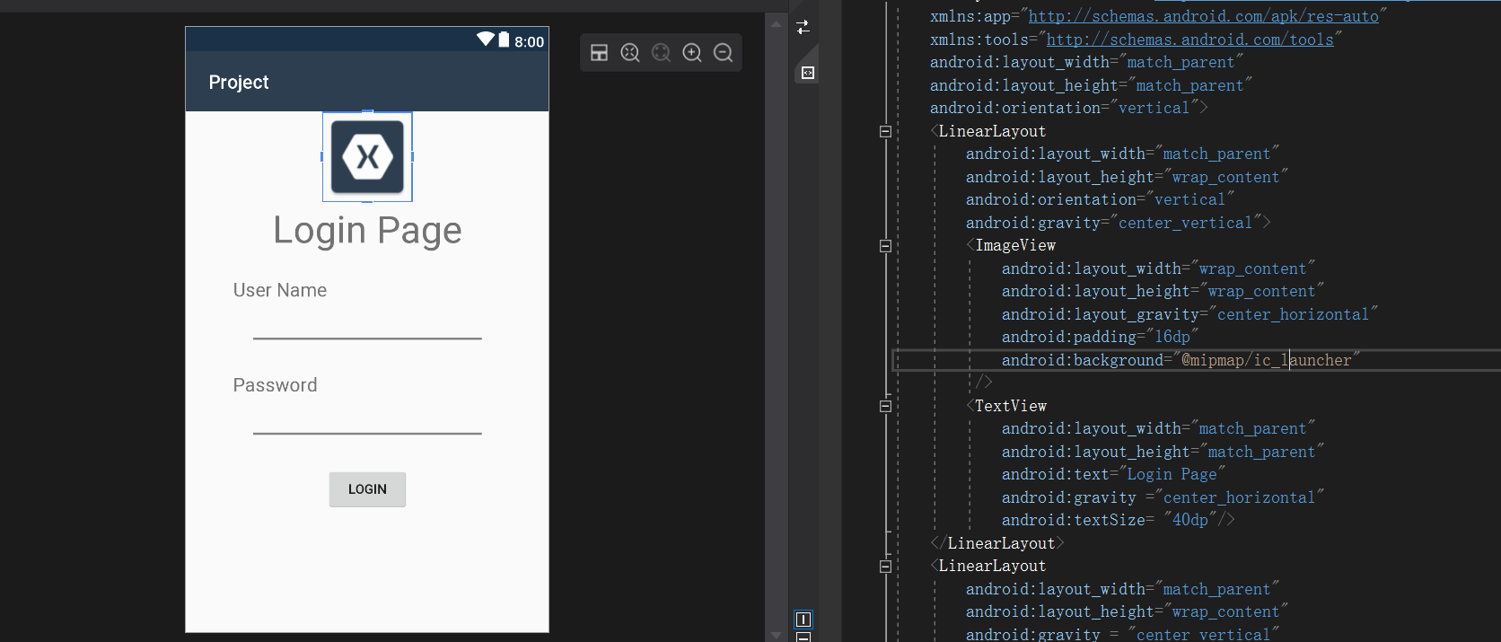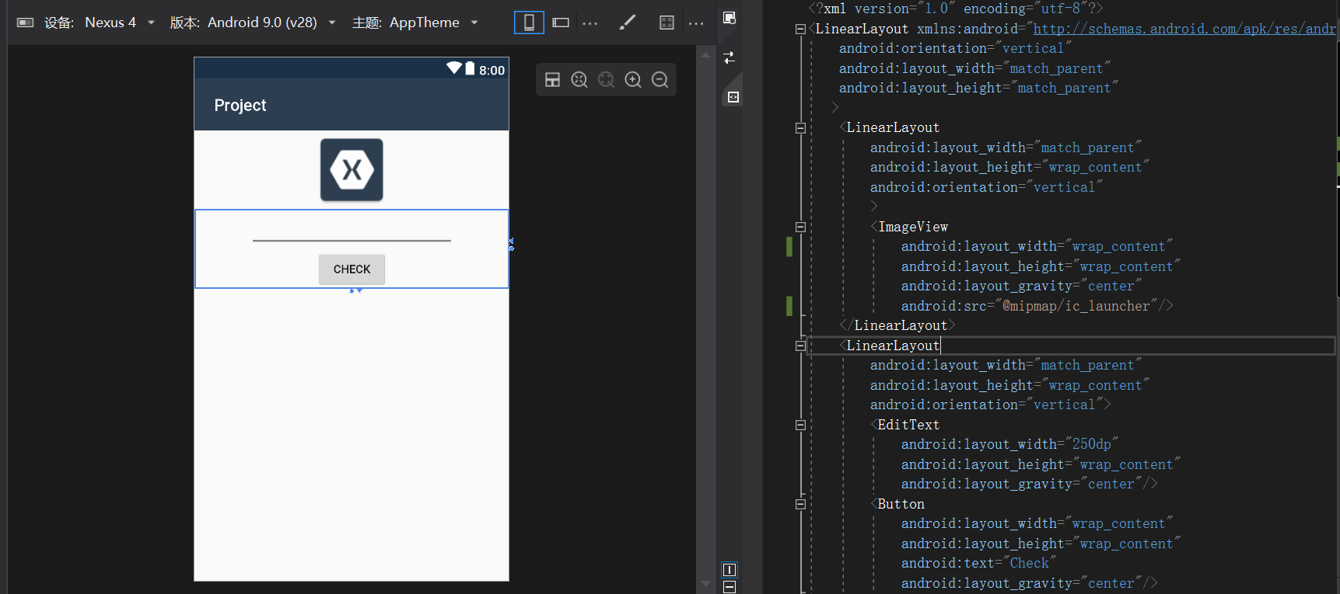

Week 3
In this week, I have learned some IOS knowledge to development. Try to create some IOS work and continue to do some work for the assessment 1. For last week, I meet some problem for Xamarin find the project ID. I think this is a bug for the visual studio. When I re-open my project, the reference will refresh. Therefore, project will work for this problem. In another way, I learned some logic and Android API for this project. For example, SetImageView() and SeyText() for project. However, this have some problem for guess number project. I will learn more project that C# for Android.
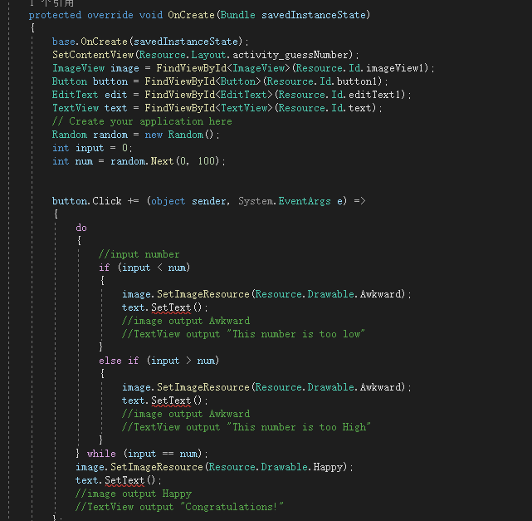

Week 4
In this week, I have got more interesting things. Like understand how to use the Xamarin form to create project for android and IOS. In there, we can use the MainPage.xaml file to control both of Android and IOS. And I have down some project for this.
This is my code from this project:
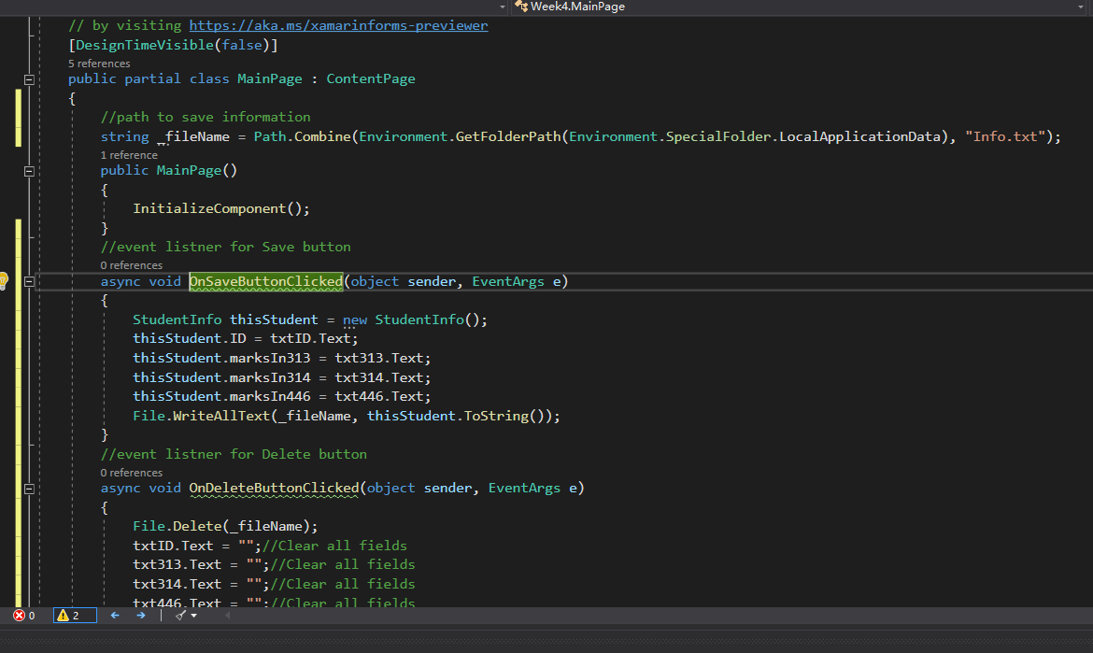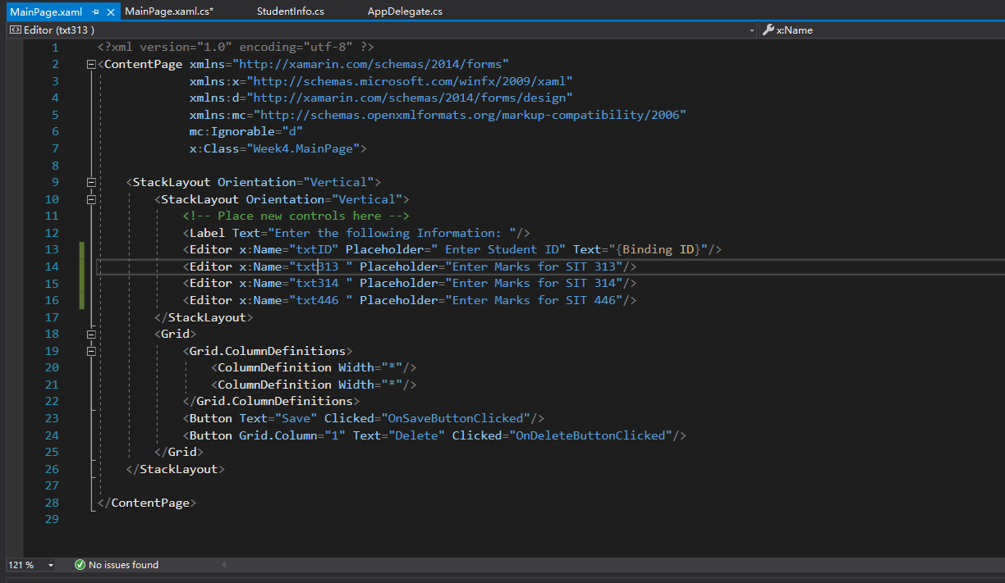
In another way, I have down my project of Assessment, I get some idea from Dr Hasan to understand how to get the EditText value when customer input some value.
This is my Assessment code:
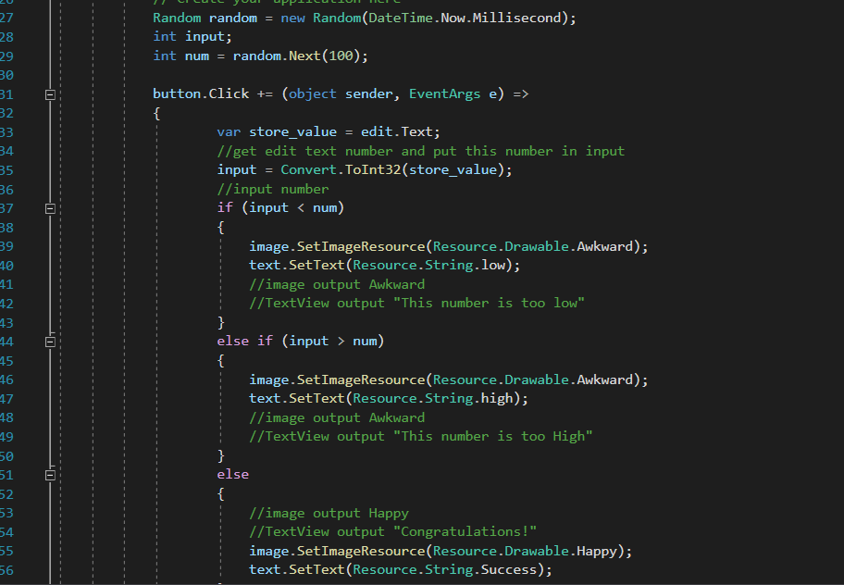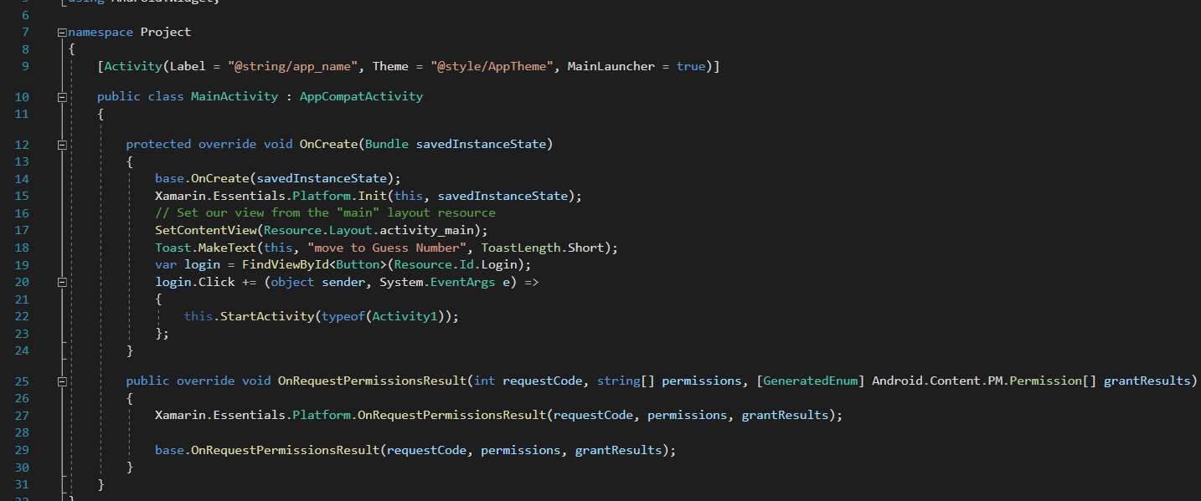
About the Xamarin and Android studio, I think Android studio is easier and more useful for development project when we just want develop Android project. This is because Xamarin have some bug like when we change some id or another thing. Android studio have more stronger library than Xamarin. Sometimes the Xamarin create Android project will break, this will affect development. However, Xamarin have some useful space that when we need create IOS and Android together, the Xamarin will more useful for Android Studio and XCODE. This will easy to change in different platform for work.

Week 5
In this week, I understand how to use the Xamarin form to create both Android application and IOS application. This week, the lecture gives our more idea for assessment and in the practice class. I real use the Xamarin to development this task. In this task, we can use the MVVM to develop an application. However, this task can not be work on my computer. This is because my computer cannot connect the mac system. Therefore, I will just show the picture about the project coding. For the another way, in this week I make a group with Wei Liu. He is a Manager and developer, I am GitHub manager and developer.
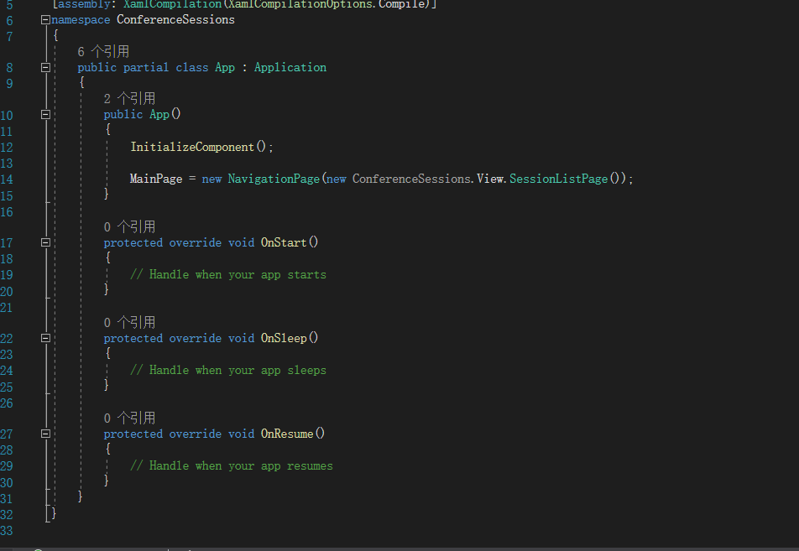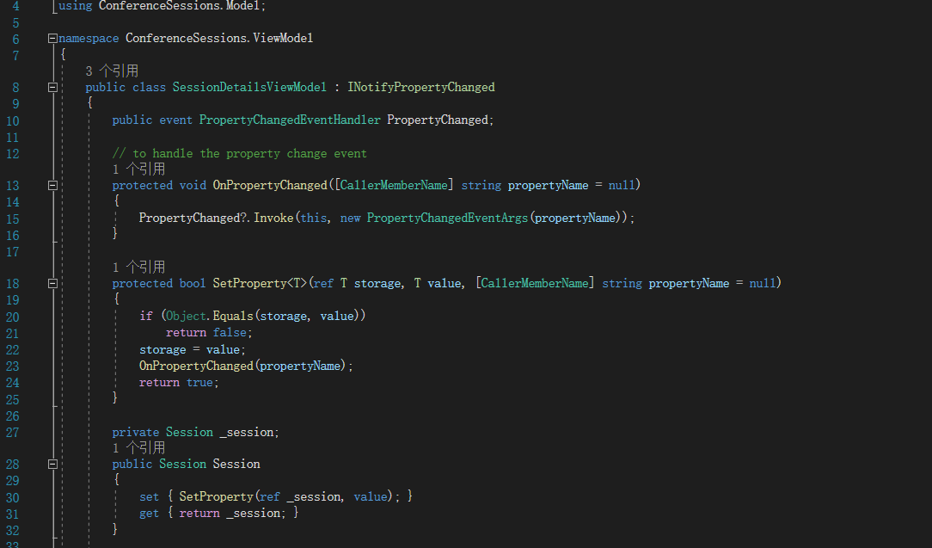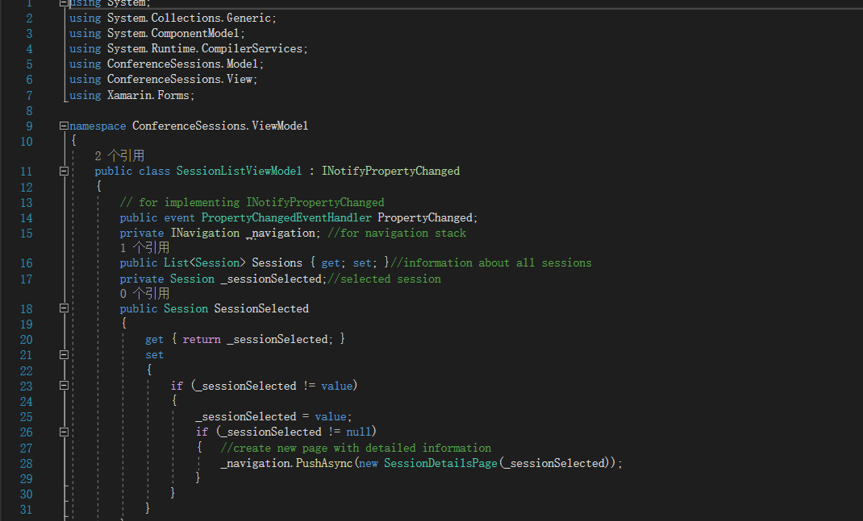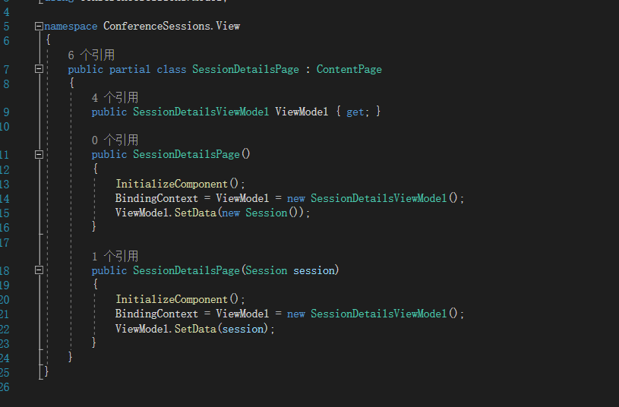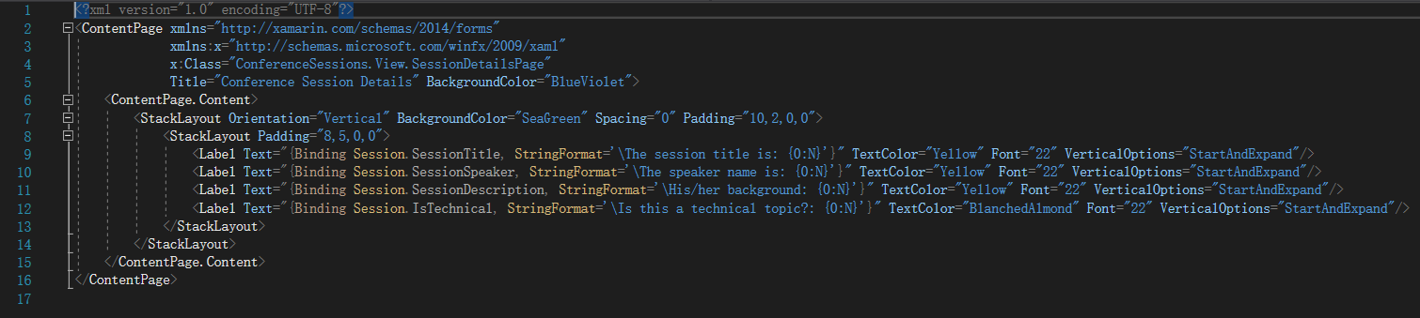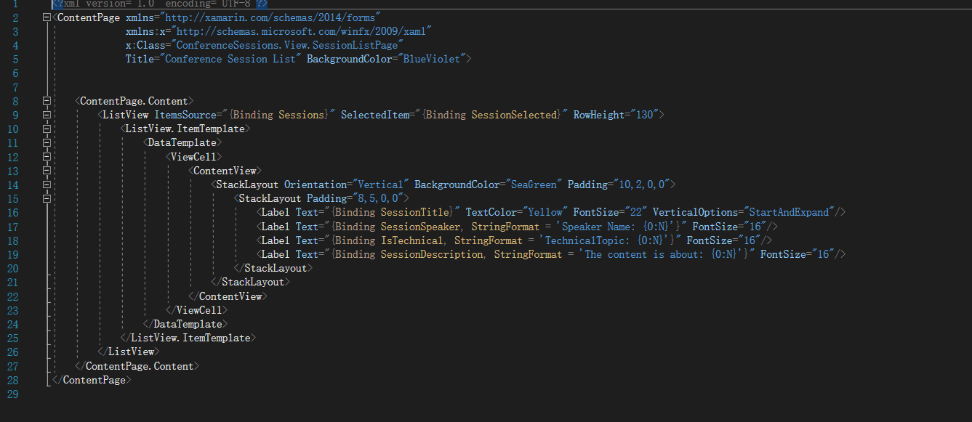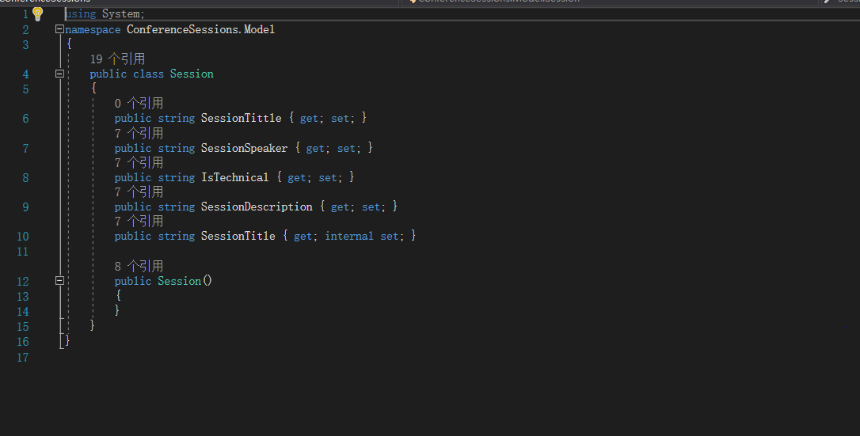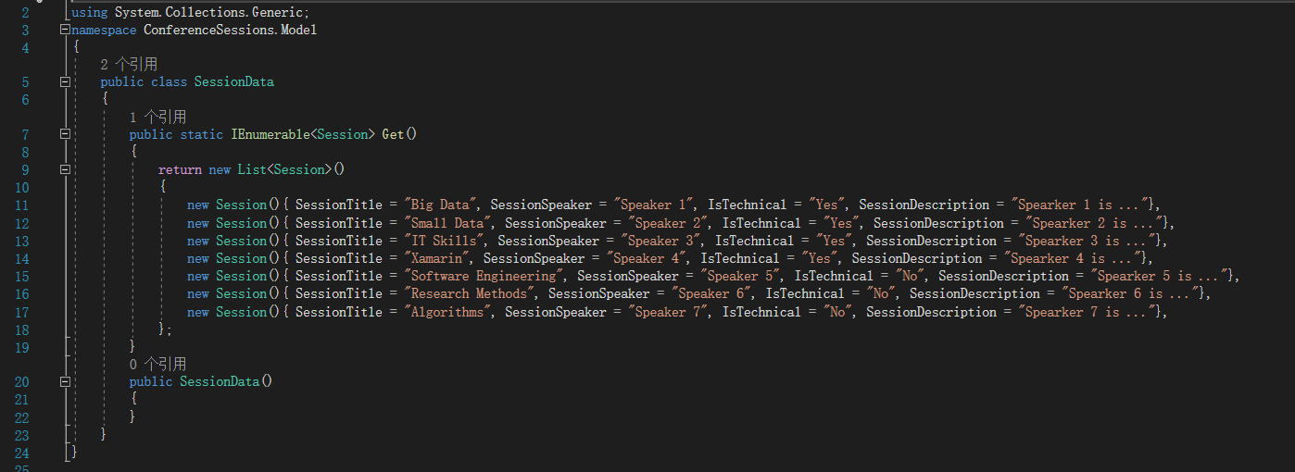

Week 6
In this week, I go to class to know how to use the local database and how to use the database and understand the database’s benefit. In the Practical class, I learned how to use the database to link View file and learned how to use the nuget.org to add location database. In the practical task2, in there I get another idea how to add new project for connecting data for website or server. About my project 2 for Assessment 2, we are started to do the detail plan and prepare to get some recourse. Therefore, I will start to do some layout for our project in next week. In there I will show some practical code in there.
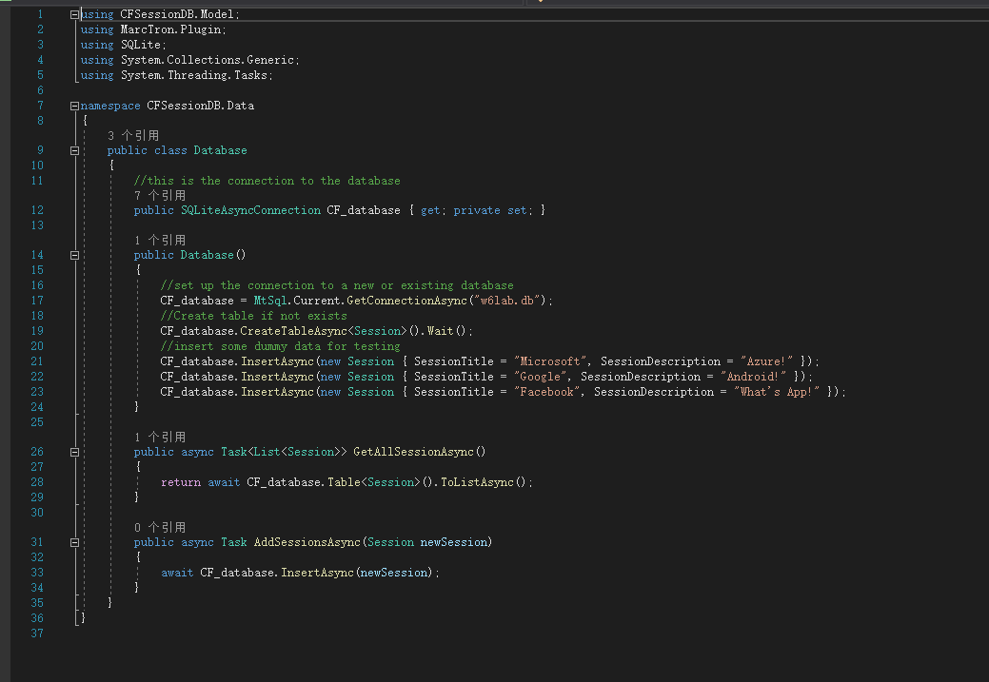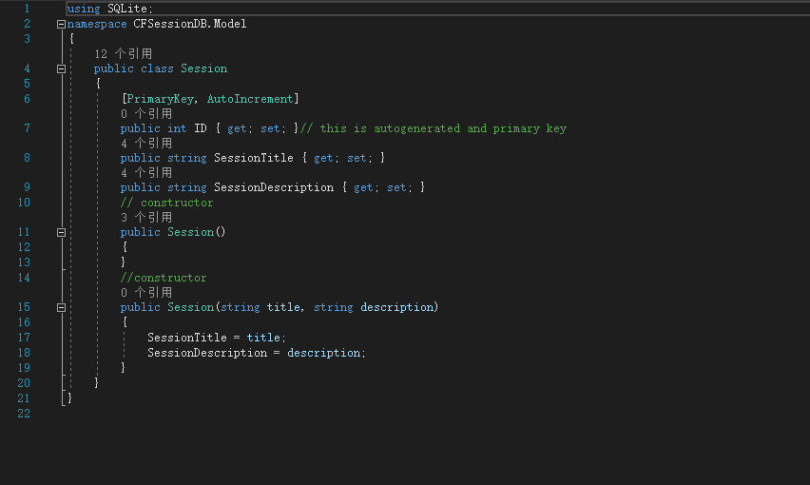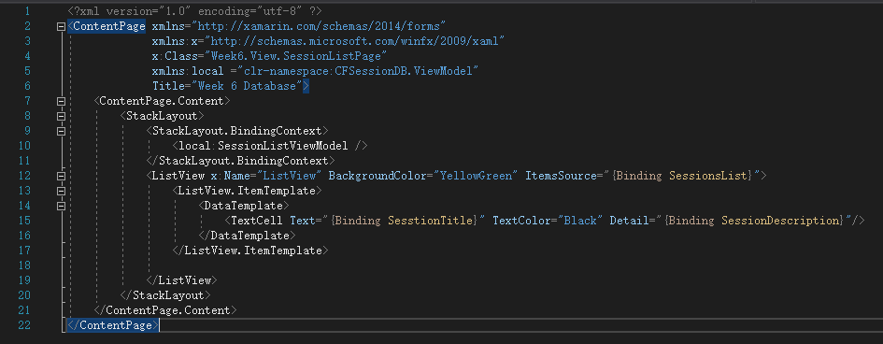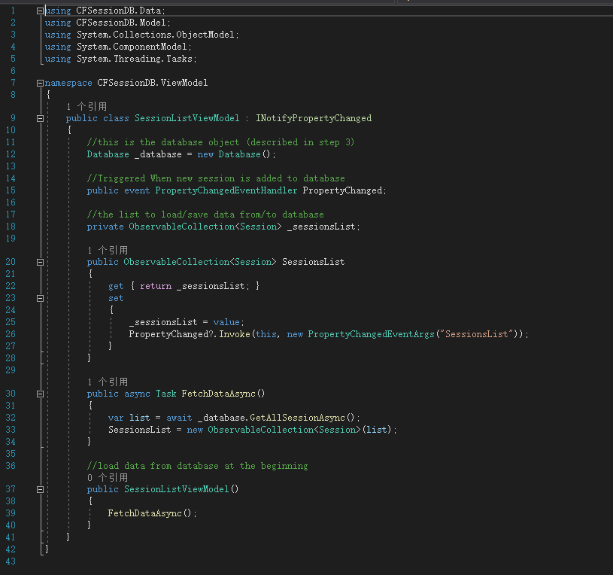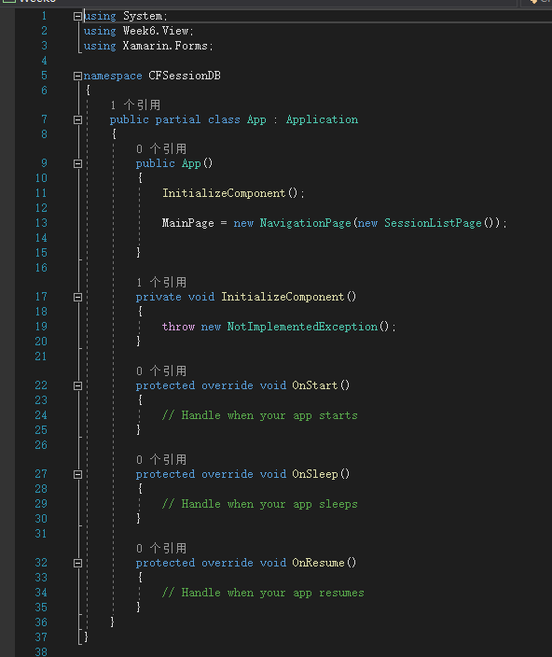

Week 7
In this week, I understand how to use the .NET Core for Web Application by API in MVC and MVVM. In the lecture, I have know what is Web API and The Web APIs’ benefit. In the Lab practical, I try to do the .NET Core for Web Application that follow the week 7 practical task. In this task, we first create the mean page about the Web API. Then we change some code and add few class file and change some port to go to next page. This is my code and display in browser page:
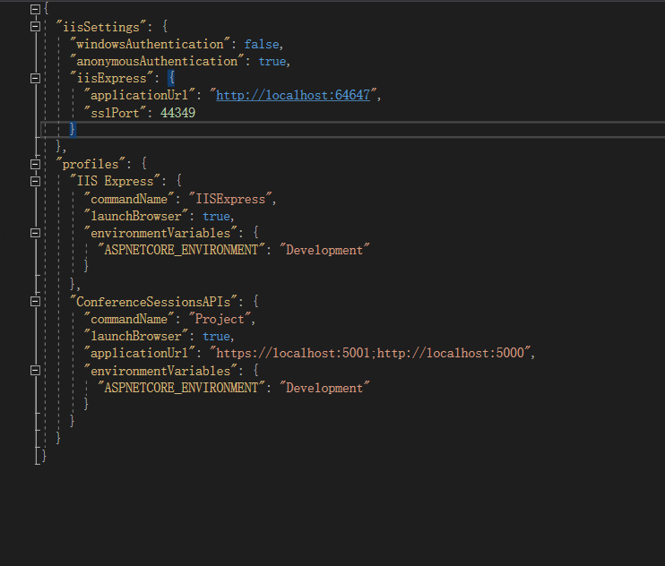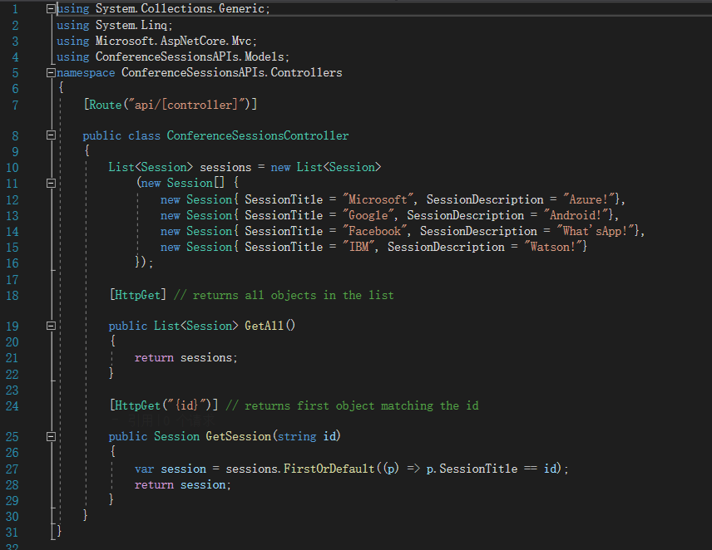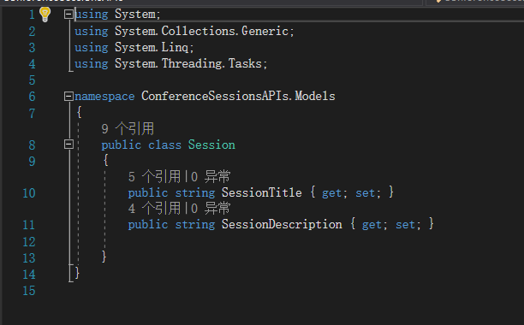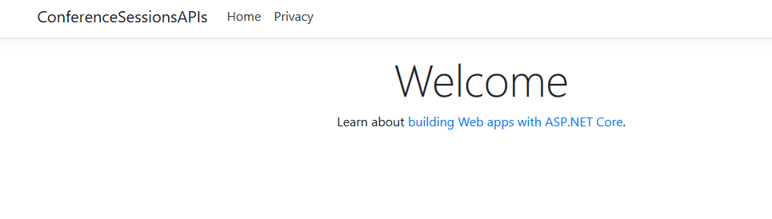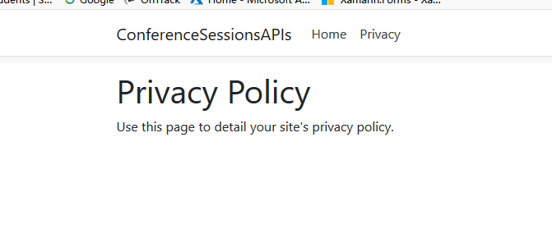

For the Assessment 2, in this week we down the create layout and find some resources for image background and prepare to do the screen switch.

Week8
In this week, we learned how to use the test for the mobile program by UI Testing. In the lecture, we understand the UI Testing benefit for our program. The Xamarin Testing can be working in the cloud. In the practical, we try to do the UI Testing. In there, I will show the picture for our task project.
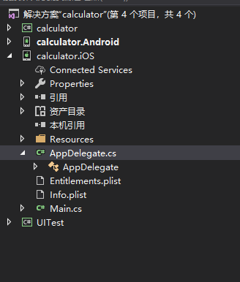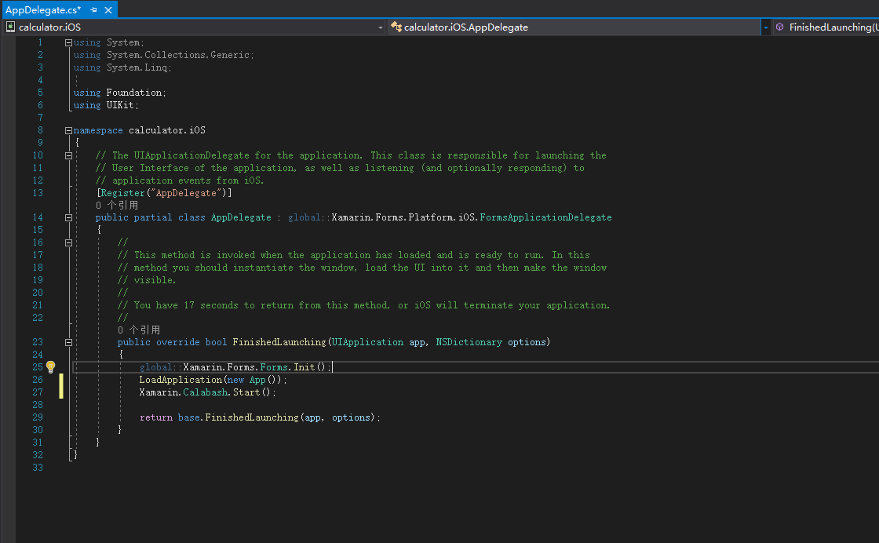
For our assessment 2 for Android project. We did on the switch program and down all of the layout for this program. Now, this will be working to click button switch to next screen. However, when the project run in Android meeting some problem. Then we fix it in publish EditText function. And start plan next week database how to work and how to input in the function

Week 9
In this week we are learning some security for system. In the local data, we can use the PCLCrypto package to get more safe. Sometimes, we can use the Auth to improve the system. In the Lab, we are in practical to try to do the task. We are correct use the PCLCypto to the project.
This is Lab screen sort:
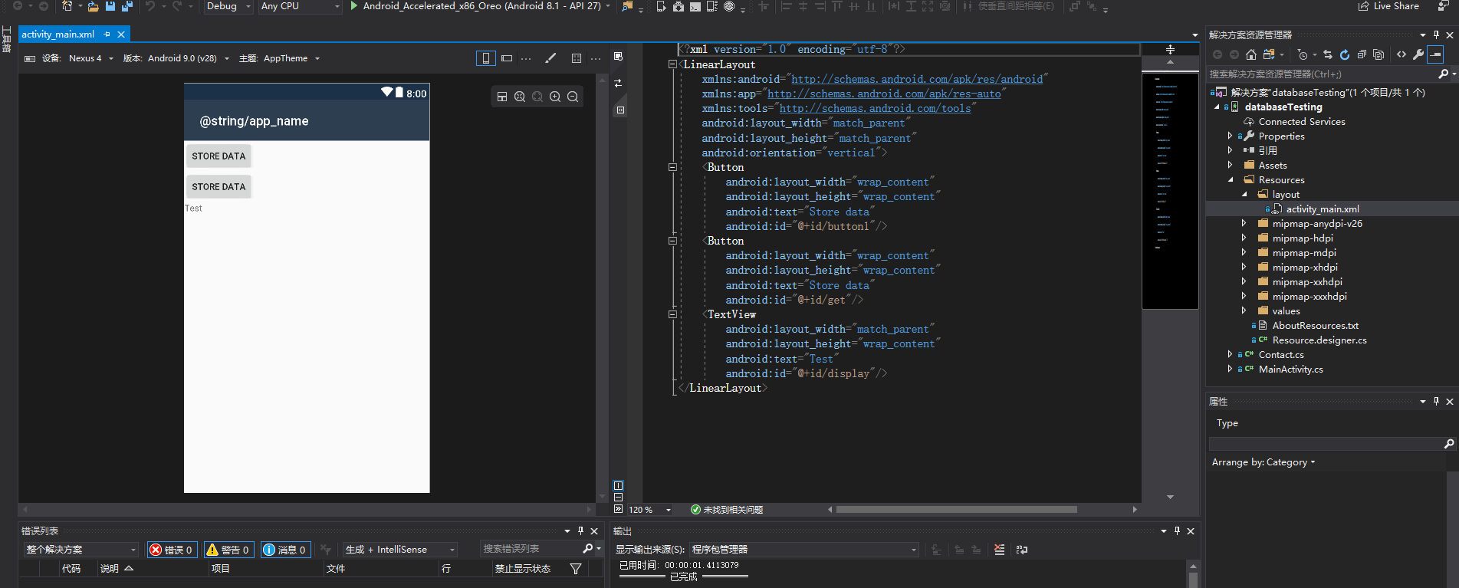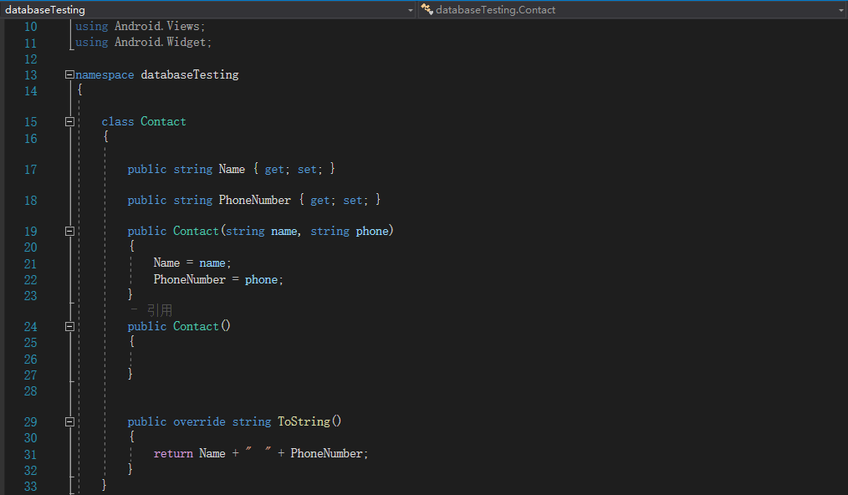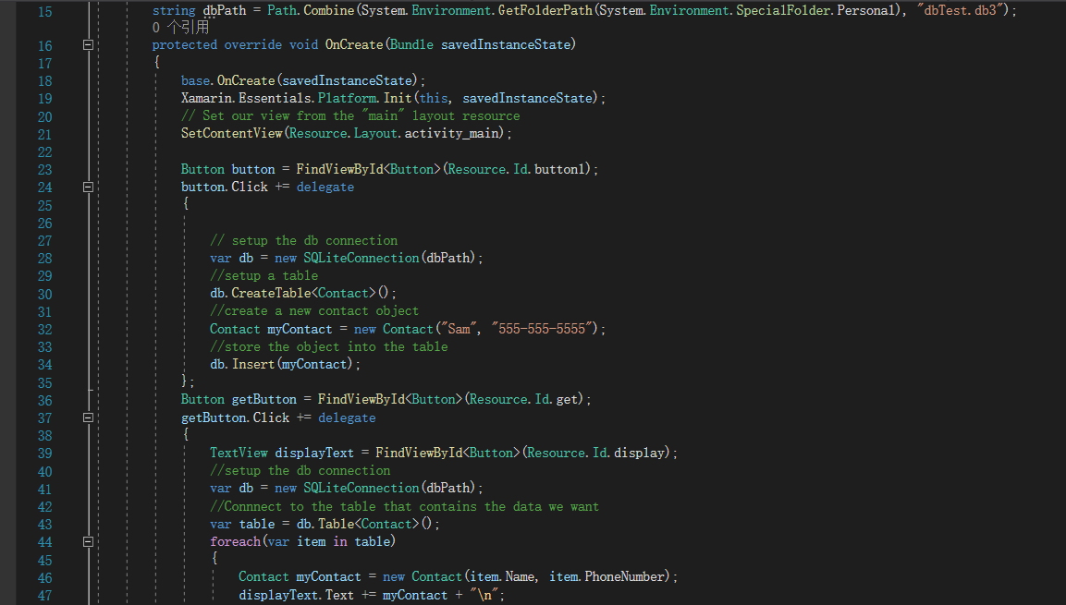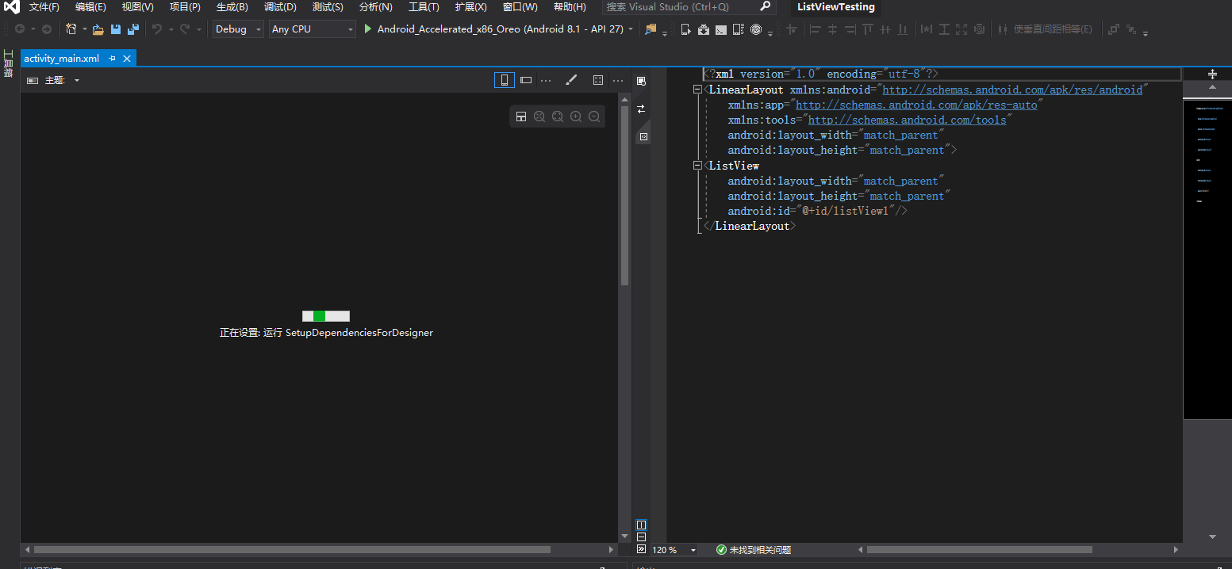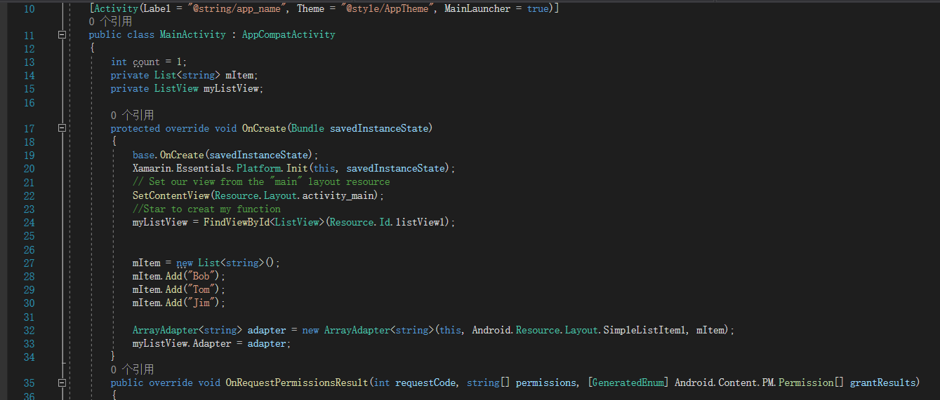
For the Assessment 2, we are started to do the database. But this one was most hart than another project. Therefore, we are planning to use 2 week to create the database. Then down all of the project for Assessment 2.
This is Assessment 2 screen sort:
