Week9 portfolio
In this week, we learned how to use the test for the mobile program by UI Testing. In the lecture, we understand the UI Testing benefit for our program. The Xamarin Testing can be working in the cloud. In the practical, we try to do the UI Testing. In there, I will show the picture for our task project.
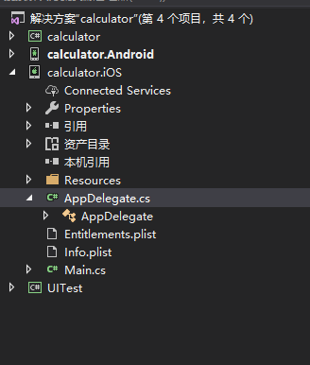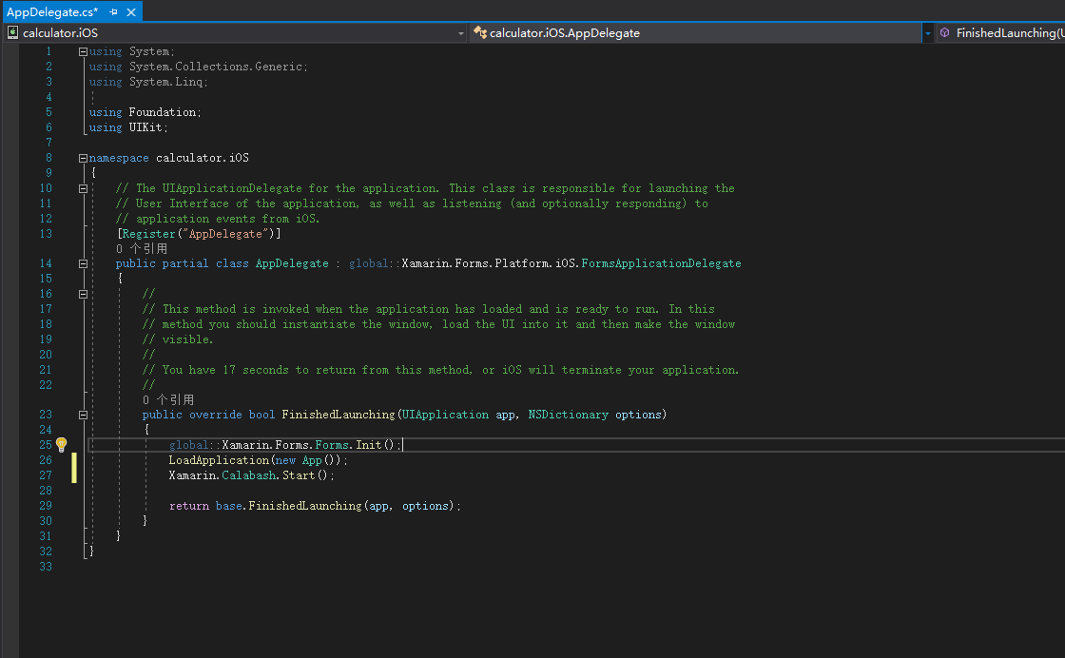
For our assessment 2 for Android project. We did on the switch program and down all of the layout for this program. Now, this will working to click button switch to next screen.

