The Hoops Hub: Leveraging Data for Competitive Advantage
The Data Analytics Department

Data Warehouse Specification for
The Hoops Hub

Version 1.0

May 6th, 2023

Table of Contents

Introduction 3
Purpose 3
Project Summary 4
Requirements Definition 4
Considerations 5
Document Change Log 5

Introduction
The sports industry, like many others, has always been a very competitive market with the constant need to gain an advantage over competitors. With the rise of big data, the sports industry is altering the way data is collected, stored, and analyzed. Leveraging this data will allow players, teams, and organizations to improve individual performance, the team overall, or make predictions for upcoming talent. This information can also be shared with broadcasters to expand marketing and promote fan engagement.
The goal of this data warehouse is to create a comprehensive and scalable data warehouse solution for the basketball/sports industry that will enable stakeholders to make data-driven decisions and gain insights into performance, fan engagement, and revenue growth. It will leverage the power of big data and drive success in the industry.
Purpose
The purpose of this document is to serve as a project specification document for the design of a data warehouse pertaining to the sports industry. It is to provide guidance for the development team for defining data problems, documenting the process, and requirements of the data warehouse. The content of this document contains the following sections: project summary, requirements definition, considerations, and change log. Within the summary and requirements sections the objectives, scope, references, outstanding issues, goals, and business questions. Lastly, usability, system security, and data requirements are covered.
Project Summary
- Objectives
  - Improve data quality.
  - Develop business intelligence reports.
  - Design data warehouse that is scalable
  - Structure data models that will enable efficient data retrieval.
  - Ensure the information in the data warehouse is secure.
- Scope
The scope of this data warehouse design project includes the development of a data warehouse system to address the outstanding issues and requirements of the sports industry.
- References
D. Bhatnagar and S. Urolagin, "Data Warehousing for Formula One (Racing) Popularity Rating Using Pentaho Tools," 2021 IEEE 6th International Conference on Computing, Communication and Automation (ICCCA), Arad, Romania, 2021, pp. 1-7, doi: 10.1109/ICCCA52192.2021.9666247.
G. Kaur and G. Jagdev, "Analyzing and Exploring the Impact of Big Data Analytics in Sports Science," 2020 Indo – Taiwan 2nd International Conference on Computing, Analytics and Networks (Indo-Taiwan ICAN), Rajpura, India, 2020, pp. 218-224, doi: 10.1109/Indo- TaiwanICAN48429.2020.9181320.
K. Apostolou and C. Tjortjis, "Sports Analytics algorithms for performance prediction," 2019 10th International Conference on Information, Intelligence, Systems and Applications (IISA), Patras, Greece, 2019, pp. 1-4, doi: 10.1109/IISA.2019.8900754.
L. Cai, C. Zhao and X. Wang, "Situation and lessons of application of NBA big data technology," 2021 International Conference on Information Technology and Contemporary Sports (TCS), Guangzhou, China, 2021, pp. 228-231, doi: 10.1109/TCS52929.2021.00054.
Ponniah, P. (2010). Data Warehousing Fundamentals for IT Professionals (Second Edition). Hoboken, NJ: John Wiley & Sons.
V. Bhatt, U. Aggarwal and C. N. S. V. Kumar, "Sports Data Visualization and Betting," 2022 International Conference on Smart Generation Computing, Communication and Networking (SMART GENCON), Bangalore, India, 2022, pp. 1-6, doi: 10.1109/SMARTGENCON56628.2022.10083831.
- Outstanding Issues
The outstanding issues within the sports industry include data quality, velocity, variety, volume, and value. There are also limitations on data collection depending on the rules and regulations of that specific sports organization.
Data Quality: Sports data can be extracted from various sources including from official sports teams/organizations and official sports data providers. Data can also be extracted from sports fantasy/betting, broadcasting, and other media. However, some media can contain some opinionated and misleading information. Social media is the number one culprit of misinformation. Often times, social media is not used correctly, and sport parody accounts are more common in today’s society. With the number of fake websites floating around, the accuracy of data is a challenge within the sports industry.
Volume and Variety: The volume of sheer information has been growing exponentially over the past decade. In addition to the variety of which data can come in, a typical data set can be as high as multiple petabytes. In terms of variety, generated data can include raw, structured, and unstructured data. In terms of data type, information can come in text type, audio, video, and pictorial form. The data warehousing system must be able to navigate between the various variety and the volume of data.
Velocity: In addition to the volume of information increasing, the speed at which it is being generated has also been increasing as technology advances. The design of the data warehouse requires an infrastructure that will keep up with the velocity of data.
Value: Even with a great amount of information it has no use or benefit it has no value. Sports teams and organizations are looking for an advantage over their competition by analyzing player stats, team performances, etc. Data with worth assists in the growth or organization and development of players.
Rules and Regulations: The power of wearable technology can fill many of the gaps when it comes to data that cannot be gathered easily. Wearable technology can access the physical conditions of the players, courts/field/arena, and psychological factors such as referees and fan support. Some professional organizations are worried about the safety of both the player and the sport itself, so they do not allow the use of these devices during the game.
Requirements Definition
- Goals
  - Improve data quality: Data is to be collected from reliable and valid resources, perform data validation and cleaning processes, and perform regular data quality checks.
  - Deliver business value: Identify and utilize key performance indicators that align with business goals.
  - Enable data analysis: Develop a dashboard to provide insights. Use other reporting tools and technologies like OLAP to enable data exploration.
  - Enhance data velocity: Ensure data is captured as close to real-time as possible to support fast data retrieval and support business decision making.
  - Scalability: Implement a data warehouse architecture that can support increasing data volume. Develop a data model that can adapt to growth and change over time.
  - Data security: Implement access control to prevent unauthorized access and ensure data is backed up regularly to prevent data loss.
  - Handle volume and variety of data: Implement a data warehouse architecture that supports large volumes of data in a variety of forms.
- Usability Requirements
  - User Interface: the system must provide a user-friendly interface that will act as a self-service portal and allow users to easily navigate through the data warehouse.
  - Reporting Tools: the system will have reporting tools to provide ad hoc reports to improve decision making.
  - Query Capability: the system will have capabilities to enable the user with flexibility and customization of queries.
  - Help Guide: FAQ and user guide will be provided to assist new users with various functionalities and a tutorial on how software is to be used.
- System Security Requirements
  - User authentication: a login system will be implemented with two factor verification to ensure the user attempting to access the data warehouse is an employee.
  - Access Control: role-based access control will be implemented to ensure that users attempting to access data is of clearance.
  - Data Classification: highly sensitive data must be classified as such so the system knows what information to protect, and users know what information is the most detrimental if leaked.
  - Employee Training: training for each employee is to be provided to ensure employees possess the skills needed for performance. It will also improve performance and reduce the risk of leaked information and/or security breaches.
  - Intrusion Detection: security precautions will be installed to prohibit breaches. Security issues and other vulnerabilities in the system will be reported.
- Business Questions
  - How are individual players performing in terms of KPI metrics?
  - How are players performances with certain teammates on the floor with them versus without?
  - How is the overall team performance?
  - What factors or trends does the team and/or player have?
  - How is the team and/or player rank in comparison to other teams and/or players in certain categories (i.e. defense, turnovers, scoring, FT made, steals etc.)?
  - What common health issues are faced by players?
  - What psychological factors can affect a player’s performance or sway a game’s outcome?
  - How is fan engagement? What factors can negatively and/or positively affect fan engagement?
  - What is the expected possession value (EPV) of a player?
  - How can this data be used as a predictive tool for betting agencies, fantasy leagues and prospect (draft) players?
- Data Requirements

ER Diagram
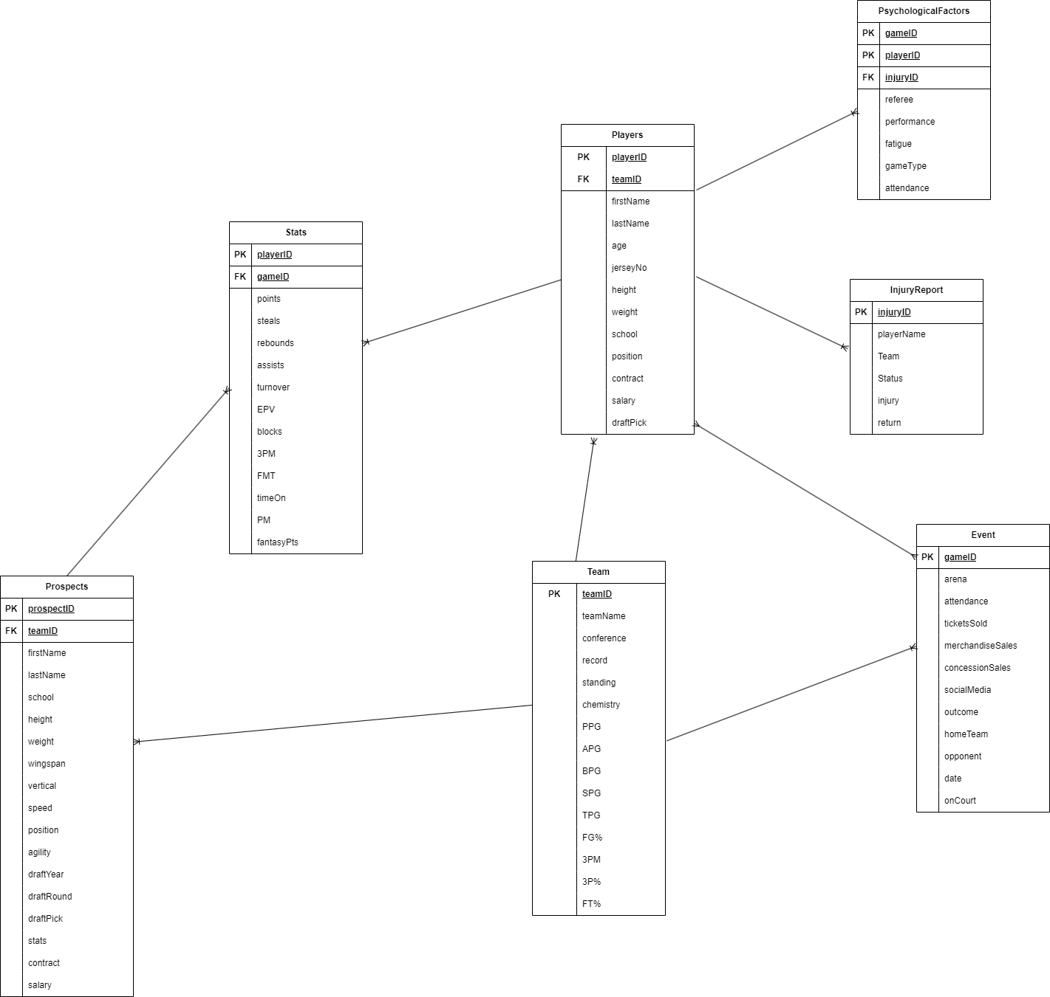

Database Design
The hoops hub data warehouse is designed as a relational database. It includes a table that can be seen below and the lines in the diagram signify the relationships between the tables. Primary and foreign keys are utilized to help users easily retrieve related information.
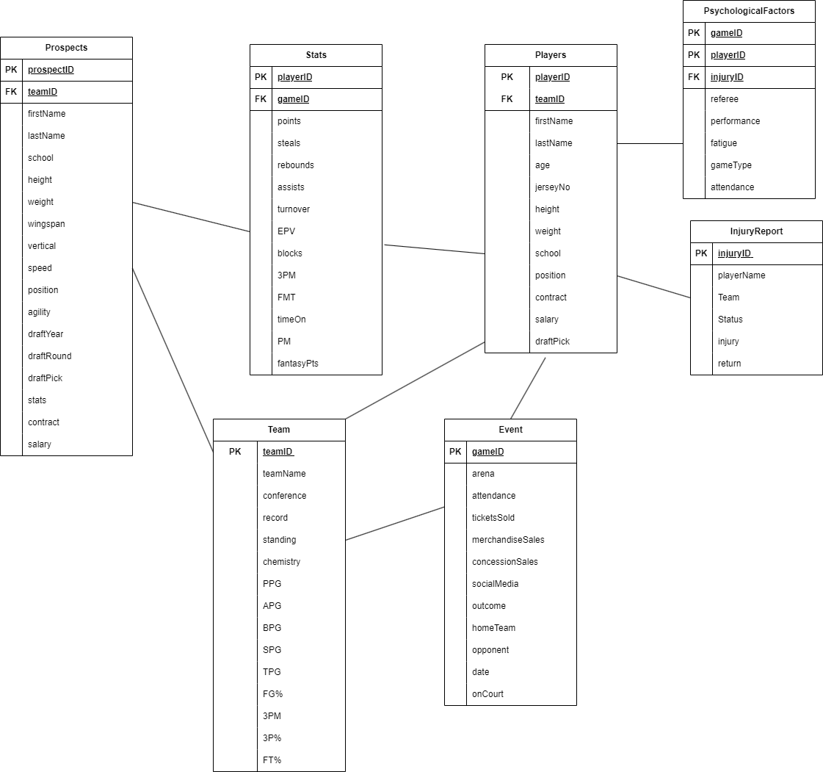

Data Dictionaries

Table Name: Players
Field Name | Data Type | Constraint | Description | Example
playerID | Int | Primary key | The unique identifier for a player | P127009
firstName | Text |  | The players first name | Lebron
lastName | Text |  | The players last name | James
teamID | Text | Foreign key | The unique identifier for the team the player plays on | T015
age | Int |  | The age of the player | 38
jerseyNo | Int |  | The players jersey number | 6
Height | Text |  | The players height | 6’9”
Weight | Int |  | The players weight | 250
School | Text |  | The school the player got drafter from | St. Vincent-St. Mary Highschool
Position | Text |  | The position the player plays | SF
contract | Text |  | the details of the players contract including length, trade clauses and other perks or incentives | 5 years
Salary | Float |  | The amount of money the player is being paid via their contract | 44,000,000
draftPick | Text |  | The year, round and pick the player was drafted | 2003: Rd1, Pk1

Table Name: Stats
Field Name | Data Type | Constraint | Description | Example
playerID | int | Primary key | the unique identifier for the player | P127009
gameID | Int | Foreign key | the unique identifier for the game the player played in | E005111
Points | Float |  | the running average number of points the player scores | 28.5
Steals | Float |  | the running average of steals a player gets per game | 1.2
Rebounds | Float |  | the running average of rebounds a player gets per game | 8.3
Assists | Float |  | The running average of assists a player gets per game | 6.8
Turnover | Float |  | The running average of turnovers a player commits per game | 5.6
EPV | Float | Optional | The expected possession value by the player | .88
Blocks | Float |  | The running average of blocks the player gets per game | 4.7
3PM | Int |  | The running total number of three pointers made by the player | 2,243
FTM | Int |  | The running total of free throws made by the player | 8,542
timeOn | Int |  | The running total number of minutes played | 38
PM | Int |  | plus/minus stat (+/-) to measure players impact on the courts versus off the court | +10
FantasyPts | Int | optional | The running total of fantasy points accumulated by the player | 5

Table Name: Team
Field Name | Data Type | Constraint | Description | Example
teamID | Int | Primary Key | The unique identifier for the team | T015
teamName | Text |  | The name of the team | Los Angeles Lakers
Conference | Text |  | The name of the conference the team plays in | Western
Record | Text |  | A running record off wins/losses | 52-28
Standing | Int |  | The teams rank | 7
Chemistry | Float |  | The | 78.9
PPG | Float |  | The average points per game made by the team | 98.5
RPG | Float |  | The average rebounds per game made by the team | 50.5
APG | Float |  | The average assists per game made by the team | 20.3
BPG | Float |  | The average blocks per game made by the team | 9.8
SPG | Float |  | The average steals per game made by the team | 3.2
TPG | Float |  | The average turnovers committed per game by the team | 8.9
FG% | Float |  | The field goal percentage of the team | 46.7
3PM | Int |  | The number of three pointers made by the team | 6
3P% | Float |  | The three-point field goal percentage made by the team | 24.0
FT% | Float |  | The free throw percentage made by the team | 86.2

Table Name: InjuryReport
Field Name | Data Type | Constraint | Description | Example
injuryID | Int | Primary key | The unique identifier for the injury report | I730981
playerName | Text |  | The name of the player who has an injury | Jimmy Butler
teamID | Int | Foreign key | The unique identifier of the team the player plays on | T43
Status | Text |  | The players current status can be one of the following: available, possible, doubtful, out | Out
Injury | Text |  | A description of the body part and type of injury the player is faced with | Ankle (sprined)
Return | Text | Optional | An estimated time the player will return to action | 3 weeks

Table Name: Event
Field Name | Data Type | Constraint | Description | Example
gameID | int | Primary key | The unique identifier for the game the game the player played in | E005111
arena | Text |  | The name of the arena the game was played in | Spectrum Center
attendance | Int |  | The total number of fans in attendance for the game | 18,938
ticketSold | Int |  | The total number of tickets sold | 19,012
merchandiseSales | Float |  | The total number of sales made on merchandise | 1,724.00
concessionSales | Float |  | The total number of sales made at concessions | 5,874.10
socialMedia | Int |  | The number of like, comments, shares, posts pertaining to the current event | 300,530
outcome | Text |  | Records either a win or a loss based on the home team | L
homeTeam | Text |  | Name of the home team for the game | Charlotte Hornets
opponent | Text |  | Name of the away team for the game | Memphis Grizzlies
date | Date |  | The date the game takes place | 3/15/2023
onCourt | Text |  | The list of players on the court (in the game) at a given time | Lamelo Ball, Kelly Oubre, Gordon Hayward, Terry Roizer, PJ Washington

Table Name: Prospects
Field Name | Data Type | Constraint | Description | Example
prospectID | Int | Primary key | Unique identifier for the given prospect | PR827301
teamID | Int | Foreign key | The unique identifier for the team the prospect will be drafted by | T13
firstName | Text |  | The first name of the prospect | Jake
lastName | Text |  | The last name of the prospect | Maverick
School | Text |  | The name of the school the prospect will be drafted from | Ben Smith Highschool
Height | Text |  | The height of the prospect | 6’5”
weight | Int |  | The weight of the prospect | 195
wingspan | Text |  | The wingspan in inches of the prospect | 23.67
vertical | Text |  | The vertical in inches of the prospect | 36.05
speed | Float |  | The speed of the prospect conducting a ¾ court sprint | 2.85
position | Text |  | The position the prospect plays | SG
agility | Text |  | A description of the prospect’s agility either can be below, average, or above | average
draftYear | Int |  | The year in which the prospect was drafted | 2023
draftRound | Int |  | The round number the prospect was drafted | 1
draftPick | Int |  | The pick number the prospect was drafted | 25
contract | text |  | the details of the players contract including length, trade clauses and other perks or incentives | 5 year , no trade clauses
salary | Float |  | The amount of money the player is being paid via their contract | 950,000.00

Table Name: PsychologicalFactors
Field Name | Data Type | Constraint | Description | Example
playerID | Int | Primary key | The unique identifier for the given player | P086314
gameID | Int | Primary key | The unique identifier for the event/game | E001116
injuryID | Int | Foreign key | The unique identifier for the injury report on a given player | I632980
referee | Text |  | The name of the referee scheduled for the game | Scott Foster
performance | Text |  | Rating on the current performance of the player. Can either be excellent, good, fair, or poor. | good
Fatigue | Float |  | The fatigue percentage on the given player | 34.00
gameType | Text |  | The type of game either home or away | away
attendance | Int |  | The number of people in attendance for the game | 19,348

- Design Constraints
  - Budget Limitations:
    - Identify areas in data analytics department where additional resources may be needed.
    - Set aside budget for hiring people with given talent/skill set.
  - Organizational Policies:
    - Some data on prospects will be missing due to optical tracking not being available at that level.
    - Organizations must all use SportVU for tracking data for consistency measures
  - Resource Limitations:
    - Use efficient hardware and software components needed for data warehouse.
  - Time Constraint:
    - Prioritize efficient and timely data loading process to ensure the availability of up to date information for real time data analysis and reporting.
Considerations
- Teams in sports industry has difficulty reserving funds for data scientists who help draw conclusions and make predictions.
- Optical tracking data is currently only available in soccer and basketball. SportVU is only available in NBA. Other organizations do not use wearable technology and/or limit the use of tracking data.
- Typical data sets can be as high as multiple petabytes. Storage system requirements must be in consideration in the design phase.
- ESPN reporters, analysts, and broadcasters use this information to provide commentary, analysis, and updates before, during, and after live game events. Queries must be optimized in order to enhance performance and provide data in real time.
Appendix
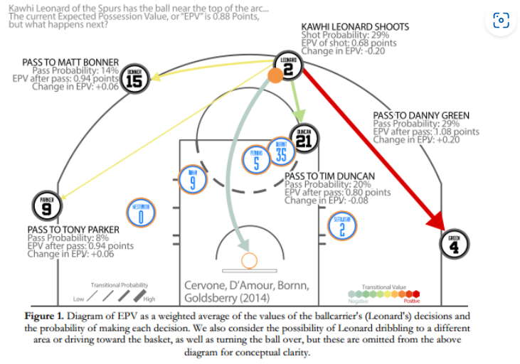

Document Change Log

Change Date | Version | CR # | Change Description | Author and Organization
02/03/23 | 1.0 |  | Initial creation. | Taylor Headen
02/10/23 | 1.1 |  | Introduction and Scope completion | Taylor Headen
2/24/23 | 1.2 |  | Resources added | Taylor Headen
3/4/23 | 1.3 |  | Project summary creation | Taylor Headen
3/8/23 | 1.3.1 |  | Objective, Scope and Outstanding issues completion | Taylor Headen
3/17 | 1.4 |  | Requirement definition creation | Taylor Headen
3/30/23 | 1.4.1 |  | Goals and business question completion | Taylor Headen
4/10/23 | 1.4.2 |  | Usability and security requirements completion | Taylor Headen
4/21/23 | 1.4.3 |  | Data dictionary completion | Taylor Headen
4/27/23 | 1.4.4 |  | Requirements completion | Taylor Headen
4/29/23 | 1.5 |  | Appendix added, consideration completion | Taylor Headen
5/4/23 | 1.6 |  | Formatting and Finishing touches | Taylor Headen

Data Warehouse Design Template (n.d.). Retrieved from https://www.google.com/search?client=safari&rls=en&ei=h2HeWv6fOY_-zgK5vrOIDQ&q=data+warehouse+design+document+template+&oq=data+warehouse+design+document+template+&gs_l=psy-ab.3..0i30k1j0i8i30k1.4517.15588.0.15915.16.12.4.0.0.0.129.1130.9j3.12.0....0...1.1.64.psy-ab..0.13.1029...0i22i30k1j0i7i30k1j0i8i7i30k1j0i13i30k1j0i8i13i30k1.0.JMhxh9fWO5g

