Justin Gewecke

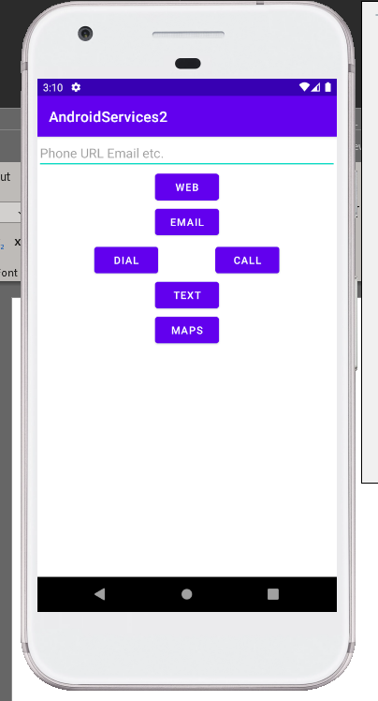

Caption: Default look of the app

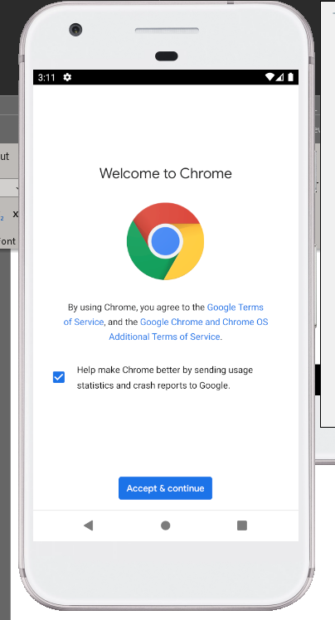

Caption: This happens when you enter google.com and hit the Web button

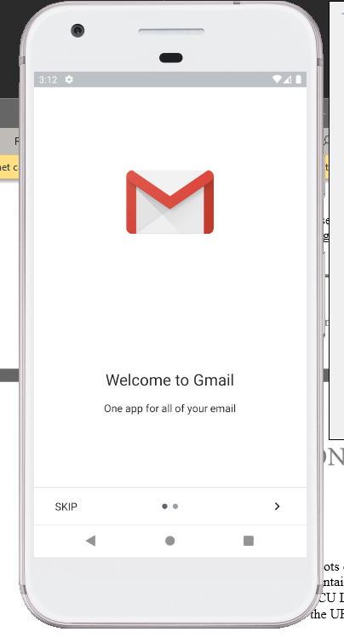

Caption: This shows when you enter an email and hit the email button

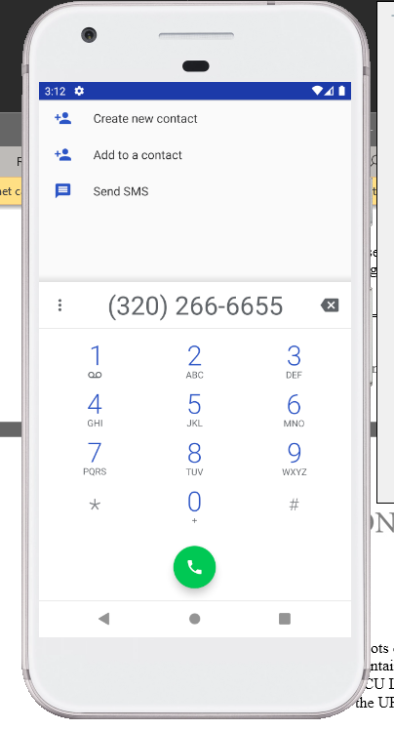

Caption: This page shows when you enter 320-266-6655 and hit the Dial button.

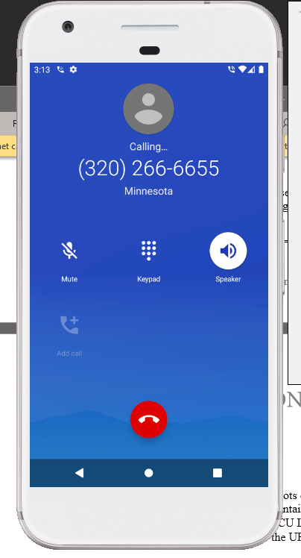

Caption: This is what happens when you enter 320-266-6655 and hit the Call button.

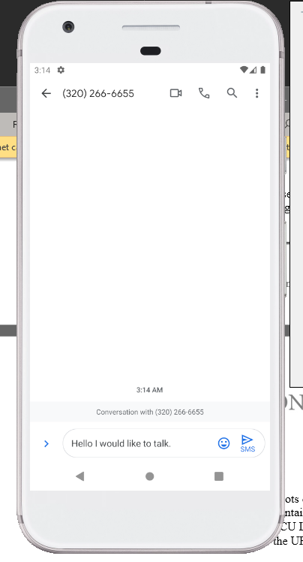

Caption: This is what happens when you enter 320-266-6655 and you hit the Text button.

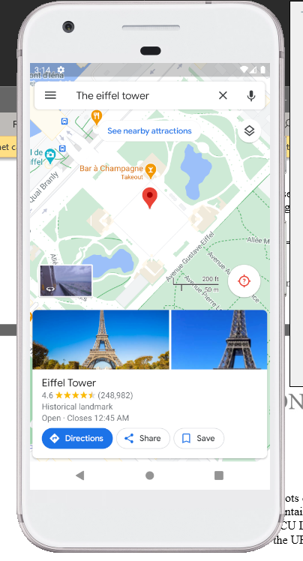

Caption: This is what happens when you enter “the Eiffel tower” and hit the maps button