Justin Gewecke

Github URL: https://github.com/Icefireburn1/CST-135-Activity6

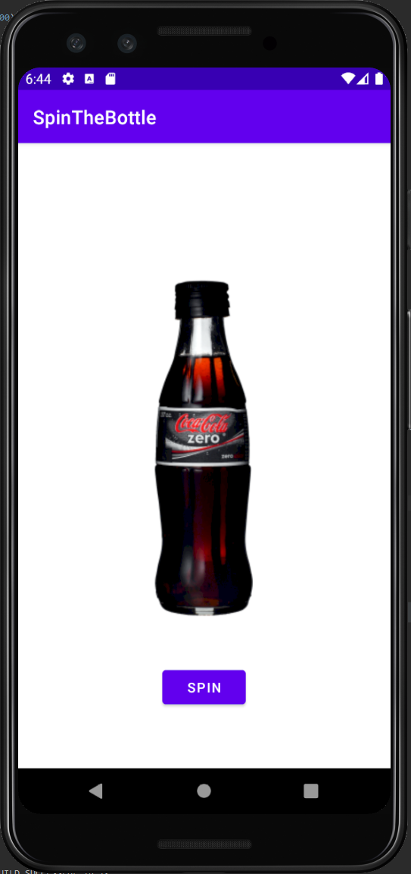

Caption: This is what you see when the app starts

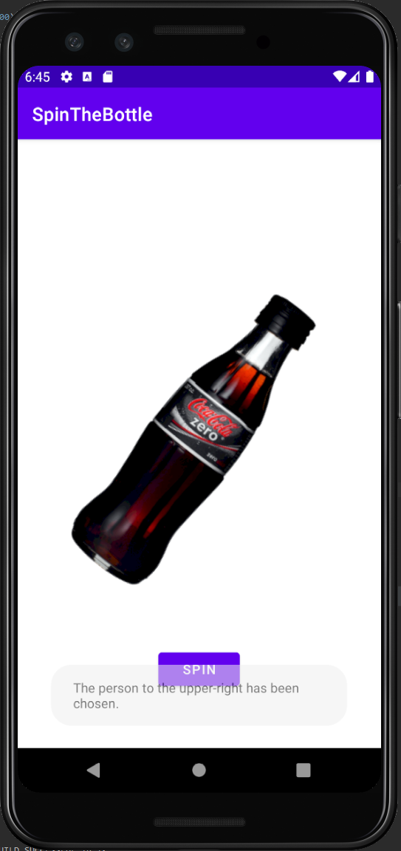

Caption: This is what happens when you let the bottle spin.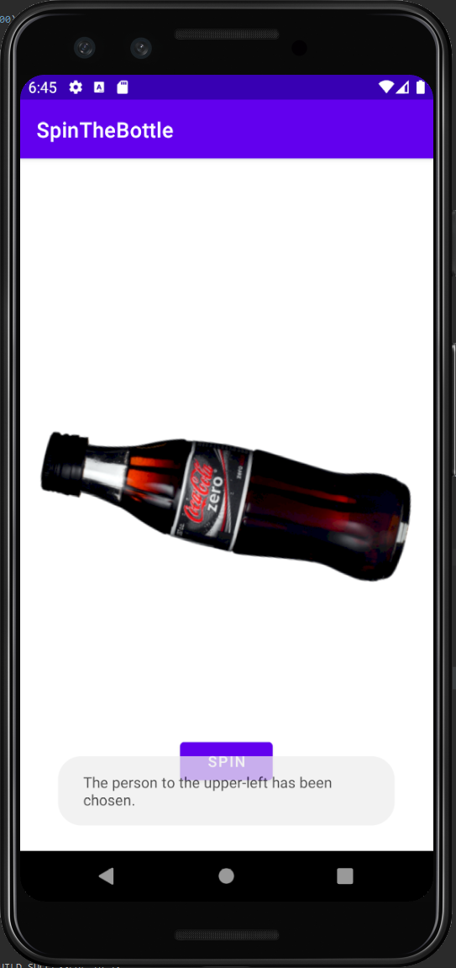

Caption: Caption: This is what happens when you let the bottle spin.