Justin Gewecke

Github URL: https://github.com/Icefireburn1/CST-135-Activity6

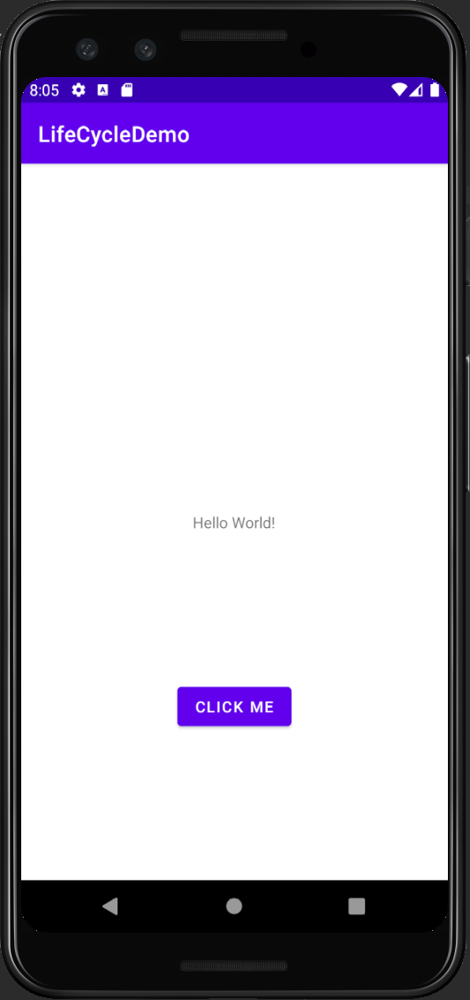

Caption: This is what you see when the app starts

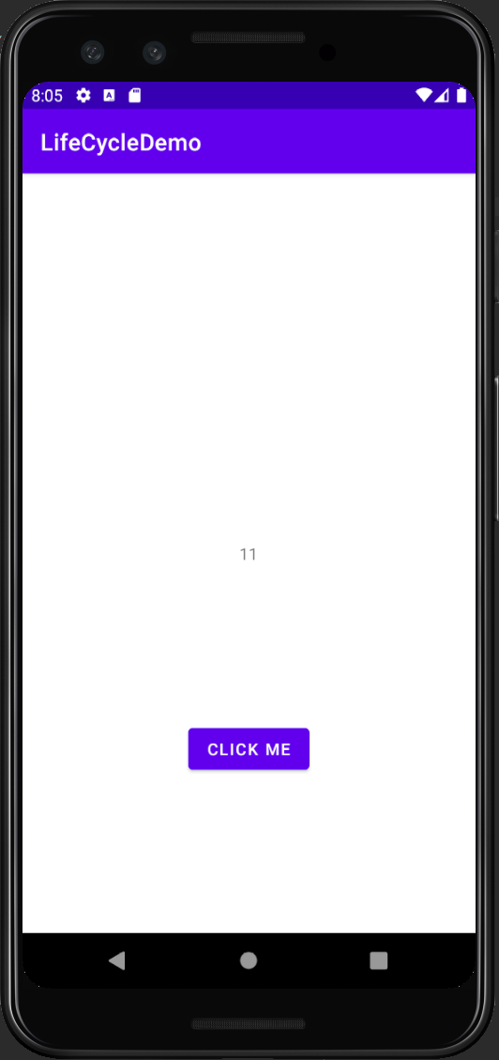

Caption: This is what happens you hit the CLICK ME button

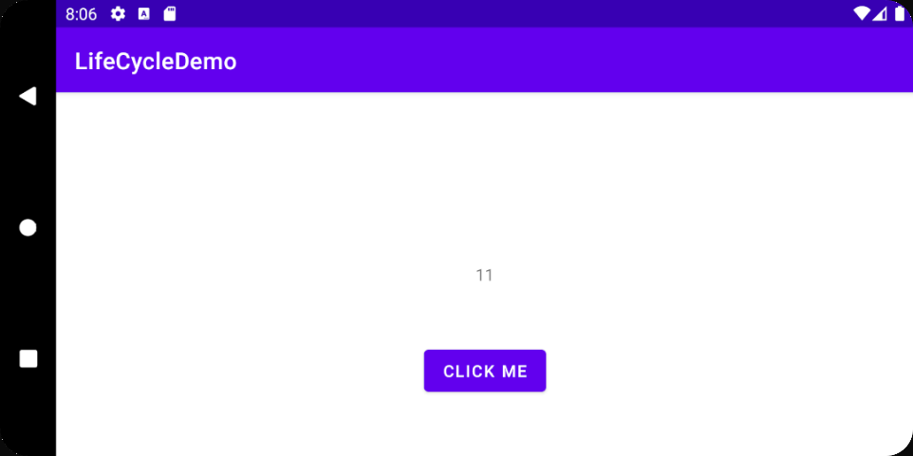

Caption: The value persists from the screen orientation changing (AKA the activity ending and resuming).