Justin Gewecke

Github URL: https://github.com/Icefireburn1/CST-135-Activity6

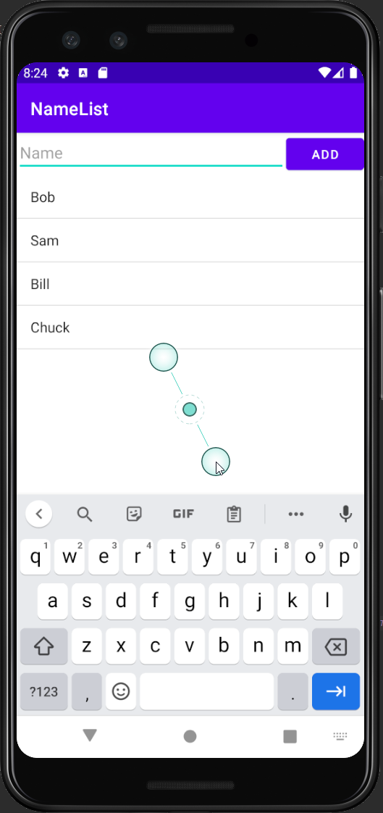

Caption: This is what the main screen looks like.

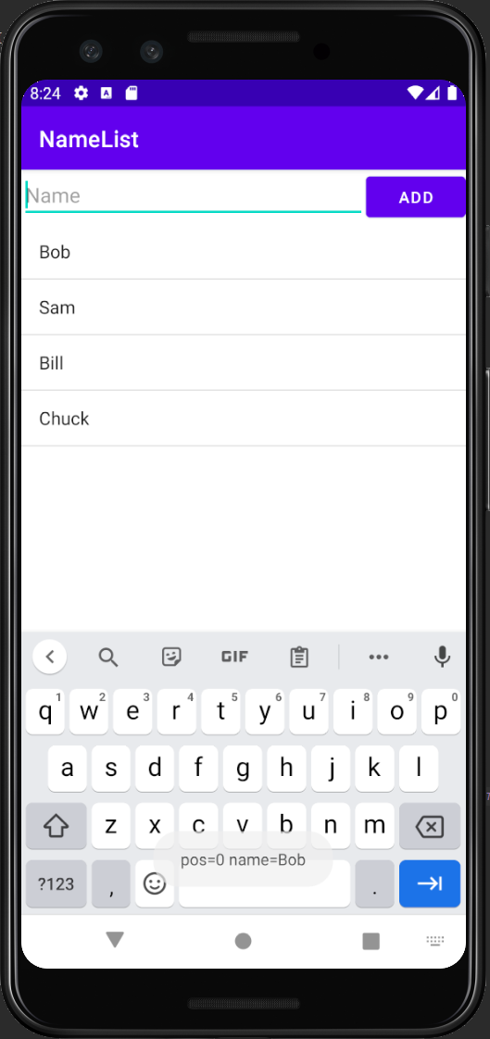

Caption: We can click on an item in the list to pull up its details.

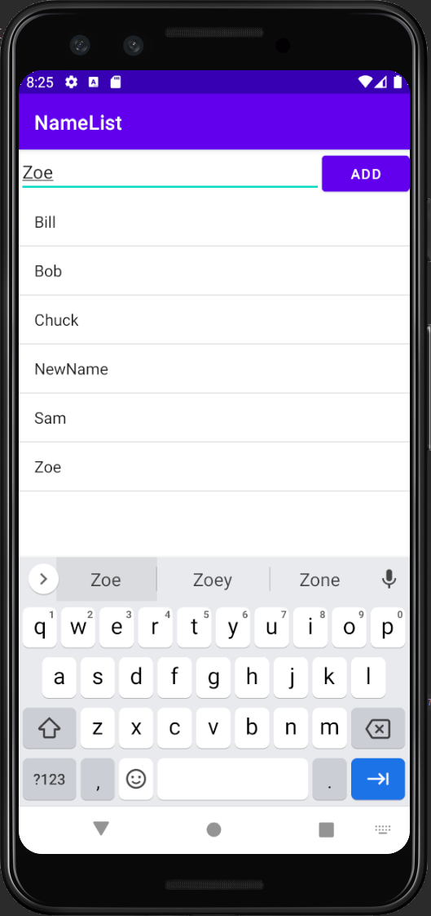

Caption: We can add new items to the list.