Justin Gewecke

Github URL: https://github.com/Icefireburn1/CST-135-Activity6

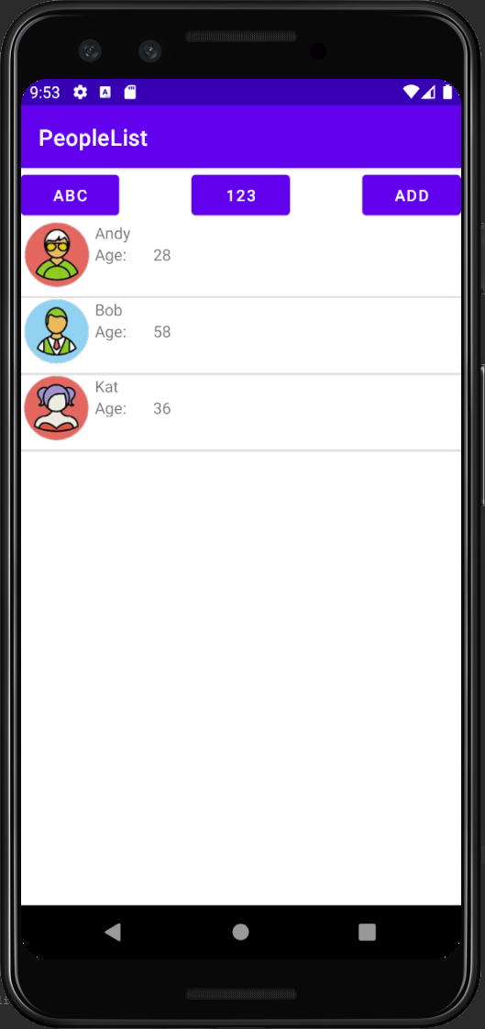

Caption: This is how the app looks like when you boot it up.



Caption: We can click the ADD button to go to a new form to create a new person.

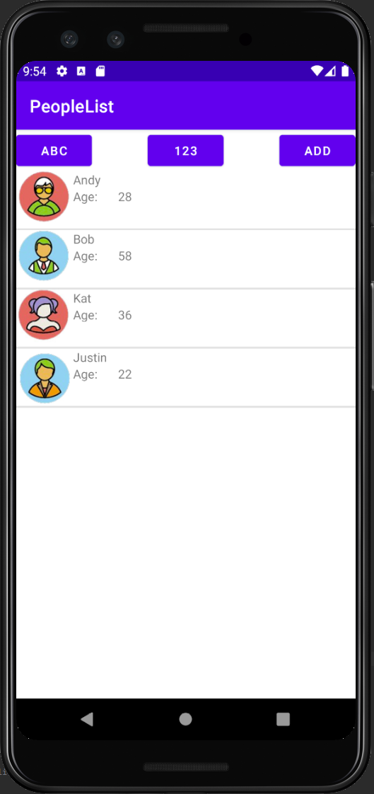

Caption: Here you can see that we added Justin to our people.

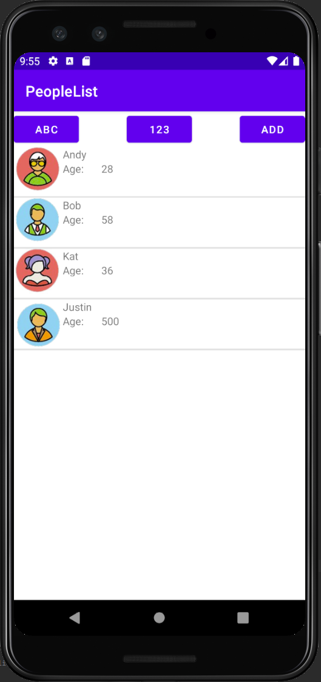

Caption: We can edit already existing people. We changed the age of Justin to 500.

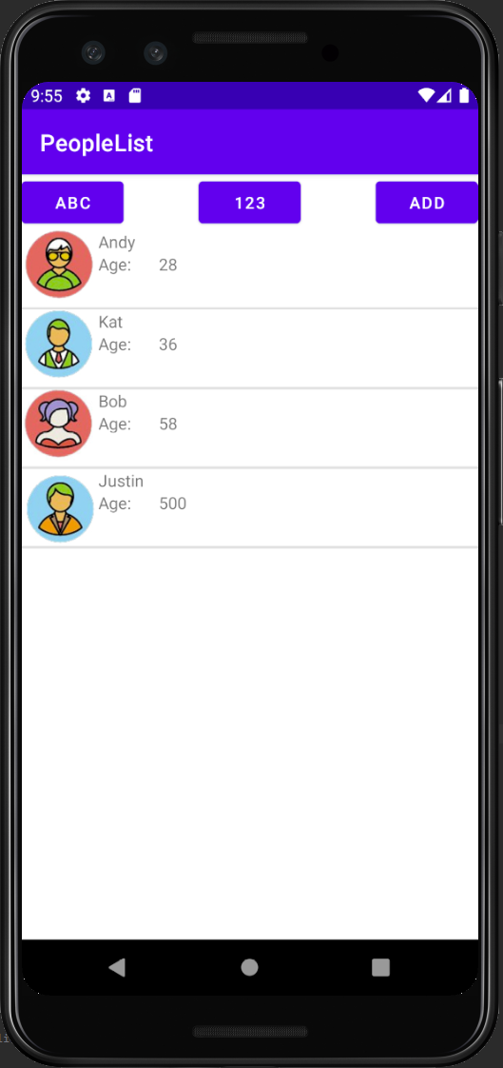

Caption: We can sort our people by age.

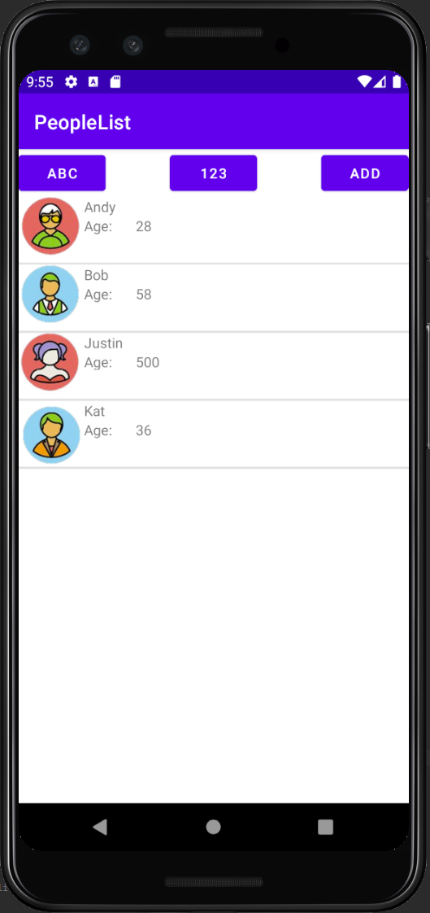

Caption: We can sort our people by alphabetical order.