Justin Gewecke

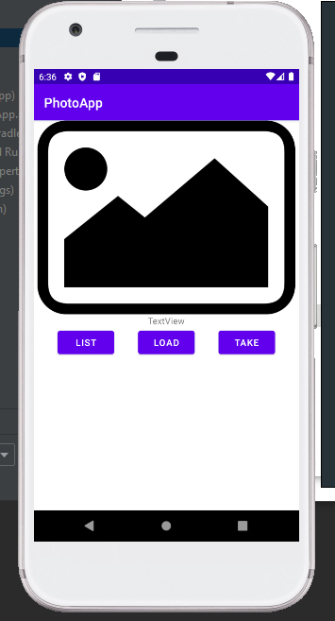

Caption: This is what you see when the app just starts

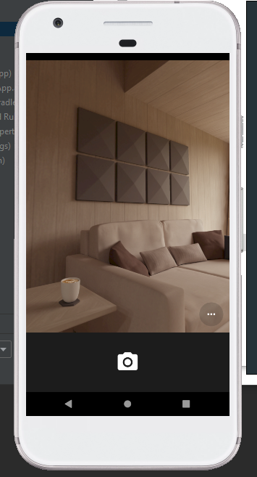

Caption: Pressing the Take button opens up the camera.

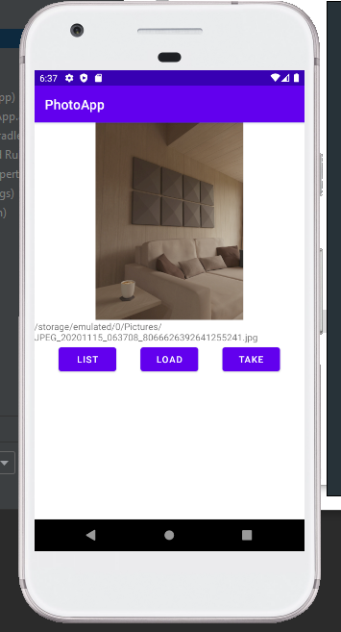

Caption: Taking a picture changes the image on the main screen.

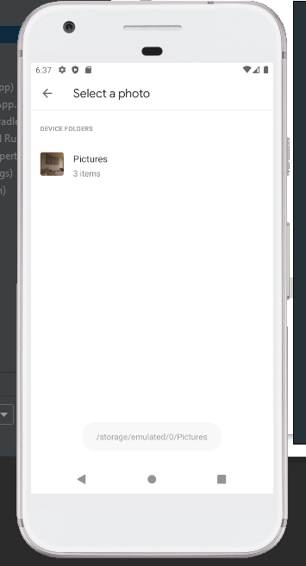

Caption: Pressing Load shows all of our pictures that we have taken.

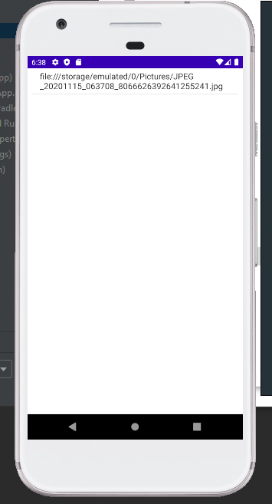

Caption: List shows us our recently opened pictures.