检测文件：./src/drivers/distance_sensor/broadcom/afbrs50/argus_hal_test.c

无争议命令行：

esbmc --unwind 1 --no-unwinding-assertions --overflow-check --memory-leak-check --nan-check --deadlock-check --lock-order-check --atomicity-check --error-label label argus_hal_test.c

-I /home/syb/Desktop/PixhawkPX4/1.12.3/Firmware/src/drivers/distance_sensor/broadcom/afbrs50/Inc

-I /home/syb/Desktop/PixhawkPX4/1.12.3/Firmware/platforms/common/include

需根据依赖选择命令行：

**px4_arch/micro_hal.h**：

选择：

-I /home/syb/Desktop/PixhawkPX4/1.12.3/Firmware/platforms/qurt/src/px4/generic/generic/include

待选区：

1.12.3/Firmware/platforms/nuttx/src/px4/nxp/k66/include/ ：

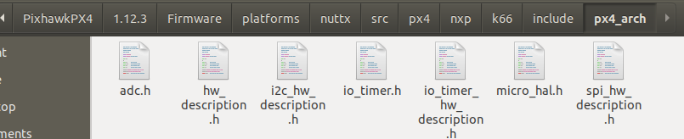

1.12.3/Firmware/platforms/nuttx/src/px4/nxp/nxp_common/include/ ：

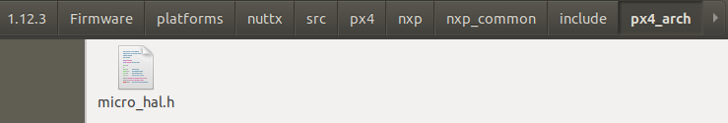

1.12.3/Firmware/platforms/nuttx/src/px4/nxp/rt106x/include/ ：

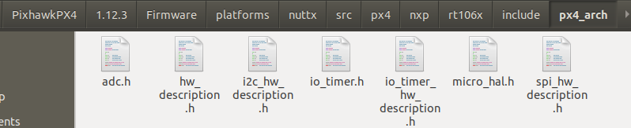

1.12.3/Firmware/platforms/nuttx/src/px4/nxp/s32k14x/include/ ：

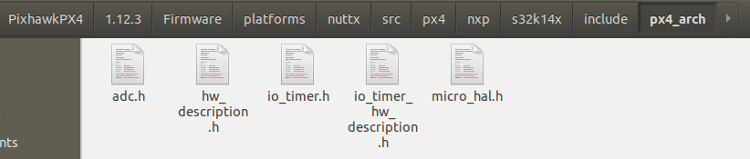

1.12.3/Firmware/platforms/nuttx/src/px4/stm/stm32_common/include/ ：

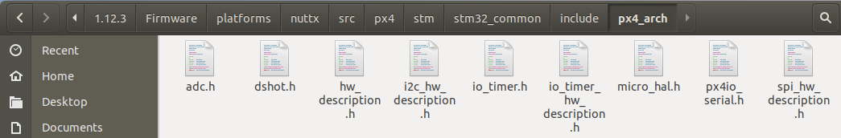

1.12.3/Firmware/platforms/nuttx/src/px4/stm/stm32f1/include/ ：

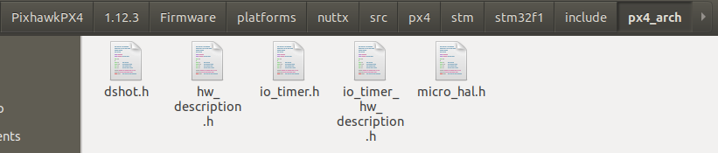

1.12.3/Firmware/platforms/nuttx/src/px4/stm/stm32f3/include/ ：

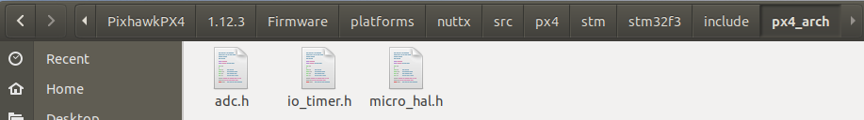

1.12.3/Firmware/platforms/nuttx/src/px4/stm/stm32f4/include/ ：

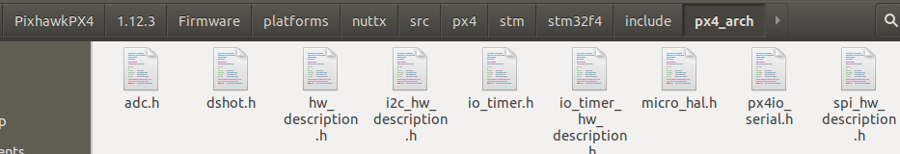

1.12.3/Firmware/platforms/nuttx/src/px4/stm/stm32f7/include/ ：

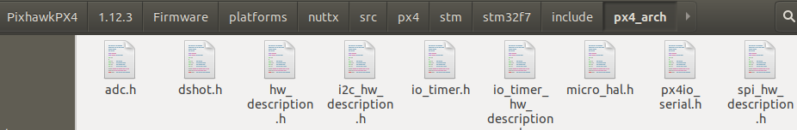

1.12.3/Firmware/platforms/nuttx/src/px4/stm/stm32h7/include/ ：

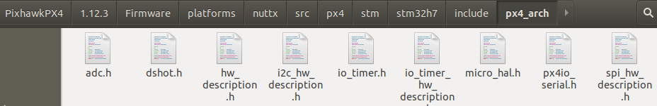

1.12.3/Firmware/platforms/posix/src/px4/generic/generic/include/ ：

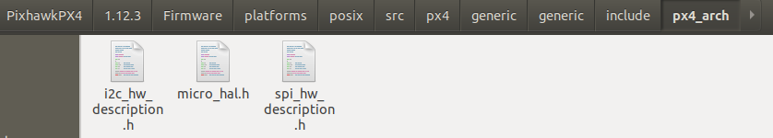

1.12.3/Firmware/platforms/qurt/src/px4/generic/generic/include/ ：

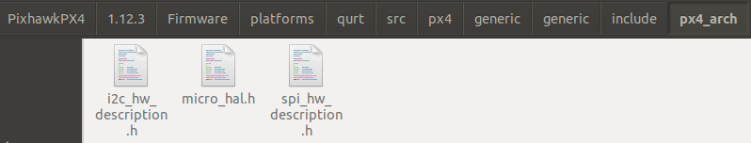

**px4_platform/micro_hal.h**：

选择：

-I /home/syb/Desktop/PixhawkPX4/1.12.3/Firmware/platforms/qurt/src/px4/common/include

待选区：

1.12.3/Firmware/platforms/nuttx/src/px4/common/include/ ：

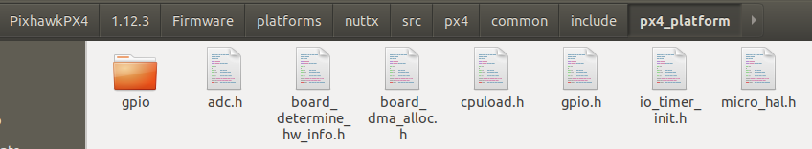

1.12.3/Firmware/platforms/posix/src/px4/common/include/ ：

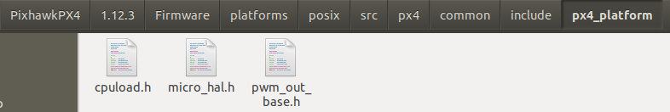

1.12.3/Firmware/platforms/qurt/src/px4/common/include/ ：

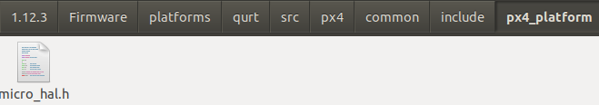

**检测反例记录**：

