检测文件：/home/syb/Desktop/PixhawkPX4/1.12.3/Firmware/src/modules/mavlink/mavlink_main.cpp

无法识别constexpr

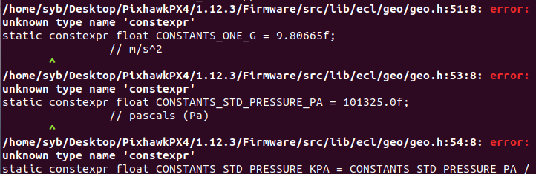

无法识别模板

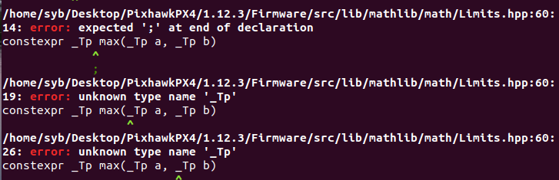

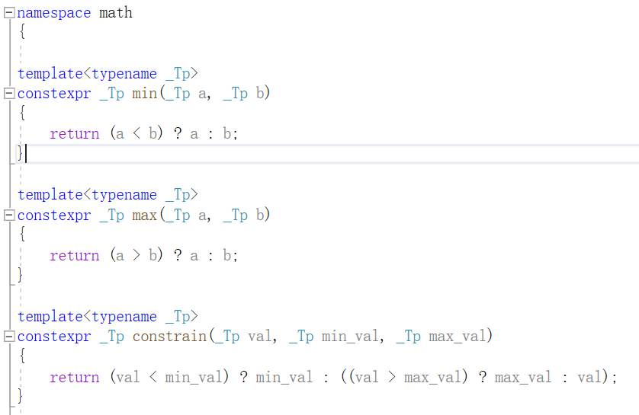

拟采用生成中间件IR的方式屏蔽constexpr影响：

clang -S -fobjc-arc -emit-llvm mavlink_main.cpp -I /home/syb/Desktop/PixhawkPX4/1.12.3/Firmware/src/include -I /home/syb/Desktop/PixhawkPX4/1.12.3/Firmware/src -I /home/syb/Desktop/PixhawkPX4/1.12.3/Firmware/platforms/common/include -I /home/syb/Desktop/PixhawkPX4/1.12.3/Firmware/platforms/qurt/include（采用qurt/include/queue.h）