检测文件：1.12.3/Firmware/src/drivers/distance_sensor/broadcom/afbrs50/API/Src/s2pi.c

无争议命令行：

esbmc --unwind 1 --no-unwinding-assertions --overflow-check --memory-leak-check --nan-check --deadlock-check --lock-order-check --atomicity-check --error-label label s2pi.c

-I /home/syb/Desktop/PixhawkPX4/1.12.3/Firmware/build/px4_fmu-v5_default/NuttX/nuttx/include

-I /home/syb/Desktop/PixhawkPX4/1.12.3/Firmware/build/px4_fmu-v5_default/NuttX/nuttx/include/nuttx

-I /home/syb/Desktop/PixhawkPX4/1.12.3/Firmware/src/drivers/distance_sensor/broadcom/afbrs50/API/Inc

-I /home/syb/Desktop/PixhawkPX4/1.12.3/Firmware/src/drivers/distance_sensor/broadcom/afbrs50/Inc

-I /home/syb/Desktop/PixhawkPX4/1.12.3/Firmware/platforms/common/include

需根据依赖选择命令行：

**board_config.h**

选择：

-I /home/syb/Desktop/PixhawkPX4/1.12.3/Firmware/boards/px4/fmu-v5/src

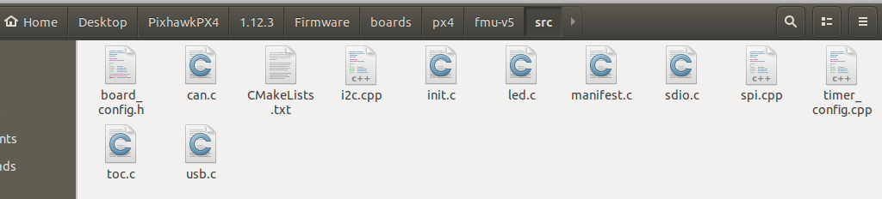

**stm32_gpio.h**

选择：

-I /home/syb/Desktop/PixhawkPX4/1.12.3/Firmware/build/px4_fmu-v5_default/NuttX/nuttx/arch/arm/src/stm32

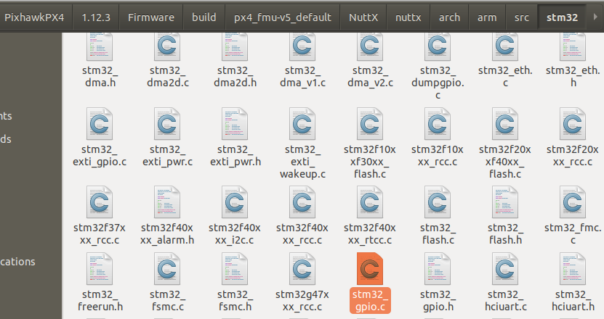

结果：宏定义出错，默认是所有硬件配置标识符都为0，因此依照这些配置标识符来区分的宏定义就无法编译。