**Data Use Agreement**

This Data Use Agreement, effective as of 12.1 , 20_25_ (“Effective Date”), is entered into by and between __邝佳轩__ (“Recipient”) and Shanghai Jiao Tong University X-LANCE Lab. The purpose of this Agreement is to provide Recipient with access to the Depression-Diagnosis-Oriented Dialogue Dataset - D4 for use in the following titled research project: ___  
面向共情对话的大语言模型合成数据方法__ (Project Name) in ___Sun Yat-sen University__ (Recipient Institution) in accord with applicable law or regulations.

1. Responsibilities of Recipient.

Recipient agrees to:

* 1. Use or disclose the D4 only as permitted by this Agreement or as required by law;
  2. Use appropriate safeguards to prevent use or disclosure of D4 other than as permitted by this Agreement or required by law;
  3. Report to SJTU X-LANCE Lab any use or disclosure of the D4 of which it becomes aware that is not permitted by this Agreement or required by law, including the presence of prohibited identifiers in D4;
  4. Require any of its subcontractors or agents that receive or have access to D4 to agree to the same restrictions and conditions on the use and/or disclosure of D4 that apply to Recipient under this Agreement;
  5. Not use the information in D4, alone or in combination to identify or contact the individuals who are data subjects.
  6. Recipient shall provide proper citation and acknowledgement to SJTU X-LANCE Lab as the source of D4 in Recipient publications, presentations or other public dissemination of work utilizing the Dataset.

1. Restrictions of Recipient.

Recipient shouldn’t:

* 1. Deduce or obtain information from D4 that results in Recipient or any third party(ies) directly or indirectly identifying any research subjects with or without the aid of other information acquired elsewhere;
  2. Use D4 in any way prohibited by applicable local, province or national laws;
  3. Transfer any part of the Data Set to any third party without prior written consent from SJTU X-LANCE Lab

1. Permitted Uses and Disclosures of D4. Recipient may use and/or disclose the D4 **only for the Research** described in this Agreement or as required by law.
2. Disclaimer of Warranties.
   1. D4 is provided "as is" and "as available" without warranties of any kind, express or implied, including, but not limited to, non-infringement, merchantability, and fitness for a particular purpose, and any implied warranties of any performance or use in trade process, all of which are explicitly rejected.
   2. Without limiting the foregoing, SJTU X-LANCE Lab does not warrant that: (A) the D4 is accurate, complete, reliable or correct; (B) the dataset files will be secure; (C) the dataset will be available in any particular (D) any defects or errors will be corrected; (E) the dataset and accompanying documents are free of viruses or other harmful components; or (F) the results of using the dataset will satisfy the recipient's requirements. Use of the data set by the recipient is entirely at the recipient's own risk.
3. Limitation of Liability

In no event shall SJTU X-LANCE Lab be liable to the recipient of (A) any direct damages, or (B) any loss of profits or special, Any form of indirect, incidental, punitive or consequential damages

1. Term and Termination.
   1. Term. The term of this Agreement shall commence as of the Effective Date and terminate 5 years from Effective Date. Should the Recipient desire to keep theD4 for a longer period, a justification in writing should be made to the SJTU X-LANCE Lab.
   2. Termination by Recipient. Recipient may terminate this agreement at any time by notifying the SJTU X-LANCE Lab and returning or destroying D4.
   3. Termination by SJTU X-LANCE Lab. SJTU X-LANCE Lab may terminate this agreement at any time by providing thirty (30) days prior written notice to Recipient.
   4. For Breach. SJTU X-LANCE Lab shall provide written notice to Recipient within ten (10) days of any determination that Recipient has breached a material term of this Agreement. SJTU X-LANCE Lab shall afford Recipient an opportunity to cure said alleged material breach upon mutually agreeable terms. Failure to agree on mutually agreeable terms for cure within thirty (30) days shall be grounds for the immediate termination of this Agreement by SJTU X-LANCE Lab. Recipient shall discontinue the use of the dataset and shall return to SJTU all copies of the Data Set and any embodiments of the data stored in or on an electronic or similar medium or other peripheral device.
2. Miscellaneous.
   1. Change in Law. The parties agree to negotiate in good faith to amend this Agreement to comport with changes in law that materially alter either or both parties’ obligations under this Agreement. Provided however, that if the parties are unable to agree to mutually acceptable amendment(s) by the compliance date of the change in applicable law or regulations, either Party may terminate this Agreement as provided in section 6.
   2. No Third Party Beneficiaries. Nothing in this Agreement shall confer upon any person other than the parties and their respective successors or assigns, any rights, remedies, obligations, or liabilities whatsoever.
   3. Counterparts. This Agreement may be executed in one or more counterparts, each of which shall be deemed an original, but all of which together shall constitute one and the same instrument.
   4. Indemnification. Recipient will indemnify and hold SJTU X-LANCE harmless from and against any and all loss, cost, expense, liability, or damage, including, without limitation, all reasonable attorneys' fees and court costs, arising from (i) Recipient’s misuse of the Data Set, (ii) Recipient’s violation of the terms of this Agreement; or (iii) infringement by Recipient or any third party of any intellectual property or other right of any person or entity contained in the Data Set. Such losses, costs, expenses, damages, or liabilities shall include, without limitation, all actual, general, special, and consequential damages.

IN WITNESS WHEREOF, each of the undersigned has caused this Agreement to be duly executed in its name and on its behalf.

**RECIPIENT**

Name: 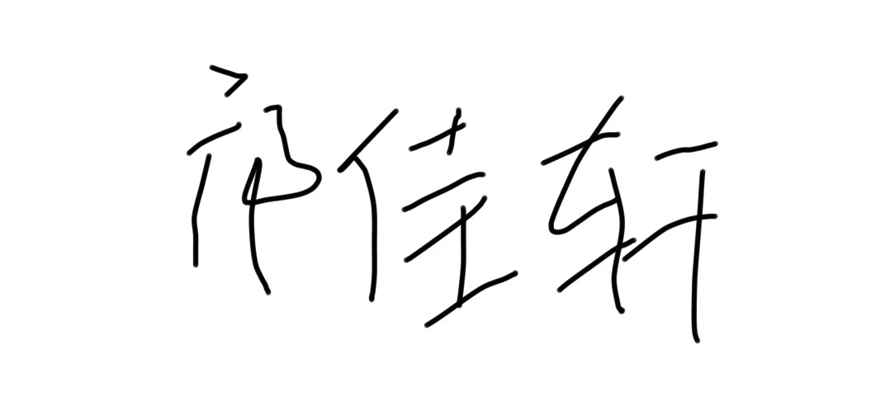

Email: iceline2002@qq.com

Institution: Sun Yat-sen University