Meeting Notes

* Mapping framework (terria)
* Geoserver database server used in mapping world
* Gis clients
* AP Vis
* Deployable to AWS
* 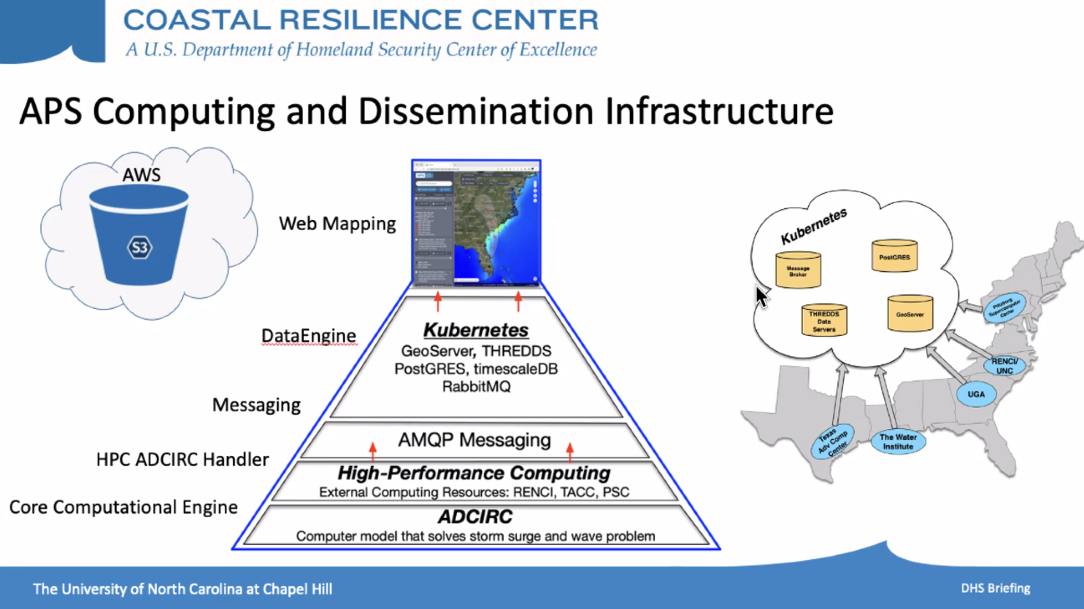
* PSC
* Using leaflet
* Diagram

  Description automatically generated
* Brian Blanton
* Download and deploy terria
* Can download and run terria in an hour