AT2 – Project

DVD Search App

Documentation

Student:

Reece Pieri

Student ID:

M087496

Course:

Diploma of Software Development – Software Deployment

Contents

Introduction 3

Configuration Files 4

What are configuration files? 4

How to use configuration files in a Java application 5

# Introduction

The DVD Search App application is designed to allow users to search through an extensive movie database. The database holds information for over 2000 movies which can be searched by keyword using GUI inputs.

# Software Development Methodology

The SDLC model used for the DVD Search App application is the waterfall model.

The reason for this choice is due to the project size, being a small project, and having very clearly defined software requirements outlined by the client.

This allows development to be well planned out in advance and to proceed with no risk of adjustments to the software requirements or modification to the scope of the project.

# Project Management Plan

The software used to produce the Project Management Plan is Microsoft Project 2016.

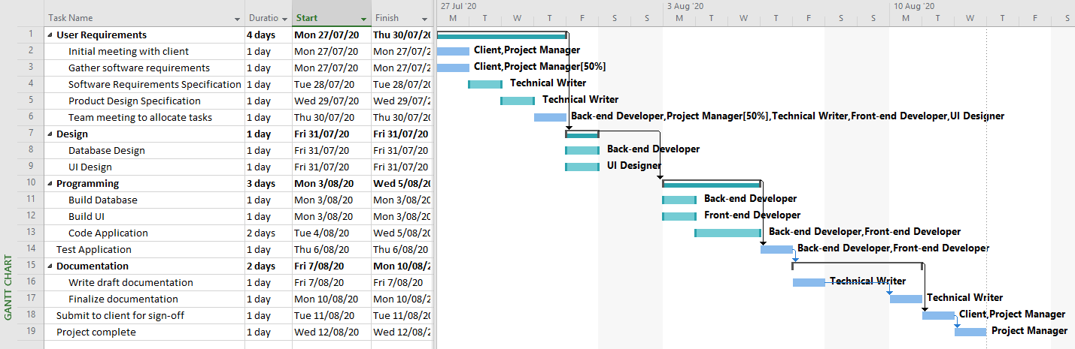

# Source Control

The source control system for the DVD Search App application is GitHub.

Access here: