JMC Music Player

Application

Student:

Reece Pieri

Student ID:

M087496

Course:

Diploma of Software Development – Java III

Contents

Introduction 4

UML Class Diagram 5

Server 5

Client 5

Third-Party Libraries 6

Method Signatures - Server 7

JMCServer 7

JMCServerController 8

Connection 8

User 8

Password 9

Method Signatures - Client 10

JMCLogin 10

JMCLoginController 11

Listener 11

JMCMusicPlayer 12

JMCMusicPlayerController 13

NewPlaylist 14

NewPlaylistController 14

Player 14

Playlist 15

Song 15

Sort 16

Test Data 17

JUnit Testing 28

# Introduction

The JMC Music Player application is designed to allow users to login to a music player client and play music. User login credentials are verified on a central server and access is granted to the media player client where they can create playlists and play music.

# UML Class Diagram

Server

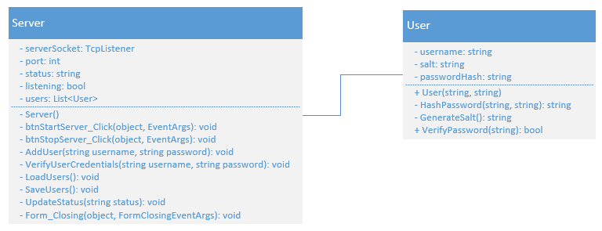

Client

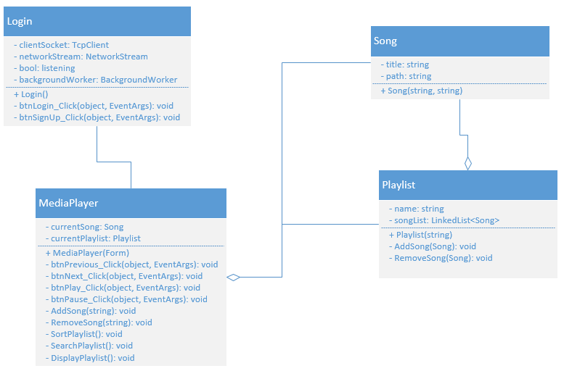

# Third-Party Libraries

|  |  |
| --- | --- |
| **Name** | **Function** |
| OpenCSV | Reads and parses .csv files. |
| GOXR3PLUS | Music player library including audio visualization |

# Method Signatures - Server

JMCServer

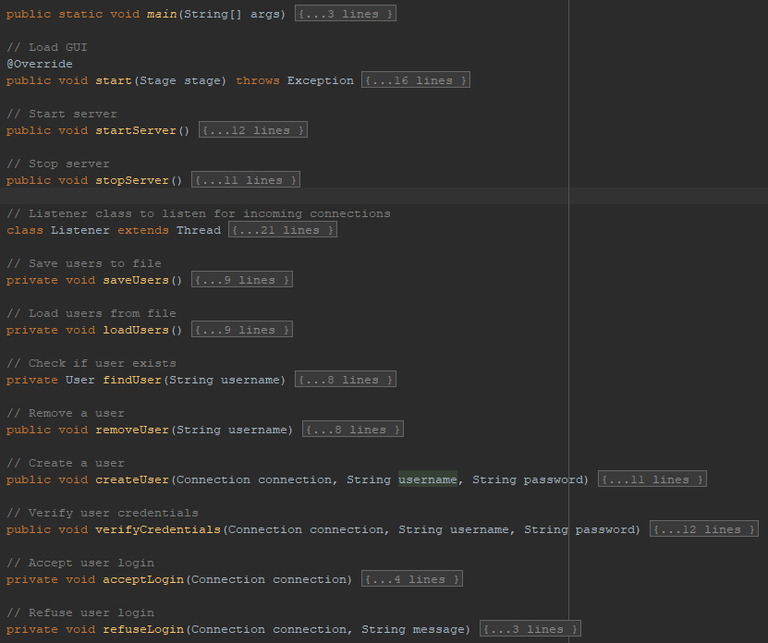

JMCServerController

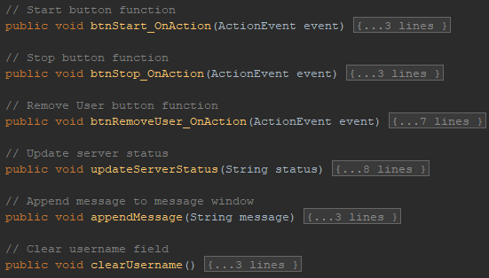

Connection

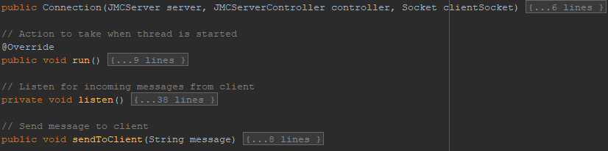

User

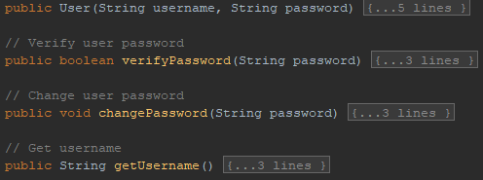

Password

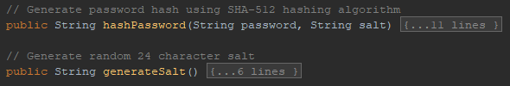

# Method Signatures - Client

JMCLogin

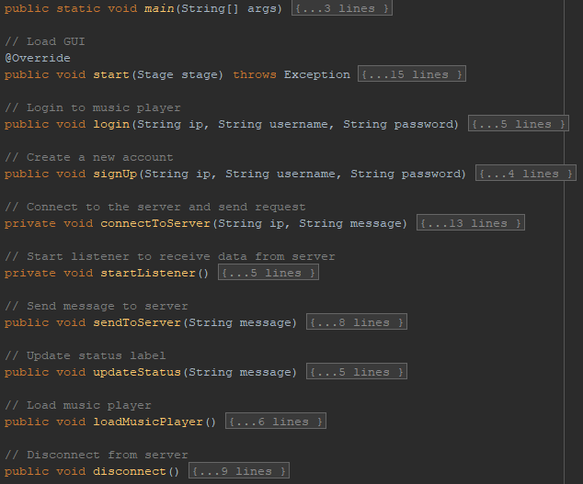

JMCLoginController

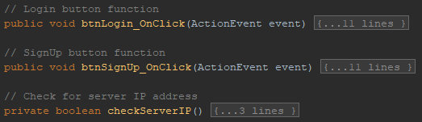

Listener

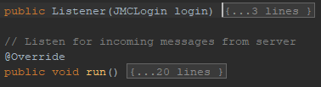

JMCMusicPlayer

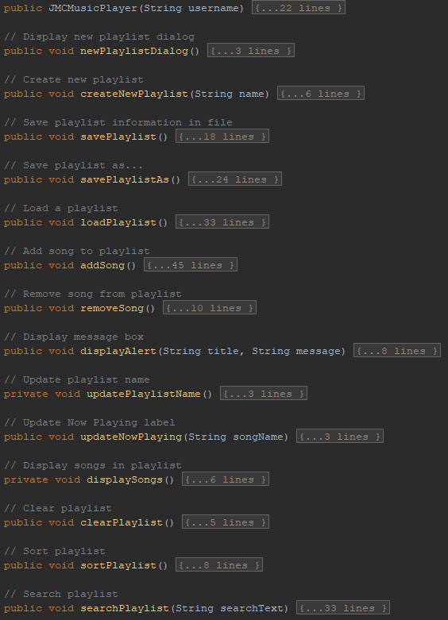

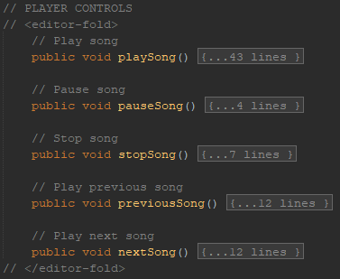

JMCMusicPlayerController

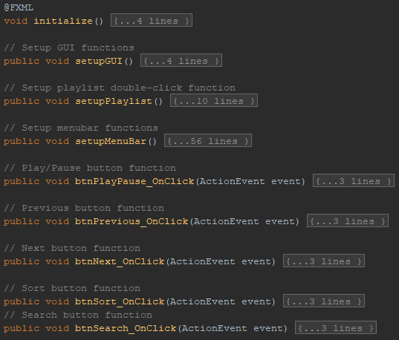

NewPlaylist

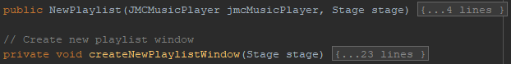

NewPlaylistController



Player

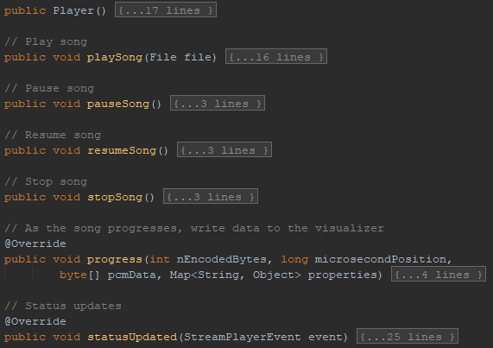

Playlist

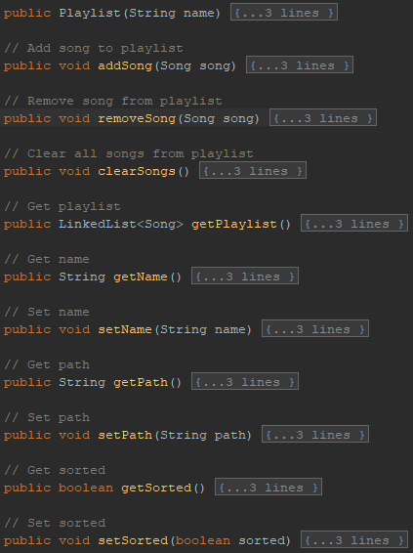

Song

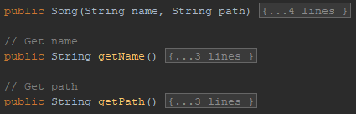

Sort

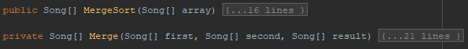

# Test Data

|  |  |  |  |
| --- | --- | --- | --- |
| **Test Case** | **Description** | **Expected Result** | **Actual Result** |
| Case 1 | Start server | Load user information from file and begin listening for incoming connections | As expected. Ref SS1. |
| Case 2 | Stop server | Save user information to file and stop listening for incoming connections | As expected. Ref SS2. |
| Case 3 | Remove user | Remove a registered user from server | As expected. Ref SS3. |
| Case 4 | Login to music player client | Login successful, close login form and open music player client | As expected. Ref SS4. |
| Case 5 | Create a new playlist | Successfully create a new playlist | As expected. Ref SS5. |
| Case 6 | Add songs to playlist | Add multiple songs to playlist via Open File dialog | As expected. Ref SS6. |
| Case 7 | Remove songs from playlist | Song removed from playlist | As expected. Ref SS7. |
| Case 8 | Clear playlist | All songs cleared from playlist | As expected. Ref SS8. |
| Case 9 | Load playlist | Playlist loaded from CSV file | As expected. Ref SS9. |
| Case 10 | Save playlist | Playlist saved to CSV file | As expected. Ref SS10. |
| Case 11 | Play music | Song begins playing | As expected. Ref SS11. |
| Case 12 | Sort playlist | Merge sort performed on playlist successfully | As expected. Ref SS12. |
| Case 13 | Search playlist | Specified song found in playlist | As expected. Ref SS13. |
| Case 14 | About | Display About message box | As expected. Ref SS14. |

|  |  |
| --- | --- |
| SS1 |  |
| SS2 |  |
| SS3 |  |
| SS4 |  |
| SS5 |  |
| SS6 |  |
| SS7 |  |
| SS8 |  |
| SS9 |  |
| SS10 |  |
| SS11 |  |
| SS12 |  |
| SS13 |  |
| SS14 |  |

# JUnit Testing

|  |  |  |
| --- | --- | --- |
| **Class** | **Test** | **Result** |
| Password | hashPassword method returns a hashed password. | Test passed. Ref SS1. |
| Password | generateSalt method returns randomly generated salt. | Test passed. Ref SS2. |
| User | verifyPassword method returns true if password input matches users password. | Test passed. Ref SS3. |
| User | verifyPassword method returns false if password input does NOT match user password. | Test passed. Ref SS4. |

|  |  |
| --- | --- |
| SS1 |  |
| SS2 |  |
| SS3 |  |
| SS4 |  |