TECHNICAL ANALYSIS
Chart Pattern Recognition



Submitted To:
Prof. Satyaprakash Tiwari

Submitted By:
Trevor Dcosta
Roll No: MSF07

Sydenham Institute of Management Studies,
Research and Entrepreneurship Education (SIMSREE)
Semester 3 — Technical Analysis

TABLE OF CONTENTS

1. Double Top — Axis Bank Ltd. (Monthly)
2. Double Bottom — SBI Life Insurance Co. Ltd. (Daily)
3. Triple Top — Tata Technologies Ltd. (1 Hour)
4. Triple Bottom — Infosys Ltd. (Daily)
5. Rectangle (Box) — Genus Power Infra Ltd. (Daily)
6. Descending Triangle — Bharti Airtel Ltd. (2 Hour)
7. Ascending Triangle — Bharat Petroleum Corp. Ltd. (Daily)
8. Symmetrical Triangle — Maruti Suzuki India Ltd. (Daily)
9. Diamond Top — Coforge Ltd. (Daily)
10. Wedge — Tata Motors Ltd. (4 Hour)

1. Double Top
Stock: Axis Bank Ltd. | Exchange: NSE | Timeframe: Monthly

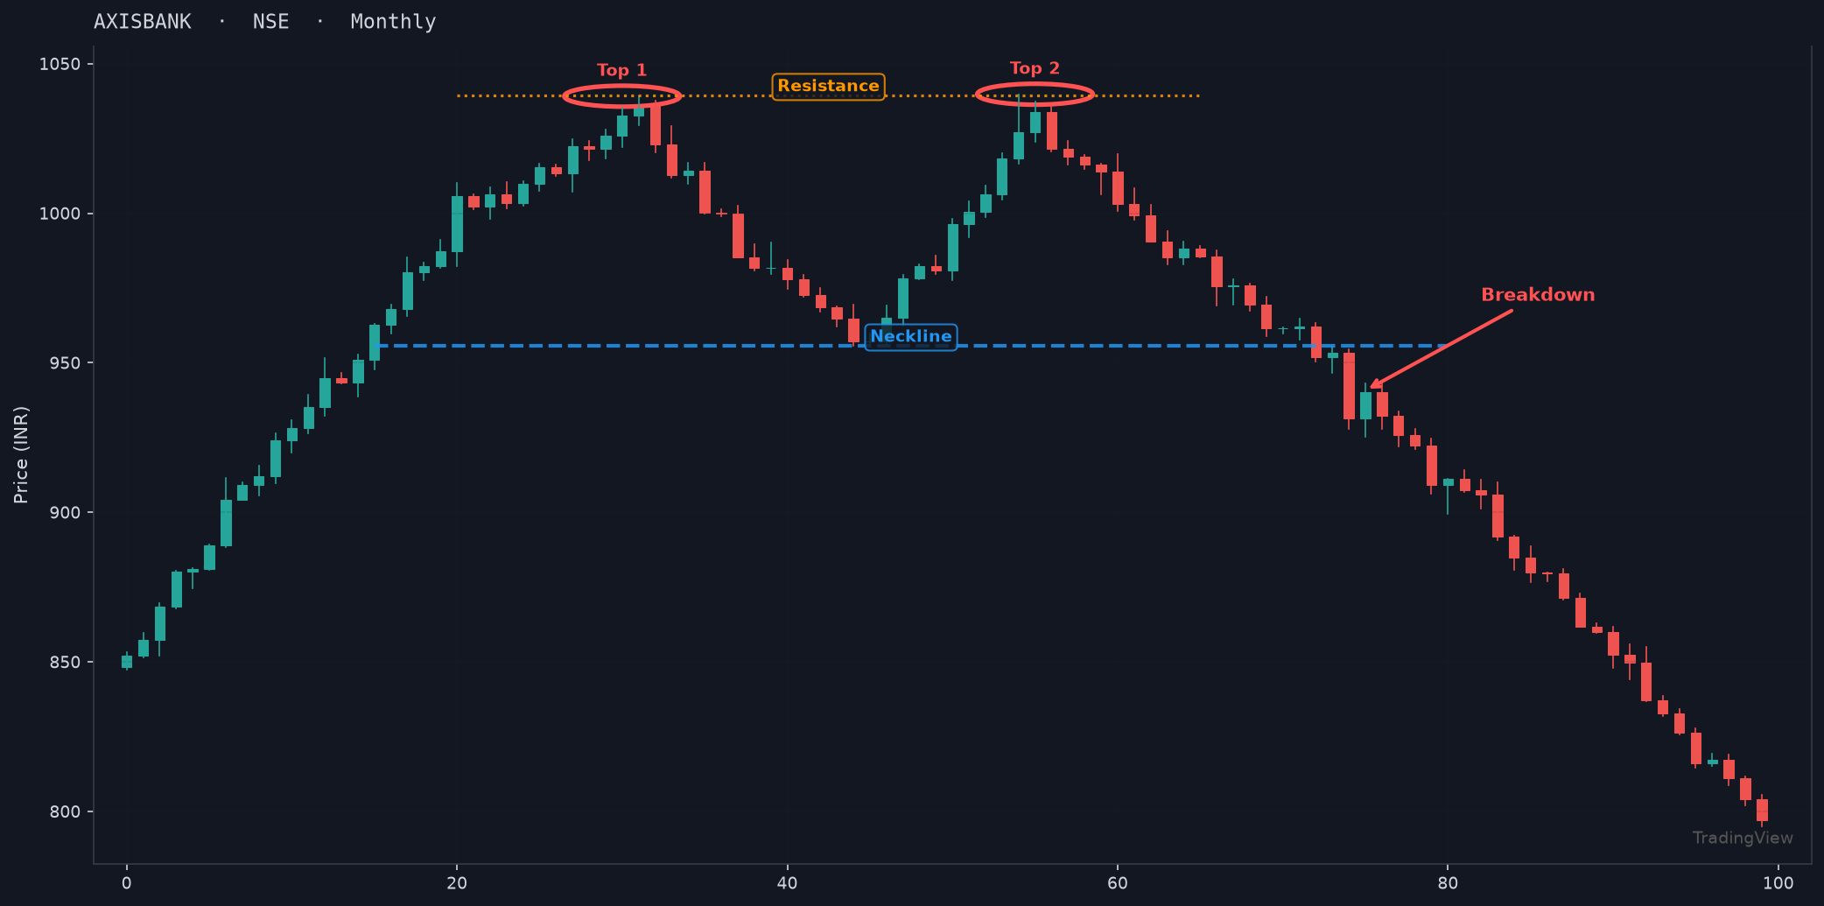

Pattern Description:
A bearish reversal pattern formed when price reaches a resistance level twice, creating two peaks at approximately the same level. The pattern is confirmed when price breaks below the neckline (support between the two peaks), signaling a potential downtrend.

2. Double Bottom
Stock: SBI Life Insurance Co. Ltd. | Exchange: NSE | Timeframe: Daily

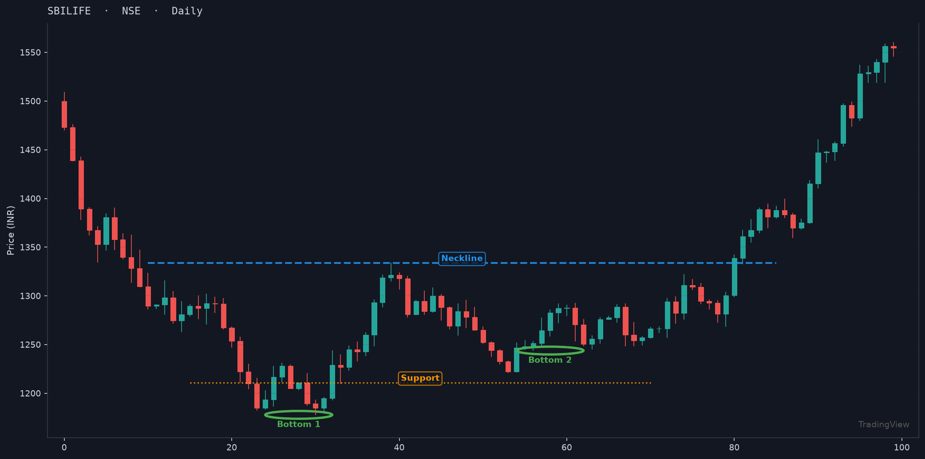

Pattern Description:
A bullish reversal pattern formed when price reaches a support level twice, creating two troughs at approximately the same level. Confirmation occurs when price breaks above the neckline (resistance between the two bottoms), indicating a potential uptrend.

3. Triple Top
Stock: Tata Technologies Ltd. | Exchange: NSE | Timeframe: 1 Hour

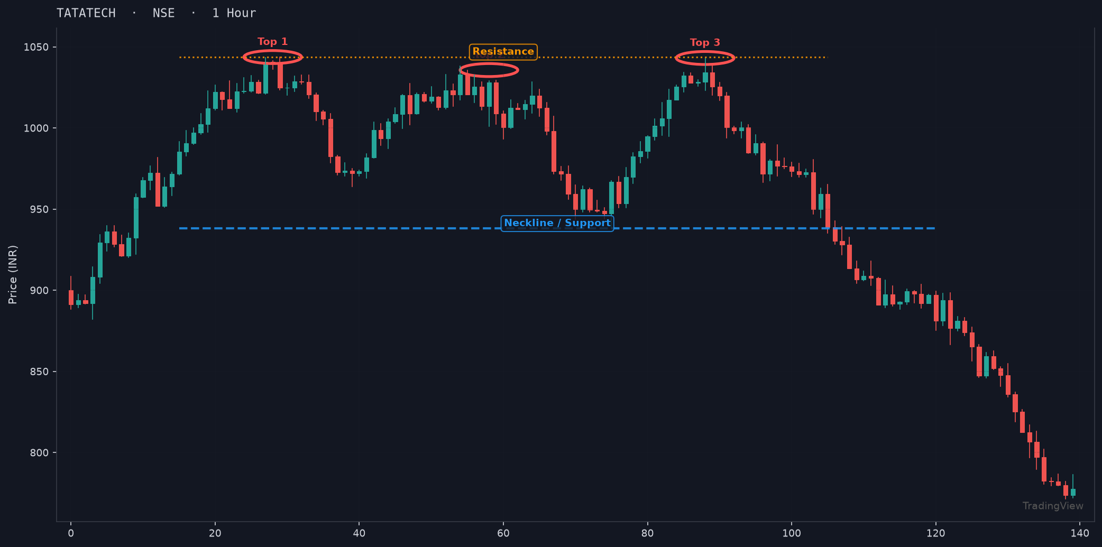

Pattern Description:
A bearish reversal pattern with three peaks at approximately the same resistance level. It signals stronger resistance than a double top and confirms when price breaks below the support level connecting the two reaction lows between the peaks.

4. Triple Bottom
Stock: Infosys Ltd. | Exchange: NSE | Timeframe: Daily

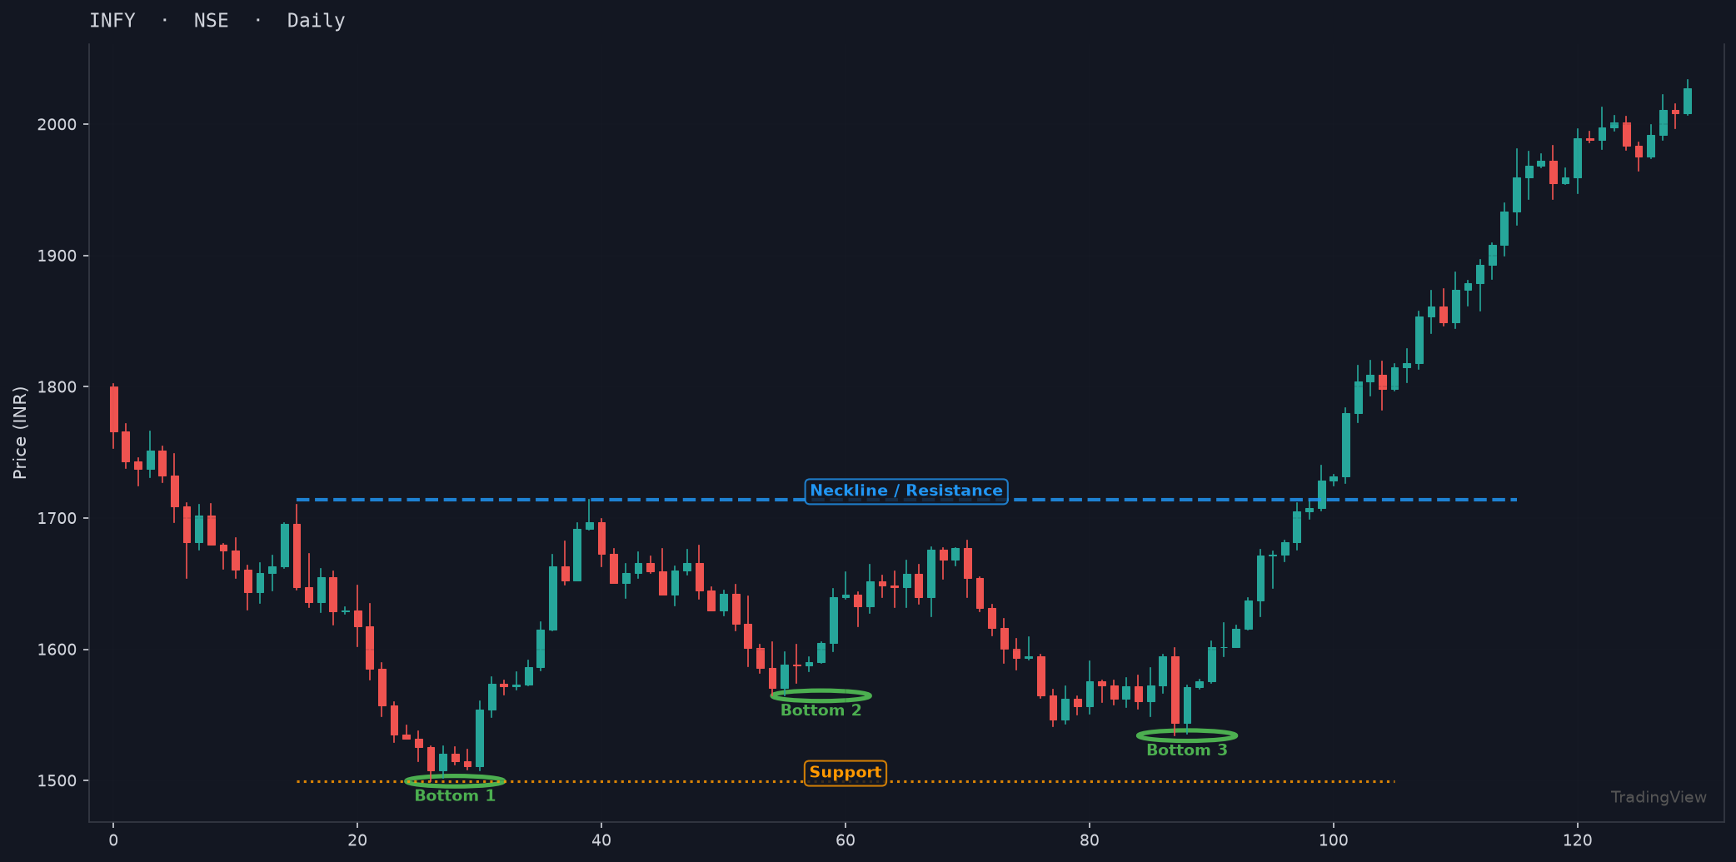

Pattern Description:
A bullish reversal pattern with three troughs at approximately the same support level. It indicates strong support and confirms when price breaks above the resistance level connecting the two reaction highs between the bottoms.

5. Rectangle (Box)
Stock: Genus Power Infra Ltd. | Exchange: NSE | Timeframe: Daily

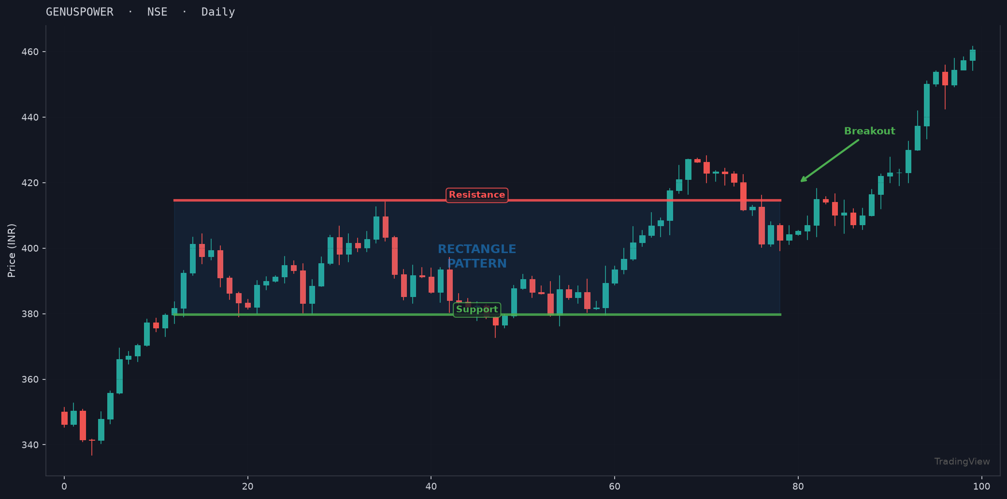

Pattern Description:
A continuation pattern where price oscillates between well-defined horizontal support and resistance levels. The breakout direction (above resistance or below support) determines the next trend direction. Volume typically decreases during the formation.

6. Descending Triangle
Stock: Bharti Airtel Ltd. | Exchange: NSE | Timeframe: 2 Hour

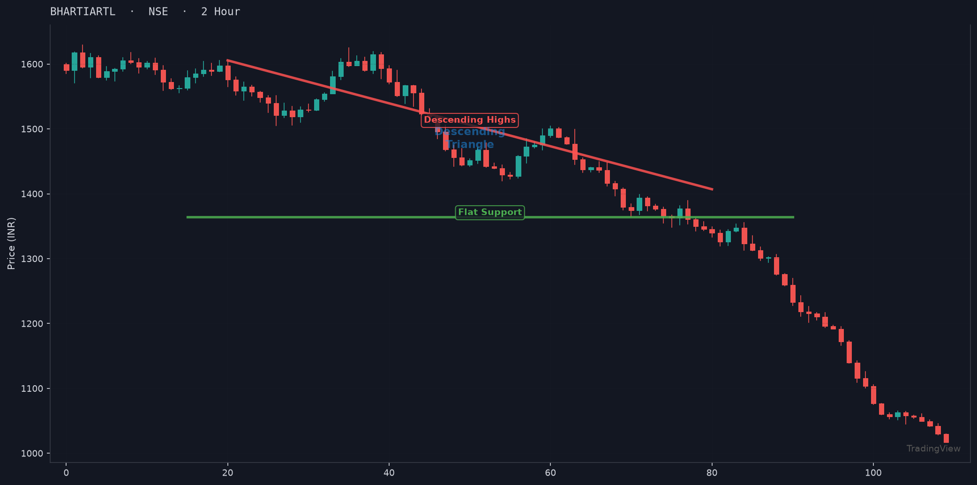

Pattern Description:
A bearish continuation pattern characterized by a flat horizontal support line and a descending trendline connecting lower highs. The converging trendlines create a triangle that typically breaks downward, though upside breakouts can occur.

7. Ascending Triangle
Stock: Bharat Petroleum Corp. Ltd. | Exchange: NSE | Timeframe: Daily

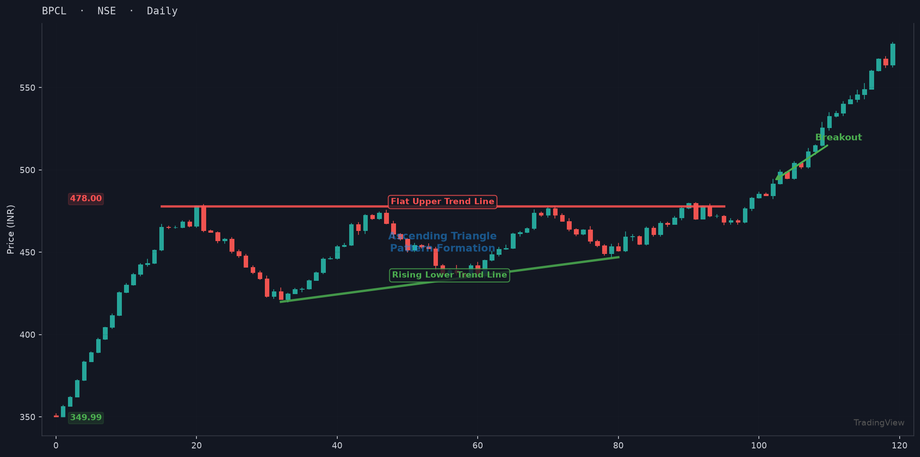

Pattern Description:
A bullish continuation pattern with a flat horizontal resistance line and an ascending trendline connecting higher lows. The converging lines indicate increasing buying pressure, and the pattern typically breaks upward through the resistance level.

8. Symmetrical Triangle
Stock: Maruti Suzuki India Ltd. | Exchange: NSE | Timeframe: Daily

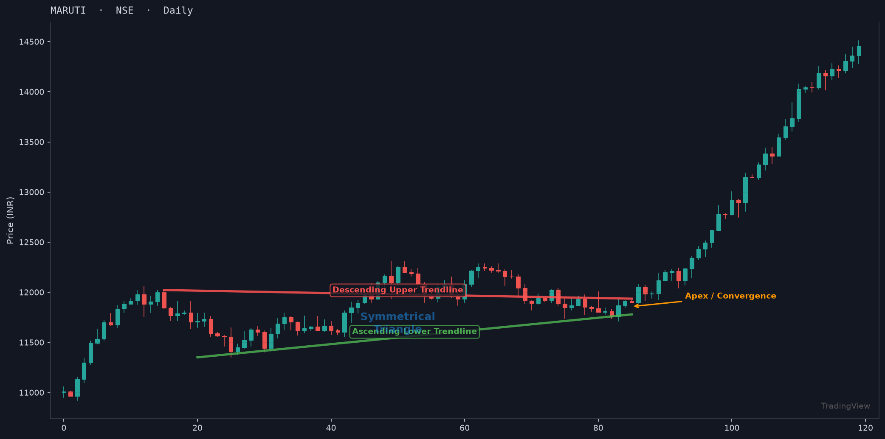

Pattern Description:
A neutral continuation pattern formed by converging trendlines — a descending upper line and an ascending lower line. The breakout can occur in either direction, with the breakout direction typically following the prior trend. Volume decreases as the pattern narrows toward the apex.

9. Diamond Top
Stock: Coforge Ltd. | Exchange: NSE | Timeframe: Daily

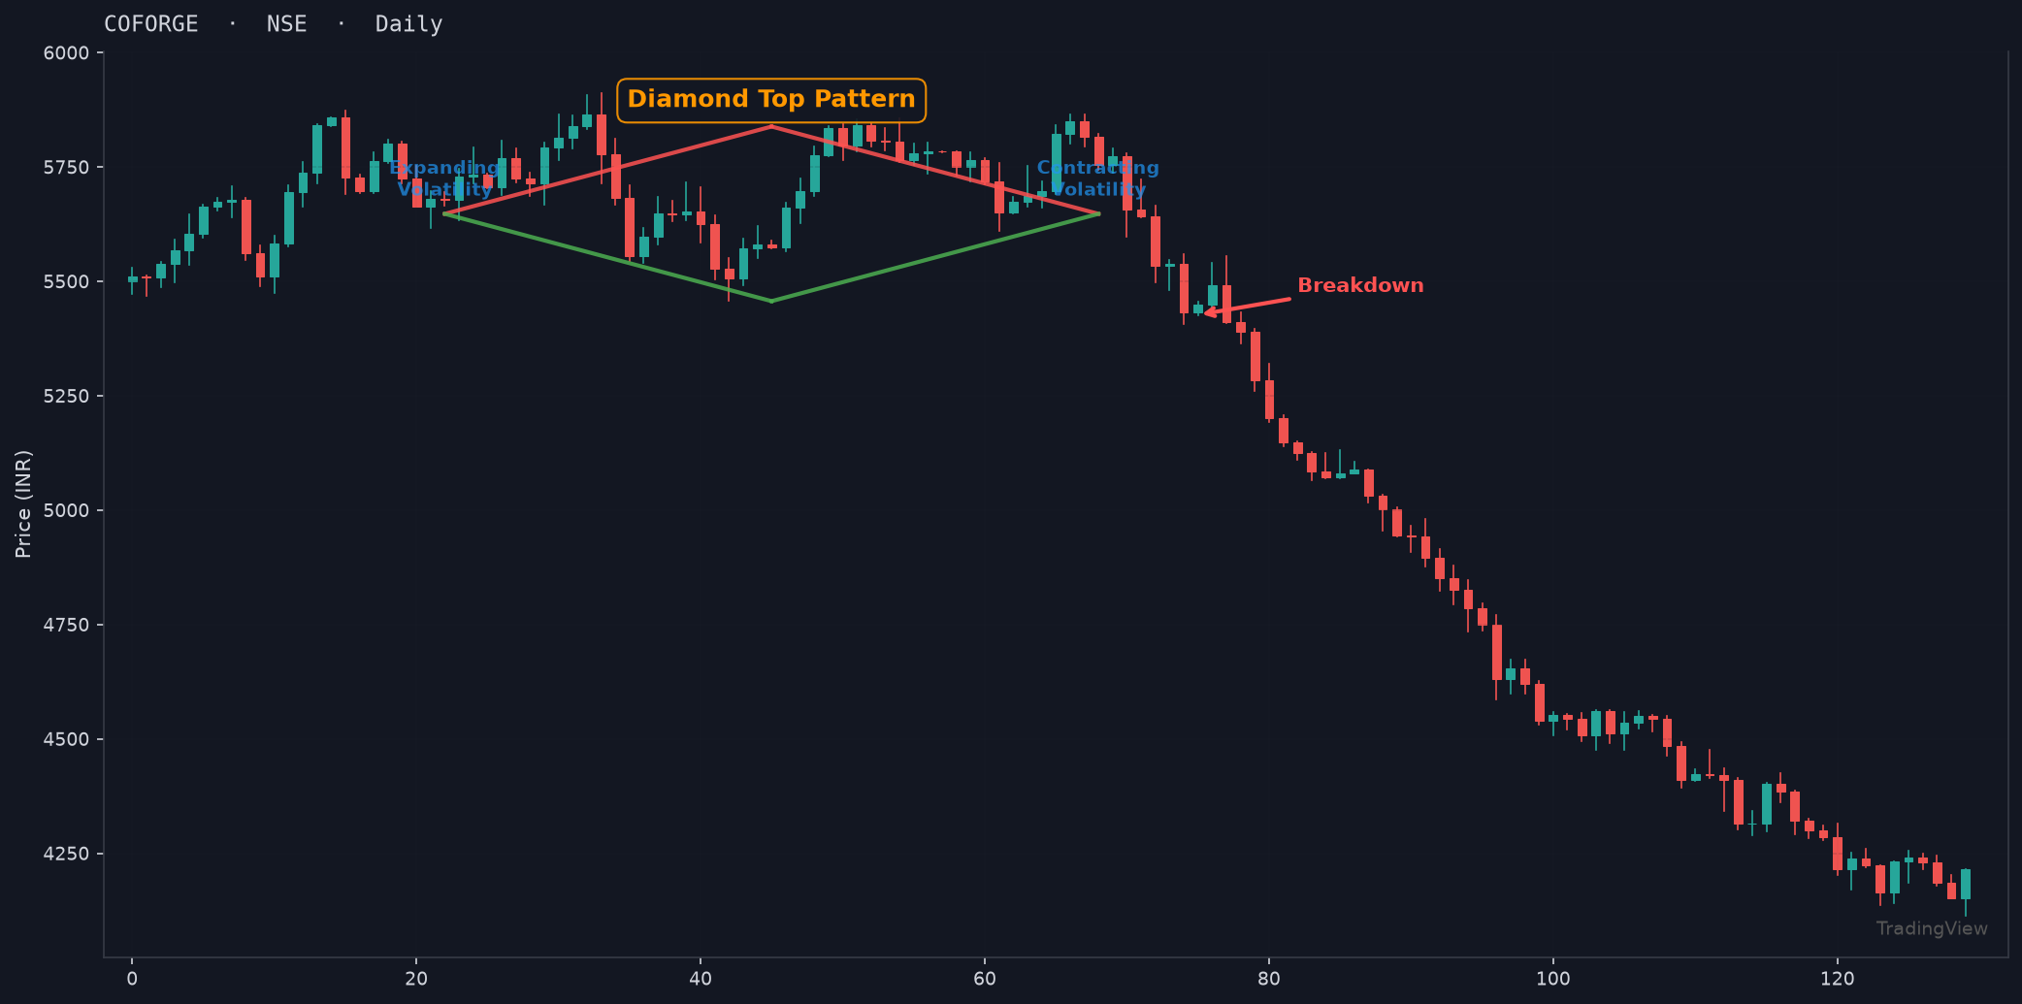

Pattern Description:
A rare bearish reversal pattern combining a broadening formation (expanding volatility) followed by a symmetrical triangle (contracting volatility), creating a diamond shape. It typically forms at market tops and signals a significant trend reversal when price breaks below the lower right trendline.

10. Wedge
Stock: Tata Motors Ltd. | Exchange: NSE | Timeframe: 4 Hour

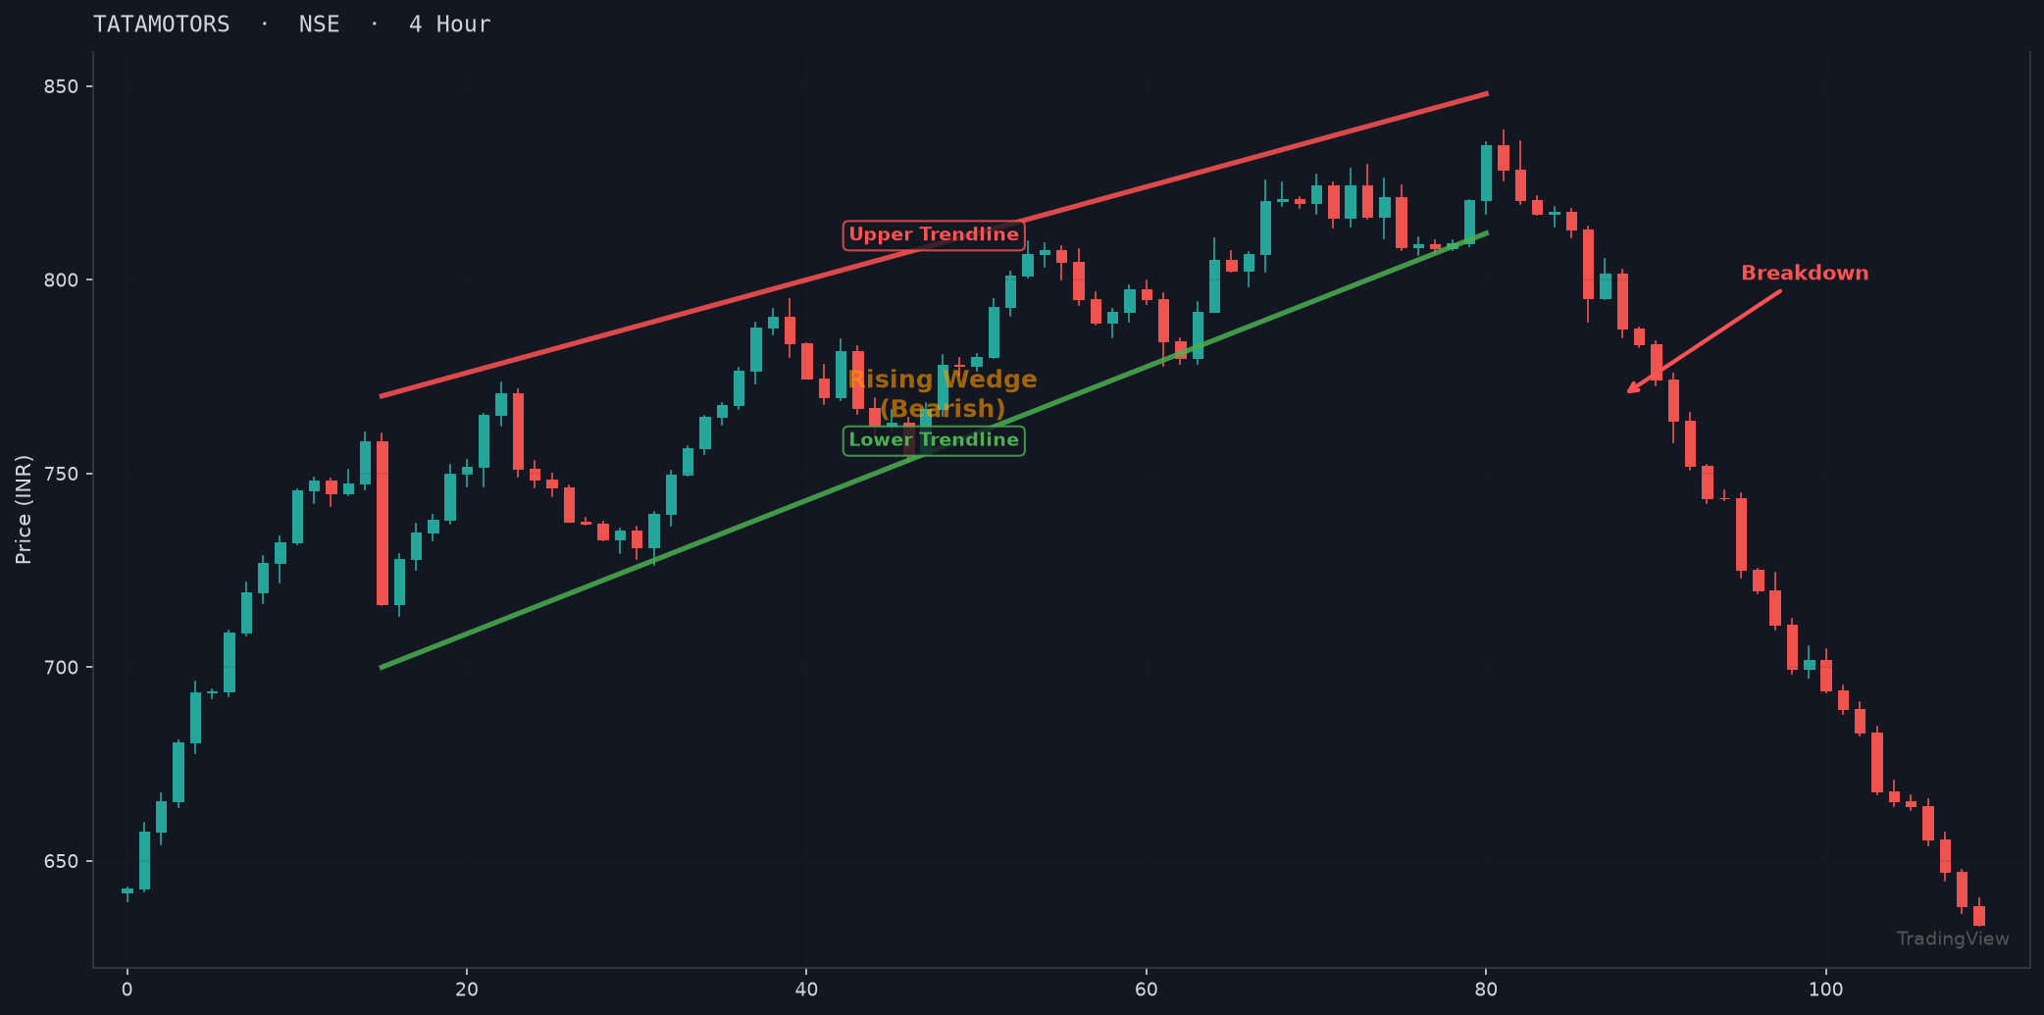

Pattern Description:
A pattern formed by two converging trendlines that slant in the same direction. A rising wedge (both lines slope up) is bearish, while a falling wedge (both lines slope down) is bullish. The pattern indicates diminishing momentum before a reversal.

