COMP-1217 Cole Dorman

Here is my wireframe of the calculator application. The user would Input the operation into the grey box, by selecting it below. Then typing in the numbers in the equation and their solution. My wireframe shows if an input was incorrect, if it was correct, it would change to green and display “You are right”.

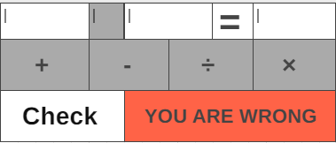

**User Story for the second feature**

* **As a student**
* **I want to see the correct answer**
* **So that I can locate my error**