Explanation:
The abstract goal that I had tried to achieve was creating a system of handling encounters, which consisted of characters. Though this was not known at the time of initial design, so I had to design it to be flexible, as the other systems in the game came into place, I revised and reworked it to better suit our project’s needs. There are not a ton of changes between the two, the primary visual difference being that we now have a combat manager class that handles the other scene’s logic and can change scene via passing a bool into SceneGod.

Mermaid Class diagrams:
Original:
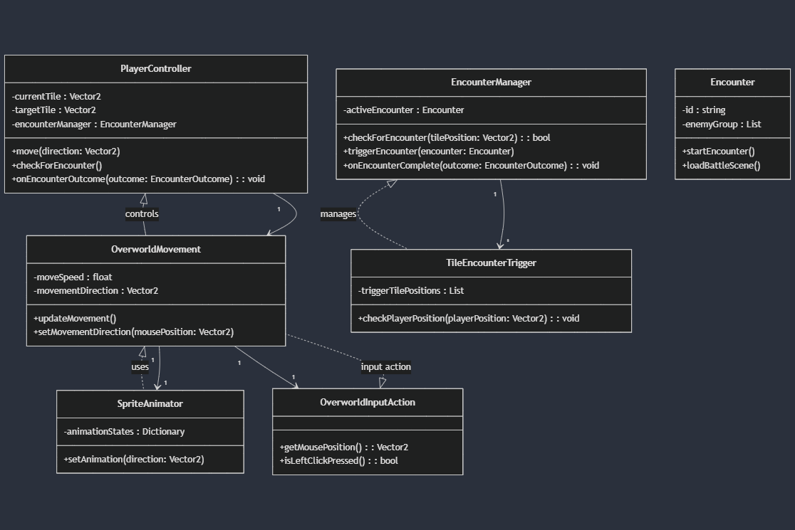
Final:
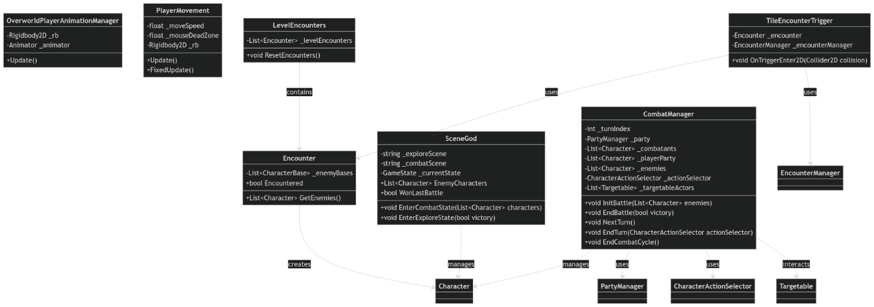
The primary class I had worked on was SceneGod, which was one of my most elegant examples of my work. It being a singleton meant that it had to have very strict rules about how it can interact with other classes. For example, it is never allowed to call any other class or another classes methods, as this could lead to null references, because it can persist between scenes when other objects don’t.
The other classes I had been overseeing the creation of was the Encounter, TileEncounterTrigger, EncounterManager and LevelEncounter classes. The purpose of each was to break apart a larger system which handled encounters. This is a perfect example of composition, and also (in my opinion) the overuse of composition. If you notice the class diagram, while breaking things into multiple classes can be helpful at times, this example is a great way to see when something should not be composed of many classes, notice the methods and the variables of each of these classes. The important thing to notice here is the extremely minimal number of variables and methods, most methods here actually just call another one-off each other to pass data around without utilizing it. The only way it’s actually used later is by the EncounterManager which simply passes it to scene god after playing hot potato. The end result of this is multiple classes, with little functionality in each, which means someone who looks over it must take into account all the classes to just understand one of them. Where instead this could be merged into a single file to increase readability. This is a very common misuse of composition when first learning about it, as people tend to over-apply newly learned concepts.

