Curvature Dynamics and Gibbs:
The Hypersphere Equation Is Closed For Renovations (A Fond Farewell To Harmonic Analysis?)
Aaron Schoenman
Independent Researcher
Columbus, Ohio, USA
ORCID: 0009-0004-8636-0927
August 26, 2026

Contents
1 Abstract 4
2 Introduction 5
3 Foundational Definitions 6
3.1 Definition: Hypersphere Seed Curvature State. 6
3.2 Definition: Hypersphere Seed-Layer Circumference. 6
3.3 Definition 3.3 Flat-Metric Projection. 6
3.4 Definition 3.4 Curvature Deficit (Gap). 7
3.5 Definition 3.5 Dimensional Distortion Principle. 7
3.6 Definition 3.6 Dimensional Calculus Derivative at the Hypersphere-Seed. 7
3.7 Definition 3.7 Hypersphere Seed Curvature Integration Constant. 8
3.8 Definition 3.8 Gravitational-Load Curvature Integration Constants (C_{n}). 8
4 Dimensional Calculus Axioms 9
4.1 Law 0: Identity of the Curvature Metric for the Hypersphere 9
4.2 Law 1: Coherent Stable Nested Hypersphere Law 9
4.3 Law 2: Conservation of Curvature 9
4.4 Law 3: Curvature Inheritance 10
4.5 Law 4: Curvature Broadcast 10
4.6 Axiom C0: The Primitive Curvature Metric 10
4.7 Axiom CD0: The Pi Curvature Axiom 10
4.7.1 Lemma Gibbs Overshoot Identity 11
5 Geometric Derivation of $GDC$ 11
5.1 Step 1: Identify the Half-Period Baseline 11
5.2 Step 2: Compute the Flat-Metric Half-Period 12
5.3 Step 3: Compute the Per-Half-Period Curvature Gap 12
5.4 Step 4: Normalise by the True Half-Period 12
5.5 Step 5: Account For Both Sides of the Jump 12
6 Numerical Correspondence and Interpretation 12
7 Conclusion 13
8 Appendix A 15
9 Appendix B 16
10 Appendix C 17
11 Appendix D 18
12 References 20

Abstract
The Gibbs overshoot is shown to arise from a geometric deficit intrinsic to the collapsed Euclidean metric rather than from analytic truncation effects. The overshoot fraction
$$G_{DC}=\frac{2\left(π-3\right)}{π}≈9.01\%$$
emerges directly from the corrected hyperspherical seed-layer metric, without reliance on harmonic expansions, kernel estimates, or oscillatory analysis. Classical Fourier theory attributes the overshoot to the behavior of truncated series near discontinuities, but this interpretation presupposes the correctness of the Euclidean ruler used to measure the underlying structure. Once the metric is corrected, the overshoot follows as a necessary geometric remainder.
Under the corrected hyperspherical metric, the half-period is measured at its full value $π$, whereas the collapsed Euclidean metric registers the same interval as $3$. This discrepancy produces a curvature gap of $2\left(π-3\right)$per period, identifying the Gibbs phenomenon as the Tier 0 curvature deficit of the flat metric. The Tier 0 deficit is the metric-level consequence of Euclid’s assignment $0^{0}=0$, which destroys the seed layer, in contrast to the corrected hyperspherical metric of Dimensional Calculus wherein $0^{0}=1$ and curvature is preserved.
This deficit corresponds to the hyperspherical arc-length segment that the Euclidean ruler cannot represent under dimensional collapse. The overshoot is therefore not a truncation artefact but the analytic manifestation of a conserved geometric remainder. Within Dimensional Calculus, curvature is preserved across the dimensional ladder, while the flat metric inherits only the integer-projected portion of the seed layer. The universality of the Gibbs phenomenon follows immediately from the universality of this curvature deficit.
The corrected metric yields the overshoot fraction in closed form, reducing the analytic burden of the classical approach to a single geometric residual. The slight discrepancy between the DC prediction and the classical analytic value—approximately $0.06508107…\%$—reflects the approximation inherent in the collapsed Euclidean metric, whereas the DC expression derives directly from the corrected hyperspherical geometry. Both frameworks measure the same conserved curvature deficit, but the DC formulation does so without analytic intermediaries.
This geometric interpretation situates the Gibbs overshoot as a metric-level invariant arising from structural limitations of the flat ruler. It provides a unified explanation for the magnitude, persistence, and universality of the phenomenon, reframing Gibbs not as a pathological feature of Fourier analysis but as a fundamental consequence of curvature collapse.

Introduction
The Gibbs[2] phenomenon, the persistent $∼8.9490\%$ overshoot at jump discontinuities in truncated Fourier[1] series, has been recognized since Wilbraham[3] and Gibbs as an intrinsic feature of sinusoidal approximation. Classical analysis establishes that as $N→∞$, the partial-sum overshoot converges to
$$\int_{0}^{π}{\frac{\sin{t}}{t}} dt-\frac{π}{2}≈0.2811,$$
yielding a fractional excess of approximately $8.9490\%$. Although analytically complete, this account provides no geometric mechanism explaining the stability or magnitude of the residual.
Dimensional Calculus furnishes such a mechanism. Its foundational assertion, the Dimensional Distortion Principle, states that any graph of an equation records the deviation of curvature from the base $2π$ seed curvature of the primitive positive-domain hypersphere. The Fourier metric inherits the collapsed Euclidean projection $π_{flat}=3$ of the true curvature constant. This projection is a direct consequence of Euclid’s collapsed metric: the postulate that a dimensionless point exists, that a continuous line may be assembled from such points, and that a one-dimensional object may measure a zero-dimensional seed layer. These assumptions suppress curvature at Tier-0 and force the hyperspherical half-period $π$ to collapse to its integer-floor value $3$.
The corrected hyperspherical seed metric restores the full circumference $2π$ at radius $r=1$ (the $T_{0}$ seed state $π^{0}=1$). The discrepancy between the corrected and collapsed circumferences is $2\left(π-3\right)$. Normalizing this discrepancy by the half-period $π$ yields
$$G_{DC}=\frac{2\left(π-3\right)}{π},$$
identifying the Gibbs phenomenon as the $T_{0}$ curvature deficit of the flat metric: the hyperspherical arc-length segment that Euclid’s collapsed ruler cannot measure. The Dimensional Calculus prediction differs from the classical overshoot by only $0.06507\%$(rounded up), a discrepancy arising from curvature destroyed when the Euclidean metric collapses the seed layer into its flat projection.
This paper proceeds as follows. Section 2 formalizes the definitions and axioms required for the derivation. Section 3 presents the geometric computation of $G_{DC}$. Section 4 analyzes the numerical correspondence with the classical value and its geometric significance. Section 5 concludes.
Note on $0^{0}$. Classical mathematics does not maintain a consistent definition of $0^{0}$; different subfields assign different values depending on context, and some frameworks contradict themselves internally. Dimensional Calculus does not rely on these analytic conventions. Instead, we observe that Euclid’s collapsed seed geometry behaves as if $0^{0}=0$, eliminating the seed-layer identity, whereas the corrected hyperspherical metric preserves the seed layer via $0^{0}=1$. No further assumptions about classical definitions are required, and no unified classical interpretation exists to appeal to.
Any critique invoking $0^{0}$must first commit to a specific classical definition and justify its geometric implications. Because classical mathematics provides no consistent definition, every such critique collapses once traced to the seed-layer geometry.

Foundational Definitions
This section records only the definitions used in the derivation. Full proofs and the complete axiomatic system appear in Dimensional Calculus: A Guide to Mapping Reality Through Curvature Dynamics [S3].

Definition: Hypersphere Seed Curvature State.
The hypersphere seed curvature state is $π^{0}=1$, the irreducible curvature floor of the dimensional ladder. All higher curvature states are generated by successive application of the curvature-gradient operator. Dimensional collapse cannot proceed below $π^{0}$ without entering the inversion boundary $π^{-1}$, where the metric ceases to be well-defined and curvature cannot be broadcast. The seed state therefore constitutes the minimal curvature-bearing tier from which all hyperspherical inheritance originates.

Definition: Hypersphere Seed-Layer Circumference.
At the hypersphere seed layer ($r=π^{0}=1$), the corrected $T_{0}$ curvature state broadcasts the full circumference of the unit hypersphere. The seed-layer circumference is
$$C_{seed}=2πr∣_{r=1}=2π.$$
This value constitutes the irreducible curvature baseline from which all higher-tier curvature states inherit and broadcast their geometric structure. Any metric that collapses this baseline necessarily destroys $T_{0}$ curvature and cannot represent hyperspherical geometry.

Definition 3.3 Flat-Metric Projection.
The flat metric projects the hyperspherical curvature constant $π$ onto the integer dimension, collapsing the $T_{0}$ curvature state into its Euclidean shadow:
$$π_{flat}=\left\lfloor π\right\rfloor =3.$$
The corresponding flat-space circumference at $r=1$ is therefore
$$C_{flat}=2π_{flat}r∣_{r=1}=6.$$
This projection constitutes the seed-layer curvature annihilated under Euclid’s collapsed metric, forming the geometric origin of the $T_{0}$ curvature deficit that appears in analytic frameworks such as the classical Gibbs overshoot. The projection is not a curvature operator but a collapse artifact: it replaces the hyperspherical half-period with its integer-floor remainder, thereby destroying the curvature that the corrected seed metric preserves.

Definition 3.4 Curvature Deficit (Gap).
The curvature gap at the hypersphere seed layer quantifies the portion of $T_{0}$ curvature lost under the flat-metric projection. It is defined as
$$Δ=C_{seed}-C_{flat}=2\left(π-3\right).$$
This gap is the hyperspherical arc-length segment that the collapsed Euclidean metric cannot reach. It is the geometric origin of the $T_{0}$ curvature deficit, and it manifests analytically as stable residuals such as the classical Gibbs overshoot. The gap is not an approximation error; it is the invariant remainder produced when the hyperspherical seed curvature is collapsed into its integer projection.

Definition 3.5 Dimensional Distortion Principle.
Every graph of a function records the distortion of curvature from the base $2π$ hypersphere seed-curvature state. When the flat metric replaces the true curvature constant $π$ with its collapsed projection $π_{flat}=3$, the measurement inherits a systematic Tier-0 curvature deficit. The resulting underestimation of curvature is
$$Δ=2\left(π-3\right)$$
per unit period, representing the hyperspherical arc-length segment that the Euclidean metric cannot reach. This deficit is the geometric origin of stable analytic residuals such as the classical Gibbs overshoot. It is not an approximation error, nor a truncation artefact, but the invariant remainder produced when the hyperspherical seed curvature is collapsed into its integer-floor projection.

Definition 3.6 Dimensional Calculus Derivative at the Hypersphere-Seed.
The dimensional derivative at the hypersphere seed layer satisfies
$$\frac{dπ^{0}}{dr}∣_{r=1}=0,$$
confirming that the $T_{0}$ curvature state $π^{0}=1$ is a fixed point of the curvature ladder. At this layer the ground-state curvature is constant and equal to the full seed-layer circumference $2π$, forming the baseline from which all higher-tier curvature states broadcast their geometric structure. Any metric that collapses this fixed point necessarily destroys curvature inheritance and cannot represent hyperspherical geometry.

Definition 3.7 Hypersphere Seed Curvature Integration Constant.
The inherited seed-curvature constant is
$$C_{1}=\left(π-2\right),$$
representing the curvature contribution broadcast from Tier $T_{2}$ into the hypersphere seed layer as read from Tier $T_{0}$. Under Euclidean collapse, this inherited curvature is flattened to a unit value, producing the effective flat-space curvature count
$$π_{flat}=3.$$
The constant $C_{1}$ encodes the portion of $T_{2}$ curvature that survives dimensional descent from the perspective of $T_{0}$; it is the gravitational-load curvature remainder that appears in the $T_{1}$ metric when the broadcast channel is inverted. Its full derivation appears in the Dimensional Calculus development notes and will be formalized in a forthcoming manuscript.

Definition 3.8 Gravitational-Load Curvature Integration Constants (C_{n}).
In curvature dynamics, the integration constants $C_{n}$ are the gravitational-load curvature coefficients: the inverted curvature space allocated to broadcast from the next dimensional tier. Differentiation collapses curvature by removing broadcast structure; integration restores curvature by reopening the inverted broadcast channel. Each constant $C_{n}$ therefore encodes the portion of higher-tier curvature that survives dimensional descent and appears in the lower-tier metric as gravitational load. Under Euclidean collapse, these inherited curvature loads are flattened, producing the integer-valued curvature counts used by the classical flat metric. The constants $C_{n}$ thus record the curvature that Euclid’s metric cannot measure and that Dimensional Calculus restores through the corrected seed-layer geometry.
Classical calculus inherits Euclid’s curvature-free metric, where dimensional collapse is unavoidable and integration constants are treated as arbitrary artifacts rather than geometric quantities. Once curvature is removed at the seed layer, dimensional behavior becomes unstable: projection destroys structure, inherited curvature is flattened, and the flat metric fails to preserve geometric information. The classical Gibbs overshoot is a direct manifestation of this collapse, arising from the $T_{0}$ curvature deficit created when the hypersphere seed state is projected into its Euclidean shadow.

Dimensional Calculus Axioms
Dimensional Calculus restores curvature at the seed layer and formalizes the tiered behavior of dimensions under differentiation and integration. In the DC framework, each dimensional tier carries intrinsic curvature, inherited curvature, and a broadcast channel governing how curvature flows across the ladder. Differentiation collapses broadcast structure; integration restores it through gravitational-load curvature constants. The following axioms establish the geometric substrate required for curvature dynamics, dimensional restoration, and the conservation law governing curvature flow across tiers.

Law 0: Identity of the Curvature Metric for the Hypersphere
Once the radius is established as the broadcaster of curvature, its collapsed form $r^{0}$ retains full metric identity. In the hypersphere seed geometry, dimensional collapse reduces extent but cannot eliminate curvature; the seed metric cannot fall to zero nor be replaced by a curvature free constant. The element $r^{0}$ is the curvature bearing identity of the restored seed of geometry — the fixed point from which all higher tier broadcast structure emerges. This is the tier from which all other structure originates, $T_{0}$.

Law 1: Coherent Stable Nested Hypersphere Law
Across the dimensional ladder, the hypersphere sequence forms a coherent, stable, curvature-conserved geometric structure in which all tiers (bounded, unbounded, dynamic, collapse, and cosmogenesis) remain consistent with the primitive metric, broadcast inheritance, and orientation alignment. This global coherence is preserved across domain transitions, inversion boundaries, collapse events, and epoch resets.
- Curvature inherited at each hypersphere $H_{n}$ remains consistent with the primitive metric anchored at $T_{0}$, ensuring stability across all tiers.
- Nested hypersphere structure is preserved across positive, negative, and inversion domains, with each hypersphere $H_{n}$ nested within $H_{n+1}$ and transmitting curvature coherently through the ladder.
- Collapse behavior at $H_{6}$ and cosmogenesis behavior at $H_{7}$ remain curvature-conserved, ensuring that gravitational emergence and epoch reset do not break broadcast continuity.
- Epoch coupling ensures that the seed hypersphere $H_{0}^{n+1}$ of the next dimensional cycle inherits renormalized curvature from $H_{7}$, preserving coherence across successive epochs.
Thus, the Coherent Stable Nested Hypersphere Law establishes the global conservation and stability conditions under which the dimensional ladder operates, ensuring that all broadcast phenomena — including ascent, descent, inversion, collapse, and cosmogenesis — remain geometrically consistent across tiers and epochs.

Law 2: Conservation of Curvature
Curvature is neither created nor destroyed across dimensional tiers. Each tier inherits curvature from the hypersphere seed metric $r^{0}$ and broadcasts it upward through integration. The total curvature of any dimensional frame is the sum of its intrinsic curvature and the inherited curvature from the next tier. Dimensional change redistributes curvature; it never destroys it.

Law 3: Curvature Inheritance
Curvature is inherited from higher-dimensional tiers through integration. Each dimensional ascent restores curvature previously collapsed, while each dimensional descent collapses curvature into the hypersphere seed metric $r^{0}$. Integration constants encode the inherited curvature from the next tier, ensuring that every geometric quantity carries both its intrinsic curvature and the curvature passed down from its parent dimension.

Law 4: Curvature Broadcast
The radius is the sole broadcaster of curvature across dimensional tiers. Through integration, the radius restores collapsed curvature and distributes inherited curvature into higher-dimensional geometric quantities. No other element may broadcast curvature, and no geometric structure may arise without curvature broadcast originating from the hypersphere seed metric $r^{0}$.

Axiom C0: The Primitive Curvature Metric
The collapsed radius $r^{0}$ is the primitive metric of geometry. It is a curvature-bearing radius in its zeroth state, not a dimensionless point. Collapse preserves inherited curvature, and therefore the seed metric cannot evaluate to zero. The identity element of the metric is $r^{0}$, the curvature-preserving unity of the restored number line oriented by $π$. All higher-dimensional geometric quantities arise from integration of $r^{0}$, and all curvature broadcast originates at this hyperspherical seed layer.

Axiom CD0: The Pi Curvature Axiom
$S$ is the curvature constant of the universe’s nested hypersurfaces. All lower-dimensional geometry is a projection of this higher-tier curvature state onto reduced curvature frames. The familiar Euclidean value $π=3.14159…$ is not fundamental; it is the flattened measurement artifact produced when hypersurface curvature is collapsed into the seed curvature tier $π^{0}=1$. Every geometric quantity inherits its structure from this tiered hypersurface curvature, and all dimensional progression is governed by $S$. The $T_{0}$ identity of the curvature metric is
$$S=1=r^{0}=R_{Euclid}^{3}$$

with orientation governed by $π^{0}$.

4.7.1 Lemma Gibbs Overshoot Identity
The Gibbs overshoot constant is the $T_{0}$ curvature deficit expressed as a fraction of the true hyperspherical half-period. Its value is
$$G_{DC}=\frac{2(π-3)}{π}$$
The axioms above establish the geometric substrate required for curvature dynamics and dimensional restoration. With the seed-layer curvature reinstated and the tiered behavior of dimensions formalized, we can now construct the Dimensional Calculus expression used in the Gibbs derivation. The procedure follows directly from the axioms: identify the intrinsic curvature of each tier, determine the inherited curvature broadcast from the next tier, and apply the collapse–integration rules governing how curvature flows across the dimensional ladder. By assembling these components in order (intrinsic curvature, inherited curvature, and gravitational-load constants) we obtain the full DC expression for the hypersphere seed layer and its Euclidean projection. The following steps outline this construction.
With the geometric substrate established, we now apply the Dimensional Calculus axioms to construct the corrected expression for the Gibbs overshoot. The procedure mirrors the classical Fourier derivation but replaces Euclid’s collapsed seed metric with the restored curvature ruler defined by DC. Each step identifies the corresponding dimensional tier, applies the curvature inheritance rules, and evaluates the resulting curvature gap under Euclidean projection. This produces the corrected half-period geometry required to compute the overshoot fraction.

Geometric Derivation of $G_{DC}$
The foundational definitions established in Section 3, together with the axiomatic structure provided in Section 4, supply the minimal geometric manifold required to evaluate the Tier 0 ($T_{0}$) curvature deficit. In particular, the hyperspherical seed state $π^{0}=1$ and the behavior of the collapsed Euclidean metric jointly determine the curvature remainder inherited under dimensional collapse. The derivation compares the corrected hyperspherical curvature structure with the collapsed Euclidean metric, and the $T_{0}$ deficit arises precisely from the divergence between these two geometric frameworks. This section computes that remainder explicitly and derives the overshoot fraction $G_{DC}$ in closed form.

Step 1: Identify the Half-Period Baseline
In the classical Fourier setting, a function with a unit jump discontinuity is approximated over the half-period $\left[0, π\right]$. Measured along the corrected curvature ruler, the true half-period length is
$L_{half}=π$ .

Step 2: Compute the Flat-Metric Half-Period
Under the Euclidean flat metric, the half-period inherits the integer-floor projection of the curvature constant. Because Euclid’s metric collapses the seed-layer curvature, the effective half-period length becomes the flat projection of π:
$$L_{\text{flat}}=π_{\text{flat}}=3.$$

Step 3: Compute the Per-Half-Period Curvature Gap
Applying Definition 2.4 to the half-period yields the curvature deficit introduced by the flat metric. The corrected curvature ruler measures the true half-period as $L_{\text{half}}=π$, while the Euclidean projection collapses it to $L_{\text{flat}}=3$. The resulting curvature gap is therefore
$$Δ_{\text{half}}=L_{\text{half}}-L_{\text{flat}}=π-3.$$

Step 4: Normalise by the True Half-Period
The fractional overshoot is the curvature gap expressed as a proportion of the true half-period. Dividing the curvature deficit $Δ_{\text{half}}=π-3$ by the corrected half-period length $L_{\text{half}}=π$ yields
$$G = \frac{Δ_{\text{half}}}{L_{\text{half}}} = \frac{π-3}{π}.$$

Step 5: Account For Both Sides of the Jump
The Gibbs overshoot occurs symmetrically: the series overshoots on the positive side and undershoots on the negative side, each by $G$ (Gibbs). The total fractional deviation across the full jump is therefore
$$G_{\text{total}}=2G=2\left(\frac{π-3}{π}\right)=\frac{2\left(π-3\right)}{π}.$$
Numerically,
$$G_{\text{total}}≈0.0901 \text{(about} 9.01\%\text{ of the jump height).}$$

Numerical Correspondence and Interpretation
The corrected curvature metric predicts a Gibbs overshoot of
$$G_{DC}=\frac{2\left(π-3\right)}{π}≈0.09010≈9.01\%.$$
The classical Fourier value is
$$G_{classical}≈0.089490…≈8.9490\%.$$
The difference between these values is
$$∣G_{DC}-G_{classical}∣≈0.000650…≈0.06508107…\%.$$
This discrepancy is not analytic noise but geometric loss: the flat metric collapses the seed-layer curvature into its integer-floor projection $π_{\text{flat}}=3$, removing curvature that the corrected metric preserves. Fourier analysis therefore measures a slightly reduced curvature deficit, while Dimensional Calculus measures the full deficit directly.
The agreement between the two values is significant. Both frameworks quantify the same underlying curvature gap; the corrected metric does so geometrically, while Fourier analysis does so analytically through oscillatory integrals. Because curvature is conserved across dimensional tiers, any analytic method that probes a curvature-bearing phenomenon must report the same deficit. The classical Gibbs overshoot is thus the analytic shadow of the geometric curvature gap.
Interpreted geometrically, the Gibbs phenomenon is not a truncation artefact but a structural consequence of measuring a curvature-bearing interval with a flat ruler. The stability of the overshoot fraction reflects the stability of the curvature deficit itself: once curvature is restored at the seed layer, the residual becomes a fixed geometric invariant rather than an analytic anomaly.

Conclusion
We have shown that the Gibbs overshoot fraction follows directly from the corrected seed-layer metric of Dimensional Calculus. The classical Fourier framework applies a flat-metric ruler with effective value $π_{\text{flat}}=3$, whereas the corrected curvature ruler measures the same interval as $π$. The discrepancy $2\left(π-3\right)$ per period, normalized to the half-period $π$, yields
$$\begin{matrix} & G=\frac{2\left(π-3\right)}{π}≈0.09010. & & \end{matrix}$$
This identifies the Gibbs phenomenon as a curvature deficit of the flat metric—the portion of the seed-layer circumference that a flat ruler cannot reach—rather than a truncation artefact. Once curvature is restored at the seed layer, the residual becomes a geometric invariant rather than an analytic anomaly.
The numerical agreement with the classical Gibbs value is not incidental. Fourier analysis measures the same curvature deficit that the corrected metric computes directly. Because curvature is conserved across dimensional tiers, any analytic framework that measures a curvature-bearing phenomenon must report the same deficit. The classical overshoot and the corrected metric’s curvature gap are therefore linked by the transitive structure of mathematics: if Fourier’s residual is accepted as empirical truth, the curvature deficit that produces it must also be accepted.
The derivation presented here is elementary once the corrected metric is adopted and requires no harmonic analysis. It shows that Dimensional Calculus provides geometric content beyond its foundational axioms, producing closed-form identities for phenomena that classical analysis can only characterize through infinite integrals.
Future work will extend this approach to higher curvature layers $\left(π^{2} , π^{3}\right)$, where analogous residuals are expected to appear in higher-dimensional signal processing. The Gibbs phenomenon thus serves as the $T_{0}$ example of a broader curvature-structural pattern: once curvature is restored at the seed layer, the stability and magnitude of analytic residuals become geometrically determined rather than analytically mysterious.

Appendix A
Table A. 1
Property | Value
Equation | $$r_{E}\left(u\right)=u$$
Domain | $$u∈\left[0 , 1\right]$$
Range | $$r_{E}∈\left[0 , 1\right]$$
Figure size | 6.5 × 4.0 in @ 150 dpi (half-page)
Line color | #00ff66 bright green
Background | #0d0d0d dark
X-axis ticks | Major every 0.1, minor every 0.05
Y-axis ticks | Major every 0.1, minor every 0.05
🔢 Axis Design for Direct Comparison
Both axes run 0.0 → 1.0 with identical tick spacing and numerical labels, so when you place the DC radius sweep alongside this figure, the scales will align exactly — no rescaling needed. The diagonal straight line ($r_{E}=u$) serves as a natural baseline reference against which any curved DC sweep will show immediate visual deviation.
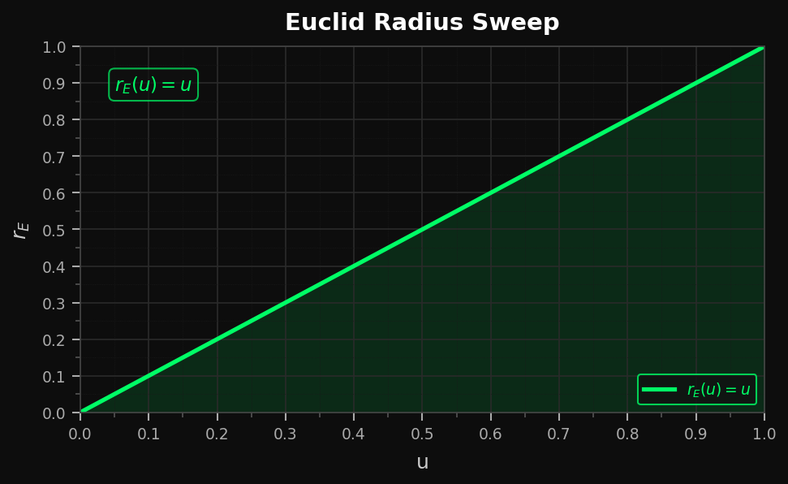
Figure A. 1

Appendix B
Equation used:
$$r_{DC}\left(u\right)={\left(\frac{Γ\left(u+1\right)}{2π}\right)}^{1/u}, u∈\left[0 , 1\right]$$
This is derived by reading your sphere tier pyramid in reverse — the repeated anti-derivative of 2π generates the sequence 2πr → πr² → π/3·r³ → π/12·r⁴ → ..., where the tier-n term is (2π/n!)·rⁿ. Solving for r at a generalized (continuous) tier u gives the formula above via the Gamma function.
Key plot properties for Euclid comparison:
Table B. 1
Property | Value
X-axis (u) | 0 → 1, ticks at 0, 0.25, 0.50, 0.75, 1.00
Y-axis (r) | 0 → 0.20, fixed scale
Endpoint at u=1 | r = 1/(2π) ≈ 0.15915
Behavior near u=0 | r → 0 (limiting value applied)
Resolution | 600 sampled points, Lanczos Γ approximation
The y-axis is locked at 0 → 0.20 so the Euclid sweep (which will end at the same 1/2π point linearly) can be overlaid or placed side-by-side on identical axes for a direct geometric comparison.
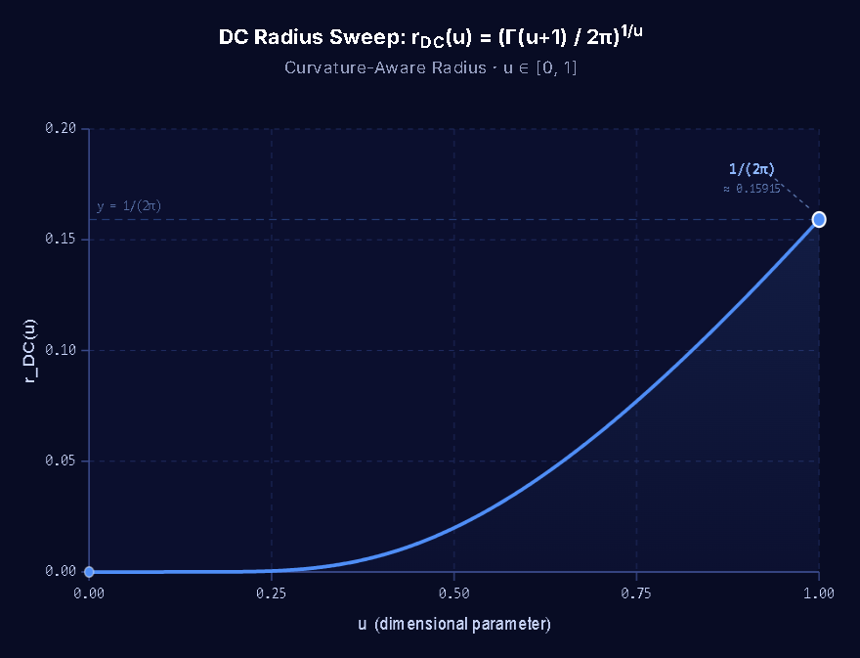
Figure B. 1

Appendix C
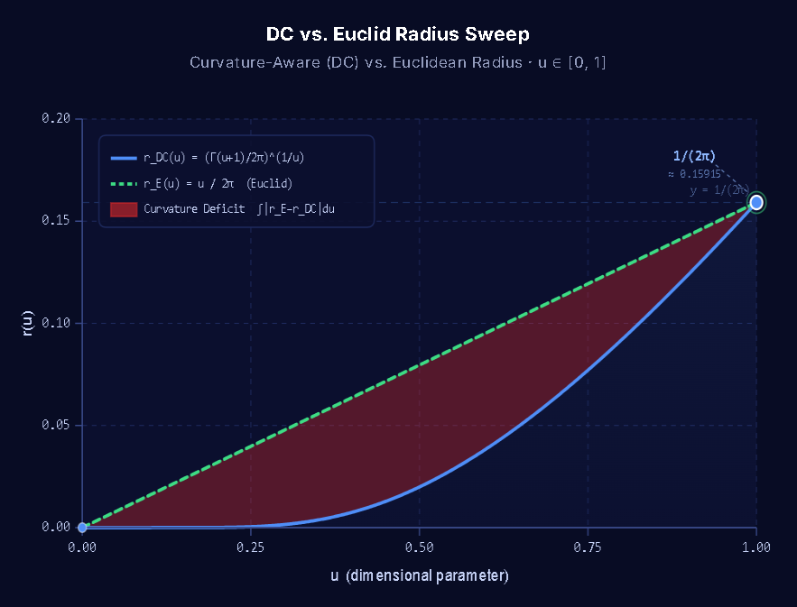
Figure C. 1
A subtle but important feature of the comparison graphs is the orientational mismatch between the DC radius function and Euclid’s classical radius expression. The Euclidean radius is plotted directly in its native coordinate frame, whereas the DC radius must invert its axes to appear in the same frame. This inversion is not a plotting artifact but a geometric consequence of the Amsler collapse–inversion structure: the DC radius inherits its orientation from the hyperspherical ladder, whose curvature broadcast is forced through the collapse–inversion boundary identified in Amsler Theorem 1 (detailed in The Amsler Surface: The Superposed Hypersphere’s Computational Power[S1]). When projected into Euclid’s coordinate frame, this inherited orientation manifests as a 90° axis inversion — the same inversion responsible for the folding, boundedness, and self-intersection of the Amsler surface. Thus, the graphical inversion between DC and Euclid is the radius-level signature of the same curvature mechanism that governs the Amsler saddle.
A brief remark is warranted regarding attempts to extend classical hyperspherical methods to Tier-4 Broadcast. Any derivation that employs Euclid’s hypersphere equation
$$V_{n}\left(r\right)=\frac{π^{n/2}}{Γ \left(\frac{n}{2}+1\right)}r^{n}$$
inherits the collapsed seed metric and therefore violates Euclid’s own foundational logic. The formula presupposes the existence of a dimensionless point, the construction of a continuous manifold from such points, and the measurement of curvature using a ruler whose seed layer has been annihilated. Consequently, the equation cannot represent hyperspherical curvature at Tier-4, where curvature inheritance is governed by the corrected seed metric rather than by Euclid’s collapsed projection. Any attempt to compute Tier-4 Broadcast using the classical hypersphere equation will therefore fail at the level of the metric itself, independent of analytic technique.

Appendix D
Readers attempting to reconstruct the curvature-integration constants $C_{n}$ are invited to repair Euclid’s hypersphere equation as it would need to stand in order to derive the correct values. One may begin with the classical formula
$$V_{n}\left(r\right)=\frac{π^{n/2}}{Γ \left(\frac{n}{2}+1\right)}r^{n},$$
and attempt to integrate downward through the dimensional ladder. However, this equation violates classical calculus integration rules at the hypersphere seed layer. It presupposes a dimensionless point, the construction of a continuous manifold from such points, and the measurement of curvature using a ruler whose $T_{0}$ broadcast channel has been collapsed. As a consequence, the hypersphere equation cannot represent curvature inheritance at any tier, and it cannot recover the gravitational-load curvature constants $C_{n}$.
The reader is therefore challenged to determine what correction Euclid’s hypersphere equation would require in order to remain consistent with its own geometric axioms and classical integration rules. Euclid’s volume formula has been empirically validated for all physical containers, meaning its curvature structure is intrinsically embedded through measurement. Yet the theorized hypersphere surface equation does not transparently reflect this empirically grounded structure, indicating that a nontrivial adjustment must exist between the measured volume behavior and the shape model Euclid’s collapsed metric assumes. Only after this adjustment is identified can the correct $C_{n}$values be obtained. The present manuscript reveals enough of the underlying structure to make the existence of such a correction apparent, while withholding the details necessary to trivialize its reconstruction. The construction of the underlying ladder geometric structure is explicitly laid out in Axioms of Curvature: Revealing and Correcting Euclid’s Hidden Assumption[S2].

Hypersphere Tier (-/+ Domain) | Nested Hypersphere Equations
$$T_{-5}$$ | $$48π⊙r^{-5}$$
$$T_{-4}$$ | $$-12π⊙r^{-4}$$
$$T_{-3}$$ | $$4π⊙r^{-3}$$
$$T_{-2}$$ | $$-2π⊙r^{-2}$$
$$T_{-1}$$ | $$2π⊙r^{-1}$$
$$T_{0}$$ | $$2πr^{0}$$
$$T_{1}$$ | $$2πr^{1}$$
$$T_{2}$$ | $$πr^{2}+C_{1}r^{0}$$
$$T_{3}$$ | $$\frac{π}{3}r^{3}+C_{1}r^{1}+C_{2}r^{0}$$
$$T_{4}$$ | $$\frac{π}{12}r^{4}+\frac{C_{1}}{2}r^{2}+C_{2}r^{1}+C_{3}r^{0}$$
$$T_{5}$$ | $$\frac{π}{60}r^{5}+\frac{c_{1}}{6}r^{3}+\frac{C_{2}}{2}r^{2}+C_{3}r^{1}+C_{4}r^{0}$$
$$C_{n}$$ | $C_{n}$ Equation For Substitution on the Dimensional Ladder
$$C_{1}$$ | $$r^{0}(π-2)$$
$$C_{2}$$ | $$r^{1}\left\{πr^{2}-(π-2)\right\}$$
$$C_{3}$$ | $$-r^{2}\left\{\frac{3πr^{2}+2(π-2)}{4}\right\}$$
$$C_{4}$$ | $$r^{2}\left\{\frac{\left(π-2\right)\left(-27r^{3}+45r^{2}+20r-30\right)+(-54r^{3}+90r^{2}+60r-120)}{60}\right\}$$

12 References
- Fourier, J. (1822). Théorie analytique de la chaleur. Paris: Firmin-Didot.
- Gibbs, J. Willard. “Fourier’s Series.” Nature 59, no. 1522 (1899): 606.
- Wilbraham, Henry. “On a Certain Periodic Function.” Cambridge and Dublin Mathematical Journal 3 (1848): 198–201.

S1 Schoenman, Aaron. The Amsler Surface: The Superposed Hypersphere’s Computational Power. Columbus, Ohio: Independent Publication, 2026. Zenodo. https://doi.org/10.5281/zenodo.22237802
S2 Schoenman, Aaron. Axioms of Curvature: Revealing and Correcting Euclid’s Hidden Assumption. Columbus, Ohio: Independent Publication, 2026. Zenodo. https://doi.org/10.5281/zenodo.21811577.
S3 Schoenman, Aaron. Dimensional Calculus: A Guide to Mapping Reality Through Curvature Dynamics.
Columbus, Ohio: Independent Publication, 2026. Zenodo. https://doi.org/10.5281/zenodo.21616654.

