WEB DEVELOPMENT

Assignment 1

**The University of Northampton**

**NAMI** College

Name: Aashish Tangnami

UN ID: 17425081

Submission Date: 6th April 5, 2017

Github link: https://ichigomagar.github.io/csy1018-assign1/

**Contents**

How I start my assignment? ……………………………………………………………………………………………………3

Designs ……………………………………………………………………………………………………3

Wireframes, responsive …………………………………………………………………………………………………4-8

Homepage ……………………………………………………………………………………………………

Bio/About me …………………………………………………………………………………………………...

My CV ……………………………………………………………………………………………………

Contact page ……………………………………………………………………………………………………

Prototypes ………………………………………………………………………………………………9-13

Screen mockups …………………………………………………………………………………………………...

Home page ……………………………………………………………………………………………………

Bio …………………………………………………………………………………………..

CV …………………………………………………………………………………………..

Contact …………………………………………………………………………………………..

Navigation bar ………………………………………………………………………………………….. 14

Navigation diagram …………………………………………………………………………………………..

My working progress …………………………………………………………………………………………..15-17

Progress …………………………………………………………………………………………..

Github link …………………………………………………………………………………………..

Validations …………………………………………………………………………………………..

HTML validation …………………………………………………………………………………………..

CSS validation …………………………………………………………………………………………..

Checking speed of my website ………………………………………………………………………………………….18

Checking errors and speed ……………………………………………………………………………………

Sources for code …………………………………………………………………………………………..18

**How I started the assignment?**

In the beginning of the assignment all the instructions and restrictions were given in the NILE. Firstly, I went through many websites of portfolio, and Joel Stanford, whose example is provided in the assignment brief in the NILE and many more. Thus, I started to begin to research about portfolio. Then after 2 weeks of research I created a design for my portfolio. Then I came to learn what things are supposed to be included in the portfolio. I went through different stages of development. For my website, I just used properties of HTML and CSS for styling my website.

**Designs**

For the assignment, I have gone through many wireframe diagrams for my portfolio and came up with the following wireframes.

For my website, I have used same header and same footer for all the pages to make look my portfolio look consistent and simple. The color I used for my header and footer is same and for icons and fonts I have used purple color. For my responsive website, the color combination and the font color and the icon color is same as before.

Some sites I visited:

<file:///C:/Users/aashish/Desktop/Web%20Work%20Term%201/SupportingDocs-Example-2.pdf>

<file:///C:/Users/aashish/Desktop/Web%20Work%20Term%201/SupportingDocs-Example-1.pdf>

<http://www.janmense.de/>

<http://www.mikereda.com/>

<http://joel.sh/about>

**Wireframes with responsive wireframes**

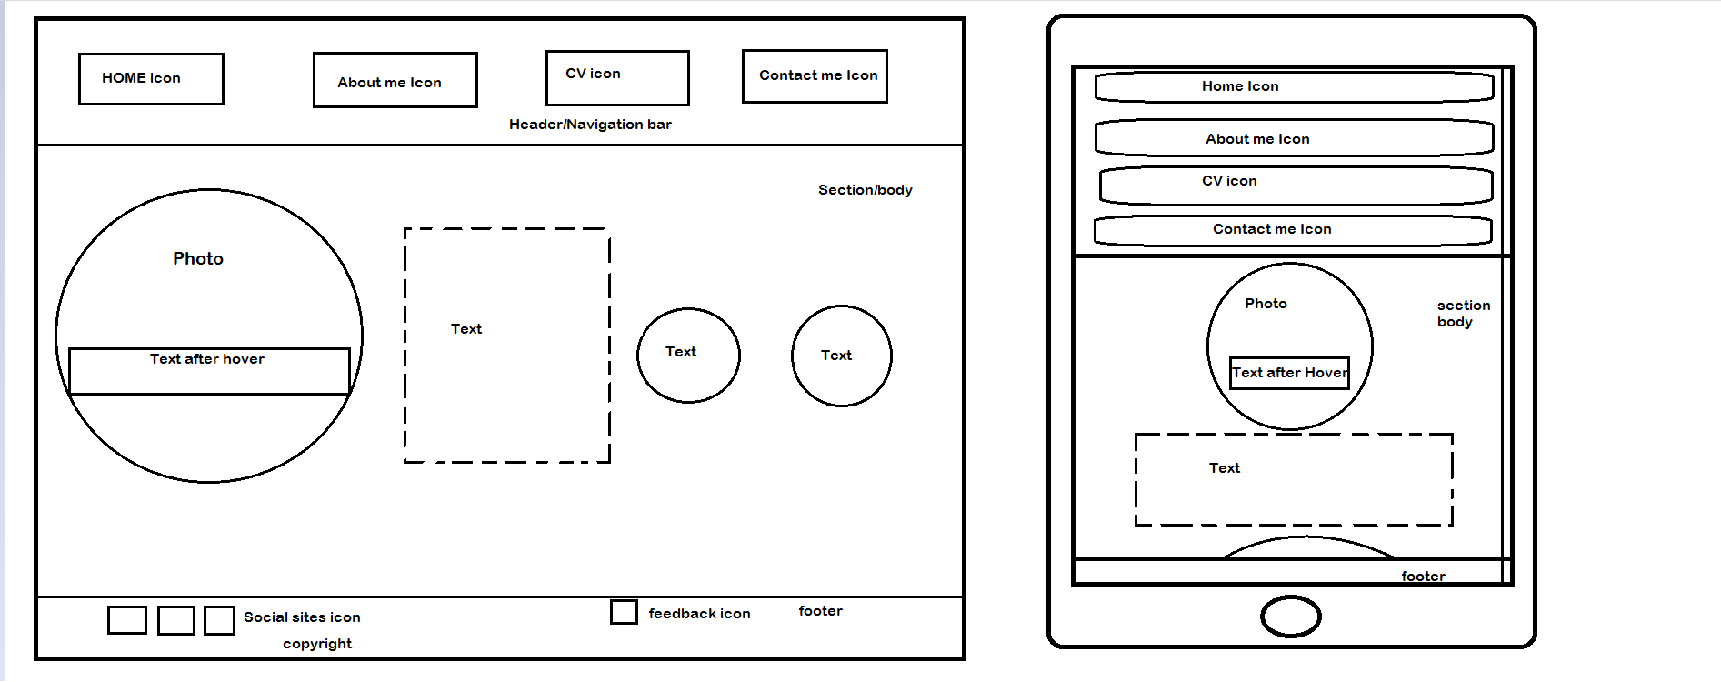**1: Home page**

I have divided the page into main three blocks. The first block is for header and the sub-blocks in the first are for the icons that I have used. Similarly, the middle block is large in size and this block contains the photos and some texts. Finally, the last block is the footer which contains social media links and feedback icon.

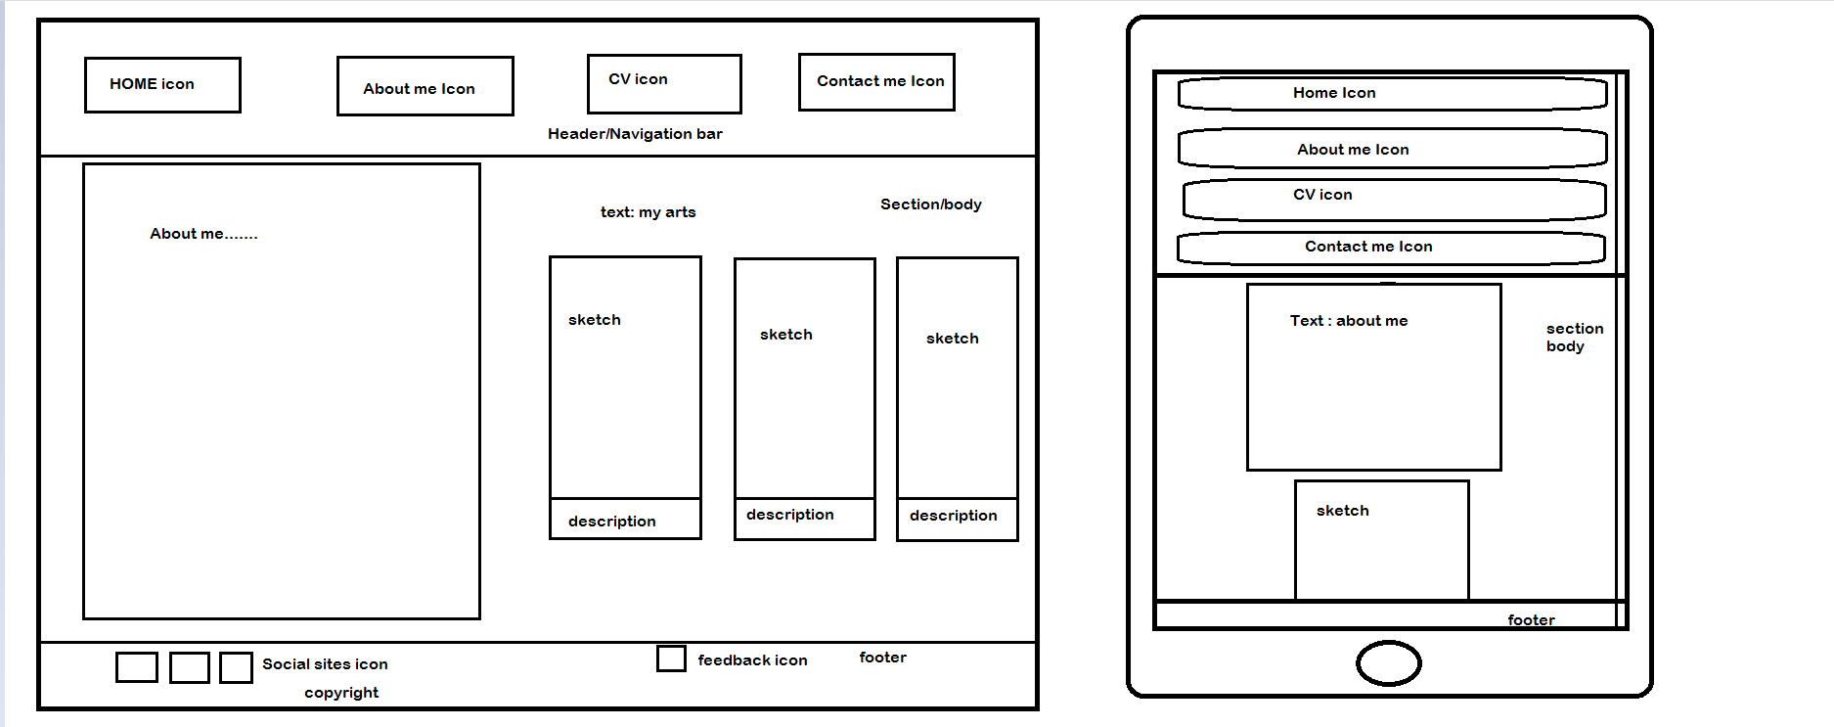**2: Bio/About me page**

In Bio page, I have same properties in header and footer block. The middle block has a big section for myself and some works I do beside web developing in picture form with description as shown in the above wireframe.

**3: CV page**

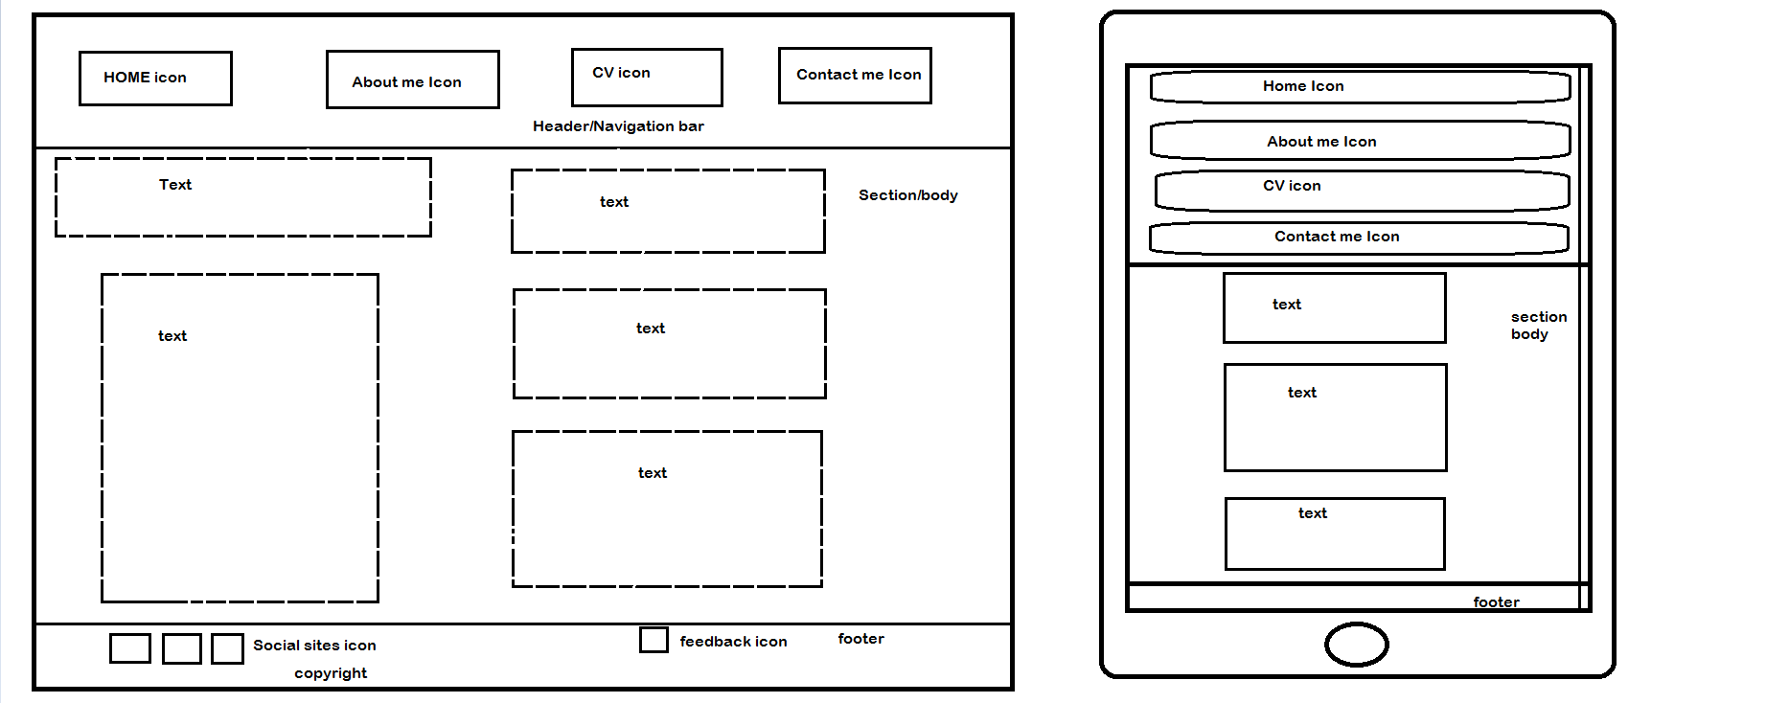

In CV page, again the properties of header and the footer block are as same in Home page and Bio page. The middle block is full of my personal information and my education life.

**4: Contact me page**

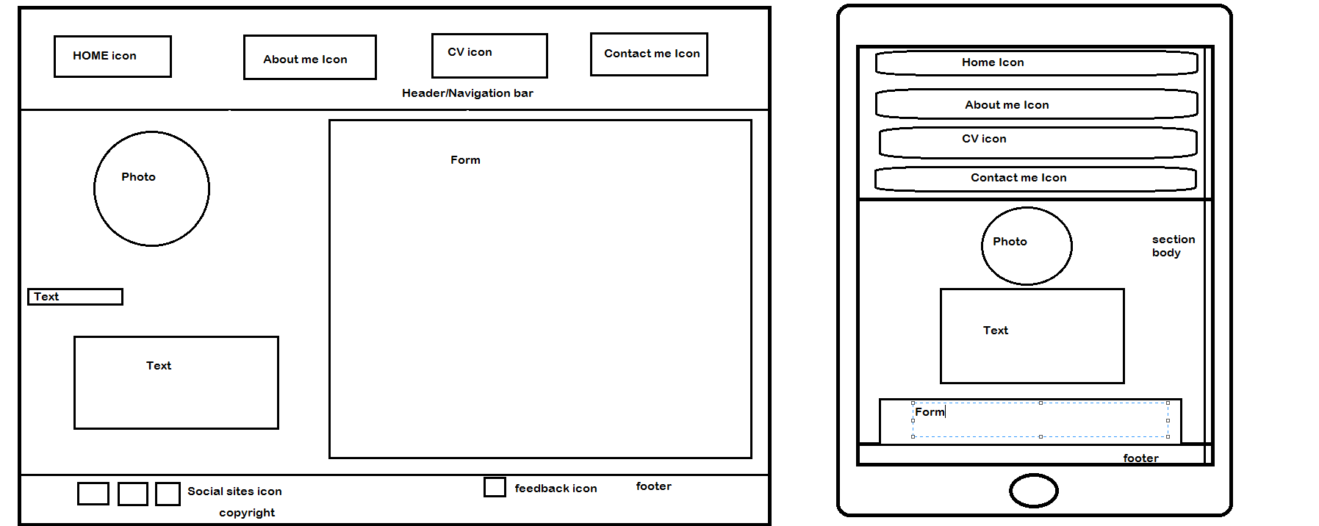

Similarly, in contact page the properties of header and footer block is same as in other pages. In the middle block, I have put a form on left through which visitor can send me feedback.

**Prototypes/Mockups**

**Portfolio:**

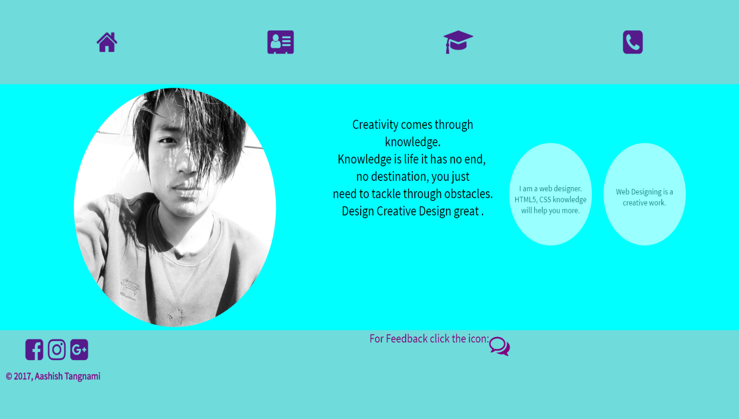**1: Home page/ Responsive home page:**

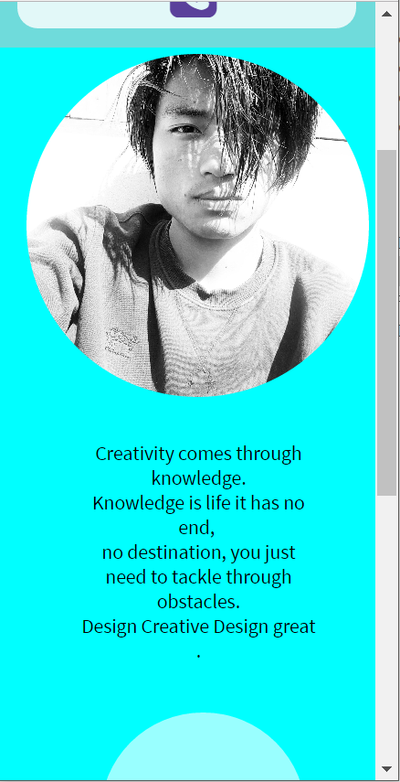When a visitor hovers on the icon it will rotate in 360 degree and the color will turn green indicating you can go on.

And when a visitor hovers on the image then text written “hello! Welcome to my portfolio” will appear.

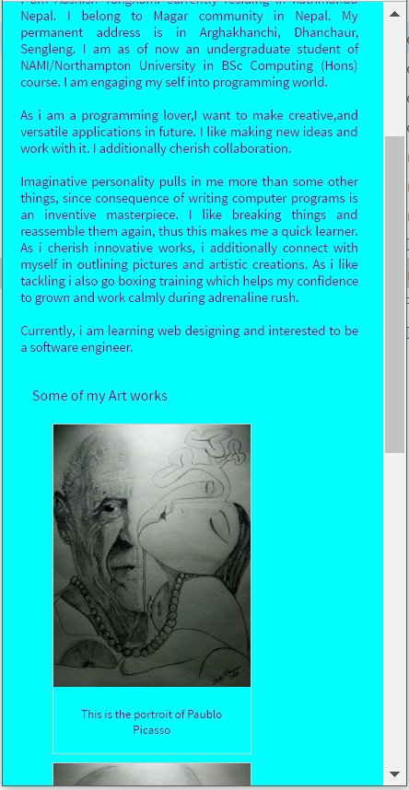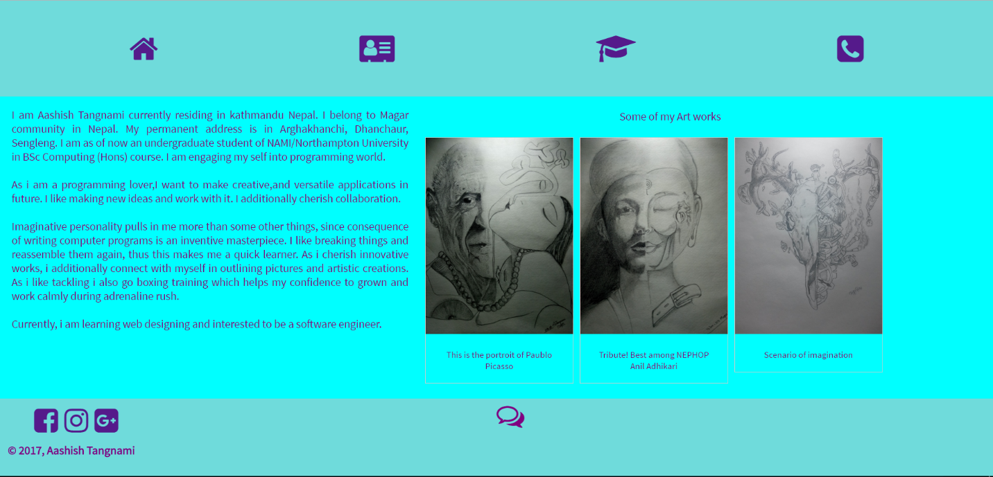**2: About me/Bio and responsive page:**

When a visitor hovers over image it will zoom out for better look.

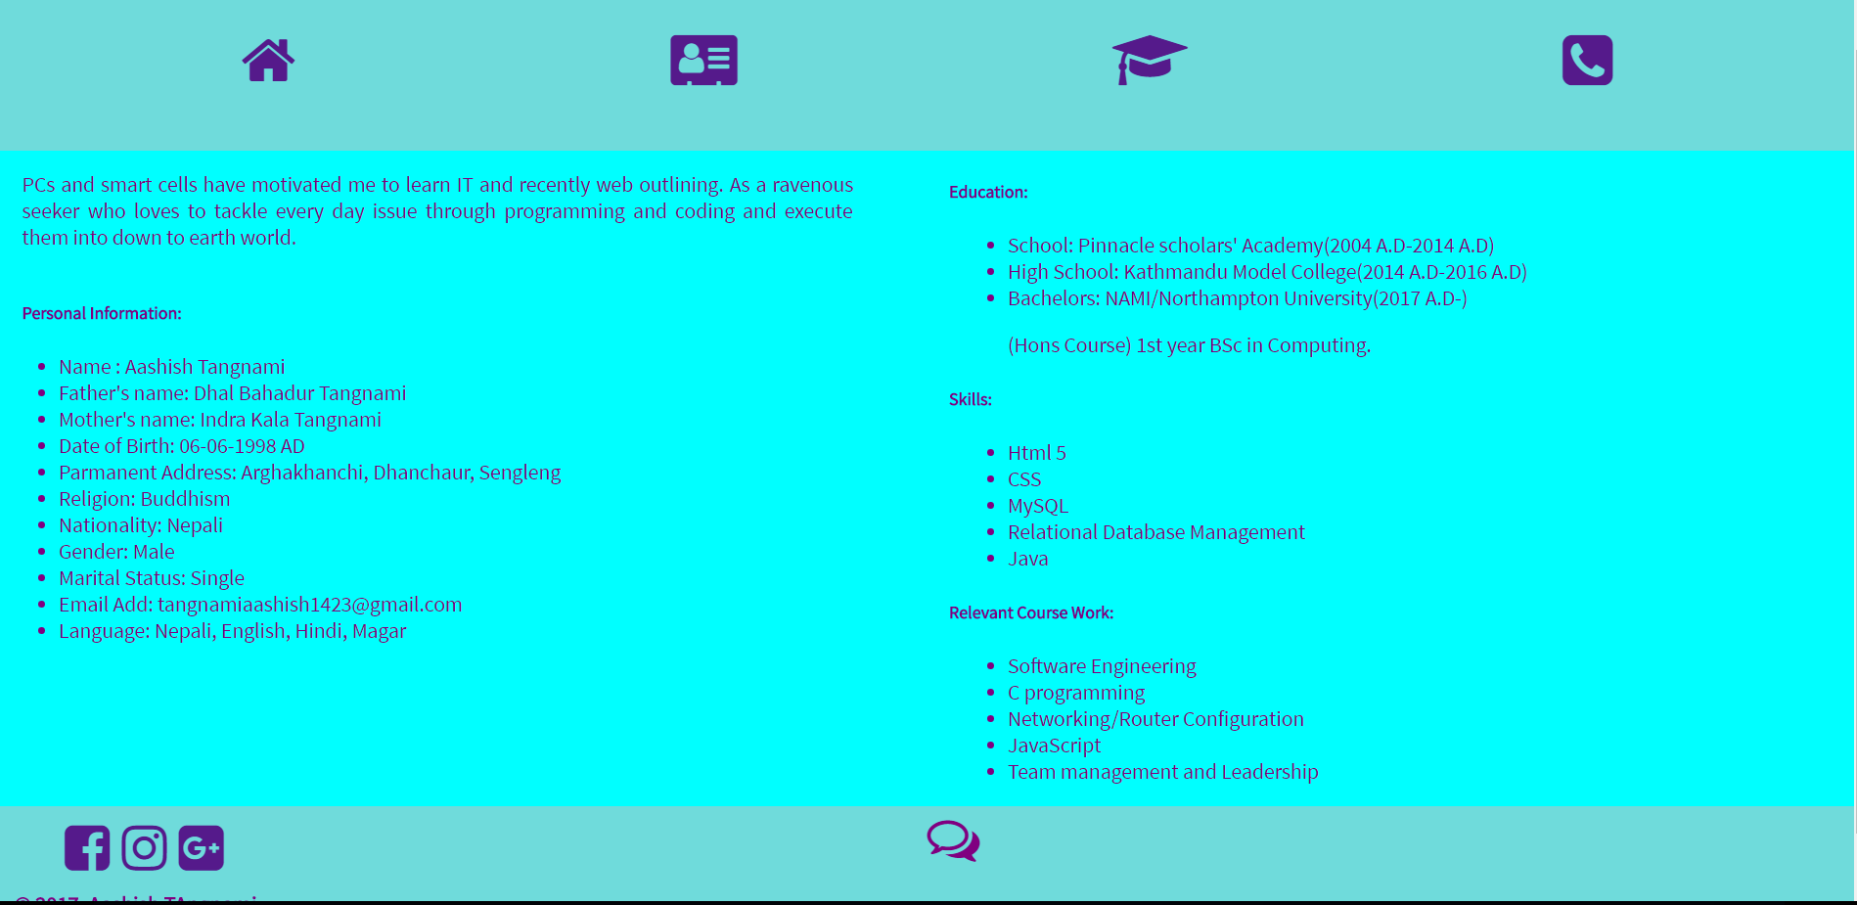**3: CV/ responsive page:**

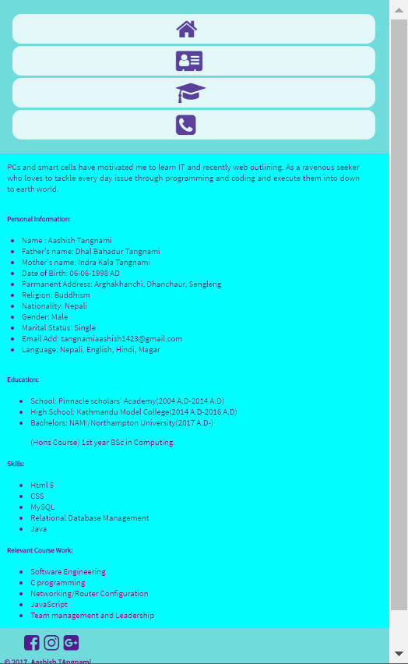

When the size of the website then the contents are arranged in column. As shown in the figure 🡪

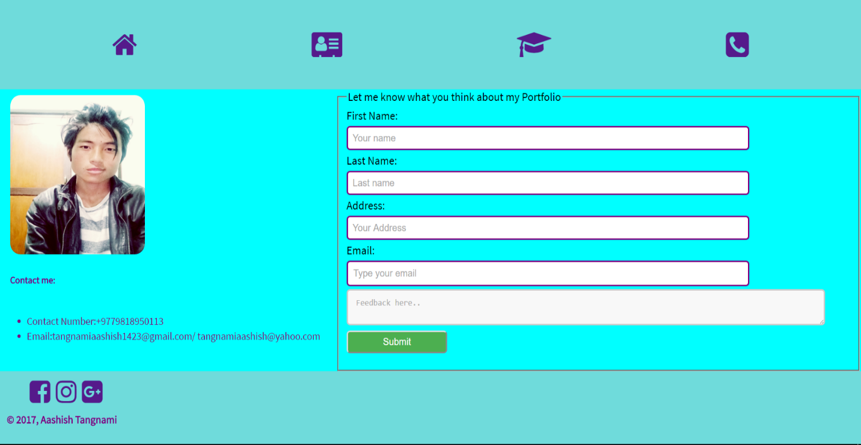**4: Contact me/ responsive page:**

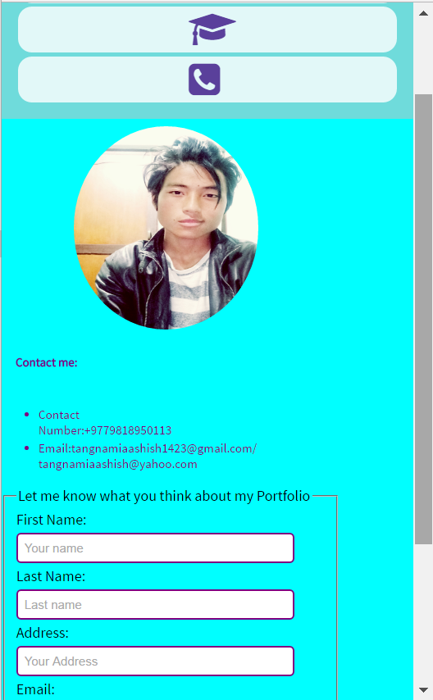Here in contact page the feedback form is in the left side.

The contact detail is below the image as seen in the mockup.

**Navigation bar:**



**Navigation Flow:**

Contact

Web 1.4

CV

Web 1.3

Bio/About me

Web 1.2

Home

Web 1.1

HOME

Web 1

Since, the navigation bar is same for all four pages the user interface will be easier.

**Work progress:**

It took me 2 weeks to complete the whole work. At first I completed the homepage design with parallel commits in Github.

* 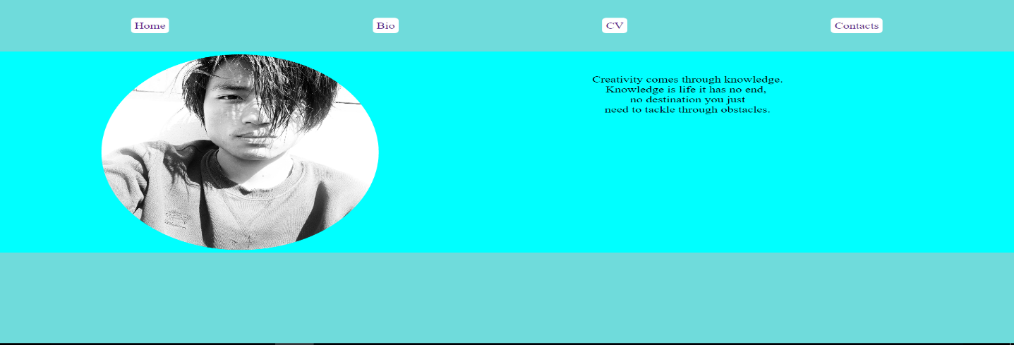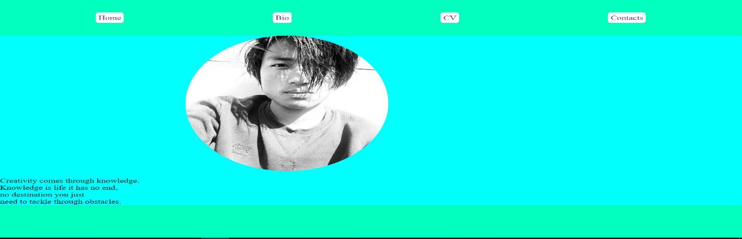Some work progress.

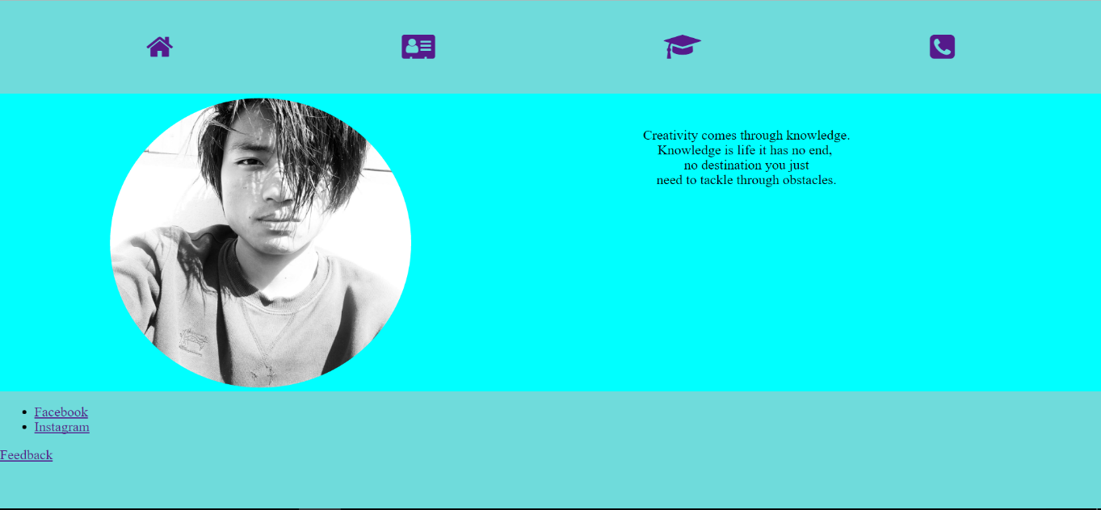

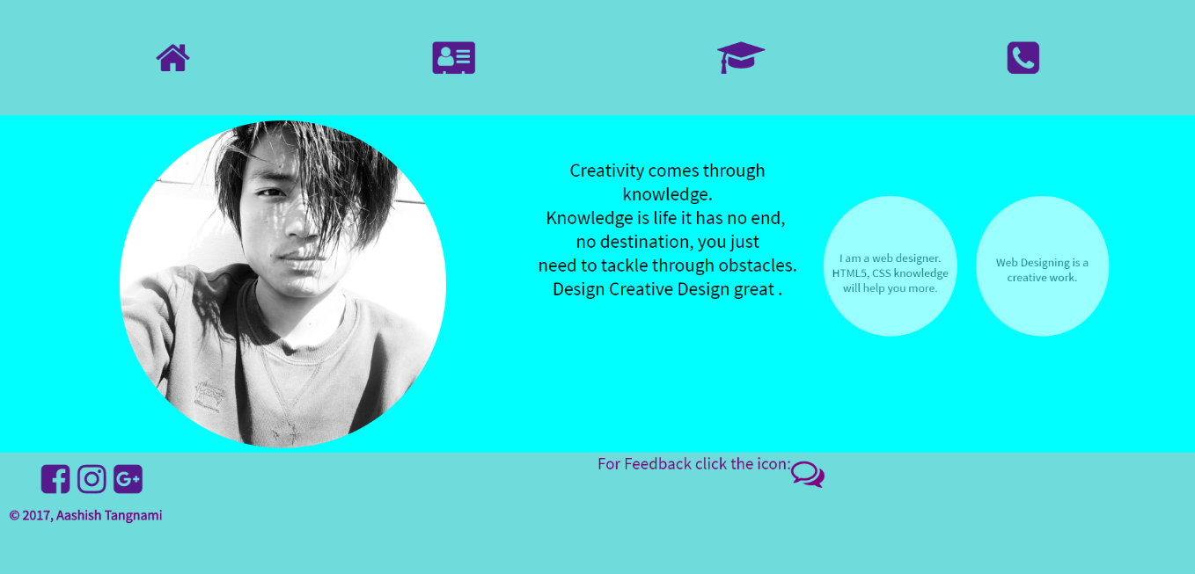

Similarly, same work progress has been throughout the work in other pages.

**Github link:**

* <https://ichigomagar.github.io/csy1018-assign1/>

**Validations**

**HTML validation:**

I have checked the html files in the <https://validator.w3.org/> and it was error free. Although the warnings are seen and they are acceptable.

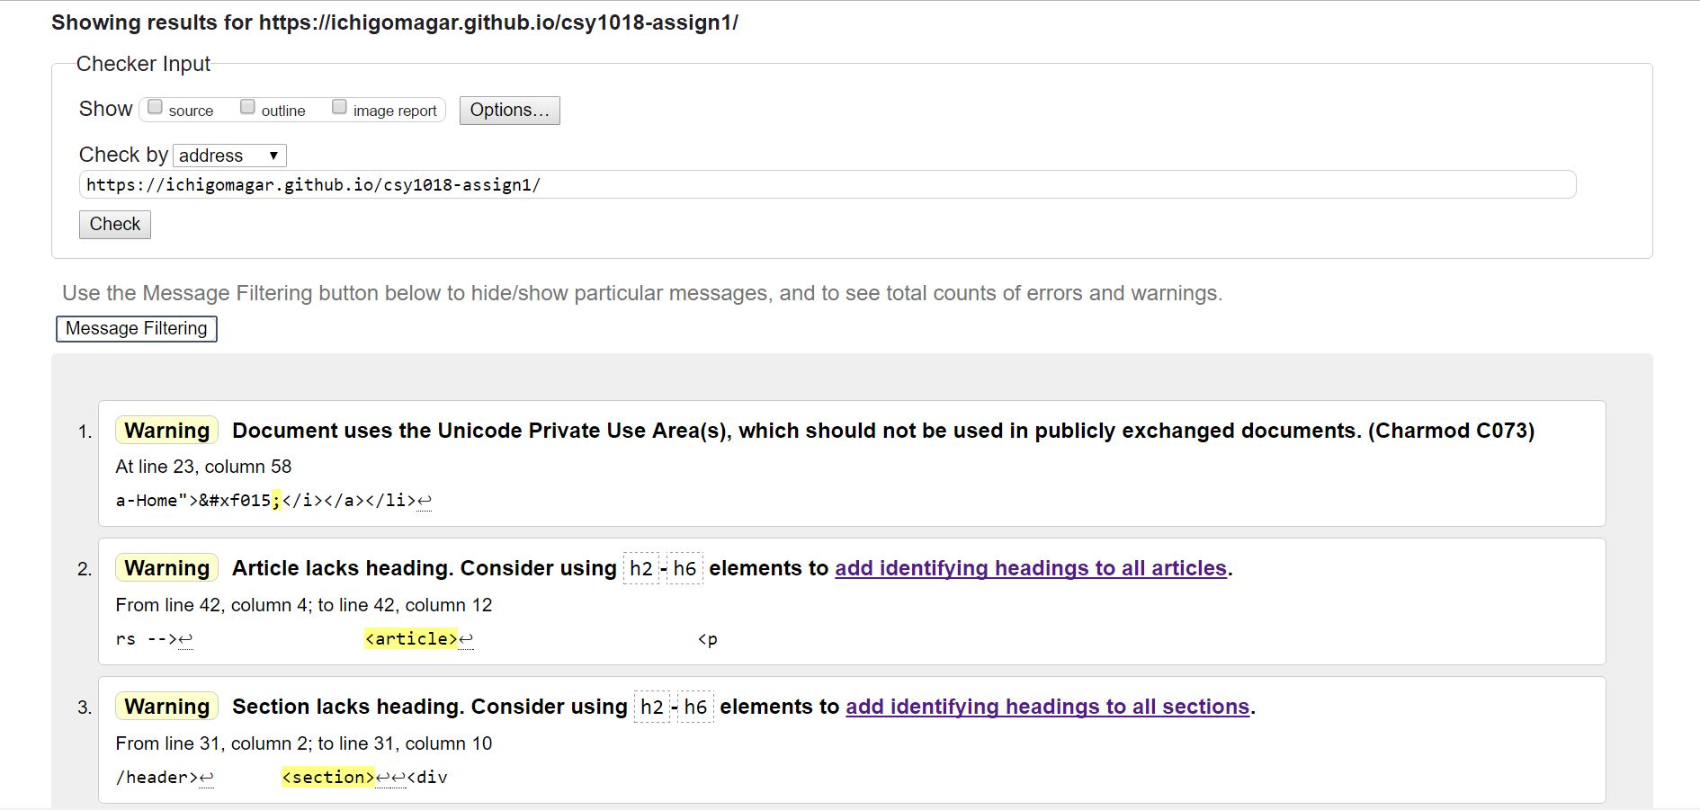

**CSS validation:**

There are two CSS files in my portfolio.

I have validated my portfolio CSS in <https://jigsaw.w3.org/css-validator/> and there is no sign of error.

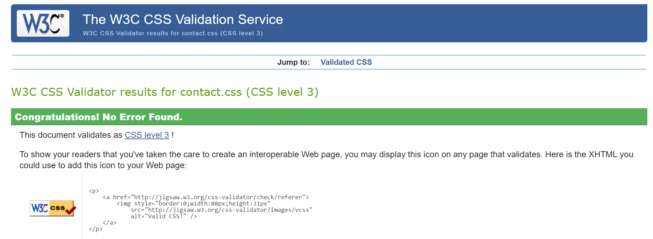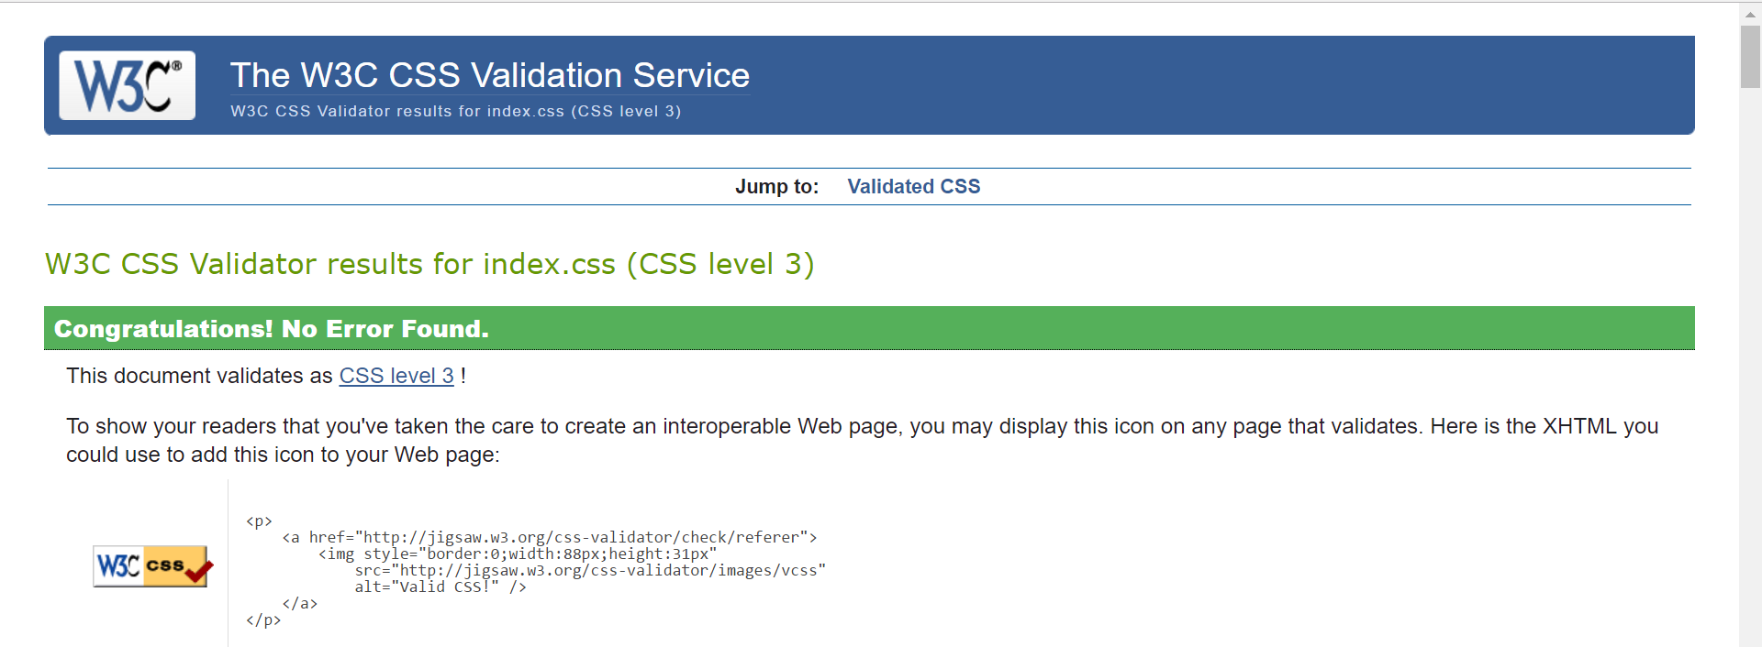

**Speed test of the website:**

Loading speed is the first impression that happens to a visitor if he/she is familiar to the internet. Thus, I tried to minimize the loading time making the portfolio error free and consistent as much as I can.

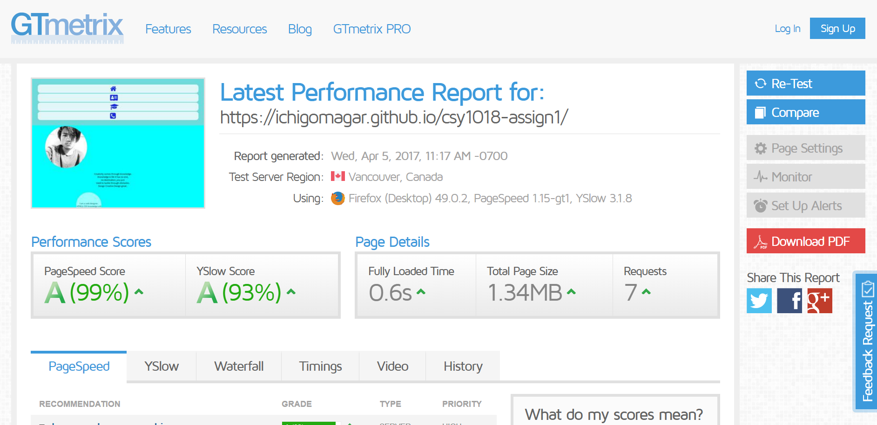

As I went through the GTmetrix website performance checker <https://gtmetrix.com/> . I have checked the site several times and the average loading time was 0.6s as seen in the screenshot

**Visual appeal:**

I tried to make all four pages having no scroll button with clear fonts and information need for the portfolio with perfect color combination.

**Source Code:**

[www.w3schools.com/](http://www.w3schools.com/)