

HOTEL MANAGEMENT SYSTEM
Software Requirement Specification

– Hanoi, September 2026 –
Record of Changes
Date | A*  M, D | In charge | Change Description
*A - Added M - Modified D - Deleted

Table of Contents
I. Project Overview 4
1.1. Project Information 4
1.2. Project Team 4
1.3. Product Background 4
1.4. Major Features 5
1.5. Tools & Infrastructures 6
II. Software Requirement Specification 6
2. Overall Requirement 6
2.1 Context Diagram 6
2.2 Main Workflows 7
2.3. User Requirements 9
2.4. System Functions 16
III. Functional Requirements 25
3. Use Case Specifications 25
3.1 Guest Management 25
3.2 Customer Management 27
3.3 Receptionist Management 32
3.4 Housekeeping Management 35
3.5 Hotel Manager Management 36
3.6 Admin Management 40
3.7 Payment Gateway (External System) 41
IV. Non-Functional Requirements 42
4.1 External interfaces 42
4.2 Quality Attributes 43
V. Requirement Appendix 45
5.1 Business Rules 45
5.2 Common Requirements 47
5.3 Application Messages List 48
VI. Mock-up 51

I. Project Overview

1. Project Information
- English name: Hotel Management System
- Vietnamese name: Hệ thống quản lý khách sạn
- Team name: SE1938 NJ - Team 3
- Software type: Web

2. Project Team
StudentID | Full Name | Role | Email
HE180515 | Đỗ Nguyễn Quang Sơn | Member | sondnqhe180515@fpt.edu.vn
HE194160 | Nguyễn Xuân Thắng | Leader | ngxuanthang05@gmail.com

3. Product Background
In recent years, the demand for travel and accommodation has increased significantly, especially for hotels with many rooms and different room types. Customers expect convenient services that allow them to easily search for hotels and rooms, check room availability, make reservations, and pay online.
However, managing room bookings, customer information, housekeeping tasks, and revenue through manual processes or separate systems often leads to inefficiencies and errors. Customers may also experience difficulties when searching for suitable rooms and confirming their reservations.
To address these challenges, the Hotel Management System is developed as a centralized platform for both online room booking and hotel operation management. The system enables customers to search for rooms, view availability, and make reservations conveniently. At the same time, it helps receptionists, housekeeping staff, managers, and administrators efficiently manage rooms, bookings, check-in and check-out, room cleaning, customers, and business performance.

4. Major Features
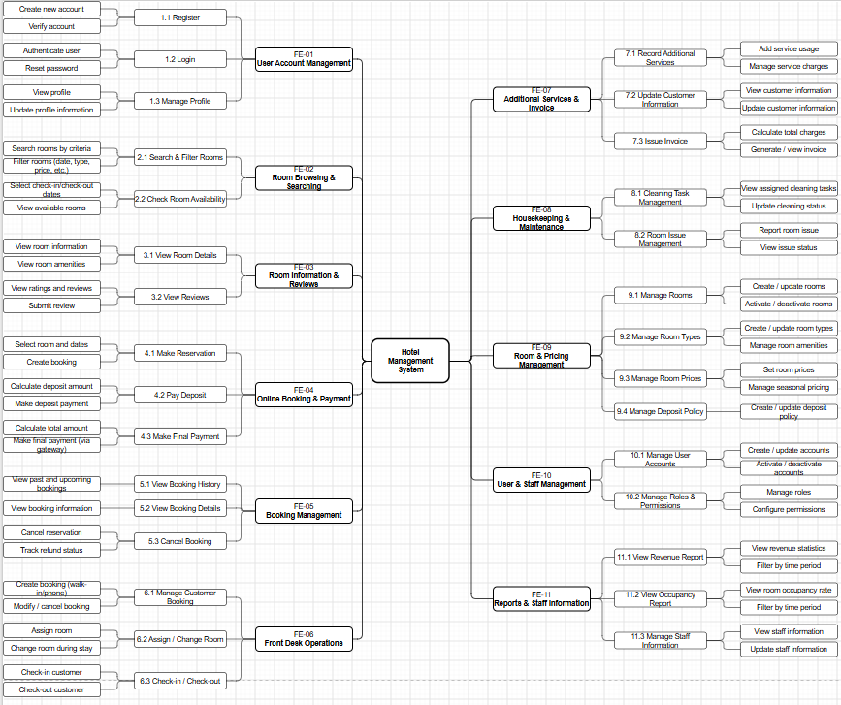

FE-01: Register, log in, and update personal account information.
FE-02: Browse, search, and filter rooms and check room availability.
FE-03: View detailed hotel and room information, and read or submit ratings and feedback.
FE-04: Book rooms online, pay deposits, and make payments through the payment gateway.
FE-05: View booking history, cancel reservations, and track refund status.
FE-06: Assign or change rooms, handle check-in and check-out, and manage customer bookings at the front desk.
FE-07: Record additional services, update customer information, and issue invoices.
FE-08: Receive cleaning tasks, update room cleaning status, and report room issues.
FE-09: Create, update, and maintain rooms, room types, prices, coupons, and deposit and cancellation / refund policies.
FE-10: Manage user accounts and staff roles.
FE-11: View revenue reports, occupancy reports, and staff information.

5. Tools & Infrastructures
Category | Tools / Infrastructure
Technology | React (Front-end), ExpressJS (Back-end)
Database | MongoDB
API | RESTful API
IDEs/Editors | Visual Studio Code
Diagramming | Visual Paradigm, Draw.io
Documentation | Google Docs/Sheets/Slides
Version Control | Git
Deployment server | Vercel, Render
Test tool | Postman
Project management | GitLab (Tasks, Defects), Excel

II. Software Requirement Specification

2. Overall Requirement

2.1 Context Diagram
The Hotel Management System is a web-based application designed to support hotel reservations and daily hotel operations. It allows guests to browse hotels and rooms, check availability, register, and log in. Authenticated customers can manage reservations, make payments or deposits, apply coupons, submit reviews, and receive notifications. Receptionists handle booking operations, check-in/check-out, room assignment, additional services, invoices, and refunds. Hotel Managers manage rooms, pricing, policies, staff, and reports. Housekeeping Staff manage cleaning tasks and room status, while Admin manages user accounts.
The system also integrates with an external Payment Gateway for payment and deposit processing.
The system interacts with seven external actors: Guest, Customer, Receptionist, Hotel Manager, Housekeeping Staff, Admin, and Payment Gateway. The following Context Diagram illustrates the system boundary and the main data flows between these actors and the Hotel Management System.
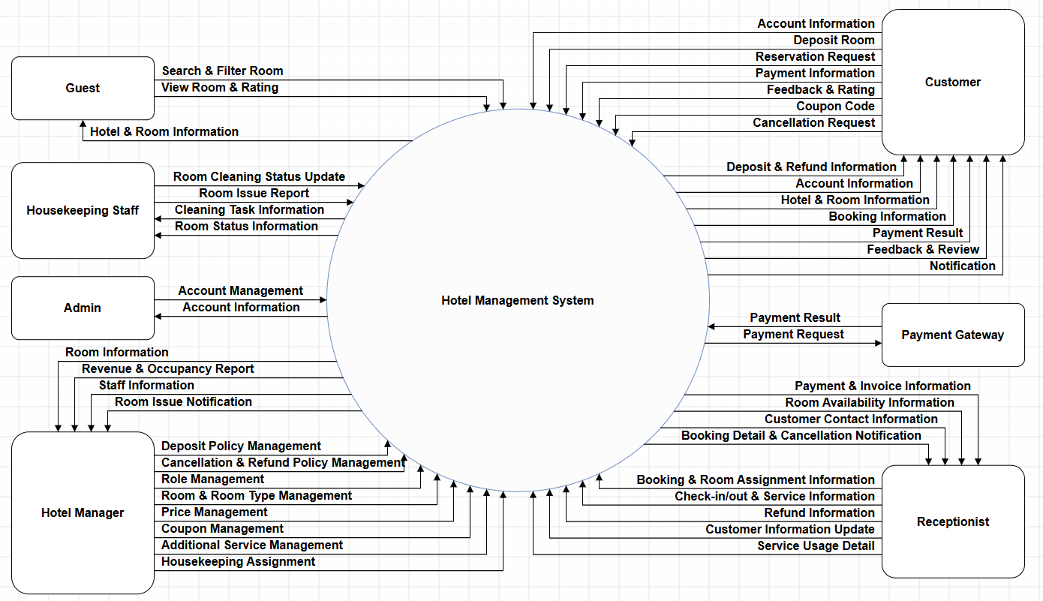

2.2 Main Workflows

2.2.0 Main Business Flow

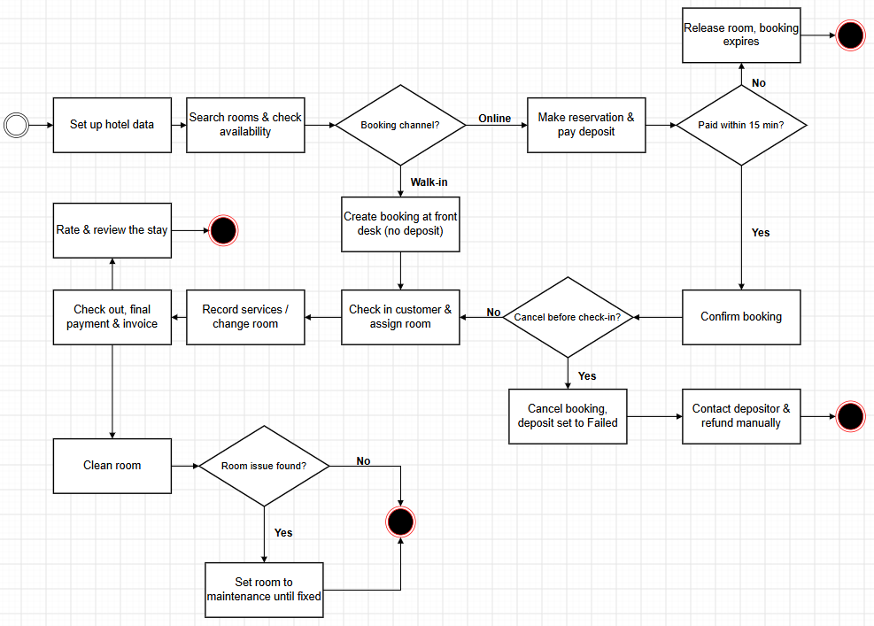

2.2.1 Front-Desk Operations & Room Lifecycle
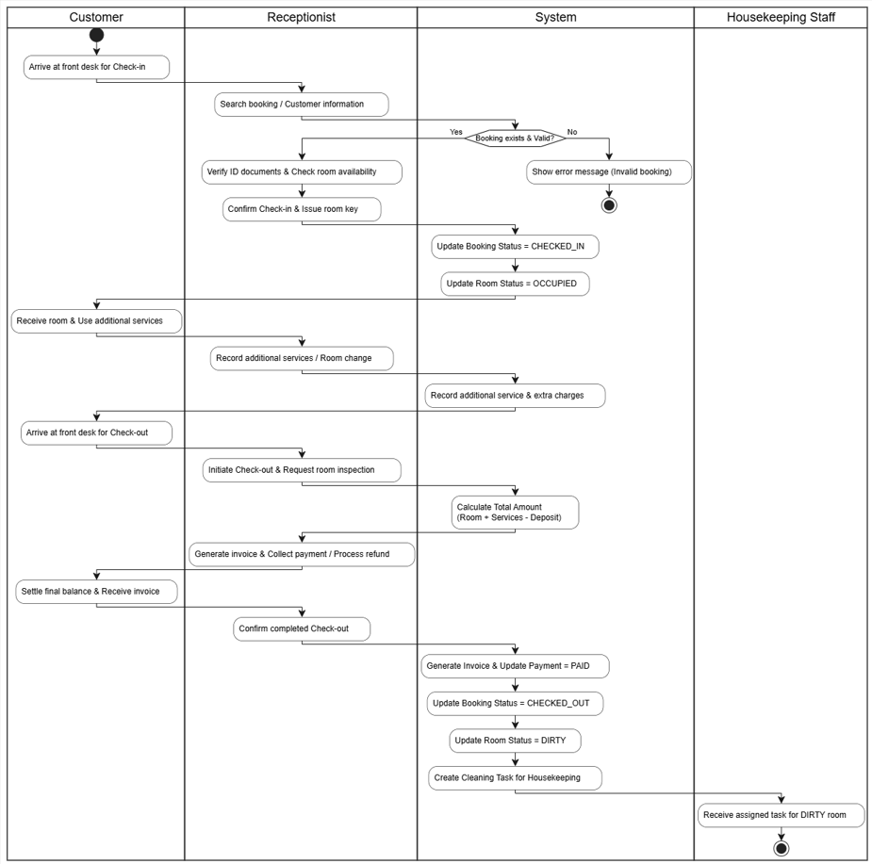

2.2.2 Reservation Workflow
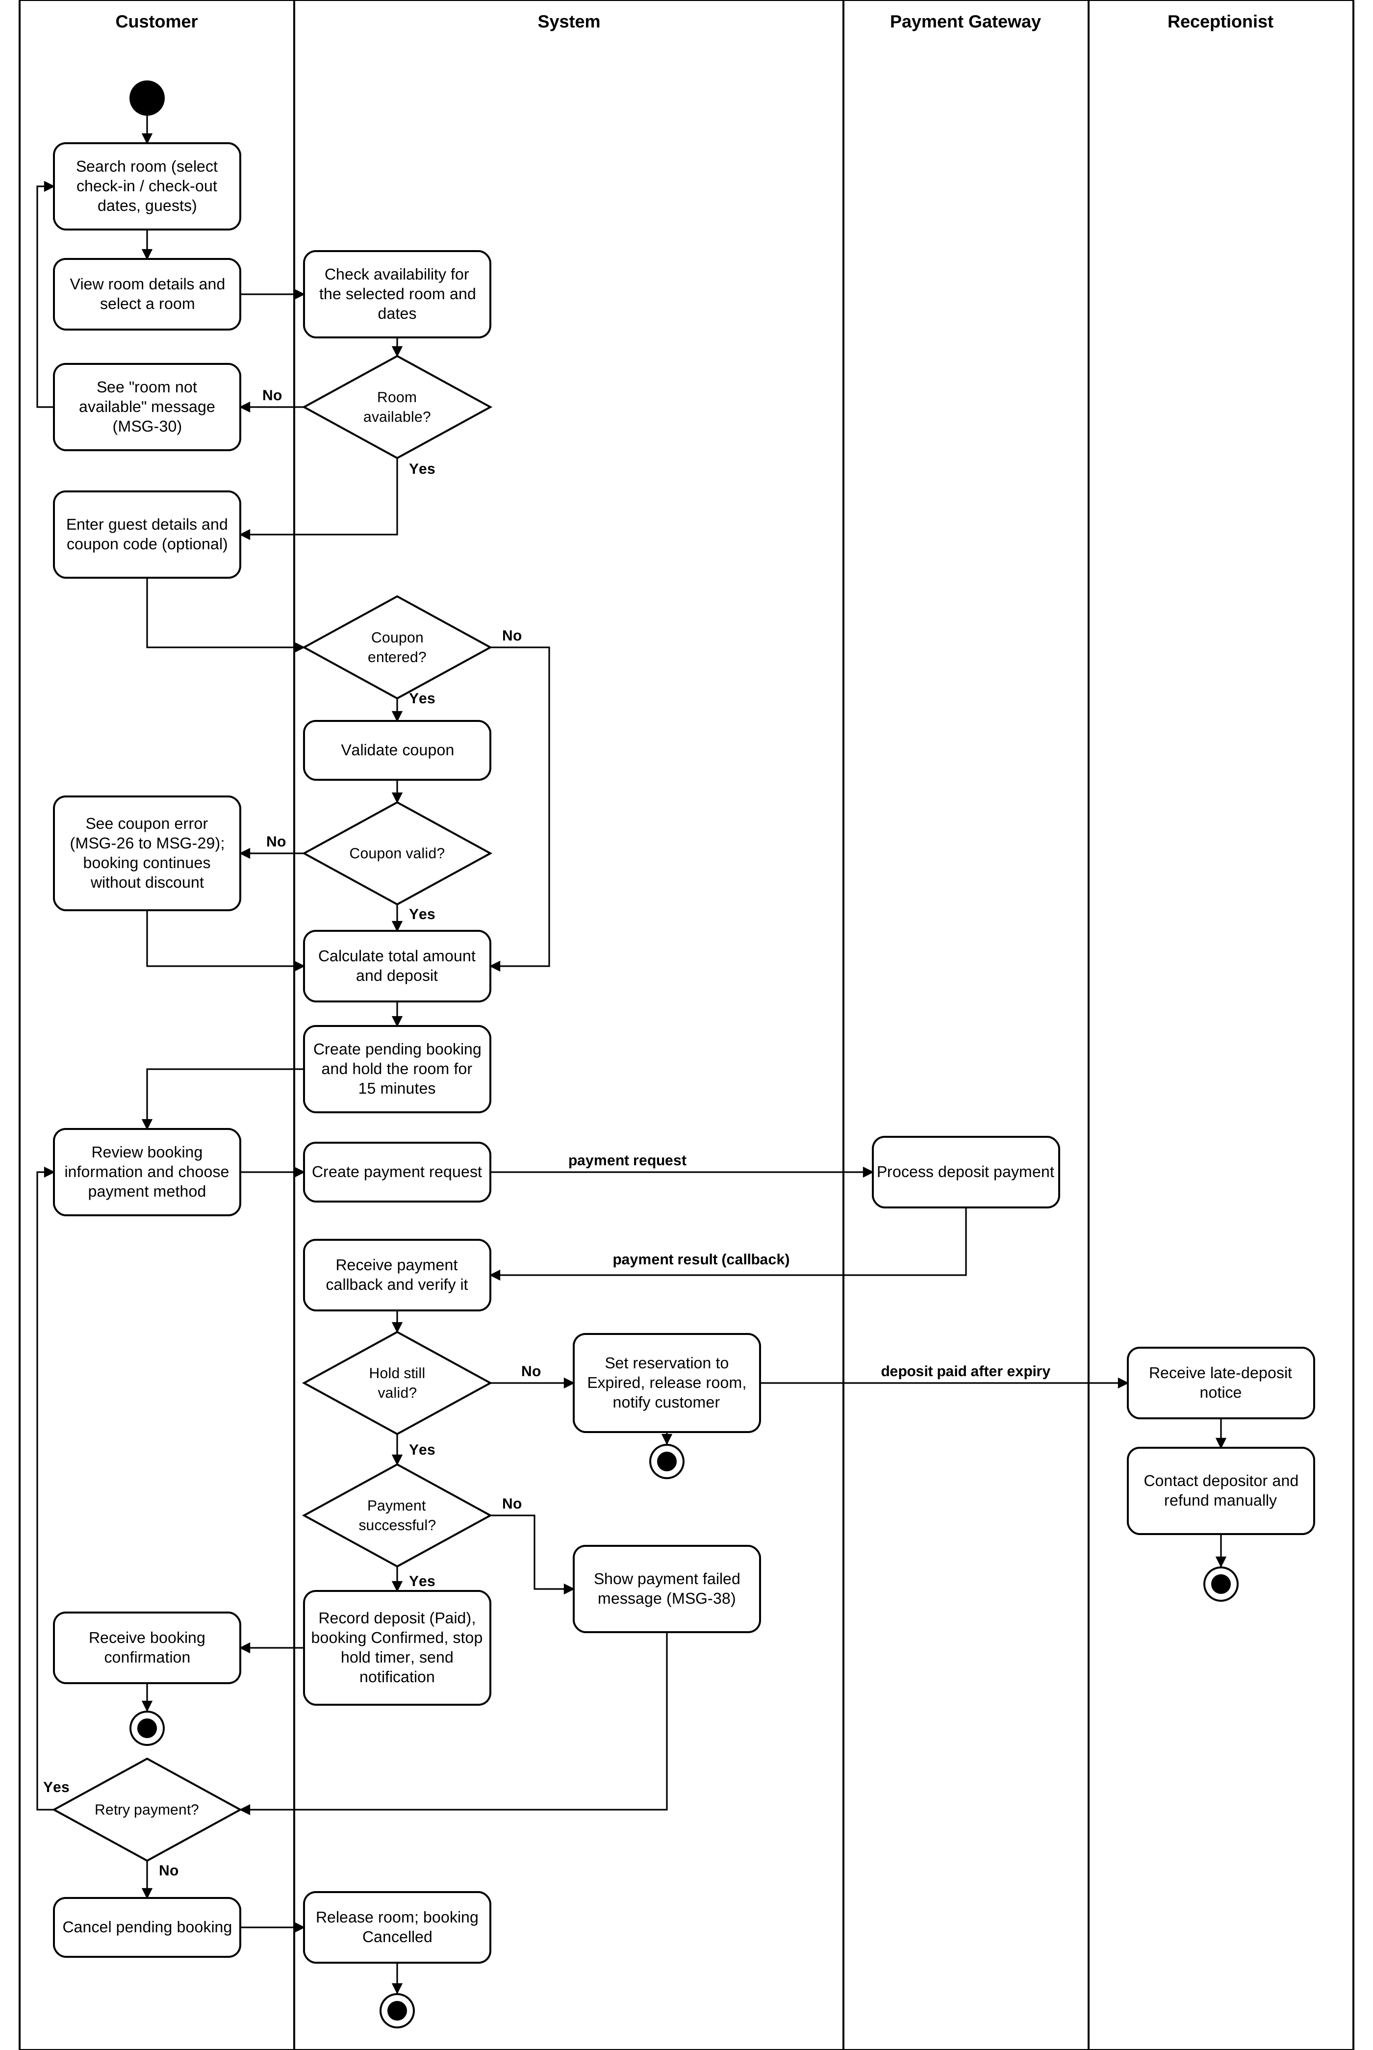

2.3. User Requirements

2.3.1. Actor
# | Actor | Description
1 | Guest | Guest can search and view hotel/room information, view room availability and hotel/room’s ratings/review.
2 | Customer | Customer can manage profile, create and manage reservations, make payments, submit reviews, and view notifications.
3 | Receptionist | Handles front-desk operations such as creating and modifying bookings, check-in/check-out, room changes, additional services, refunds, and customer information.
4 | Hotel Manager | Manages rooms, room types, prices, coupons, additional services, hotel policies, staff, staff roles and permissions, housekeeping assignment, and views revenue and occupancy reports.
5 | Housekeeping Staff | Manages assigned cleaning tasks, updates room cleaning status, and reports room issues.
6 | Admin | Manages system user accounts and account status.
7 | Payment Gateway | External system used to process online payments and deposits.

2.3.2 Use Case List (UC)
ID | Use Case | Feature | Use Case Description
UC01 | Register | User Access & Customer Experience | Create a new customer account.
UC02 | Login | User Access & Customer Experience | Authenticate a user and provide system access based on role.
UC03 | Manage Profile | User Access & Customer Experience | View and update personal profile information.
UC04 | Search Room | User Access & Customer Experience | Search and filter rooms based on dates and requirements.
UC05 | View Room Details | User Access & Customer Experience | View room type, price, amenities, and other details.
UC06 | Check Room Availability | Reservation & Payment | Check whether selected rooms are available for the requested dates.
UC07 | Make Reservation | Reservation & Payment | Create a new room reservation.
UC08 | Modify Reservation | Reservation & Payment | Change information of an existing reservation.
UC09 | Cancel Reservation | Reservation & Payment | Cancel an eligible reservation.
UC10 | View Booking History | Reservation & Payment | View previous and current bookings.
UC11 | View Booking Details | Reservation & Payment | View detailed information of a selected booking.
UC12 | Make Deposit Payment | Reservation & Payment | Pay the required deposit to confirm a reservation.
UC13 | Make Final Payment | Reservation & Payment | Pay the remaining amount for a booking.
UC14 | Submit Review | User Access & Customer Experience | Submit a rating and review after completing a stay.
UC15 | View Notifications | User Access & Customer Experience | View booking, payment, and system notifications.
UC16 | Create Booking | Front Desk Operations | Receptionist creates a booking for a walk-in customer (no deposit).
UC17 | Modify Booking | Front Desk Operations | Receptionist updates an existing booking.
UC18 | Cancel Booking | Front Desk Operations | Receptionist cancels a booking according to policy.
UC19 | Check-in Customer | Front Desk Operations | Verify the booking and complete customer check-in.
UC20 | Change Room | Front Desk Operations | Change the assigned room during the customer stay.
UC21 | Record Additional Services | Front Desk Operations | Record additional services used by a customer.
UC22 | Check-out Customer | Front Desk Operations | Complete customer check-out and calculate final charges.
UC23 | Process Refund | Front Desk Operations | Receptionist contacts the depositor of a cancelled booking and records the manual refund.
UC24 | Manage Customer Information | Front Desk Operations | View and update customer information needed for hotel operations.
UC25 | Manage Rooms | Hotel Operations & Housekeeping | Create, update, deactivate, and manage hotel rooms.
UC26 | Manage Room Types | Hotel Operations & Housekeeping | Manage room types, capacities, amenities, and base prices.
UC27 | Manage Room Prices | Hotel Operations & Housekeeping | Configure room pricing for different periods.
UC28 | Manage Coupons | Hotel Operations & Housekeeping | Create and manage coupon codes used at checkout.
UC29 | Manage Deposit Policy | Hotel Operations & | Configure deposit rules used for reservations.
UC30 | Manage Cancellation / Refund Policy | Hotel Operations & Housekeeping | Configure cancellation and refund rules.
UC31 | View Revenue Report | Hotel Operations & Housekeeping | View hotel revenue information and statistics.
UC32 | View Occupancy Report | Hotel Operations & Housekeeping | View room occupancy statistics for selected periods.
UC33 | Manage Staff | Hotel Operations & Housekeeping | Manage hotel staff information and status.
UC34 | Manage Cleaning Tasks | Hotel Operations & Housekeeping | View, perform, and update room cleaning tasks.
UC35 | Report Room Issue | Hotel Operations & Housekeeping | Report maintenance or room issues discovered during cleaning.
UC36 | Manage User Accounts | User Access & Customer Experience | Admin manages user accounts and account status.
UC37 | Manage Roles & Permissions | User Access & Customer Experience | Hotel Manager manages staff roles and access permissions.
UC38 | Process Gateway Payment | Reservation & Payment | External payment gateway processes payment transactions.
UC39 | Manage Additional Services | Hotel Operations & Housekeeping | Manage the catalog of additional services and their unit prices.

2.3.3 Use Case Diagrams

2.3.3.1 UCs for Guest
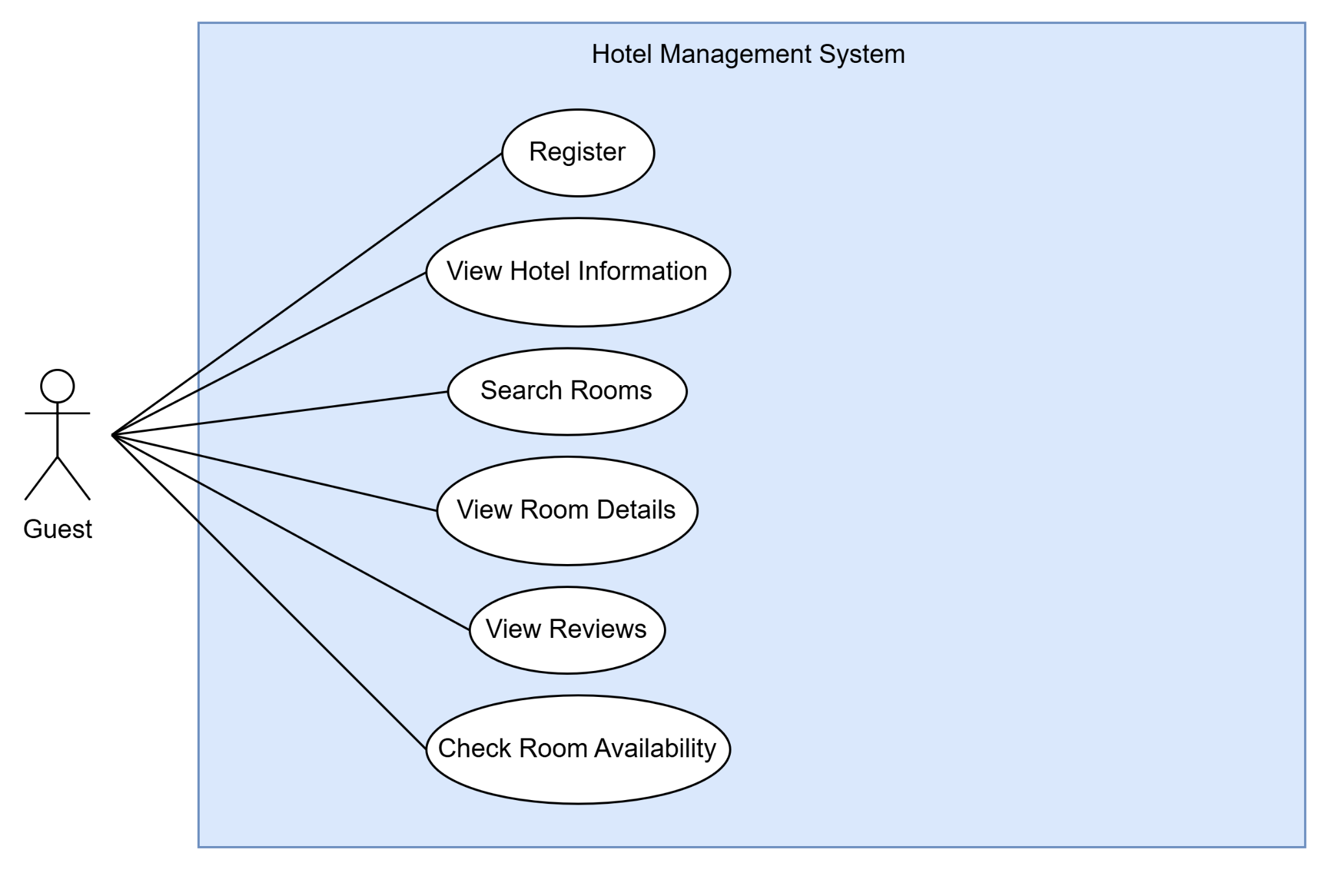

2.3.3.2 UCs for Customer
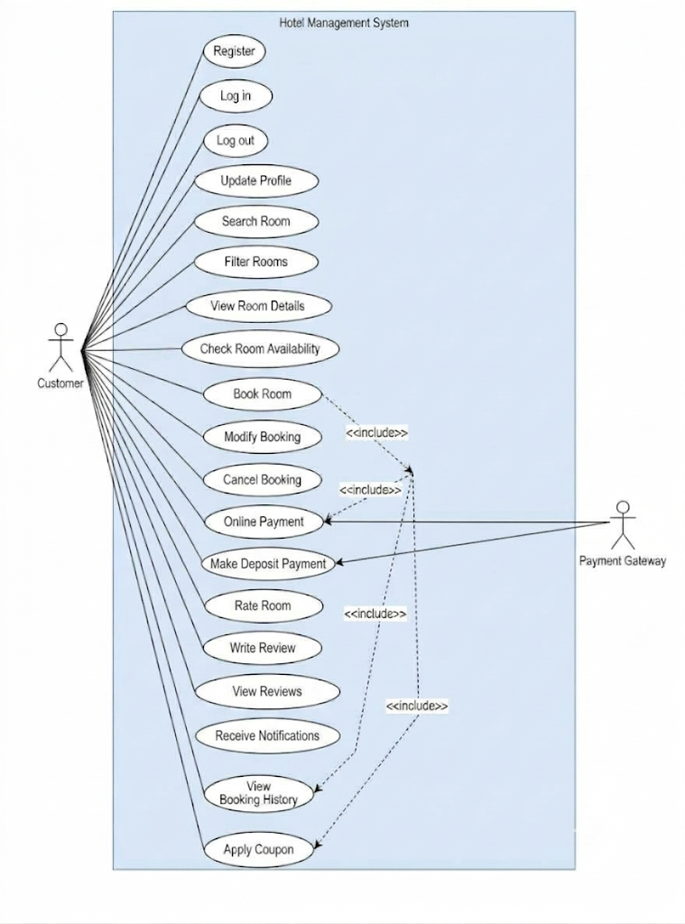

2.3.3.3 UCs for Receptionist
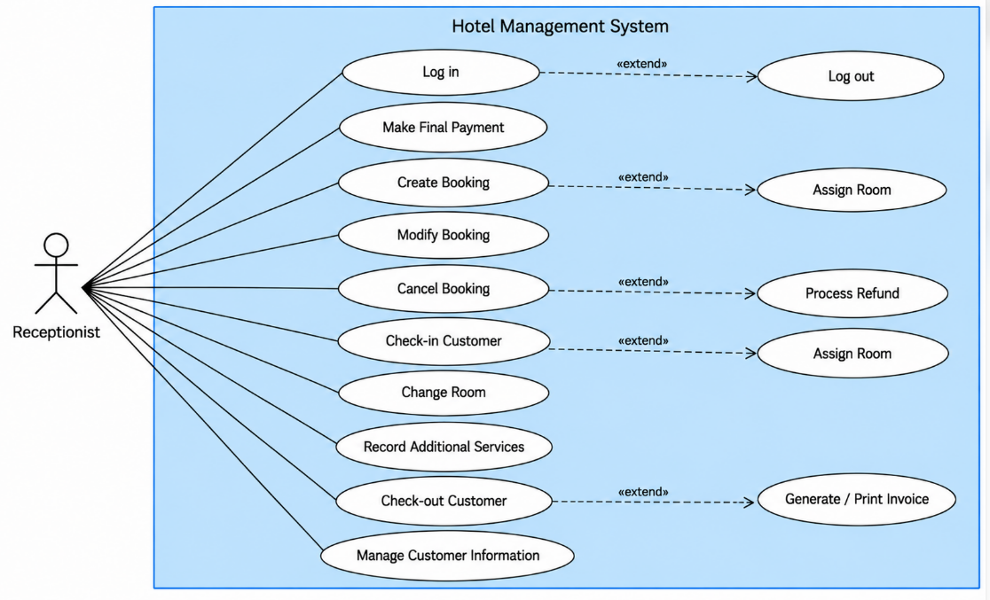

2.3.3.4 UCs for Housekeeping Staff
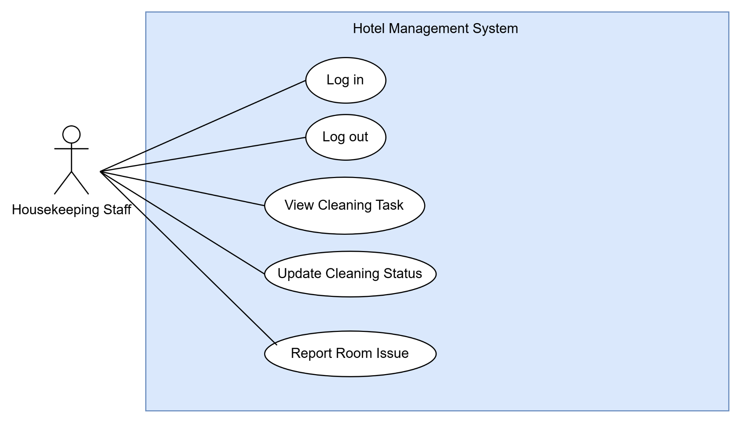

2.3.3.5 UCs for Hotel Manager
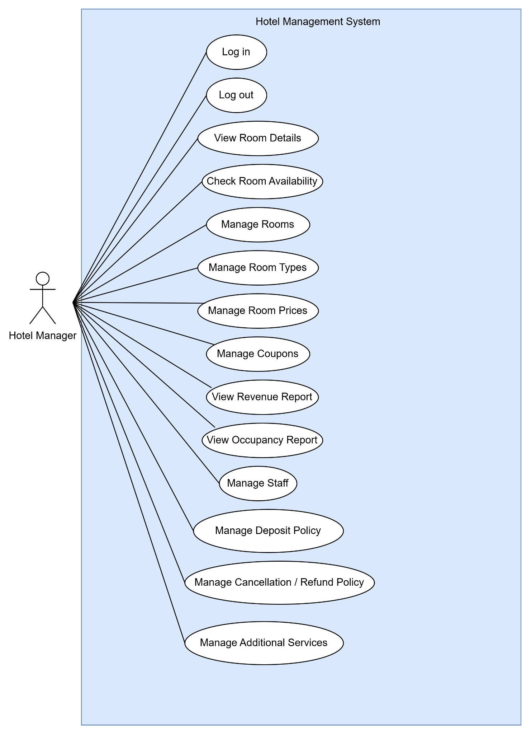

2.3.3.6 UCs for Admin
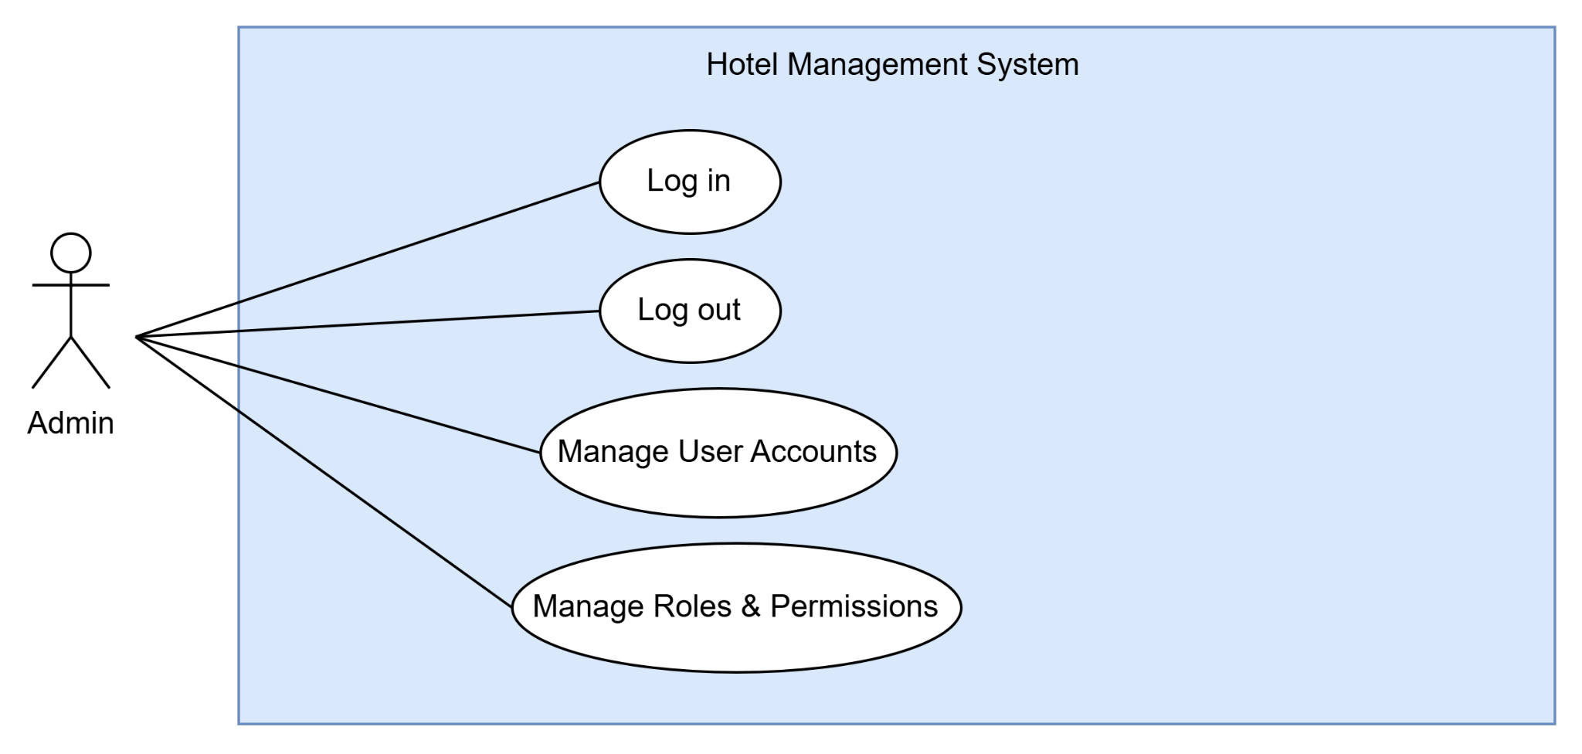

2.4. System Functions

2.4.1 Screen Flow
Screens Flow for Customer
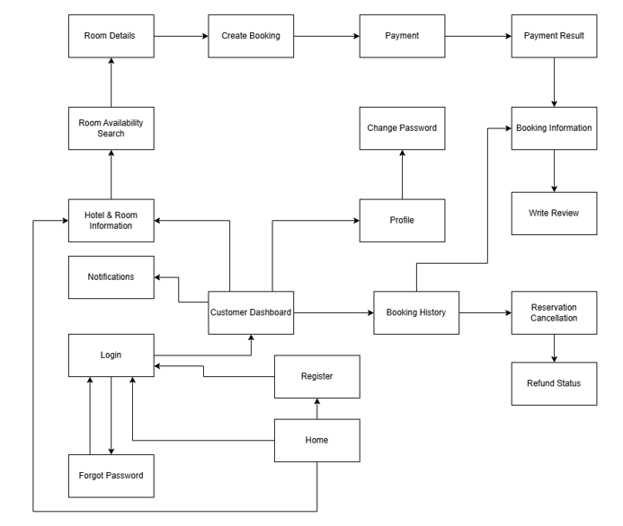

Screens Flow for Receptionist
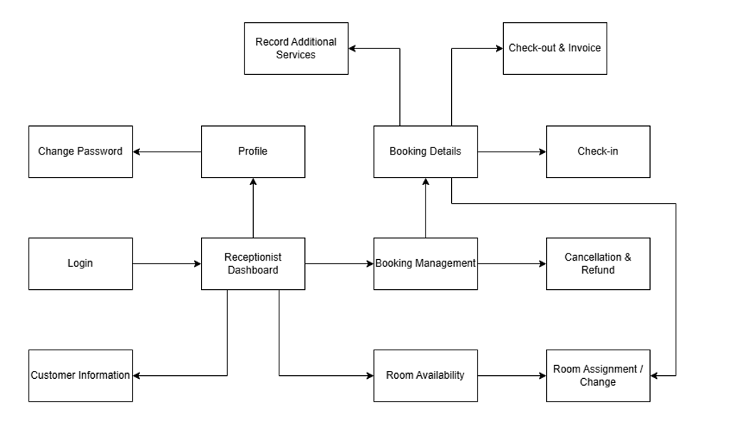
Screens Flow for Housekeeping Staff
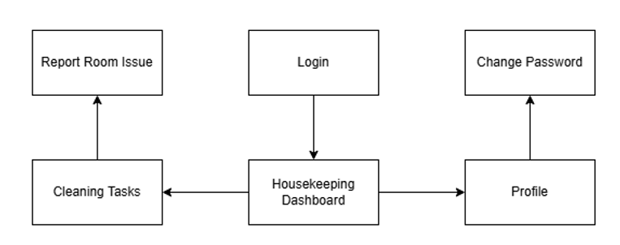
Screens Flow for Hotel Manager
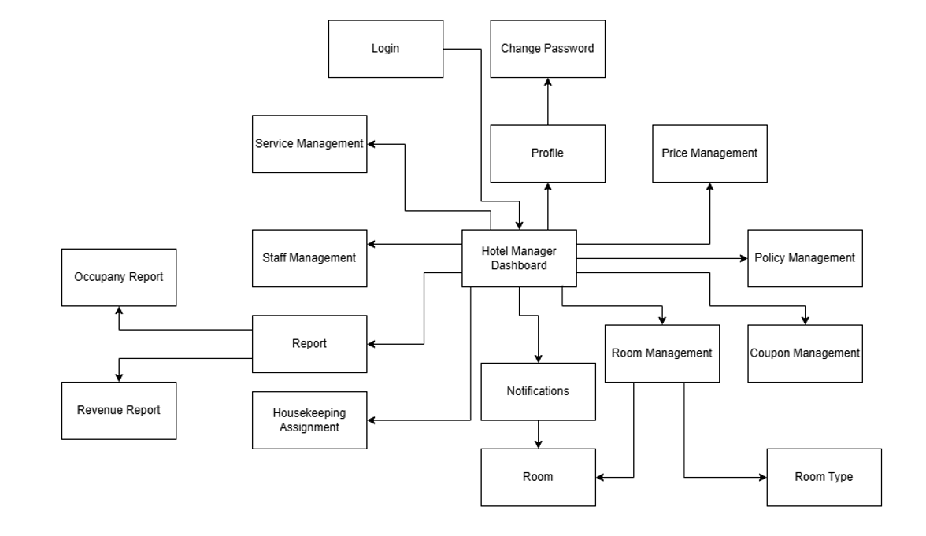
Screens Flow for Admin
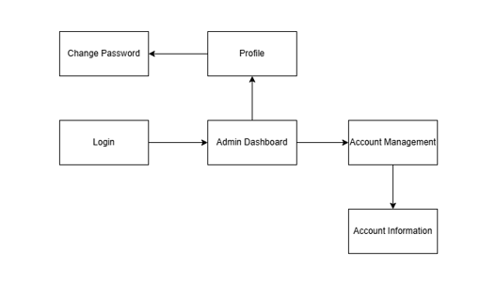

2.4.2. Screen Details

Screens Details for Customer
# | Feature | Screen | Description
1 | Authentication | Home | Provides the main entry point for customers to access the hotel system and navigate to Register or Login.
2 | Authentication | Register | Allows customers to create a new account by providing the required account and personal information.
3 | Authentication | Login | Allows customers to log in to the system using their registered account credentials.
4 | Authentication | Forgot Password | Allows customers to reset their password when they forget their current password.
5 | Dashboard | Customer Dashboard | Provides customers with access to the main functions of the system, including room information, booking, profile, and booking history.
6 | Account Management | Profile | Allows customers to view and update their personal account information.
7 | Account Management | Change Password | Allows customers to change their account password.
8 | Room Information | Hotel & Room Information | Displays general hotel information and available room information for customers.
9 | Room Search | Room Availability Search | Allows customers to search for available rooms based on their booking requirements.
10 | Room Information | Room Details | Displays detailed information about a selected room, including room type, price, capacity, and amenities.
11 | Booking Management | Create Booking | Allows customers to create a booking for a selected room and provide the required booking information.
12 | Payment Management | Payment | Allows customers to make a payment or deposit for their booking through the supported payment method.
13 | Payment Management | Payment Result | Displays the result and status of the customer's payment transaction.
14 | Booking Management | Booking Information | Displays detailed information about a customer's booking, including room, booking dates, booking status, and payment status.
15 | Booking Management | Booking History | Allows customers to view their previous and current booking records.
16 | Cancellation & Refund | Reservation Cancellation | Allows customers to request cancellation of an eligible reservation.
17 | Cancellation & Refund | Refund Status | Displays the refund status and related information for a cancelled reservation.
18 | Notification | Notifications | Allows customers to view booking, payment, and refund notifications.
19 | Review | Write Review | Allows customers to rate and review a room type after completing a stay.

Screens Details for Receptionist
# | Feature | Screen | Description
1 | Authentication | Login | Allows receptionists to log in to the hotel management system using their account credentials.
2 | Dashboard | Receptionist Dashboard | Provides receptionists with access to booking, room, customer, check-in, and check-out functions.
3 | Account Management | Profile | Allows receptionists to view and update their personal account information.
4 | Account Management | Change Password | Allows receptionists to change their account password.
5 | Booking Management | Booking Management | Allows receptionists to search, view, and manage customer bookings.
6 | Booking Management | Booking Details | Displays detailed information about a selected booking, including customer, room, dates, and booking status.
7 | Check-in Management | Check-in | Allows receptionists to process customer check-in and record the required check-in information.
8 | Check-out Management | Check-out & Invoice | Allows receptionists to process customer check-out and review the invoice and payment information.
9 | Cancellation & Refund | Cancellation & Refund | Allows receptionists to process booking cancellations and manage related refund information.
10 | Customer Management | Customer Information | Allows receptionists to view and update customer information.
11 | Room Management | Room Availability | Displays available rooms and their current status for booking and room assignment.
12 | Room Management | Room Assignment / Change | Allows receptionists to assign a room to a booking or change the assigned room.

Screens Details for Housekeeping Staff
# | Feature | Screen | Description
1 | Authentication | Login | Allows housekeeping staff to log in to the hotel management system using their account credentials.
2 | Dashboard | Housekeeping Dashboard | Provides housekeeping staff with access to cleaning tasks and room status functions.
3 | Housekeeping Management | Cleaning Tasks | Displays assigned room cleaning tasks and allows housekeeping staff to manage the cleaning task status.
4 | Account Management | Profile | Allows housekeeping staff to view and update their personal account information.
5 | Account Management | Change Password | Allows housekeeping staff to change their account password.

Screens Details for Hotel Manager
# | Feature | Screen | Description
1 | Authentication | Login | Allows hotel managers to log in to the hotel management system using their account credentials.
2 | Dashboard | Hotel Manager Dashboard | Provides hotel managers with access to room, staff, pricing, coupon, policy, profile, and reporting functions.
3 | Account Management | Profile | Allows hotel managers to view and update their personal account information.
4 | Account Management | Change Password | Allows hotel managers to change their account password.
5 | Staff Management | Staff Management | Allows hotel managers to view and manage hotel staff information.
6 | Report Management | Report | Provides access to hotel management reports, including occupancy and revenue reports.
7 | Report Management | Occupancy Report | Displays room occupancy information and related occupancy statistics.
8 | Report Management | Revenue Report | Displays hotel revenue information and related revenue statistics.
9 | Room Management | Room Management | Allows hotel managers to manage room information and room status.
10 | Room Management | Room | Allows hotel managers to view and manage individual room information.
11 | Room Management | Room Type | Allows hotel managers to manage room types and their related information.
12 | Pricing Management | Price Management | Allows hotel managers to manage room pricing information.
13 | Coupon Management | Coupon Management | Allows hotel managers to manage coupons and related discount information.
14 | Policy Management | Deposit & Cancellation / Refund Policy | Allows hotel managers to configure deposit rules and cancellation / refund rules.
15 | Notification | Notifications | Allows hotel managers to receive notifications, including room issue reports from housekeeping staff, and open the related room.
16 | Housekeeping Management | Housekeeping Assignment | Allows hotel managers to assign housekeeping staff to rooms that need cleaning after check-out.
17 | Service Management | Additional Service Management | Allows hotel managers to manage the catalog of additional services and their unit prices.

Screens Details for Admin
# | Feature | Screen | Description
1 | Authentication | Login | Allows administrators to log in to the hotel management system using their account credentials.
2 | Dashboard | Admin Dashboard | Provides administrators with access to account management functions.
3 | Account Management | Profile | Allows administrators to view and update their personal account information.
4 | Account Management | Change Password | Allows administrators to change their account password.
5 | Account Management | Account Management | Allows administrators to manage user accounts in the hotel management system.
6 | Account Management | Account Information | Displays detailed information about a selected user account.

2.4.3. User Authorization
Screen / Activity | Customer | Receptionist | Hotel Manager | Housekeeping | Admin | Guest
Authentication
Register |  |  |  |  |  | X
Login | X | X | X | X | X | X
Logout | X | X | X | X | X
User Profile
View Own Profile | X | X | X | X | X
Update Own Profile | X | X | X | X | X
Change Password | X | X | X | X | X
Hotel / Room Search
Search Room | X | X |  |  |  | X
Filter Room | X | X |  |  |  | X
View Room Details | X | X | X |  |  | X
Check Availability | X | X | X |  |  | X
Reservation Management
Make Own Reservation | X
View Own Booking History / Details | X
Modify Own Reservation | X
Cancel Own Reservation | X
Create Booking for Walk-in Customer |  | X
View Managed Booking |  | X
Modify Managed Booking |  | X
Cancel Managed Booking |  | X
Reception Operations
Check-in |  | X
Check-out |  | X
Assign Room |  | X
Change Room |  | X
Record Additional Services |  | X
Print Invoice |  | X
Manage Customer Information |  | X
Handle Booking Refund |  | X
Payment / Coupon
Online Payment | X
Make Final Payment (Customer online / Receptionist at check-out) | X | X
View Payment / Booking Payment Status | X | X
Apply Coupon | X | X
Review
View Reviews | X |  | X |  |  | X
Rate Room | X
Write Review | X
Notification
View / Receive Notification | X |  | X
Housekeeping
Assign Housekeeping to Room |  |  | X
View Cleaning Tasks |  |  |  | X
Update Cleaning Status |  |  |  | X
Report Room Issue |  |  |  | X
View Room Issue Reports |  |  | X
Room Management
Query Room / Room Type Data |  |  | X
Add Room / Room Type |  |  | X
Update Room / Room Type |  |  | X
Deactivate / Delete Room / Room Type |  |  | X
Price & Coupon Management
Query Price Data |  |  | X
Add Price |  |  | X
Update Price |  |  | X
Delete Price |  |  | X
Manage Coupons (Add / Update / Deactivate) |  |  | X
Manage Additional Services (Add / Update / Deactivate) |  |  | X
Policy Management
Manage Deposit Policy |  |  | X
Manage Cancellation / Refund Policy |  |  | X
Reports
View Revenue Report |  |  | X
View Occupancy Report |  |  | X
Staff Management
Query Staff Data |  |  | X
Add Staff |  |  | X
Update Staff / Role |  |  | X
Deactivate / Remove Staff |  |  | X
Account Management
Query Account Data |  |  |  |  | X
Add / Activate Account |  |  |  |  | X
Update Account / Status |  |  |  |  | X
Deactivate Account |  |  |  |  | X

Role descriptions:
- Customer: Registered hotel customer who searches rooms, creates and manages own reservations, pays online, applies coupons, receives notifications, and submits room reviews.
- Receptionist: Front-desk staff who creates and manages bookings for customers, performs check-in/check-out, assigns or changes rooms, records additional services, prints invoices, manages customer information, and handles booking refunds.
- Hotel Manager: Hotel management role responsible for rooms, room types, prices, staff and role management, assigning Housekeeping Staff to rooms, the additional service catalog, receiving room issue notifications, and revenue/occupancy reports.
- Housekeeping: Operational staff who clean the rooms assigned by the Hotel Manager and update room cleaning status.
- Admin: System administrator responsible for user account management and account status maintenance. Staff roles and permissions are managed by the Hotel Manager.
- Guest: An unauthenticated user who can browse hotel and room information, check availability, view reviews, register, and log in

2.4.4. Non-Screen Functions
# | Feature | System Function | Description
1 | Authentication & Authorization | Role-Based Access Validation | Validate authenticated requests and enforce role permissions before protected API operations are executed.
2 | Reservation Management | Room Availability Validation | Check date overlap, room status, and room inventory before a reservation is created or modified to prevent double booking.
3 | Reservation Management | Reservation / Room Status Synchronization | Update reservation and room states after booking creation, modification, cancellation, check-in, check-out, and room change events.
4 | Payment | Payment Gateway API Processing | Create payment requests, receive and verify gateway callbacks/webhooks, and update payment and booking payment status.
5 | Refund | Refund Follow-up Service | Mark the deposit payment of a cancelled booking as Failed, keep the depositor's information for the Receptionist's manual refund, and synchronize refund status with the related booking/payment.
6 | Notification | Notification Service | Send event-based notifications for booking confirmation, modification, cancellation, payment result, refund status, and other configured customer events.
7 | Coupon | Coupon Validation & Discount Calculation | Validate coupon status, validity period, eligibility, and usage rules, then calculate the applicable discount during checkout.
8 | Reports | Net Revenue Calculation | Aggregate successful payments and subtract valid refunds/adjustments to calculate net revenue for a selected reporting period.
9 | Reports | Occupancy Rate Calculation | Calculate occupancy from occupied room-nights versus available room-nights for the selected reporting period.
10 | Reservation Management | Reservation Hold Expiration | Automatically set a reservation to Expired when its 15-minute room hold ends without a confirmed deposit, release the room and notify the Customer (BR-29).

III. Functional Requirements

3. Use Case Specifications

3.1 Guest Management

3.1.1. Register
ID and Name | UC01 - Register
Created by
Primary Actor | Guest | Secondary Actor | None
Description | Create a new Customer account.
Preconditions | Guest is on the system and is not logged in.
Main Sequence | 1. Guest selects "Register".  2. System displays the registration form (Full Name, Email, Phone Number, Password, Confirm Password).  3. Guest enters the required information and submits the form.  4. System validates the data format and checks that the email is not already registered.  5. System creates the Customer account and displays a success message (MSG-13).
Alternative Sequences | 3a. Invalid or missing data:  System highlights the invalid fields with messages (MSG-04, MSG-05, MSG-15).  Guest corrects the data and resubmits.  4a. Email already registered:  System displays MSG-14.  Guest enters another email or goes to Login.
Post conditions | A new Customer account is created and the Guest can log in.
Business Rule | Email must be unique. Password policy follows CR-12.

3.1.2. Login
ID and Name | UC02 - Login
Created by
Primary Actor | All users (every role logs in through this use case) | Secondary Actor | None
Description | Authenticate a user and provide system access according to the user's role.
Preconditions | The user has an active account.
Main Sequence | 1. User opens the Login screen.  2. User enters Email and Password and submits.  3. System validates the credentials and the account status.  4. System creates a session and redirects the user to the dashboard of his/her role (Customer, Receptionist, Hotel Manager, Housekeeping Staff or Admin).
Alternative Sequences | 1a. Forgot password:  User selects "Forgot Password" and follows the password reset steps.  3a. Wrong credentials:  System displays MSG-11 and keeps the user on the Login screen.  3b. Account inactive:  System displays MSG-12 and denies access.
Post conditions | The user is logged in and sees only the functions permitted for the role.
Business Rule | Role-based access follows 2.4.3 User Authorization (BR-26). Sessions expire as defined in 4.2.4.

3.1.3. Search Room
ID and Name | UC04 - Search Room
Created by
Primary Actor | Guest | Secondary Actor | None
Description | Search and filter rooms by stay dates and requirements.
Preconditions | The user opens the Hotel & Room Information or Room Availability Search screen.
Main Sequence | 1. User enters the check-in date, check-out date and number of guests, and optionally selects filters (room type, price range, amenities).  2. System validates the dates.  3. System finds the room types that match the criteria and are available.  4. System displays the result list with room type, price for the selected dates, capacity and availability.
Alternative Sequences | 2a. Invalid dates:  System displays MSG-32 (check-out date not later than check-in date) or MSG-56 (check-in date in the past) and asks the user to correct the dates.  3a. No matching room:  System displays MSG-10 and suggests changing the dates or filters.
Post conditions | A list of matching rooms is displayed.
Business Rule | Displayed price uses the dynamic rate for the stay dates, otherwise the Base Price of the room type (BR-07). Stay dates follow BR-12.

3.1.4. View Room Details
ID and Name | UC05 - View Room Details
Created by
Primary Actor | Guest | Secondary Actor | None
Description | View the room type, price, amenities and other details of a room, including ratings and reviews.
Preconditions | The user has opened the room list or search result.
Main Sequence | 1. User selects a room / room type.  2. System retrieves the room type information, price, capacity, amenities and reviews.  3. System displays the Room Details screen.
Alternative Sequences | 2a. Room type inactive or not found:  System informs the user that the room is no longer available and returns to the list.
Post conditions | Room details are displayed.
Business Rule | Only Active room types are shown to Guests and Customers (BR-02).

3.1.5. Check Room Availability
ID and Name | UC06 - Check Room Availability
Created by
Primary Actor | Guest | Secondary Actor | None
Description | Check whether the selected rooms are available for the requested dates.
Preconditions | A room type and a stay period have been selected.
Main Sequence | 1. User selects the stay period for a room type.  2. System checks date overlap with existing bookings, room status and room inventory.  3. System displays the available quantity / availability result.
Alternative Sequences | 2a. Not available:  System displays MSG-30 and suggests other dates or room types.
Post conditions | The availability result is displayed.
Business Rule | Rooms in Maintenance status are never counted as available (BR-05, BR-10).

3.2 Customer Management

3.2.1. Manage Profile
ID and Name | UC03 - Manage Profile
Created by
Primary Actor | Customer | Secondary Actor | None
Description | View and update personal profile information and change the password.
Preconditions | Customer is logged in.
Main Sequence | 1. Customer opens the Profile screen.  2. System displays the current profile.  3. Customer edits the information and saves (or opens Change Password).  4. System validates the data and updates the profile.
Alternative Sequences | 3a. Change password with wrong current password:  System displays MSG-16.  4a. Invalid data:  System displays validation messages (MSG-04, MSG-05, MSG-52).
Post conditions | Profile information (or password) is updated (MSG-02, MSG-17).
Business Rule | Customers can view and update only their own profile (BR-26).

3.2.2. Make Reservation
ID and Name | UC07 - Make Reservation
Created by
Primary Actor | Customer | Secondary Actor | None
Description | Create a new room reservation.
Preconditions | Customer is logged in and has selected an available room and stay period.
Main Sequence | 1. Customer selects "Create Booking" for the chosen room and dates.  2. System displays the booking form with price summary.  3. Customer enters the booking information and optionally a coupon code.  4. System checks room availability again and validates the coupon (if any).  5. System calculates the total and the deposit amount and creates the booking with a pending-payment status.  6. System displays the booking, holds the selected room for 15 minutes (BR-29) and proceeds to the deposit payment (UC12).
Alternative Sequences | 4a. Room no longer available:  System displays MSG-30 and returns to the search.  4b. Coupon invalid:  System displays the coupon error (MSG-26 to MSG-29); the booking continues without discount.
Post conditions | A booking is created; it is confirmed after the deposit is paid. If the deposit is not confirmed within the hold time, the reservation expires and the room is released (BR-29).
Business Rule | BR-10, BR-12, BR-13, BR-29. Availability is checked again at confirmation (CR-16).

3.2.3. Modify Reservation
ID and Name | UC08 - Modify Reservation
Created by
Primary Actor | Customer | Secondary Actor | None
Description | Change information of an existing reservation.
Preconditions | Customer is logged in and owns an existing reservation that can still be modified.
Main Sequence | 1. Customer opens Booking Information and selects "Modify".  2. Customer changes the allowed information (e.g., stay dates).  3. System checks room availability and recalculates the amount.  4. System saves the change and sends a notification.
Alternative Sequences | 3a. Not available:  System displays MSG-30; the original booking is unchanged.
Post conditions | The reservation is updated and the customer is notified.
Business Rule | A Customer can modify only his/her own reservations (BR-11).

3.2.4. Cancel Reservation
ID and Name | UC09 - Cancel Reservation
Created by
Primary Actor | Customer | Secondary Actor | None
Description | Cancel an eligible reservation.
Preconditions | Customer is logged in and owns a reservation.
Main Sequence | 1. Customer opens Booking Information and selects "Cancel".  2. System checks whether the reservation is eligible under the Cancellation / Refund Policy.  3. System asks for confirmation (MSG-09).  4. Customer confirms.  5. System cancels the reservation, releases the room and, when a deposit payment exists, sets the deposit status to Failed and keeps the depositor's information for the Receptionist's refund follow-up (UC23).
Alternative Sequences | 2a. Not eligible:  System displays MSG-34 and the reservation remains unchanged.
Post conditions | The reservation is cancelled (MSG-33) and the refund status is available when applicable.
Business Rule | BR-11, BR-16, BR-17.

3.2.5. View Booking History
ID and Name | UC10 - View Booking History
Created by
Primary Actor | Customer | Secondary Actor | None
Description | View previous and current bookings.
Preconditions | Customer is logged in.
Main Sequence | 1. Customer opens Booking History.  2. System retrieves the customer's bookings.  3. System displays the list with dates, room, booking status and payment status.
Alternative Sequences | 2a. No booking:  System displays MSG-10.
Post conditions | The booking list is displayed.
Business Rule | A Customer sees only his/her own bookings (BR-26).

3.2.6. View Booking Details
ID and Name | UC11 - View Booking Details
Created by
Primary Actor | Customer | Secondary Actor | None
Description | View detailed information of a selected booking.
Preconditions | Customer is logged in and has at least one booking.
Main Sequence | 1. Customer selects a booking in Booking History.  2. System displays room, stay dates, amounts, booking status, payment status and refund status.
Alternative Sequences | 1a. Booking not found:  System displays an error and returns to Booking History.
Post conditions | Booking details are displayed.
Business Rule | A Customer can view only his/her own bookings.

3.2.7. Make Deposit Payment
ID and Name | UC12 - Make Deposit Payment
Created by
Primary Actor | Customer | Secondary Actor | Payment Gateway
Description | Pay the required deposit to confirm a reservation.
Preconditions | Customer is logged in and has a booking waiting for deposit payment.
Main Sequence | 1. Customer selects "Payment" on the booking and chooses a supported payment method.  2. System validates the booking and the deposit amount.  3. System creates a payment request and sends it to the Payment Gateway.  4. Payment Gateway processes the transaction and returns the result through callback / webhook.  5. System verifies the callback, updates the payment status and the booking payment status.  6. System displays the Payment Result screen and sends a notification.
Alternative Sequences | 2a. Missing or invalid payment information:  System displays MSG-35 or MSG-36 and rejects the request.  4a. Payment failed or not confirmed:  System does not mark the booking as paid and displays MSG-38 or MSG-39.  Customer may retry the payment.  4b. Gateway unavailable or timeout:  System displays MSG-40 and keeps the booking unpaid (see UC38).  4c. Room hold expires before the gateway confirms the deposit:  System sets the reservation to Expired, releases the room and notifies the Customer (BR-29, BR-28). A deposit confirmed after expiry is handled as a refund case (UC23).
Post conditions | The deposit is recorded and the booking is confirmed (MSG-37).
Business Rule | BR-13, BR-14, BR-29. The booking must belong to the customer; payment is confirmed only after verified callback.

3.2.8. Make Final Payment
ID and Name | UC13 - Make Final Payment
Created by
Primary Actor | Customer, Receptionist | Secondary Actor | Payment Gateway
Description | Pay the remaining amount of a booking (also processed by the Receptionist at check-out).
Preconditions | The booking exists and has an outstanding amount.
Main Sequence | 1. Customer (or Receptionist) opens Booking Information and reviews the outstanding amount.  2. System retrieves the booking and the recorded payments and determines the remaining amount.  3. User selects the payment method and confirms.  4. System creates a payment request when paying online and sends it to the Payment Gateway.  5. Payment Gateway returns the result; System verifies it and updates the payment and booking payment status.  6. System displays the payment result.
Alternative Sequences | 5a. Payment failed or not confirmed:  System does not mark the remaining amount as paid (MSG-38, MSG-39).
Post conditions | The remaining amount is recorded as paid.
Business Rule | BR-14. Remaining amount = room charge + additional services - coupon discount - payments already recorded as successful (e.g., the deposit)

3.2.9. Submit Review
ID and Name | UC14 - Submit Review
Created by
Primary Actor | Customer | Secondary Actor | None
Description | Submit a rating and review after completing a stay.
Preconditions | Customer is logged in and has completed a stay.
Main Sequence | 1. Customer opens the completed booking and selects "Write Review".  2. Customer gives a rating and comment and submits.  3. System validates the input and saves the review.  4. System displays the review on the room type.
Alternative Sequences | 2a. Stay not completed:  System displays MSG-55 and does not accept the review.
Post conditions | The review is saved (MSG-54).
Business Rule | BR-23.

3.2.10. View Notifications
ID and Name | UC15 - View Notifications
Created by
Primary Actor | Customer | Secondary Actor | None
Description | View booking, payment and system notifications.
Preconditions | Customer is logged in.
Main Sequence | 1. Customer opens the notification list.  2. System displays notifications for booking confirmation, modification, cancellation, payment result and refund status.  3. Customer opens a notification to read it.
Alternative Sequences | 2a. No notification:  System displays MSG-10.
Post conditions | Notifications are displayed and marked as read.
Business Rule | BR-28.

3.3 Receptionist Management

3.3.1. Create Booking
ID and Name | UC16 - Create Booking
Created by
Primary Actor | Receptionist | Secondary Actor | None
Description | Create a booking at the front desk for a walk-in customer who has no online reservation. No deposit is required.
Preconditions | Receptionist is logged in and the customer has no online reservation.
Main Sequence | 1. Receptionist searches for available rooms for the requested dates.  2. Receptionist selects a room type and enters or selects the customer information.  3. System checks availability and calculates the amount.  4. Receptionist confirms; System creates the booking without a deposit.
Alternative Sequences | 3a. Room not available:  System displays MSG-30.
Post conditions | A booking is created for the walk-in customer (MSG-31).
Business Rule | BR-10, BR-11, BR-12, BR-13. A customer who reserved online already has a booking and has paid the deposit online (UC07, UC12); the Receptionist verifies that booking against the customer's information at check-in (UC19) instead of creating a new one. A walk-in booking needs no deposit.

3.3.2. Modify Booking
ID and Name | UC17 - Modify Booking
Created by
Primary Actor | Receptionist | Secondary Actor | None
Description | Update an existing booking.
Preconditions | Receptionist is logged in and the booking exists.
Main Sequence | 1. Receptionist searches for and opens the booking.  2. Receptionist edits the allowed information.  3. System checks availability and recalculates the amount.  4. System saves the change and notifies the customer.
Alternative Sequences | 3a. Not available:  System displays MSG-30; booking is unchanged.
Post conditions | The booking is updated.
Business Rule | BR-10, BR-11.

3.3.3. Cancel Booking
ID and Name | UC18 - Cancel Booking
Created by
Primary Actor | Receptionist | Secondary Actor | None
Description | Cancel a booking according to the cancellation policy.
Preconditions | Receptionist is logged in and the booking exists.
Main Sequence | 1. Receptionist opens the booking and selects "Cancel".  2. System checks eligibility and asks for confirmation (MSG-09).  3. Receptionist confirms.  4. System cancels the booking, releases the room and, when a deposit payment exists, sets the deposit status to Failed and flags the booking for refund follow-up (UC23).
Alternative Sequences | 2a. Not eligible:  System displays MSG-34.
Post conditions | The booking is cancelled (MSG-33).
Business Rule | BR-16, BR-17.

3.3.4. Check-in Customer
ID and Name | UC19 - Check-in Customer
Created by
Primary Actor | Receptionist | Secondary Actor | None
Description | Verify the booking and complete customer check-in.
Preconditions | The booking is valid and a room is available for assignment.
Main Sequence | 1. Receptionist finds the booking (the customer's online reservation with its paid deposit, or a booking created at the front desk) and verifies the customer information against it.  2. Receptionist assigns a room (or confirms the assigned room).  3. System checks that the room is Available and records the check-in.  4. System updates the room status to Occupied and the booking status.
Alternative Sequences | 1a. Booking not found:  System displays MSG-10.  3a. Room not available (e.g., still Cleaning or Maintenance):  System displays MSG-30; Receptionist selects another room.
Post conditions | Check-in is completed (MSG-44).
Business Rule | BR-05, BR-18.

3.3.5. Change Room
ID and Name | UC20 - Change Room
Created by
Primary Actor | Receptionist | Secondary Actor | None
Description | Change the assigned room during the customer's stay.
Preconditions | The customer is checked in.
Main Sequence | 1. Receptionist opens the checked-in booking and selects "Change Room".  2. System shows rooms that are available for the remaining stay.  3. Receptionist selects the new room and confirms.  4. System updates the assignment and the status of both rooms (old room to Cleaning, new room to Occupied).
Alternative Sequences | 2a. No room available:  System displays MSG-30.
Post conditions | The new room is assigned (MSG-45).
Business Rule | BR-05, BR-10.

3.3.6. Record Additional Services
ID and Name | UC21 - Record Additional Services
Created by
Primary Actor | Receptionist | Secondary Actor | None
Description | Record additional services used by a customer.
Preconditions | The customer is checked in.
Main Sequence | 1. Receptionist opens the booking and selects "Add Service".  2. Receptionist selects the service and quantity.  3. System calculates the cost (quantity x unit price) and adds it to the booking.
Alternative Sequences | 2a. Invalid quantity:  System displays MSG-05.
Post conditions | The service charge is recorded and will appear on the invoice (MSG-01).
Business Rule | BR-19.

3.3.7. Check-out Customer
ID and Name | UC22 - Check-out Customer
Created by
Primary Actor | Receptionist | Secondary Actor | None
Description | Complete customer check-out, calculate final charges and generate the invoice.
Preconditions | The customer is checked in.
Main Sequence | 1. Receptionist opens the booking and selects "Check-out".  2. System retrieves the booking and payment information.  3. System calculates and displays the billing information (room charge, additional services, discount, payments, balance).  4. Receptionist reviews it and, if a balance remains, processes the final payment (UC13).  5. Receptionist confirms check-out; System records it and updates the room status to Cleaning.  6. System generates and stores the invoice and makes it available for review and printing.
Alternative Sequences | 2a. Required booking or payment information missing:  System displays MSG-46 and prevents check-out.  6a. Invoice generation fails:  System displays MSG-48 and does not mark the invoice as generated.
Post conditions | Check-out is completed (MSG-47) and the invoice is generated.
Business Rule | BR-20, BR-21. The room status becomes Cleaning; the Hotel Manager then assigns Housekeeping Staff to the room (UC34).

3.3.8. Process Refund
ID and Name | UC23 - Process Refund
Created by
Primary Actor | Receptionist | Secondary Actor | None
Description | Contact the depositor of a cancelled booking, refund the deposit manually and record the refund result.
Preconditions | Receptionist is logged in. A reservation has been cancelled and its deposit payment status is Failed.
Main Sequence | 1. Receptionist opens Cancellation & Refund and selects a cancelled booking whose deposit status is Failed.  2. System displays the depositor's information (name, phone number, email, payment reference, deposit amount), checks that the booking is eligible for a refund and calculates the refund amount.  3. Receptionist contacts the customer and makes the refund outside the system (not through the Payment Gateway).  4. Receptionist records the refund result; System updates the refund status and synchronizes it with the booking and payment.  5. Customer can view the refund status on the Refund Status screen.
Alternative Sequences | 1a. Payment cannot be identified:  System does not process the refund, records the issue and displays MSG-43.  2a. Not eligible for refund:  System records the cancellation without a refund and displays MSG-42.
Post conditions | The refund is recorded and its status is shown (MSG-41).
Business Rule | BR-17, BR-32.

3.3.9. Manage Customer Information
ID and Name | UC24 - Manage Customer Information
Created by
Primary Actor | Receptionist | Secondary Actor | None
Description | View and update customer information needed for hotel operations.
Preconditions | Receptionist is logged in.
Main Sequence | 1. Receptionist searches for a customer.  2. System displays the customer information.  3. Receptionist edits the information and saves.  4. System validates and updates the data.
Alternative Sequences | 4a. Invalid data:  System displays MSG-04 or MSG-05.
Post conditions | Customer information is updated (MSG-02).
Business Rule | Receptionists cannot change account roles or status (BR-26).

3.4 Housekeeping Management

3.4.1. Manage Cleaning Tasks
ID and Name | UC34 - Manage Cleaning Tasks
Created by
Primary Actor | Housekeeping Staff | Secondary Actor | Hotel Manager
Description | Housekeeping Staff clean a room after the guest has used it and update the cleaning status. The Hotel Manager assigns the Housekeeping Staff member to the room.
Preconditions | Housekeeping Staff is logged in and has been assigned to a room that needs cleaning (the room is in Cleaning status after check-out).
Main Sequence | 1. The Hotel Manager assigns a Housekeeping Staff member to the room. The assigned staff opens Cleaning Tasks.  2. System lists the rooms assigned to the staff member, urgent rooms (e.g., for new arrivals) first.  3. Staff selects a task and changes its status.  4. System saves the status; when the task is Completed, it changes the room status from Cleaning to Available.
Alternative Sequences | 3a. Invalid status change:  System displays MSG-49 and keeps the current status.
Post conditions | The task status is updated; a completed task makes the room available (MSG-50).
Business Rule | BR-22. Status flow: Pending -> In Progress -> Completed.

3.4.2. Report Room Issue
ID and Name | UC35 - Report Room Issue
Created by
Primary Actor | Housekeeping Staff | Secondary Actor | Hotel Manager
Description | Report maintenance or room issues discovered during cleaning.
Preconditions | Housekeeping Staff is logged in and has an assigned task.
Main Sequence | 1. Staff selects a room in Cleaning Tasks and chooses "Report Issue".  2. Staff enters the issue description and submits.  3. System saves the report and sends a notification to the Hotel Manager, who sees it on the Notifications screen and opens the reported room; the room may be set to Maintenance.
Alternative Sequences | 2a. Description empty:  System displays MSG-04.
Post conditions | The issue is recorded and the Hotel Manager is notified (MSG-01).
Business Rule | A room in Maintenance cannot be assigned to new bookings (BR-05). Notification: BR-28.

3.5 Hotel Manager Management

3.5.1. Manage Rooms
ID and Name | UC25 - Manage Rooms
Created by
Primary Actor | Hotel Manager | Secondary Actor | None
Description | Create, update, deactivate and manage the physical rooms of the hotel.
Preconditions | Hotel Manager is logged in and at least one Active room type exists.
Main Sequence | 1. Hotel Manager opens Room Management.  2. Hotel Manager selects "Add Room" or "Edit".  3. Hotel Manager enters Room Number and selects the Room Type and status.  4. System validates the data and saves the room.
Alternative Sequences | 3a. Duplicate room number:  System displays MSG-20.  3b. Room set to Maintenance:  System excludes the room from new bookings.
Post conditions | The room is saved; a new room has the status Available by default (MSG-01).
Business Rule | BR-03, BR-04, BR-05.

3.5.2. Manage Room Types
ID and Name | UC26 - Manage Room Types
Created by
Primary Actor | Hotel Manager | Secondary Actor | None
Description | Define room categories with amenities, capacity and base price.
Preconditions | Hotel Manager is logged in.
Main Sequence | 1. Hotel Manager opens Room Type Management and selects "Add New" or "Edit".  2. Hotel Manager enters Room Type Name, capacity, amenities and base price.  3. System validates the data and saves the room type.
Alternative Sequences | 1a. Delete a room type that has rooms:  System blocks the deletion and displays MSG-19; the type can only be set to Inactive.  3a. Invalid data:  System displays MSG-18, MSG-21 or MSG-22.
Post conditions | The room type list is updated (MSG-01).
Business Rule | BR-01, BR-02.

3.5.3. Manage Room Prices
ID and Name | UC27 - Manage Room Prices
Created by
Primary Actor | Hotel Manager | Secondary Actor | None
Description | Configure room prices (seasonal, weekend, holiday) for different periods.
Preconditions | Hotel Manager is logged in and room types exist.
Main Sequence | 1. Hotel Manager opens Pricing Management and selects "Create Price Rate" or "Edit".  2. Hotel Manager selects the room type and enters start date, end date and applied price.  3. System validates the data and saves the rate.
Alternative Sequences | 3a. Invalid data:  System displays MSG-23 or MSG-24.
Post conditions | The rate is saved and used for searches in its period (MSG-01).
Business Rule | BR-06, BR-07. Without a matching rate the Base Price is used.

3.5.4. Manage Coupons
ID and Name | UC28 - Manage Coupons
Created by
Primary Actor | Hotel Manager | Secondary Actor | None
Description | Issue and manage voucher codes that customers enter at checkout.
Preconditions | Hotel Manager is logged in.
Main Sequence | 1. Hotel Manager opens Coupon Management and selects "Add" or "Edit".  2. Hotel Manager enters Coupon Code, Discount Value, Usage Limit, validity period and minimum spend.  3. System validates the data and saves the coupon.
Alternative Sequences | 3a. Invalid data or duplicate code:  System displays MSG-25, MSG-04 or MSG-05.
Post conditions | The coupon is saved (MSG-01) and can be applied by customers.
Business Rule | BR-08, BR-09. Validation at checkout checks validity, expiry, usage count and minimum spend.

3.5.5. Manage Deposit Policy
ID and Name | UC29 - Manage Deposit Policy
Created by
Primary Actor | Hotel Manager | Secondary Actor | None
Description | Configure the deposit rules used for reservations.
Preconditions | Hotel Manager is logged in.
Main Sequence | 1. Hotel Manager opens the Deposit Policy configuration.  2. Hotel Manager enters the deposit rule and saves.  3. System validates and stores the policy.
Alternative Sequences | 2a. Invalid value:  System displays MSG-05.
Post conditions | The policy applies to new reservations (MSG-02).
Business Rule | BR-13, BR-31.

3.5.6. Manage Cancellation / Refund Policy
ID and Name | UC30 - Manage Cancellation / Refund Policy
Created by
Primary Actor | Hotel Manager | Secondary Actor | None
Description | Configure cancellation and refund rules.
Preconditions | Hotel Manager is logged in.
Main Sequence | 1. Hotel Manager opens the Cancellation / Refund Policy configuration.  2. Hotel Manager enters the rules and saves.  3. System validates and stores the policy.
Alternative Sequences | 2a. Invalid value:  System displays MSG-05.
Post conditions | The policy is used to decide cancellation and refund eligibility (MSG-02).
Business Rule | BR-16, BR-17, BR-32.

3.5.7. View Revenue Report
ID and Name | UC31 - View Revenue Report
Created by
Primary Actor | Hotel Manager | Secondary Actor | None
Description | View hotel revenue information and statistics.
Preconditions | Hotel Manager is logged in.
Main Sequence | 1. Hotel Manager opens the Revenue Report and selects a period.  2. System aggregates successful payments and subtracts valid refunds / adjustments.  3. System displays the net revenue.
Alternative Sequences | 2a. No data:  System displays MSG-10.
Post conditions | The revenue report is displayed.
Business Rule | BR-27.

3.5.8. View Occupancy Report
ID and Name | UC32 - View Occupancy Report
Created by
Primary Actor | Hotel Manager | Secondary Actor | None
Description | View room occupancy statistics for selected periods.
Preconditions | Hotel Manager is logged in.
Main Sequence | 1. Hotel Manager opens the Occupancy Report and selects a period.  2. System calculates occupied versus available room-nights.  3. System displays the occupancy rate.
Alternative Sequences | 2a. No data:  System displays MSG-10.
Post conditions | The occupancy report is displayed.
Business Rule | BR-27.

3.5.9. Manage Staff
ID and Name | UC33 - Manage Staff
Created by
Primary Actor | Hotel Manager | Secondary Actor | None
Description | Manage hotel staff information, status and operational roles.
Preconditions | Hotel Manager is logged in.
Main Sequence | 1. Hotel Manager opens Staff Management and selects "+ Add Staff" or "Edit".  2. Hotel Manager enters Full Name, Email, Phone Number and selects the Role.  3. System validates the data and saves the staff record.
Alternative Sequences | 3a. Invalid data:  System displays MSG-04, MSG-05, MSG-51 or MSG-52.
Post conditions | The staff record is saved; a role change takes effect on the next session (MSG-53).
Business Rule | BR-24, BR-25.

3.5.10. Manage Additional Services
ID and Name | UC39 - Manage Additional Services
Created by
Primary Actor | Hotel Manager | Secondary Actor | None
Description | Maintain the catalog of additional services (service name and unit price) that the Receptionist records on a booking.
Preconditions | Hotel Manager is logged in.
Main Sequence | 1. Hotel Manager opens Service Management and views the list of additional services.  2. Hotel Manager selects "+ Add Service" or "Edit" for an existing service, or deactivates a service.  3. Hotel Manager enters the Service Name and Unit Price.  4. System validates the data and saves the change.
Alternative Sequences | 3a. Service Name is empty or Unit Price is invalid:  System displays MSG-04 or MSG-05.
Post conditions | The service catalog is updated and is available to the Receptionist when recording additional services (MSG-01 / MSG-02 / MSG-03).
Business Rule | BR-30, BR-19.

3.5.11. Manage Roles & Permissions
ID and Name | UC37 - Manage Roles & Permissions
Created by
Primary Actor | Hotel Manager | Secondary Actor | None
Description | Manage staff roles and access permissions.
Preconditions | Hotel Manager is logged in.
Main Sequence | 1. Hotel Manager opens Staff Management and selects a staff account.  2. Hotel Manager changes the staff member's role.  3. System saves the change; the new permissions apply from the user's next session.
Alternative Sequences | 2a. Role not allowed:  System displays MSG-06.
Post conditions | The role is updated (MSG-53).
Business Rule | BR-25, BR-26.

3.6 Admin Management

3.6.1. Manage User Accounts
ID and Name | UC36 - Manage User Accounts
Created by
Primary Actor | Admin | Secondary Actor | None
Description | Manage user accounts and account status. Roles are managed by the Hotel Manager (UC37).
Preconditions | Admin is logged in.
Main Sequence | 1. Admin opens Account Management and views the account list.  2. Admin selects an account to view its information, or selects "Add".  3. Admin creates, activates, updates or deactivates the account.  4. System validates and saves the change.
Alternative Sequences | 3a. Invalid data or duplicate email:  System displays MSG-14, MSG-04 or MSG-05.
Post conditions | The account is saved (MSG-01 / MSG-02 / MSG-03).
Business Rule | BR-25.

3.7 Payment Gateway (External System)

3.7.1. Process Gateway Payment
ID and Name | UC38 - Process Gateway Payment
Created by
Primary Actor | Payment Gateway | Secondary Actor | None
Description | The external Payment Gateway processes payment and deposit transactions requested by the system.
Preconditions | The system has created a payment request for an existing booking (UC12 / UC13).
Main Sequence | 1. System sends the payment request (booking reference, amount, transaction reference) to the Payment Gateway.  2. Payment Gateway processes the transaction.  3. Payment Gateway returns the result through callback / webhook.  4. System checks that the callback matches an existing transaction and booking, and verifies its content.  5. System updates the payment status and the booking payment status.
Alternative Sequences | 3a. Error, timeout, or no valid callback received:  System does not mark the booking as paid and displays MSG-39 / MSG-40.  4a. Callback does not match a transaction or is invalid:  System rejects it and does not change any status.
Post conditions | The payment status is consistent with the verified transaction result. The sandbox environment is used for testing.
Business Rule | BR-14, BR-15.

IV. Non-Functional Requirements

4.1 External interfaces

4.1.1 User Interfaces
The system is a web application used through a browser. The interface is role-based: Guests and Customers use the public site, and each staff role has its own dashboard. Screens, screen flows and role permissions are described in 2.4 System Functions.
Interface area | Users | Main screens
Public site | Guest, Customer | Home, Register, Login, Forgot Password, Hotel & Room Information, Room Availability Search, Room Details, Create Booking, Payment, Payment Result, Booking Information, Booking History, Reservation Cancellation, Refund Status, Notifications, Write Review, Profile, Change Password.
Receptionist Dashboard | Receptionist | Booking Management, Booking Details, Check-in, Check-out & Invoice, Cancellation & Refund, Customer Information, Room Availability, Room Assignment / Change, Profile, Change Password.
Housekeeping Dashboard | Housekeeping Staff | Cleaning Tasks, Profile, Change Password.
Hotel Manager Dashboard | Hotel Manager | Room Type Management, Room Management, Pricing Management, Coupon Management, Staff Management, Revenue Report, Occupancy Report, Policy Management, Housekeeping Assignment, Service Management, Notifications, Profile, Change Password.
Admin Dashboard | Admin | Account Management, Account Information, Profile, Change Password.

4.1.2 Hardware Interfaces
The system does not require any dedicated hardware. Users access it from a PC, laptop, tablet or smartphone with a supported web browser and an Internet connection. Invoices are printed through the browser print function to any printer available at the front desk.

4.1.3 Software Interfaces
# | External component | Purpose | Data exchanged | Notes
1 | Payment Gateway (sandbox for testing, production for release) | Process online payments and deposits. | Out: payment request (booking reference, amount, transaction reference, return URL). In: payment result, callback / webhook notification. | A payment is recorded as successful only after the callback / webhook has been verified (see UC12, UC13 and UC38). The gateway provider is not named in this SRS.
2 | MongoDB database | Persistent storage of users, rooms, bookings, payments, refunds, invoices, coupons, cleaning tasks, reviews and notifications. | CRUD operations from the ExpressJS back end. | Accessed only by the back end; never directly from the browser.
3 | Internal RESTful API (React front end <-> ExpressJS back end) | Exchange data between the web client and the server. | JSON request / response. | Protected endpoints validate the authenticated user and role before execution (Non-Screen Function: Role-Based Access Validation).

4.1.4 Communication Interfaces
Protocol / interface | Description
HTTPS (TLS) | All client-server and server-gateway communication is encrypted, as required in 4.2.4 Security.
REST over HTTP, JSON | The React client calls the ExpressJS API using JSON payloads and standard HTTP methods and status codes. Protected endpoints require an authentication token.
Payment gateway callback / webhook | The server exposes a publicly reachable endpoint that receives asynchronous payment results. The content must be verified and matched to an existing transaction before any status is updated.

4.2 Quality Attributes

4.2.1 Usability
● Learnability: The user interface must be intuitive enough that a first-time Customer can search for an available room, view its details, and complete a reservation within 3 minutes without external guidance.
● Accessibility: The layout must adhere to WCAG 2.1 AA standards, maintaining high typography contrast ratios and using explicit textual badges, distinct icons, and layout structures alongside color cues to indicate room availability and booking, payment, room, and cleaning task statuses for visually impaired users.
● Operational Ease: The Receptionist, Housekeeping, Hotel Manager, and Admin dashboards must provide search and filter functions, drop-down selectors, and automated calculations (e.g., invoice totals and discounts) to minimize manual data entry when assigning rooms, recording additional services, configuring room prices, and updating cleaning status.

4.2.2 Reliability
● System Availability: The system must maintain a minimum uptime of 99.9% (24/7 operations), ensuring uninterrupted online booking and payment workflows and continuous front-desk operations (check-in and check-out). Scheduled maintenance windows must be restricted to off-peak hours (02:00 AM – 04:00 AM).
● Fault Tolerance: In the event of payment gateway timeouts or network interruptions during checkout, the system must execute atomic rollbacks, safely preserving the booking information, not marking the booking as paid, and releasing any temporarily held room (see BR-29) without data corruption.
● Data Integrity & Recovery: The underlying database must perform automated hourly incremental backups (or continuous point-in-time recovery) and daily full backups. The Disaster Recovery policy requires a Recovery Time Objective (RTO) under 2 hours and a Recovery Point Objective (RPO) under 1 hour.

4.2.3 Performance
● Response Time: Room searches, availability checks, room detail pages, and filtering queries must render within 1.5 seconds under normal traffic loads.
● Concurrency Handling: The core booking and inventory engine must handle at least 100 concurrent booking transactions simultaneously during peak holiday periods without race conditions (double booking).
● Payment Callback Processing: The payment callback / webhook endpoint must verify the received transaction and update the payment and booking payment status within 5 seconds after the callback is received.

4.2.4 Security
● Data Encryption: All client-server communications must be strictly enforced over Transport Layer Security (TLS 1.3 / HTTPS). User passwords must be hashed using strong cryptographic algorithms (such as bcrypt or Argon2), and sensitive credentials/tokens must be encrypted at rest using AES-256.
● Role-Based Access Control (RBAC): Access rights must be strictly partitioned across system roles (Guest, Customer, Receptionist, Hotel Manager, Housekeeping Staff, Admin) as defined in 2.4.3 User Authorization. Strict isolation must ensure a Customer can view only his/her own bookings, payments, and invoices, and no role can access functions or data outside its permissions.
● Session Management & Form Validation: Inactive user sessions must automatically terminate after 15 minutes of inactivity for staff and administrative accounts (Receptionist, Housekeeping Staff, Hotel Manager and Admin) and 30 minutes for Guests and Customers. All incoming requests across all input fields must undergo strict server-side validation and sanitization to neutralize Cross-Site Scripting (XSS), NoSQL/query injection, and CSRF attacks.
● Audit Logging: All sensitive operations, such as account and role changes, staff changes, room price and coupon changes, cancellations, refunds, and invoice generation, must be immutably recorded in system audit logs with actor IDs, IP addresses, and timestamps.

V. Requirement Appendix

5.1 Business Rules
ID | Category | Rule definition | Source
BR-01 | Room Type | Room Type Name is required and unique. Capacity must be a positive integer (> 0). Base price must be greater than or equal to 0. | SRS UC26
BR-02 | Room Type | A Room Type that has physical rooms linked to it cannot be deleted; it can only be changed to "Inactive". | SRS UC26
BR-03 | Room | Room Number is required and unique across the system. Every room belongs to one Active Room Type. | SRS UC25
BR-04 | Room | A new room has the status "Available" by default. Room statuses are Available, Occupied, Cleaning and Maintenance. | SRS UC25; MongoDB collection "rooms"
BR-05 | Room | A room in "Maintenance" status must not be assigned to any new booking. | SRS UC25, UC35
BR-06 | Pricing | A price rate requires a start date, an end date (end date >= start date) and an applied price greater than 0. | SRS UC27
BR-07 | Pricing | For a stay date, the system uses the matching rate configured in Pricing Management; if none exists it falls back to the Base Price of the Room Type. Overlapping rates for the same room type and date are not allowed | SRS UC27
BR-08 | Coupon | Coupon Code is required, alphanumeric and unique system-wide. Discount Value must be greater than 0. Usage Limit must be a positive integer. | SRS UC28
BR-09 | Coupon | A coupon is applied only if its code is valid, it has not expired, its usage count is below the usage limit and the minimum spend (if any) is met. Otherwise no discount is applied and an error message is shown. | SRS UC28
BR-10 | Reservation | Before a reservation is created or modified, the system checks date overlap, room status and room inventory so that the same room cannot be double-booked. | SRS Non-Screen Function 2
BR-11 | Reservation | A Customer can modify and cancel only his/her own reservations. A Receptionist can create, modify and cancel bookings on behalf of customers. | SRS 2.4.3 User Authorization
BR-12 | Reservation | Check-out date must be later than check-in date (MSG-32), and check-in date must not be in the past (MSG-56). | SRS UC04, UC07, UC16
BR-13 | Deposit | An online reservation is confirmed, and the room is held for the customer, after the required deposit is paid online through the Payment Gateway. When the customer arrives, the Receptionist verifies the customer's information against the online reservation and its deposit (UC19); the deposit is not collected at the front desk. A walk-in customer without an online reservation is booked by the Receptionist (UC16) and does not pay a deposit. The deposit amount follows the Deposit Policy configured by the Hotel Manager (BR-31). | SRS UC12, UC16, UC19, UC29
BR-14 | Payment | A payment or deposit is recorded as successful only after the gateway callback / webhook has been received and verified. Failed, invalid or unconfirmed transactions must never mark the booking as paid. | SRS UC12, UC13, UC38
BR-15 | Payment | A callback / webhook that does not match an existing payment transaction and booking is rejected and does not change any status. | SRS UC38
BR-16 | Cancellation | A reservation can be cancelled only if it is eligible under the Cancellation / Refund Policy configured by the Hotel Manager; otherwise the request is rejected. | SRS UC09, UC18, UC30
BR-17 | Refund | A refund is made by the Receptionist, outside the Payment Gateway, only for an eligible cancelled reservation whose deposit payment can be identified. When a deposit is cancelled the system sets its payment status to Failed and keeps the depositor's information so that the Receptionist can contact the customer. If the booking is cancelled but not eligible for a refund, the cancellation is recorded without a refund. The booking / payment is marked as refunded only after the Receptionist confirms the refund. | SRS UC23
BR-18 | Check-in | Only an existing, valid booking can be checked in, and the room assigned to it must be Available. Check-in changes the room status to Occupied . | SRS UC19
BR-19 | Additional Services | Additional services recorded by the Receptionist (quantity x unit price from the service catalog) are added to the booking's charges and appear on the invoice. | SRS UC21, UC39; MongoDB collections "additional services", "booking services"
BR-20 | Check-out | Check-out can be completed only if the booking exists, the required booking information is available and the related payment information can be retrieved. Otherwise check-out is blocked. | SRS UC22
BR-21 | Invoice | An invoice is generated only after check-out has been completed and the billing information is sufficient. It is stored and made available for Receptionist review and printing. | SRS UC22
BR-22 | Housekeeping | Cleaning task status must follow Pending -> In Progress -> Completed. When a task is marked Completed, the room status changes from "Cleaning" to "Available". | SRS UC34
BR-23 | Review | Only a Customer who has completed a stay can submit a rating and review for the room type. | SRS UC14
BR-24 | Staff | Full Name is required (2-50 characters), Email is required and valid, Phone Number is required (10-11 digits), Role is selected from the active roles. A role change takes effect on the staff member's next active session. | SRS UC33
BR-25 | Account | The Admin can create, activate, update and deactivate user accounts and change account status; the Admin does not manage roles. The Hotel Manager manages staff roles and permissions, and can also add staff and change the status of staff accounts (UC33, UC37). A deactivated account cannot log in. | SRS UC33, UC36, UC37
BR-26 | Access Control | Each role can use only the screens and functions assigned to it in 2.4.3 User Authorization. A Guest can only browse hotel / room information, check availability, view reviews, register and log in. | SRS 2.4.3 User Authorization
BR-27 | Report | Net revenue = successful payments - valid refunds / adjustments in the selected period. Occupancy rate = occupied room-nights / available room-nights in the selected period. | SRS Non-Screen Functions 8, 9
BR-28 | Notification | The system sends event-based notifications for booking confirmation, modification, cancellation, payment result and refund status changes, and notifies the Hotel Manager when Housekeeping reports a room issue. | SRS Non-Screen Function 6
BR-29 | Room Hold | When a Customer starts the deposit payment, the selected room is held for 15 minutes and is excluded from availability for other bookings (BR-10). If the gateway has not confirmed the deposit when the hold expires, the reservation is set to Expired, the room is released and the Customer is notified (BR-28). A deposit confirmed after expiry is handled as a refund case | SRS UC07, UC12, 4.2.2
BR-30 | Additional Service Catalog | Service Name is required and unique; Unit Price must be greater than or equal to 0. A service already recorded on a booking cannot be deleted, only set to Inactive. Changing a unit price does not change amounts already recorded on existing bookings | SRS UC39
BR-31 | Deposit Policy | The deposit is a percentage of the total booking amount configured by the Hotel Manager; the percentage must be greater than 0 and at most 100. A new deposit policy applies to new online reservations only. Walk-in bookings created by the Receptionist require no deposit. | SRS UC29
BR-32 | Cancellation / Refund Policy | The Hotel Manager configures the cancellation deadline (time before check-in) and the share of the deposit that is refunded for each deadline. A cancellation request is evaluated against the policy when it is made; a cancellation outside the allowed deadline is rejected (BR-16), and a cancelled booking whose policy gives no refund is recorded without a refund (BR-17). The values are configured in the system and are not fixed in this SRS. | SRS UC30

5.2 Common Requirements

ID | Category | Requirement
CR-01 | Authentication | All functions except those available to a Guest require login. Unauthenticated access redirects to the Login screen; after login the user is taken to the dashboard of his/her role. Logout is available to every logged-in role.
CR-02 | Authorization | Permissions are enforced both on the screen and on the API according to 2.4.3 User Authorization. A request without permission is rejected with the message MSG-06.
CR-03 | Mandatory fields | Mandatory fields are marked with a red asterisk (*). Required fields are validated on the client and again on the server. Leading and trailing spaces are trimmed.
CR-04 | Input validation | Email must follow the format user@domain.com, phone numbers must have 10-11 digits, dates must be valid, and amounts / quantities must be positive numbers. An invalid field is highlighted and an inline message is shown below it.
CR-05 | Date and time | Dates are displayed as dd/MM/yyyy and times in 24-hour format (HH:mm) in the hotel's local time (GMT+7) Timestamps are stored in UTC.
CR-06 | Currency | Amounts are shown in VND with thousand separators and no decimals . All amount calculations (deposit, discount, remaining payment, refund, invoice) are performed on the server.
CR-07 | List screens | List screens support pagination (default 10 records per page), keyword search and filter / sort on key columns. When no record matches, the message MSG-10 is shown.
CR-08 | Confirmation | A confirmation dialog (MSG-09) is shown before deleting, deactivating, cancelling, refunding or completing check-out.
CR-09 | Deactivation instead of deletion | Records referenced by other data (room types, rooms, coupons, staff, user accounts) are set to "Inactive" instead of being physically deleted, so that booking and payment history remain intact.
CR-10 | System messages | Success, error, warning and confirmation messages follow the Application Messages List (5.3). Success messages disappear automatically after a few seconds; error messages stay until the user acts.
CR-11 | Duplicate submission | While a request is being processed (especially booking and payment), the submit button is disabled and a loading indicator is shown, so the same action cannot be submitted twice.
CR-12 | Password | Passwords have at least 8 characters including an upper-case letter, a lower-case letter and a digit. Passwords are stored hashed (see 4.2.4). Changing a password requires the current password.
CR-13 | Session | Inactive sessions end automatically after the periods defined in 4.2.4 Security, and the user must log in again (MSG-07).
CR-14 | Audit data | Every record stores its creation and last update time and the user who performed the change. Sensitive operations are written to the audit log as defined in 4.2.4.
CR-15 | Notifications | Customers receive in-app notifications for the events listed in BR-28. A notification failure must not roll back the business transaction.
CR-16 | Concurrency | Room availability is checked again at the moment a booking is confirmed. If another booking has taken the room in the meantime, the request fails with MSG-30.
CR-17 | Status display | Statuses (booking, payment, room, cleaning task, refund) are shown with a text label plus a colour, never colour alone, in line with the accessibility requirement in 4.2.1.
CR-18 | Responsive layout | Screens work on desktop, tablet and mobile browsers (down to 360 px wide) and on the latest two versions of Chrome, Edge, Firefox and Safari.

5.3 Application Messages List
Messages are shown to the user as described in CR-10. Text in braces {} is replaced with the actual field name or action at run time.
Message ID | Type | Context / trigger | Message content
MSG-01 | Success | Create / save a record | Saved successfully.
MSG-02 | Success | Update a record | Updated successfully.
MSG-03 | Success | Deactivate / delete a record | Deactivated successfully.
MSG-04 | Error | Required field left empty | {Field} is required.
MSG-05 | Error | Field value has an invalid format | {Field} is invalid.
MSG-06 | Error | User has no permission for the action | You do not have permission to perform this action.
MSG-07 | Warning | Session expired | Your session has expired. Please log in again.
MSG-08 | Error | Unexpected server error | An unexpected error occurred. Please try again later.
MSG-09 | Confirm | Before delete / deactivate / cancel / refund / check-out | Are you sure you want to {action}?
MSG-10 | Info | List or search returns no record | No data found.
MSG-11 | Error | Login with wrong email or password | Invalid email or password.
MSG-12 | Error | Login with an inactive account | Your account is inactive. Please contact the administrator.
MSG-13 | Success | Customer registers successfully | Registration successful. Please log in.
MSG-14 | Error | Register with an existing email | This email is already registered.
MSG-15 | Error | Password and confirm password differ | Password and confirm password do not match.
MSG-16 | Error | Wrong current password when changing password | The current password is incorrect.
MSG-17 | Success | Password changed | Your password has been changed successfully.
MSG-18 | Error | Duplicate room type name | Room type name already exists.
MSG-19 | Error | Delete a room type that has rooms | This room type has rooms linked to it and cannot be deleted. Set its status to Inactive instead.
MSG-20 | Error | Duplicate room number | Room number already exists.
MSG-21 | Error | Capacity is not a positive integer | Capacity must be a positive integer.
MSG-22 | Error | Base price is negative | Base price must be greater than or equal to 0.
MSG-23 | Error | Applied price is not positive | Applied price must be greater than 0.
MSG-24 | Error | End date earlier than start date | End date must be on or after the start date.
MSG-25 | Error | Duplicate coupon code | Coupon code already exists.
MSG-26 | Error | Coupon is past its expiry date | Coupon expired.
MSG-27 | Error | Coupon usage count reached the limit | Reached limit. This coupon can no longer be used.
MSG-28 | Error | Order total below the minimum spend | The booking amount does not meet the minimum spend required for this coupon.
MSG-29 | Error | Coupon code does not exist | Coupon code is invalid.
MSG-30 | Error | Selected room is not available | The selected room is not available for the selected dates. Please choose another room or date.
MSG-31 | Success | Booking created | Booking created successfully.
MSG-32 | Error | Check-out date not after check-in date | Check-out date must be later than check-in date.
MSG-33 | Success | Booking cancelled | Booking cancelled successfully.
MSG-34 | Error | Cancel a booking that is not eligible | This booking is not eligible for cancellation.
MSG-35 | Error | Payment request missing required information | Please provide the required payment information.
MSG-36 | Error | Payment request has invalid data | The payment request is invalid. Please check the booking and payment information.
MSG-37 | Success | Verified successful payment | Payment successful.
MSG-38 | Error | Payment failed or was rejected by the gateway | Payment failed. Your booking has not been marked as paid. Please try again.
MSG-39 | Warning | No confirmed result received from the gateway | Your payment result has not been confirmed yet. Please check the booking status again later.
MSG-40 | Error | Payment gateway unavailable or timed out | The payment service is currently unavailable. Please try again later.
MSG-41 | Success | Refund recorded | Refund recorded. You can track its status on the Refund Status screen.
MSG-42 | Info | Cancelled booking is not eligible for a refund | The booking has been cancelled and is not eligible for a refund.
MSG-43 | Error | Related payment cannot be identified | The related payment could not be identified. The refund cannot be processed.
MSG-44 | Success | Check-in completed | Check-in completed successfully.
MSG-45 | Success | Room assigned / changed | Room assigned successfully.
MSG-46 | Error | Check-out with missing booking or payment information | Required booking or payment information is missing. Check-out cannot be completed.
MSG-47 | Success | Check-out completed | Check-out completed successfully.
MSG-48 | Error | Invoice generation failed | The invoice could not be generated. Please try again.
MSG-49 | Error | Invalid cleaning task status change | Invalid status change. A task must follow Pending, In Progress, Completed.
MSG-50 | Success | Cleaning task completed | Cleaning task completed. The room is now available.
MSG-51 | Error | Staff full name length is invalid | Full name must be between 2 and 50 characters.
MSG-52 | Error | Phone number format is invalid | Phone number must have 10 to 11 digits.
MSG-53 | Success | Staff role updated | Role updated. The new permissions apply from the user's next session.
MSG-54 | Success | Review submitted | Thank you. Your review has been submitted.
MSG-55 | Error | Review before completing the stay | You can review a room only after completing your stay.
MSG-56 | Error | Check-in date is in the past | Check-in date must not be in the past.

VI. Mock-up

6.1. UC26 - Manage Room Types
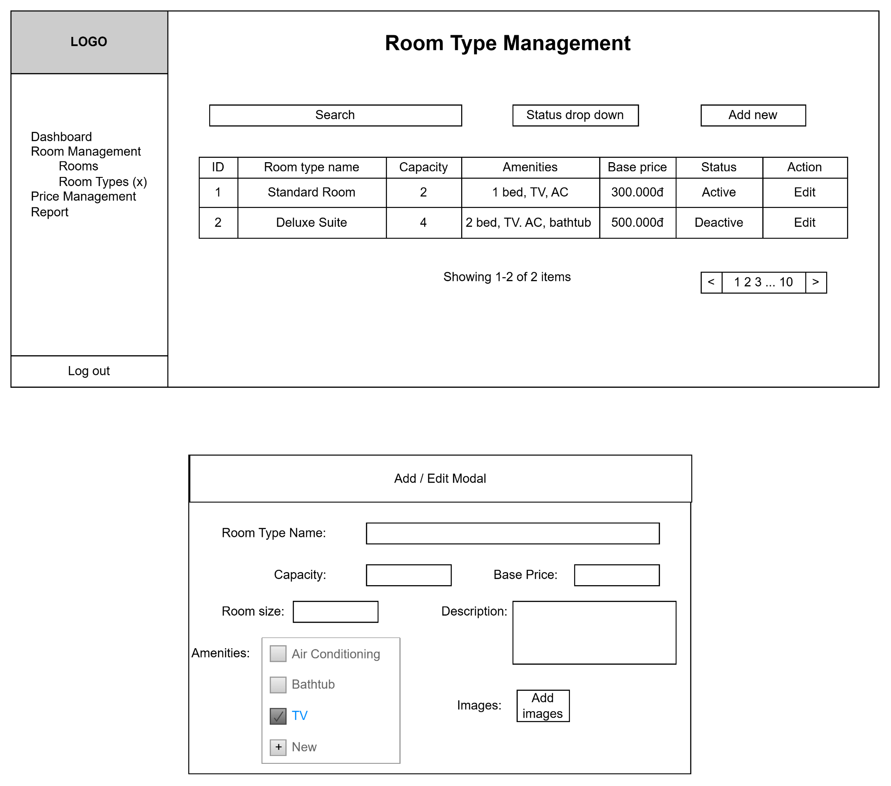

6.2. UC25 - Manage Rooms
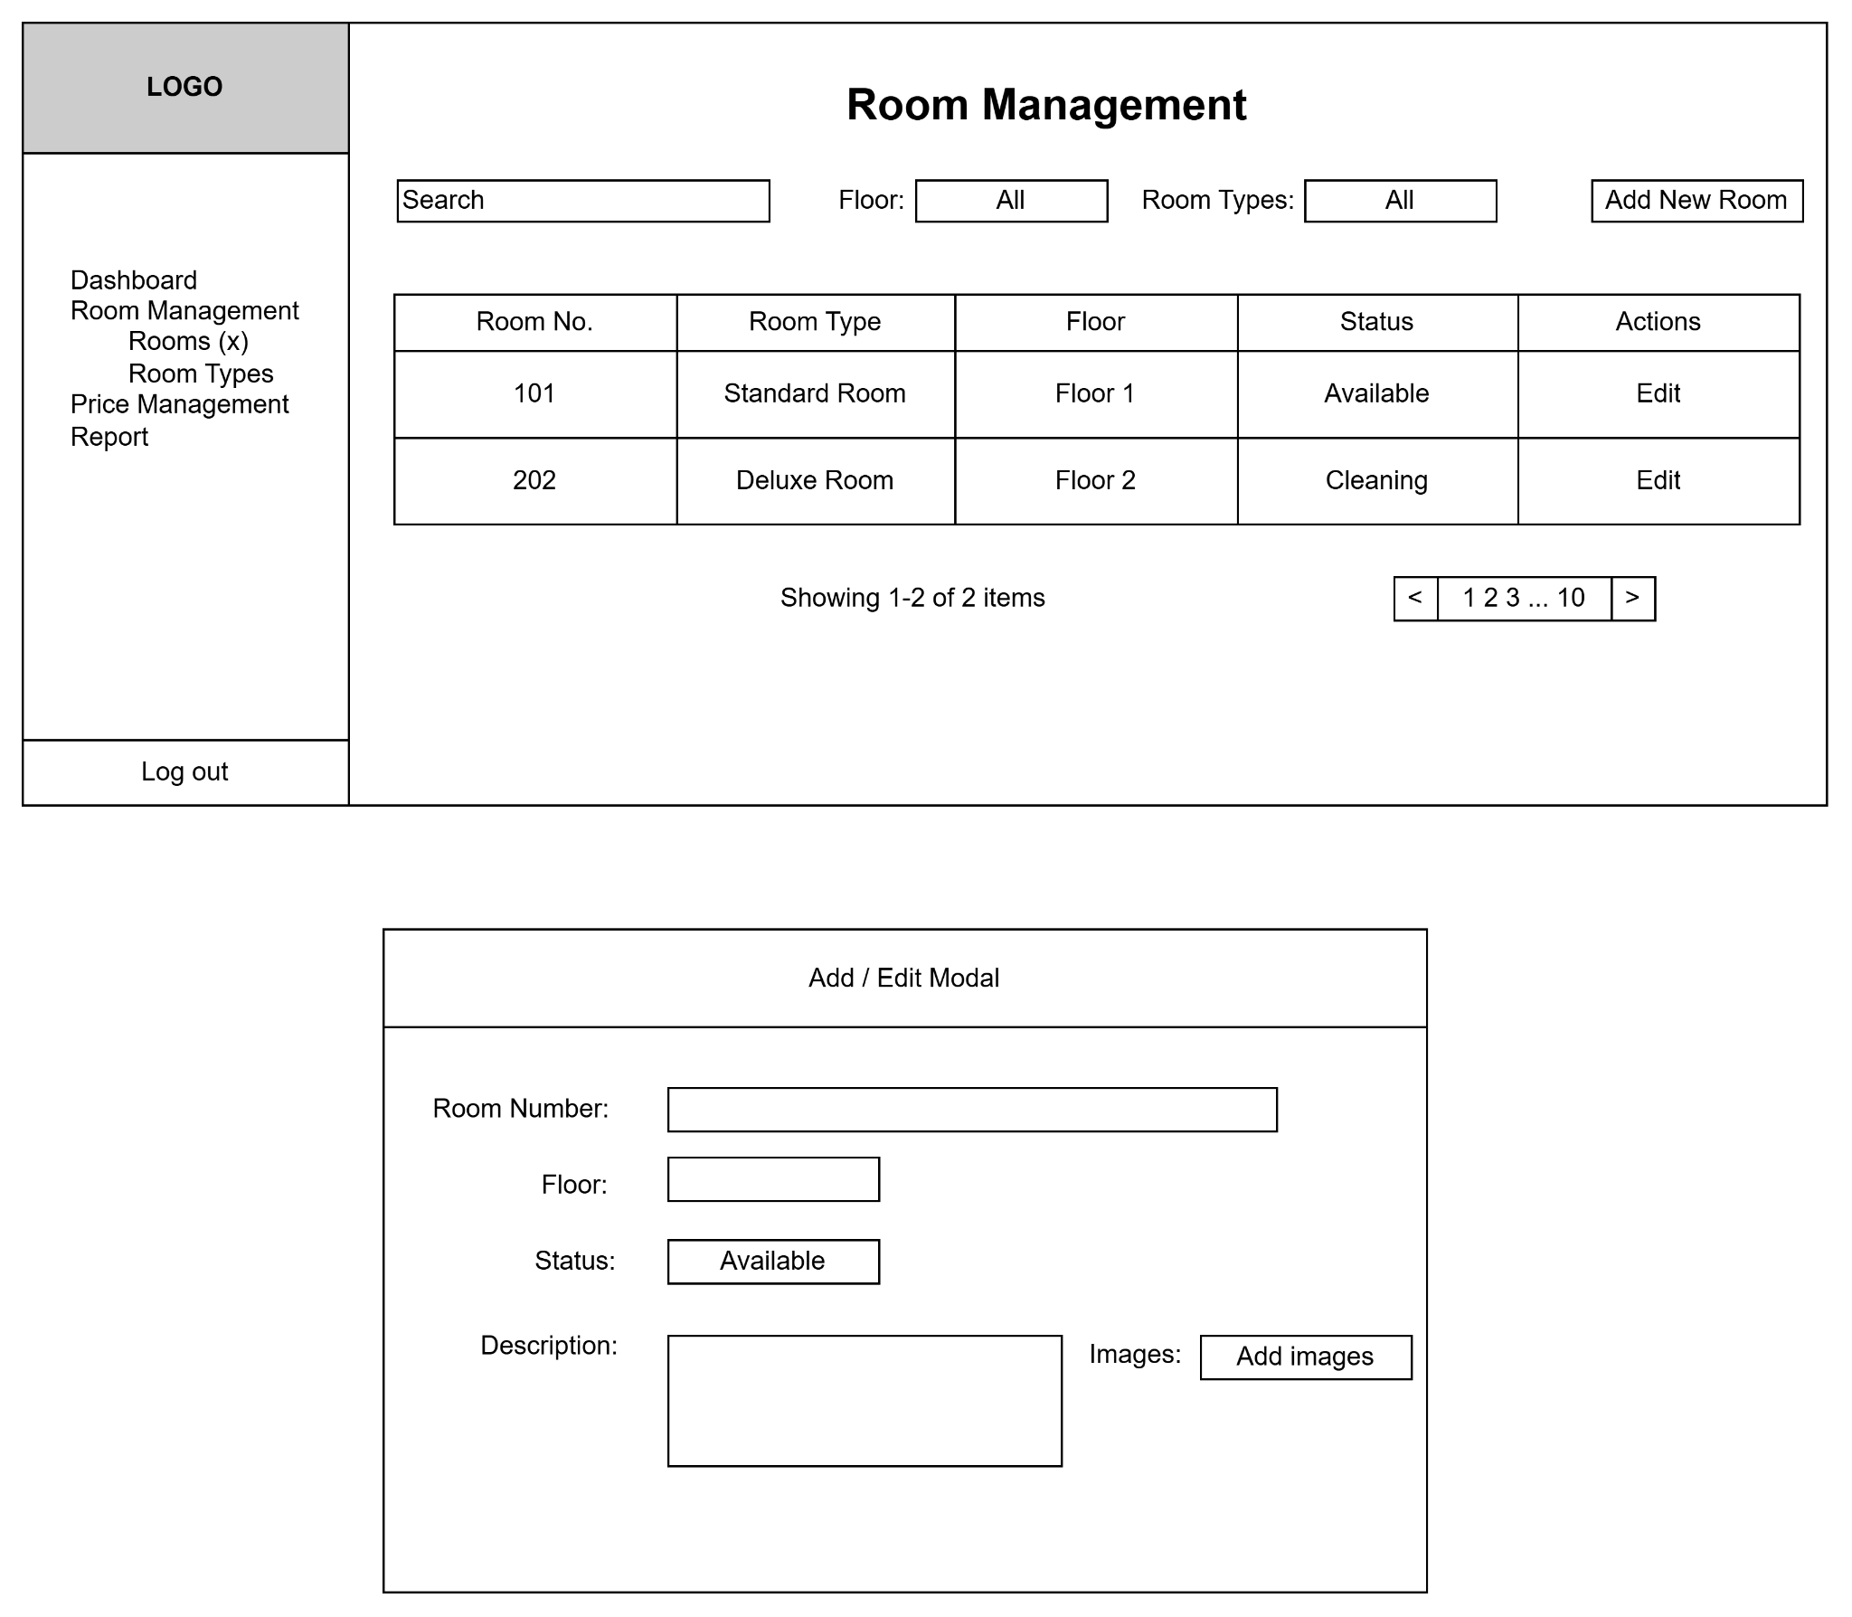

6.3. UC27 - Manage Room Prices
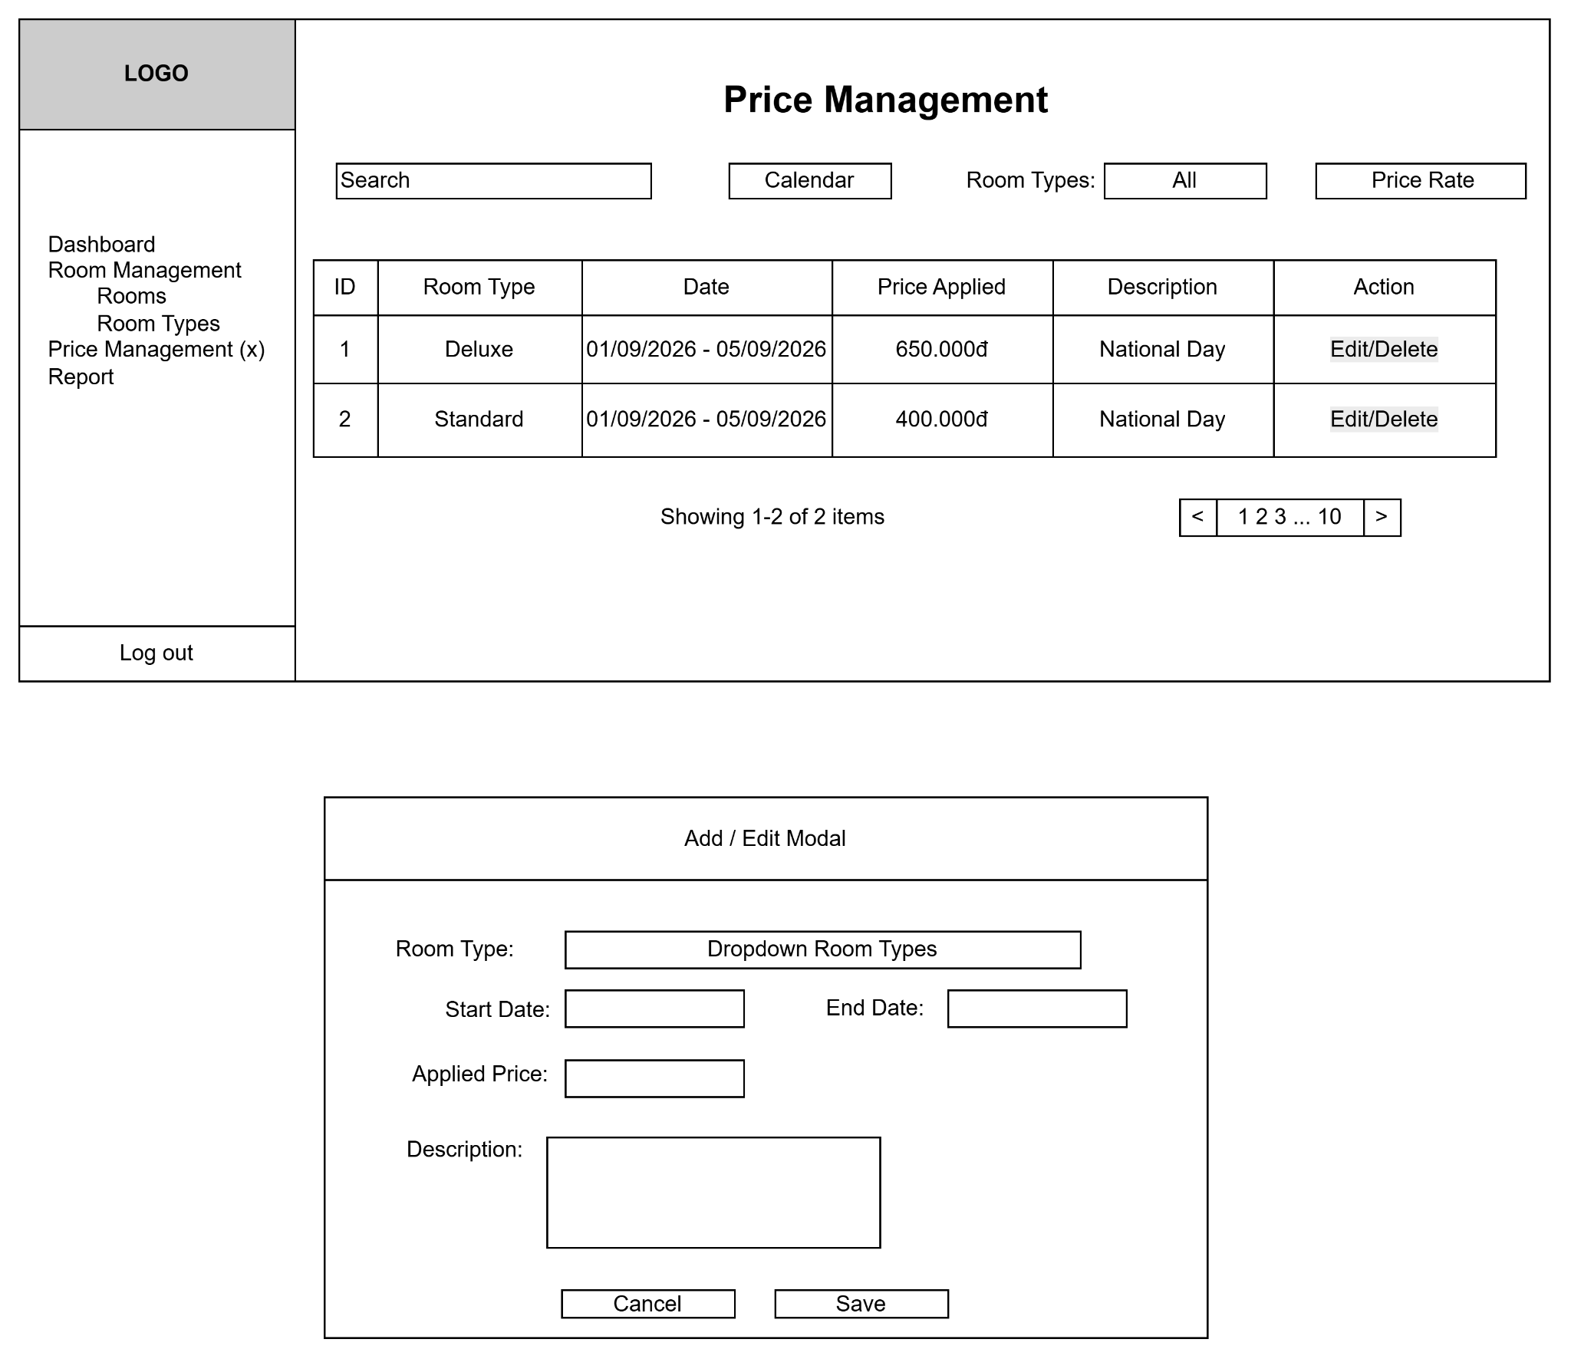

6.4. UC28 - Manage Coupons
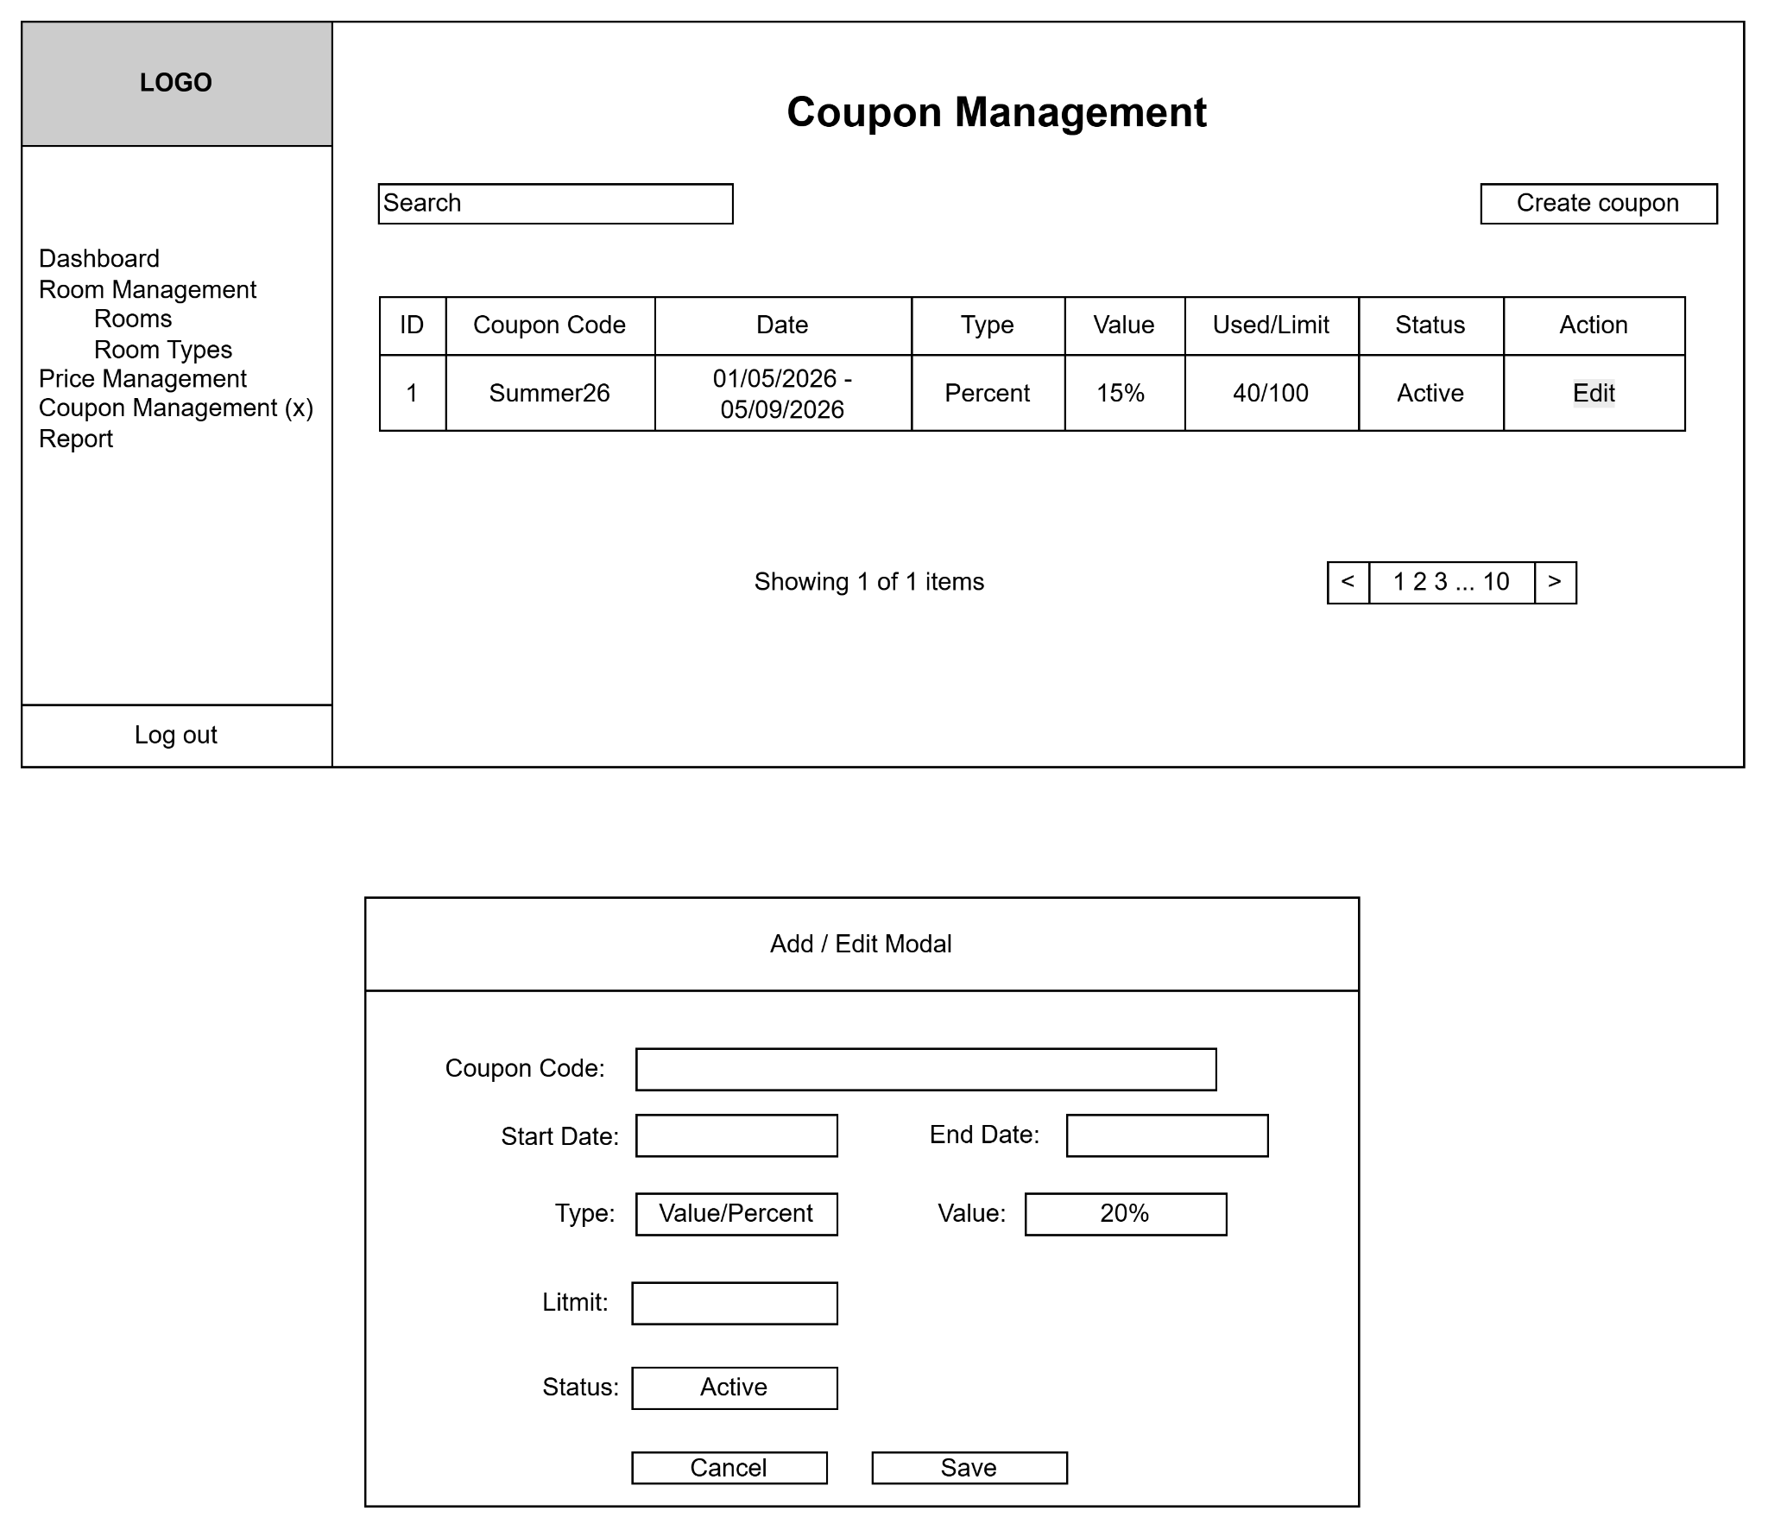

6.5. UC34 - Manage Cleaning Tasks
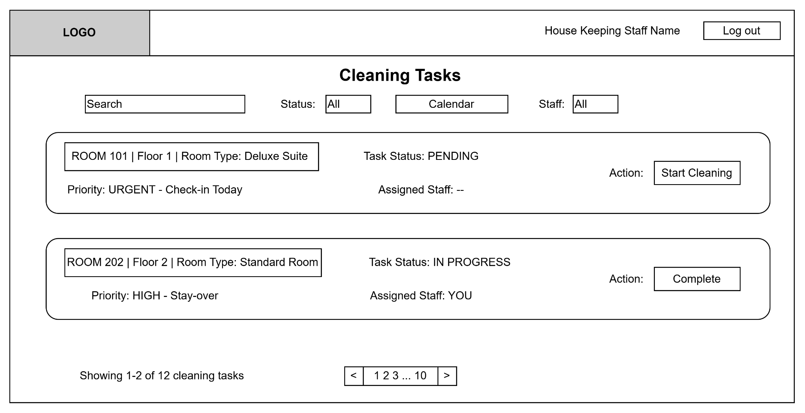

6.6. UC33 - Manage Staff
