

HOTEL MANAGEMENT SYSTEM
Software Design Specification

– Hanoi, August 2022 –

Record of changeS
Date | A*  M, D | In charge | Change Description
*A - Added M - Modified D - Deleted

Table of Contents
I. Overview 4
1. Code Packages 4
2. Database Design 5
a. Database Schema 5
b. Table Description 6
II. Code Designs 7
1. <Feature/Function Name1> 7
a. Class Diagram 7
b. Class Specifications 7
c. Sequence Diagram(s) 8
d. Database Queries 8
2. <Feature/Function Name2> 8

I. Overview

1. Code Packages
The Hotel Management System follows a client-server architecture. The React and Vite client currently contains the application entry point, root component, and global styles. The Node.js server currently provides database scripts, MongoDB connection configuration, and fourteen Mongoose models. Dashed packages in the diagram are reserved extension points and do not contain implementation yet.
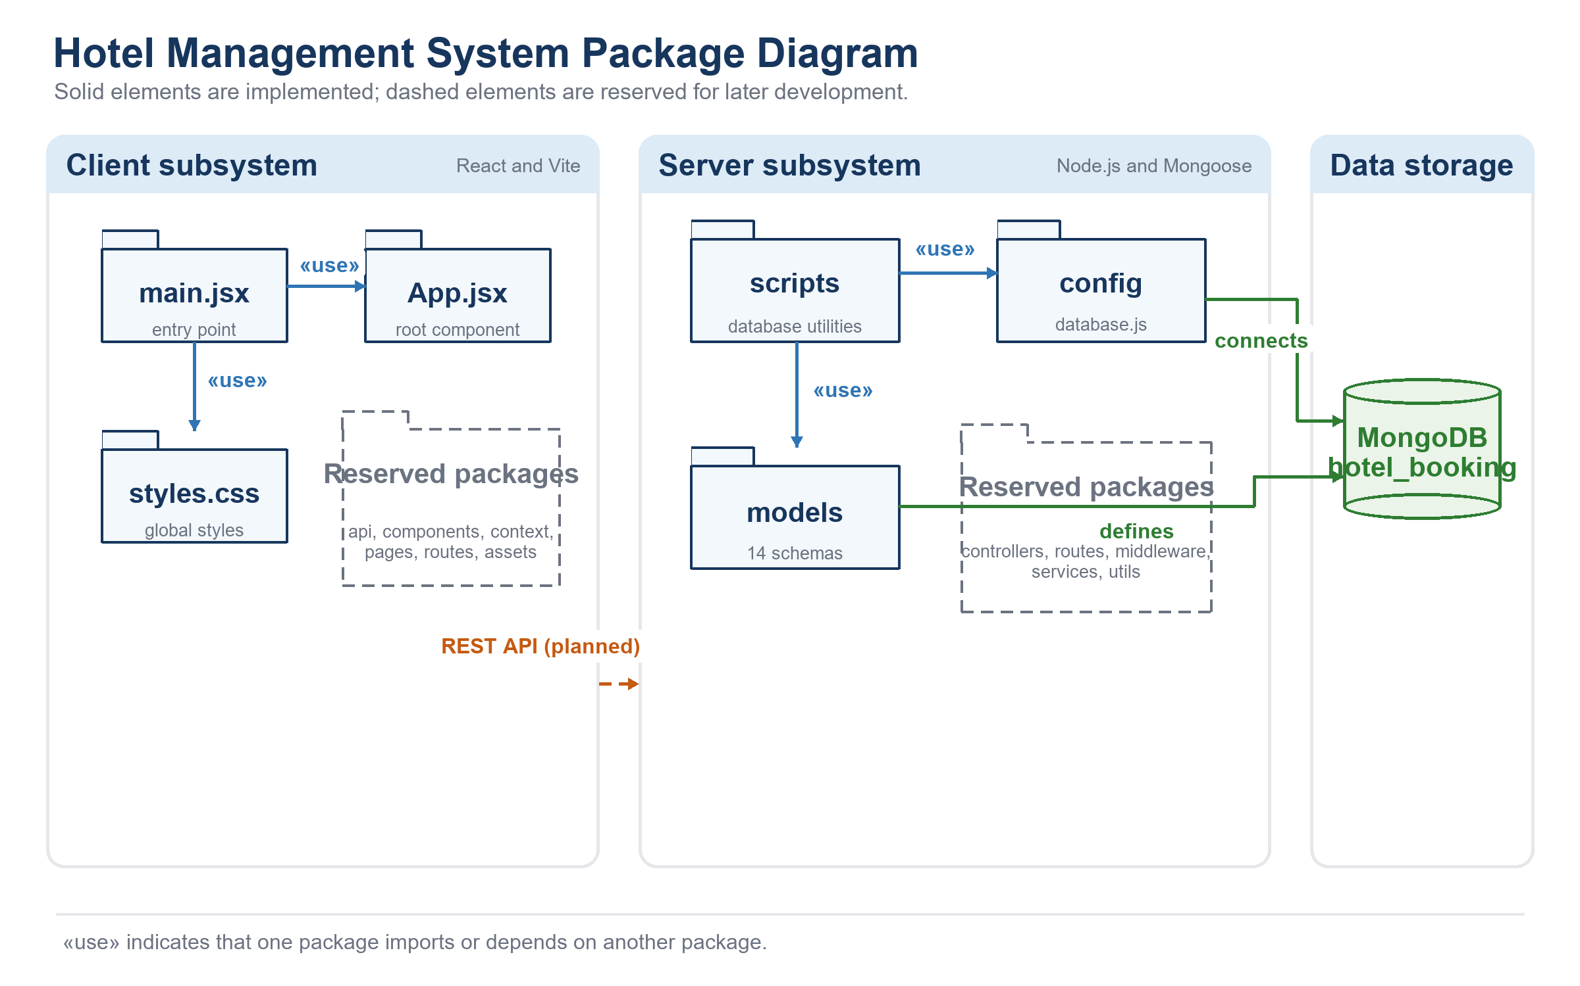
Package and class naming conventions
Folder and package names use lowercase words. React components and Mongoose model files use PascalCase; JavaScript variables and functions use camelCase. MongoDB reference fields use the Id suffix, and multiword enum values use lowercase snake_case. Mongoose model names are singular PascalCase while generated collection names are lowercase and plural.
Package descriptions
No | Package | Description
01 | client/src | Frontend root containing the React entry point, root component, and global stylesheet.
02 | client/src/api | Reserved for functions that communicate with server API endpoints.
03 | client/src/assets | Reserved for frontend images, icons, fonts, and other static source assets.
04 | client/src/components | Reserved for reusable React user-interface components.
05 | client/src/context | Reserved for shared React context and client-side application state.
06 | client/src/pages | Reserved for page-level React components representing application screens.
07 | client/src/routes | Reserved for frontend route declarations and navigation rules.
08 | server/scripts | Contains database utilities that initialize collections, synchronize indexes, and maintain a development connection.
09 | server/src/config | Contains database connection configuration and validates the MONGO_URI environment variable.
10 | server/src/models | Implements 14 Mongoose schemas with fields, validation rules, references, timestamps, and indexes.
11 | server/src/controllers | Reserved for HTTP request handlers that coordinate application operations.
12 | server/src/routes | Reserved for server endpoint definitions and controller mappings.
13 | server/src/middleware | Reserved for authentication, authorization, validation, and error-handling middleware.
14 | server/src/services | Reserved for reusable business rules and integration logic.
15 | server/src/utils | Reserved for general-purpose server helper functions.

2. Database Design

a. Database Schema
The application uses the MongoDB database hotel_booking through Mongoose. Relationships are represented by ObjectId fields with ref metadata; MongoDB does not enforce foreign keys. User profiles, room-type seasonal pricing, and booking rooms and services are embedded within their owning documents. Collection names below follow Mongoose's lowercase plural convention rather than MySQL table naming.
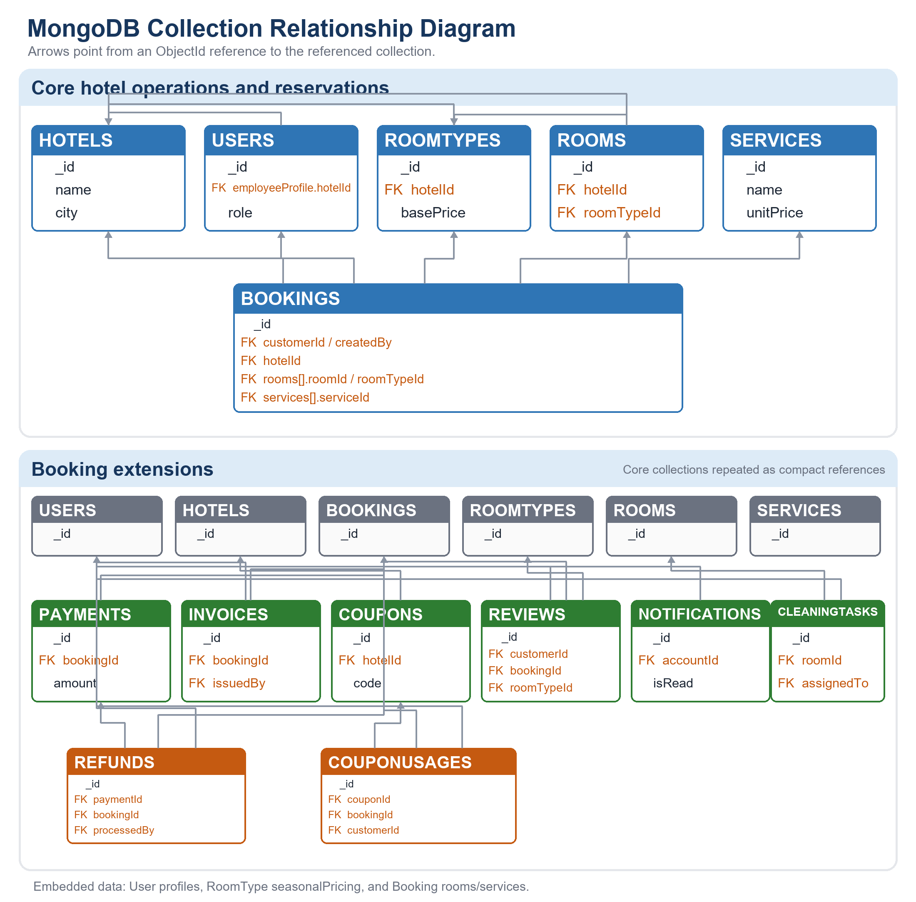

b. Table Description
No | Table | Description
01 | users | Stores customer and employee accounts, roles, status, login data, and embedded profiles.
02 | hotels | Stores hotel identity, address, city, star rating, and contact information.
03 | roomtypes | Stores room categories, prices, capacity, amenities, images, and embedded seasonal pricing.
04 | rooms | Stores physical rooms, their hotel and room-type references, room number, floor, and status.
05 | services | Stores optional services and their unit prices.
06 | bookings | Stores reservations, stay dates, customer and hotel references, embedded rooms and services, discounts, totals, source, and status.
07 | payments | Stores booking payment attempts, method, amount, transaction reference, status, and payment time.
08 | refunds | Stores refund requests linked to payments and bookings, including processing status and staff reference.
09 | invoices | Stores the unique invoice associated with a booking, its issuer, total, tax, and issue time.
10 | coupons | Stores promotion codes, discount rules, validity dates, usage limits, and optional hotel ownership.
11 | couponusages | Records a customer's use of a coupon for a booking and prevents duplicate use by that customer.
12 | reviews | Stores one rating and comment per booking, linked to the customer and reviewed room type.
13 | notifications | Stores account notifications, message type, content, and read status.
14 | cleaningtasks | Stores room-cleaning assignments, schedule, progress status, and completion time.

II. Code Designs

1. <Feature/Function Name1>
[Provide the detailed design for the function <Feature/Function Name1>. It include Class Diagram, Class Specifications, and Sequence Diagram(s)]

a. Class Diagram
[This part presents the class diagram for the relevant feature]
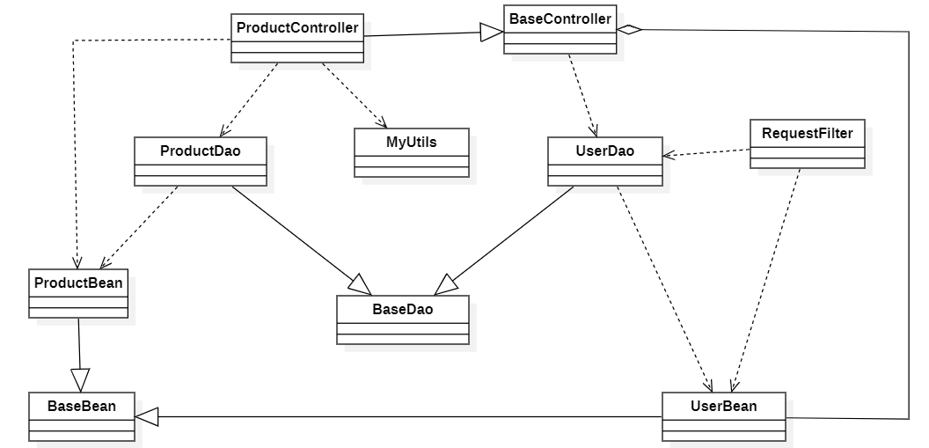

b. Class Specifications
[Provide the description for each class and the methods in each class, following the table format as below]

XYZ Class
[Provide the detailed description for the class methods]
No | Method | Description
01 | <method name> | <Description of the method, including the inputs, outputs & internal method processing>

ABC Class
Class Methods
[Provide the detailed description for the class methods]
No | Method | Description
01 | <method name> | <Description of the method, including the inputs, outputs & internal method processing>

c. Sequence Diagram(s)
[Provide the sequence diagram(s) for the feature, see the sample below]
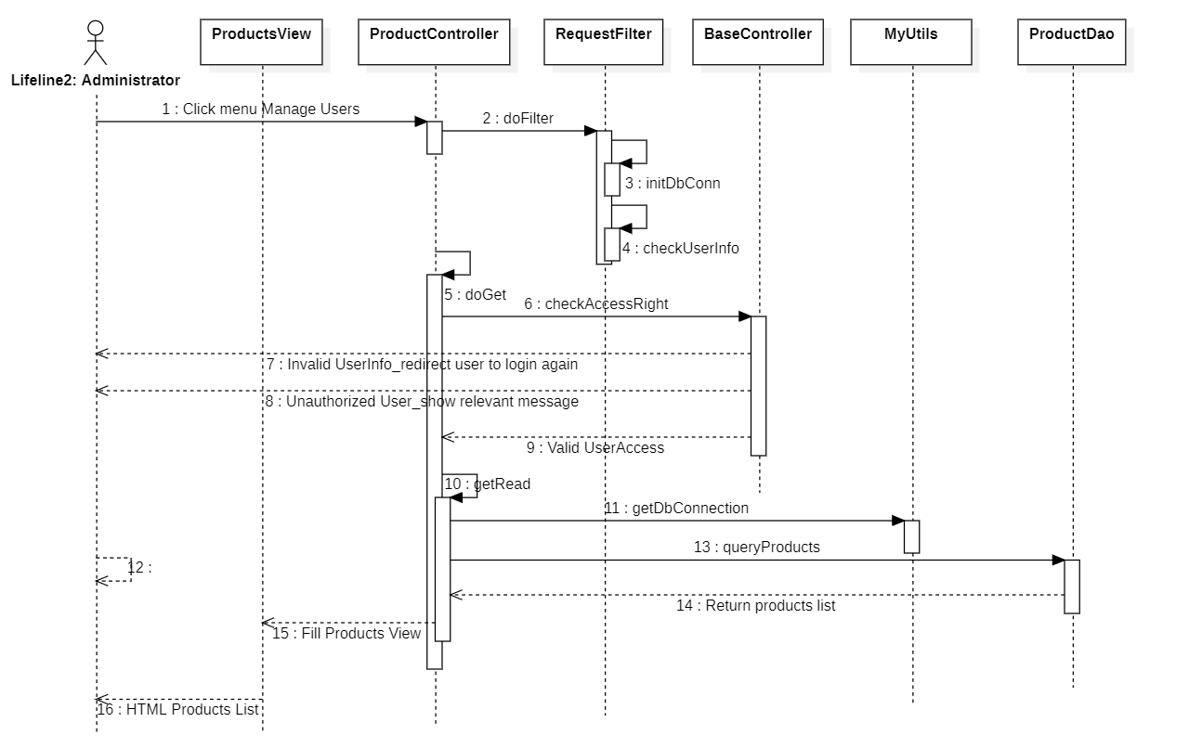

d. Database Queries
[Provide the detailed SQL (select, insert, update...) which are used in implementing the function/screen]

2. <Feature/Function Name2>
…

