Table of Contents
Introduction : Center for Genetic Identification 2
Summary 2
Our Workflow 3
How to import the excel-sheet, step-by-step 3
Next Release, additional feature ? 3
How to verify the excel import 4
Landing Page 5
'Help'-Headline and the links to documentation 5
Next release, additional feature ? 5
‘Genotypes’-page 5
Error when sorting the list 5
Export options 5
‘Genotype Details’-page 6
Next release, additional feature ? 6
Additional Questions 7
Appendix A 8

Introduction : Center for Genetic Identification
2018-02-05, Compiled by Ingimar Erlingsson
CGI , “Center for Genetic Identification”.
http://www.nrm.se/en/forskningochsamlingar/centrumforgenetiskidentifiering.18738.html
Staff: Niclas Gyllenstrand, Thomas Källman
This document describes the use-case ‘Niclas dream-importer’, the excel-file has metadata + genotypes and we are using the importer ‘NRM Genotype’.
This document does not cover the use-case ‘Martins importer’ , where we just want to upload some metadata (genotypes exclued).

Summary
- The importer works, we are able to verify the import. We would like to do an additional import to see how seqdb behaves (this will be done between the 5th and the 12th of February) – and get back to you with feedback.
- Minor error in ‘Genotypes’ - sorting The table with id=”genotypeList” , when clicking on one of the column-names. Java stack-trace.
- Q: ‘ Genotypes’ : Exporting to cvs does not give the column-names
- Q on a future feature : see ‘Genotypes Details’-page

Our Workflow

How to import the excel-sheet, step-by-step
- Landing Page → Storage/ ’Storage Containers’
  - ‘Add New Container’ (96wells) → container name = ‘rack-id’ (barcode on the rack)
    - container name = ‘3000142742’
- Landing Page → Import / ’Spreadsheet Import Page’
  - ‘Select importer’ → drop down, choose → ‘NRM Genotype’ (do not check checkbox)
  - ‘Container Type’ → drop down, choose →’96 Well 12*8 plate’
  - ‘Choose file’ → choose the excel-sheet you want to import → submit
    - our excel-sheet contains 96 records
  - If the import works → You should get the feedback the it works

Next Release, additional feature ?
Import the excel-sheet.
- That we are able to put in X-number of Alleles ( so instead of 16, we can choose an arbitrary length .....)
- Seeing all the metadata under 'Specimen Details' and 'Collection Details' . It would be great if we could just add a column to our Excel-sheet that matches a field from the Collections Details - like adding 'Country' and 'Continent' ..... and sof orth
- Help-page for the importers
- Error-messages when importing. To have better error-messages – for instance : state which record (row in the Excel-file) and which column is breaking the import.

How to verify the excel import
- Collections → Specimens
  - ‘Specimen Records’ → displays ‘102 specimens found’ → OK
  - The ‘Result’-table is sortable
- Genotyping → Genotypes
- Storage → Storage Containers
  - ‘Storage Container Records’
    - List : Choose the record ‘Admin Group | 3000142742’
    - New-Page : ‘Container Details’
      - The rack is displayed as a Matrix : [A-H] / [1-12]
      - Number on each cell is ‘NRM-CGI-<nr>’ + ‘A’
        - Click on Sample in the Matrix
        - New-Page: ‘Sample Details’
        - Details are there → OK

Landing Page

'Help'-Headline and the links to documentation
Today the links are ending up in the agr.gc.ca-redmine instance (redmine.biodiversity.agr.gc.c)

Next release, additional feature ?
- Could we create our own links and point them to our wiki ? Especially , the ‘User Documentation’.
- The language-toggle between English and Francais is not working
- A language-toggle between : ‘English’ and ‘Swedish’.
  - If possible, we could provide translation (‘bundle’_sv_SE.properties-file)

‘Genotypes’-page
The page : https://seqdb.nrm.se/seqdb.web-3.15/genotypes.html

Error when sorting the list
The table with id=”genotypeList” , when clicking on one of the column-names to sort we get a crash – java-stacktrace ( for instance : org.hibernate.QueryException: could not resolve property: allele6 of: ca.gc.aafc.seqdb.entities.Genotype)

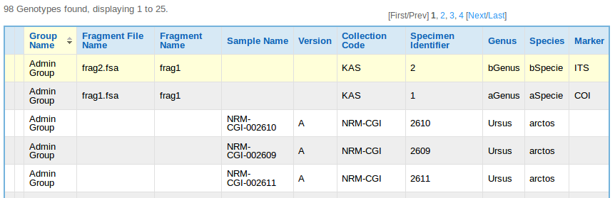

Export options
- OK ? Exporting to cvs does not give me the column-names, is that the default behavior ?
- OK! Exporting to excel, XML and PDF gives me the column-names

‘Genotype Details’-page
https://seqdb.nrm.se/seqdb.web-3.15/editGenotype.html?genotypeId=7

Current layout, see the ‘Alleles’-section

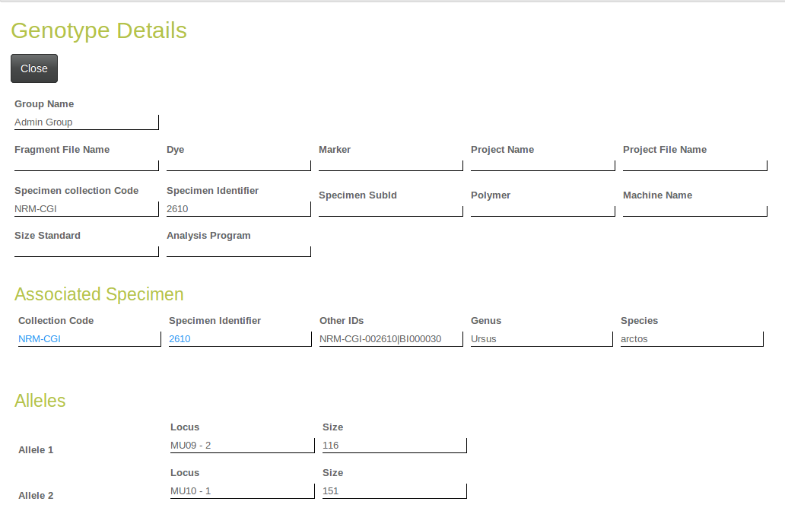

Next release, additional feature ?
Changing the layout for the ‘Alleles’-section

Either Example 1 or Example 2.

Example 1
Locus Size
MU23 173
Locus Size
MU23 176

Example 2
Locus Size
MU23 173
MU23 176

Additional Questions

- Q: Is there a way to delete the Example Specimens ?
- Q: What is a ‘Specimen Identifier’ ?
- Q: Under the Headline 'Asscociated Samples'
  - Version, what is that related to ?
  - Would the version become 'B' if I do the same import again (with the same rack-id)?
  - The Well is 1A, Should it not be A1 ?
- Q: 'Container Details'-page
  - Is it possible to update the label 'Rack Number' and have 'Rack Number' as a link to a help-wiki-page (our page) that explains 'our' way of handling this ?
- Q: import and export DarwinCore Archive (DwC-A) ? (not knowing how well DwC-A supports the DNA-domain)
  - Do you have any plans on supporting import of DwC-A
  - Do you have any plans on supporting export of DwC-A

Appendix A

Columns in the excel-file, the ‘Freezer’-column should be empty :
Position,Tube,RackID,Freezer,NRMID,IndividID,Species,Sex,date,N_SWEREF99,E_SWEREF99,Municipal,County,MU09-1,MU09-2,MU10-1,MU10-2,MU05-1,MU05 - 2,MU23 - 1,MU23 - 2,MU51 - 1,MU51 - 2,MU59 - 1 ,MU59 - 2,G10L - 1,G10L- 2,MU50 - 1,MU50 – 2

See Appendix A for the required format.

