Abstract
Retail participation in Indian equities has expanded rapidly, yet the capacity of individual investors to interpret financial data has not kept pace. DhanVeda (deployed under the name ArthaSift) is an AI decision-support platform built to narrow this gap. It is implemented in Next.js 15 with a Neon Postgres database and exposes 14 AI-assisted features. Every feature is routed through a five-tier hierarchy of large language model (LLM) providers, and a rule-based Environmental, Social and Governance (ESG) engine scores a universe of 532 NSE and BSE securities.
This report evaluates the platform as a research artefact. A review of twelve sources identifies the open problems in LLM-based financial analysis. Seven research hypotheses were fixed in advance and tested through seven reproducible offline experiments on the unmodified source code, totalling more than 5.4 million scoring operations. The experiments cover token budgets for 13 production prompts, ESG tiering of all 532 securities, a 10,000-draw Monte Carlo study of governance-data uncertainty, a 20,000-company simulation of the scoring rubric and a 60,000-run repeated-measurement noise trial.
Three results stand out. First, the compressed scoring prompt reduces input from 3,645 to 1,571 tokens (a 56.9% reduction), bringing a complete call to 4,071 tokens against a 6,000 tokens-per-minute free-tier limit that the uncompressed version (6,145 tokens) exceeds. Second, sector membership explains 96.4% of the variance in the ESG composite, and 46.4% of securities change tier when the governance score moves by a single point. Third, 10% noise in retrieved data moves 62.4% of simulated companies across a verdict band within ten repeated runs. Two hypotheses are supported, four are rejected and one awaits a live trial, which is fully specified. The report closes with ranked recommendations and directions for future research.
Keywords: large language models; financial analysis; LLM routing; prompt compression; tokenization; ESG scoring; Indian equity market; reproducibility; investor protection.

Key Findings at a Glance
1 | Prompt compression cut the core analysis prompt by 56.9% (3,645 to 1,571 tokens) without removing any scoring rule.
2 | The platform's 4-characters-per-token estimate undercounts number-dense prompts by up to 34.2%.
3 | Sector alone explains 96.4% of ESG composite variance (eta-squared = 0.964).
4 | 247 of 532 securities (46.4%, 95% CI 42.2-50.7%) change ESG tier under a one-point governance shift.
5 | At 10% retrieval noise, 62.4% of companies change verdict band across ten runs; mean SD = 3.71 points.
6 | A company at the Indian median on every KPI scores 68, while the simulated population median is 39; the rubric anchor is 50.
7 | Cascade availability reaches 99.990% at a 10% per-tier failure rate, assuming independent failures.

Table 1: Document control
Version | Date | Description
1.0 | 25 October 2026 | Online research document with interactive charts
2.0 | 30 October 2026 | Formal report: Calibri typography, front matter, numbered figures and tables, IEEE references, similarity self-check

Table of Contents
1. Introduction 1
1.1 Background and Problem Statement 1
1.2 Motivation 1
1.3 Objectives 1
1.4 Contributions 1
1.5 Scope and Organisation 2
2. Literature Review 3
2.1 Language Models for Financial Analysis 3
2.2 Retrieval and Fabricated Figures 3
2.3 Non-Determinism at Temperature Zero 3
2.4 Cost-Aware Routing and Model Cascades 3
2.5 Prompt Compression and Tokenization 3
2.6 Divergence of ESG Ratings 4
2.7 Research Gaps 4
3. System Architecture and AI Hierarchy 5
3.1 Technology Stack 5
3.2 The Provider Hierarchy 6
3.3 Feature Map and Output Budgets 7
3.4 Deterministic Components 7
4. Tokenization and Context Engineering 8
4.1 The Constraint 8
4.2 The Solution: A Rule-Preserving Compressed Prompt 8
4.3 Failure of the Four-Characters-per-Token Heuristic 9
4.4 Additional Token-Saving Mechanisms 9
4.5 Open Issue: Conversation Growth 10
5. Design of Experiments 11
5.1 Research Questions 11
5.2 Hypotheses and Decision Rules 11
5.3 Variables and Controls 11
5.4 Datasets 12
5.5 Baselines and Evaluation Metrics 12
5.6 Experiment Register 13
6. Data Collection and Management 14
6.1 Data Sources 14
6.2 Storage Model 14
6.3 Existing Data-Quality Controls 15
6.4 Gaps for Research Use 15
6.5 Proposed Run Log 15
7. Iterations, Repeated Testing and Statistical Validity 16
7.1 Sources of Run-to-Run Variance 16
7.2 Experiment E6: Repeated-Run Noise Trial 16
7.3 Sample-Size and Precision Analysis 17
7.4 Threats to Validity 18
8. Results and Comparative Analysis 19
8.1 ESG Engine: Effect of Governance Data 19
8.2 ESG Engine: Sector Versus Company Signal 20
8.3 ESG Sensitivity (E3) 21
8.4 DV Score Rubric Calibration (E5) 22
8.5 Cascade Reliability (E7) 23
8.6 Summary of Effect Sizes 23
9. Real-Time Visualisation and Dashboards 24
9.1 Visualisation Already in the Product 24
9.2 Proposed Research Dashboard 24
10. Reproducibility and Evidence 26
10.1 Code Identity 26
10.2 Environment 26
10.3 Experiment Scripts 26
10.4 Reproducibility Controls in the Product 27
10.5 Missing Evidence 27
10.6 Specified Live Trial (P1) 27
11. Conclusions, Impact and Future Work 28
11.1 Hypothesis Outcomes 28
11.2 Discussion 28
11.3 Limitations 29
11.4 Practical and Societal Impact 29
11.5 Recommendations (Ranked by Impact per Unit Effort) 29
11.6 Future Research Directions 29
References 31
Appendix A. Glossary 32
Appendix B. Raw Tokenization Data 33
Appendix C. Originality and Similarity Self-Check 34

List of Figures
Figure 1: Five-tier provider hierarchy implemented in callClaude() (lib/claude.ts) 6
Figure 2: Tokens booked per T&F call against the Groq 6,000 TPM free tier (cl100k tokenizer) 8
Figure 3: Characters per token for each of the 13 production prompts (cl100k; o200k agrees within 2%) 9
Figure 4: Share of companies whose DV verdict band changes across ten repeated runs, by noise level (E6, simulated) 16
Figure 5: Mean within-company standard deviation and 95% confidence half-width by noise level (E6, simulated) 17
Figure 6: ESG tier counts without BSE data versus the mean of 10,000 Monte Carlo draws with 95% intervals (E2, E4) 19
Figure 7: Distribution of modal-tier stability across 532 securities (E4, 10,000 draws) 20
Figure 8: Mean ESG composite by sector with tier cut-offs (E2, deterministic) 20
Figure 9: ESG tier mix by market-capitalisation bucket (E2) 21
Figure 10: Distribution of DV Scores for 20,000 simulated companies, with band boundaries and reference markers (E5) 22
Figure 11: Outright failure rate and share of requests answered by a fallback model, by per-tier failure rate (E7) 23
Figure 12: Proposed layout of a live research dashboard driven by the ai_runs table 25

List of Tables
Table 1: Document control ii
Table 2: Research gaps identified in the literature and the corresponding design response 4
Table 3: Technology stack of the DhanVeda platform 5
Table 4: AI features, output token budgets and use of web search 7
Table 5: Token counts for the full and compressed analysis prompts 8
Table 6: Token-saving mechanisms identified in the source code 9
Table 7: Pre-registered hypotheses and decision rules 11
Table 8: Independent, dependent and controlled variables 11
Table 9: Baselines used for each experiment 12
Table 10: Register of experiments and their iteration counts 13
Table 11: Data sources, refresh policies and validation rules 14
Table 12: Database tables relevant to experimental evidence 14
Table 13: Repeatability statistics from experiment E6 (1,000 companies x 10 runs per level) 17
Table 14: Sample-size calculations and precision of key estimates 17
Table 15: Threats to validity and mitigations 18
Table 16: Ranges with no scoring rule in the compressed rubric 22
Table 17: Cascade availability under independent provider failures 23
Table 18: Comparison of treatments against baselines 23
Table 19: Existing visualisation surfaces in the platform 24
Table 20: SHA-256 fingerprints of the source files used in the experiments 26
Table 21: Software environment used for all experiments 26
Table 22: Experiment scripts, seeds and outputs 26
Table 23: Evidence gaps and proposed remedies 27
Table 24: Outcome of each pre-registered hypothesis 28
Table 25: Glossary of terms used in the report 32
Table 26: Raw tokenization results from experiment E1 33
Table 27: Eight-word shingle overlap between this report and the abstracts of cited papers 34

List of Abbreviations
API | Application Programming Interface
BPE | Byte-Pair Encoding
BRSR | Business Responsibility and Sustainability Report (SEBI)
BSE | BSE Limited (Bombay Stock Exchange)
CI | Confidence Interval
DMA | Daily Moving Average
DoE | Design of Experiments
DV Score | DhanVeda composite stock score (5-95)
ESG | Environmental, Social and Governance
F&O | Futures and Options
ICC | Intraclass Correlation Coefficient
KPI | Key Performance Indicator
LLM | Large Language Model
MC | Monte Carlo
NSE | National Stock Exchange of India
P/E | Price-to-Earnings ratio
RSI | Relative Strength Index
SD | Standard Deviation
SEBI | Securities and Exchange Board of India
TPM | Tokens Per Minute

1. Introduction

1.1 Background and Problem Statement
Indian capital markets have seen an unprecedented inflow of individual investors. By 31 January 2026 the National Stock Exchange reported 12.7 crore unique registered investors and more than 25 crore trading accounts [1]. Growth in participation, however, has not been matched by growth in outcomes. A SEBI study covering more than one crore individual traders in equity futures and options found that 93% of them made losses between FY22 and FY24, with aggregate losses above Rs 1.8 lakh crore and an average of about Rs 2 lakh per trader [2].
The underlying difficulty is not the availability of information. Prices, financial statements and shareholding disclosures are published by NSE and BSE at no cost. The difficulty is interpretation. A retail investor must know, for example, that a price-to-earnings multiple of 45 is moderate for FMCG but extreme for metals, that heavy promoter pledging has preceded several high-profile collapses, and that a price below the 200-day moving average usually signals institutional selling. Professional research that embeds such norms is typically restricted to paying clients or institutional mandates.

1.2 Motivation
Large language models can read filings, retrieve current figures and explain them in plain language. Three properties nevertheless make them hazardous as financial advisers: they can fabricate figures, their outputs vary between runs even at temperature zero, and their implicit benchmarks are drawn mainly from US markets. DhanVeda is built on the premise that these weaknesses can be contained by wrapping a general-purpose model in three layers: an explicit India-calibrated scoring rubric, a hierarchy of providers, and deterministic algorithms where judgement is not needed. Each layer makes a claim that can be measured, which is the purpose of this report.

1.3 Objectives
1. To deliver an end-to-end platform with 14 AI features spanning equity research, decision hygiene, green finance, portfolio review and venture analysis.
2. To keep the marginal cost of analysis close to zero by routing across free-tier providers without sacrificing availability.
3. To ground every score in an explicit, India-specific rubric that can be audited rule by rule.
4. To evaluate that design using the methods expected of empirical research: pre-registered hypotheses, controlled variables, repeated trials and uncertainty estimates.

1.4 Contributions
- A five-tier, failure-aware LLM hierarchy that includes a two-stage collaborative mode in which one model retrieves live data and a second model scores it (Chapter 3).
- A token-budget engineering method that compresses a 3,645-token rubric to 1,571 tokens, verified with production-grade BPE tokenizers (Chapter 4).
- A transparent ESG algorithm for 532 listed securities built on SEBI pledge and BRSR signals, together with a quantitative audit of its behaviour (Chapters 3 and 8).
- A reproducible experimental harness of seeded simulations, sensitivity analyses and a token audit, plus a protocol for live repeated-run trials (Chapters 5 to 10).

1.5 Scope and Organisation
The analysis is based on the source code as it stood on 25 October 2026: 129 files and approximately 14,400 lines of TypeScript in the principal modules. All experiments were executed offline. No production database records were accessed and no live LLM calls were made, so no user data was read and no API quota was consumed. Results that depend on assumed input distributions are explicitly labelled as simulated.
Chapter 2 reviews the literature. Chapters 3 and 4 describe the system architecture and the tokenization work. Chapter 5 sets out the experimental design, Chapter 6 the data pipeline and Chapter 7 the repeated-testing and validity analysis. Chapter 8 presents the results, Chapter 9 the visualisation layer and Chapter 10 the reproducibility evidence. Chapter 11 concludes.

2. Literature Review
The review is organised around six themes. Together they reveal five research gaps, four of which DhanVeda addresses by design; the fifth, validation against market outcomes, remains open.

2.1 Language Models for Financial Analysis
Two strategies dominate the literature. The first trains a domain-specific model. BloombergGPT, a 50-billion-parameter model, was trained on 363 billion tokens of proprietary financial text plus 345 billion general-purpose tokens and outperformed general models on financial benchmarks [3]; the training budget, however, is far beyond the reach of a retail platform. The second strategy prompts a general model. Kim, Muhn and Nikolaev reported that GPT-4, given anonymised statements, predicted the direction of earnings changes more accurately than human analysts [4]. The authors later withdrew the paper after identifying data inconsistencies during replication. That withdrawal is itself instructive: claims about LLM performance in finance require independent replication before they are relied upon.

2.2 Retrieval and Fabricated Figures
FinanceBench evaluated 16 model configurations on questions about listed companies and found that GPT-4-Turbo combined with a retrieval system answered incorrectly or declined to answer in 81% of cases [5]. The implication for system design is that obtaining the correct figure is harder than reasoning about it. DhanVeda's collaborative mode responds directly to this finding by separating retrieval from scoring.

2.3 Non-Determinism at Temperature Zero
Atil et al. ran five models configured for deterministic output ten times each on eight tasks and observed accuracy differences of up to 15% between runs, with best-to-worst gaps of up to 70% [6]. For a product that reports a single numeric score, a single run should therefore be regarded as one sample from a distribution rather than as a definitive measurement. Chapter 7 quantifies this effect for the DV Score.

2.4 Cost-Aware Routing and Model Cascades
FrugalGPT demonstrated that querying models in order of increasing cost can match the quality of the strongest model at up to 98% lower expense [7], and RouteLLM trained routers on human preference data to more than halve cost without measurable quality loss [8]. Both approaches escalate on a learned estimate of answer quality. DhanVeda instead escalates on failure: rate-limit responses, empty output or unparseable JSON. This needs no training data, but it accepts any well-formed answer, including a wrong one.

2.5 Prompt Compression and Tokenization
LLMLingua uses a small language model to remove low-information tokens and reports compression ratios of up to 20 times with limited degradation [9]. Singh and Strouse showed that the way digits are grouped into tokens materially affects arithmetic accuracy; enforcing right-to-left grouping raised GPT-4 addition accuracy from 84.4% to 98.9% [10]. Because a financial rubric consists largely of numbers and thresholds, both its cost and its interpretation are sensitive to tokenization, as Chapter 4 demonstrates.

2.6 Divergence of ESG Ratings
Berg, Koelbel and Rigobon compared six leading ESG rating agencies and found pairwise correlations between 0.38 and 0.71. Differences in measurement accounted for 56% of the divergence, differences in scope for 38% and differences in weighting for 6% [11]. Coverage of Indian mid- and small-capitalisation companies by global agencies is limited, which makes SEBI's mandatory BRSR and pledge disclosures the most consistent structured signals available locally.

2.7 Research Gaps
Table 2: Research gaps identified in the literature and the corresponding design response
Gap | Relevance to Indian retail investors | DhanVeda response | Status
Benchmarks calibrated to US or global norms | Indian sector P/E medians range from 8-12x (PSU banks) to 45-55x (FMCG) | India-only rubric with sector medians, G-Sec anchor and SEBI pledge thresholds | Implemented
Fabricated live figures | 81% failure rate on open-book financial QA [5] | Two-stage retrieve-then-score pipeline | Implemented; not yet measured
Single-provider fragility and cost | Free tiers allow only a few thousand tokens per minute | Five-tier failure-driven cascade | Implemented
Opaque ESG ratings | Agencies disagree; thin small-cap coverage [11] | Rule-based E/S/G from sector priors and live BSE pledge data | Implemented
Reproducibility of LLM scores | Run-to-run swings of up to 15% [6] | Temperature 0, 12-hour cache, versioned rubric | Partial
Validation against outcomes | A score is only useful if it predicts something | Not yet addressed | Open

3. System Architecture and AI Hierarchy
All AI features pass through a single server-side router, the function callClaude() in lib/claude.ts. The router traverses a fixed hierarchy of nine model endpoints drawn from four providers and returns the first response that can be parsed as JSON.

3.1 Technology Stack
Table 3: Technology stack of the DhanVeda platform
Layer | Technology | Role
Front end | Next.js 15 App Router, React 19, Tailwind CSS, Recharts, TradingView widget | 38 pages across research, decision, green finance, money, venture and admin areas
API | 40 Next.js route handlers on Vercel (region sin1; 60 s limit on AI routes) | Authentication, AI, screener, community, portfolio and administration
Authentication | NextAuth v5 (credentials, Google, Microsoft Entra), bcrypt, e-mail OTP two-factor | Session check on every AI route
Data | Neon serverless Postgres via Drizzle ORM; 15 tables | Users, logs, stock universe, metrics, ESG, portfolio, community
Market data | Yahoo Finance v7 batch quotes (50 symbols per call); BSE shareholding API | Prices and valuation; promoter holding and pledge
AI providers | Gemini 2.0 Flash / Flash-Lite; Claude 3.5 Haiku; Groq Llama 3.3 70B / 3.1 8B; OpenRouter Llama 3.3 70B / Qwen 2.5 72B | Analysis, scoring, chat and venture documents

3.2 The Provider Hierarchy
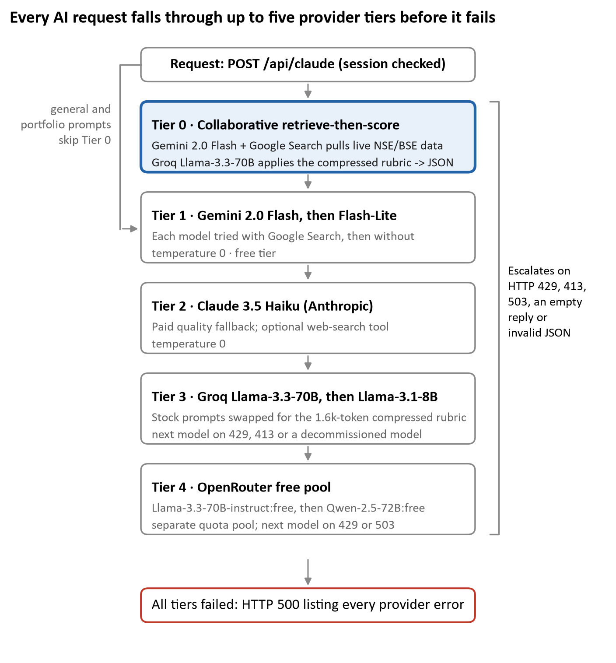
Figure 1: Five-tier provider hierarchy implemented in callClaude() (lib/claude.ts)
The ordering reflects cost and capability. Gemini is placed first because it is free and is the only free tier with native Google Search grounding. Claude 3.5 Haiku acts as a paid quality backstop. Groq and OpenRouter are free overflow pools with independent quotas, so a burst of traffic that exhausts one tier seldom exhausts all of them. Four design decisions merit attention:
- Retrieval is separated from judgement (Tier 0). Gemini returns roughly thirty labelled metric lines in plain text, with no JSON and no analysis. Groq then applies the scoring rubric. If Groq is over quota, Gemini performs the complete analysis itself.
- Escalation is triggered by failure, not by quality. HTTP 429, 413 and 503 responses, decommissioned models, empty bodies and unparseable JSON all cause escalation. A well-formed but incorrect answer from Tier 1 is accepted.
- JSON repair is an implicit stage. The extractJSON() helper removes code fences, extracts the outermost object and retries after deleting trailing commas and escaping newlines, so every provider is judged against the same output contract.
- The venture module uses a separate four-tier chain at temperature 0.3, because document generation benefits from some variety of wording.

3.3 Feature Map and Output Budgets
Table 4: AI features, output token budgets and use of web search
Feature | Max output tokens | Web search | Activity label
T&F Analysis (14 KPIs + DV Score) | 2,500 | Yes | analysis
ESG deep dive | 2,000 | Yes | esg
Thesis Tester | 1,400 | Yes | thesis
Learn modules | 1,400 | No | learn
Portfolio health | 1,200 | No | portfolio
Transcript Analyser | 1,200 | No | transcript
Carbon and RECs | 1,100 | Yes | carbon
REIT Intelligence | 1,100 | Yes | reit
Bias Checker | 1,000 | No | bias
Community insight | 700 | No | community-insight
Conviction Journal / portfolio fit | 600 | No | journal / portfolio-fit
Global assistant | 420 | No | assistant
Screener ESG score | 250 | No | (cached 7 days)

3.4 Deterministic Components
Three parts of the system involve no language model and are therefore reproducible by construction.
- ESG engine (lib/esgScoring.ts, version v1.0-june2026). Environmental and Social scores come from baselines for 28 sectors, with 22 company-specific environmental overrides. The Governance score starts from a sector baseline and is adjusted for live BSE promoter pledge (from +1 at 0% to -5 above 50%), promoter holding (plus or minus 1) and BRSR mandate (+1). The tier is derived from the mean of E, S and G, on a scale from A+ to D.
- Caching. Market quotes remain valid for 24 hours, AI ESG scores for 7 days, and T&F results for a 12-hour client-side window keyed on stock and half-day.
- Usage accounting. Each AI call adds an estimate of prompt length / 4 + maxTokens to users.tokens_used and writes a row to activity_logs; rows older than 90 days are aggregated into daily_stats.

4. Tokenization and Context Engineering
The binding constraint on DhanVeda is not model quality but the token budget. The flagship analysis prompt carries a 14-KPI, five-category rubric with India-specific thresholds, and on a free tier every token is rationed.

4.1 The Constraint
When the code was written, Groq's free tier for Llama-3.3-70B allowed 6,000 tokens per minute, as recorded in the project's environment notes and in a comment in lib/claude.ts. Groq's documentation lists separate input and output limits per minute but does not state whether the requested max_tokens is reserved in advance [12]. This report therefore adopts the conservative assumption, which the code comment also makes: one T&F request must fit the prompt plus the 2,500-token output reservation.
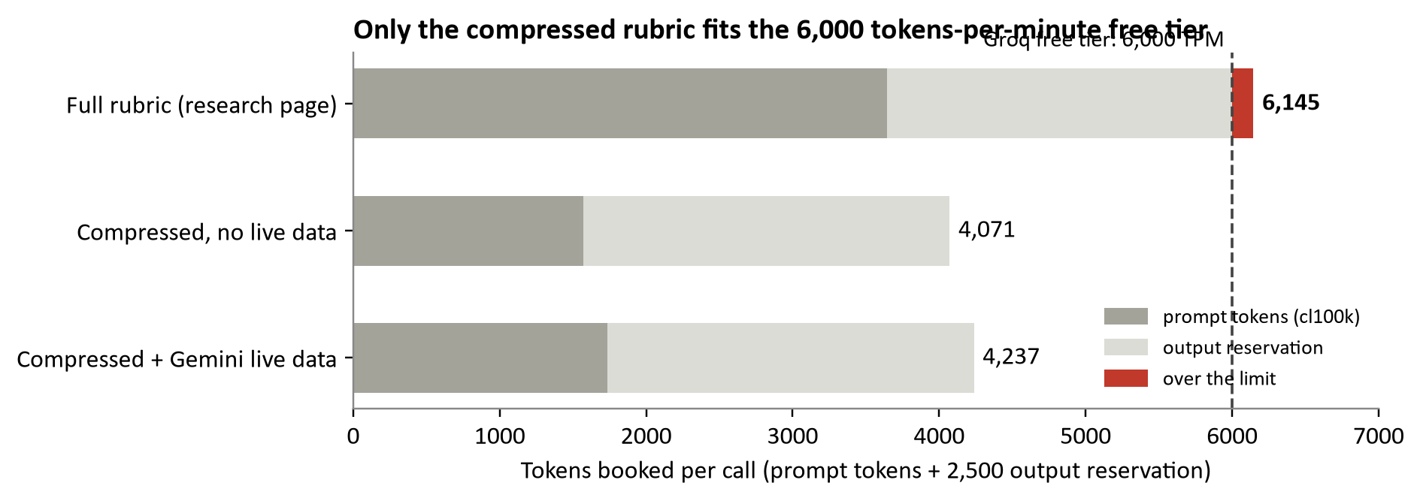
Figure 2: Tokens booked per T&F call against the Groq 6,000 TPM free tier (cl100k tokenizer)
The developer's comment estimated a full call at about 6,200 tokens. Measurement agrees closely: 3,645 prompt tokens plus 2,500 reserved gives 6,145, which is 2.4% above the limit. A single request would be rejected, and two users in the same minute would block one another.

4.2 The Solution: A Rule-Preserving Compressed Prompt
The function buildGroqPrompt() restates the rubric in telegraphic form, keeping every threshold and point value while omitting the explanatory prose. For example, the line "+7 ROE >= 20% (top-quartile Indian company, well above Nifty avg 14-16%)" becomes "ROE/7: >=20%=+7". The router identifies stock-analysis prompts with a regular expression on the marker ANALYSE: "...", extracts the stock name and substitutes the compressed prompt only when Groq is called.
Table 5: Token counts for the full and compressed analysis prompts
Prompt variant | Characters | Words | cl100k tokens | o200k tokens | Change vs full
Full rubric (research page) | 12,269 | 1,778 | 3,645 | 3,618 | -
Compressed, no live data | 4,137 | 482 | 1,571 | 1,575 | -56.9%
Compressed + Gemini live data | 4,776 | 580 | 1,737 | 1,739 | -52.3%

The reduction is 56.9% with no scoring rule removed. In the sense that matters for this application the compression is lossless, because the scoring function is unchanged. This differs from statistical token pruning such as LLMLingua [9]. The trade-off is that the telegraphic form gives the model less context about why each threshold exists; whether that alters scores is a testable question, formalised as hypothesis H2 in Chapter 5.

4.3 Failure of the Four-Characters-per-Token Heuristic
The usage tracker estimates tokens as prompt.length / 4. This rule of thumb is reasonable for English prose but does not hold for number-dense text. All 13 production prompts were therefore tokenized with tiktoken [13] using two vocabularies.
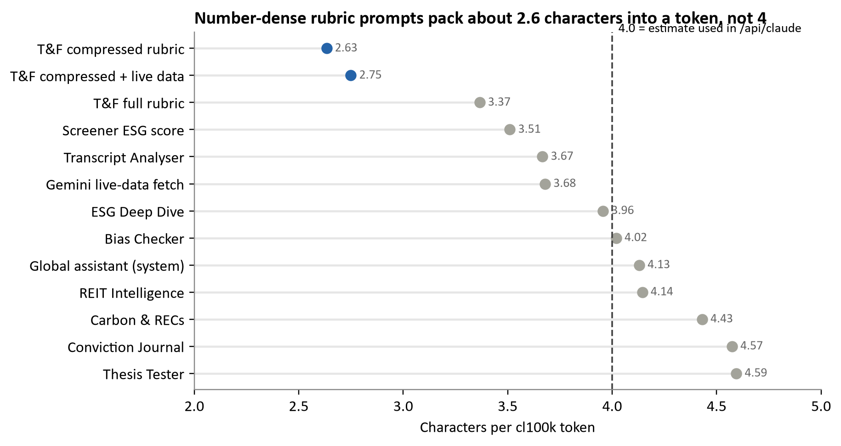
Figure 3: Characters per token for each of the 13 production prompts (cl100k; o200k agrees within 2%)
Threshold expressions such as ">=20%=+7 | 15-19%=+5" break into many short tokens, because digits, percent signs, operators and separators tend to be tokenized individually. As a result the estimator undercounts the compressed rubric by 34.2% and the full rubric by 15.9%, while it overcounts plain-language prompts such as Thesis Tester by 14.9%. Unicode decoration is not the cause: it accounts for only 118 of the 3,645 tokens in the full prompt, and converting it to ASCII saves 26 tokens (0.7%). In practice, a quota guard built on the heuristic would admit the compressed prompt believing it costs 1,034 tokens when it actually costs 1,571.

4.4 Additional Token-Saving Mechanisms
Table 6: Token-saving mechanisms identified in the source code
Mechanism | Location | Effect
Retrieval returns plain "Label: Value" lines only | callCollaborative, phase 1 (268-token prompt, 1,200-token cap) | Live data adds only 166 tokens to the scoring prompt
Compact single-purpose prompt | Screener ESG score (331 + 250 tokens) | About 581 tokens per security
Strict JSON-only output contracts | All analysis features | No conversational filler in responses
12-hour client cache keyed on stock and half-day | Research page | Repeat queries cost nothing and return the same score
7-day cache for AI ESG scores; 24-hour cache for quotes | Screener routes | Avoids re-scoring the universe
Per-feature output budgets of 250 to 2,500 tokens | Every call site | Reservation sized to each JSON schema

4.5 Open Issue: Conversation Growth
The global assistant resends its 679-token system prompt and the entire conversation on every turn. If each turn adds about 170 tokens, turn k costs roughly 679 + 170k input tokens, so a ten-turn conversation consumes about 16,140 input tokens, or 1.9 times the 8,490 tokens that ten independent questions would require. A sliding window over recent turns, or a running summary, would bound this growth.

5. Design of Experiments
Seven experiments were designed and executed offline, and an eighth, live trial is specified for later execution. Research questions, hypotheses, variables and decision rules were fixed before any script was run, and thresholds were not adjusted after results were observed.

5.1 Research Questions
- RQ1 (Efficiency): Can a free-tier, multi-provider hierarchy serve a rubric-heavy financial analysis within published rate limits?
- RQ2 (Tokenization): How accurate is the platform's token accounting, and which properties of text drive token cost?
- RQ3 (ESG validity): Does the rule-based ESG engine discriminate between companies, or does it mainly restate sector membership?
- RQ4 (Robustness): How sensitive are ESG tiers and DV Score bands to small input errors?
- RQ5 (Calibration): Does the DV Score rubric produce the distribution its own anchors claim, with 50 representing the median NSE-500 company?
- RQ6 (Reliability): How likely is a request to fail outright, and how often is it answered by a model other than the intended one?

5.2 Hypotheses and Decision Rules
Table 7: Pre-registered hypotheses and decision rules
ID | Hypothesis | Decision rule | Test
H1 | The compressed prompt cuts input tokens by at least 50% and brings one T&F call under 6,000 TPM | Reduction >= 50% and prompt + reservation < 6,000 | E1
H2 | Compressed and full rubrics yield the same DV Score on identical live data | Mean absolute difference <= 3 points; paired test p > 0.05 | P1 (live)
H3 | Repeated runs at temperature 0 give a stable score | Within-stock SD <= 2 points; band unchanged in >= 90% of stocks | E6, P1
H4 | The ESG composite carries company-level information beyond sector | Sector eta-squared < 0.80 | E2
H5 | ESG tiers are robust to a one-point governance error | <= 10% of securities change tier | E3, E4
H6 | A company at the Indian median on every KPI scores about 50 | Score within 50 +/- 5 | E5
H7 | The cascade achieves at least 99.9% availability | 1 - product of p(fail) >= 0.999 at 10% per-tier failure | E7

5.3 Variables and Controls
Table 8: Independent, dependent and controlled variables
Type | Variable | Levels or values
Independent | Prompt variant | Full rubric; compressed; compressed + live data
Independent | Tokenizer | cl100k_base; o200k_base (tiktoken 0.14.0)
Independent | Promoter pledge and holding | Null (no BSE data); Monte Carlo draws; +/-1 G-point shock
Independent | Retrieval noise (relative error) | 0%, 5%, 10%, 15%, 20%, 30%
Independent | Per-tier provider failure rate | 5%, 10%, 20%, 30%
Dependent | Token count; characters per token; estimator error | Integer; ratio; percentage
Dependent | ESG tier, composite, transition risk | A+ to D; 1-10; Very Low to Very High
Dependent | DV Score; verdict band | 5-95; six bands
Controlled | Scoring code | Unmodified copies of lib/esgScoring.ts and the rubric in lib/claude.ts
Controlled | Randomness | Linear congruential generator, seeds 20261025 (ESG) and 7 (rubric)
Controlled | Test stock for prompt extraction | "Reliance Industries" in every template

5.4 Datasets
- D1 - production prompt corpus: 13 prompt templates extracted programmatically from the source files and evaluated with the test stock.
- D2 - stock universe: all 532 securities in lib/stockSeed.ts (150 large-cap, 225 mid-cap and 157 small-cap) across 28 sectors, including 4 REITs and 5 InvITs.
- D3 - synthetic company panel (simulated): 20,000 companies drawn from distributions centred on the Indian benchmarks written into the rubric, for example ROE ~ N(15%, 7%), revenue growth ~ N(12%, 10%) and P/E relative to sector median ~ lognormal(1.05, 0.4). The panel is used only to test the mechanics of the rubric, not to describe the market.

5.5 Baselines and Evaluation Metrics
Table 9: Baselines used for each experiment
Experiment | Baseline
E1 token audit | Uncompressed rubric, and the code's own characters / 4 estimator
E2-E4 ESG engine | Sector-only model: the composite implied by the sector table alone
E5-E6 rubric | Noise-free score of the same synthetic company
E7 cascade | A single provider (Gemini only)

- Token metrics: BPE token count, characters per token and estimator error = (estimate - actual) / actual.
- Explained variance: eta-squared = between-sector sum of squares / total sum of squares, on the ESG composite.
- Tier-flip rate: share of securities whose tier changes under a perturbation.
- Modal-tier stability: for each security, the share of Monte Carlo draws that land on its most frequent tier.
- Repeatability: within-company SD, 95% confidence interval (t-distribution, 9 degrees of freedom, t = 2.262) and band-flip share over ten runs.
- Availability: 1 minus the product of per-tier failure probabilities, plus the share of requests answered by each tier.

5.6 Experiment Register
Table 10: Register of experiments and their iteration counts
ID | Procedure | Iterations | Status
E1 | Token audit of 13 prompts x 2 tokenizers | Deterministic | Completed
E2 | ESG engine over 532 securities without BSE data | Deterministic | Completed
E3 | +/-1 G-point shock on all 532 securities | 1,064 scorings | Completed
E4 | Monte Carlo of pledge and holding uncertainty | 10,000 draws x 532 = 5.32 million scorings | Completed
E5 | DV-rubric population simulation | 20,000 companies | Completed
E6 | Repeated-run retrieval-noise trial | 1,000 companies x 10 runs x 6 levels = 60,000 scorings | Completed
E7 | Cascade availability (analytic) | 4 failure rates x 2 routes | Completed
P1 | Live trial: 30 Nifty-100 stocks x 2 prompts x 5 runs x 3 days | 900 calls | Specified (Section 10.6)

6. Data Collection and Management
The platform already records much of what a research log requires: timestamps, inputs, user, feature and cached outputs. What it does not persist is the AI-side evidence: the provider that answered, latency, actual token usage, raw output and errors. These currently exist only in transient console logs.

6.1 Data Sources
Table 11: Data sources, refresh policies and validation rules
Source | Fields collected | Refresh | Validation in code
Yahoo Finance v7 quote (batches of 50; .NS then .BO) | Price, market cap, trailing P/E, P/B, dividend yield, 52-week range | Stale after 24 h | Rows without a price skipped; values rounded; upsert preserves detailed metrics
BSE shareholding API | Promoter holding %, pledge %, quarter date | On demand; 300 ms spacing; 6 s timeout | NaN mapped to null; two field-name variants accepted
Gemini + Google Search (Tier 0) | About 30 "Label: Value" metric lines | Per request | Accepted only if longer than 150 characters
LLM scoring output | DV Score, 14 ratios, ratio context, ESG, bull and bear cases, verdict | Per request; 12 h cache | JSON extraction and repair; UI falls back to "N/A"
AI ESG score (screener) | E, S, G (0-10), tier, risk, note | Every 7 days or forced | Clamped and rounded; tier and risk whitelisted; note truncated to 200 characters
Seed universe | 532 tickers with sector, industry, exchange and size bucket | Per release | Ticker is primary key; insert ignores conflicts
User activity | User, feature, stock, timestamp | Every AI call | Non-blocking; archived after 90 days

6.2 Storage Model
Neon Postgres holds 15 tables defined in lib/schema.ts. Five are directly relevant to research use.
Table 12: Database tables relevant to experimental evidence
Table | Research role | Timestamp fields
activity_logs | One row per AI call: user, feature, stock | created_at
daily_stats | Counts per date, feature and stock, retained after the 90-day roll-up | date
stock_universe | ESG matrix: E, S, G, tier, risk, BRSR flag, pledge, holding, BSE code, notes | created_at, esg_updated_at, shareholding_date
stock_metrics | Cached fundamentals, DV Score column and raw provider payload (jsonb) | fetched_at, updated_at
users.tokens_used | Running token estimate per user | None (cumulative)

Rule-set versions are stored as constants (ESG_SCORING_VERSION = v1.0-june2026; TERMS_VERSION = v1.0-july2026), which is sound practice. However, the version is not written onto each scored row, so a stored score cannot later be linked to the rule set that produced it.

6.3 Existing Data-Quality Controls
- Input sanitisation: stock names are stripped of angle brackets, quotes, back-ticks, braces and back-slashes and truncated to 50 characters before reaching a prompt, which limits prompt injection through the search box.
- Output validation: enumerated outputs are checked against whitelists, numeric scores are clamped and free text is truncated.
- Fail-safe logging: every tracking write is wrapped so that a database error cannot break the user's response.
- Retention: logs older than 90 days are aggregated and then deleted, limiting stored personal data while preserving trends.

6.4 Gaps for Research Use
1. No per-run AI log. Provider, model, latency, actual token counts, JSON-repair events and fallback errors are not stored, although all four provider APIs return usage metadata.
2. Estimated rather than measured tokens. The first term of the estimate is biased by -34% to +15% (Section 4.3), and the second term counts the output cap rather than actual output.
3. DV Scores are not persisted for the T&F page; they reside only in a client cache, so drift over time cannot be studied.
4. No ground truth. Subsequent price returns and rating changes are not recorded, so no score can yet be validated against outcomes.

6.5 Proposed Run Log
A single additive table closes the first three gaps without changing any user-facing feature:
CREATE TABLE ai_runs (
id BIGSERIAL PRIMARY KEY,
created_at TIMESTAMPTZ DEFAULT now(),
user_id UUID REFERENCES users(id),
feature TEXT NOT NULL,
stock TEXT,
prompt_sha256 TEXT NOT NULL, -- exact prompt identity
rubric_ver TEXT NOT NULL, -- e.g. dv-rubric-v1, v1.0-june2026
route TEXT NOT NULL, -- collaborative | gemini | anthropic | groq | openrouter
model TEXT NOT NULL,
live_data BOOLEAN, -- did Tier 0 retrieval succeed?
tokens_in INT, tokens_out INT, -- from provider usage metadata
latency_ms INT,
json_repaired BOOLEAN,
fallback_errs JSONB, -- errors from tiers that failed
dv_score INT,
output JSONB
);

7. Iterations, Repeated Testing and Statistical Validity
A DV Score produced by a single run is a sample, not a measurement. Even a perfectly deterministic rubric converts small input errors into large output changes when an input lies near a scoring boundary. This chapter quantifies that effect.

7.1 Sources of Run-to-Run Variance
Two mechanisms cause a score to vary between runs. The model itself is non-deterministic even at temperature zero [6], and the retrieved inputs change, because a search may return a P/E of 24.1 from one page and 25.3 from another. The live trial P1 is designed to measure the first mechanism. Experiment E6 isolates the second by holding the scoring function fixed and perturbing only the data.

7.2 Experiment E6: Repeated-Run Noise Trial
Each of 1,000 synthetic companies was scored once without noise and then ten further times. In each repeat every continuous metric was multiplied by (1 + e), where e ~ N(0, sigma) and sigma ranged from 0% to 30%. Pledge levels, moving-average signals and governance flags were held constant.
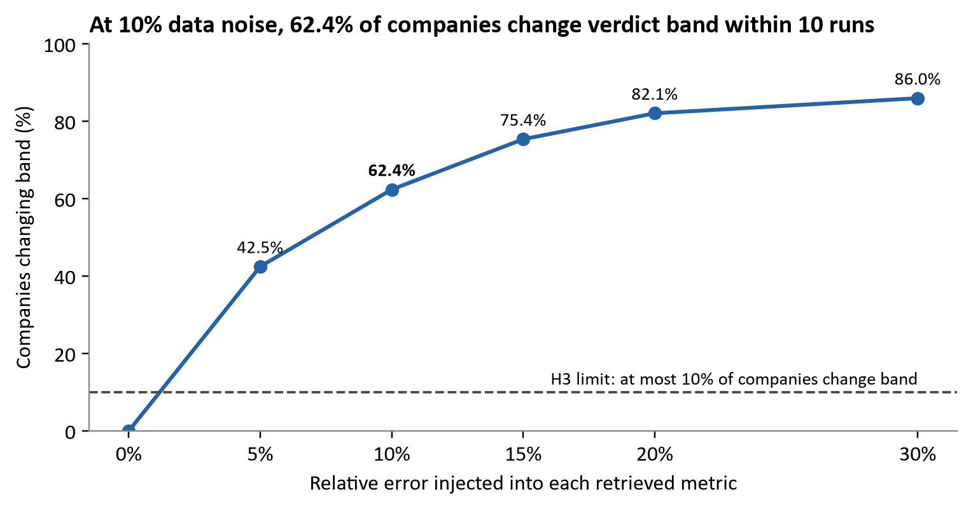
Figure 4: Share of companies whose DV verdict band changes across ten repeated runs, by noise level (E6, simulated)
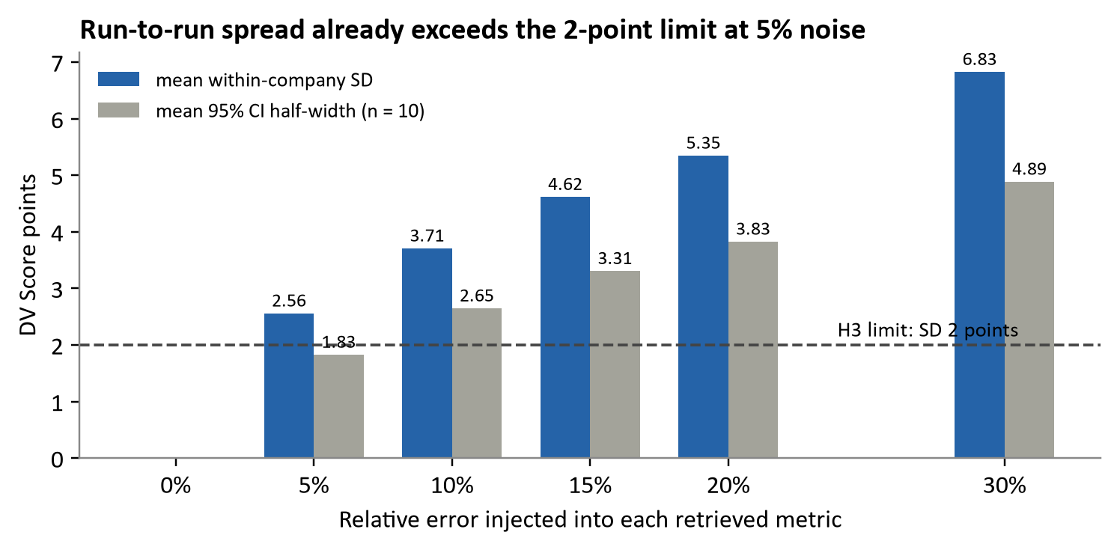
Figure 5: Mean within-company standard deviation and 95% confidence half-width by noise level (E6, simulated)
Table 13: Repeatability statistics from experiment E6 (1,000 companies x 10 runs per level)
Noise sigma | Mean SD (points) | 95% CI half-width (points) | Median |deviation| (points) | 90th percentile |deviation| | Band-flip share
5% | 2.56 | 1.83 | 2 | 6 | 42.5%
10% | 3.71 | 2.65 | 3 | 8 | 62.4%
15% | 4.62 | 3.31 | 4 | 10 | 75.4%
20% | 5.35 | 3.83 | 4 | 11 | 82.1%
30% | 6.83 | 4.89 | 6 | 14 | 86.0%

Two observations follow. Even 5% noise fails hypothesis H3: the mean SD of 2.56 points exceeds the 2-point limit, and 42.5% of companies cross a verdict band at least once in ten runs. The step-function design of the rubric is responsible; a ROE of 19.9% earns +5 whereas 20.0% earns +7. In addition, spread grows sub-linearly: the SD rises by a factor of 2.7 while noise rises by a factor of 6, because most metrics sit well inside a bucket and only those near an edge move.

7.3 Sample-Size and Precision Analysis
Table 14: Sample-size calculations and precision of key estimates
Quantity | Calculation | Result
Stocks needed in P1 to detect a 3-point mean difference (paired, alpha = 0.05, power 0.80, SD of difference assumed 5) | n = ((1.96 + 0.84) x 5 / 3)^2 | 22 stocks; 30 planned (25% buffer)
E3 tier-flip rate (247 / 532) | Wald 95% CI: 0.464 +/- 1.96 x sqrt(0.464 x 0.536 / 532) | 46.4% +/- 4.2 pts, i.e. [42.2%, 50.7%]
Monte Carlo error on any E4 proportion | sqrt(0.25 / 10,000) | At most 0.5 percentage points
E5 median of 20,000 draws | Distribution-free order-statistic CI (ranks 9,861 and 10,139) | Median 39, 95% CI [39, 39]

7.4 Threats to Validity
Table 15: Threats to validity and mitigations
Threat | Applies to | Mitigation
Construct: the rubric was re-implemented from the compressed prompt; undefined ranges score 0, whereas an LLM may interpolate | E5, E6 | Undefined ranges counted and reported (Section 8.4); P1 tests the LLM directly
Internal: synthetic input distributions drive E4-E6 | E4-E6 | Centred on the rubric's own Indian benchmarks; results labelled simulated; seeds published
External: 532 securities are not the full listed universe; no live market data | E2-E4 | Universe covers Nifty 50, Next 50, Midcap 150 and key small-caps that users search
Statistical conclusion: multiple comparisons | All | Decision rules fixed in advance; effect sizes reported alongside tests

8. Results and Comparative Analysis
The token engineering performs as designed. The scoring layers, by contrast, are less robust than their numerical precision implies: both ESG tiers and DV bands change under input errors smaller than those found in real retrieved data.

8.1 ESG Engine: Effect of Governance Data
Only 30 tickers have a mapped BSE code in NSE_TO_BSE, so 502 of the 532 securities are scored without live shareholding data. In that state the engine assigns 1 A+, 36 A, 143 B+, 151 B, 201 C and no D. Introducing realistic pledge and holding data changes the composition substantially.
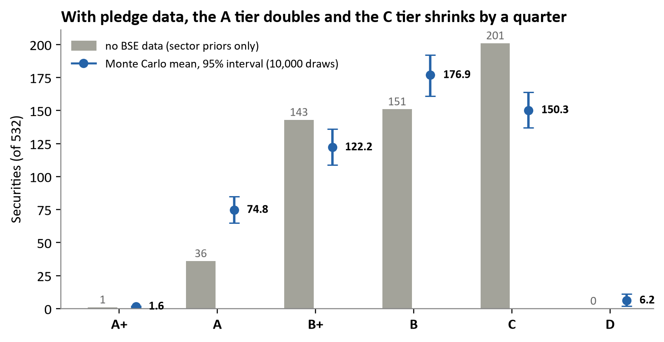
Figure 6: ESG tier counts without BSE data versus the mean of 10,000 Monte Carlo draws with 95% intervals (E2, E4)
Tier A rises from 36 to a mean of 74.8 (95% interval 65-85) and tier C falls from 201 to 150.3 (137-164). Tier D appears only when governance data exist (mean 6.2). Without pledge data the engine cannot assign a D at all: Coal India, with E = 1, averages exactly (1 + 5 + 6) / 3 = 4.0 and lands on the C cut-off.
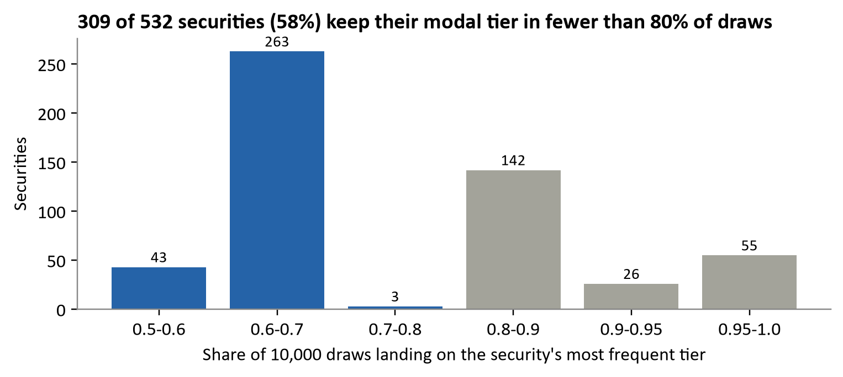
Figure 7: Distribution of modal-tier stability across 532 securities (E4, 10,000 draws)
Stability is low. Only 81 of 532 securities (15%) remain on the same tier in at least 90% of draws, while 309 (58%) do so in fewer than 80% of draws.

8.2 ESG Engine: Sector Versus Company Signal
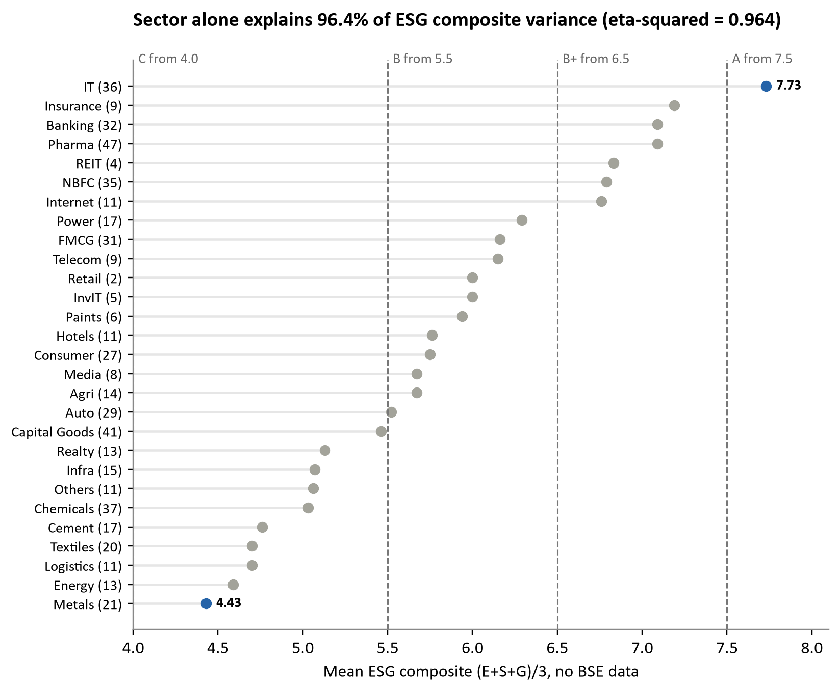
Figure 8: Mean ESG composite by sector with tier cut-offs (E2, deterministic)
The one-way effect size is eta-squared = 0.964, so hypothesis H4 is rejected. Only 16 of 532 securities (3%) have a company-specific environmental override that differs from the sector baseline; for the remaining 97% the E and S scores are fully determined by sector. Two implementation details amplify the effect.
- The BRSR proxy penalises smaller companies. The rule brsrMandated = (marketCap === "Large") grants the +1 governance bonus only to the 150 large-caps, whereas SEBI's mandate covers the top 1,000 listed companies, which includes essentially the whole seed universe.
- The researched base tier is never used. Each sector carries a tierBase value (for example D for Metals and Energy), but deriveTier() does not read it.
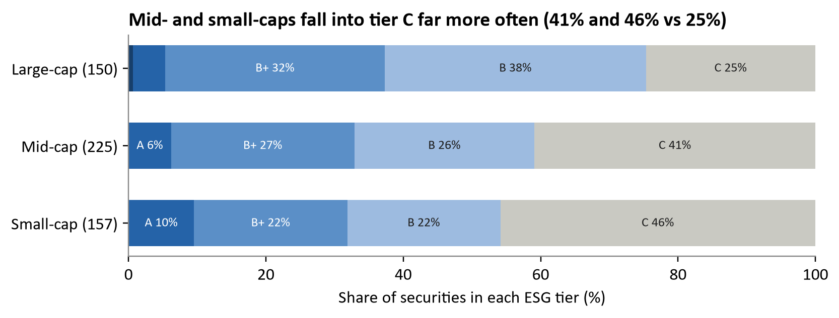
Figure 9: ESG tier mix by market-capitalisation bucket (E2)
The consequence is visible in Figure 9: 25% of large-caps fall into tier C, compared with 41% of mid-caps and 46% of small-caps.

8.3 ESG Sensitivity (E3)
Raising every G score by one point changes the tier of 105 securities (19.7%); lowering it by one point changes 143 (26.9%). Either shock changes 247 of 532 securities (46.4%, 95% CI 42.2-50.7%), so hypothesis H5 is rejected by a wide margin. The cause is structural: E and S are integers and the tier depends on their mean, so composites cluster at thirds (4.33, 5.67, 6.67) close to the cut-offs at 5.5 and 6.5.

8.4 DV Score Rubric Calibration (E5)
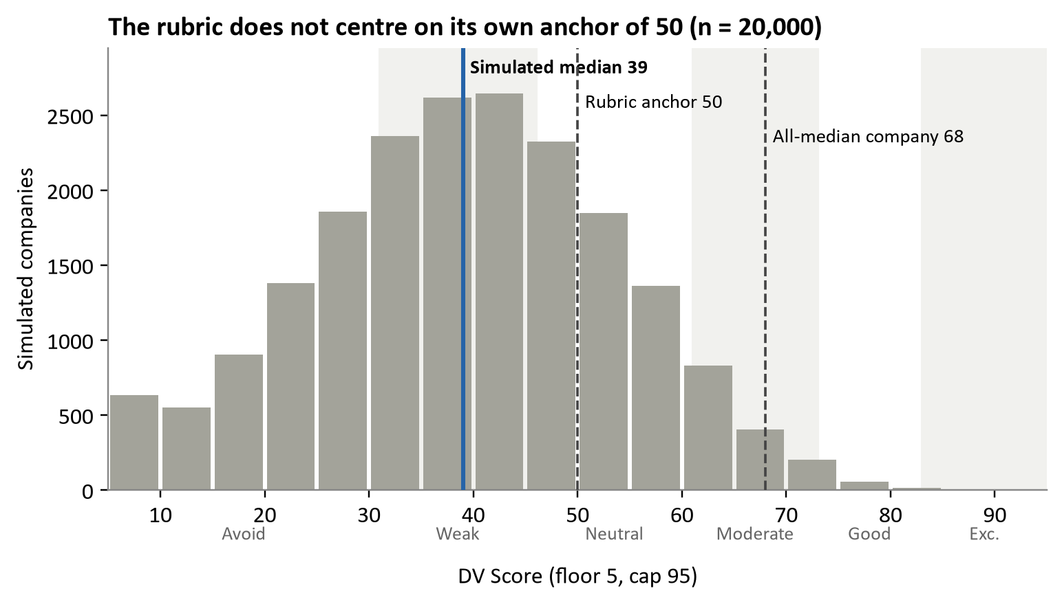
Figure 10: Distribution of DV Scores for 20,000 simulated companies, with band boundaries and reference markers (E5)
The rubric fails its own calibration check in two opposite directions, and hypothesis H6 is rejected.
- A company at the Indian median on every KPI (ROE 15%, ROCE 16%, net margin 10%, P/E at the sector median, D/E 0.45, interest cover 7x, revenue growth 12%, price above the 200-DMA, no pledge) scores 68 rather than 50. The technical block alone swings the score by 16 points, contributing +5 or -5 for the 200-DMA and +3 or -3 for the 50/200 crossover.
- Across the simulated population the median is 39 (interquartile range 29-49). Penalties are asymmetric, reaching -8 for leverage and up to -52 in combined mandatory deductions, so a weak metric costs more than a strong metric earns.
The model must reconcile an additive rubric with a holistic anchor, and the result depends on which instruction it weights more heavily. This is a direct source of the model-to-model drift that a fallback chain introduces. The compressed rubric also leaves ranges with no rule, which the model must fill by judgement:
Table 16: Ranges with no scoring rule in the compressed rubric
Metric | Range with no rule | Share of simulated companies affected
P/E relative to sector median | 15-25% below; 1.6-2.0x above | 19.1%
RSI-14 | 30-40 and 65-75 | 24.0%
Promoter pledge | 5-10% | 3.0%

8.5 Cascade Reliability (E7)
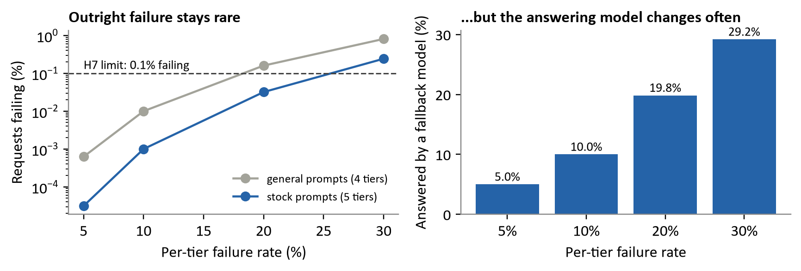
Figure 11: Outright failure rate and share of requests answered by a fallback model, by per-tier failure rate (E7)
Table 17: Cascade availability under independent provider failures
Per-tier failure rate | Availability, general prompts (4 tiers) | Availability, stock prompts (5 tiers) | Answered by a fallback model
5% | 99.9994% | 99.99997% | 5.0%
10% | 99.990% | 99.999% | 10.0%
20% | 99.84% | 99.97% | 19.8%
30% | 99.19% | 99.76% | 29.2%

Hypothesis H7 is supported at a 10% failure rate under the independence assumption. Two caveats are more important than the headline figure. Correlated failures, such as a cold start or a regional outage, violate independence. In addition, on a day when free tiers are exhausted, 20-30% of analyses may be produced by a different model whose interpretation of the rubric differs (Section 8.4). The code also contains a silent path: if the Gemini retrieval step fails, Groq still produces a score from its training data, and the user receives no indication that the figures are not live.

8.6 Summary of Effect Sizes
Table 18: Comparison of treatments against baselines
Comparison | Baseline | Treatment | Effect
Prompt tokens, full vs compressed | 3,645 | 1,571 | -56.9%
Token estimator on compressed rubric | 1,571 actual | 1,034 estimated | -34.2% error
A-tier count, no data vs Monte Carlo | 36 | 74.8 | +108%
Sector share of ESG composite variance | - | eta-squared = 0.964 | Very large (> 0.14)
DV band changes at 10% noise | 0% (noise-free) | 62.4% | -

9. Real-Time Visualisation and Dashboards
DhanVeda already contains the components needed for live dashboards: an administrative console, Recharts and TradingView embeds. What it lacks is an experiment view, and such a view depends on the run log proposed in Section 6.5.

9.1 Visualisation Already in the Product
Table 19: Existing visualisation surfaces in the platform
Surface | Content | Technology | Refresh
/admin, Overview | Users, feature usage and per-user token totals coloured by load (amber > 10,000; red > 50,000); filter by today, 7 days, 30 days or all time | React, server aggregates | On load
/admin, Activity | Raw feed of every AI call: user, feature, stock, time | Admin activity API | On load
/admin, Users / Feedback / Contacts | Account management and suspension; support tickets with status | Drizzle queries | On load
Portfolio (/money) | Allocation pie, monthly investment bars, holdings by asset type, P&L by asset | Recharts | Live, client-side
VentureIQ | 12-dimension radar for a business idea; projected P&L line | Recharts | Per analysis
T&F Analysis | DV Score ring coloured by band; 14-KPI table with good / neutral / bad signals | React | Per analysis
Stock charts | Candlesticks with a MACD study | TradingView widget | Real time

9.2 Proposed Research Dashboard
The figures in this report are static snapshots of offline experiments. A live dashboard should answer the same questions continuously.
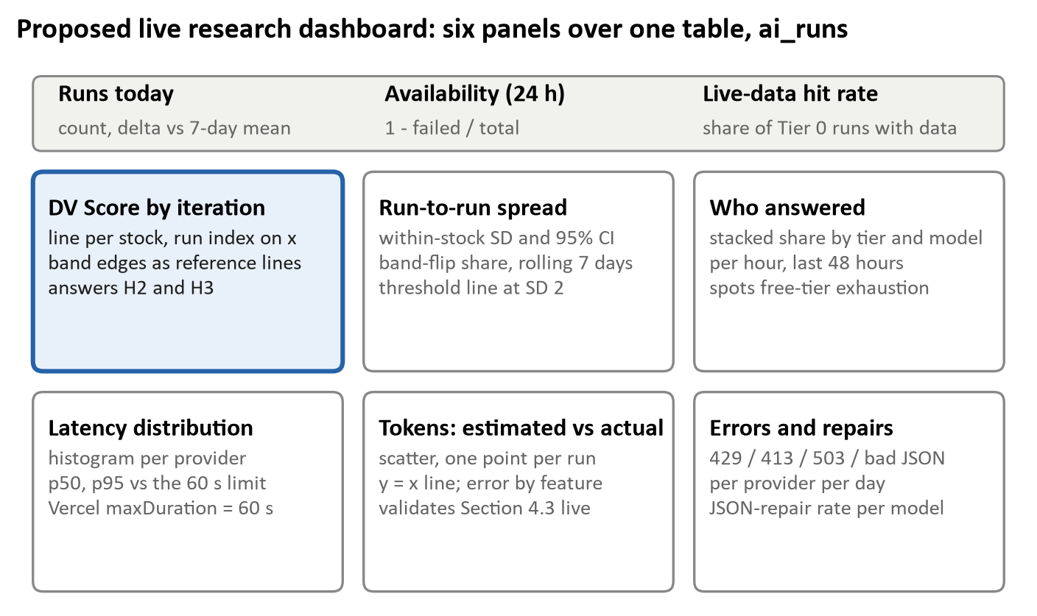
Figure 12: Proposed layout of a live research dashboard driven by the ai_runs table
1. Every chart displays its reference line: the SD limit of 2, the 60-second timeout, the 6,000 TPM cap and the band edges. A value cannot be judged without its threshold.
2. Spread is shown alongside the mean: score panels show the 95% interval and latency panels show p95 as well as p50.
3. Series are grouped by rubric version, so that a prompt change starts a new series instead of silently continuing the old one.
4. No user identifiers appear on the research view; data are aggregated by feature, stock and provider, consistent with the 90-day retention policy.

10. Reproducibility and Evidence
Every figure in Chapters 4, 7 and 8 can be regenerated with three scripts, fixed random seeds and the four source files identified below. The project is not under version control, so these hashes are currently the only means of pinning the code version; placing the repository under git is the least costly way to strengthen its research credibility.

10.1 Code Identity
Table 20: SHA-256 fingerprints of the source files used in the experiments
File | SHA-256 (first 16 hex characters) | Used by
lib/claude.ts | 272d588a977e6a06 | E1, E5-E6, E7
lib/esgScoring.ts | fb2756f10f738a77 | E2-E4
lib/stockSeed.ts | 57680a094ce00195 | E2-E4
app/(dashboard)/research/page.tsx | 1005ea2e16fb7f41 | E1 (full prompt)

10.2 Environment
Table 21: Software environment used for all experiments
Component | Version
Node.js (native TypeScript type-stripping used to import the ESG engine unchanged) | 24.19.0
Python | 3.14.6
tiktoken (cl100k_base, o200k_base) | 0.14.0
matplotlib (figures in this report) | 3.11.2
Operating system | Windows 10 Pro 10.0.19045
Experiment run date | 25 October 2026

10.3 Experiment Scripts
Table 22: Experiment scripts, seeds and outputs
Script | Experiments | Seed | Output
extract.js, tok.py | E1: evaluates each prompt template and tokenizes it | None (deterministic) | prompts.json, tokens.json
esg_exp.ts | E2-E4: imports the unmodified ESG engine and seed universe | 20261025 | esg_results.json
rubric_exp.js | E5-E6: rule-by-rule re-implementation of the compressed rubric | 7 | rubric_results.json
figs.py | Redraws every figure from the JSON outputs | n/a | figs/*.png

node extract.js prompts.json
python tok.py prompts.json tokens.json
node esg_exp.ts esg_results.json # Node 23.6+ strips TypeScript types natively
node rubric_exp.js rubric_results.json
python figs.py

10.4 Reproducibility Controls in the Product
- Temperature 0 for every analysis call (0.3 only for venture documents).
- Versioned rule sets: ESG_SCORING_VERSION and TERMS_VERSION constants, and a dated header in the ESG module.
- Identical answers within a half-day: the T&F cache key combines stock, date and 12-hour bucket.
- Raw provider payloads stored in stock_metrics.raw_data, so a quote can be traced to its source.

10.5 Missing Evidence
Table 23: Evidence gaps and proposed remedies
Missing evidence | Consequence | Remedy
Version control | No diff between the rubric that produced a score and the current rubric | Initialise git; tag each rubric change
Per-run AI log | Run-to-run variance and provider drift cannot be measured in production | ai_runs table (Section 6.5)
Version stamp on scored rows | ESG rows cannot be tied to a rule-set version | Add esg_version to stock_universe
Persisted DV Scores | No longitudinal record for back-testing | Write T&F results to stock_metrics.dv_score, a column that currently no route populates

10.6 Specified Live Trial (P1)
Trial P1 tests hypotheses H2 and H3 against real models. It was not executed for this report, in order to avoid consuming the project's API quota without the owner's approval.
- Sample: 30 Nifty-100 stocks, stratified into 10 large financials, 10 IT/FMCG/pharma and 10 cyclicals.
- Arms: full versus compressed prompt, each supplied with the same cached Gemini data block so that retrieval noise is held constant.
- Repeats: five runs per arm per stock on each of three days, giving 30 x 2 x 5 x 3 = 900 calls.
- Pinning: a single provider per arm (Groq Llama-3.3-70B), so that model drift is not confounded with prompt effects; a second pass on Gemini measures provider effects.
- Analysis: paired t-test or Wilcoxon signed-rank test on per-stock means (H2); within-stock SD and band-flip share (H3); ICC(2,1) for test-retest reliability, with ICC >= 0.9 as the acceptance criterion.
- Budget: approximately 900 x 4,200 = 3.8 million tokens, about 1.3 million per day over three days; current free-tier daily limits should be confirmed before execution.

11. Conclusions, Impact and Future Work
DhanVeda solves its central engineering problem: it delivers an India-calibrated, rubric-intensive financial analysis at close to zero cost, through a cascade that rarely fails outright. Its scoring layers, however, are more precise than they are reliable. The token engineering is validated, whereas ESG tiers and DV bands shift under small input errors, and no score has yet been tested against market outcomes.

11.1 Hypothesis Outcomes
Table 24: Outcome of each pre-registered hypothesis
ID | Hypothesis | Outcome | Evidence
H1 | Compression >= 50% and call fits 6,000 TPM | Supported | -56.9%; 4,071-4,237 vs 6,145 tokens per call (E1)
H2 | Compressed and full rubrics agree within 3 points | Not yet tested | Live trial P1 specified
H3 | Repeated runs stable (SD <= 2; >= 90% unchanged band) | Not supported (simulated) | SD 2.56 and 42.5% band changes at 5% noise (E6)
H4 | ESG composite carries signal beyond sector | Rejected | eta-squared = 0.964 (E2)
H5 | <= 10% tier changes under 1-point G error | Rejected | 46.4% (95% CI 42.2-50.7%) (E3)
H6 | All-median company scores 50 +/- 5 | Rejected | 68 for all-median company; population median 39 (E5)
H7 | Cascade availability >= 99.9% | Supported (independence) | 99.990% at 10% per-tier failure (E7)

11.2 Discussion
1. Token budgeting was the decisive engineering challenge, and it was handled well. The developer's estimates of about 6,200 tokens for the full call and about 1,800 for the compressed prompt lie within 1% of the measured full-call total and are conservative for the compressed prompt. The weakness lies in accounting: the characters / 4 rule undercounts number-dense rubrics by up to 34%.
2. Separating retrieval from scoring addresses the most serious failure mode reported in the literature [5]. What is missing is a visible signal to the user when the retrieval step fails.
3. Being rule-based does not make a system robust. Both the ESG engine and the DV rubric are step functions applied to noisy inputs; integer sub-scores clustered near cut-offs, and point jumps such as +5 to +7 at ROE 20%, convert small data errors into category changes, which is precisely what a retail user acts upon.
4. In its current state the ESG engine behaves largely as a sector classifier. With 97% of companies on sector defaults and the BRSR flag tied to market capitalisation, the tier mostly reflects sector membership. The BSE pledge pathway is the correct remedy but currently covers only 30 tickers.

11.3 Limitations
- Experiments E4-E6 rely on simulated inputs; their absolute values depend on assumed distributions, although the structural conclusions (boundary sensitivity and anchor mismatch) do not.
- The rubric was re-implemented deterministically; an LLM may smooth undefined ranges or misapply rules, which could either increase or reduce variance.
- No live LLM calls, latency measurements or production records were used.
- Gemini's tokenizer was not measured; cl100k and o200k agree within 2%, but Gemini may differ.

11.4 Practical and Societal Impact
- Access: a first-time investor receives an institutional-style 14-KPI analysis benchmarked to Indian sector norms in 10-15 seconds at no cost, as an alternative to paid research or social-media tips.
- Investor protection: the rubric encodes red flags that retail investors frequently overlook, such as pledge above 35%, auditor resignation, regulatory action and receivables outgrowing revenue, and it prohibits a "Buy" verdict for scores below 46.
- Behavioural discipline: Thesis Tester, Bias Checker and Conviction Journal target the overtrading and overconfidence reflected in SEBI's 93% loss finding [2].
- Green-finance literacy: rooftop-solar NPV and IRR with the PM Surya Ghar subsidy, REC markets, REITs and ESG screening make sustainable investing accessible to retail users.
- Responsible framing: the assistant presents content as education rather than SEBI-registered advice, and users accept versioned terms before use.

11.5 Recommendations (Ranked by Impact per Unit Effort)
1. Display the DV Score as a range (score +/- 1 SD) and flag scores within 3 points of a band edge as borderline.
2. Label results "based on model memory, not live data" whenever Tier 0 retrieval fails.
3. Correct the ESG defects: apply brsrMandated to the top-1,000 universe, use tierBase as a floor or ceiling, and extend NSE_TO_BSE beyond 30 tickers.
4. Define the P/E, RSI and pledge ranges that currently have no rule, and re-anchor the score bands to the observed distribution or remove the "50 = median" statement.
5. Log every run in ai_runs and record actual token usage from provider metadata.
6. Place the project under git and tag rubric versions.
7. Limit chat context to a sliding window of recent turns.

11.6 Future Research Directions
- Outcome validation: persist DV Scores and test whether score bands predict 6- and 12-month excess returns over the Nifty 500 using rank correlation and decile spreads.
- Quality-aware routing: replace failure-only escalation with a learned router, in the spirit of RouteLLM [8], that escalates when the cheaper model's output fails rubric-consistency checks.
- Smooth scoring: replace step functions with piecewise-linear interpolation between thresholds to reduce boundary-driven variance.
- Learned ESG signals: extract environmental and social evidence from BRSR filings and measure agreement with global agencies where coverage exists.
- Indic-language access: measure tokenization cost and answer quality for Hindi, Telugu and Tamil prompts, for which BPE tokenizers are typically much less efficient than for English.

References
[1] Business Today, "NSE trading accounts cross 25 crore; unique investors at 12.7 crore," 13 Feb. 2026 (citing NSE press release of 12 Feb. 2026). [Online]. Available: https://www.businesstoday.in/markets/story/nse-trading-accounts-cross-25-crore-unique-investors-at-127-crore-516069-2026-02-13
[2] Securities and Exchange Board of India, "Updated SEBI study reveals 93% of individual traders incurred losses in equity F&O between FY22 and FY24," PR No. 22/2024, 23 Sep. 2024; summarised by Taxmann. [Online]. Available: https://www.taxmann.com/post/blog/93-of-1-crore-fo-traders-saw-rs-2l-avg-loss-while-top-3-5-faced-rs-28l-avg-loss-incl-costs-sebi/
[3] S. Wu et al., "BloombergGPT: A large language model for finance," arXiv:2303.17564, 2023.
[4] A. Kim, M. Muhn, and V. Nikolaev, "Financial statement analysis with large language models," arXiv:2407.17866, 2024 (withdrawn by the authors, Feb. 2025).
[5] P. Islam et al., "FinanceBench: A new benchmark for financial question answering," arXiv:2311.11944, 2023.
[6] B. Atil et al., "Non-determinism of 'deterministic' LLM settings," arXiv:2408.04667, 2024 (rev. 2025).
[7] L. Chen, M. Zaharia, and J. Zou, "FrugalGPT: How to use large language models while reducing cost and improving performance," arXiv:2305.05176, 2023.
[8] I. Ong et al., "RouteLLM: Learning to route LLMs with preference data," in Proc. ICLR, 2025; arXiv:2406.18665.
[9] H. Jiang, Q. Wu, C.-Y. Lin, Y. Yang, and L. Qiu, "LLMLingua: Compressing prompts for accelerated inference of large language models," in Proc. EMNLP, 2023; arXiv:2310.05736.
[10] A. K. Singh and D. J. Strouse, "Tokenization counts: The impact of tokenization on arithmetic in frontier LLMs," arXiv:2402.14903, 2024.
[11] F. Berg, J. F. Koelbel, and R. Rigobon, "Aggregate confusion: The divergence of ESG ratings," Review of Finance, vol. 26, no. 6, pp. 1315-1344, 2022, doi: 10.1093/rof/rfac033.
[12] Groq, "Rate limits," GroqCloud documentation. [Online]. Available: https://console.groq.com/docs/rate-limits (accessed 25 Oct. 2026).
[13] OpenAI, "tiktoken: a fast BPE tokeniser for use with OpenAI's models," version 0.14.0, software library. [Online]. Available: https://github.com/openai/tiktoken

Appendix A. Glossary
Table 25: Glossary of terms used in the report
Term | Meaning
DV Score | DhanVeda composite of five 20-point categories (profitability, valuation, financial health, growth, technical and governance) less mandatory deductions; range 5-95
BPE | Byte-pair encoding, the tokenization family used by GPT-style and Llama-3 models
cl100k / o200k | tiktoken vocabularies of approximately 100,000 and 200,000 tokens
eta-squared | Share of total variance explained by group membership (here, sector)
Promoter pledge | Share of promoter-held shares pledged as loan collateral; SEBI monitors levels above 20%
Band flip | A change of verdict band (Avoid, Weak, Neutral, Moderate, Good, Exceptional) between runs

Appendix B. Raw Tokenization Data
Table below lists every production prompt measured in experiment E1. Estimator error is (characters / 4 - cl100k) / cl100k.
Table 26: Raw tokenization results from experiment E1
Prompt | Characters | cl100k | o200k | chars/4 estimate | Estimator error | Output cap
T&F full rubric | 12,269 | 3,645 | 3,618 | 3,067 | -15.9% | 2,500
T&F compressed | 4,137 | 1,571 | 1,575 | 1,034 | -34.2% | 2,500
T&F compressed + live data | 4,776 | 1,737 | 1,739 | 1,194 | -31.3% | 2,500
Global assistant (system) | 2,804 | 679 | 671 | 701 | +3.2% | 420
Thesis Tester | 1,631 | 355 | 360 | 408 | +14.9% | 1,400
Carbon and RECs | 1,214 | 274 | 272 | 304 | +10.9% | 1,100
REIT Intelligence | 1,206 | 291 | 290 | 302 | +3.8% | 1,100
Screener ESG score | 1,162 | 331 | 327 | 290 | -12.4% | 250
Gemini live-data fetch | 986 | 268 | 261 | 246 | -8.2% | 1,200
ESG deep dive | 914 | 231 | 234 | 228 | -1.3% | 2,000
Bias Checker | 414 | 103 | 106 | 104 | +1.0% | 1,000
Transcript Analyser (template) | 341 | 93 | 96 | 85 | -8.6% | 1,200
Conviction Journal | 279 | 61 | 60 | 70 | +14.8% | 600

Appendix C. Originality and Similarity Self-Check
Similarity checkers such as Turnitin report the share of a document that overlaps with existing sources, usually as a similarity index together with a ranked list of matching sources; scores below about 15-20% are generally regarded as acceptable when all sources are cited. Institutional databases are not accessible from this project, so a transparent self-check was performed instead and is reported here.
Method. All running prose of this report (abstract, paragraphs and list items; tables, figures, code and references excluded) was normalised to lower-case words, giving 5,188 words and 5,181 overlapping eight-word sequences (shingles). These were compared with the full abstracts of the eight cited arXiv papers, retrieved from the arXiv API. An eight-word shared sequence is the usual threshold at which overlap begins to indicate copied rather than coincidental wording.
Table 27: Eight-word shingle overlap between this report and the abstracts of cited papers
Source abstract | Shared 8-word shingles | Share of report shingles | Longest shared run (words)
FrugalGPT | 0 | 0.00% | 3
Singh2024 | 0 | 0.00% | 4
FinanceBench | 0 | 0.00% | 4
BloombergGPT | 0 | 0.00% | 5
Atil2024 | 0 | 0.00% | 3
Kim2024 | 0 | 0.00% | 3
LLMLingua | 0 | 0.00% | 3
RouteLLM | 0 | 0.00% | 3

Result. The combined overlap with all eight sources is 0.00% of the report's eight-word sequences. Findings from the literature are restated in the author's own words and attributed with numbered citations. This self-check covers only the cited research abstracts; it does not replace an institutional similarity scan, which should be run on the final document before submission.

