Application Installer
1. Purpose
This document explains the process of creating an installer package for a WPF Application.
The installer will generate:
- Setup.exe (bootstrapper)
- MyAppInstaller.msi (main installer package)
End-users can install the application simply by double-clicking Setup.exe.
2. Prerequisites
- Visual Studio 2022: The development environment for your application. Microsoft Visual Studio Installer Projects An official extension required to create setup projects.
- To Install: Go to Extensions > Manage Extensions in Visual Studio, search for "Microsoft Visual Studio Installer Projects," download and extract it, and restart Visual Studio.
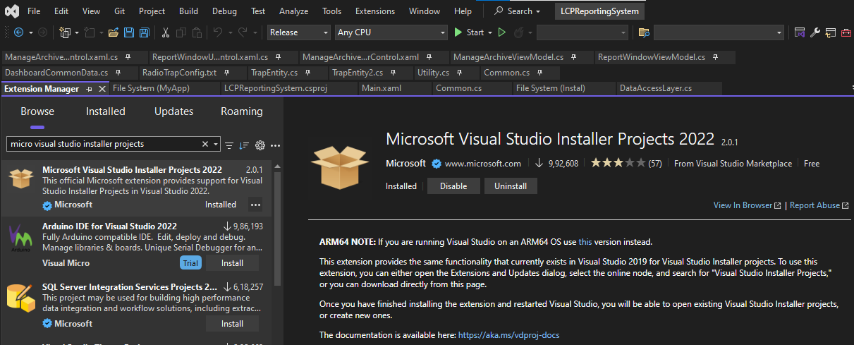
3. Build the Main Application
- To Open the Application solution in Visual Studio. Go to Build > Build Solution (or press Ctrl + Shift + B).
- Confirm that the output files (MyApp.exe, .dll, and any content files) are generated in the following directory.
4. Add a Setup Project
- In the Solution Explorer, right-click on your solution (which already having WPF app) and select Add > New Project
- Then, in the search bar select Setup Project. Select the Setup Project template and click on Next button.
- Then create new project Name (MyAppInstaller) and click on Create button.
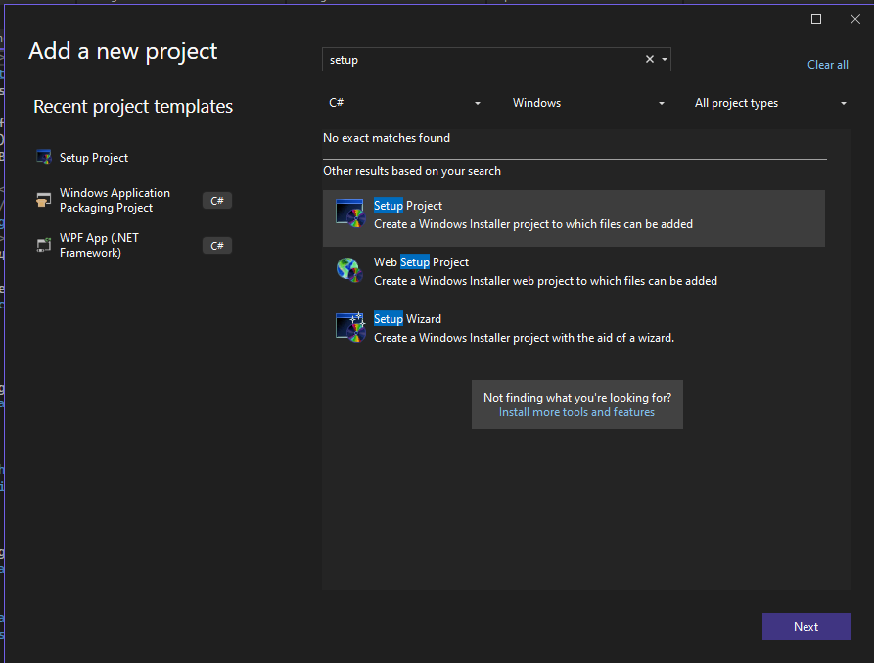

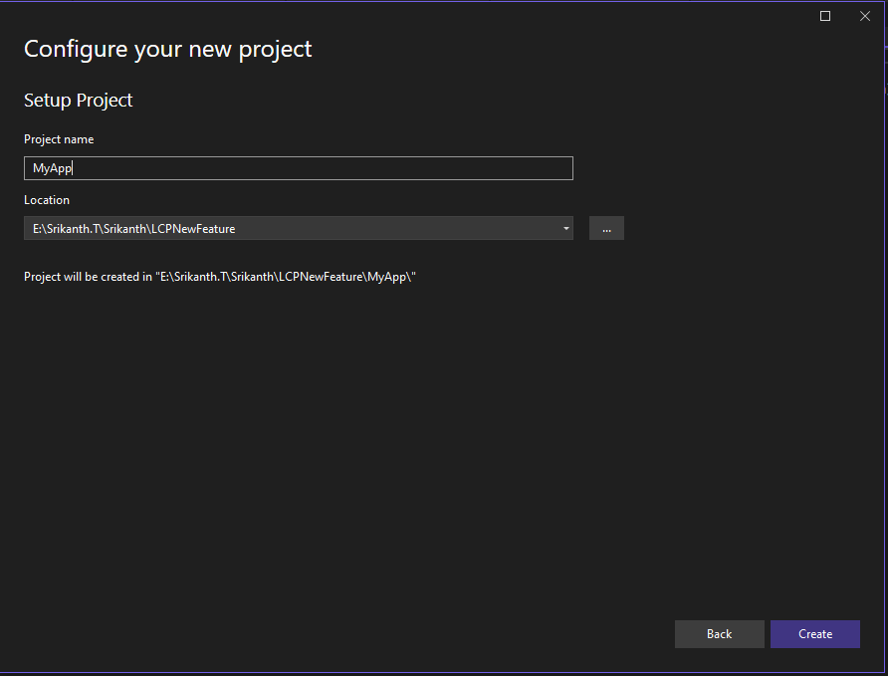

5. Configure File System View
In the Solution Explorer to Right-click on the (MyAppInstaller) project. Go to View > File System. This will open a window showing three menus…
1.Application Folder
2.User Desktop
3.Users Programs Menu
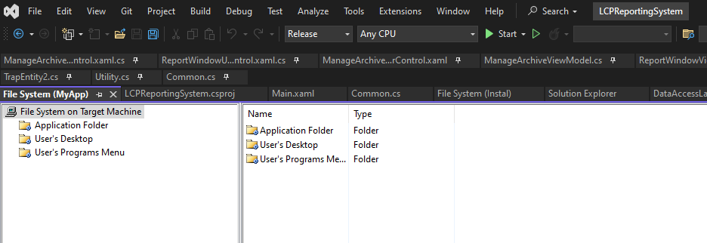
Add Application Files……
- Right-click on the Application Folder open popup window Select Add > Project Output....From the dropdown menu, choose your MyApp Application project.
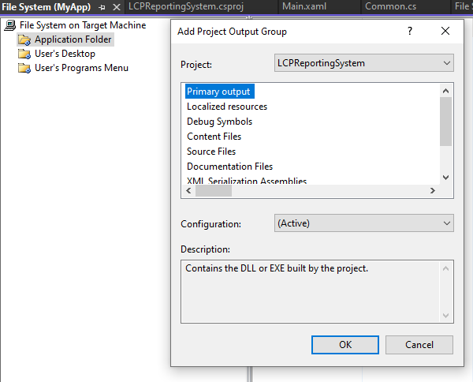
- Select Primary output and click OK button. This step adds your application's compiled .exe and .dll files
Add Content Files….
- If you have other project content (e.g., images, JSON files, etc.), again Right-click Application Folder > Add > Project Output... > Content Files.
- If files are still missing, you may need to add them manually Right-click Application Folder > Add > Folder, then Add > File... and select the files from your bin\Release to copy from directory.

5.1 Create Shortcuts
In the Application Folder, right-click the Primary output. Select Create Shortcut to Primary output from MyAppInstaller. Rename the new shortcut to MyApp Application.
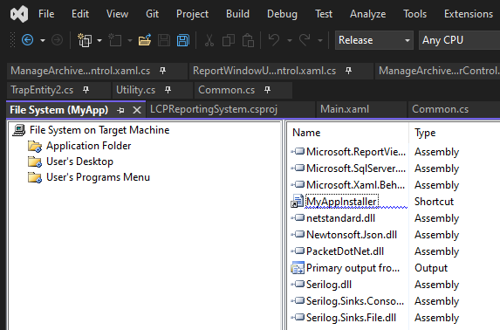

6. Set Properties
- Right-click on the MyAppInstaller project in Solution Explorer and select >Properties.
- Set properties like Product Name, Company Name, and Version (if needed).
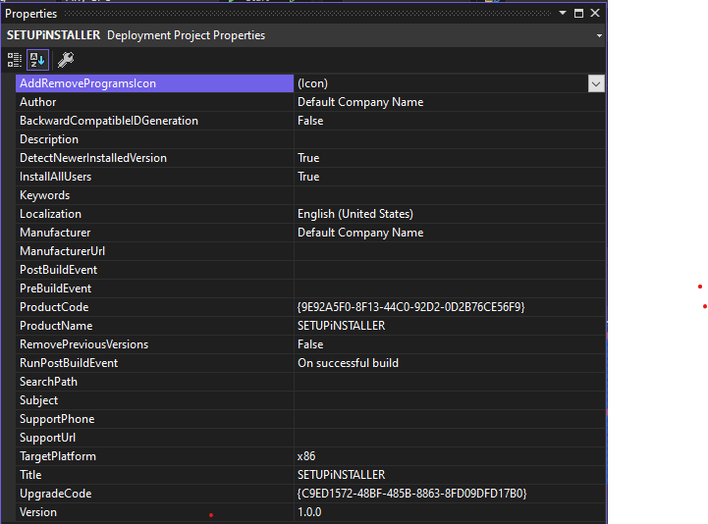

7. Build the Installer
- This step generates the final installation files.
- In the Solution Explorer, right-click on MyAppInstaller project.
- Select Build option.
- Once the build is complete, you can find the output in folder like (Debug / release).
- In this folder, you will find both the Setup.exe (the bootstrapped) and the MyAppInstaller.msi (the main installer package).
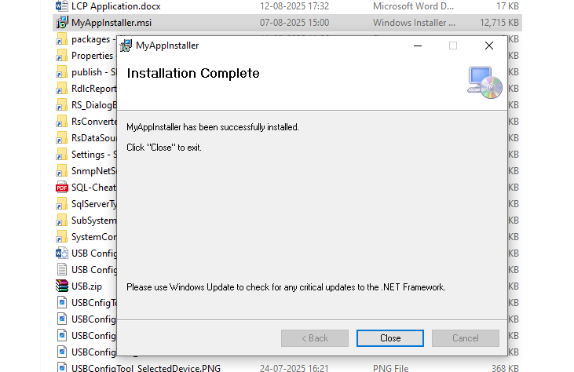

8. Testing
- Send Setup.exe to a testing machine.
- Double-click on Setup.exe and follow the installation wizard.After installation, verify the following:
- The application files are installed in the correct directory, typically C:\Program Files (x86)\MyApp.
- By using MyApp.exe or desktop shortcut (which is selected in installation process), runs the application.

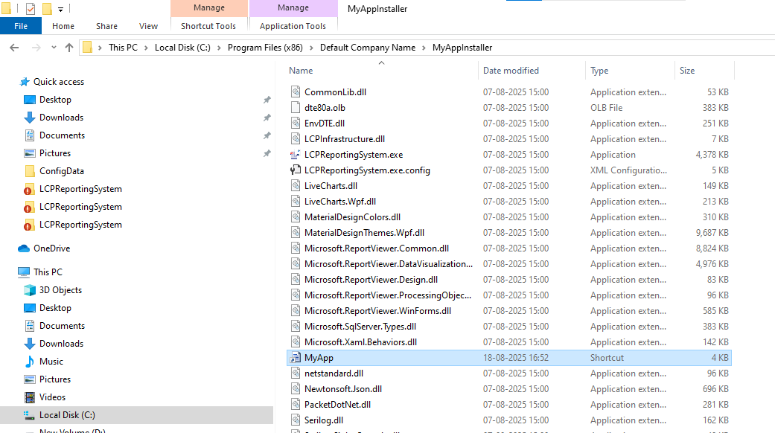

9. Diagram for Creating Installer process
