LAB-10

**Name:** T. Manoj **ID:** N190171

# Write a PHP script, which changes the color of the first character of a word.

**Code :**

<html>

<body>

<form action="" method="POST">

Name:<input type="text" name="name"/>

Color of first character:<input type="text" name="color"/>

<input type="submit"/>

</form>

<?php

function FirstCharacter($word, $color) {

$firstChar = mb_substr($word, 0, 1); // Get the first character

$restOfWord = mb_substr($word, 1); // Get the remaining characters

$coloredWord = '<span style="color: ' . $color . ';">' . $firstChar . '</span>' . $restOfWord; // Wrap the first character in a <span> tag with the specified color

echo $coloredWord;

}

FirstCharacter($_POST['name'],$_POST['color']);

?>

</body>

</html>

Output:

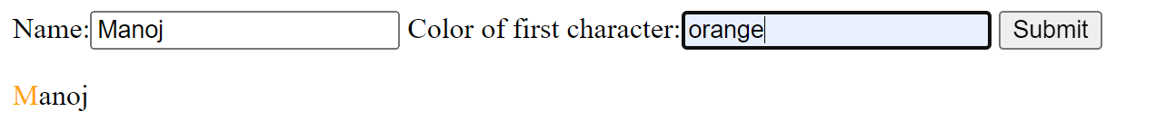

# Write a e PHP script to display string, values within a table. Note : Use HTML table elements into echo.

Code:

<html>

<style>

*{background:white; color:black;}

table, th, td {

border: 1px solid black; border-collapse: collapse;

}

td:first-of-type{ color:red;

}

td {

padding: 15px;

}

</style>

<body>

<?php

echo "<table cell-spacing='10px' cell-padding='10px'>

<tr>

<td>Name</td>

<td>Dollars</td>

<tr>

<tr>

<td>Manoj</td>

<td>1374$</td>

</tr>

<tr>

<td>Sai</td>

<td>2477$</td>

</tr>

<tr>

<td>Raj</td>

<td>1575$</td>

</tr>

</table>"

?>

</body>

</html>

Output:

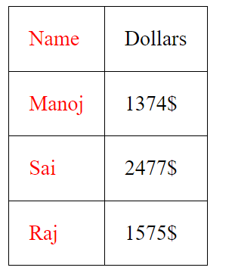

# Write a PHP script to count number of lines in a file. create a directory and display the list of

**txt files in the directory.**

Code:

<html>

<body style="background:white;color:black;">

<?php

$file=file("./File.txt");

// $file_data=file_get_contents("./File.txt");

$num_of_lines=count($file);

echo "File data : <br><br>"; for($i=0;$i<count($file);$i++)

{

echo strval($i+1).": ".$file[$i]."<br>";

}

echo "<h1> noof lines in file : $num_of_lines <h1>";

?>

</body>

</html> Output: 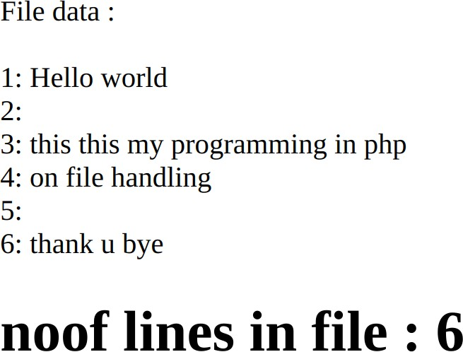

Code:

<html>

<body style="background:white;color:black; ">

<?php

$directory = "/opt/lampp/htdocs/htmlcode";

$files = scandir($directory);

echo "<h2>List of directory and files <h2><br><br>"; foreach ($files as $file) {

if ($file != "." && $file != "..") { if(is_file($file))

{

echo "File:".$file . "<br>";

}

else

{

echo "Dir:".$file . "<br>";

}

}

}

?>

</body>

</body>

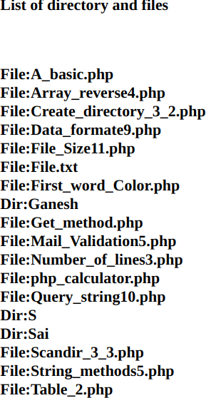Output:

# Write a PHP script to sort an array in reverse order (highest to lowest).

Code:

<html>

<body style="background:white;color:black" >

<?php

$array = [4, 2, 1, 3, 5];

echo "Before :["; for($i=0;$i<count($array);$i++)

{

echo $array[$i].",";

}

echo "]<br><br>"; rsort($array);

echo "After :["; for($i=0;$i<count($array);$i++)

{

echo $array[$i].",";

}

echo "]";

?>

</body>

</html>

Output:

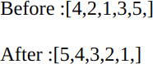

# Write a PHP script to : -

1. **transform a string all uppercase letters.**

# transform a string all lowercase letters.

1. **make a string&#39;s first character uppercase.**

# make a string&#39;s first character of all the words uppercase.

Code:

<html>

<body style="background:white;color:black;">

<?php

$str1="Ganesh";

echo"<h1>String to uppercase</h1><br>Before :".$str1; echo"<br>After:".strtoupper($str1);

echo"<h1>String to lowercase</h1><br>Before: ".$str1; echo"<br>After:".strtolower($str1);

$str2 = "hello world";

echo"<h1>string`s first character uppercase</h1><br>Before: ".$str2;

echo"<br>After:".ucfirst($str2);

echo"<h1>string`s first character of all the words uppercase.</h1><br>Before: hello world";

echo"<br>After:".ucwords("hello world");

?>

</body>

</html>

Output:

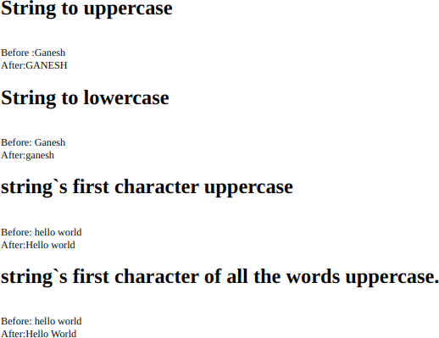

# Write a PHP program to valid an email address.

Code:

<html>

<body style="background:white;color:black;">

<form action="<?php $_SERVER['PHP_SELF?'] ?>" method="POST" >

Enter Mail:<input type="email" name="mail" placeholder="Enter mail"/>

<input type="submit"/>

</form>

</body>

</html>

<?php if($_SERVER['REQUEST_METHOD']=="POST")

{

$pattern = "/^[a-zA-Z0-9._-]+@[a-zA-Z0-9-]+(?:\.[a-zA-Z]+)*$/"; if (preg_match($pattern, $_POST['mail'])) {

echo "Valid email address.".$_POST['mail'];

} else {

echo "Invalid email address.";

}

}

?>

Output:

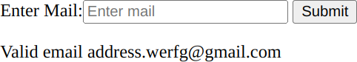

1. Write a PHP Calculator class which will accept two values as arguments, then add them,

subtract them, multiply them together, or divide them on request.

Code:

<html>

<body style="background:white;color:black;">

<form action="<?php $_SERVER['PHP_SELF'] ?>" method="POST">

Enter num1:<input type="text" name="num1"><br> Enter num2:<input type="text" name="num2">

<br>

<input type="submit" name="add" value="+"/>

<input type="submit" name="mul" value="*" />

<input type="submit" name="div" value="/"/>

<input type="submit" name="sub" value="-" />

</form>

</body>

</html>

<?php if($_SERVER['REQUEST_METHOD']=='POST')

{

$num1=$_POST['num1'];

$num2=$_POST['num2']; if(is_numeric($num1) && is_numeric($num2))

{

if(isset($_POST['add']))

{

echo "<h2>addition of $num1 and $num2

:</h2>"."<h3>".$num1+$num2."</h3>";

}

elseif(isset($_POST['mul']))

{

echo "<h2>multipulication of $num1 and $num2

:</h2><h3>".($num1*$num2)."</h3>";

}

elseif(isset($_POST['div']))

{

if($num2 ==0)

{

echo"<h1>$num1 is cant divisible by $num2</h2>";

}

else{

echo "<h2>division of $num1 and $num2

:</h2><h3>".($num1/$num2)."</h3>";}

}

elseif(isset($_POST['sub']))

{

echo "<h2>subtraction of $num1 and $num2

:</h2><h3>".($num1-$num2)."</h3>";

}

}

else

{

echo "<h1>Entered invalid number please try again</h1>";

}

}

?>

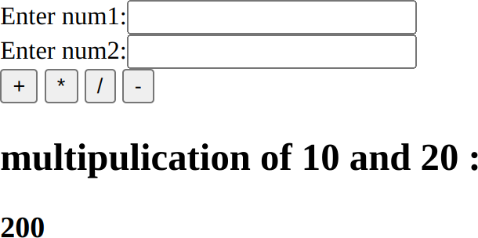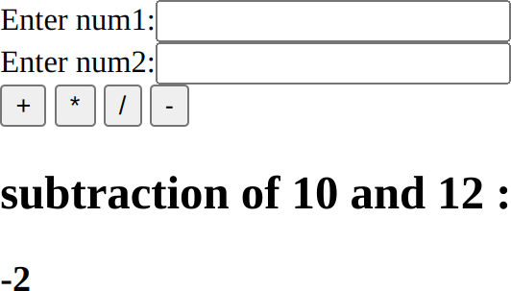Output:

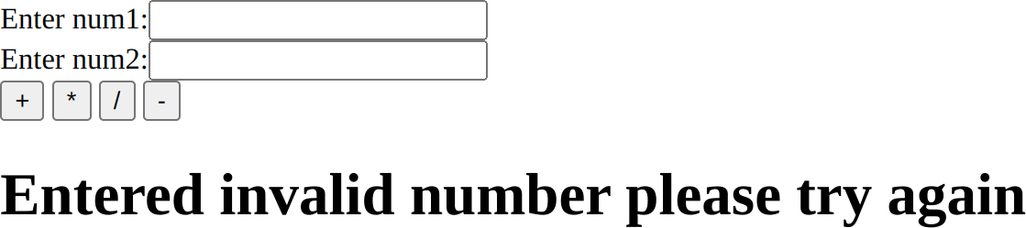

# Write a PHP class that sorts an ordered integer array with the help of sort() function.

Code:

<html>

<body style="background:white;color:black" >

<?php

$array = array(11, -2, 4, 35, 0, 8, -9);

echo "Before :["; for($i=0;$i<count($array);$i++)

{

echo $array[$i].",";

}

echo "]<br><br>"; sort($array); echo "After :[";

for($i=0;$i<count($array);$i++)

{

echo $array[$i].",";

}

echo "]";

?>

</body>

</html>

Output:

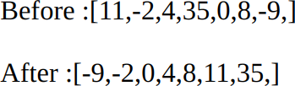

# Write a PHP script to convert a string to Date and DateTime. Sample Date : 12-08-2004;

**Expected Output : 2004-12-08**

Code:

<html>

<body style="background:white;color:black;">

<form action="<?php $_SERVER['PHP_SELF'] ?>" method="POST">

<h2>Enter data in formate day/month/year:<h2>

<input type="text" name="date"/>

<input type="submit" value="d/m/y"/>

</form>

</body>

</html>

<?php if($_SERVER['REQUEST_METHOD']=='POST')

{

$stringDate = $_POST['date'];

$dateFormat = 'd-m-Y';

$date = DateTime::createFromFormat($dateFormat, $stringDate); if($date==true)

{

// Convert string to date format

$date = date('Y-m-d', strtotime($stringDate));

echo "<br> <br><br>Original String Date(d/m/y):" . $stringDate . "<br>";

echo "Converted Date (y/d/m): " . $date . "<br>";

}

else{

echo "<br><br><h1>Entered invalid date</h1>";

}

}

?>

Output:

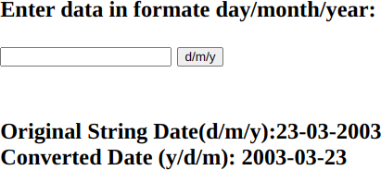

# Write a PHP script to get the characters after the last &#39;/&#39; in an url.

**Sample URL :** [**http://www.example.com/5478631;**](http://www.example.com/5478631%3B) **Expected Output :5478631&;**

Code:

<html>

<body style="background:white;color:black;">

<form action="<?php $_SERVER['PHP_SELF'] ?>" method="POST">

<h2>Enter URL:<h2>

<input type="text" name="url"/>

<input type="submit" />

</form>

</body>

</html>

<?php if($_SERVER['REQUEST_METHOD']=="POST")

{

$url =$_POST['url'];

// Split the URL by '/'

$parts = explode('/', $url);

// Get the last element from the array

$charactersAfterLastSlash = end($parts);

echo "<br>input: " . $url . "<br>";

echo "output'/': " . $charactersAfterLastSlash . "\n";

}

?>

Output:

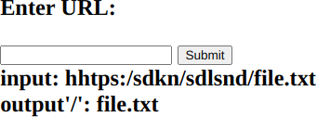

# Write a PHP program to get the size of a file.

Code:

<html>

<body style="background:white;color:black;">

<form action = "<?php $_SERVER['PHP_SELF'] ?>" method="POST">

Enter File name :<input type="text" name="fname" />

<input type="submit" />

</form>

</body>

</html>

<?php if($_SERVER['REQUEST_METHOD']=="POST")

{

$files=scandir("/opt/lampp/htdocs/htmlcode");

$x=false;

foreach($files as $file)

{

if($file==$_POST['fname'])

{

echo "<h2>Size of $file is :".filesize($file)." Bytes</h2>";

$x=true;

}

}

if(!$x)

{

echo "<br><h1>File is not found in present directory</h1>";

}

}

?>

Output:

