**W.T. LAB-02**

**NAME:** TANGELLA MANOJ **CLASS:** SG-08

**ID NO:** N190171  **ROLL NO:** 14

**QUESTION:**

1.Create a Registration form  
2. Sign in form  
3. Forgot password form  
Note: Link all these forms and apply the CSS styles using External css file.

**REGISTRATION FORM**

**CODE:**

<html>

<head>

<title>

REGISTRATION FORM

</title>

<link rel="stylesheet" href="C:\Users\MANOJ\Desktop\html\lab2\css1.css">

</head>

<body>

<form>

<fieldset><center>

<p>REGISTRATION</p>

<table align="center">

<tr>

<td>

Firstname:

</td>

<td>

<input type="text" name="Firstname">

</td>

</tr>

<tr>

<td>

Lastname:

</td>

<td>

<input type="text" name="Lastname">

</td>

</tr>

<tr>

<td>

User-Id:

</td>

<td>

<input type="text" name="User-Id">

</td>

</tr>

<tr>

<td>

Gender:

</td>

<td>

<input type="radio" name="Gender">

Male

<input type="radio" name="Gender">

Female

</td>

</tr>

<tr>

<td>

Email:

</td>

<td>

<input type="email" name="Email">

</td>

</tr>

<tr>

<td>

Password:

</td>

<td>

<input type="Password" name="Password">

</td>

</tr>

<tr>

<td>

Confirm Password:

</td>

<td>

<input type="Password" name="Password">

</td>

</tr>

</table>

<input type="submit" value="Submit"><br><br>

If you have already accont please <a href="signin.html">sign in</a>

</center>

</fieldset>

</body>

</html>

**CSS CODE:**

body{

background-image: url(https://png.pngtree.com/thumb_back/fh260/background/20190727/pngtree-minimalistic-white-honeycomb-paper-cut-wind-business-background-image_285722.jpg);

background-size: cover;

text-align: center;

font-weight: bold;

}

fieldset{

margin:10px 400px 400px 400px;

background-image: url(https://encrypted-tbn0.gstatic.com/images?q=tbn:ANd9GcQf0fQAk5DiYZcjdom_yV9qROkpIqHG6iY_-g&usqp=CAU);

background-size: cover;

}

table{

text-align: center;

align-content: center;

border-spacing: 40px;

}

**OUTPUT**

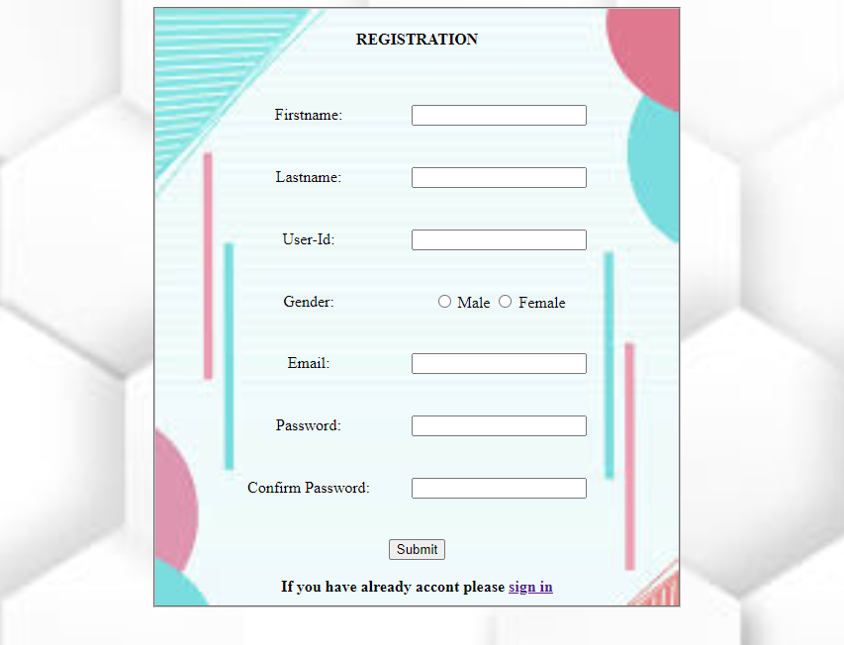

**SIGN IN FORM**

**CODE:**

<html>

<head>

<title>

Sign in Form

</title>

<link rel="stylesheet" type="text/css" href="C:\Users\MANOJ\Desktop\html\lab2\css2.css">

</head>

<body>

<fieldset>

<p>SIGN IN</p>

<form>

<table align="center">

<tr>

<td>

Username:

</td>

<td>

<input type="text" name="Username">

</td>

</tr>

<tr>

<td>

Password:

</td>

<td>

<input type="Password" name="Password">

</td>

</tr>

</table>

<button>Login</button><br>

<br>

If you have not an Account <a href="Registration.html">Sign up</a>

<br>

<br>

Forget Password? <a href="forget.html">click here</a>

</form>

</fieldset>

</body>

</html>

**CSS CODE:**

body{

background-image: url(https://i.pinimg.com/474x/24/38/e6/2438e632b29645a56eb9f7844945a219.jpg);

background-size: cover;

text-align: center;

}

fieldset{

background-image: url(https://images.unsplash.com/photo-1581985673473-0784a7a44e39?ixlib=rb-4.0.3&ixid=MnwxMjA3fDB8MHxzZWFyY2h8M3x8YmFja2dyb3VuZCUyMGRlc2lnbnxlbnwwfHwwfHw%3D&w=1000&q=80);

margin:10px 500px 400px 450px;

background-size: cover;

}

table{

text-align: center;

align-content: center;

border-spacing: 70px;

}

button{

border-radius: 50px;

width: 250px;

font-size: 16px;

}

**OUTPUT**

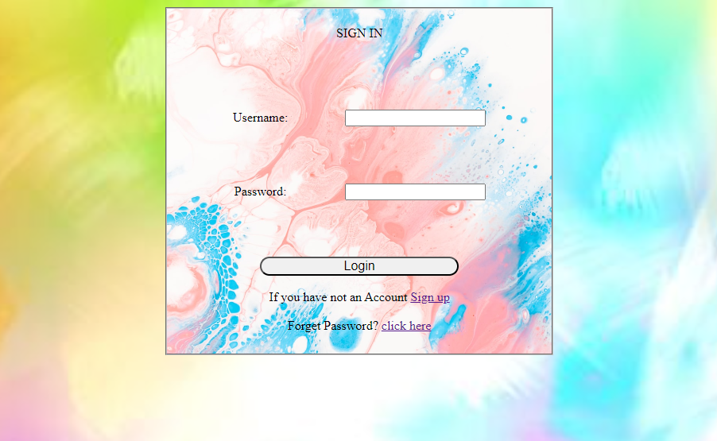

**FORGOT FORM**

**CODE:**

<html>

<head>

<title>

Forget Password Form

</title>

<link rel="stylesheet" type="text/css" href="C:\Users\MANOJ\Desktop\html\lab2\css3.css">

</head>

<body>

<fieldset>

<p> RESET PASSWORD</p>

<form>

<table align="center">

<tr>

<td>

Enter New Password:

</td>

<td>

<input type="Password" name="Password">

</td>

</tr>

<tr>

<td>

Confirm Password:

</td>

<td>-

<input type="Password" name="Password">

</td>

</tr>

<tr>

<td>

Enter OTP:

</td>

<td>

<input type="number" name="number" maxlength="4">

</td>

</tr>

</table>

<input type="submit" name="submit">

</form>

</fieldset>

</html>

**CSS CODE:**

body{

background-image: url(https://png.pngtree.com/thumb_back/fh260/background/20190727/pngtree-minimalistic-white-honeycomb-paper-cut-wind-business-background-image_285722.jpg);

background-size: cover;

text-align: center;

font-weight: bold;

}

fieldset{

margin:10px 500px 400px 500px;

background-image: url(https://encrypted-tbn0.gstatic.com/images?q=tbn:ANd9GcQf0fQAk5DiYZcjdom_yV9qROkpIqHG6iY_-g&usqp=CAU);

background-size: cover;

}

table{

text-align: center;

align-content: center;

border-spacing: 40px;

}

**OUTPUT**

