**W.T. LAB-06**

**NAME:** TANGELLA MANOJ **CLASS:** SG-08

**ID NO:** N190171  **ROLL NO:** 14

1. **Write a JavaScript program to calculate multiplication and division of two numbers (input from user).**

Code:-

<!DOCTYPE html>

<html>

<head>

<title>call</title>

<style>

fieldset{

width: 400px;

position: absolute;

top: 90px;

left: 400px;

background-color: skyblue;

border-radius: 30px;

}

body{

background-color: black;

}

table{

padding: 15px;

border-spacing: 25px;

color: blue;

font-size: 1.2rem;

}

input[type='text']{

background-color: slategray;

border-color: red;

}

input[type='button']{

width: 100px;

color: blue;

border-radius: 30px;

font-size: .9rem;

background-color: lightgray;

height: 25px;

}

input[type='button']:hover{

box-shadow:2px 2px 5px 5px gray;

font-size: 1rem;

background-color: cyan;

}

</style>

</head>

<body>

<div class="form">

<fieldset align="center">

<table align="center">

<tr>

<td>1st Number :</td>

<td><input type="number" name="first" id="first"></td>

</tr>

<tr>

<td>2nd Number :</td>

<td><input type="number" name="first" id="second"></td>

</tr>

<tr>

<td><input type="button" value="Divide" id="divide" onclick="divide()"></td>

<td><input type="button" value="Multiply" id="multiply" onclick="multiply()"></td>

</tr>

<tr>

<td><input type="button" value="Add" id="add" onclick="add()"></td>

<td><input type="button" value="Subtract" id="sub" onclick="subtract()"></td>

</tr>

<tr>

<td><p id="para">The Result:</p></td>

<td><p id="re"></p></td>

</tr>

</table>

</fieldset>

</div>

<script>

function add(){

var op1 = document.getElementById("first").value;

var op2 = document.getElementById("second").value;

document.getElementById("re").innerHTML = Number(op1)+Number(op2);

}

function subtract(){

var op1 = document.getElementById("first").value;

var op2 = document.getElementById("second").value;

document.getElementById("re").innerHTML = op1-op2;

}

function divide(){

var op1 = document.getElementById("first").value;

var op2 = document.getElementById("second").value;

document.getElementById("re").innerHTML = op1/op2;

}

function multiply(){

var op1 = document.getElementById("first").value;

var op2 = document.getElementById("second").value;

document.getElementById("re").innerHTML = op1*op2;

}

</script>

</body>

</html>

**2. Write a JavaScript program to convert temperatures to and from Celsius, Fahrenheit.**

Code:-

<!DOCTYPE html>

<html>

<head>

<title>Temperature</title>

<style>

.btn{

position: relative;

left: 30px;

}

</style>

</head>

<body align="center">

<h1 align="center">

Temperature converter

</h1><br><br>

<form>

Temperature :-

<input type="number" name="Temperature" id="temp">

<br>

<br>

<div class="btn">

<input type="button" value="celsius" onclick="cel()">

<input type="button" value="Fahrenheit" onclick="far()">

</div>

<p id="con"> </p>

</form>

<script>

function cel(){

document.getElementById("con").innerHTML=`In Celsius : ${(document.getElementById("temp").value - 32)*(5/9)}`;

}

function far(){

document.getElementById("con").innerHTML=`In Fahrenheit : ${(document.getElementById("temp").value * 9/5)+32}`;

}

</script>

</body>

</html>

**3. Create an array called crew to organize the Serenity’s crew and set it equal to the variables below . You don't need to type out the actual strings, just use the provided variables. var captain = "Mal"; var second = "Zoe"; var pilot = "Wash"; var companion = "Inara"; var mercenary = "Jayne"; var mechanic = "Kaylee"; Then, print the crew array to the console**

Code:-

<!DOCTYPE html>

<html>

<head>

<title>Crew</title>

</head>

<body>

<script>

var captain = "Mal";

var second = "Zoe";

var pilot = "Wash";

var companion = "Inara";

var mercenary = "Jayne";

var mechanic = "Kaylee";

var crew=[captain,second,pilot,companion,mercenary,mechanic];

console.log(crew);

</script>

</body></html>

**4. James was creating an array with the colors of the rainbow, and he forgot some colors. The standard rainbow colors are usually listed in this order: var rainbow = ["Red", "Orange", "Yellow", "Green", "Blue", "Purple"]; but James had this: var rainbow = ["Red", "Orange", "Blackberry", "Blue"]; Using only the splice() method, insert the missing colors into the array, and remove the color "Blackberry" by following these steps: Remove "Blackberry" Add "Yellow" and "Green" Add "Purple" 5. Use the array's forEach() method to loop over the following array and add 100 to each of the values.**

Code:-

<!DOCTYPE html>

<html>

<head>

<title>Splice operation</title>

</head>

<body>

<script>

var rainbow = ["Red", "Orange", "Yellow", "Green", "Blue", "Purple"];

var secondrbow = ["Red", "Orange", "Blackberry", "Blue"];

secondrbow.splice(2,1,"Yellow","Green");

secondrbow.splice(5,0,"Purple")

console.log(rainbow);

console.log(secondrbow);

</script>

</body>

</html>

**5. Use the array's forEach() method to loop over the following array and add 100 to each of the values if the value is divisible by 3. var test = [12, 929, 11, 3, 199, 1000, 7, 1, 24, 37, 4, 19, 300, 3775, 299, 36, 209, 148, 169, 299, 6, 109, 20, 58, 139, 59, 3, 1, 139]; Remember that the "Test Run" button will display any logged content, so feel free to use console.log() to test your code.**

Code:-

<!DOCTYPE html>

<html>

<head>

<title>For each</title>

</head>

<body>

</body>

<script>

var array = [12, 929, 11, 3, 199, 1000, 7, 1, 24, 37, 4, 19, 300, 3775, 299, 36, 209, 148, 169, 299, 6, 109, 20,58, 139, 59, 3, 1, 139];

var newarray = [];

var i=0;

array.forEach(function(arr){

if(arr%3==0){

arr+=100;

newarray[i++] = arr;

}

else{

newarray[i++] = arr;

}

})

console.log(array);

console.log(newarray);

</script>

</html>

**6. Use a nested for loop to take the numbers array below and replace all of the values that are divisible by 2 (even numbers) with the string "even" and all other numbers with the string "odd"**

**Code:-**

<!DOCTYPE html>

<html>

<head>

<title>Multi. Array Access</title>

</head>

<body>

<script>

var numbers = [

[243, 12, 23, 12, 45, 45, 78, 66, 223, 3],

[34, 2, 1, 553, 23, 4, 66, 23, 4, 55],

[67, 56, 45, 553, 44, 55, 428, 452, 3],

[12, 31, 55, 445, 79, 44, 674, 224, 4, 21],

[4, 2, 3, 52, 13, 51, 44, 1, 67, 5],

[5, 65, 4, 5, 6, 5, 43, 23, 4424],

[74, 532, 6, 7, 35, 17, 89, 43, 43, 66],

[53, 6, 89, 10, 23, 52, 111, 44, 109, 80],

[67, 6, 53, 537, 2, 168, 16, 2, 1, 8],

[76, 7, 9, 6, 3, 73, 77, 100, 56, 100]

];

var newarray = new Array();

for(var i=0;i<numbers.length;i++){

newarray[i] = new Array();

for(var j=0;j<numbers.length;j++){

if(numbers[i][j]%2==0){

newarray[i][j] = "even";

}

else{

newarray[i][j] = "odd";

}

}

console.log(newarray);</script></body></html>

**7. Create an javaScript Object - Your code should have an object `savingsAccount` . * - Your `savingsAccount` object should have the `balance` and `interestRatePercent` property * - Your `savingsAccount` object should have a `printAccountSummary()` method * - Your `printAccountSummary()` method should return the EXACT expected message.**

**Code:-**

<!DOCTYPE html>

<html>

<head>

<meta charset="utf-8">

<meta name="viewport" content="width=device-width, initial-scale=1">

<title>Bank</title>

</head>

<body>

<script>

let savingAccount = {

balance : 5000,

interestRatePercent : 8,

PrintAccountSummary : function(){

console.log(`Your balance is ${this.balance} with bank interest ${this.interestRatePercent}`);}}

savingAccount.PrintAccountSummary();

</script>

</body>

</html>

**Outputs:-**

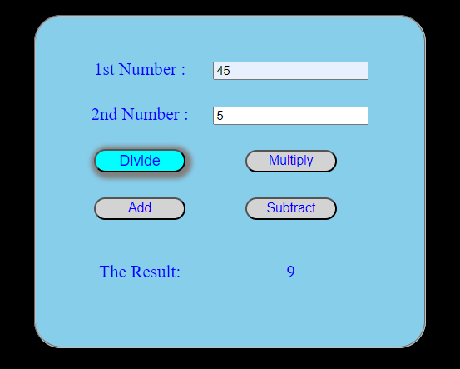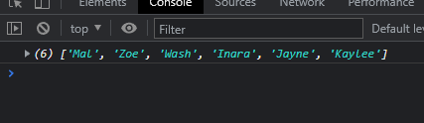

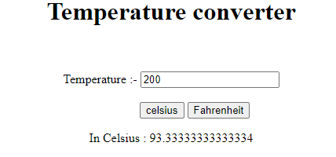

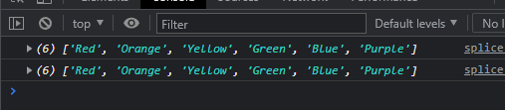

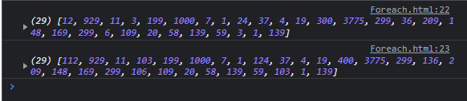

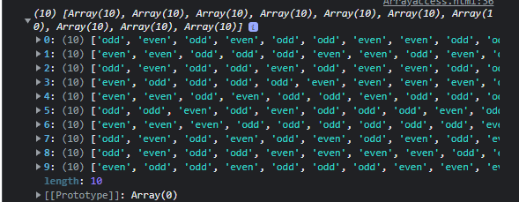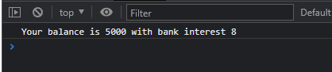

**II. JQuery Exercises:-**

1. **Set background-image using jQuery CSS property**

**Code:-**

<!DOCTYPE html>

<html>

<head>

<meta charset="utf-8">

<meta name="viewport" content="width=device-width, initial-scale=1">

<title>Bg js</title>

<script src="http://ajax.googleapis.com/ajax/libs/jquery/2.1.3/jquery.min.js"></script>

<style>

body{

border: 2px solid red;

}

</style>

</head>

<body>

<div id="h">

<p>Lorem Ipsum is simply dummy text of the printing and typesetting industry. Lorem Ipsum has been the industry's standard dummy text ever since the 1500s, when an unknown printer took a galley of type and scrambled it to make a type specimen book. It has survived not only five centuries, but also the leap into electronic typesetting, remaining essentially unchanged. It was popularised in the 1960s with the release of Letraset sheets containing Lorem Ipsum passages, and more recently with desktop publishing software like Aldus PageMaker including versions of Lorem Ipsum.

</p>

</div>

<script >

$("#h").css({

'background-image':'url("kfc.jpg")',

'background-size':'containe',

'background-position':'center',

'background-repeat' :'repeat-x',

'max-height':'100%',

'width' : '100%'

});

</script>

</body>

</html>

**2. Count child elements using jQuery. Note: Count number of "p" elements from the following**

**Code:-**

<!DOCTYPE html>

<html>

<head>

<meta charset="utf-8">

<meta name="viewport" content="width=device-width, initial-scale=1">

<title>count</title>

<script src="http://ajax.googleapis.com/ajax/libs/jquery/2.1.3/jquery.min.js"></script>

</head>

<body>

<div class="para">

<p>Red</p>

<p>green</p>

<p>white</p>

<p>blue</p>

<p>orange</p>

</div>

<div class="btn">

<input type="button" value="click here" id="btn">

</div>

<script>

$(document).ready(function(){

$("#btn").click(function(){

var count = $("p").length;

console.log(count);

console.log(`The No of Total Paragraphs are:-${count}`);

})

})

</script>

</body></html>

**3.Access HTML form data using jQuery and print on the web page.**

**Code:-**

<!DOCTYPE html>

<html>

<head>

<meta charset="utf-8">

<meta name="viewport" content="width=device-width, initial-scale=1">

<title>Form Access</title>

<script src="http://ajax.googleapis.com/ajax/libs/jquery/2.1.3/jquery.min.js"></script>

</head>

<body>

<form style="margin-top: 200px;">

<table align="center" style="border-spacing: 8px;">

<tr>

<td>

Enter New Password:

</td>

<td>

<input type="Password" name="Password" id="new">

</td>

</tr>

<tr>

<td>

Confirm Password:

</td>

<td>

<input type="Password" name="Password" id="conf">

</td>

</tr>

<tr>

<td>

Enter OTP:

</td>

<td>

<input type="number" name="number" maxlength="4">

</td>

</tr>

</table>

<div style="display: flex;justify-content: center;"> <!--align="center"-->

<input type="button" name="submit" value="submit" id="btn">

</div>

</form>

<div>

<p id="para">hello</p>

</div>

<script>

$("#btn").click(function(){

$("#para").html(`New:${$("#new").val()},\n Confirm:${$("#conf").val()}`)

});

</script>

</body>

</html>

**4. Assign font size and font family and background colour to a**

**tag by using style property.**

**Code:-**

<!DOCTYPE html>

<html>

<head>

<meta charset="utf-8">

<meta name="viewport" content="width=device-width, initial-scale=1">

<script src="C:\Users\MANOJ\Desktop\compress.js"></script>

<title>Fontjq</title>

<body>

<p>Hello world</p>

<p>Connecting to Web</p>

<p> Contaiining background color and text color</p>

<script>

$(document).ready(function(){

$("p").css({"font-size":"30px","background-color":"cyan","font-family":"Courier New', Courier, monospace"});

});

</script>

</body>

</body>

</html>

**5. Create a Zebra Stripes table effect.**

**Code:-**

<!DOCTYPE html>

<html>

<head>

<title>zebra</title>

<style>

table{

border-spacing: 5px;

width: 800px;

height: 200px;

}

</style>

<script src="http://ajax.googleapis.com/ajax/libs/jquery/2.1.3/jquery.min.js"></script>

</head>

<body>

<table border=1px align="center">

<tr>

<th>Student Name</th>

<th>Branch</th>

</tr>

<tr>

<td>Manoj</td>

<td>Cse</td>

</tr>

<tr>

<td>Hari</td>

<td>Cse</td>

</tr>

<tr>

<td>Siva</td>

<td>Cse</td>

</tr>

<tr>

<td>Ram</td>

<td>Ece</td>

</tr>

</table>

<script>

$(document).ready(function(){

$("td:even,th:even").css({"background-color":"orange"});

$("td:odd,th:odd").css({"background-color":"cyan"});

$("table").css({"border-collapse":"collapse","text-align":"center"});

});

</script>

</body>

</html>

**6. Create a div tag and on click of a button it should display your name.**

**Code:-**

<!DOCTYPE html>

<html>

<head>

<meta charset="utf-8">

<meta name="viewport" content="width=device-width, initial-scale=1">

<script src="C:\Users\MANOJ\Desktop\compress.js"></script>

<title>Display Name</title>

</head>

<body align="center">

<input type="button" value="Myself" id="btn">

<p>

</p>

<script>

$("#btn").click(function() {

$("p").html("My name is Manoj");

});

</script>

</body>

</html>

**7. Create one textarea and one button. On click of the button the length of text entered inside the textarea will be displayed and Use one progress bar for showing the number of text entered.**

**Code:-**

<!DOCTYPE html>

<html>

<head>

<meta charset="utf-8">

<meta name="viewport" content="width=device-width, initial-scale=1">

<title>text length</title>

<script src="C:\Users\MANOJ\Desktop\compress.js"></script>

<style></style>

</head>

<body align="center">

<div class="form">

<textarea rows="5" cols="30" class="text"></textarea>

</div>

<input type="button" value="submit" class="btn">

<br>

<input type="text" class="content">

<script>

$("document").ready(function(){

$(".btn").click(function(){

var len = $(".text").val().length;

$(".content").attr("value",`${len}`);

});

});

</script>

</body>

</html>

**8. Create one style class and name it error, give its border colour as red and background colour as yellow. Apply this class to the text box when the focus is moved out of it and if entered data is more than 10**

**Code:-**

<!DOCTYPE html>

<html>

<head>

<meta charset="utf-8">

<meta name="viewport" content="width=device-width, initial-scale=1">

<title>Error</title>

<script src="C:\Users\MANOJ\Desktop\compress.js"></script>

</head>

<body align="center">

<textarea rows="10" cols="30" class="error" onmouseleave="out()"></textarea>

<script>

function out(){

var len = $(".error").val().length;

if(len>10){

$(".error").css({"background-color":"yellow","border":"4px solid red"});

}

}

</script>

</body>

</html>

**9. Create one button and a textbox. On click of the button the text written in text box should display on the button**

**Code:-**

<!DOCTYPE html>

<html>

<head>

<meta charset="utf-8">

<meta name="viewport" content="width=device-width, initial-scale=1">

<title>buttonretrieve</title>

<script src="C:\Users\MANOJ\Desktop\compress.js"></script>

</head>

<body align="center">

<textarea rows="8" cols="30" class="text"></textarea>

<br>

<input type="button" value="submit" class="btn">

<script>

$(".btn").click(function(){

var ret = $(".text").val();

console.log(ret);

$(".btn").attr("value",`${ret}`);

});

</script>

</body>

</html>

**Outputs:-**

