**W.T. LAB-09**

**NAME: TANGELLA MANOJ CLASS: SG-08**

**ID NO: N190171 ROLL NO: 14**

# Responsive pricing tables

# HTML, CSS, Bootstrap &amp; Modern Javascript.

# Compact pricing tables with different color variations that are easy to customize and adapt to your design.

<!DOCTYPE html>

<html>

<head>

<title>Responsive Prices</title>

</head>

<body>

<link href='https://stackpath.bootstrapcdn.com/bootstrap/5.0.0-alpha1/css/bootstrap.min.css' rel='stylesheet'>

<link href='' rel='stylesheet'>

<style>body {

background: #473947;

padding: 30px 0

}

a{

text-decoration: none;

}

.pricingTable {

text-align: center;

background: #fff;

margin: 0 -15px;

box-shadow: 0 0 10px #ababab;

padding-bottom: 40px;

border-radius: 10px;

color: #cad0de;

transform: scale(1);

transition: all .5s ease 0s

}

.pricingTable:hover {

transform: scale(1.05);

z-index: 1

}

.pricingTable .pricingTable-header {

padding: 40px 0;

background: #4682;

border-radius: 10px 10px 20% 20%;

transition: all .5s ease 0s

}

.pricingTable:hover .pricingTable-header {

background: #937634

}

.pricingTable .pricingTable-header i {

font-size: 50px;

color: #858c9a;

margin-bottom: 10px;

transition: all .5s ease 0s

}

.pricingTable .price-value {

font-size: 35px;

color: #ff9624;

transition: all .5s ease 0s

}

.pricingTable .month {

display: block;

font-size: 14px;

color: #cad0de

}

.pricingTable:hover .month,

.pricingTable:hover .price-value,

.pricingTable:hover .pricingTable-header i {

color: #fff

}

.pricingTable .heading {

font-size: 24px;

color: #ff9624;

margin-bottom: 20px;

text-transform: uppercase

}

.pricingTable .pricing-content ul {

list-style: none;

padding: 0;

margin-bottom: 30px

}

.pricingTable .pricing-content ul li {

line-height: 30px;

color: #a7a8aa

}

.pricingTable .pricingTable-signup a {

display: inline-block;

font-size: 15px;

color: #fff;

padding: 10px 35px;

border-radius: 20px;

background: #ffa442;

text-transform: uppercase;

transition: all .3s ease 0s

}

.pricingTable .pricingTable-signup a:hover {

box-shadow: 0 0 10px #736738

}

.pricingTable.blue .heading,

.pricingTable.blue .price-value {

color: #746739

}

.pricingTable.blue .pricingTable-signup a,

.pricingTable.blue:hover .pricingTable-header {

background: #834738

}

.pricingTable.blue .pricingTable-signup a:hover {

box-shadow: 0 0 10px #4b64ff

}

.pricingTable.red .heading,

.pricingTable.red .price-value {

color: #ff4b4b

}

.pricingTable.red .pricingTable-signup a,

.pricingTable.red:hover .pricingTable-header {

background: #325797

}

.pricingTable.red .pricingTable-signup a:hover {

box-shadow: 0 0 10px #ff4b4b

}

.pricingTable.green .heading,

.pricingTable.green .price-value {

color: #40c952

}

.pricingTable.green .pricingTable-signup a,

.pricingTable.green:hover .pricingTable-header {

background: #538623}

pricingTable.green .pricingTable-signup a:hover {

box-shadow: 0 0 10px #40c952

}

.pricingTable.blue:hover .price-value,

.pricingTable.green:hover .price-value,

.pricingTable.red:hover .price-value {

color: #fff

}

@media screen and (max-width:990px) {

.pricingTable {

margin: 0 0 20px

}

}</style>

<script type='text/javascript' src='https://cdn.jsdelivr.net/npm/popper.js@1.16.0/dist/umd/popper.min.js'></script>

<script type='text/javascript' src='https://stackpath.bootstrapcdn.com/bootstrap/5.0.0-alpha1/js/bootstrap.min.js'></script>

<div class="demo">

<div class="container">

<div class="row">

<div class="col-md-3 col-sm-6">

<div class="pricingTable">

<div class="pricingTable-header">

<i class="fa fa-adjust"></i>

<div class="price-value"> $10.00 <span class="month">per month</span> </div>

</div>

<h3 class="heading">Standard</h3>

<div class="pricing-content">

<ul>

<li><b>50GB</b> Disk Space</li>

<li><b>50</b> Email Accounts</li>

<li><b>50GB</b> Monthly Bandwidth</li>

<li><b>10</b> subdomains</li>

<li><b>15</b> Domains</li>

</ul>

</div>

<div class="pricingTable-signup">

<a href="#">sign up</a>

</div>

</div>

</div>

<div class="col-md-3 col-sm-6">

<div class="pricingTable green">

<div class="pricingTable-header">

<i class="fa fa-briefcase"></i>

<div class="price-value"> $20.00 <span class="month">per month</span> </div>

</div>

<h3 class="heading">Business</h3>

<div class="pricing-content">

<ul>

<li><b>60GB</b> Disk Space</li>

<li><b>60</b> Email Accounts</li>

<li><b>60GB</b> Monthly Bandwidth</li>

<li><b>15</b> subdomains</li>

<li><b>20</b> Domains</li>

</ul>

</div>

<div class="pricingTable-signup">

<a href="#">sign up</a>

</div>

</div>

</div>

<div class="col-md-3 col-sm-6">

<div class="pricingTable blue">

<div class="pricingTable-header">

<i class="fa fa-diamond"></i>

<div class="price-value"> $0.00 <span class="month">per month</span> </div>

</div> <h3 class="heading">Premium</h3>

<div class="pricing-content">

<ul>

<li><b>70GB</b> Disk Space</li>

<li><b>70</b> Email Accounts</li>

<li><b>70GB</b> Monthly Bandwidth</li>

<li><b>20</b> subdomains</li>

<li><b>25</b> Domains</li>

</ul>

</div>

<div class="pricingTable-signup">

<a href="#">sign up</a>

</div></div> </div>

<div class="col-md-3 col-sm-6">

<div class="pricingTable red">

<div class="pricingTable-header">

<i class="fa fa-cube"></i>

<div class="price-value"> $0.00 <span class="month">per month</span> </div>

</div>

<h3 class="heading">Extra</h3>

<div class="pricing-content">

<ul>

<li><b>80GB</b> Disk Space</li>

<li><b>80</b> Email Accounts</li>

<li><b>80GB</b> Monthly Bandwidth</li>

<li><b>25</b> subdomains</li>

<li><b>30</b> Domains</li>

</ul>

</div>

<div class="pricingTable-signup">

<a href="#">sign up</a>

</div></div> </div> </div></div></div></body</html>

**Output:-**

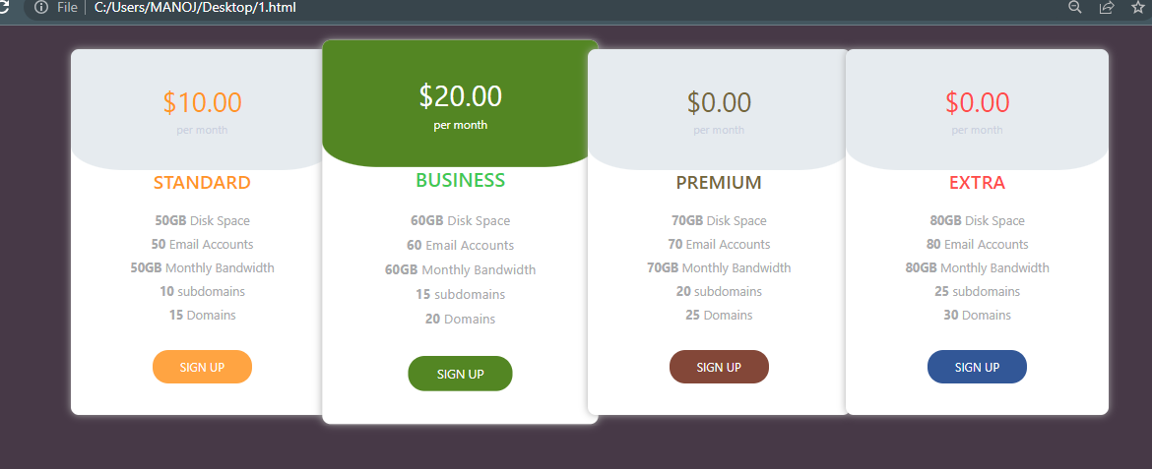

# Write a Node js program to How to Access the File System in Node.js(all fs methods)?

# Create a Node.js file that reads the HTML file, and return the content:

var http = require("http");

var fs = require("fs");

http.createServer((req,res)=>{

fs.readFile("jsnode.txt",function(err,data){

// res.writeHead(200, {'Content-Type': 'text/html'});

res.write(data);

res.end();

})

}).listen(1001);

**Output:-**



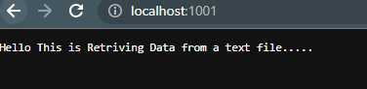

**Create a new file using the appendFile() method:**

var fs = require('fs');

fs.appendFile('node2.txt', 'File create by using appendFile method!', function (err) {

if (err) throw err;

console.log('file created..');

});

**Output:-**



**Create a new, empty file using the open() method:**

var fs = require('fs');

fs.open('node3.txt', 'w', function (err, file) {

if (err) throw err;

console.log('file created..'); });

**Output:-**



**Create a new file using the writeFile() method:**

var fs = require('fs');

fs.writeFile('node4.txt', 'file created by writeFile method', function (err) {

if (err) throw err;

console.log('file created...');

});

**Output:-**

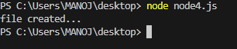

**Delete “node4.txt":**

var fs = require('fs');

fs.unlink('node4.txt', function (err) {

if (err) throw err;

console.log('File deleted!');

});

**Output:-**



**Rename "node3.txt" to "renamed.txt":**

var fs = require('fs');

fs.rename('node3.txt', 'renamed.txt', function (err) {

if (err) throw err;

console.log('renamed successful');

});

**Output:-**



1. **How to send different HTML files based on query parameters in Node.js?**

# The following approach covers how to send different HTML files based on the query parameters in Node.js

# Approach: The task can be easily fulfilled by receiving the query parameters and map different HTML files with the respective parameters.

# 

# Step 1: Create your project folder and install the express module using the following command: npm install express

# Step 2: Create a main.js file in the root directory of your project and write down the following code in it.

# Write a Nodejs program to use URL module?

# const http = require("http");

# const url = require("url");

# const PORT = 8000;

# const server = http.createServer(function (req, res) {

# const header = { "Content-Type": "application/json" };

# const parsed = url.parse(req.url, true);

# const { pathname, query } = parsed;

# const message = query?.message;

# if (pathname === "/") {

# res.writeHead(200, header);

# res.write(JSON.stringify({ message: message }));

# }

# else {

# res.writeHead(400, header);

# res.write(JSON.stringify({ error: "Bad req" }));

# }

# res.end();

# });

# server.listen(PORT);

# console.log(`Listening at port ${PORT}`);

# Output:-

# 

# Create a local module for performing all arithmetic operations and used in another file called arithmetic.js file to access them.

# code for arthimatic operations

# function add(a, b) {

# return a + b;

# }

# function subtract(a, b) {

# return a - b;

# }

# function multiply(a, b) {

# return a * b;

# }

# function divide(a, b) {

# return a / b;

# }

# module.exports = {

# add,

# subtract,

# multiply,

# divide,

# };

# const arithmetic = require('./arithmetic');

# const result1 = arithmetic.add(9, 3);

# console.log(result1); // Output: 12

# const result2 = arithmetic.subtract(10, 8);

# console.log(result2); // Output: 2

# const result3 = arithmetic.multiply(2, 4);

# console.log(result3); // Output: 8

# const result4 = arithmetic.divide(10,5);

# console.log(result4); // Output: 2

# How to Build a Simple Web Server with Node.js?

# var http = require('http');

# var server = http.createServer(function (req, res) {

# });

# server.listen(6090);

# console.log('Node.js web server at port 6090 is running..')

# Output:-

# 