Database Documentation
T's Travel — Client Site | isaaccra_clientsite
Author: Isaac Crft
Course: CSC372
Database: isaaccra_clientsite
Tables: trips, inquiries

Table 1: trips
Overview
Purpose: Stores the four travel packages offered by T's Travel
Data stored: Trip name, type, description, price per person, and max group size
Supports the site: The four rows match the four radio button options on the inquiry form on destinations.php — adventure, relaxation, cultural, and family
Relates to: inquiries — one trip can have many inquiries (one-to-many). The trips.trip_id column is referenced as a foreign key in the inquiries table

Column Structure
Column Name | Data Type | Size | Key | Notes
trip_id | INT | 11 | PRIMARY KEY | Auto-increments with each new trip
trip_name | VARCHAR | 100 | — | Full display name of the package
trip_type | VARCHAR | 20 | — | Matches radio button: adventure / relaxation / cultural / family
description | TEXT | — | — | Long-form description of the package
price_per_person | DECIMAL | 10,2 | — | Cost per traveler, e.g. 1299.99
max_travelers | INT | 11 | — | Maximum group size allowed

Sample Data — phpMyAdmin Screenshot
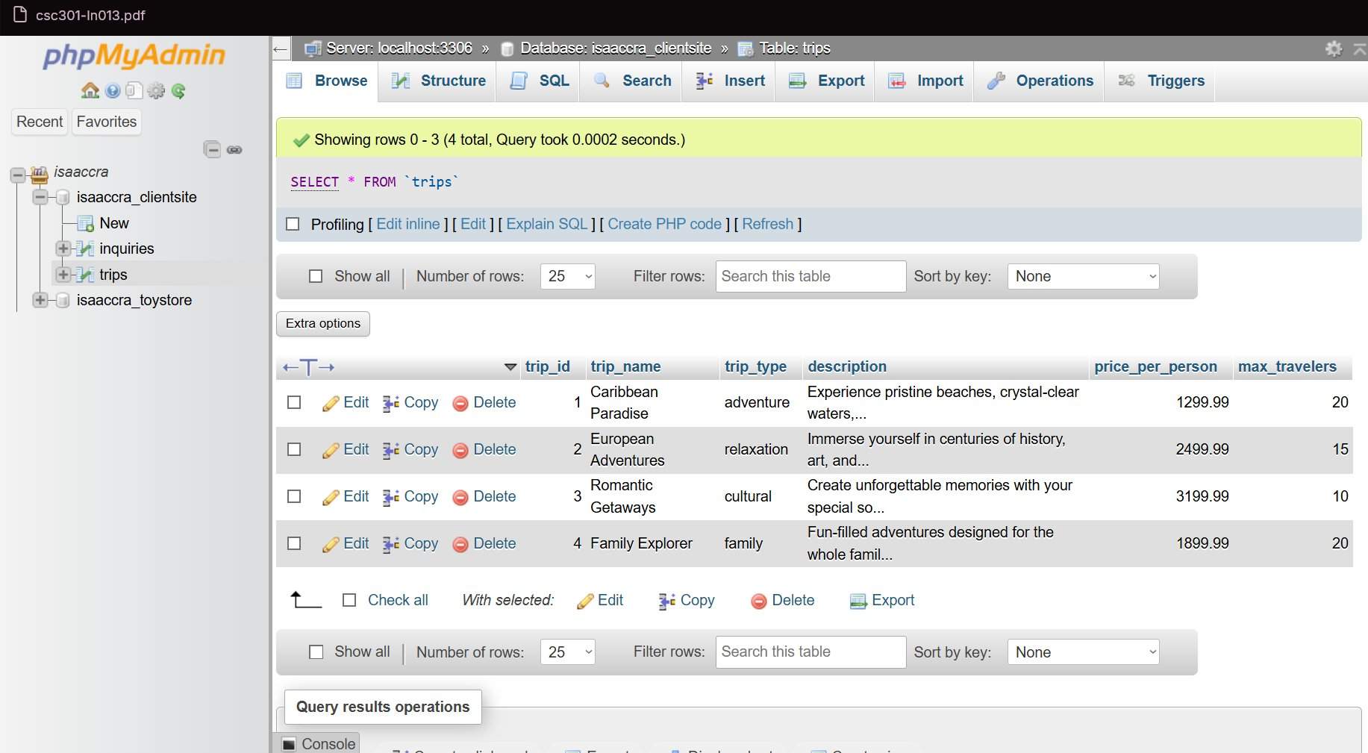

Sample Data — Rows
ID | Trip Name | Type | Description | Price | Max
1 | Caribbean Paradise | adventure | Experience pristine beaches... | 1299.99 | 20
2 | European Adventures | relaxation | Immerse yourself in centuries... | 2499.99 | 15
3 | Romantic Getaways | cultural | Create unforgettable memories... | 3199.99 | 10
4 | Family Explorer | family | Fun-filled adventures for families | 1899.99 | 20

Table 2: inquiries
Overview
Purpose: Stores every trip inquiry submitted through the Plan Your Trip form on destinations.php
Data stored: The linked trip (trip_id), the selected trip type, the visitor's full name, number of travelers, and the submission timestamp
Supports the site: When the form validates successfully, a new row is inserted here — allowing T's Travel to review and respond to all customer inquiries
Relates to: trips — the trip_id column is a foreign key referencing trips.trip_id, linking each inquiry to a specific package. This enforces referential integrity at the database level

Column Structure
Column Name | Data Type | Size | Key | Notes
inquiry_id | INT | 11 | PRIMARY KEY | Auto-increments with each submission
trip_id | INT | 11 | FOREIGN KEY → trips | Links this inquiry to a specific trip package
trip_type | VARCHAR | 20 | — | Radio button value submitted on the form
full_name | VARCHAR | 50 | — | Visitor name — matches is_valid_text(2, 50)
travelers | INT | 11 | — | Party size — matches is_valid_number(1, 20)
submitted_at | DATETIME | — | — | Auto-recorded timestamp of submission

Sample Data — phpMyAdmin Screenshot
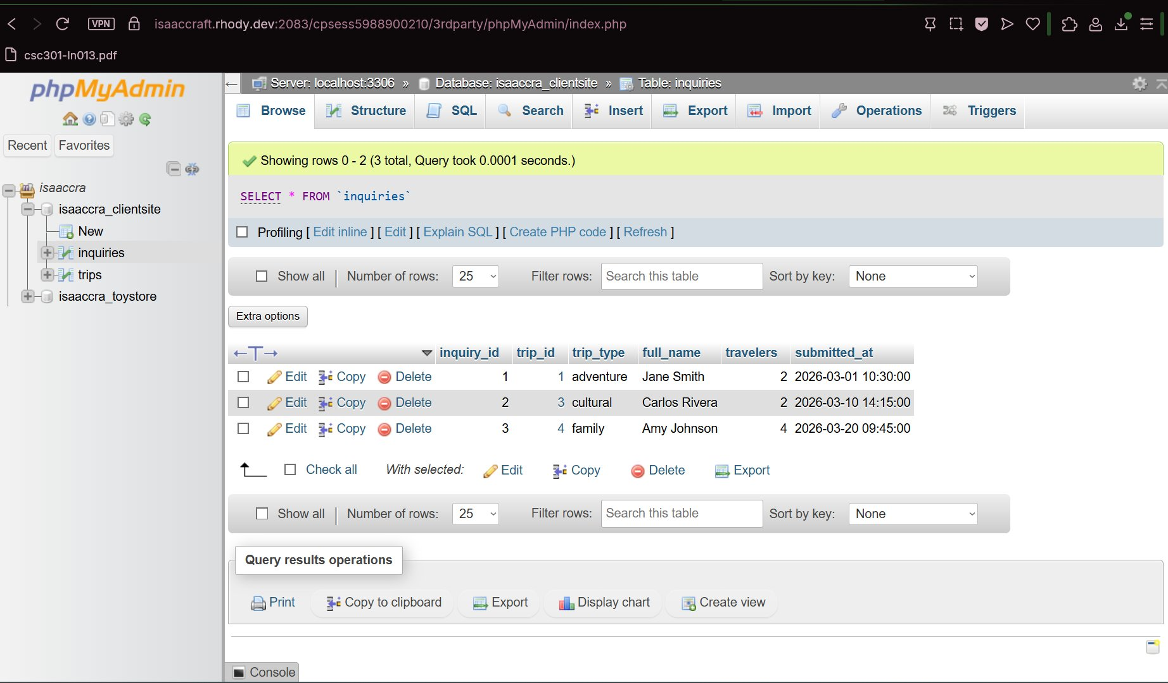

Sample Data — Rows
ID | Trip ID | Trip Type | Full Name | Travelers | Submitted At
1 | 1 | adventure | Jane Smith | 2 | 2026-03-01 10:30:00
2 | 3 | cultural | Carlos Rivera | 2 | 2026-03-10 14:15:00
3 | 4 | family | Amy Johnson | 4 | 2026-03-20 09:45:00

Table Relationship Summary
The two tables share a one-to-many relationship:
- One trip can have many inquiries submitted for it
- inquiries.trip_id is a FOREIGN KEY referencing trips.trip_id
- The foreign key constraint prevents an inquiry from referencing a trip_id that does not exist in the trips table
- trip_type is stored in both tables — in trips as the canonical value, and in inquiries as a snapshot of what the visitor selected so the record is self-contained

trips (trip_id PK) ←— inquiries (trip_id FK)

