IPE 13: D3 Project – Home automation

Group members: Merz Carina, Rausch Rene, Tomesch Sebastian, Yang Inwon  
Day of presentation: Mo, 13.06.16

1. Meeting: Getting started

* Tuesday, 24.05.2016 16:30-18:00, everybody present
* Checking the hardware
* Definition of the home automation system

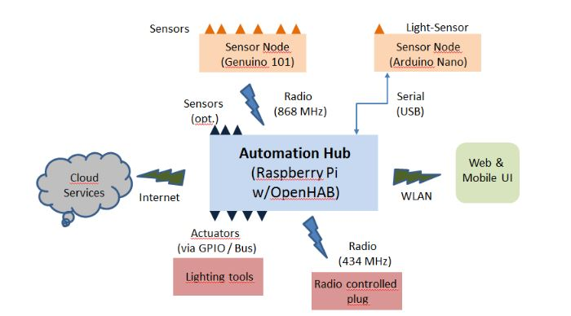

* Definition of tasks for the next meeting on Monday, 30.05
  + Everybody: github account
  + Carina:
    - github repo: done, IPE13_D3_5
    - connect Pi to Win10: look for the wiki page
    - openHAB: problems to access via pi-ip:8080/habmin

solution: it takes time to start up the pi, so just wait

changing sitemap: 192.168.137.5:8080/habmin

user’s view: 192.168.137.5/openhab.app?sitemap=test

* + Rene: takes care for 101 and Uno, sensors
  + Basti: cloud services, thingspeak, my.openHAB
  + Inwon: how to control radio controlled plug via Pi

2. Meeting: Soldering and wiring

* Monday, 30.05.16 13:15 – 16:30, everybody present
* Carina & Inwon: Connecting Pi to GPIOs, checking them via blink
* Basti & Rene: Soldering the board of the radio module

3. Meeting: Connecting

* Friday, 03.06 09:45 – 10:45, everybody present

**Informations**

MY Open HAB Temperature auslesen

<https://my.openhab.org/>

Getting startet: <http://www.makeuseof.com/tag/getting-started-openhab-home-automation-raspberry-pi/>

Connect open HAB mit channel: <https://ifttt.com/openhab>

Possible channels for open HAB: <https://ifttt.com/channels>

Open hab account:

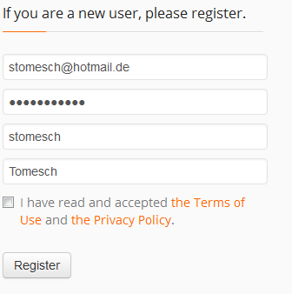

Accountinformations for ifttt

https://ifttt.com/recipes

Login: [stomesch@hotmail.de](mailto:stomesch@hotmail.de)

pw ask basti

Accountinformations for thingsspeak:

<https://thingspeak.com/channels>

UUID: stomesch

Login: [stomesch@hotmail.de](mailto:stomesch@hotmail.de)

Password buddy5Inwon

Inwon : Link for connecting and controlling the plug

<http://pygmalion.nitri.de/remote-controlled-mains-sockets-with-raspberry-pi-561.html>