IPE13 D3 Home automation project

Group 5 with Sebastian Tomesch, Rene Rausch, Inwon Yang and Carina Merz

Final architecture

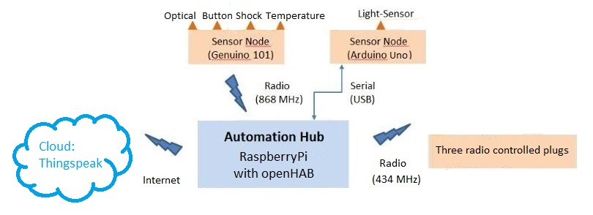

What did we use?

* SW tools: Arduino IDE, openHAB, Thingspeak
* SW for Pi: pilight (plug controlling), Gateway for Pi by Mr. Haschler
* SW for Uno: modified universalNode.ino by Mr. Haschler
* Libraries for 101: OneWire, DallasTemperature

What did we learn?

* Integration is hard. Success depends on peanuts.
* Allrounder are needed to succeed here (soldering, coding, research)
* You don’t need to know everything.   
  You need to know the right people who help you.
* Correct usage of RaspberryPi, Arduino/Genuino and Cloudservices
* Importance of communication in project Management