20742: 泰波拿契數

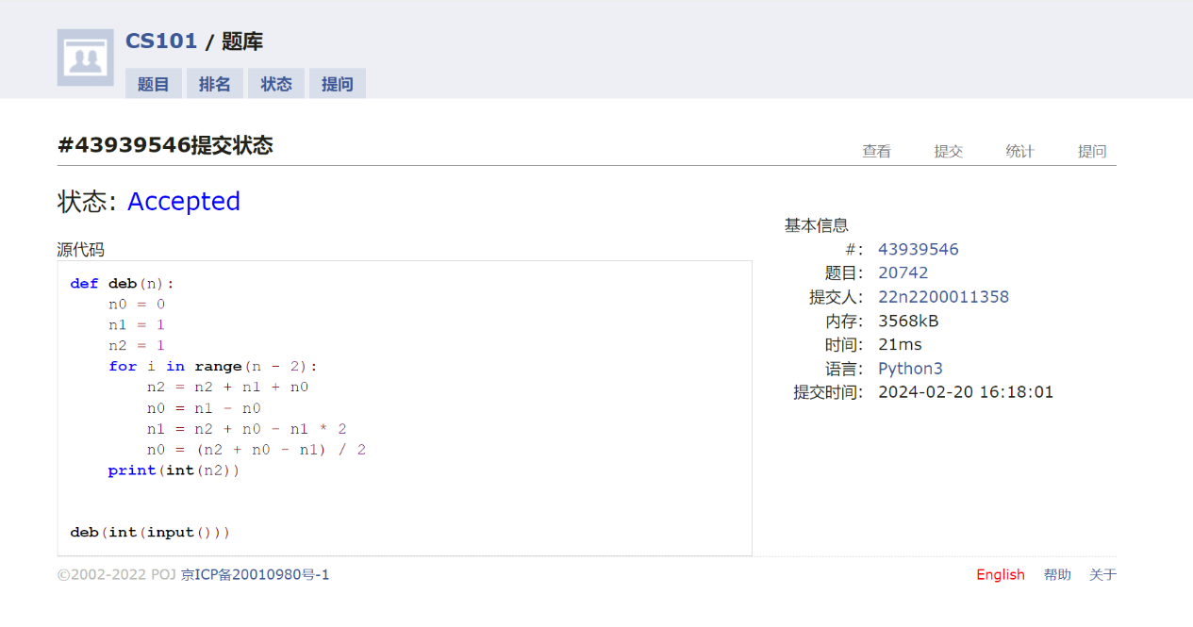def deb(n):  
 n0 = 0  
 n1 = 1  
 n2 = 1  
 for i in range(n - 2):  
 n2 = n2 + n1 + n0  
 n0 = n1 - n0  
 n1 = n2 + n0 - n1 \* 2  
 n0 = (n2 + n0 - n1) / 2  
 print(int(n2))

22359: Goldbach Conjecture

def gc22359(num):  
 lt = [2]  
 for i in range(1, num // 2):  
 n = i \* 2 + 1  
 a = True  
 for it in lt:  
 if n % it == 0:  
 a = False  
 break  
 if a:  
 if num - 2 in lt:  
 print(2, num - 2)  
 break  
 if num - n in lt:  
 print(num - n, n)  
 break  
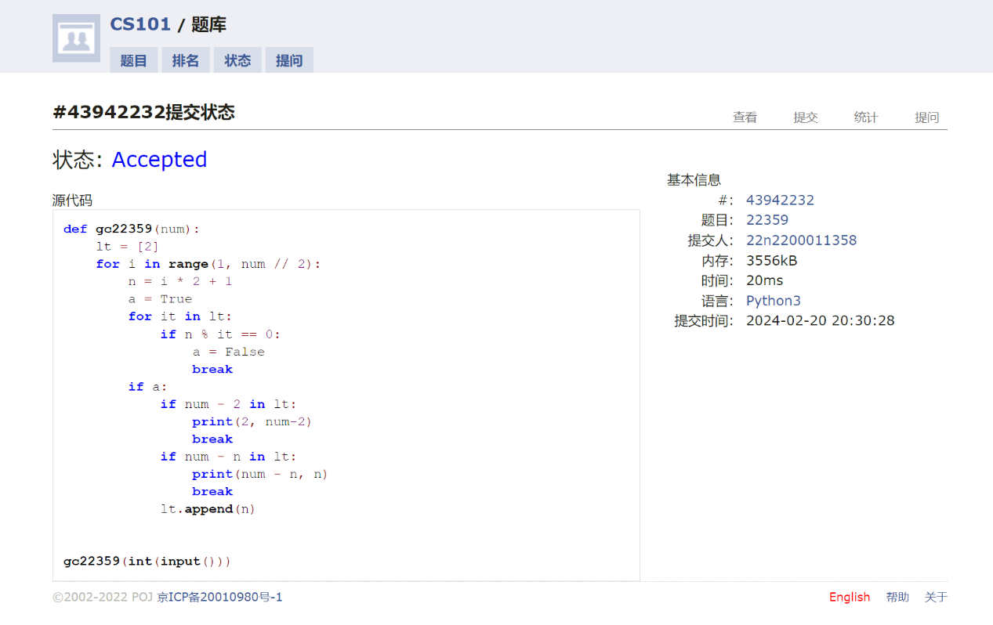 lt.append(n)

23563: 多项式时间复杂度

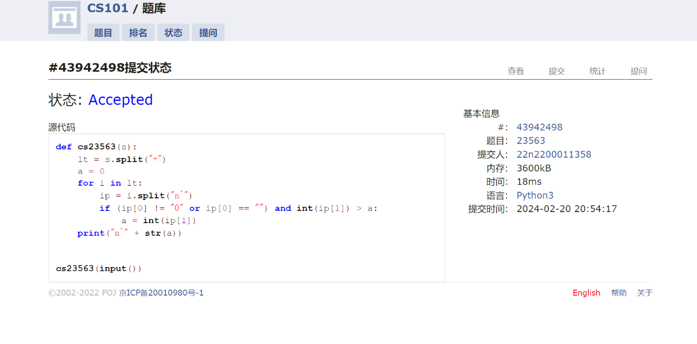def cs23563(s):  
 lt = s.split("+")  
 a = 0  
 for i in lt:  
 ip = i.split("n^")  
 if (ip[0] != "0" or ip[0] == "") and int(ip[1]) > a:  
 a = int(ip[1])  
 print("n^" + str(a))

24684: 直播计票

def cs24684(s):  
 lt = []  
 for i in range(1, 100001):  
 lt.append(0)  
 for i in s.split():  
 lt[int(i)] += 1  
 m = max(lt)  
 for i in range(100000):  
 if lt[i] == m:  
 print(i, end=" ")

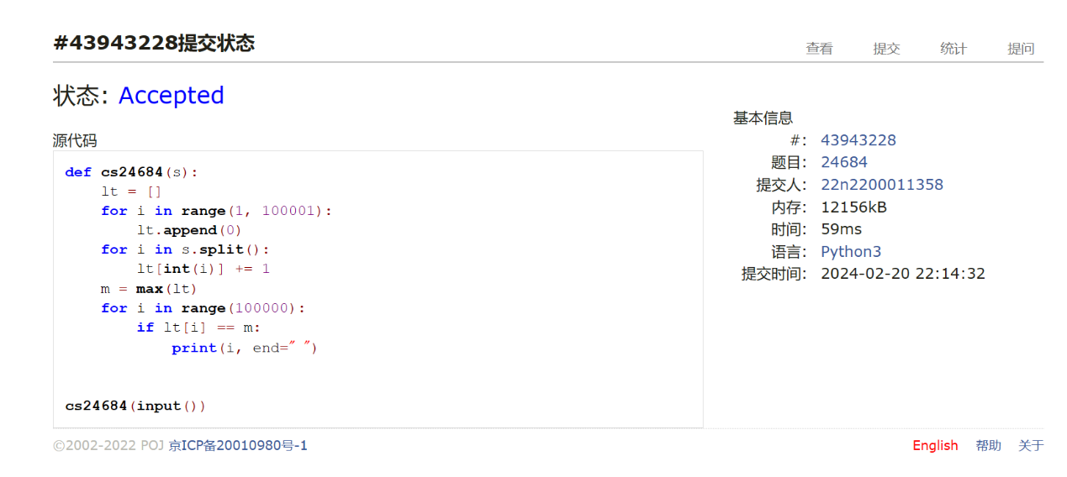

def a118(s):  
 s = s.lower()  
 s = s.replace("a", "")  
 s = s.replace("y", "")  
 s = s.replace("e", "")  
 s = s.replace("i", "")  
 s = s.replace("u", "")  
 s = s.replace("o", "")  
 print("." + ".".join(s))

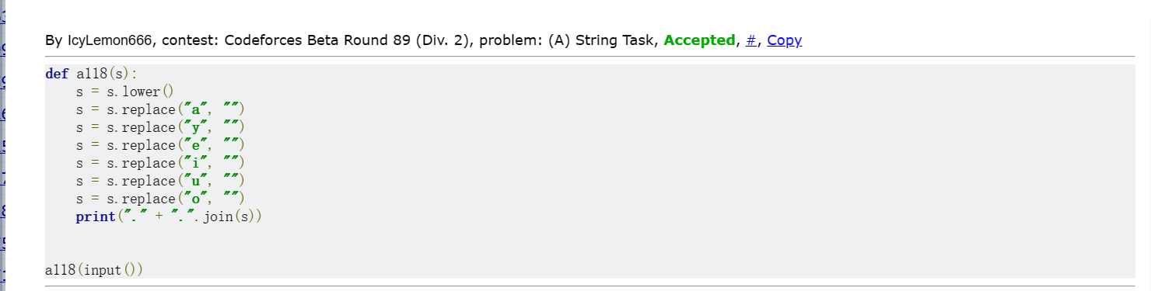

def a58(s):  
 n1 = s.find("h")  
 if n1 + 1:  
 n2 = s.find("e", n1 + 1)  
 if n2 + 1:  
 n3 = s.find("l", n2 + 1)  
 if n3 + 1:  
 n4 = s.find("l", n3 + 1)  
 if n4 + 1:  
 n5 = s.find("o", n4 + 1)  
 if n5 + 1:  
 print("YES")  
 else:  
 print("NO")  
 else:  
 print("NO")  
 else:  
 print("NO")  
 else:  
 print("NO")  
 else:  
 print("NO")

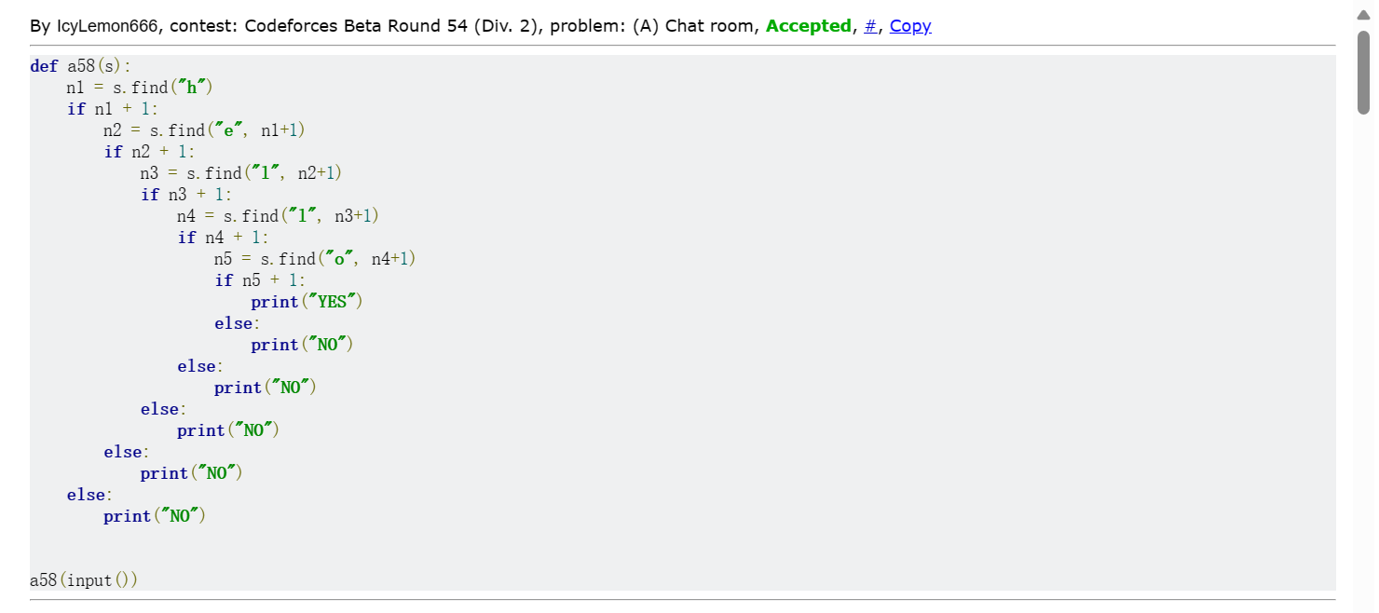

总结：本次作业用于回忆语法，简单