[27653: Fraction类](http://cs101.openjudge.cn/2024sp_routine/27653/)

def cs27653(l):  
 d = l[1] * l[3]  
 c = l[0] * l[3] + l[1] * l[2]  
 a = min(c, d)  
 b = c + d - a  
 while a != 0:  
 tmp = b % a  
 b = a  
 a = tmp  
 print(c // b, end="/")  
 print(d // b) 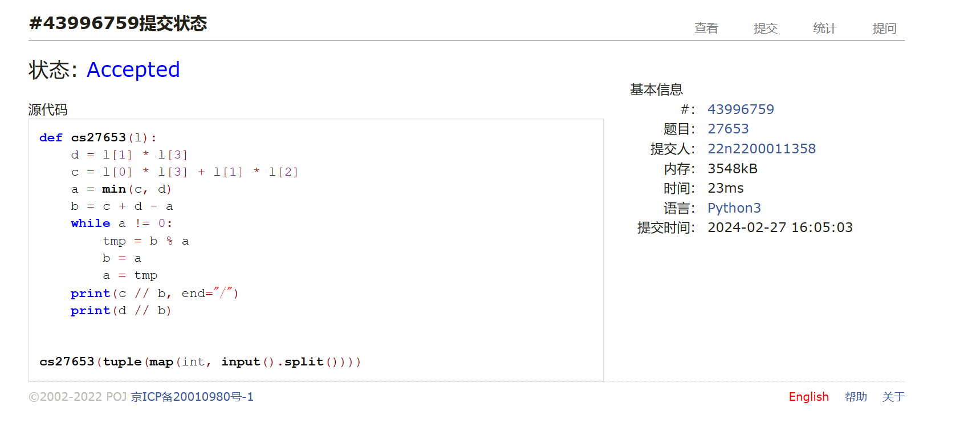

[04110: 圣诞老人的礼物-Santa Clau’s Gifts](http://cs101.openjudge.cn/practice/04110/)

def cs04110(t):  
 def take1(e):  
 return e[0] / e[1]  
  
 n = t[0]  
 w = t[1]  
 l = []  
 for i in range(n):  
 l.append(tuple(map(int, input().split())))  
 l.sort(key=take1, reverse=True)  
 i, ans = 0, 0  
 while w > 0 and i < n:  
 w -= l[i][1]  
 ans += l[i][0]  
 i += 1  
 ans += min(w, 0) * l[i - 1][0] / l[i - 1][1]  
 ans = (ans * 100) // 10 / 10  
 print(ans) 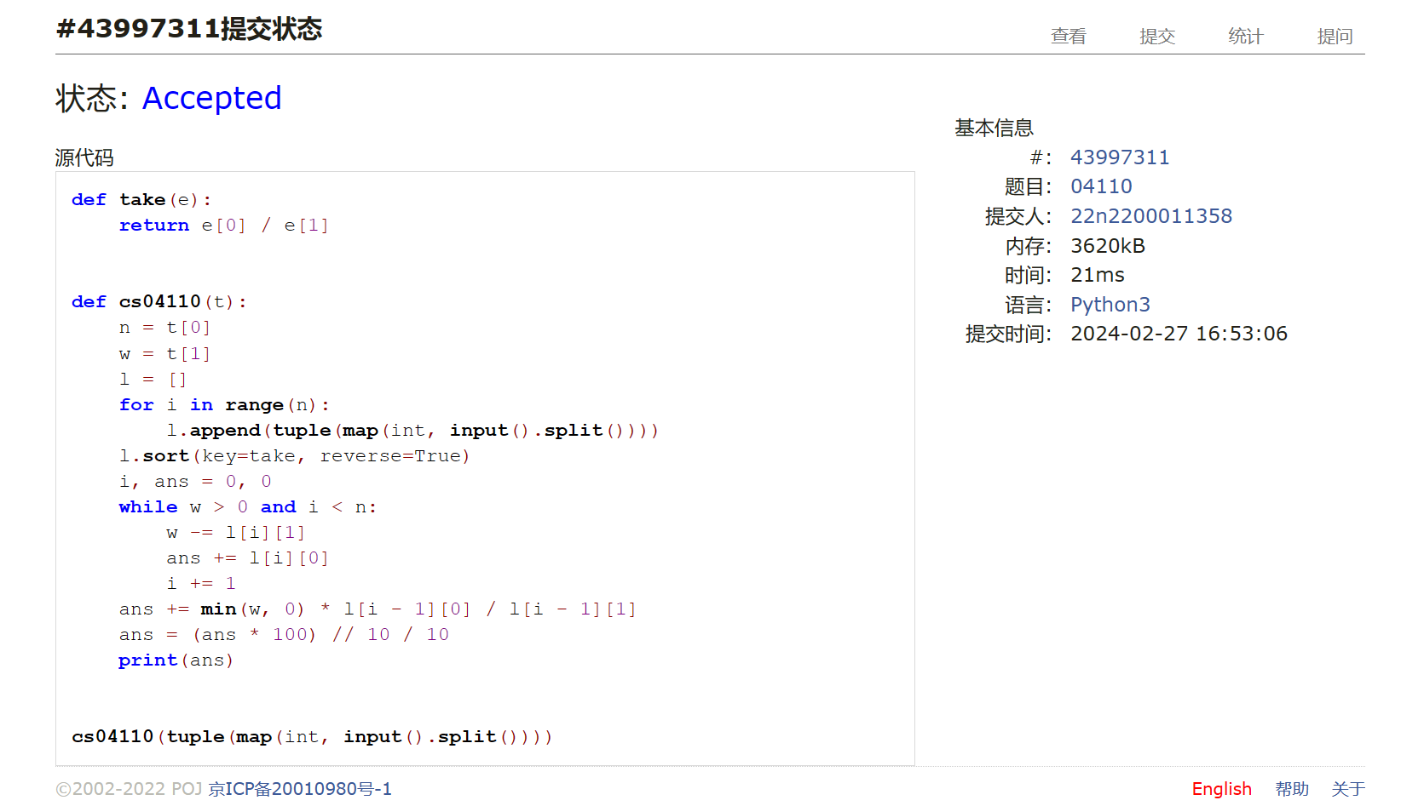

[18182: 打怪兽](http://cs101.openjudge.cn/practice/18182/)

def cs18182(nc):  
 def take2(e):  
 return e[0], -e[1]  
  
 for i in range(nc):  
 n, m, b = map(int, input().split())  
 lt = []  
 for j in range(n):  
 lt.append(tuple(map(int, input().split())))  
 lt.sort(key=take2)  
 pre = lt[0][0]  
 t = 0  
 for j in lt:  
 if j[0] == pre:  
 t += 1  
 if t > m:  
 continue  
 else:  
 pre = j[0]  
 t = 1  
 b -= j[1]  
 if b <= 0:  
 print(j[0])  
 break  
 if b > 0: print("alive")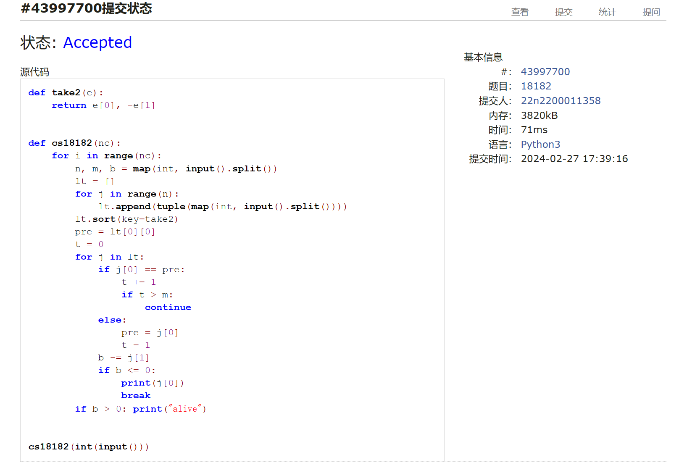

[18176: 2050年成绩计算](http://cs101.openjudge.cn/practice/18176/)

def cs18176(n):  
 from math import sqrt  
 lt = {2, 3, 5, 7, 11, 13, 17, 19}  
 for i in range(23, 10000, 2):  
 bol = True  
 for j in range(3, int(sqrt(i)) + 1, 2):  
 if i % j == 0:  
 bol = False  
 break  
 if bol: lt.add(i)  
 for i in range(n):  
 sc = tuple(map(int, input().split()))  
 ans = 0  
 for j in sc:  
 a = sqrt(j)  
 if a == int(a) and a in lt:  
 ans += j  
 ans /= len(sc)  
 if ans:  
 print(format(ans, ".2f"))  
 else:  
 print(0)  
  
  
'cs18176(int(input().split()[0]))'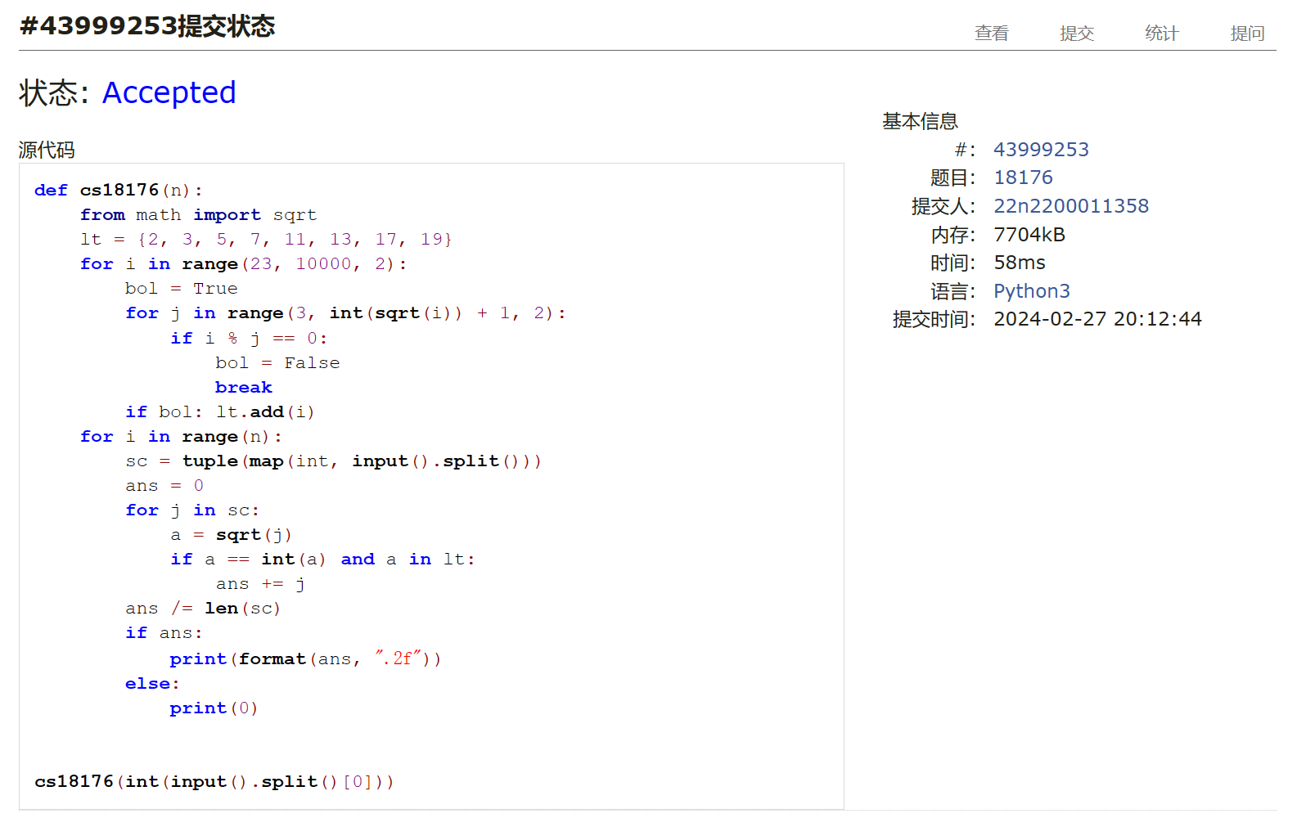

[B - T-primes](https://codeforces.com/contest/230/problem/B)

def b230(n):  
 from math import sqrt  
 t = tuple(map(int, input().split()))  
 lt = {2}  
 for i in range(3, 1000000, 2):  
 bol = True  
 for j in range(3, int(sqrt(i)) + 1, 2):  
 if i % j == 0:  
 bol = False  
 break  
 if bol: lt.add(i)  
 for i in t:  
 a = sqrt(i)  
 if a == int(a) and a in lt:  
 print("YES")  
 else:  
 print("NO")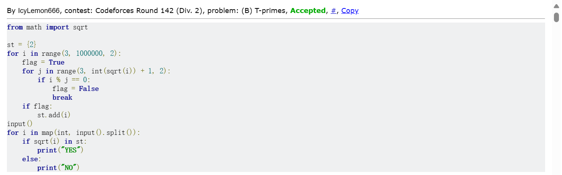

[A - XXXXX](https://codeforces.com/contest/1364/problem/A)

def a1364(t):  
 for i in range(t):  
 n, x = map(int, input().split())  
 tp = tuple(map(int, input().split()))  
 a, b, s = n + 1, 0, 0  
 for j in range(n):  
 s += tp[j]  
 if tp[j] % x != 0:  
 if a - n - 1:  
 b = j + 1  
 else:  
 a = j + 1  
 if s % x == 0:  
 print(max(n - a, b - 1))  
 else:  
 print(n) 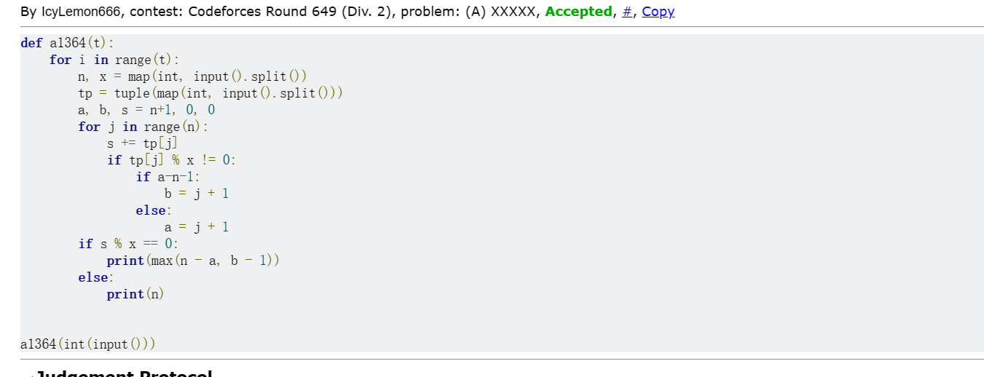

总结：本次学习了符合一定条件的最长子序列问题的处理，以及学习了一些低时间复杂度的质数生成，包括筛法。本次就是这两个问题耗时较多。