[02945: 拦截导弹](http://cs101.openjudge.cn/practice/02945/)

def cs02945(n):  
 a = tuple(map(int, input().split()))  
 d = [1] * n  
 for i in range(n):  
 for j in range(i):  
 if a[j] >= a[i]:  
 d[i] = max(d[i], d[j] + 1)  
 print(max(d)) 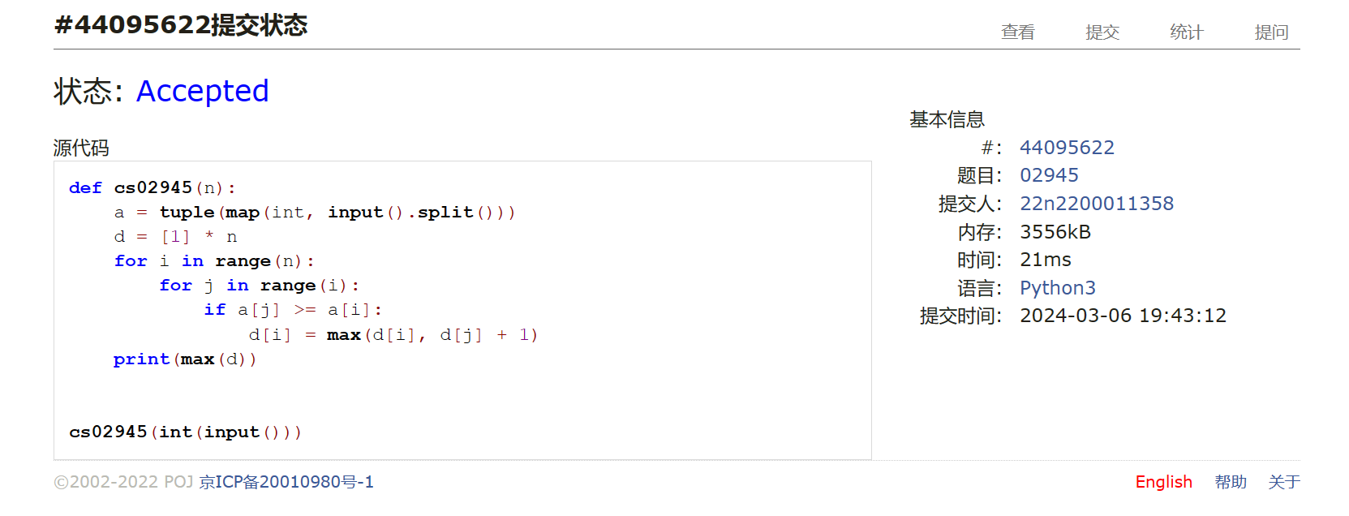

[04147: 汉诺塔问题(Tower of Hanoi)](http://cs101.openjudge.cn/practice/04147/)

def cs04147(lt):  
 n = int(lt[0])  
 if n > 0:  
 cs04147((n - 1, lt[1], lt[3], lt[2]))  
 print(str(n) + ":" + lt[1] + "->" + lt[3])  
 cs04147((n - 1, lt[2], lt[1], lt[3])) 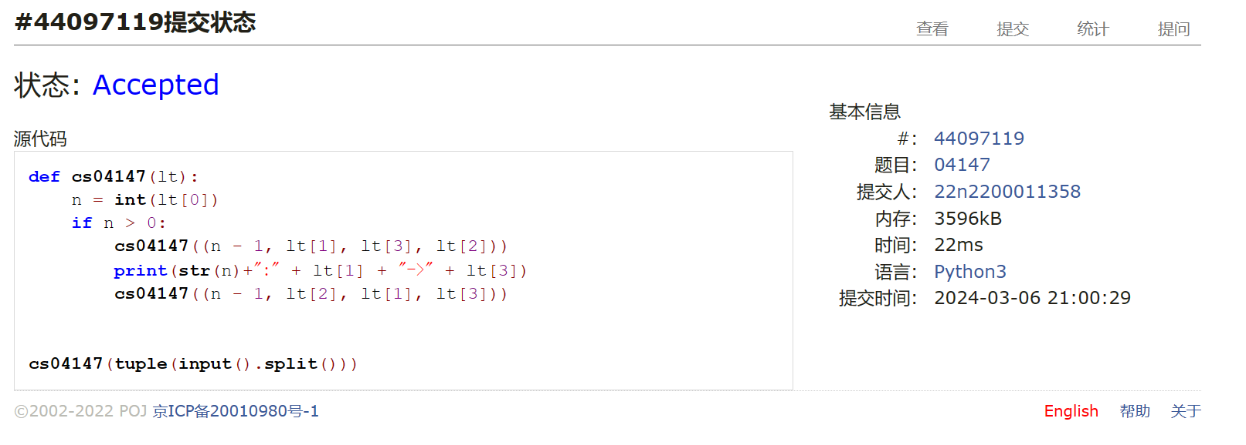

[03253: 约瑟夫问题No.2](http://cs101.openjudge.cn/practice/03253/)

def cs03253():  
 while True:  
 n, p, m = map(int, input().split())  
 if (n, p, m) == (0, 0, 0):  
 break  
 ans = ""  
 lt = [str(i + 1) for i in range(n)]  
 for i in range(n, 0, -1):  
 ans += "," + lt.pop((p + m - 2) % i)  
 p = (p + m - 2) % i + 1  
 print(ans[1:]) 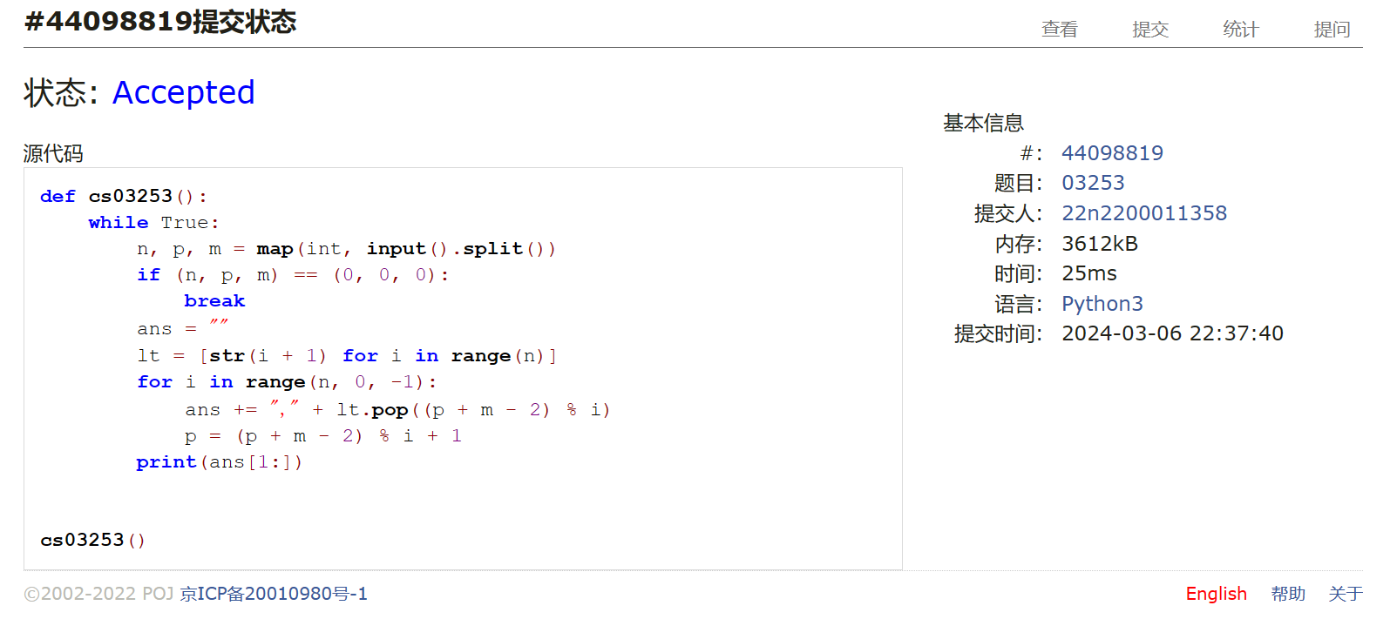

[21554: 排队做实验 (greedy)v0.2](http://cs101.openjudge.cn/practice/21554/)

def cs21554(n):  
 a = list(map(int, input().split()))  
 b = [i + 1 for i in range(n)]  
  
 def id(ni):  
 return a[ni - 1]  
  
 b.sort(key=id)  
 s = 0  
 for i in range(n - 1):  
 s += a[b[i] - 1] * (n - i - 1)  
 print(b[i], end=" ")  
 print(b[n - 1])  
 print(format(s / n, ".2f"))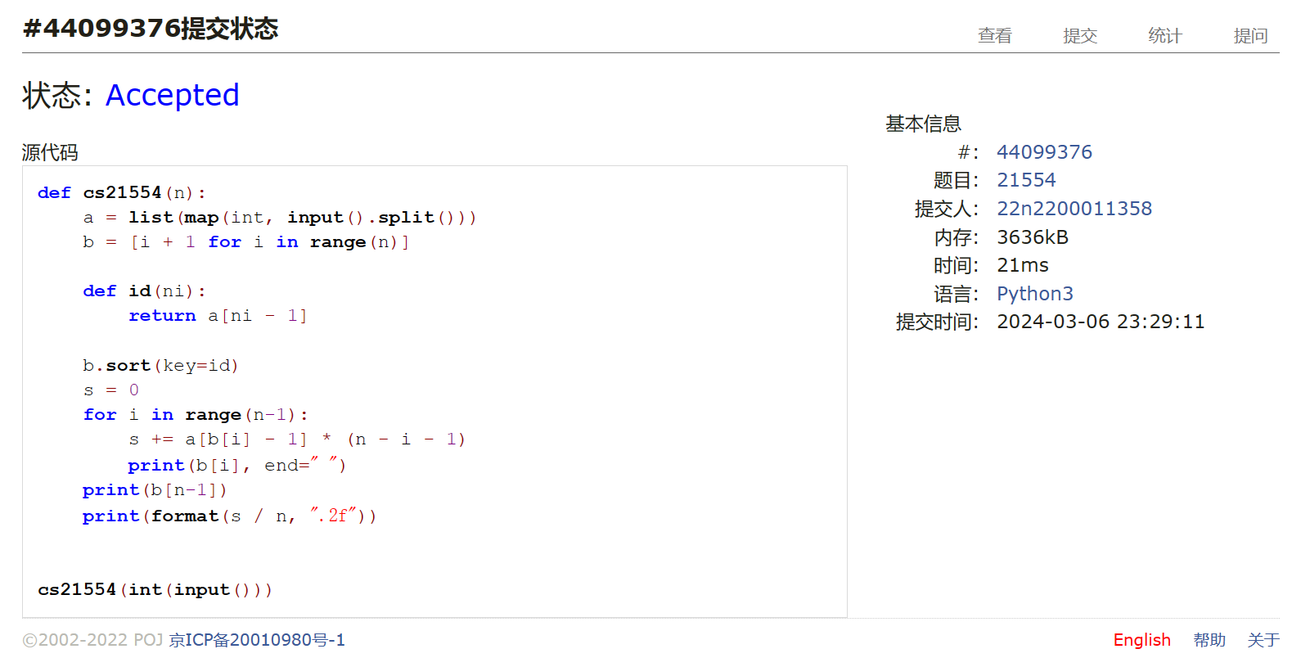

[19963: 买学区房](http://cs101.openjudge.cn/practice/19963/)

def cs19963(n):  
 a1, a2 = [i for i in range(n)], [i for i in range(n)]  
 b = tuple(tuple(map(int, i[1:-1].split(","))) for i in input().split())  
 c = tuple(map(int, input().split()))  
  
 def bi(ni):  
 return (int(b[ni][0]) + int(b[ni][1])) / c[ni]  
  
 def ci(ni):  
 return c[ni]  
  
 a1.sort(key=bi, reverse=True)  
 b1 = [bi(i) for i in a1]  
 a2.sort(key=ci)  
 b2 = [ci(i) for i in a2]  
  
 print(len(set(a1[:b1.index(b1[n // 2])]).intersection(set(a2[:b2.index(b2[n // 2])])))) 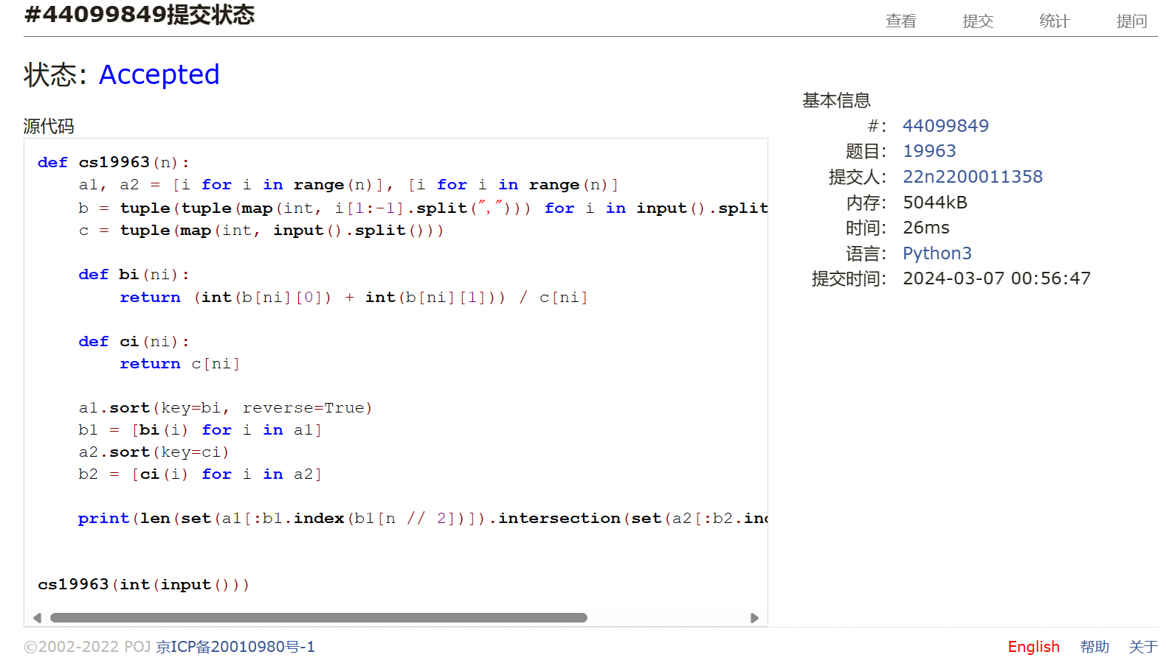

[27300: 模型整理](http://cs101.openjudge.cn/practice/27300/)

def cs27300(n):  
 k = []  
 dct = {}  
 for i in range(n):  
 a, b = input().split("-")  
 if a in k:  
 pass  
 else:  
 dct[a] = []  
 k.append(a)  
 dct[a].append(b)  
 k.sort()  
  
 def s(sc):  
 if sc[-1] == "B":  
 return float(sc[:-1]) * 1000  
 else:  
 return float(sc[:-1])  
  
 for i in k:  
 dct[i].sort(key=s)  
 print(i, end=": ")  
 for j in dct[i][:-1]:  
 print(j, end=", ")  
 print(dct[i][-1])  
  
  
cs27300(int(input()))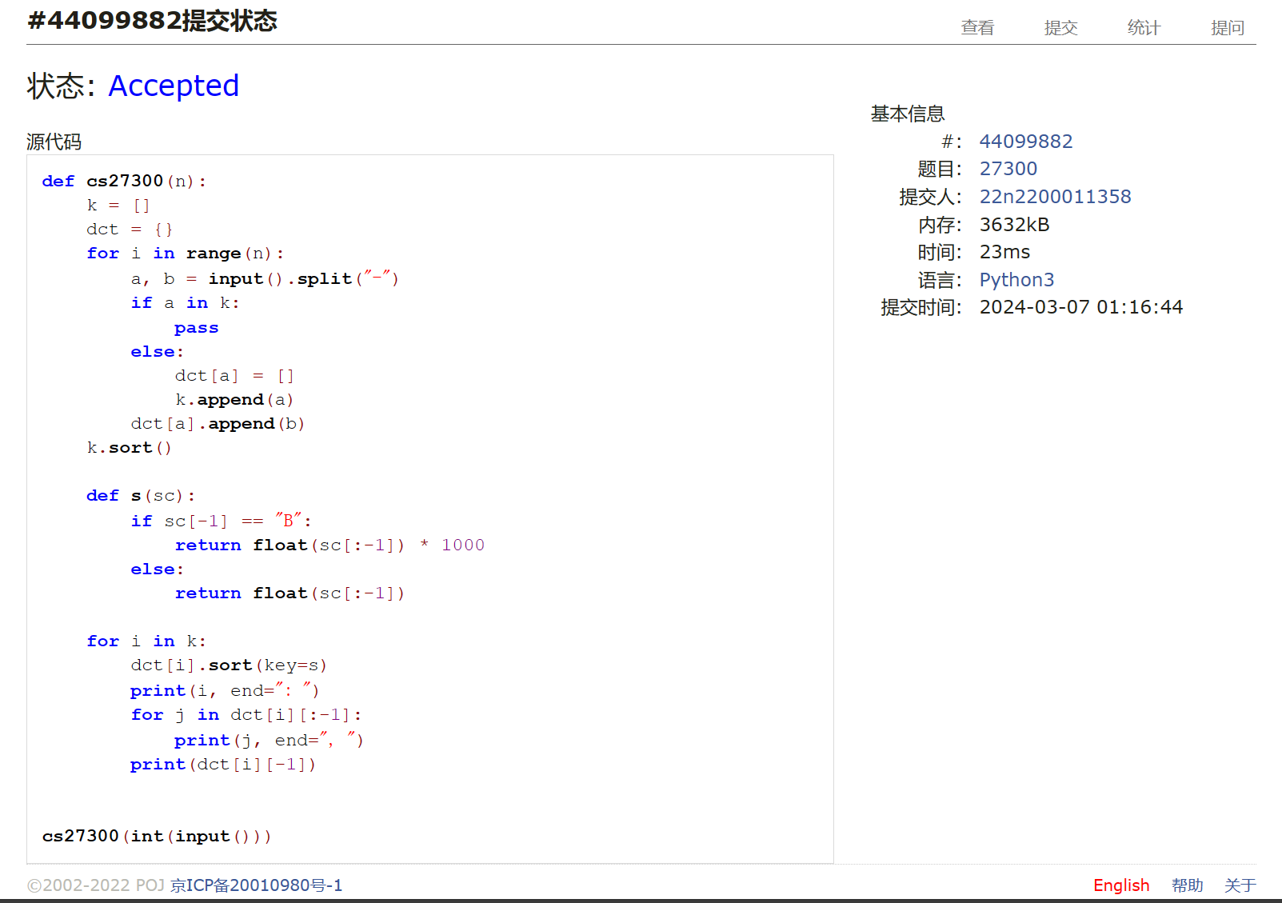

总结：本次月考因课程冲突未能参加，后面自己限时内能AC4，题目分级一如既往地有迷惑性，最后两题反而很简单。本次复习了DP，递归等算法，在汉诺塔题上因指标不清耗时过多