**04081:树的转换**

def cs04081():  
 ipt = input()  
 h1, h2 = 0, 0  
 d1, d2 = 0, 0  
 flag = 0  
 k = "d"  
 for i in ipt:  
 if i == "d":  
 d1 += 1  
 else:  
 d1 -= 1  
 h1 = max(h1, d1)  
 dct = {i + 1: [] for i in range(h1)}  
 for i in ipt:  
 if i == "d":  
 if k == "d":  
 flag += 1  
 d2 += 1  
 dct[flag].append(d2)  
 else:  
 d2 += 1  
 dct[flag].append(d2)  
 else:  
 if k == "u":  
 d2 -= len(dct[flag])  
 flag -= 1  
 h2 = max(h2, d2)  
 k = i  
  
 print(h1, "=>", h2)

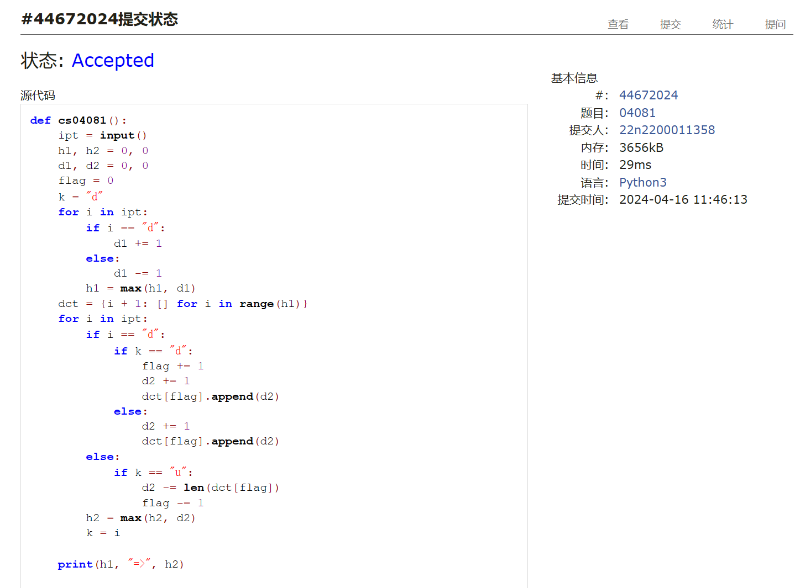

## 08581:扩展二叉树

def cs08581():  
 ipt = input()  
 lst = []  
 ans1, ans2 = "", [""]  
 ipt1 = ""  
 for i in ipt:  
 if lst and lst[-1] == ".":  
 lst.pop()  
 ans1 += lst.pop()  
 lst.append(i)  
 if i != ".":  
 ipt1 += i  
 print(ans1)  
  
 def getp(ipt_, ans):  
 tmp = ans.split(ipt_[0])  
 ans2[0] = ipt_[0] + ans2[0]  
 d = len(ipt_) - len(tmp[1])  
 if tmp[1] != "":  
 getp(ipt_[d:], tmp[1])  
 if tmp[0] != "":  
 getp(ipt_[1:d], tmp[0])  
  
 getp(ipt1, ans1)  
 print(ans2[0])

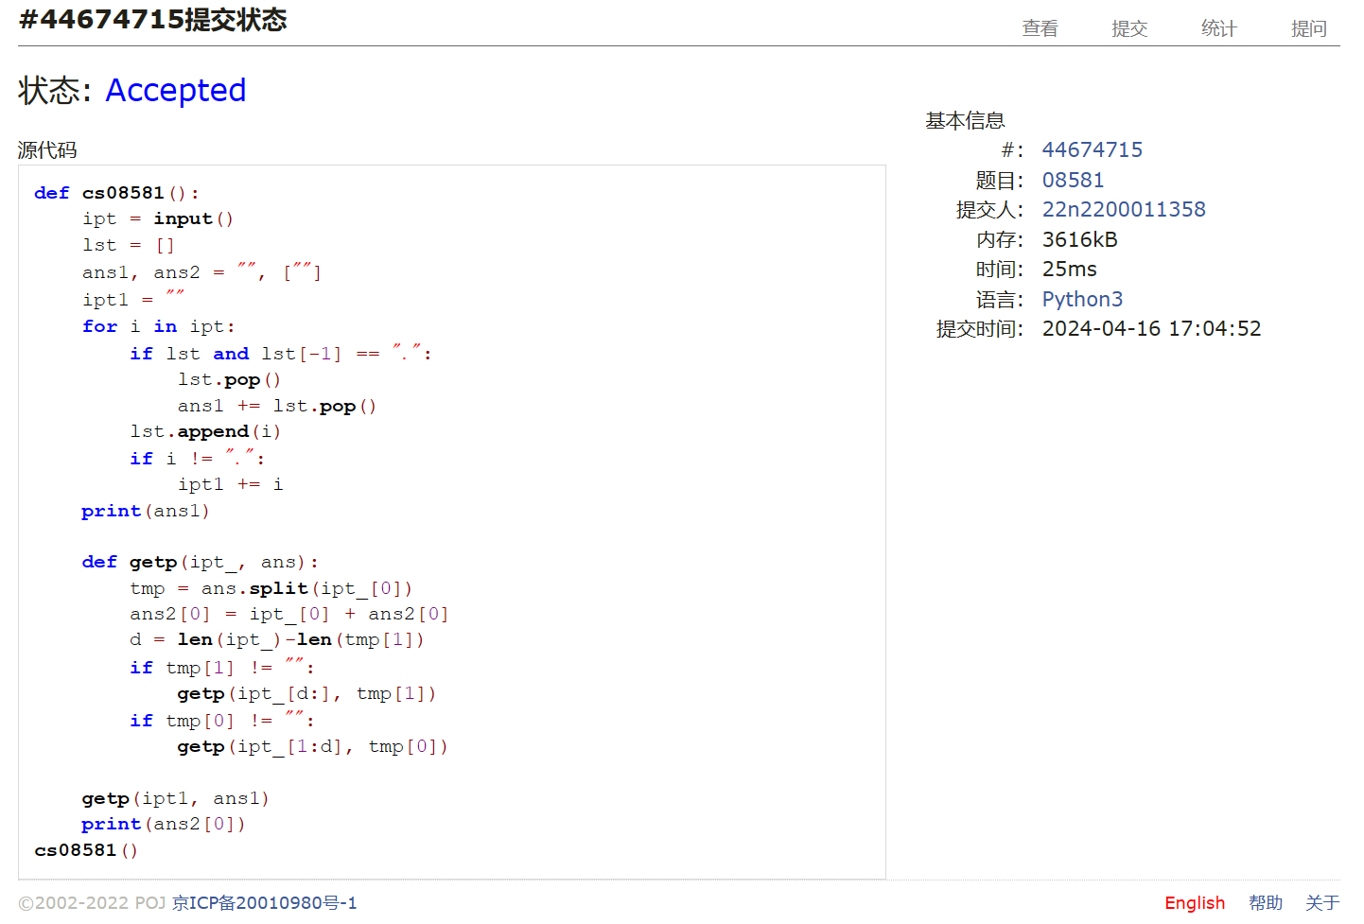

## 22067:快速堆猪

def cs22067():  
 try:  
 lst, mn, k, ans = [], {}, set(), 20001  
 while True:  
 ipt = input().split()  
 if ipt[0] == "push":  
 w = int(ipt[1])  
 lst.append(w)  
 if w in k:  
 mn[w] += 1  
 else:  
 ans = min(ans, w)  
 mn[w] = 1  
 k.add(w)  
 elif lst:  
 if ipt[0] == "pop":  
 d = lst.pop()  
 mn[d] -= 1  
 if not mn[d]:  
 k.remove(d)  
 if ans == d:  
 ans = min(k)  
 else:  
 print(ans)  
 except:  
 pass

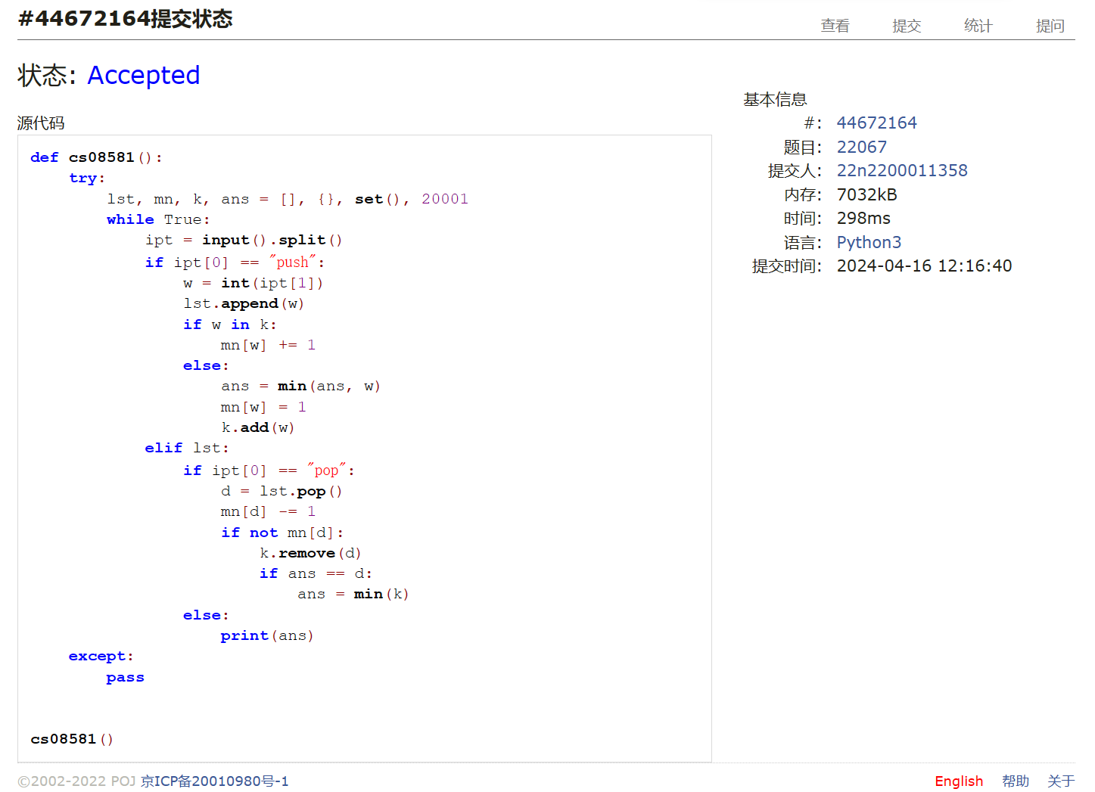

## 04123:马走日

def cs04123():  
 for ii in range(int(input())):  
 n, m, x, y = map(int, input().split())  
 ans = [0]  
 cst0 = [(1, 2), (2, 1), (-1, -2), (-2, -1), (1, -2), (2, -1), (-1, 2), (-2, 1)]  
 cst = []  
 for i0 in range(n):  
 cst.append([])  
 for j0 in range(m):  
 cst[i0].append([])  
 for it in cst0:  
 xi = it[0] + i0  
 yj = it[1] + j0  
 if 0 <= xi < n and 0 <= yj < m:  
 cst[i0][j0].append((xi, yj))  
 a = [[True for j in range(m)] for i in range(n)]  
  
 def go(i, j, d):  
 if d == m * n:  
 ans[0] += 1  
 else:  
 a[i][j] = False  
 for ij in cst[i][j]:  
 if a[ij[0]][ij[1]]:  
 go(ij[0], ij[1], d + 1)  
 a[i][j] = True  
  
 go(x, y, 1)  
 print(ans[0])

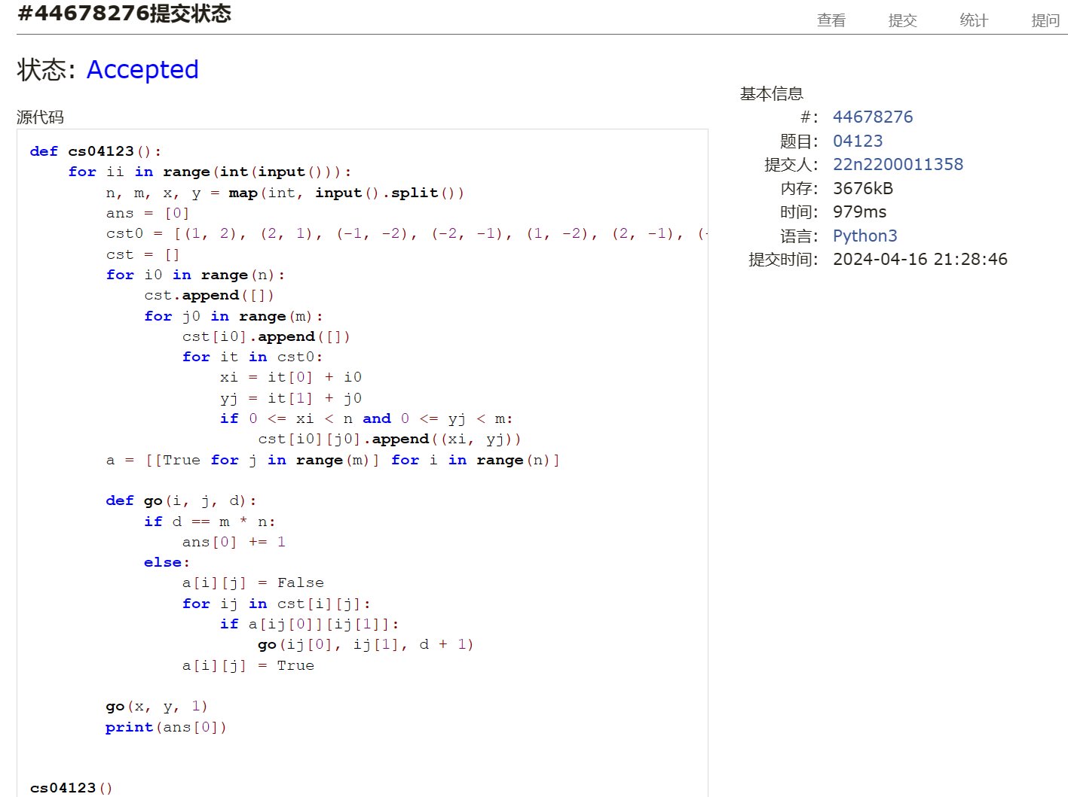

总结：要期中考了，先放个AC4的半成品（逃）